UNIVERSITY OF SCIENCE AND TECHNOLOGY HOUARI BOUMEDIENE (USTHB).
FACULTY OF COMPUTER SCIENCE.
DEPARTMENT OF INFORMATION.
SPECIALTY: SIGL.
MODULE: INFORMATION AND COMMUNICATION TECHNOLOGIES (TIC).

TIC FINAL PROJECT

The integrated TIC Ecosystem: A comprehensive Analysis of Google, Microsoft, Git, and GitHub for Modern collaboration and Development

Submitted to:

Dr. REDOUANE BOUCHEKIR
Prepared by:

BOUTERBIAT YASSINE (37613506).
Groupe ID:
ID8
- BOUTERBIAT YASSINE,
- ARABI YASSER,
- SOUIHER AKERAM EDDINE,
- CHEBCHOUB MOHAMED,
- AMARA TAKI EDDINE.
Date: December 14,2025
Academic year :2025/2026

Summary:
In this document, the author summarizes the study on TIC, which describes how TIC has changed the way global business operates; as well as education and the accelerated global development of societies. The study takes a closer look at the Integrated TIC Ecosystem with regard to the foundational toolsets of Google Services (Workspace), Microsoft Office (365), Git and GitHub. It demonstrates that each of these technologies can work together to support collaboration in today's workplace, improve business productivity and provide the tools needed to develop software through the agile development process.
The report defines TIC , and then details each of the four toolsets in a section format that highlights each toolset's features and capabilities. The report concludes by identifying an opportunity for integrating all of these platforms in order to maximise their potential and sustain competitiveness and resilience within the digital age. The content of this study will be used as a single source for the various subsequent phases of the project using LaTeX and PowerPoint.

TIC FINAL PROJECT 1
Summary: 2
1.0 Introduction to TIC 4
1.1defining information and Communication technology (TIC) 4
1.2Report objectives and Structure 4
1.3 The Transformative Impact of TIC 5
2.0 the Transformative Role of Google Services in cloud-Based Collaboration 7
2.1 Google Workspace: A Productivity Suite for Modern Teams 7
2.2 Case Study: Google Drive and version Management 8
3.0 Microsoft Tools: Enabling Workplace Productivity 9
3.1 the Microsoft 365 Ecosystem 9
3.2 Advanced integration with Teams and OneDrive 10
4.0 GIT: Foundations of Modern software Development 11
4.1 Understanding Distributed version control 11
4.2 Core Concepts Commits, Branches, and Merges 11
5.0 GitHub: A Global platform for Code collaboration 13
5.1 Beyond Code Hosting: pull Requests and Code Review 13
5.2 GitHub’s Role in Open Source and Education 13
6.0 Synthesis: The integrated TIC Toolkit 15
6.1 Interoperability and Cross-Platform Workflows 15
6.2 Future Directions of Enterprise ICT 16
7.0 Conclusion and Recommendations 17
8.0 References and Bibliography 18

Introduction to TIC

1.1defining information and Communication technology (TIC)
TIC or Information and Communication Technology, is a broad category that includes everything that relates to the use of technology for the handling of information and the communication of information. TIC serves as the foundation for today’s economy through the development of digital products, software programs, networks, and services. Additionally, TIC provides organizations with the means by which to improve their methods of doing business, increase global commerce opportunities, and facilitate the growth and development of relationships.
Today, the benefits and opportunities provided by TIC are realized by businesses of all types and in every industry, therefore, how an organization implements TIC strategically will have a significant influence on the organization's capacity for productivity and innovation during the 21st Century.

1.2Report objectives and Structure
The purpose of this document is to evaluate the four key components of contemporary cooperative information and communication technology (TIC) toolkits: Google Services, Microsoft Office Suite, Git, and GitHub. This evaluation will identify the strengths of each component and demonstrate how together they can provide a powerful and effective Digital Ecosystem. To do this, the report will examine first the two productivity suites (Google Services and Microsoft Office Suite) then discuss the two advanced development tools (Git and GitHub) and finally, provide an overview of these four tools and their combined use in enterprise-level TIC systems. The contents of this report will serve as the basis for the future assignment exercises.
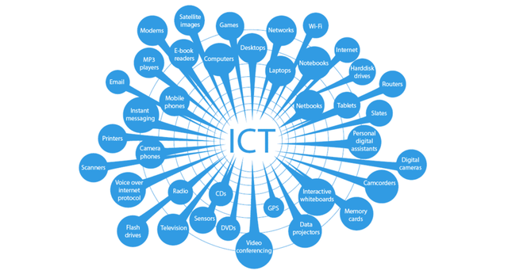

1.3 The Transformative Impact of TIC
The impact of Telecommunications and Information Communication Technology (TIC) is far-reaching and affects so much more than just the way we communicate with each other. TIC has transformed our world in many different ways including:
- Facilitating Globalization:

TIC connects markets globally and encourages companies to work together across countries through TIC. For example, ecommerce websites such as Alibaba enable small businesses to connect with customers around the world. Digital platforms provide tools to allow users to communicate in multiple languages, which removes barriers to trade, education and cultural exchange, thus enabling smooth communication.

TIC has increased workplace globalisation through platforms such as Zoom and Slack, allowing for hybrid working models.

The development of cloud-based services and global supply chain platforms has created a truly global marketplace, allowing companies to operate in many countries with very little infrastructure.

- Enabling Inclusive Education
People from disadvantaged or under-privileged backgrounds, as well those living in remote areas of the world, now have the opportunity of lifelong learning through websites such as Codecademy and SoloLearn

The true story of a young girl from rural Kenya who reached the highest level on her national examination by leverage online study resources is inspiring.

Technology such as Augmented Reality (AR) and interactive learning tools have greatly increased engagement in school; however, now with developments in innovative technologies utilizing AR and other platforms, teachers have an opportunity to provide students with personalised learning experiences. Platforms such as Google Classroom and Moodle provide both students and teachers to establish a collaborative environment, promoting the ongoing educational experience.

Further, there are currently many educational organisations utilising Virtual Reality (VR) technology to create replicated environments that expose students to "hands-on" experiences related to various technical disciplines, including areas like engineering and medicine.

Open Educational Resources (OER) are further expanding the availability of quality educational resources for all students.

- Catalyzing Economic Growth
FinTech, E-commerce and Digital Platforms create new ways for people to interact with the market and offer jobs. The online payment systems provided by PayPal and Stripe are examples of how these platforms have enabled businesses to reach out to markets outside their own borders.

The annual contribution to the national GDP of TIC enabled sectors including Cloud Computing Services, Content Creation and Application Development is substantial in many countries. With the emergence of Digital Marketplaces, small and medium sized businesses have been able to take advantage of the same Digital Tools.

Automation and Artificial Intelligence (AI) are providing businesses with greater productivity by replacing manual processes with automated ones. This increase in productivity is due to AI and automation increasing the speed of production and accuracy of products in many manufacturing environments using robots and machines. In addition, AI can enhance sales for retailers by allowing them to better track products as well as recommend products to consumers. Lastly, by providing trucks with the best route to deliver goods, it improves on-time delivery and reduces fuel costs for shipping goods. Overall, these systems provide increased

- Enhancing Disaster Response
Technology has changed the way we communicate and respond to emergencies, making it easier to be prepared and recover from disasters through quick access to the right information. An excellent example of this is the use of aerial drones—equipped with various types of sensors—to assist in post-disaster search and rescue operations.

Mobile applications and early warning systems provide critical communications during and prior to a disaster (e g. via SMS, or text messaging). With regards to natural disaster alerts, crisis mapping platforms such as CrisisMapper provide a visual representation (usually a map) of realtime data (e g. people, buildings). They also allow for more efficient emergency responding strategies.

Both satellite-based technology and TIC's have been instrumental in the monitoring of the Earth's changing environments in terms of helping develop and supply needed long-term mitigations for disasters. Crowdsourcing information in crisis situations via social media platforms is also a valuable tool utilized during these types of crisis events.

- Promoting Environmental sustainability
By leveraging information and communications technologies (TIC), such as IoT and AI, you can make better use of resources, improve ecosystem monitoring, and track carbon footprint for climate change interventions.

TIC enables the application of renewable energy management systems and AI algorithms to provide real-time, efficient distribution of power supplied from renewable sources. Digital twins are used in conjunction with TIC to model the physical system and predict its future state while reducing the potential for environmental damage.

Similarly, smart grids and precision agriculture are other areas where TIC supports environmental sustainability by enhancing energy efficiency, conserving resources, and reducing waste.

2.0 the Transformative Role of Google Services in cloud-Based Collaboration

2.1 Google Workspace: A Productivity Suite for Modern Teams

Through a combination of innovative products bundled together as Google Workspace, Google has changed how people work using technology, taking the ability to work together in real-time from any device to become part of everyday business operations. Google Docs, Google Sheets, Google slides, and Google Drive are all built to collaborate simultaneously between many users in real-time. This eliminates all of the obstacles to collaboration, such as having to wait on e-mail replies for collaborative projects or managing different versions of documents using e-mail attachments, by enabling instant feedback and improving collaboration.

Google has been committed to developing a method of providing browser-based applications on multiple platforms through its continued dedication to developing browser-based applications, enabling users to access their full suite of collaborative tools from any computer, smartphone, or tablet, which is critical for all forms of flexible working and meeting business needs.

2.2 Case Study: Google Drive and version Management

The core function of Google Drive is as the primary storage space for all data in the cloud with an emphasis on security and easy access. Another popular characteristic of Google Drive is the automatic tracking of changes made to Documents (Document History). A change made to a Document, no matter how small, will be saved so that users could revert back to any prior version without needing to create manual backups themselves. This built-in versioning capability serves a dual purpose: It acts as the basis for establishing a framework for file governance and it reduces the time required for learning to use different external file versioning applications. The ability to share Files through a direct link rather than requiring file transfer also enhances the speed at which organizations can share Knowledge.

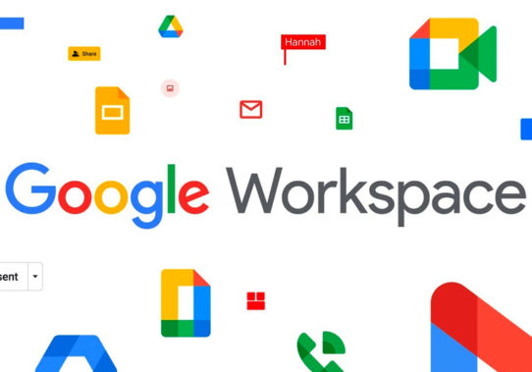

3.0 Microsoft Tools: Enabling Workplace Productivity

3.1 the Microsoft 365 Ecosystem

Microsoft 365 is the contemporary version of the traditional Office suite. The combination of traditional desktop applications (Word, Excel, PowerPoint) with comprehensive cloud capabilities makes it extremely powerful. It is often considered the preferred solution by large corporations and governments due to its growth-oriented administrative capabilities, its extensive integration with Windows systems, and its advanced compliance features. Its greatest strength is the combination of the depth of features that are available across its constituent applications as well as the depth of feature offerings from its main application (i.e., Excel). Excel continues to maintain its status as the industry's leading standard for data analysis and financial modelling for complex and voluminous datasets and calculations.
Table 3.1: Comparison of core collaboration Features between Google and Microsoft Suites:
Microsoft365 (M365) | Google workspace | Feature
Excellent (cloud and Desktop) | Excellent (Native cloud) | Real-time collaboration
Excellent (legacy Enterprise focus) | Strong (Focused on cloud) | Date Security & Compliance
Excellent (Excel Depth) | Good (Evolving sheets) | Best for Complex Analytics
Outlook/Teams | Gmail/Meet | Primary communication Hub

3.2 Advanced integration with Teams and OneDrive

The ICT capabilities of Microsoft 365 (M365) are evidenced by the work performed through Microsoft Teams to connect all areas of your working environment and provide you with an efficient, seamless way to work with your team members. Team members can communicate with one another through chat features, video conferencing, and by sharing documents. The ease of being able to integrate your work files into your Teams environment provides you with the ability to work effectively as a team member and improve your productivity as an organization. Microsoft Teams has removed the need for organizations to switch between multiple applications or tools to access and collaborate on files securely and in a synchronized manner. All of your work projects will be secure with access control through permission levels. Through Microsoft Teams as an online workspace for communication and OneDrive as an online file storage system, M365 provides an operating platform for large businesses.

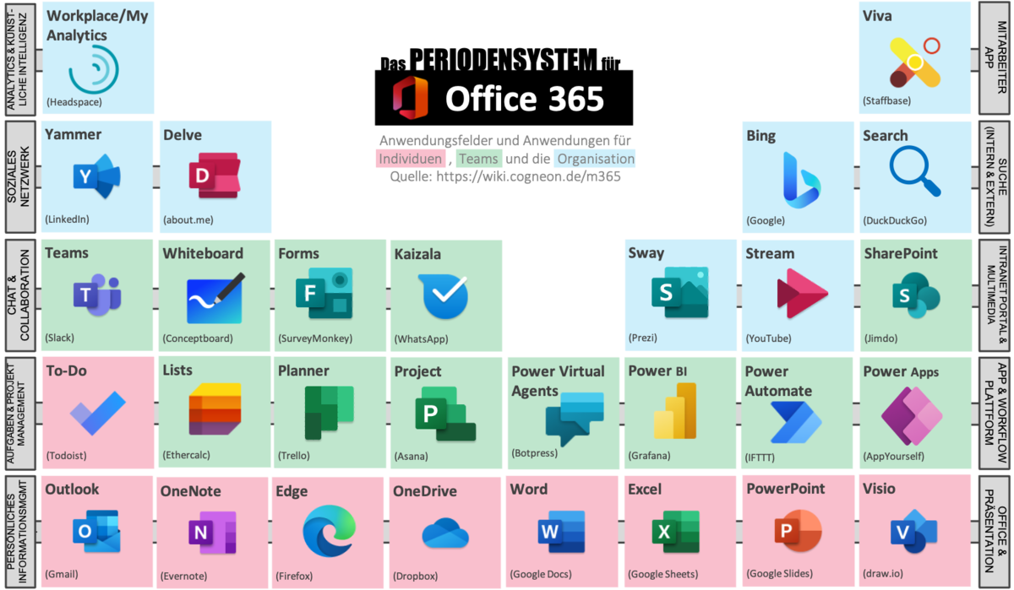

4.0 GIT: Foundations of Modern software Development

4.1 Understanding Distributed version control

As an industry standard Distributed Version Control System (DVCS), Git allows multiple developers to work on one piece of software without overwriting one another's code or corrupting the codebase. Given the increasing complexity of software and the way developers collaborate in large numbers, Git was developed to prevent developers from overwriting one another's work or corrupting a complex piece of software as they were each developing their own code. The distributed nature of Git means that each developer has a complete, local copy of the repository's entire history, creating redundancy and enabling them to work offline confidently. As such, Git can be viewed as a tool that changes the way that developers collaborate on software from a disorganized fashion to a structured process that preserves the history of all changes made.

4.2 Core Concepts Commits, Branches, and Merges

A deep understanding of Git can be gained through three key principles. The first principle is 'Commit,' which saves a snapshot of the current repository, along with a message describing what has been done. The second principle is 'Branch,' which allows developers to have separate development lines (branches) for bugs and feature development. By using branched lines to develop bugs/features, it minimizes the risk of introducing instability to the 'main code base.' Lastly, 'Merge' is the process of integrating developed code into another code base. All developers' contributions will be aligned. Git's branching model has been an integral part of Agile and DevOps Models of Delivery and provides fast and reliable delivery of features.
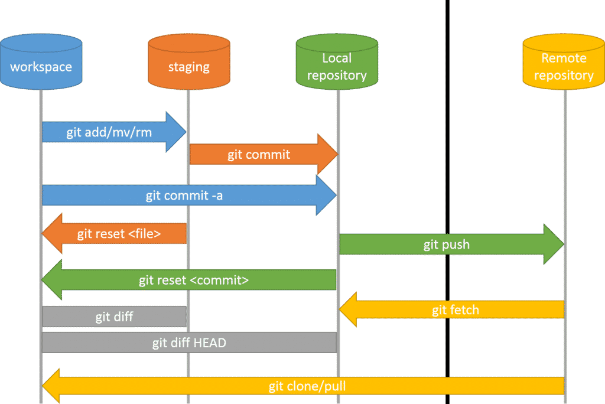

5.0 GitHub: A Global platform for Code collaboration

5.1 Beyond Code Hosting: pull Requests and Code Review

On a local level, Git manages your version controls, whereas on a global level, GitHub operates as a cloud-hosted service that supplies an additional social and project management layer to your Git repositories. GitHub turns Git into a vast shared collaboration platform for both local and remote teams across the world. The most important aspect of collaborative ICT on GitHub is the Pull Request (PR) system. A Pull Request is a request to merge changes made to a specific branch of code into the primary code repository, thereby starting a rigorous code review cycle that is supervised through GitHub's interface. Quality assurance is vital, as this system allows others to review, comment on and suggest improvements to the proposed code before it is merged into the main code repository.

5.2 GitHub’s Role in Open Source and Education

Open-source developer(s) from around the world use GitHub as their primary source of support for the creation and maintenance (in many cases) of the digital infrastructure of the contemporary technological world is based on millions of publicly accessible repositories on GitHub. The open-source nature of these repositories allows countless developers to collaborate on their various projects, resulting in rapid innovation across all sectors of technology.
In addition, through its GitHub Education Programme, GitHub provides students/scholars with access to free professional tools which include a number of professional software packages available only to paying customers of those same software. By doing this, GitHub is an essential resource for developing the next generation of ICT Professionals; it provides students with hands-on, real-world experience using the modern software development/maintenance methodologies currently in use.



6.0 Synthesis: The integrated TIC Toolkit

6.1 Interoperability and Cross-Platform Workflows

Integrating the four systems shows their true value as part of a collaboration strategy. An effective ICT strategy requires the interoperability of the systems used in this type of collaboration. For example: A software development team will use Microsoft Teams or Google Meet daily for their stand-up meetings; they will collaborate on project specifications using Google Docs or Microsoft Word; they will manage the actual code they implement using Git and GitHub. To accomplish this level of interoperability, tools called "connectors" are usually used. There are two types of connectors (the developer tools and productivity links). For instance, Microsoft's Visual Studio Code is Git native and enables developers to commit code directly to GitHub from within it, thus linking the development environment to the hosting environment. In addition, most project management solutions today provide the ability to integrate directly with GitHub (for tracking code changes) and Microsoft Teams (for notification and communication), thereby linking the administrative work of a project with the work of coding it. The use of a cross-platform approach helps to maximise the efficiency of the process by taking the best aspects from each application in order to manage document creation and messages, and to securely maintain the integrity of the codebase, using the best-in-class applications that lead their respective industries.

6.2 Future Directions of Enterprise ICT

The Future of Enterprise ICT: Artificial Intelligence (AI) and a Cloud-Centric Approach
The Future of Enterprise ICT is evolving rapidly thanks to developments in AI and the increasing Centralization of Cloud Technology. Examples include Google (with Gemini) and Microsoft (with Copilot), both of which use generative AI within their productivity applications to automate processes such as drafting content and summarizing data. As these technologies mature, the user role will transition from creating content to curating it, leading to a paradigm shift in the nature of Knowledge Work. In addition, there will continue to be a convergence of the previously distinct types of communication platform (e.g., Teams, Meet) and Development Platform (e.g., GitHub), enabling users to move seamlessly from discussions of Code to Code Deployment (i.e., publishing their work). To be ready for these disruptions, organisations need to start developing employee skills in AI-assisted Collaboration and Multi-Platform Management.

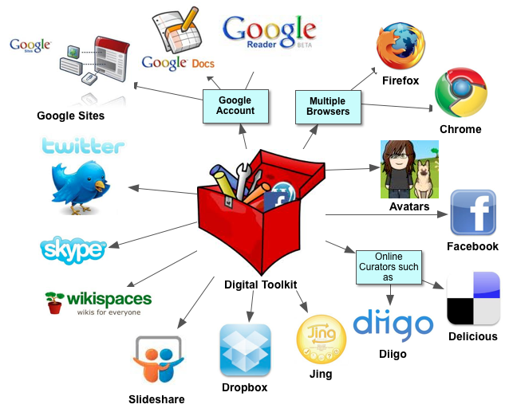

7.0 Conclusion and Recommendations

The TIC Toolkit is one of the more critical components of the Digital Enterprise. With Google Workspace, Microsoft 365, Git, and GitHub comprising the backbone of many organizations’ ICT infrastructure and providing the foundation for the organization’s communication and documentation requirements and technical development capabilities, Organizations will only benefit from implementing an ICT Strategy if (a) each of these tools has technical proficiency in its use; and (b) they will be utilized as one cohesive
​Recommendation: We recommend that Organizations develop a standardized Workflow that allows for the assignment of Tools specific to each Job Requirement to enable maximum productivity. For example: Assigning M365 for all Formal Documentation; Git/GitHub for all Versioned Code, and Teams for Instant Messaging/Collaboration/Communication/ etc. eliminates many of the
issues related to Data Fragmentation/Version Conflicts.

8.0 References and Bibliography

- Chacon, S., & Straub, B (2024). Pro Git (2nd Ed).
A Press Google (2023)
Google Workspace for Enterprise: Security and Collaboration Guide. [Associated Google Support/Admin URL]
GitHub (2024). Understanding the Pull Request Workflow and Code Review
- [Associated GitHub Documentation/Blog URL]
Laudon, K.C., & Laudon, J.P. (2025).
Management Information Systems: Managing the Digital Firm (19th Ed). Pearson Education.
- Microsoft (2024). Microsoft 365 and Copilot: Integration, Security, and Compliance Documentation. [Associated Microsoft Learn URL]
- Turban, E., Pollard, C., & Wood, G. (2022). Information Technology for Management: Advancing Digital Transformation. John Wiley & Sons.
- GitHub Guides. (2024). Retrieved from GitHub Docs
- Salesforce Customer Success Platform. (2024). Retrieved from
Le n°1 du CRM : Logiciel de Gestion Client - Salesforce

