Lecture 06 - Phase Diagram Examples and Fe-C
Source: `STM/Material(1)/06_phase diagrams examples_2025-2026.pdf; STM/Material(2)/Exercises8-9`
Purpose: open-note exam guide. It prioritizes answer structure, formulas, tutorial methods, and professor-style traps.

Fe-C Reference Diagram
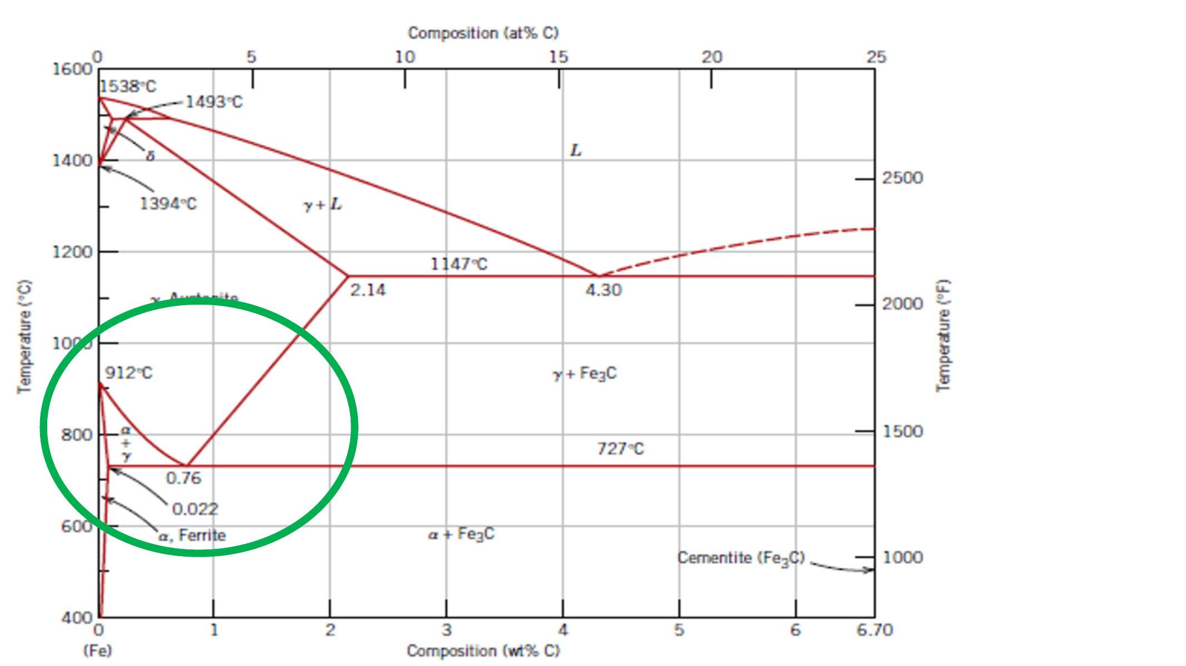
Fe-C reference diagram
Keep these landmarks in your notes:
- 0.022 wt.% C: approximate maximum solubility of C in ferrite at the eutectoid temperature.
- 0.76 wt.% C: eutectoid composition.
- 727 C: eutectoid temperature.
- 2.14 wt.% C: approximate maximum solubility of C in austenite at the eutectic temperature.
- 4.30 wt.% C: eutectic composition.
- 6.70 wt.% C: cementite Fe3C composition.

Steel Microstructures at Room Temperature
- Hypo-eutectoid steel, C < 0.8% in the slides: ferrite and pearlite.
- Eutectoid steel, C about 0.8%: pearlite.
- Hyper-eutectoid steel, C > 0.8%: cementite and pearlite.
- Pearlite is the eutectoid mixture of ferrite + cementite formed from austenite.
- Coarse pearlite forms at higher isothermal transformation temperature because diffusion is easier. Fine pearlite forms at lower temperature because diffusion distance is shorter and lamellae are finer.
- Spheroidite/globular pearlite forms by heating pearlitic steel just below eutectoid temperature for a long time, for example 700 C for 18-24 h. Driving force: reduce ferrite/cementite interfacial area. Result: easier plastic deformation.

Fe-C Lever Rule Recipes
Hypo-eutectoid, C0 < 0.76:
- Pro-eutectoid ferrite = (0.76 - C0)/(0.76 - 0.022).
- Austenite just before eutectoid = (C0 - 0.022)/(0.76 - 0.022).
- At room temperature, pearlite fraction equals the austenite fraction just before eutectoid.
Hyper-eutectoid, C0 > 0.76:
- Pro-eutectoid cementite = (C0 - 0.76)/(6.70 - 0.76).
- Austenite just before eutectoid = (6.70 - C0)/(6.70 - 0.76).
- At room temperature, pearlite fraction equals the austenite fraction just before eutectoid.
Worked tutorial examples:
- 0.20% C steel: pro-eutectoid ferrite = 76%, pearlite = 24%.
- 1.20% C steel: pearlite = 92.5%, pro-eutectoid cementite = 7.4%.

Peritectic Exercise Pattern
- Peritectic reaction in Fe-C: L + delta -> gamma.
- For low-carbon steels near the peritectic, identify whether the point is L, L+delta, L+gamma, delta+gamma, or gamma.
- Use the horizontal rule for phase compositions, then lever rule for relative amounts.
- Example for 0.34% C at a two-phase L+delta point: if C_delta = 0.05 and C_L = 0.40, delta = (0.40 - 0.34)/(0.40 - 0.05) = 17%, liquid = 83%.
- Example for 0.13% C on the same tie line: delta = (0.40 - 0.13)/(0.40 - 0.05) = 77%, liquid = 23%.

Martensite, Tempering, Bainite
- Martensite is produced when austenite transforms without enough diffusion for equilibrium ferrite/cementite formation. It is a hard, brittle, supersaturated phase and is not read as an equilibrium field on the Fe-C phase diagram.
- Tempering martensite decomposes martensite into ferrite plus fine cementite particles. Tempered martensite improves toughness relative to as-quenched martensite.
- Bainite is another non-equilibrium transformation product, typically represented by time-temperature transformation thinking rather than an equilibrium Fe-C diagram.
- Exam trap: phase diagrams show equilibrium phases. Martensite is not located as a stable phase field on the equilibrium Fe-Fe3C diagram.

Al-Cu/Precipitation Example
- The lecture examples include precipitation hardening. If solubility decreases on cooling, a supersaturated solid solution can precipitate fine particles.
- More solute can give a higher density of precipitates, increasing strength when precipitates obstruct dislocation motion.
- Overaging/coarsening lowers strengthening because precipitates become fewer/larger and easier for dislocations to bypass.

Exam Traps
- Pearlite is not a phase; it is a microconstituent made of ferrite + cementite.
- Pro-eutectoid ferrite/cementite forms before the eutectoid reaction; pearlite forms from the remaining austenite during the eutectoid reaction.
- Do not use 6.70 as if it were pure carbon; it is cementite Fe3C composition in wt.% C.
- If asked at 400 C for pro-eutectoid cementite in a hyper-eutectoid steel, the amount of pro-eutectoid cementite is still calculated from the 727 C eutectoid tie line; below 727 C the remaining austenite has transformed to pearlite.

Source Slide Checklist
This is a compact OCR/text extraction from the source PDF. Use it as a searchable reminder of the slide wording, not as a replacement for diagrams.

Source page 1
- Phase diagrams: examples

Source page 3
- A3

Source page 4
- Steel microstructure at room
- temperature
- • Hypo-eutectoidic
- (C<0,8%): ferrite
- and pearlite
- • eutectoidic
- (C=0,8%): pearlite
- • Hyper-eutectoidic
- (C>0,8%):
- cementite and
- pearlite

Source page 5
- Hypo-eutectoidic Hyper-eutectoidic
- Tensile
- strength
- Yield
- strength
- Mechanical strength
- wt% carbon
- Mechanical
- properties of
- steel
- vs.
- microstructure

Source page 6
- Trattamenti termici per gli
- acciai
- Materiali per l’Ingegneria
- M.Ferraris 6
- Mechanical properties of steel vs. microstructure

Source page 8
- 655 °C 600 °C 534 °C 487 °C
- Microstructure of pearlite formed at different isothermal T:
- If > T → coarse pearlite (> diffusion)
- If < T → fine pearlite (< diffusion)

Source page 9
- If a steel with pearlitic microstructure is heated just below
- eutectoidic T for long time (e.g. 700 °C 18-24 h) → globular
- pearlite or spheroidite .
- Driving force → minimizing the interfacial surface area
- between ferrite and cementite.

Source page 10
- Spheroidite → < interfacial area → < density of GBs →
- easier plastic deformation

Source page 11
- Martensite
- Austenite → Martensite
- Fast cooling from A3 to RT (quenching)
- A3: point of austenitization (mobile point!)
- Martensite: polymorphic transformation of austenite to
- martensite (single phase) → it can host a higher amount of
- C → solid solution effect against motion of dislocations.

Source page 12
- Microstructure and mechanical properties of steels

Source page 13
- Tempering
- Increase of ductility and toughness of martensite → heat treatment at
- 250-650 °C
- Phase transformation:
- martensite → ferrite + cementite
- Tempered martensite: fine particles of cementite in a matrix of ferrite
- → sorbite (similar to spheroidite)

Source page 14
- For tempered martensite:
- ➢ > tempering T →
- ➢ > rate of particle
- growth →
- ➢ residual ferrite with low
- C →
- ➢ > ductility but < yield
- strenght and hardness

Source page 15
- Heating to
- complete
- austenitization
- Increase
- dislocations….
- quenching

Source page 16
- Leghe di allumino Materiali per l’Ingegneria
- M.Ferraris 16

Source page 17
- Al-Cu
- Precipitation hardening for Al-Cu alloys
- CuAl 2
- intermetallic

Source page 18
- a
- Al-Cu
- Precipitation hardening for Al-Cu alloys

Source page 19
- a
- Al-Cu
- Precipitation hardening for Al-Cu alloys

Source page 20
- • Example of
- precipitation
- hardening: Al-Cu, Cu-
- Sn (bronze), Mg-Al,
- ….
- o invecchiamento

Source page 21
- Here to maximize mechanical strength
- Guinier-Preston zones

Source page 23
- Mechanical
- properties vs.
- microstructure of Al
- alloys and thermal
- treatments
- Higher amount of Cu → higher reinforcing
- effect → higher density of precipitates

Source page 24
- Practical examples of the use of
- phase diagrams in materials design

Source page 26
- a b c
- At 205 °C → (ab/ac)×100 = 65%

Source page 27
- P

Source page 29
- Historical example
- In 1958, at the beginning of the US space project, an
- engineer proposed to use tungsten (W) with a purity of
- 99.9% as the material for the exhaust nozzles of the
- engines.
- The choice was based on a few points:
- • tungsten has a melting temperature of 3410 °C, about
- 400 °C above the temperature of the exhaust gases;
- • tungsten is hard and can resist abrasion due to hot
- exhaust gases
- • tungsten was not too expensive ($ 25,000 per nozzle) as
- compared to advanced ceramics at that time

Source page 30
- Three prototypes are produced and tests started.
- The first nozzle only resisted a few seconds at about 3000
- °C and then melted
- The second and third nozzles melted even before reaching
- 3000 °C
- The residues of the two destroyed nozzles were analyzed;
- the composition of the material was, in both cases, W =
- 98.5% and C = 1.5%

Source page 31
- ~ 0,1% C

