Internet-in-a-Box Project
Contact: Braddock Gaskill – braddock@braddock.com – 443-854-4691
Feb 2013

The Internet-in-a-Box is a small, inexpensive device which provides essential Internet resources without any Internet connection. It provides a local copy of half a terabyte of the world's Free information.

An Internet-in-a-Box provides:

-Wikipedia: Complete Wikipedia in a dozen different languages
-Maps: Zoomable world-wide maps down to street level
-E-books: Over 35 thousand e-books in a variety of languages
-Software: Huge library of Open Source Software, including installable Ubuntu Linux OS with all software package repositories. Includes full source code for study or modification.
-Video: Hundreds of hours of instructional videos
-Chat: Simple instant messaging across the community

The device comes in two variants, Wired, and Wireless.

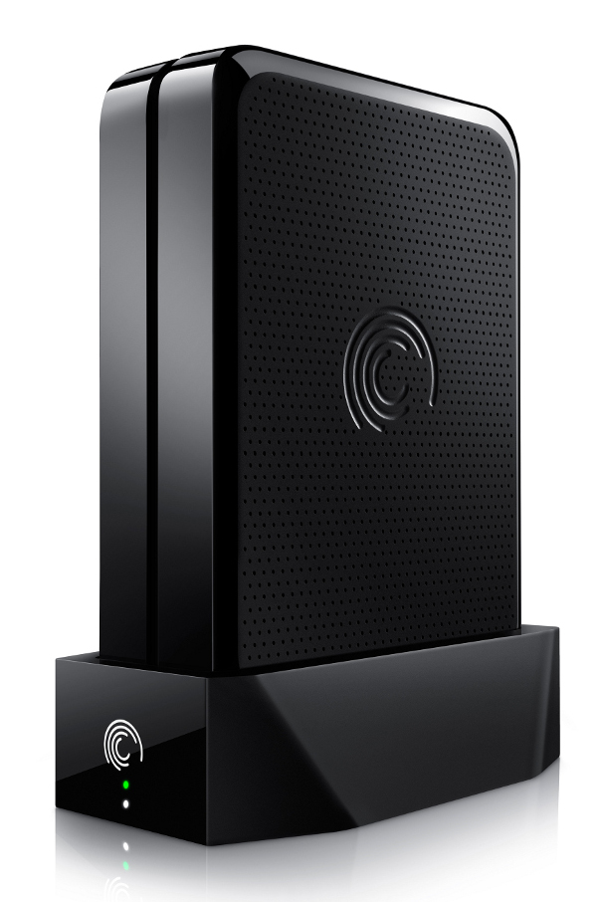
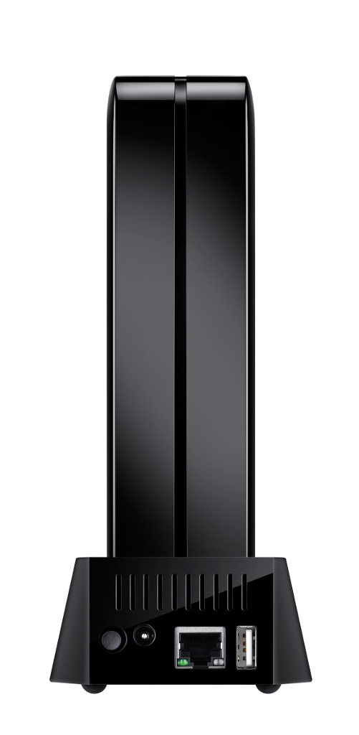
Wired Internet-in-a-Box: This device easily connects to an existing wired ethernet computer network, providing Internet services to the local area network. Just plug it in.



Wireless Internet-in-a-Box: A completely self-contained wireless hotspot which provides services to any wifi-capable phone, tablet, or laptop within range. This unit can even be solar powered and deployed anywhere in the world. Just turn it on.

About: The Internet-in-a-Box is a fully Open Source project being developed by volunteers in California. We are seeking schools and communities worldwide who would benefit from our work. We anticipate an initial trial release within four months.

