Estimation of daily potential evapotranspiration with the modified Thornthwaite method

HISTORY:
The original Thornthwaite method (Thornthwaite 1948) was developed to estimate monthly potential evapotranspiration (PET) for a standard month with 30 days and an average 12 hour daily photoperiod (daylength) based on monthly mean of daily average air temperatures (Tavg).
Willmott et al. (1985) adjusted the Thornthwaite PET to account for months with days other than 30 and for days with other than 12 hour daylength. Also, an alternative formula was proposed for the cases when Tavg > 26.5 C in the given month as this was known to be a limit of applicability of the original formula.
Camargo et al. (1999) suggested to use effective temperature (Teff) instead of Tavg.
Pereira et al. (2004) used the so far modified method to esimate daily PET by modifying Teff to account for the PET differences between days that have the same Teff but different photoperiods.
CALCULATION:
PET (Thornthwaite 1948 and Willmott et al. 1985):
$PET=0$ if $T_{eff}<0$
$PET=16∙{\left(10∙\frac{T_{eff}}{I}\right)}^{α}∙\frac{N}{360}$ if ${0≤T}_{eff}<26.5$
$PET=-415.85+32.24∙T_{eff}-0.43∙T_{eff}^{2}$ if $T_{eff}≥26.5$
Only monthly values and at Teff = 26.5 the step has to be smooth
Pet= Pet * N /364.386
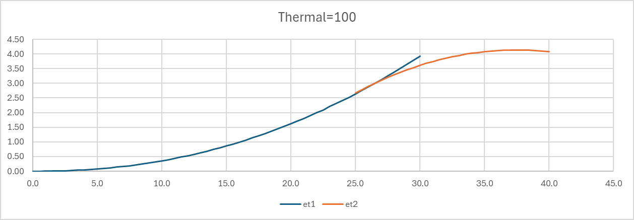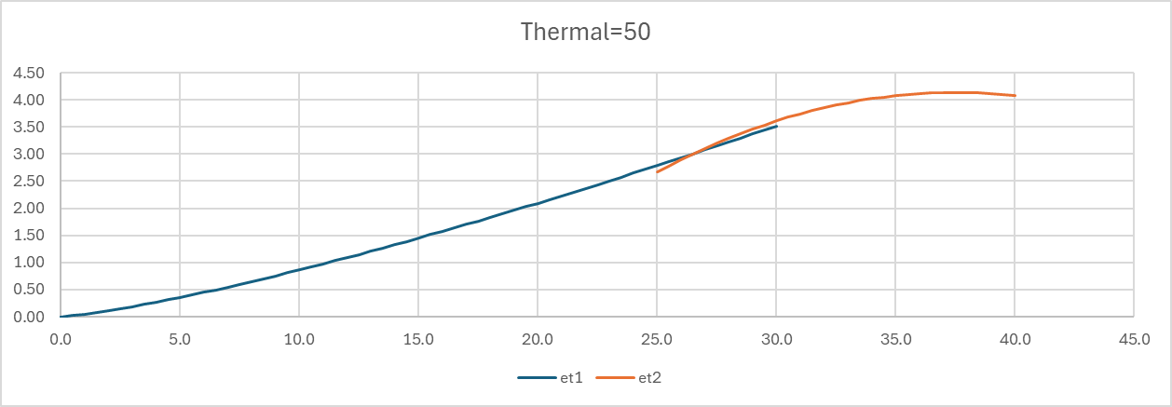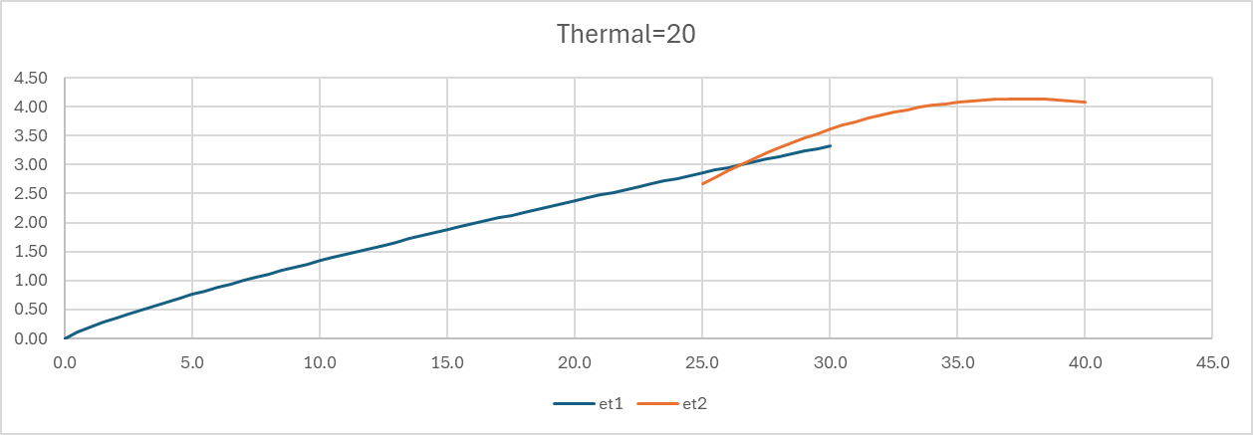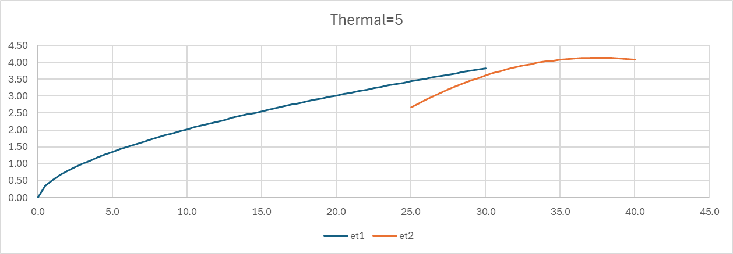
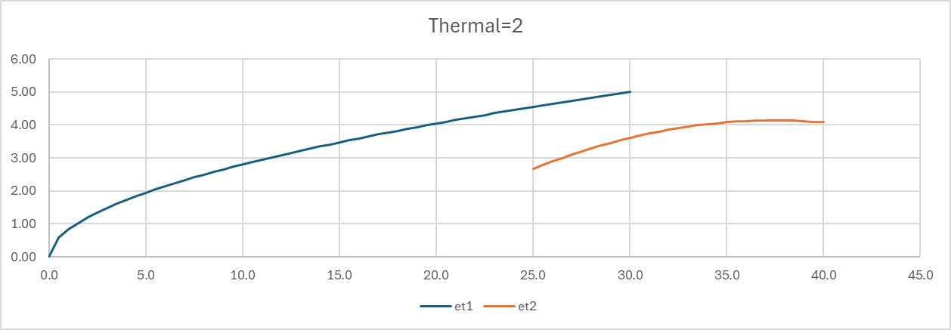

Pet> 26.5 does not vary with I. Which is not a big problem with I>20.

where
- $PET$: potential evapotranspiration [mm/d]
- $T_{eff}$: daily effective temperature [C]
- $I$: thermal index (function of $T_{eff}$)
- $α$: exponent (function of $I$)
- $N$: photoperiod (daylength) of the given day [h]
Effective temperature (Camargo et al. 1999 and Pereira et al. 2004):
$$T_{eff}=\frac{N}{24-N}∙\frac{1}{2}∙k∙\left(3∙T_{max}-T_{min}\right)$$
where
- $k$: parameter, found the be 0.69-0.72 (0.72 proposed by Camargo et al. and 0.69 proposed by Pereira et al.)
- $T_{max}$: daily maximum temperature [C]
- $T_{min}$: daily minimum temperature [C]
Thermal index of the year:
$I=\sum_{n=1}^{12}{{\left(0.2∙T_{eff,mean}\right)}^{1.514}}$ with Teff <0: Teff=0
where
- $n$: index of month
- $T_{eff,mean}$: the monthly mean of daily $T_{eff}$ values in the given month [C]
So $I$ has to be calculated by
- calculating $T_{eff}$ for every day in the given year
- calculating $T_{eff,mean}$ for each month in the year by averaging all $T_{eff}$ values in the given month
- using the above formula for $I$
The exponent:
$$α=6.75∙{10}^{-7}∙I^{3}-7.71∙{10}^{-5}∙I^{2}+1.7912∙{10}^{-2}∙I+0.49239$$
Photoperiod (daylength):
$$N=\frac{24}{π}ω_{s}$$
where
- $ω_{s}$: the hourly angle between sunrise and sunset [rad]
$$ω_{s}=arccos[-tan (φ)∙tan (δ)]$$
where
- $φ$: local latitude [rad]
- $δ$: solar declination [rad]
$$δ=0.409∙sin\left(2π∙\frac{D}{365}-1.39\right)$$
where
- $D$: day of year (e.g. 10 is Jan 10 and 41 is Feb 10)

REFERENCES
Camargo, A.P., Marin, F.R., Sentelhas, P.C., Picini, A.G. (1999). Adjust of the Thornthwaite’s method to estimate the potential evapotranspiration for arid and superhumid climates, based on daily temperature amplitude. Rev. Bras. Agrometeorol. 7 (2), 251–257 (in Portuguese with English summary).
Pereira, A. R., & Pruitt, W. O. (2004). Adaptation of the Thornthwaite Scheme for Estimating Daily Reference Evapotranspiration. Agricultural Water Management, 66, 251-257.
https://doi.org/10.1016/j.agwat.2003.11.003
Thornthwaite, C.W. (1948). An approach toward a rational classification of climate. Geogr. Rev. 38, 55–94
Willmott, C.J., Rowe, C.M., Mintz, Y. (1985). Climatology of the terrestrial seasonal water cycle. J. Climatol. 5, 589–606.

