Danube Water Balance

Evaluation of precipitation data

Historical Meteo datasets

1 EMO1- Thiemig et all 2022
2 MSWEP v2.8 0.10deg (Beck et al. 2019)
3 E-obs
4 GSWP3-W5E5
5 20crv3-era5

1 EMO-1
https://data.jrc.ec.europa.eu/dataset/0bd84be4-cec8-4180-97a6-8b3adaac4d26

EMO (European Meteorological Observations) is a European high-resolution, (sub-)daily, multi-variable gridded meteorological data set built on historical and real-time observations. EMO is a Copernicus Emergency Management Service product and includes at daily resolution: total precipitation, temperatures (minimum and maximum), wind speed, solar radiation and water vapour pressure. In addition, EMO also makes available 6-hourly precipitation and mean temperature. The raw observations from the ground weather stations underwent a set of quality controls, before SPHEREMAP and Yamamoto interpolation methods were applied in order to estimate for each grid cell the variable value and its affiliated uncertainty, respectively

Gomes, Goncalo; Thiemig, Vera; Skøien, Jon Olav; Ziese, Markus; Rauthe-Schöch, Armin; Rustemeier, Elke; Rehfeldt, Kira; Walawender, Jakub; Kolbe, Christine; Pichon, Damien; Schweim, Christoph; Salamon, Peter (2020): EMO: A high-resolution multi-variable gridded meteorological data set for Europe. European Commission, Joint Research Centre (JRC) [Dataset] doi: 10.2905/0BD84BE4-CEC8-4180-97A6-8B3ADAAC4D26

Thiemig, V., Gomes, G. N., Skøien, J. O., Ziese, M., Rauthe-Schöch, A., Rustemeier, E., . . . Salamon, P. (2022). EMO-5: a high-resolution multi-variable gridded meteorological dataset for Europe. Earth Syst. Sci. Data, 14(7), 3249-3272. doi:10.5194/essd-14-3249-2022

2 MSWEP

MSWEP V2.8 features new data sources, improved weight maps, less peaky precipitation estimates, a longer record (1979–2020), near real-time (NRT) estimates, and compatibility with Multi-Source Weather (MSWX). See the technical documentation for the version history and more information on MSWEP-NRT, the file naming convention, and the data format. See the system status page for near real-time information on the availability and performance of MSWEP-NR

Version 2.8 (Nov 2020)
https://gwadi.org/multi-source-weighted-ensemble-precipitation-mswep
http://www.gloh2o.org/mswep/

Beck, H. E., A. I. J. M. Van Dijk, V. Levizzani, J. Schellekens, D. G. Miralles, B. Martens and A. De Roo (2017). “MSWEP: 3-hourly 0.25° global gridded precipitation (1979-2015) by merging gauge, satellite, and reanalysis data.” Hydrology and Earth System Sciences 21(1): 589-615.
Beck, H. E., Pan, M., Roy, T., Weedon, G. P., Pappenberger, F., van Dijk, A. I. J. M., Huffman, G. J., Adler, R. F., and Wood, E. F.: Daily evaluation of 26 precipitation datasets using Stage-IV gauge-radar data for the CONUS, Hydrol. Earth Syst. Sci., 23, 207–224, https://doi.org/10.5194/hess-23-207-2019, 2019.

E-Obs
https://www.ecad.eu/download/ensembles
E-OBS comes as an ensemble dataset and is available on a 0.1 and 0.25 degree regular grid for the elements daily mean temperature TG, daily minimum temperature TN, daily maximum temperature TX, daily precipitation sum RR, daily mean sea level pressure PP, daily mean wind speed FG, daily mean relative humidity HU and global radiation QQ. They cover the area: 25N-71.5N x 25W-45E. The data files are in NetCDF-4 format. The Global 30 Arc-Second Elevation Data Set (GTOPO30), a global raster Digital Elevation Model (DEM) with a horizontal grid spacing of 30 arc seconds (approximately 1 kilometer) developed by USGS is used for the elevation file as well.
Cornes, R., G. van der Schrier, E.J.M. van den Besselaar, and P.D. Jones. 2018: An Ensemble Version of the E-OBS Temperature and Precipitation Datasets, J. Geophys. Res. Atmos., 123. doi:10.1029/2017JD028200

GSWP3-W5E5

GSWP3 and W5E5 global meteorological forcing data processed for ISIMIP3a. Daily data covering 1801-1900 (spinclim), 1851-1900 (transclim) and 1901-2019 (obsclim, counterclim) on a 0.5°x0.5° lat-lon grid.
Combination of W5E5 v2.0 (Cucchi et al., 2020, and Lange et al., 2021) for 1979-2019 with GSWP3 v1.09 (Kim, 2017) homogenized to W5E5 for 1901-1978. The homogenization reduces discontinuities at the 1978/1979 transition and was done using the ISIMIP3BASD v2.5.0 bias adjustment method (Lange, 2019 and Lange, 2020).
Contains W5E5 data and data from the GSWP3 dataset, developed by Hyungjun Kim with support by the Japan Society for the Promotion of Science KAKENHI (16H06291). Original W5E5 data covers the entire globe at 0.5° horizontal and daily temporal resolution from 1979 to 2016 (http://doi.org/10.5880/pik.2019.023). Combination of W5E5 v2.0 for 1979-2019 (https://doi.org/10.48364/ISIMIP.342217) with GSWP3 v1.09 homogenized to W5E5 for 1901-1978. The homogenization reduces discontinuities at the 1978/1979 transition and was done using the ISIMIP3BASD v2.5.0 bias adjustment method (https://doi.org/10.5194/gmd-12-3055-2019 ; https://doi.org/10.5281/zenodo.4686991 ). ISIMIP3a counterfactual data for impact attribution is produced using the ATTRICI v1.1 detrending method (https://doi.org/10.5194/gmd-14-5269-2021.

https://www.isimip.org/gettingstarted/input-data-bias-adjustment/details/110/

- Dirmeyer, P. A., Gao, X., Zhao, M., Guo, Z., Oki, T. and Hanasaki, N. (2006). GSWP-2: Multimodel Analysis and Implications for Our Perception of the Land Surface. Bulletin of the American Meteorological Society, 87(10), 1381–98.
- Hyungjun Kim. (2017). Global Soil Wetness Project Phase 3 Atmospheric Boundary Conditions (Experiment 1) [Data set]. Data Integration and Analysis System (DIAS). https://doi.org/10.20783/DIAS.501
- Cucchi, M., Weedon, G. P., Amici, A., Bellouin, N., Lange, S., Müller Schmied, H., Hersbach, H. and Buontempo, C. (2020). WFDE5: bias-adjusted ERA5 reanalysis data for impact studies. Earth System Science Data, 12, 2097–2120
- Lange, S., Menz, C., Gleixner, S., Cucchi, M., Weedon, G.P., Amici, A., Bellouin, N., Müller-Schmied, H., Hersbach, H., Buontempo, C., Cagnazzo, C. (2021). WFDE5 over land merged with ERA5 over the ocean (W5E5 v2.0). ISIMIP Repository. https://doi.org/10.48364/ISIMIP.342217

20crv3-era5
20CRv3-ERA5 global meteorological forcing data processed for ISIMIP3a. Daily data covering 1801-1900 (spinclim), 1851-1900 (transclim) and 1901-2021 (obsclim, counterclim) on a 0.5°x0.5° lat-lon grid
Combination of ERA5 for 1979-2021 with 20CRv3 (ensemble member 1) homogenized to ERA5 for 1901-1978. The homogenization was done in the same way as for GSWP3-W5E5

- Hersbach, H, Bell, B, Berrisford, P, et al. The ERA5 global reanalysis. Q J R Meteorol Soc. 2020; 146: 1999– 2049. https://doi.org/10.1002/qj.3803
- Slivinski, LC, Compo, GP, Whitaker, JS, et al. Towards a more reliable historical reanalysis: Improvements for version 3 of the Twentieth Century Reanalysis system. Q J R Meteorol Soc. 2019; 145: 2876– 2908.https://doi.org/10.1002/qj.3598
- Compo, G.P., Whitaker, J.S., Sardeshmukh, P.D., Matsui, N., Allan, R.J., Yin, X., Gleason, B.E., Vose, R.S., Rutledge, G., Bessemoulin, P., Brönnimann, S., Brunet, M., Crouthamel, R.I., Grant, A.N., Groisman, P.Y., Jones, P.D., Kruk, M.C., Kruger, A.C., Marshall, G.J., Maugeri, M., Mok, H.Y., Nordli, Ø., Ross, T.F., Trigo, R.M., Wang, X.L., Woodruff, S.D. and Worley, S.J. (2011), The Twentieth Century Reanalysis Project. Q.J.R. Meteorol. Soc., 137: 1-28. https://doi.org/10.1002/qj.776

Analysis historical precipitation datasets

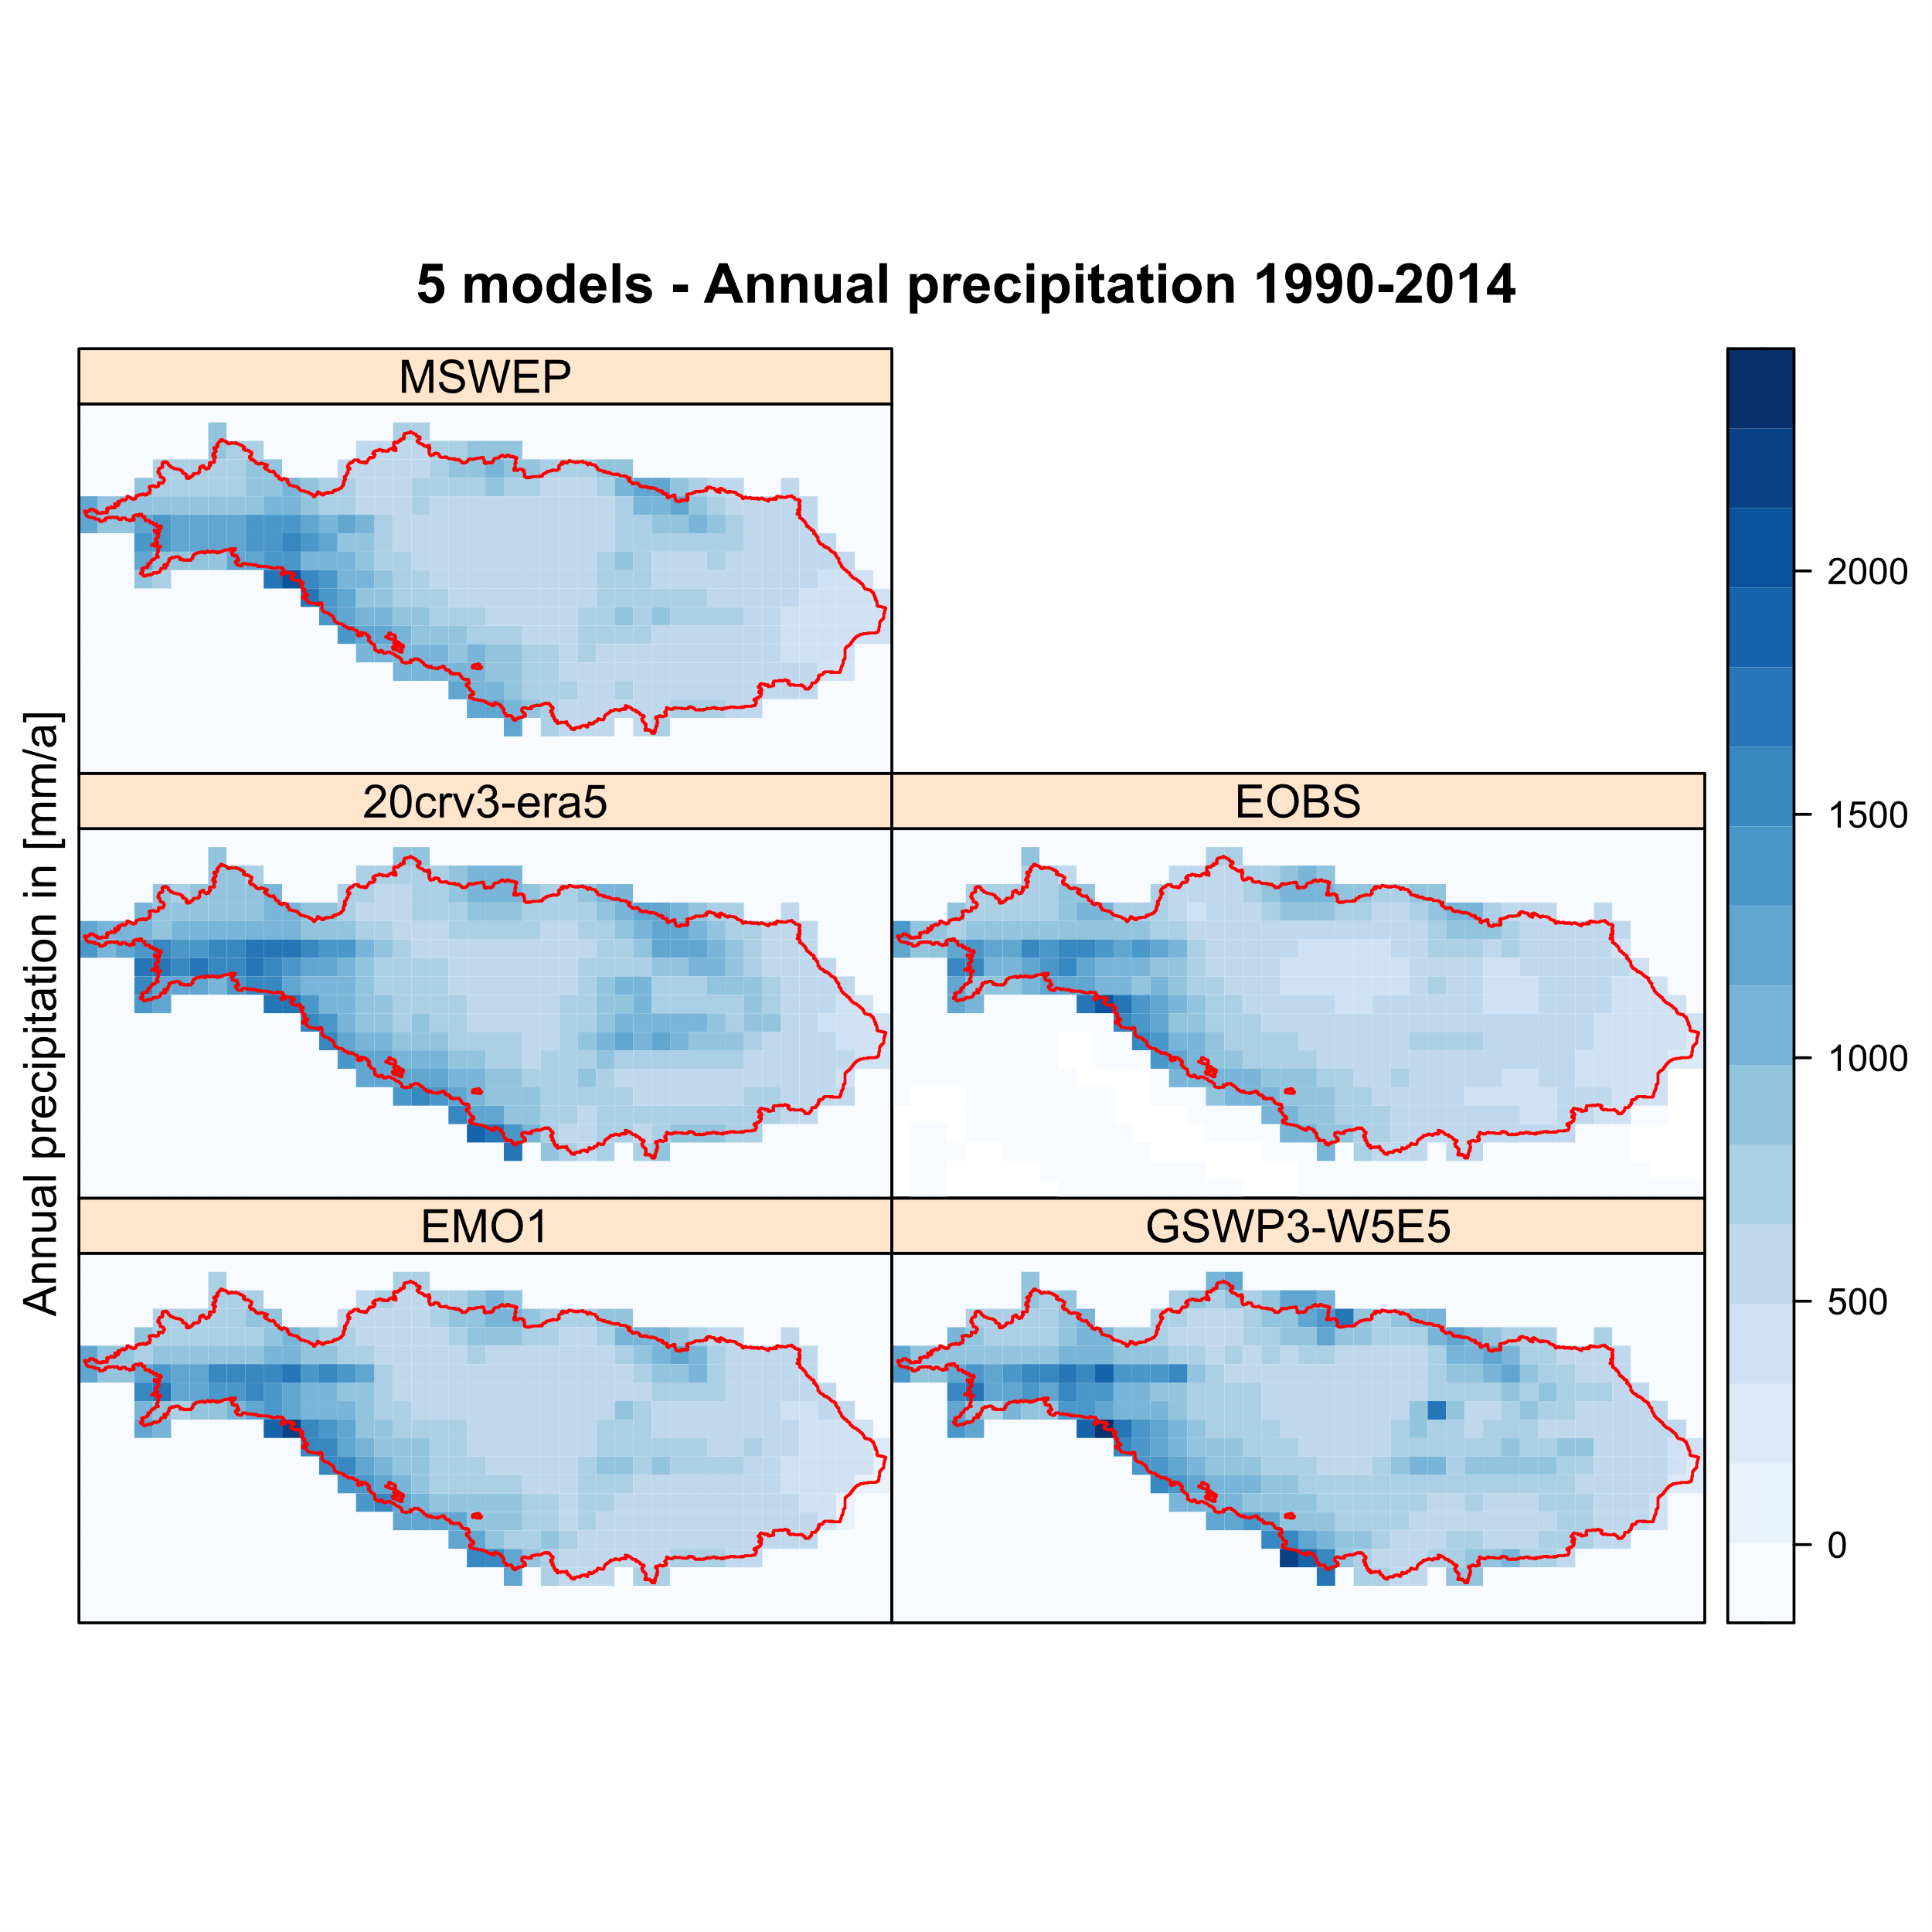
Fig 1: Annual precipitation – Danube

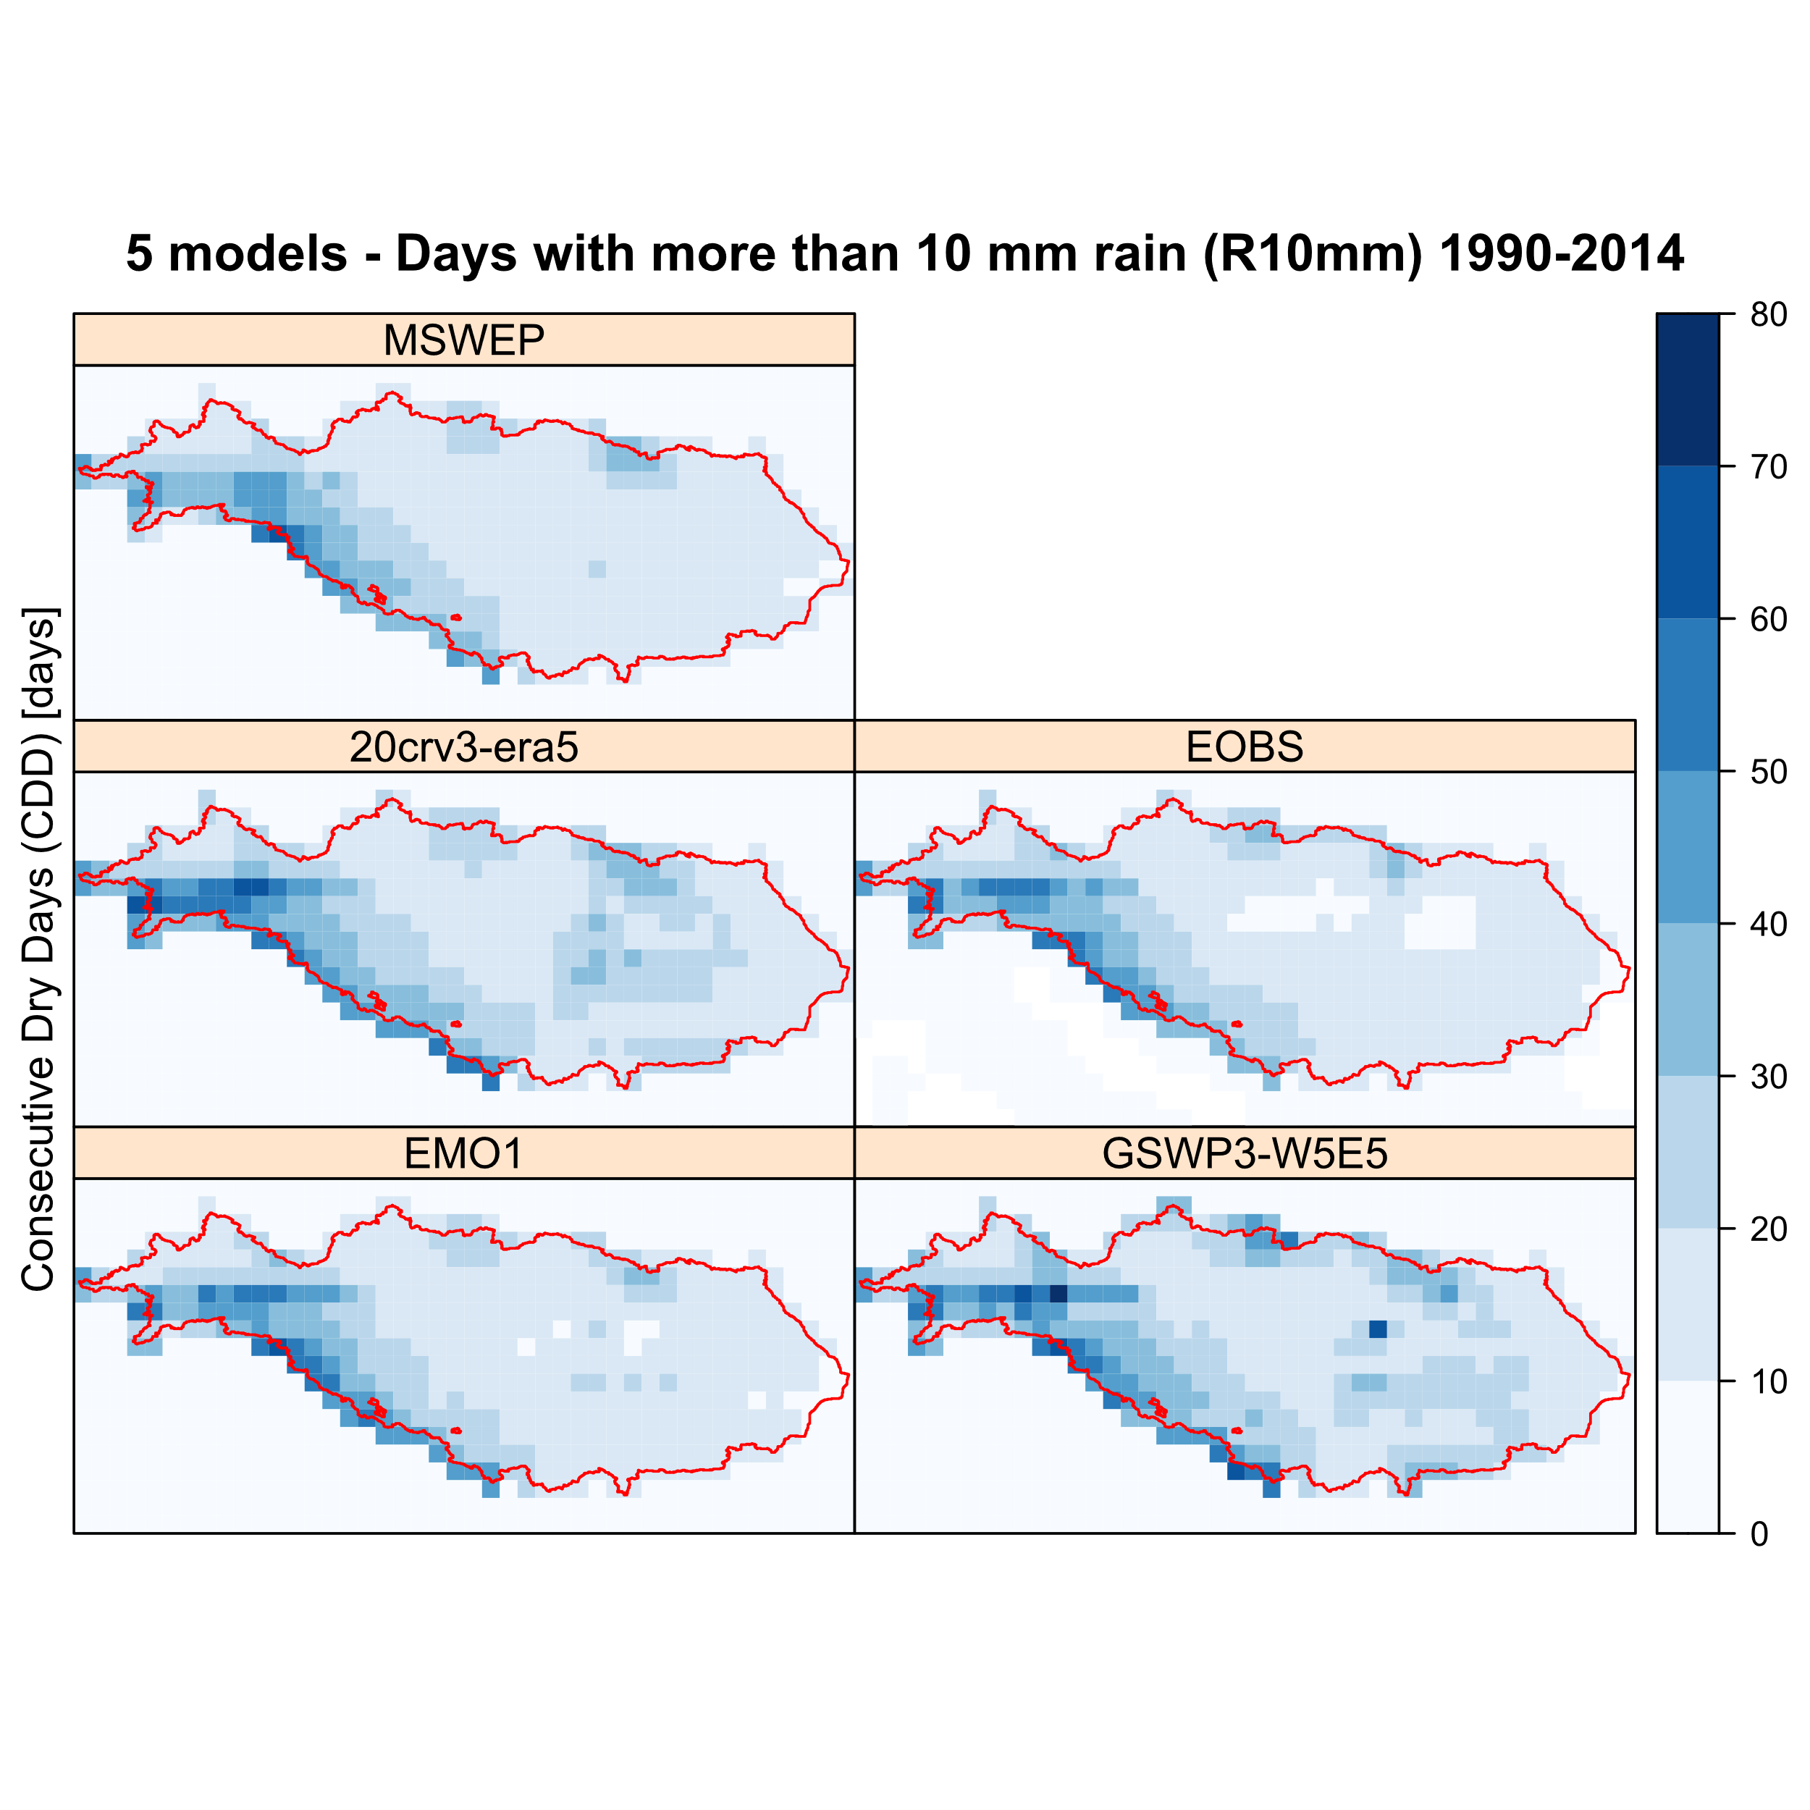
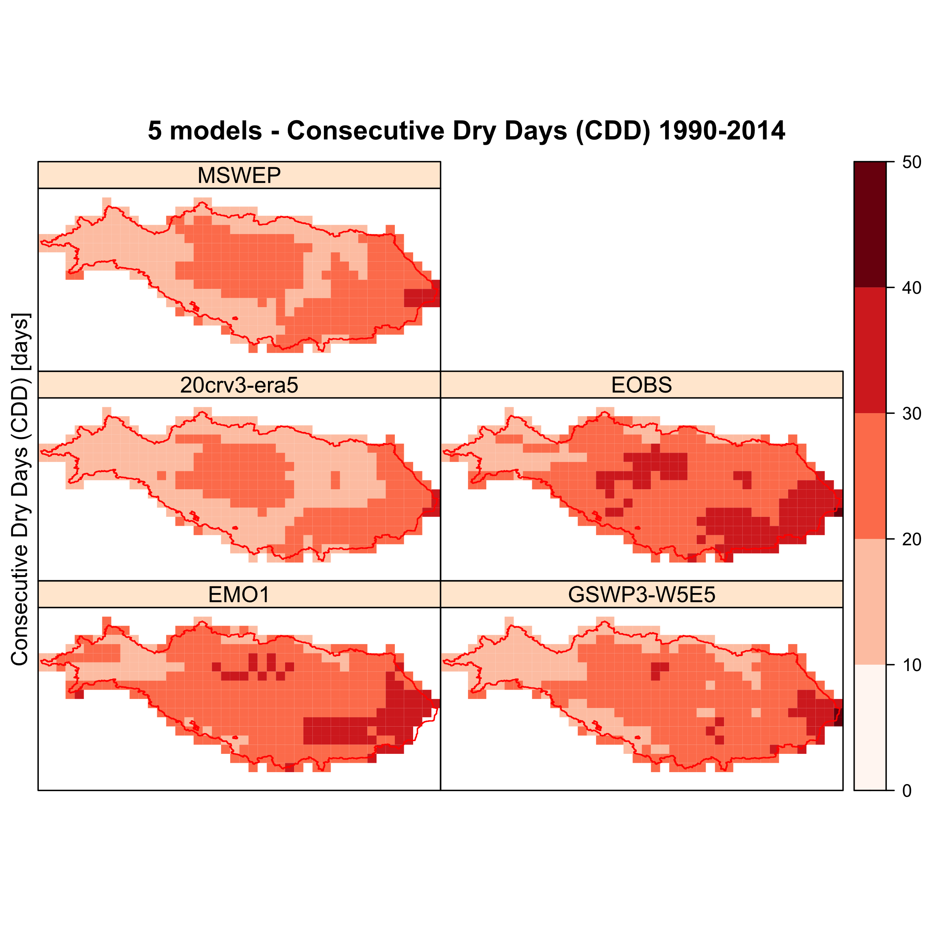

Fig: 2 Consecutive dry days and days with more than 10mm rain

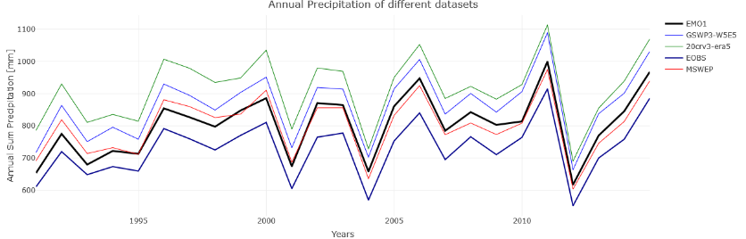

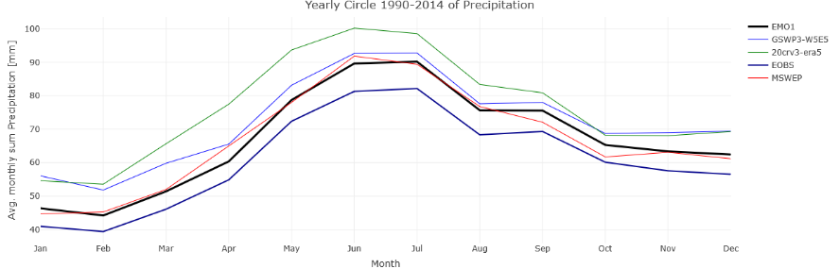

Fig 3: Annual precipitation and yearly cycle – all Danube

Comparing five datasets of historical precipitation. EMO1, MSWEP, Eobs and ISIMIP3a datasets: GSWP3-W5E5 and 20crv3-era5.

The spread between these five is big (20% difference between Eobs and 20crv3-era5). with EMO1 and MSWEP in the middle.

For further analysis climate change indeces are taken from https://etccdi.pacificclimate.org/list_27_indices.shtml (Kartl et al. 1999, Peterson et al. )
With altogether 27 indeces. We took a small sample of this.

Consecutive dry days shows a difference between MSWEP and EMO1 with EMO1 drier in the middle Danube and the lower Danube (see fig. 2)

Analysis control runs GCMs precipitation datasets
ISIMIP3a

CMIP6 based
Statistical downscaling
bias adjustment: ISIMIP3BASD v2.5.0 (Lange 2019b, Lange 2021
http://doi.org/10.5281/zenodo.4686991
Resolution: 30 arcmin
Period: 1850-2100
GCMs: GFDL-ESM4, IPSL-CM6A-LR, MPI-ESM1-2-HR, MRI-ESM2-0, UKESM1-0-LL and 5 more
(CanESM5, CNRM-CM6-1, CNRM-ESM2-1, EC-Earth3, MIROC6)
SSP-RCPs
Variables: huss, hurs, pr, prsn, ps, rlds, rsds, sfcWind, tas, tasmax, tasmin

The Inter-Sectoral Impact Model Intercomparison Project (ISIMIP) provides a framework for the collation of a consistent set of climate impact data across sectors and scales. It also provides a unique opportunity for considering interactions between climate change impacts across sectors through consistent scenarios.
The ISIMIP3b part of the third simulation round is dedicated to a quantification of climate-related risks at different levels of global warming and socio-economic change. ISIMIP3b group I simulations are based on historical climate change as simulated in CMIP6 combined with observed historical socio-economic forcing. ISIMIP3b group II simulations are based on climate change according to the CMIP6 future projections combined with socio-economic forcings fixed at 2015 levels. ISIMIP3b group III simulations additionally account for future changes in socio-economic forcing.
This dataset covers the CMIP6-based and bias-adjusted atmospheric climate input data for all three groups of ISIMIP3b simulations. Such data are available for 5 CMIP6 global climate models (GFDL-ESM4, IPSL-CM6A-LR, MPI-ESM1-2-HR, MRI-ESM2-0, UKESM1-0-LL), 5 CMIP6 experiments (piControl, historical, SSP126, SSP37, SSP585) and 11 CMIP6 variables (huss, hurs, pr, prsn, ps, rlds, rsds, sfcWind, tas, tasmax, tasmin).
Methods:
The observational reference dataset used for bias adjustment is W5E5 v2.0 (Cucchi et al. 2020, Lange et al. 2021). The method used for bias adjustment is ISIMIP3BASD v2.5.0 (Lange 2019b, Lange 2021). For more details see the ISIMIP3 protocol paper (Frieler et al. 2021): https://egusphere.copernicus.org/preprints/2023/egusphere-2023-281/

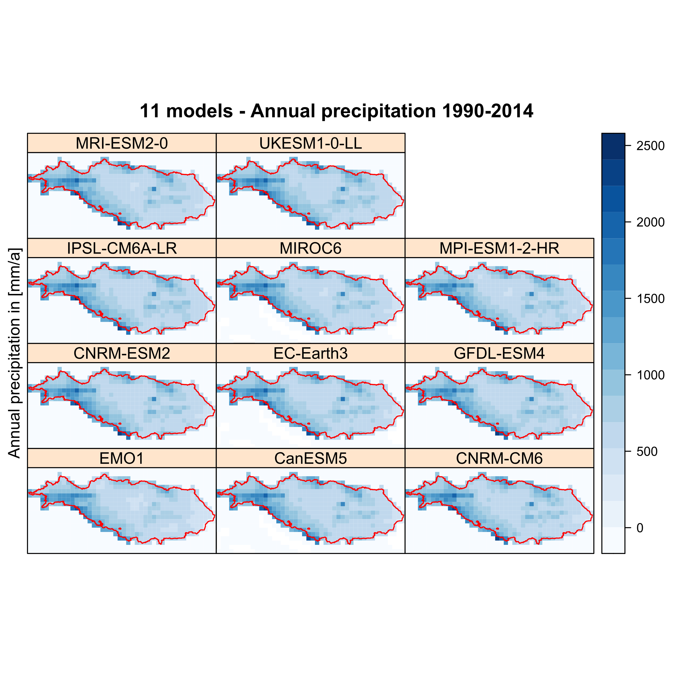

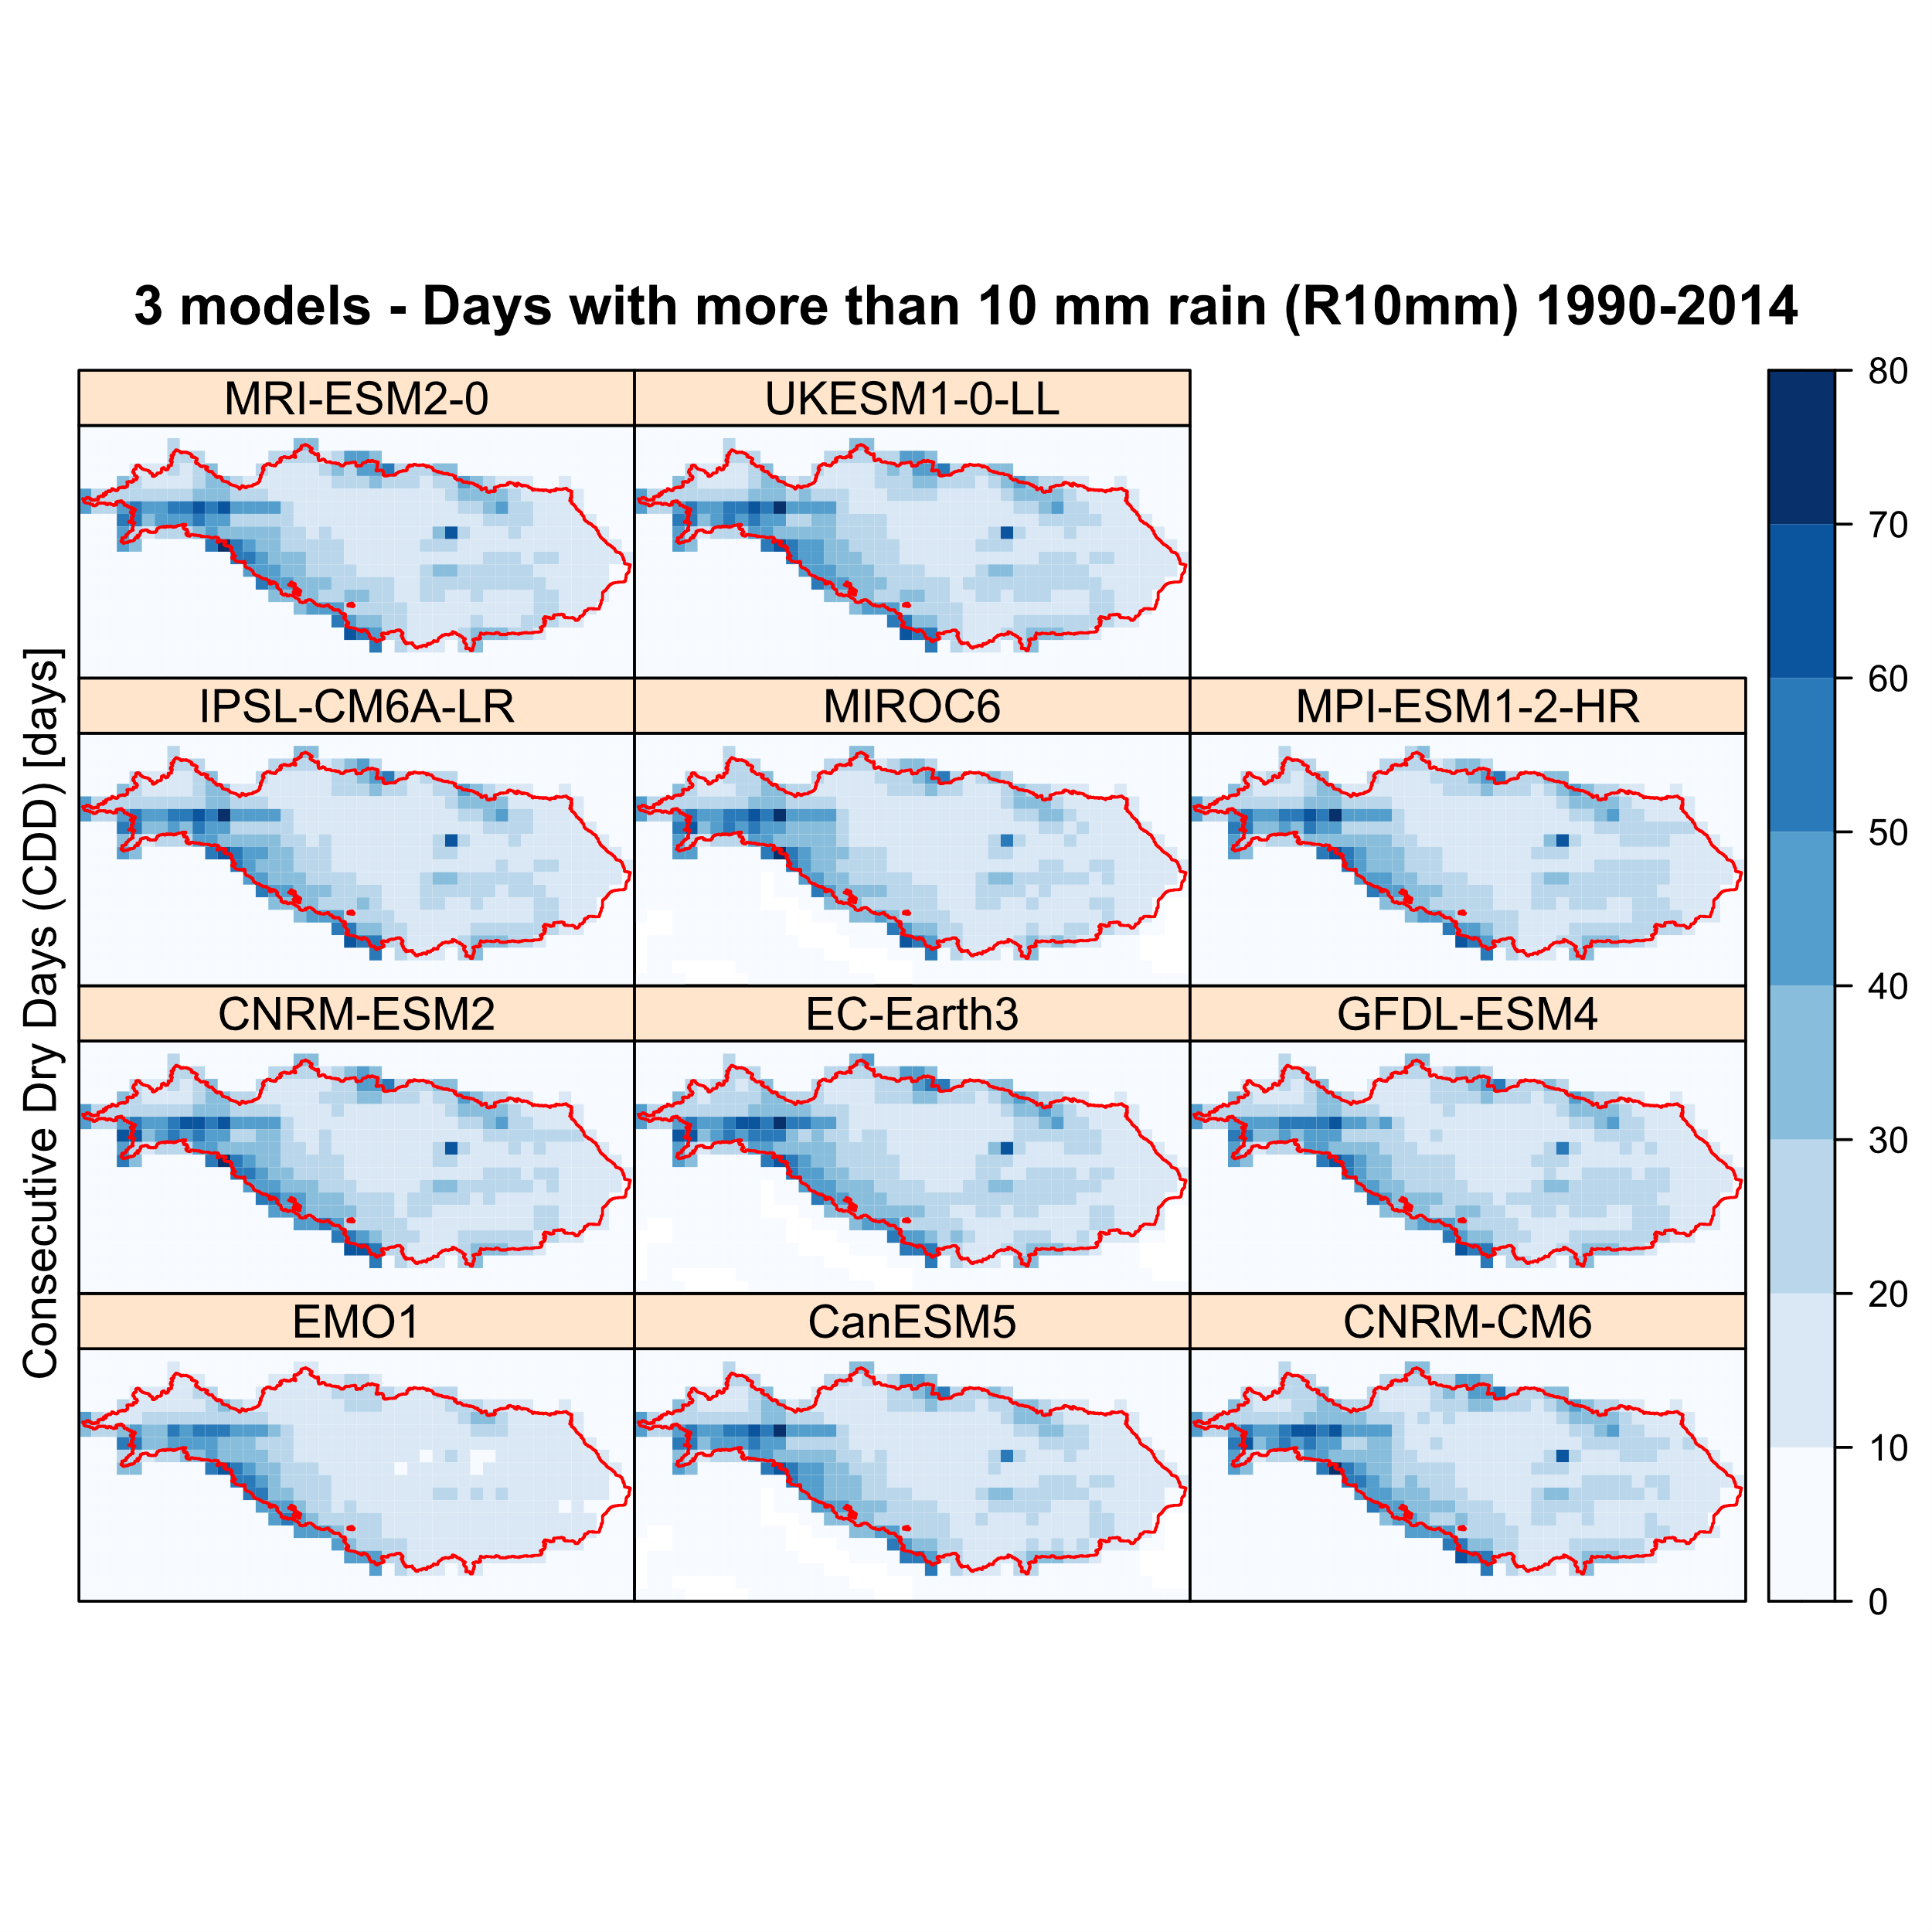
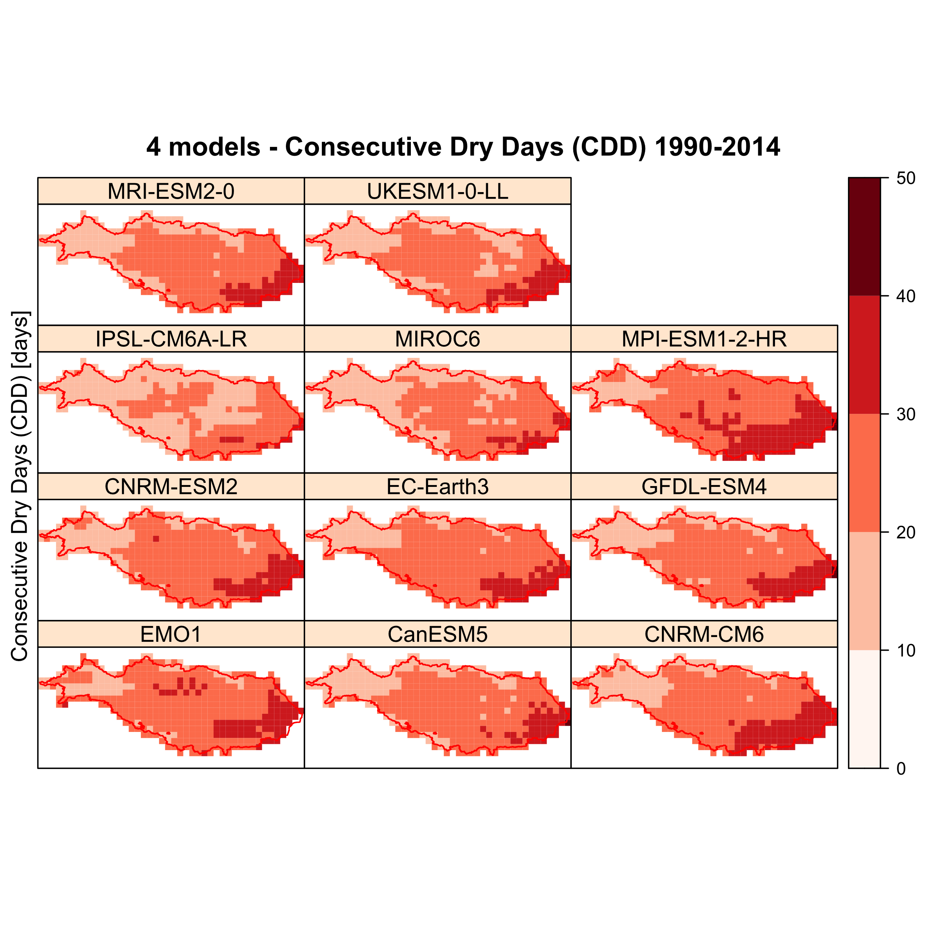
Fig 4: Annual precipitation – Danube – ISIMIP3a
Fig: 5 Consecutive dry days and days with more than 10mm rain – ISIMIP3a

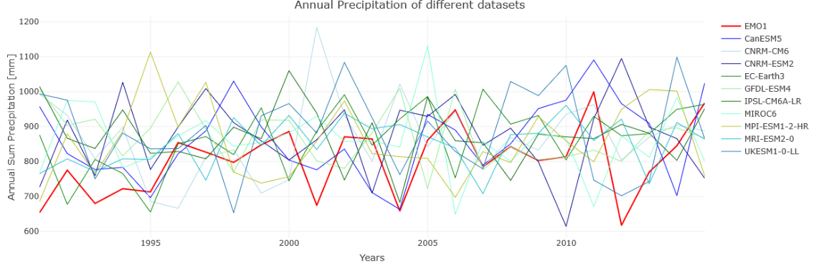

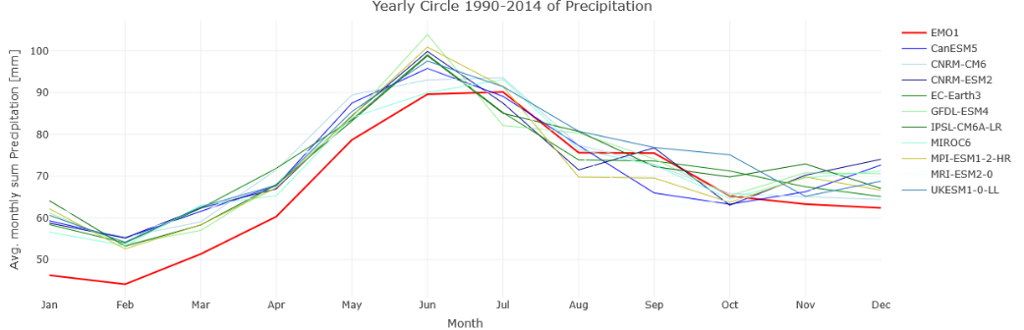
Fig 6: Annual precipitation and yearly cycle – all Danube – ISIMIP 3a

We tested 10 GCMs of the ISIMIP3a ensemble.
For the historical period 1990-2014 they are all pretty close together for the annual cycle. ISIMIP3a are bias-corrected using GSWP-W5E5 as reference and all of them show the same behaviour as the historical GSWP-W5E5 with higher precipitation in winter and spring than EMO5. The 10 ensemble member does not show the same trend and extremes as the historical timeseries (compare fig3 – fig6 – annual precipitation) .
The spatial distribution of dry days (fig 5) can very a lot between the 10 different ensemble members. All ensemble members show a strong peak in precipitation and in number of rainy days in the middle of the Danube, which reflects the strong influence of the bias-correction reference (see GSWP-W5E5 in fig 2).

Analysis control runs GCMs precipitation datasets
Restore4Life

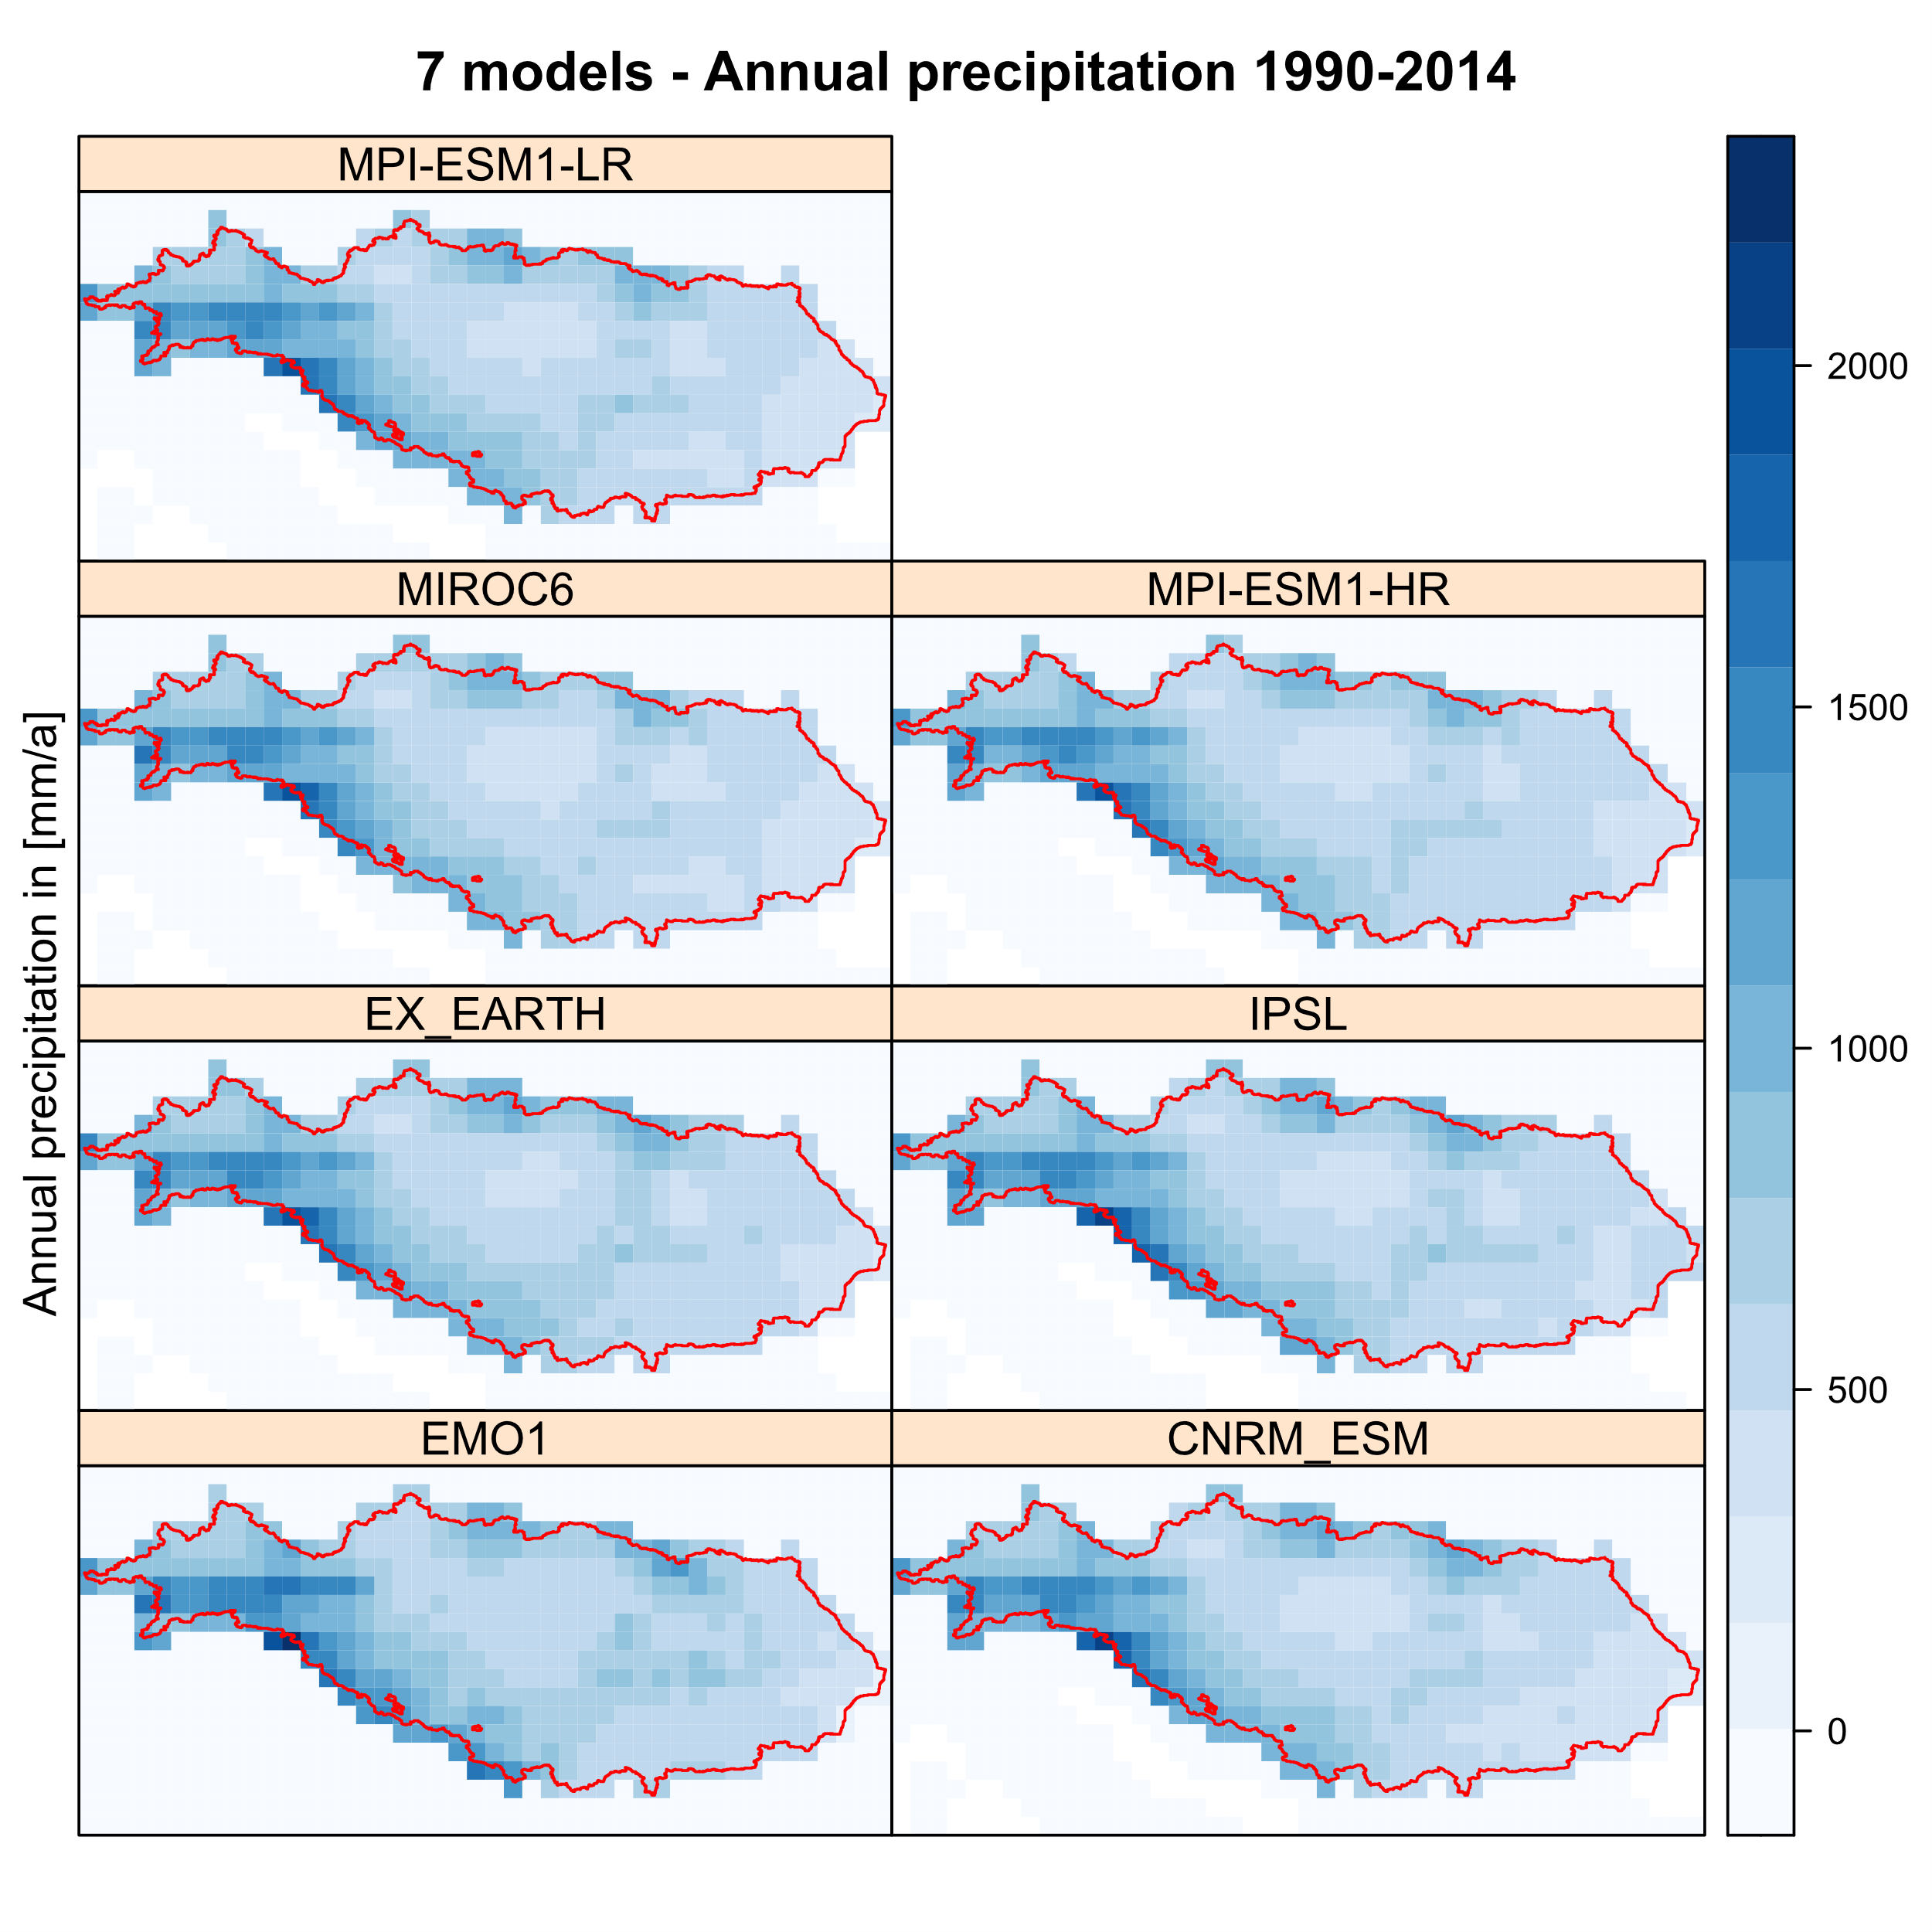
Fig 7: Annual precipitation – Danube – restore4life

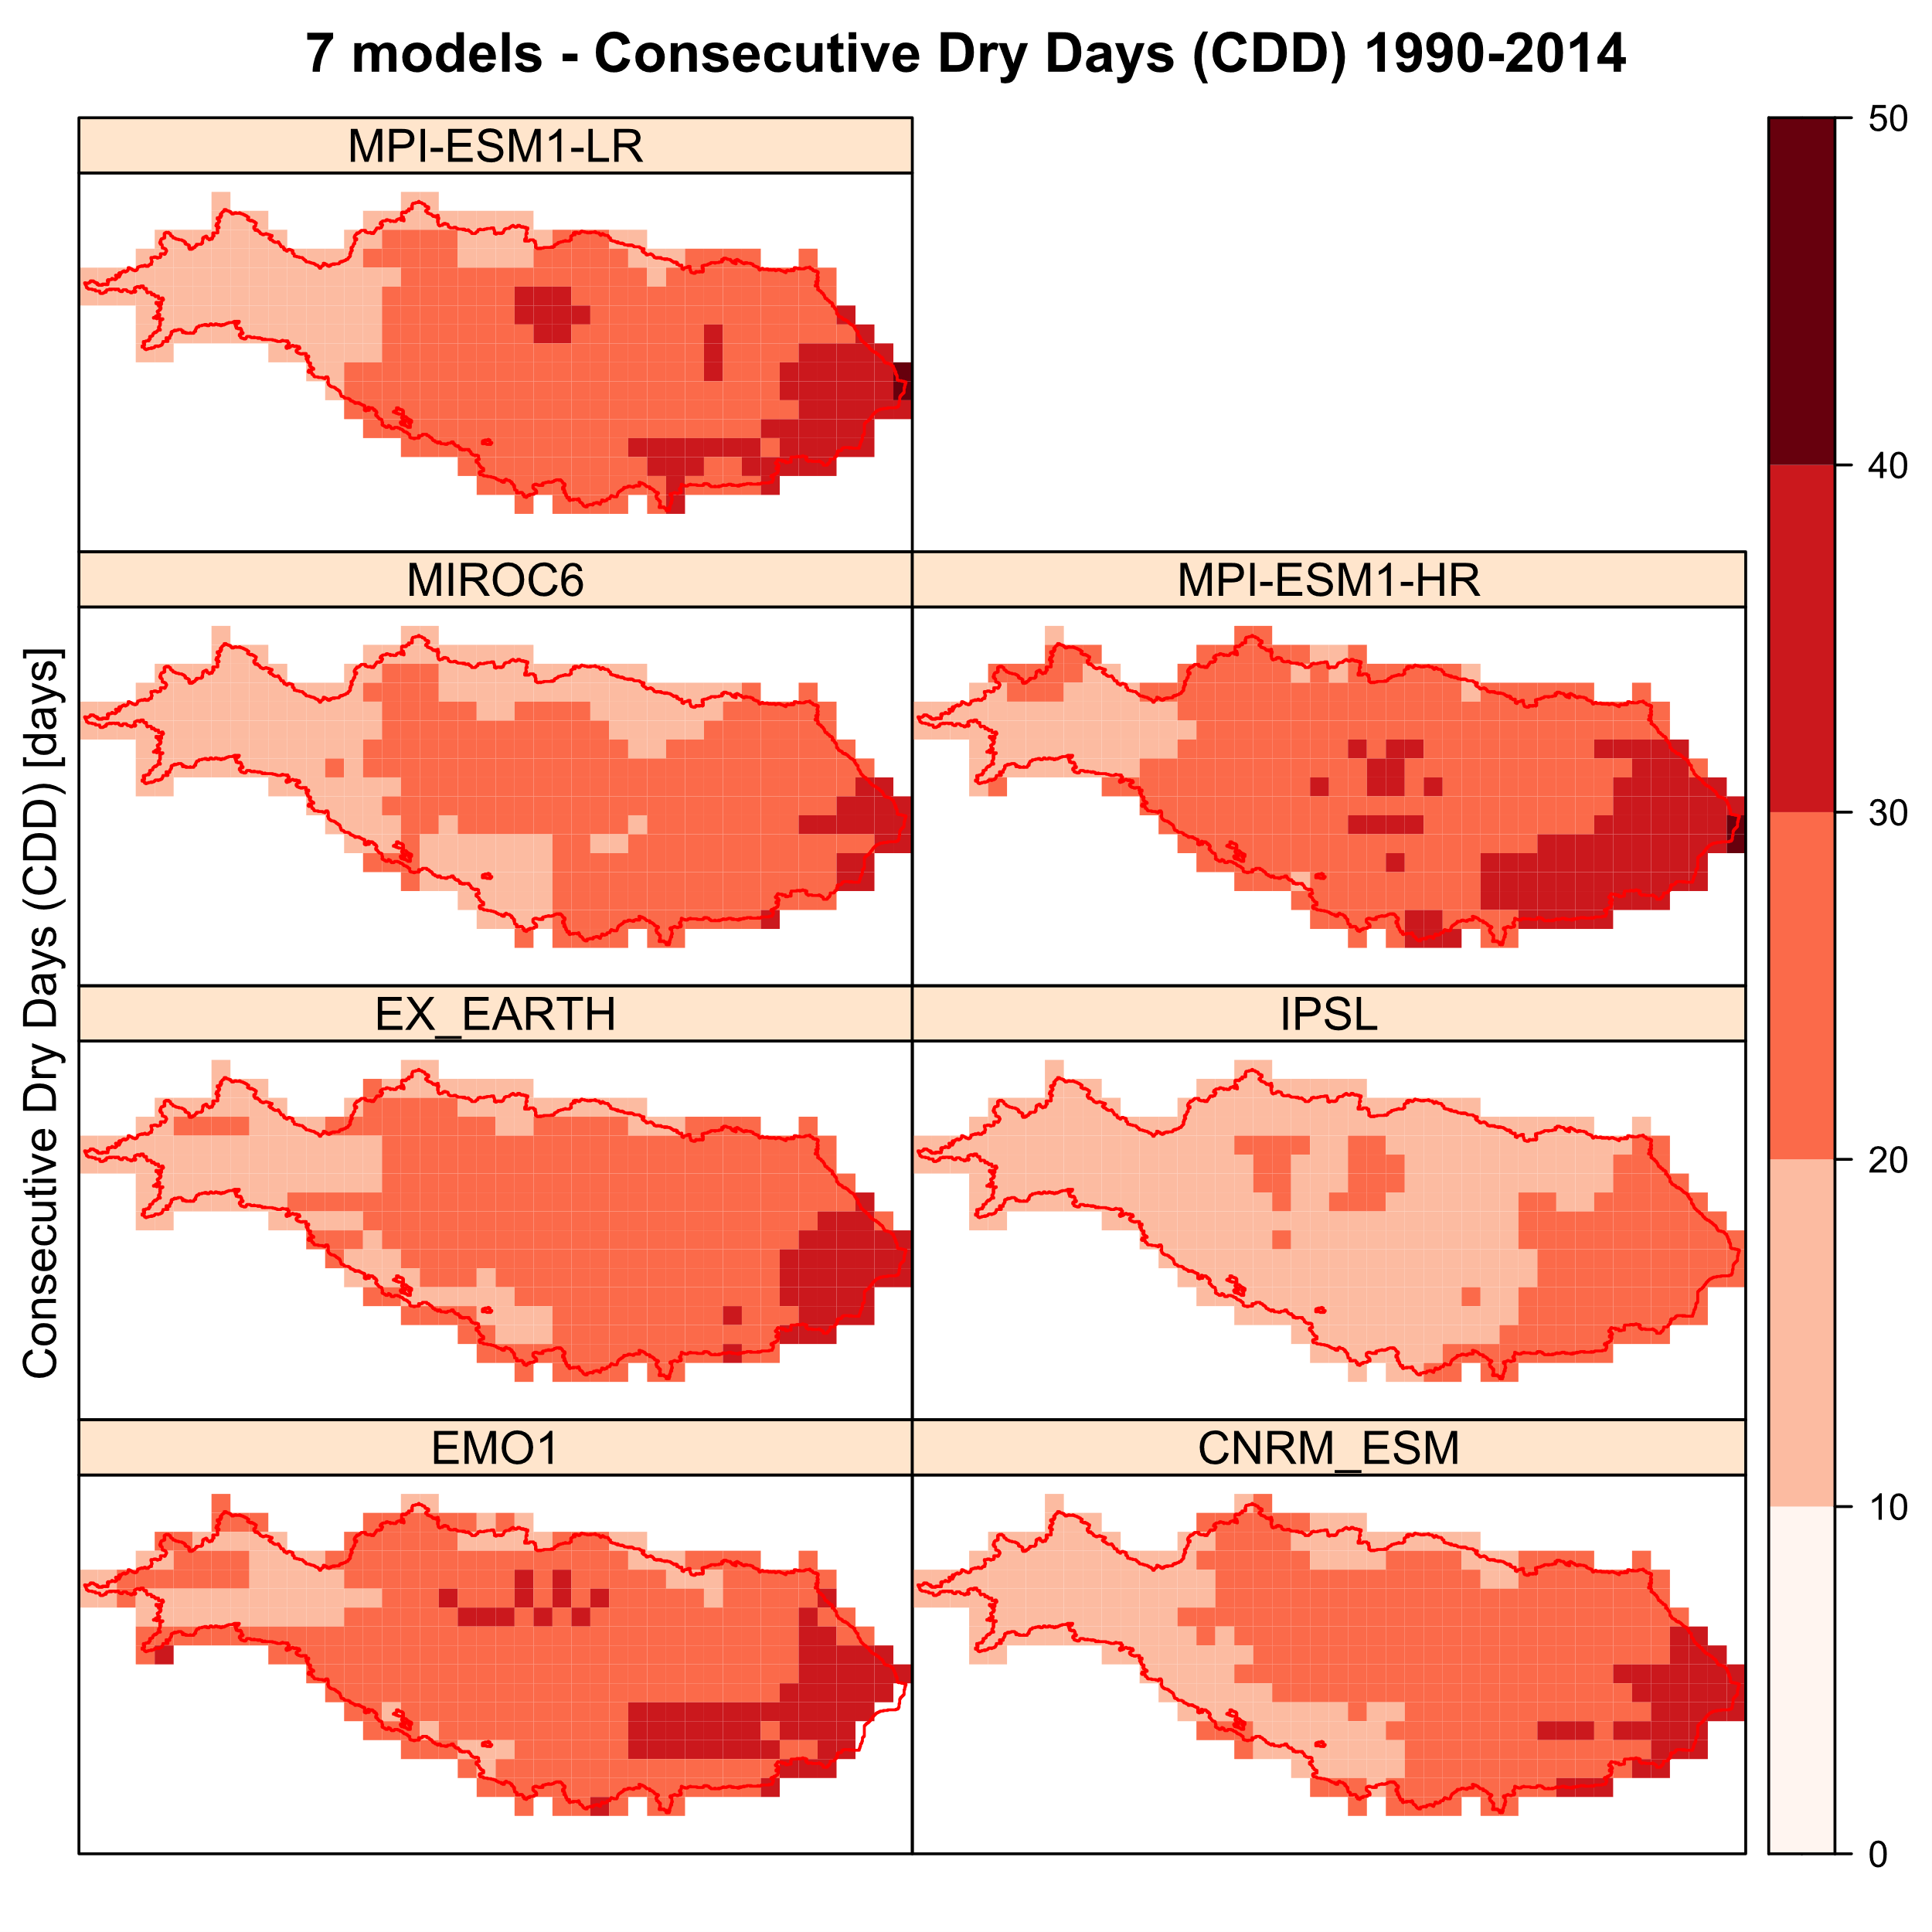

Fig: 8 Consecutive dry days and days with more than 10mm rain – restore4life

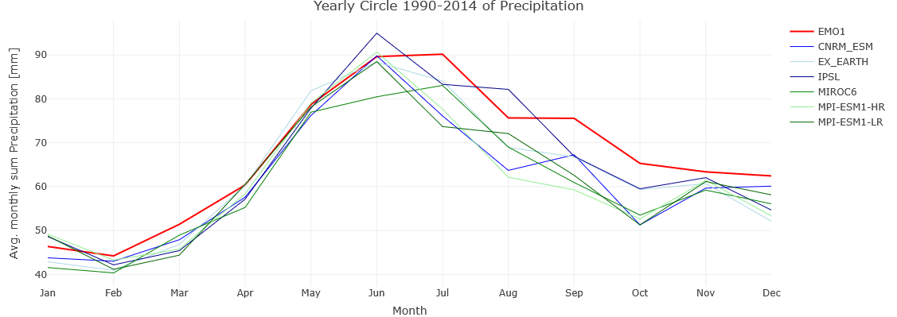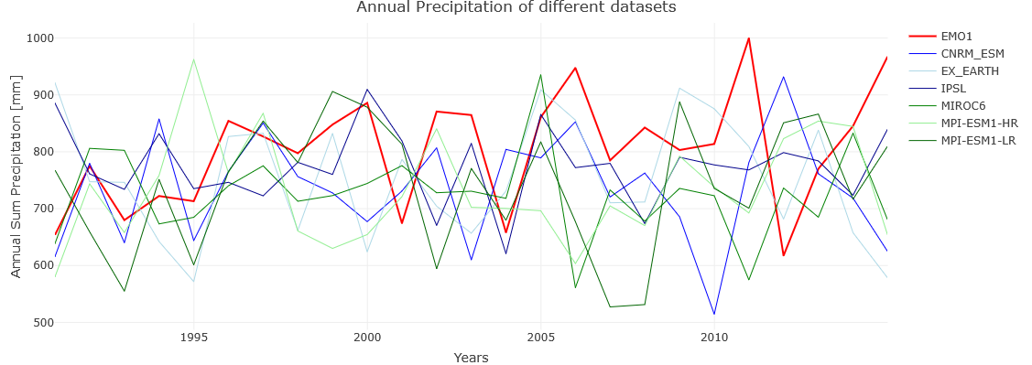
Fig 9: Annual precipitation and yearly cycle – all Danube – restore4life

We tested 6 GCMs of the restore4life ensemble. The annual cycle is very close to the EMO1 precipitation in Winter and Spring but differ more in Summer and Autumn than the Isimip3a dataset. While the annual precipitation of Isimip3a show some more extremes to higher precipitation, the restore4life show some more extreme years to low precipitation.
Also in this ensemble you see the strong influence of the bias-correction dataset (here: Eobs). For example the Karpats have less precipitation in all of the restore4life ensembles than the Isimip3a or the historical datasets (except Eobs).

Performance of different GCMs compared with observed historical precipitation

Precipitation is the most important spatially and temporally distributed input driving variable to for the hydrological model and at the same time one of the variables with a wide range of the most significant uncertainty range. Therefore, we tested precipitation of the GCM control period from 1990 to 2014 against the EMO1 dataset. As selection criteria, some of the core indices of WMO (2009) are used, similar to the study of Attogouinon et al. (2020). The ETCCDI web page defines the 27 core indices: http://etccdi.pacificclimate.org/list_27_indices.shtml. From this list, we used six indices for precipitation, the standard deviation, and the 95% and 99% percentile of monthly precipitation

Table 1 shows nine indices used to compare the model performance with the reference precipitation and gives a ranking based on these indices (the closer to the IMD dataset, the better the ranking).

Table 1: Indices and ranking for precipitation for 16 compared to EMO1

Rx5day: Monthly maximum consecutive 5-day precipitation [mm]
SDII: Simple precipitation intensity index [-]
R20mm: Annual count of days when PRCP≥ 20mm [days]
CWD: Maximum length of wet spell, maximum number of consecutive days with RR ≥ 1mm [days]
R95pTOT: Annual total PRCP when RR > 95p [mm]
PRCPTOT: Annual total precipitation in wet days [mm]
SD month: Standard deviation monthly aggregated values [mm]
95% month: 99% percentile monthly values [mm]
99% month: 95% percentile monthly values [mm]
http://etccdi.pacificclimate.org/list_27_indices.shtml

There is no evidence that Isimip3a or restore4life ensemble performance is closer to EMO1 dataset for precipitation. The spawn inside each dataset is bigger than the difference between both.

The restore4life dataset has the disadvantage that it comes only with precipitation and with temperature (daily average, minimum, maximum) and the isimip3a comes with all variables necessary for the Penman-Monteith evapotranspiration calculation.
The restore4life dataset comes with a higher resolution in 6 arcmin than the isimip3a datasets (30 arcmin). But during the run with CWatM both datasets will be downscaled to 1 arcmin using monthly spatial distribution of the EMO1 dataset.

References

- Karl, T.R., N. Nicholls, and A. Ghazi, 1999: CLIVAR/GCOS/WMO workshop on indices and indicators for climate extremes: Workshop summary. Climatic Change, 42, 3-7.
- Peterson, T.C., and Coauthors: Report on the Activities of the Working Group on Climate Change Detection and Related Rapporteurs 1998-2001. WMO, Rep. WCDMP-47, WMO-TD 1071, Geneve, Switzerland, 143pp.

