**GLOBIOM-forest RCP1p9 SCENARIO**

**1. Dominant management types 2020-2100**

-this does not work very well in 0.5ﹾ resolution, because often dominant management type does not change even if changes in non-dominant managements (-> needs higher resolution)

-alternatively look the development of single management type

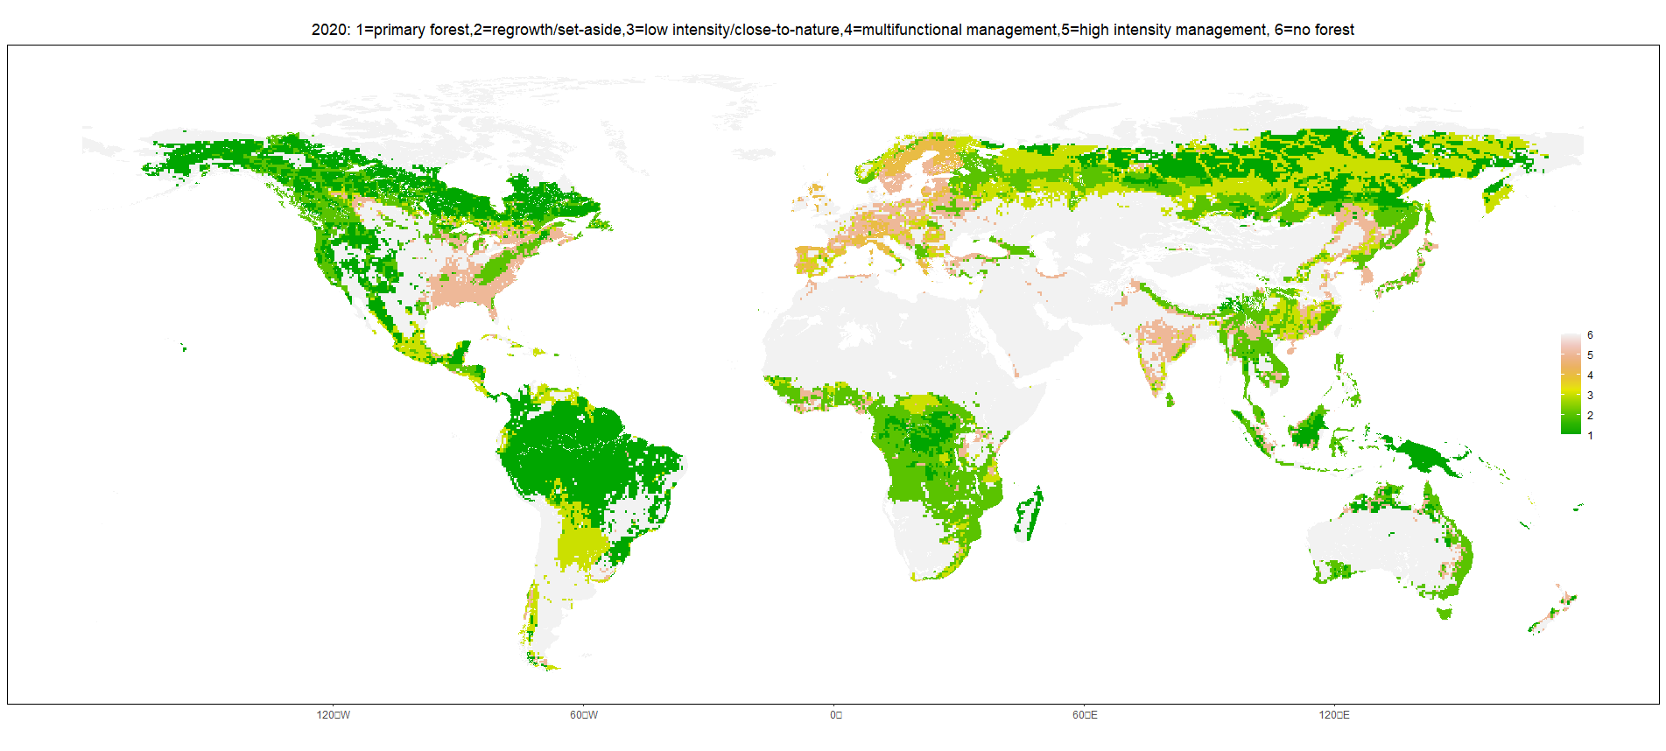

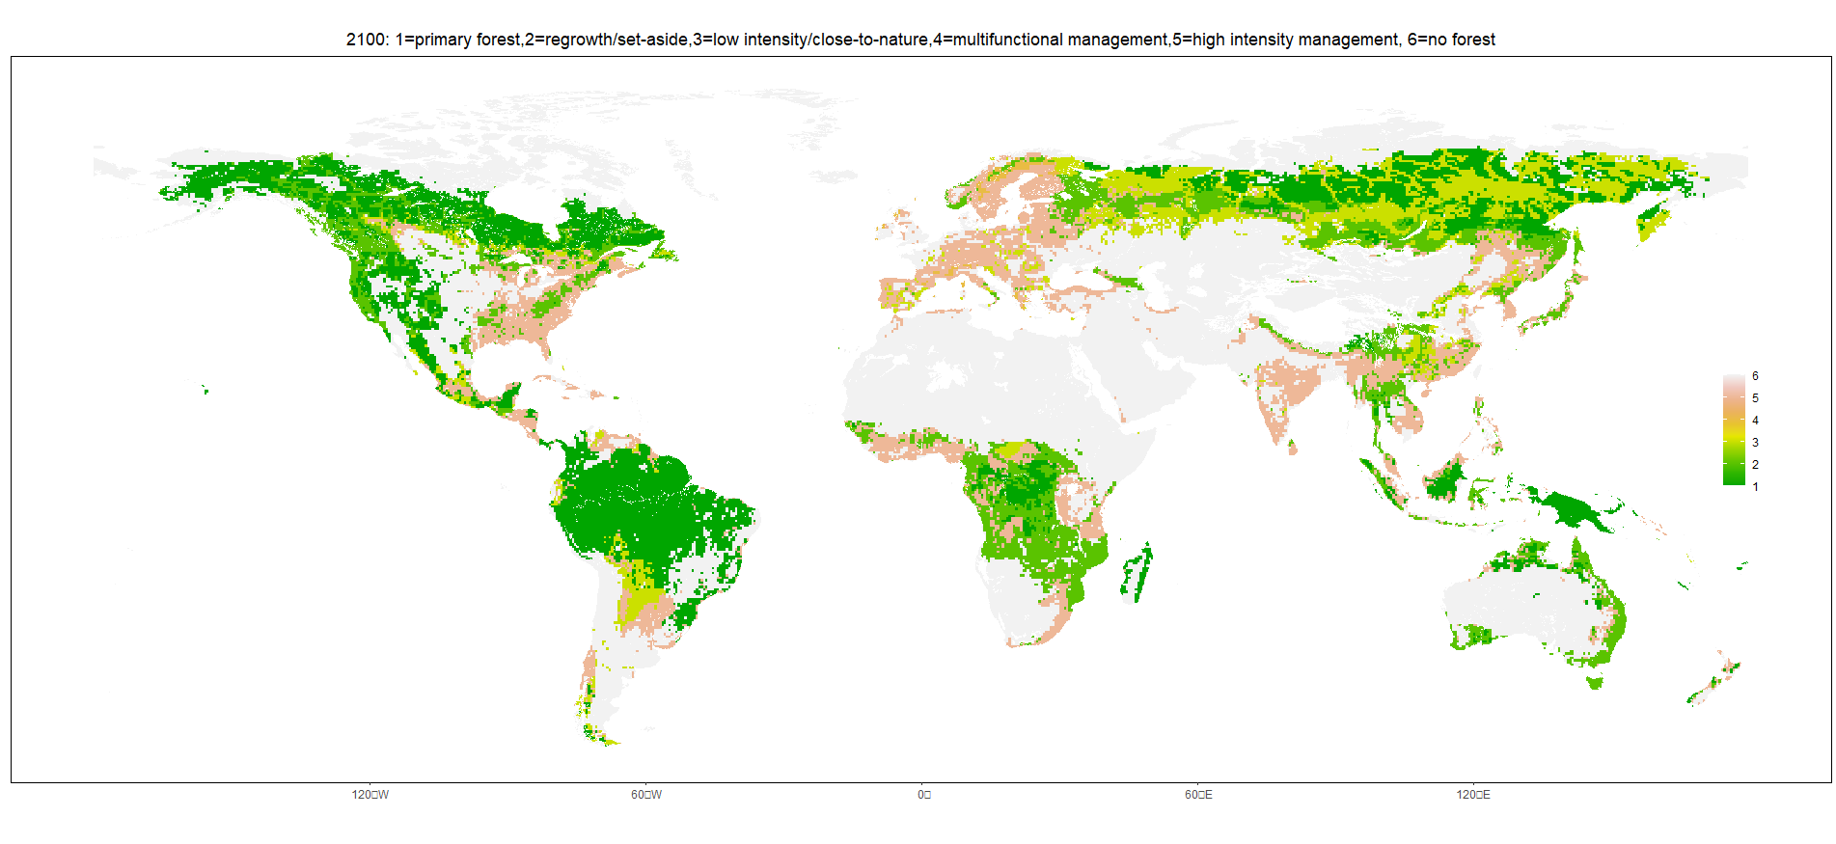

**2. Share of high intensity management 2020-2100**

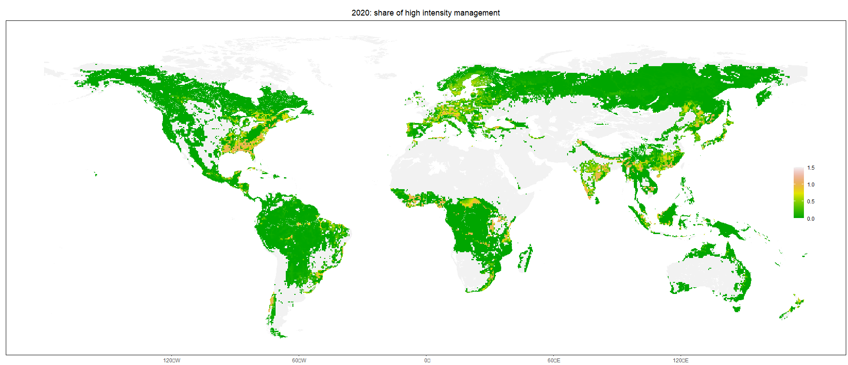

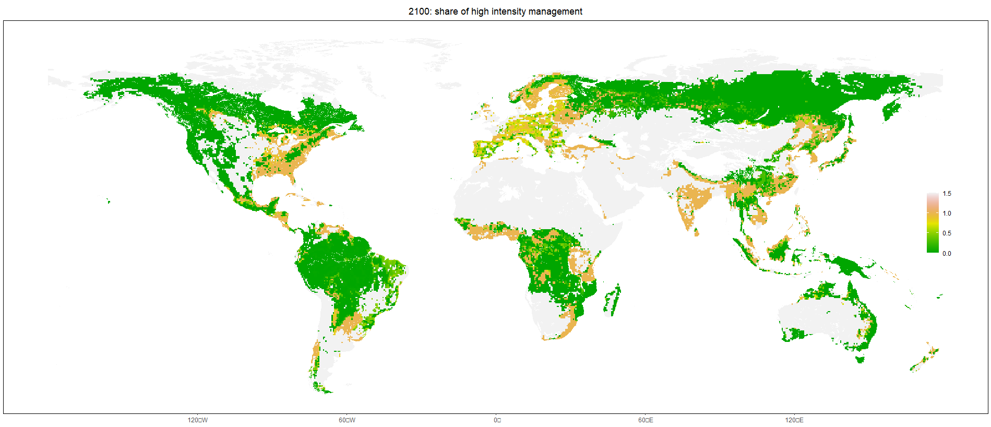

**3. Harvest intensity 2020-2100**

-harvest intensity= roundwood harvest/increment (maximum intensity =1)

-this would also work better with higher resolution

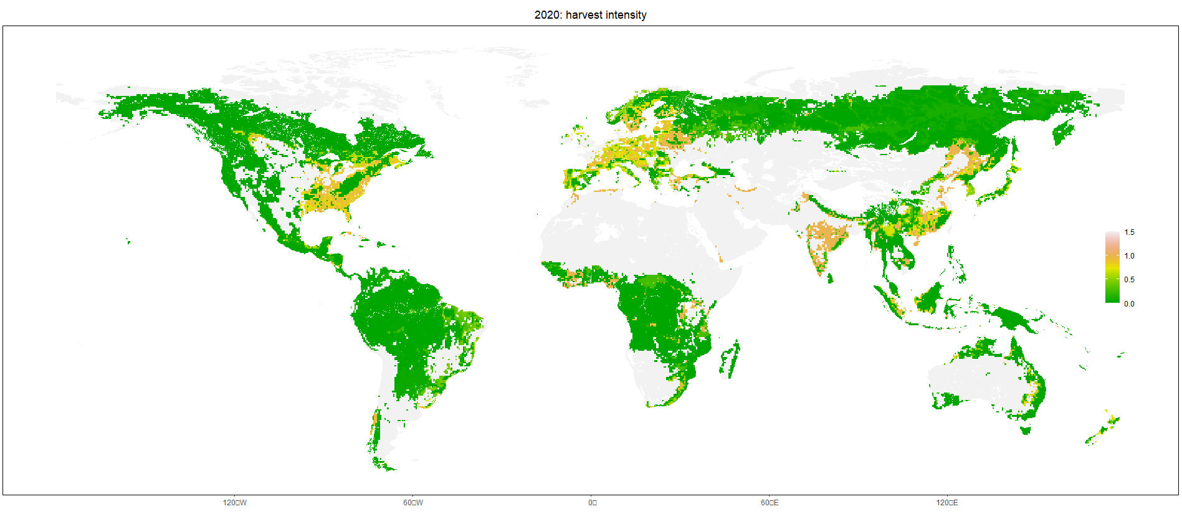

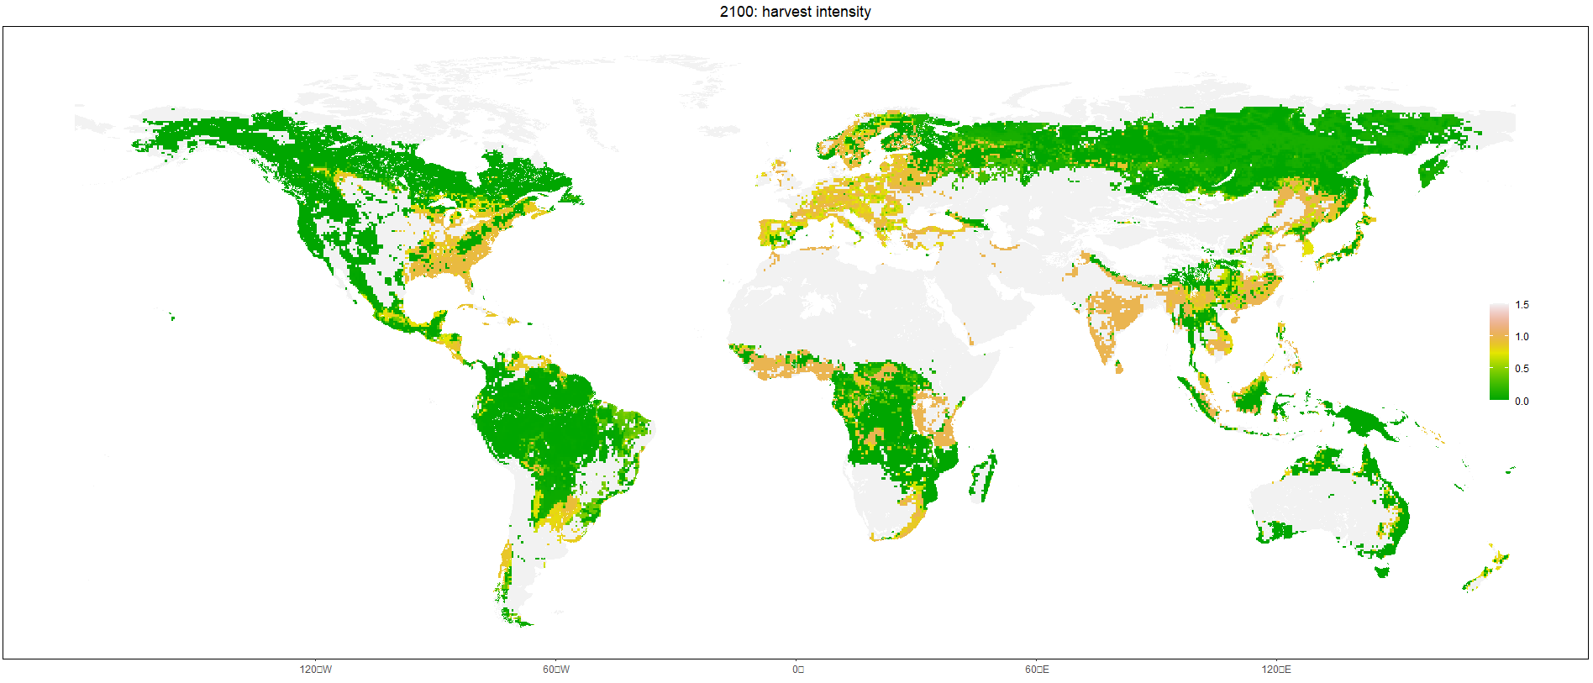

**4. Roundwood harvests per grid 2020-2100**

