**Correction of station location for EFAS and GLOFAS calibration**

To compare simulated and observed discharge, grid-based hydrological models must fit reported station locations to the resolution-dependent gridded river network.

In most cases this is done by comparing reported basin area for the station vs. upstream area calculated from the river network (LDD). For EFAS and GLOFAS manual correction of station also plays an important factor.

Here we use an Intersection over Union ratio approach to selected station locations on a coarser grid-scale, reducing the errors in assigning stations to the correct upstream basin. The approaqch is explained in the method part and in Burek and Smilovic (2023).

We put the python programs to run the evaluation on:

https://github.com/iiasa/Lisflood_preprocessing/tree/main/calib_stations

Datasets to run the programs and the results will be placed on the ECMWF shared diskspace.

For the Danube GloFAS we looked at 46 stations and corrected 24 stations automatically, but only 6 with relevant changes.

For the Danube EFAS we looked at 315 stations and corrected 84 stations, but only 9 with relevant changes.

The small number of major corrections reflects the already high quality for station selection processes due to several rounds of EFA/Glofas calibrations.

**Method**

The method is explained in detail in Burek and Smilovic (2023). An outline is given here:

1. The station is allocated to a high-res (3 arcsec) flow direction grid. The automatic station allocation follows the protocol of Lehner (2012).
2. Each station will have corresponding coordinates on the high-res flow-direction grid.
3. With the station coordinates and the high-res flow-direction, we derive a shapefile of the station basin.
4. A shapefile is produced on low resolution (1 arcmin for EFAS, 3 arcmin for Glofas) for all 25 surrounding coarse grid cells (surrounding the high-res coordinates).
5. The shapefile with the highest similarity to the high-res shapefile is chosen.

Figure 1 illustrates the method for 5 arcmin and for cell location No. 7, which is one 5′ cell south of the cell where the Passau/Inn station is located. Even if this cell does not represent the cell where the station is located, it fits the upstream area in accordance with the best intersection-over-union ratio of all 25 cells around the station location.

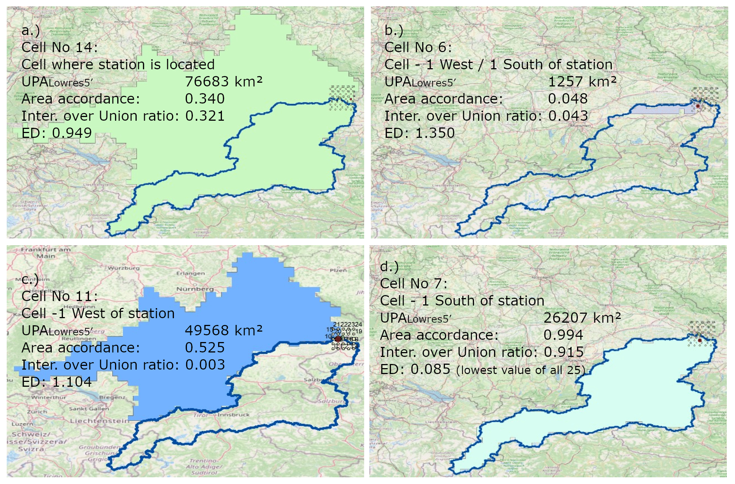

Fig 1: Concept of similarity for the Passau/Inn station, Germany – GRDC 6343900 with a high-resolution watershed map shown in blue outline and four different watershed maps based on 5′ resolution network around the station location (from Burek and Smilovic, 2023)

**Datasets**

* Merit DEM (Yamazaki et al. 2017,2019)  
  <https://hydro.iis.u-tokyo.ac.jp/~yamadai/MERIT_DEM/>  
  3 arcsec data tiles combined to a European DEM (European extend of LISFLOOD EFAS)
* EU-Hydro (Copernicus Land Monitoring Service)  
  <https://land.copernicus.eu/en/products/eu-hydro>
* Shape files of river network. Rasterized by attribute Strahler to 3 arcsec European raster
* Resulting river network on 3 arcsec:
  + Burned in EU-Hydro network to improve the natural DEM
  + Merit DEM - 5 * Strahler EU-Hydro
  + Filled up with ArcGIS Hydro fill tool to make a hydrological sound DEM
  + Flow direction tool from ArcGIS to create river network
* EFAS river network LDD and Upstream area (Danube extend)
* Glofas river network LDD and Upstream area (Danube extend)

**Programs**

**1_findMeritcoord.py**

Using a high-resolution upstream area dataset (here: Merit data DEM + EU-hydro burned in)

to get the location of the station on a 3 arcsec network. The approach of Lehner (2012) and Burek and Smilovic (2023) is used here.

Input data:

ups_danube_3sec.tif: Upstream area on 3 arcsec

metastation_45.txt: Gloafas calibration stations from Metadata_calib_stations_Danube_EFASv5_GloFASv4.xlsx

Output: Glofas_Merit_2.txt

metastation_45.txt + high-res location and upstream area

**2_makeshape.py**

Create high-res (3 arcsec) shape files of the basins.

The station points defined in 1_findMeritcoord.py are used to create the shapefiles.

Python library pyflwdir is needed (Eilander et al. 2021)

<https://pypi.org/project/pyflwdir/0.5.2/>

Input data:

Glofas_Merit_2corr.txt (manual corrected output from 1_findMeritcoord.py)

Danube_fd.tif (3 arcsec river network)

Output:

../shape_glofas_3sec: 3 arcsec shape file of station basin

**4_basincom_1min.py**

Creates shapefiles in low-res and adds the station location at lower resolution to a list

Using the shapefile in high-res and comparing it to the 25 neighboring shapefiles in low-res.

Selects the shapefile in low-resolution, which is most similar to high-res

Python library pyflwdir is needed (Eilander et al. 2021)

<https://pypi.org/project/pyflwdir/0.5.2/>

Input data:

* Glofas_Merit_2corr.txt (manual corrected output from 1_findMeritcoord.py)
* Low resolution LDD and upstream area
* Shapefiles of high resolution

Output:

* Textfile copying Glofas_Merit_2corr.txt and adding the station location and area in low-res
* Shapefile in low resolution
* If location is different to the former EFAS/Glofas location, another shapefile is stored in shape_efas / shape_glofas.

Programs are stored in:

<https://github.com/iiasa/Lisflood_preprocessing/tree/main/calib_stations>

**Output**

**Shape_3sec:**

315 ArcGis shapefiles of station basins on 3 arcsec for EFAS

e.g. 0001_Danube_Schwabelweis_DE_3sec.shp  
0001 -> ObsID from Danube_EFAS1arcmin_cal.stations.xlsx

**shape_glofas_3sec**

45 ArcGis shapefiles of station basins on 3 arcsec for Glofas

e.g. 0429_Danube_Danube_DEU_3sec.shp

0429 -> GloFAS ID from Danube_GloFAS3arcmin_cal.stat

**shape_1min:**

315 ArcGis shapefiles of station basins on 1 arcmin for EFAS

0001_Danube_Schwabelweis_DE_1min.shp

**shape_3min:**

45 ArcGis shapefiles of station basins on 3 arcmin

e.g. 0429_Danube_Danube_DEU_3min.shp

0429 -> GloFAS ID from Danube_GloFAS3arcmin_cal.stat

**Metadata_calib_stations_Danube_EFASv5_station.xlsx**

Danube_EFAS1arcmin_cal.stations: sheet from Danube EFAS stations

compare_efas: compare Efas stations to 3 arcsec stations

new_lat_3sec, new_lon_3sec, new_area-3sec from MERRIT 3sec river network

Column Z-AW: manual inspections of 18 stations

result_efas: results for stations on 1 arcmin

**Metadata_calib_stations_Danube_GloFASv4_stations.xlsx**

Danube_EFAS1arcmin_cal.stations: sheet from Danube GLOFAS stations

compare_glofas: compare GLOFAS stations to 3 arcsec stations

new_lat_3sec, new_lon_3sec, new_area-3sec from MERRIT 3sec river network

Column AB-BB: manual inspections of 4 stations

result_glofas: results for stations on 3 arcmin

**Glofas examples**

**Station 0436 Oberndorf, Danube**

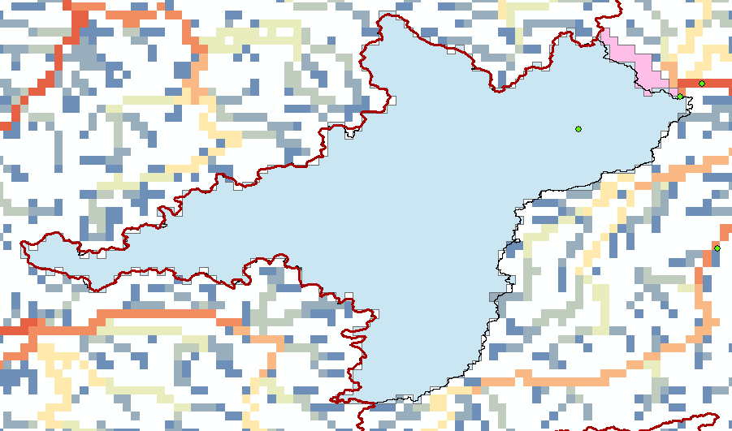

Fig 2: Station 436 – Oberndorf, Danube. Blue – shapefile of new calculated station basin. Pink – EFAS station shapefile (most parts below the blue shape). The EFAS station includes the river Schwarze Laber, which joins the Danube after the station Oberndorf.

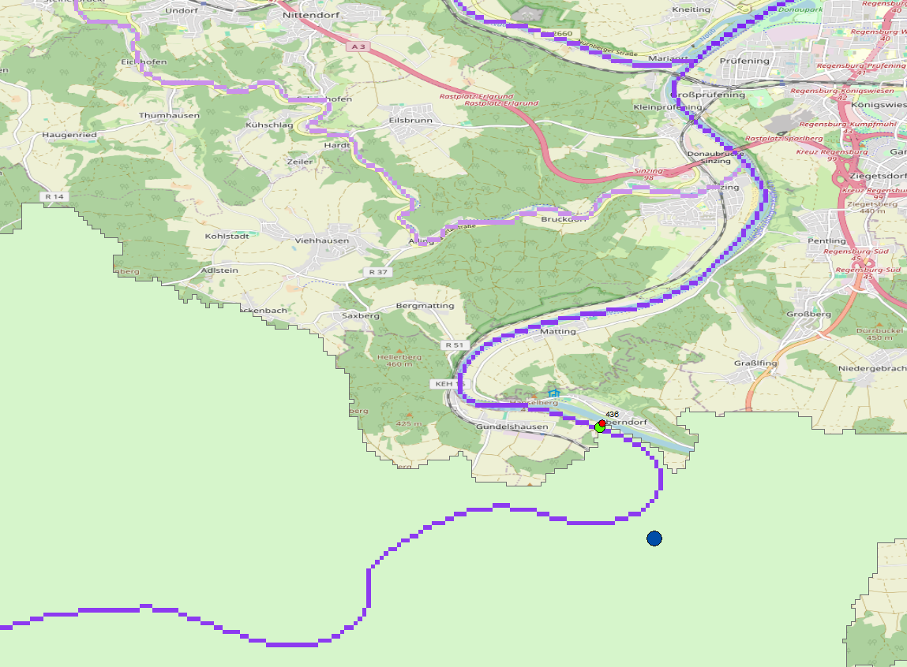

Fig 3: Detail of station 436. Red point – provided station location, green point – shifted station location to match high-res (3 arcsec) river network. Blue point – middle point of station location on 3 arcmin. Light green shape – high-res shape file on 3 arcsec.

**Station 0517 - Tisza, Hungary**

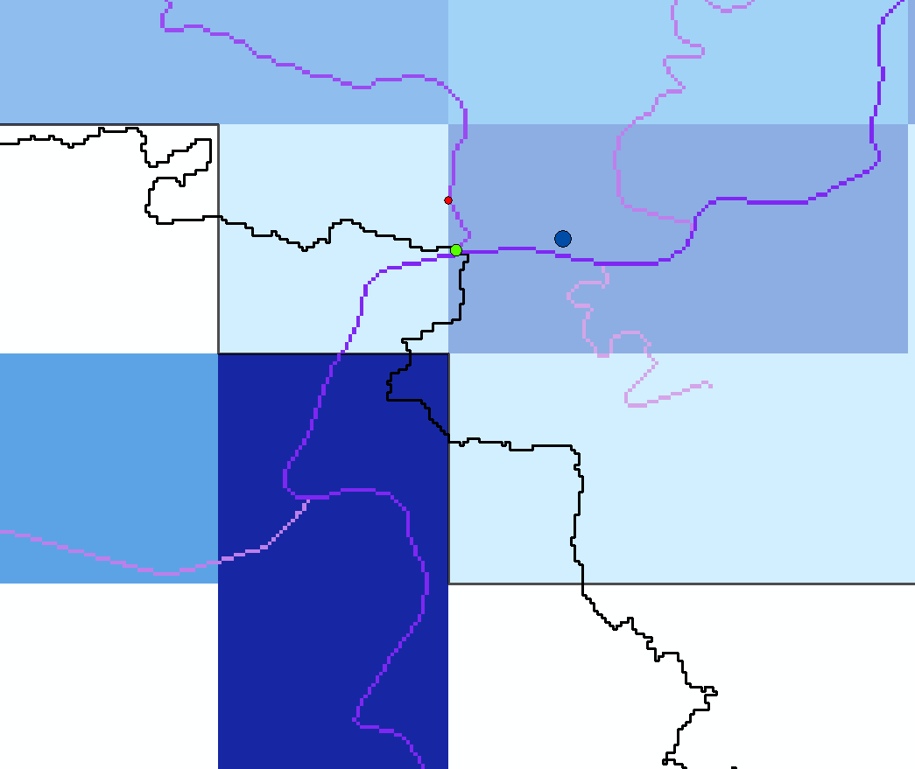

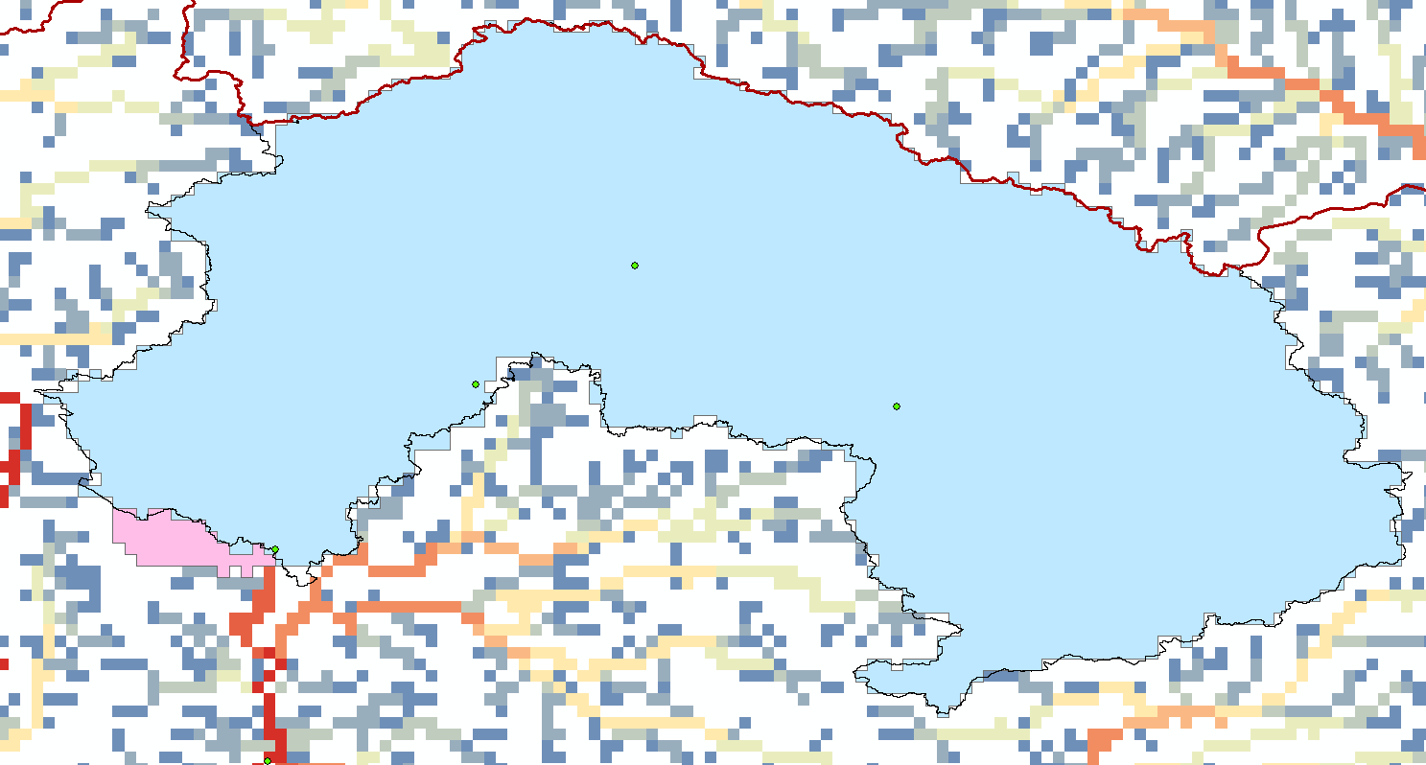

Fig 4: Station 517 – Tisza, Hungary. River is joining after the station 517. In Glofas this river is included in the river network of station 517. Red point – provided station location, light green point – shifted station to river matching provided basin area.

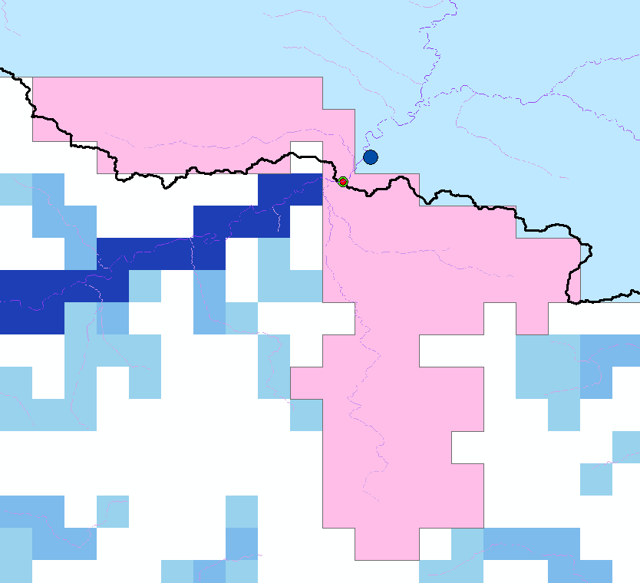**Station 559 – Maros, Danube**

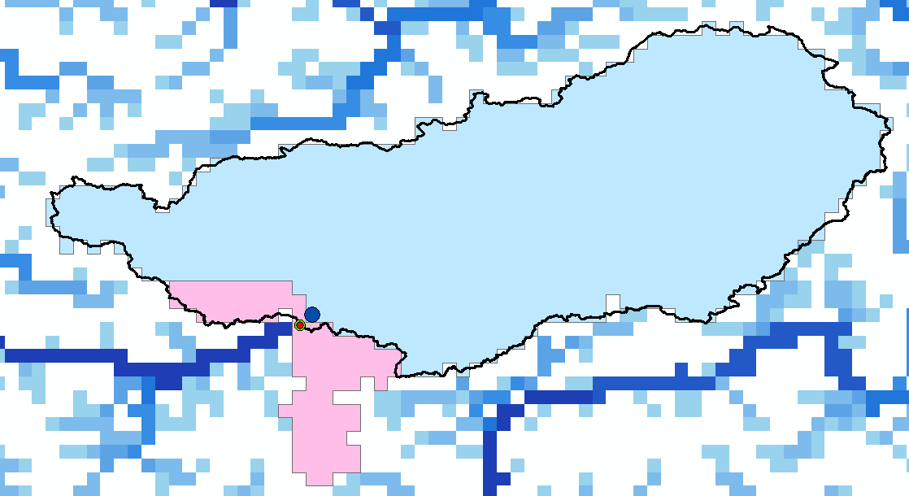

Fig 5: Station 559 – Maros, Danube, Romania. Here, the river from the west (Ampoi) joins before the station and the river from the south (Sebes) joins after the station. But both rivers join into the same 3 arcmin cell. Here, the similarity of shapes algorithm decides in favor of leaving out both tributaries rather than including both

**EFAS examples**

**Station 660, Koros - Bekes, Hungary**

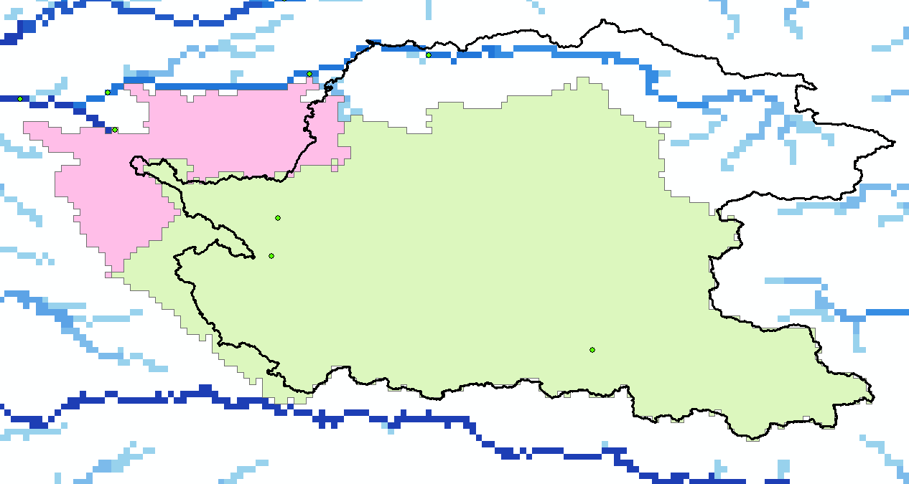

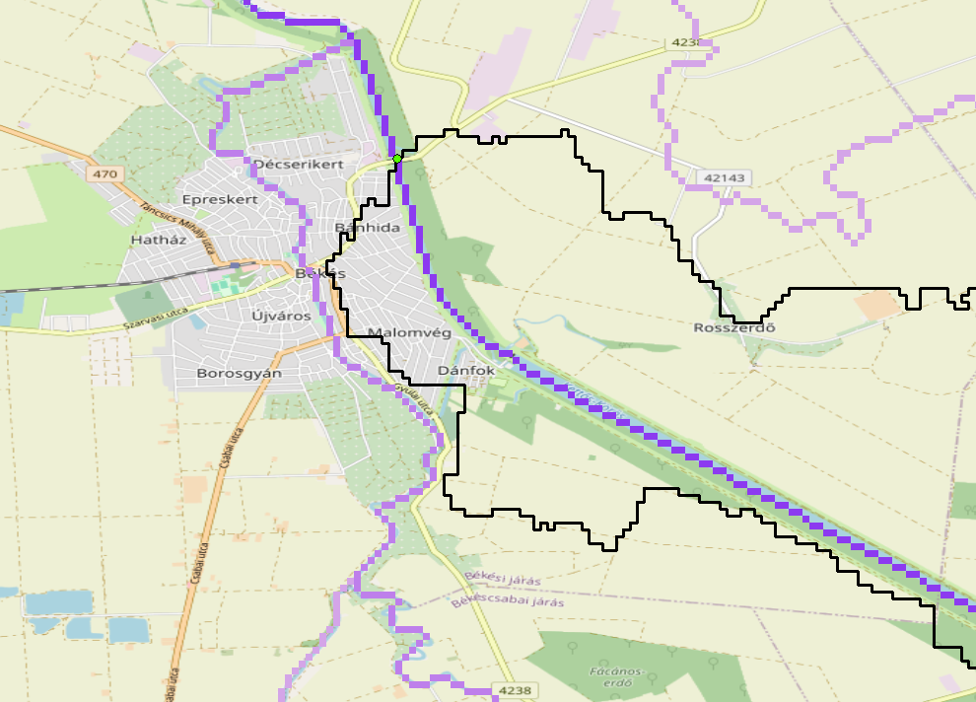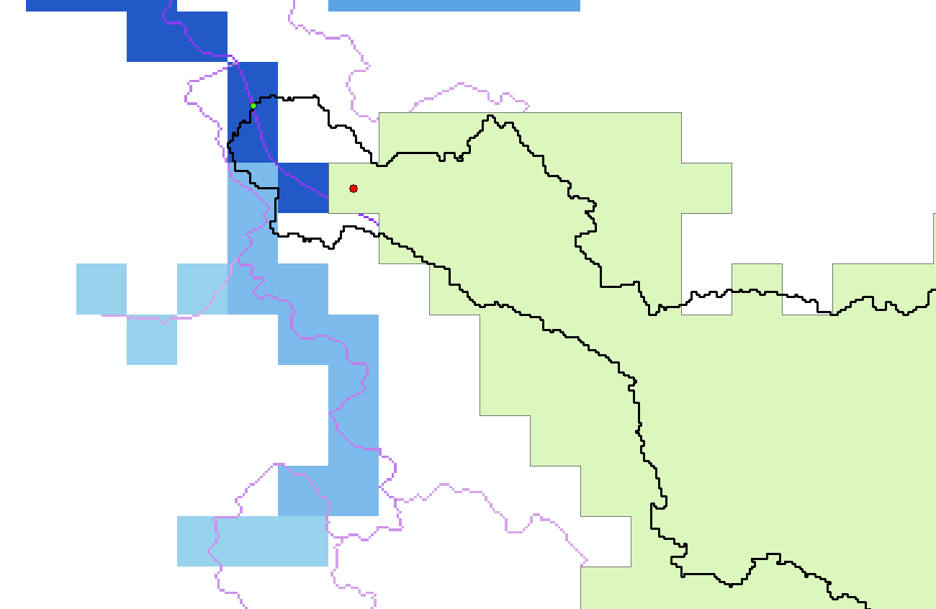

Fig 6: Station 660, Koros - Bekes, Hungary. The EFAS station location (shapefile in pink) includes much more than the new calculated station location. The black outline is the 3 arcsec basin. It seems that the 1 arcmin is corrected and does not include the north-eastern part. But the station in Bekes, does not include the rivers in the West and North-West.

**Station 263, Danube - Bajina_Bata**

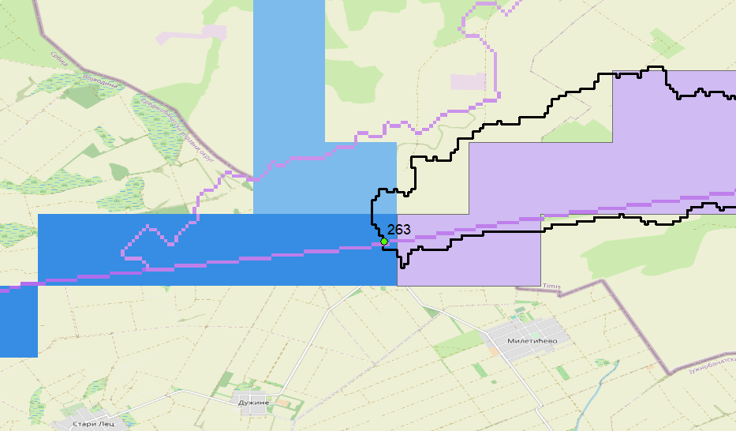

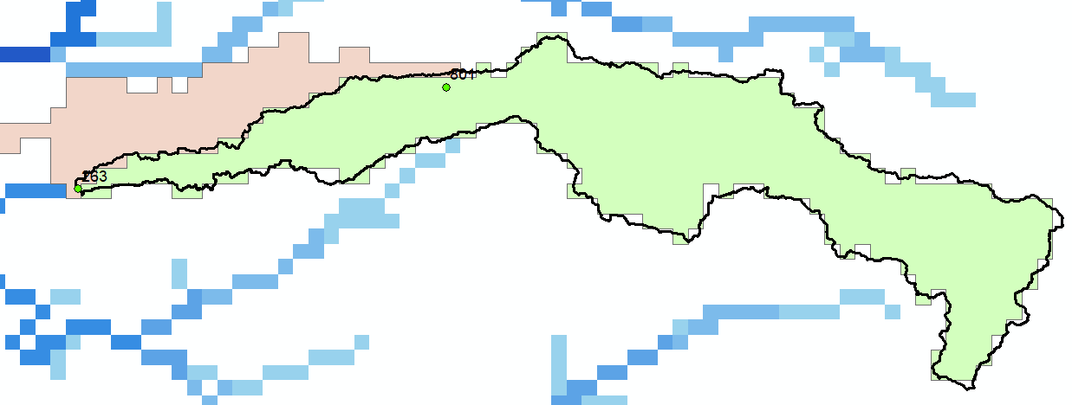

Fig 7: Station 263, Danube - Bajina_Bata. The EFAS station basin includes the river which joins downstream of the station location

**Summary**

The Glofas and Efas stations are already in a good shape. It seems many stations are shifted to the right (in terms of – fitting to the network resolution of 1 arcmin or 3 arcmins).

There are only a few stations which can be corrected and for one station you cannot avoid an error (station 559 Glofas) as two rivers joins at the same 3 arcmin grid cell and only one belongs to the station basin. The only way to change this, is to change the LDD.

For Glofas 6 stations with changes (442, 517, 551, 559, 599, 615)

For EFAS we found 9 stations with major changes (181, 247, 263, 457, 460, 657, 660, 676, 713)

**References**

Burek, P. and Smilovic, M.: The use of GRDC gauging stations for calibrating large-scale hydrological models, Earth Syst. Sci. Data, 15, 5617–5629, https://doi.org/10.5194/essd-15-5617-2023

Eilander, D., van Verseveld, W., Yamazaki, D., Weerts, A., Winsemius, H. C., and Ward, P. J.: A hydrography upscaling method for scale-invariant parametrization of distributed hydrological models, Hydrol. Earth Syst. Sci., 25, 5287–5313, <https://doi.org/10.5194/hess-25-5287-2021>

Lehner, B.: Derivation of watershed boundaries for GRDC gauging stations based on the HydroSHEDS drainage network – Technical Report prepared for the GRDC, Global Runoff Data Centre, Koblenz, Germany, 18, 2012.

Yamazaki D., D. Ikeshima, R. Tawatari, T. Yamaguchi, F. O'Loughlin, J.C. Neal, C.C. Sampson, S. Kanae & P.D. Bates A high accuracy map of global terrain elevations Geophysical Research Letters, vol.44, pp.5844-5853, 2017 doi: 10.1002/2017GL072874

Yamazaki, D., Ikeshima, D., Sosa, J., Bates, P. D., Allen, G. H., and Pavelsky, T. M.: MERIT Hydro: A High-Resolution Global Hydrography Map Based on Latest Topography Dataset, Water Resour. Res., 55, 5053–5073, 2019, <https://doi.org/10.1029/2019WR024873>