**ODPSCP Protocol Version: 0.4**

Created through https://github.com/iiasa/ODPSCP

Generated on 2024-10-20

# Protocol content

1. Protocol content 1

2. Overview 2

3. Design 5

4. Specification 7

5. Context 10

6. Prioritization 12

# Overview

**What is the title of the conducted study?**

*This field records basic information about the study and its scientific context.*

Areas of global importance for conserving terrestrial biodiversity, carbon and water

**List the authors of the study.**

*Create a list of all authors with link to their ORCID if specified.*

| firstname | surname | orcid |
| --- | --- | --- |
| Martin | Jung | 0000-0002-7569-1390 |

**Email of corresponding author.**

*The email address of the corresponding author.*

<martin's would be here email>

**Link to the published study.**

*Enter a Digital Object Identifier or any other permanent link.*

Jung, Martin, et al. "Areas of global importance for conserving terrestrial biodiversity, carbon and water." Nature Ecology & Evolution 5.11 (2021): 1499-1509. https://doi.org/10.1038/s41559-021-01528-7

**What is the target extent of the planning study?**

*Spatial planning can be conducted at a range of different scales and this field aims to provide the various options. Local refers to a study at any given single site, National to planning at a country level, Regional for studies beyond single countries (e.g. bioregions), Continental for entire continents (e.g. Europe, Africa) and global for truly global studies.*

global

**If available, provide a geospatial delineation of the study region.**

*A geospatial dataset can be provided such as gridded or vector planning unit file. Note that the maximum file size is 30 MB.*

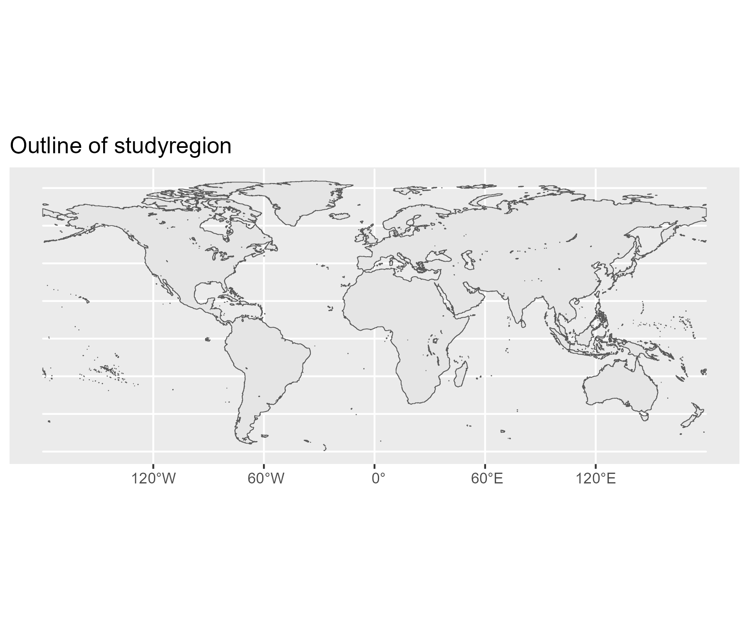

**If available, provide a geospatial delineation of the study region.**

*A geospatial dataset can be provided such as gridded or vector planning unit file. Note that the maximum file size is 30 MB.*

Not specified

**What is the location of the study?**

*Add text description of the study location.*

The study was conducted at global scale covering all continents except Antarctica.

**What is the temporal range of the study?**

*Define the study range.*

Planning was conducted from 2015 - 2030

**What is the temporal range of the study?**

*Define the study range.*

Data used for the planning considered the year 2015 as baseline, yet the inferences were made to inform Global conservation policies up to 2030.

**What is the biophysical realm in which the planning work was conducted?**

*Spatial planning have been carried out within and across different realms. Here we record where a study has been conducted. Note that multiple realms can be selected!*

Terrestrial (above ground)

Terrestrial (below ground)

**Are the used input data made available and if so where?**

*If applicable please enter a link to the data storage repository.*

No

**Are the used input data made available and if so where?**

*If applicable please enter a link to the data storage repository.*

Not specified

**Are the created outputs made openly available and if so where?**

*If set to true, please enter a link to the data storage repository.*

Yes

**Are the created outputs made openly available and if so where?**

*If set to true, please enter a link to the data storage repository.*

https://zenodo.org/records/5006332

**Have analytical scripts or steps to reproduce the results been made available?**

*If set to true, please enter a link to the code repository*

Yes

**Have analytical scripts or steps to reproduce the results been made available?**

*If set to true, please enter a link to the code repository*

https://github.com/Martin-Jung/NatureMapCode/

# Design

**What is the aim of the study?**

*Describe in 1-2 sentences what the study aims to achieve.*

Identify those areas globally that jointly minimizes the number of threatened species, maximizes carbon retention and water quality regulation, and ranks terrestrial conservation priorities globally.

**Does the planning work follow a specific analytical framework?**

*Possible answers include references to a specific published framework, or if this has been defined in the study.*

Defined within study

**Does the planning work follow a specific analytical framework?**

*Possible answers include references to a specific published framework, or if this has been defined in the study.*

Not specified

**Is there a theory of change underlying this work?**

*Most SCP applications are applied rather than curiosity driven. The primary question here is whether the pathway to impact and influencing outcomes is clear.*

No

**Is there a theory of change underlying this work?**

*Most SCP applications are applied rather than curiosity driven. The primary question here is whether the pathway to impact and influencing outcomes is clear.*

Not specified

**What is the primary purpose of the study?**

*Why was the planning was conducted. A range of commonly applied responses is provided.*

Area-based allocation

**Had the planning multiple objectives?**

*For a given purpose and objective function there can be often multiple, sometimes competing objectives involved in the planning. For example, if one would to identify management options that can maximize both species and carbon storage as features by altering their weights.*

Yes

**Had the planning multiple objectives?**

*For a given purpose and objective function there can be often multiple, sometimes competing objectives involved in the planning. For example, if one would to identify management options that can maximize both species and carbon storage as features by altering their weights.*

Joint priorities of biodiversity, carbon and water, assessed through varying combinations of weights.

**Are there multiple variants or scenarios explored in the planning?**

*Instead of a single planning exercise, many studies often record multiple scenarios or variants which we can record here.*

Yes

**Are there multiple variants or scenarios explored in the planning?**

*Instead of a single planning exercise, many studies often record multiple scenarios or variants which we can record here.*

Variants included those that considered current protected areas as input or not. Or those that used specific weights as configuration.

**Were stakeholders involved in the design of the study?**

*Spatial plans are naturally context specific and different planning options might have different synergies or tradeoffs. To facilitate sucessful implementation it is thus important to consider stakeholders in the design of spatial plans*

No

**Were stakeholders involved in the design of the study?**

*Spatial plans are naturally context specific and different planning options might have different synergies or tradeoffs. To facilitate sucessful implementation it is thus important to consider stakeholders in the design of spatial plans*

Not specified

**What type of stakeholders were engaged?**

*Engagement can happen at multiple levels and with different types of stakeholders. Here we record what type of stakeholders were engaged.*

Not specified

**How were stakeholders engaged?**

*Describe in a few words how precisely stakeholder were engaged.*

Not specified

# Specification

**How are planning units defined?**

*Describe the type of planning units used in this work.*

Gridded

**How are planning units defined?**

*Describe the type of planning units used in this work.*

Not specified

**What was the spatial grain of planning?**

*Describe the grain of planning units if applicable.*

10

**What was the spatial grain of planning?**

*Describe the grain of planning units if applicable.*

World Mollweide projection in equal area.

**Select or enter unit used for the spatial grain.**

*Leave empty if not applicable.*

km2

**Where there any costs of selecting a planning unit? Select one or multiple.**

*Where there any costs or penalities for selecting a planning unit? Select one or multiple.*

Area only

**Where there any costs of selecting a planning unit? Select one or multiple.**

*Where there any costs or penalities for selecting a planning unit? Select one or multiple.*

Fractional terrestrial areas (excluding water) were included in each planning unit.

**Was there any ecosystem specificity?**

*SCP can be conducted on all land or sea within a given region, but it can also be specific to certain ecosystems or land-use types, such as for example forests.*

Not specified

**Was there any ecosystem specificity?**

*SCP can be conducted on all land or sea within a given region, but it can also be specific to certain ecosystems or land-use types, such as for example forests.*

Not specified

**Where any zones used for the planning?**

*Planning can be structured by multiple management or land-use zones. Here we describe them, also listing any parameters that structure their zone.*

Not specified

**Where any zones used for the planning?**

*Planning can be structured by multiple management or land-use zones. Here we describe them, also listing any parameters that structure their zone.*

**Any areas or actions that were included or excluded by default?**

*In a planning project, certain areas or actions can be included or excluded by default.*

None

Areas or Action included

**Any areas or actions that were included or excluded by default?**

*In a planning project, certain areas or actions can be included or excluded by default.*

Current protected areas were included by default in some runs.

**What types of threats are included in the planning?**

*Select any threats that were targeted in the planning or that, directly or indirectly, shape the planning outcome. The threat description broadly follows the IUCN Threat categorization system.*

Residential & commercial development

Agriculture & Aquaculture

**What types of threats are included in the planning?**

*Select any threats that were targeted in the planning or that, directly or indirectly, shape the planning outcome. The threat description broadly follows the IUCN Threat categorization system.*

Not specified

**How were threats considered in the planning?**

*There are multiple ways of including threats, for example by considering them as risk factor in the prioritization, as cost or penalty in selecting a solution. Here we record these various options.*

Feature (individual)

**How were threats considered in the planning?**

*There are multiple ways of including threats, for example by considering them as risk factor in the prioritization, as cost or penalty in selecting a solution. Here we record these various options.*

Features were refined to a Area of habitat so as to exclude threats to species within their distribution.

**What types of features are included in the spatial planning?**

*Please provide a classification of the included features.*

Species (distributions)

Nature contributions to people (supply)

**What types of features are included in the spatial planning?**

*Please provide a classification of the included features.*

Not specified

**Were any features aggregated before use in the planning?**

*If applicable, please describe which and how.*

TRUE

**Were any features aggregated before use in the planning?**

*If applicable please describe which and how.*

Individual carbon data of AGBC, BGBC and SOC were aggregated (sum) to a total carbon estimate for the planning.

**List the features**

*Add the features to the list.*

| name | group | number |
| --- | --- | --- |
| Species distribution (Vertebrates and Plants) | Species (distributions) | 227837 |
| Carbon storage | Nature contributions to people (supply) | 1 |
| Clean Water | Nature contributions to people (supply) | 1 |

**How were features created?**

*Describe the origin of the features.*

We used the best available global species range data including all extant terrestrial vertebrates and a representative proportion of all accepted species in the World Checklist of Vascular Plants. Extant mammal (5,685 species) and amphibian (6,660) species range data were obtained from the IUCN Red List database (v.2019-2), while bird (10,953) range maps were obtained from Birdlife International. Data on the reptile ranges were obtained from the IUCN database when available (6,830 species) and otherwise from the Global Assessment of Reptile Distributions (GARD) database (3,755). We obtained native plant range maps (193,954 species) from a variety of sources, including the IUCN, Botanic Gardens Conservation International (BGCI) and the Botanical Information and Ecology Network (BIEN). Where data on species habitat and elevational preferences were available, we refined each species’ range to obtain the area of habitat (AOH) in which the species could persist. We used spatial estimates of the density of above-ground and below-ground biomass carbon and vulnerable soil carbon, applied with root-to-shoot ratios, IPCC emission estimates to account for vulnerable soil carbon owing to land-use change. For capturing water regulation and supply, we used estimates of potential clean water provision calculated by WaterWorld and Co$ting Nature model. Water estimates were adjusted for the heterogeneity within hydrobasins.

# Context

**What are the decision or output variables?**

*For a given objective, decisions can be reached by allocating certain amount of land or costs.*

Proportional share

**Which temporal conditions does the planning consider?**

*Was the planning conducted in a way that considers future states or conditions?*

Current conditions

**Was connectivity somehow considered in the planning?**

*Connectivity can be an important aspect when considering the realism of any conservation plan.*

No

**Was connectivity somehow considered in the planning?**

*Connectivity can be an important aspect when considering the realism of any conservation plan.*

Not specified

**Additional detail to how connectivity was considered?**

*Any other methodological detail on how connectivity was considered in the planning.*

Not specified

**Any other constraints used in the planning?**

*Other constraints can for example constraint lower or upper estimates on allocated land.*

Not specified

**Were targets used for features?**

*Were targets used to determine how benefits of features accrue in the planning? If so how were they defined?*

Minimum Area of Suitable Habitat

**Were targets used for features?**

*Were targets used to determine how benefits of features accrue in the planning? If so how were they defined?*

Targets were defined for Biodiversity so as to minimize species extinction risks so that species would qualify for a Least concern extinction risk (see publication). For other targets given to NCPs, we aimed to obtain as much as possible (100%).

**Where some features weighted differently than others?**

*Are differential weights applied to features? For example for threatened species?*

Yes

**Where some features weighted differently than others?**

*Are differential weights applied to features? For example for threatened species?*

Different weight combinations to carbon and water were explored. Furthermore weights to biodiversity were altered in some variants so to account for species threats, functional and phylogenetic distinctiveness.

# Prioritization

**Which software or algorithmic approach was used to conduct the planning exercise?**

*Select from common classes of algorithms available to end users*

prioritizr

**Which software or algorithmic approach was used to conduct the planning exercise?**

*Select from common classes of algorithms available to end users*

Not specified

**What is the version number of the algorithm approach or other software?**

*Enter a version number of the used software. Also provide any other information related to software (for example if a specific solver was used for integer programming).*

prioritizr version nr. 7.1.0.0 was used in R. Publicly available from https://prioritizr.net/

**What is being identified and how?**

*Was a specific benefit or objectiv function being used in the prioritization, or are there any specifics on how outcomes were identified?*

Areas of importance for the conservation of biodiversity, carbon and water were determined by solving a series of global optimization problems. For each feature included in the analysis, we aimed to minimize the proportional shortfall of their targets until an incremental area budget had been reached.

**Are there key parameters related to the solving of the planning problem?**

*Records any specific parameters related to the prioritization that would be useful to know.*

The gurobi solver (version 8.0) was used and solutions were optained by solving to optimality (gap = 0).

**How were the final priorities identified?**

*Not always is there a single solution to the prioritization process. This field records how the final priorities (those reported in the study) were obtained.*

Other

**How were the final priorities identified?**

*Not always is there a single solution to the prioritization process. This field records how the final priorities (those reported in the study) were obtained.*

Final priority maps were obtained by creating hierarchical nested solutions, which were then ranked. The ranking was done through a simple arithmetric average of the solutions and then normalizing them to a range of 1 to 100 (less is higher). Special care was taken so that solutions were area-consistent.

**Was the performance of the study in any way evaluated?**

*Most studies describe their outputs in terms of what is gained by the solutions.*

Yes

**Was the performance of the study in any way evaluated?**

*Most studies describe their outputs in terms of what is gained by the solutions.*

| name | description | unit |
| --- | --- | --- |
| Mean Target Achievement | Representation of features in the solution was assessed by calculating the shortfall to the target. Shortfalls were then averaged across feature combinations. | Unitless |

**Was the prioritization somehow differently evaluated?**

*Any other form of performance evaluation applied?*

Not specified