# South African model extension: transport sector and user behavior

Author: Kamila Krych

## Methods

This work is an extension of the model MESSAGEix-South Africa (Orthofer et al., 2019); the extension is focused on the transport sector and elements of behavioral realism introduced by McCollum et al (2017). The development of the model is divided into a few stages, which are reflected in the methods and results section of the report. Part 1 reflects the modification of the transport sector in MESSAGE from one based on energy to one based on passenger-kilometers. Part 2 shows the introduction of vehicles providing transport capacity, characterized by investment costs and lifetimes. Part 3 introduces elements of behavioral realism, by disaggregating the transport demand and adding disutility costs for different types of vehicles.

### Part 1: Transport demand modification

The MESSAGEix-South Africa model includes projections of useful energy demand under SSP2 scenario assumptions (Orthofer et al., 2019), including the demand for transport, both public and private, expressed in units of energy (PJ). This demand includes entire transport sector, i.e., both passenger transport and freight. However, the demand for transport can also be expressed in units of passenger-km for personal mobility and ton-km for freight.

#### Passenger transport

To express personal mobility in passenger-km, we can use a relation between GDP per capita and traffic volume (TV) per capita, derived from empirical data (Schafer & Victor, 2000, Fig. 5):

$$\begin{aligned}\frac{TV}{cap}={\left(\frac{GDP}{cap}\right)}^{e}⋅f^{*}\#\left(1\right)\end{aligned}$$

In case of South Africa, we can set $e=0.89$ and $f^{*}=1.96$. These two parameters are calculated using the same approach as in (McCollum et al., 2017), based on the logarithm of equation (1) and two points determining the trajectory: baseline 2005 for developing countries (4972 US$/cap and 3660 km/cap/year) and an assumed convergence point (330000 US$/cap and 150000 km/cap/year). The passenger traffic volume can be therefore calculated using the GDP and population numbers under SSP2 scenario assumptions (IIASA Energy Program, 2018) (Table 1). This approach is a simplification, in which we assume that the demand for transport is exogenous and independent of fuel prices. In the work which inspired this project (McCollum et al., 2017), neither GDP nor transport demand are fixed, both are subject to changes during model optimization. Such an approach requires changes in MACRO code, which were out of scope for this project.

#### Freight

Freight expressed in ton-km is somehow coupled with GDP growth, as visible in case of EU countries (European Environment Agency, 2013; Verny, 2007). It has been estimated that the South African freight demand was 297 billion ton-km in 2008 (Eeden et al., 2010). Based on this value, and the assumption that the freight demand in South Africa is linearly dependent on GDP, we can calculate the values of the freight demand in time (Table 1).

#### Modes of transport

The calculated passenger transport and freight demand values can still be disaggregated into modes of transport. Previous work often assumed that people have a fixed travel time budget, and that increasing mobility (dependent on GDP) implies that people must shift to faster modes of transport (Schafer & Victor, 2000). For African countries, the past data showed prevalence of bus-based passenger transport, slowly decreasing to give way to more car transport (Figure 1). The parametrization of the mode-sharing approach can be based on a logit function (Kyle & Kim, 2011; McCollum et al., 2017). However, for simplification, this work assumed constant mode shares based on the most recent data (Figure 1): 54% bus, 37% cars, 6% rail and 4% high-speed modes such as air travel. Similarly, the mode shares for freight were assumed to be constant with respect to data from 2008, when it was estimated that around 60% of the freight volume was road-based and the remaining 40% were rail-based (Eeden et al., 2010). This is a simplification with respect to the original work which inspired this project (McCollum et al., 2017), where the modes of transport were determined using logit functions, interlinked with MESSAGE and MACRO.

Table 1: Assumptions for GDP, population, and transport demand by year.

|  |  |  |  |  |
| --- | --- | --- | --- | --- |
| **Year** | **GDP**  **(billion US$2005/yr)** | **Population  (million)** | **Passenger transport demand  (Gpkm/a)** | **Freight demand (Gtkm/a)** |
| 2000 | 336.204 | 44.76 | 236.03 | 223.60 |
| 2005 | 405.757 | 47.793 | 280.88 | 269.86 |
| 2010 | 473.772 | 50.133 | 323.94 | 315.09 |
| 2020 | 709.196 | 54.797 | 467.70 | 471.67 |
| 2030 | 1024.291 | 58.585 | 652.56 | 681.23 |
| 2040 | 1369.723 | 61.254 | 848.30 | 910.97 |
| 2050 | 1736.314 | 63.045 | 1,049.89 | 1,154.78 |
| 2060 | 2132.356 | 64.042 | 1,261.55 | 1,418.18 |
| 2070 | 2549.391 | 64.028 | 1,477.60 | 1,695.54 |

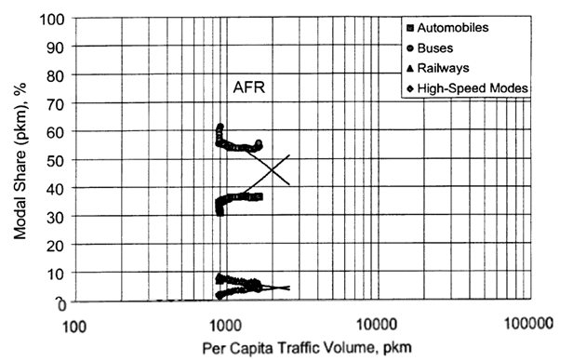

Figure 1: Modal share of passenger transport in African countries (Schafer & Victor, 2000).

#### Converting energy-based to kilometer-based transport

In order to convert the MESSAGEix-South Africa model from energy-based (GWa) to kilometer-based (Gpkm and Gtkm), several adjustments must be made. Because the entire model is operated using units of GWa, the required step of the model development is the determination of energy needed to supply one unit of Gpkm or Gtkm. In this work, only selected categories of transport technologies are considered – only car passenger transport is disaggregated into different powertrain technologies, while the other categories are assumed to make use of just one selected energy commodity. For car passenger transport, it was possible to find South-African specific data on fuel economy (IEA, 2021) and occupancy (Merven et al., 2012). For bus passenger transport, an estimate of 30 liters diesel/100 km and occupancy of 25 passengers/bus was assumed, based on South African literature (Merven et al., 2012). For other transport modes, sources from countries other than South Africa were used due to lack of data (Deutsche Bahn, 2018; Mathiesen et al., 2014). The results can be seen in Table 2.

Table 2: Fuel economy of various transport modes.

|  |  |  |  |  |  |  |
| --- | --- | --- | --- | --- | --- | --- |
|  |  |  |  |  | **Fuel economy** | |
| **Transport type** | **Mode** | **Powertrain** | **Fuel economy  (lge/100 km)** | **Occupancy  (per/veh)** | **(MJ/pkm or MJ/tkm)** | **(GWa/Gpkm or GWa/Gtkm)** |
| Passenger (pkm) | Car | Petrol | 7.1 | 1.4 | 1.73 | 0.0550 |
| Passenger (pkm) | Car | Diesel | 8 | 1.4 | 1.95 | 0.0620 |
| Passenger (pkm) | Car | Electric | 2 | 1.4 | 0.49 | 0.0155 |
| Passenger (pkm) | Bus | Diesel | 33.80 | 25 | 0.46 | 0.0147 |
| Passenger (pkm) | Air |  |  |  | 1.5 | 0.0476 |
| Passenger (pkm) | Rail |  |  |  | 0.35 | 0.0111 |
| Freight (tkm) | Rail |  |  |  | 0.33 | 0.0105 |
| Freight (tkm) | Road |  |  |  | 1.21 | 0.0384 |

### Part 2: Transport capacity

The next step in model development is the introduction of transport capacity, i.e., introduction of vehicles, characterized by investment costs and technical lifetimes. The vehicles are a means to supply transport demand. For simplification, this and the following parts of the model focus only on the passenger transport supplied by car, as this is the only commodity that can be supplied by different technologies (different powertrain types). Introducing the other commodities into the model would make sense from the perspective of energy demand and energy prices (they would increase the overall demand for chosen commodities). However, due to time constraints, these commodities were not added into MESSAGEix-South Africa and were only accounted for manually in the Results section of this work.

The car powertrain types considered in this work were limited to gasoline internal combustion engine (GSLICE), natural gas internal combustion engine (NGICE) and battery electric vehicle with a 100-mile range (EV100). The diesel engine was not considered, as the disutility costs (see Part 3 of the methods section in this report) were the same for gasoline and diesel cars.

The technical lifetime of cars was assumed to be an average of 15 years, using the same assumptions as (McCollum et al., 2017, Suppl. Inf.) for an average consumer. The investment cost was calculated based on the baseline vehicle costs shown in the results of (McCollum et al., 2017), assuming African-specific 10400 vehicle-km per year (McCollum et al., 2017, Suppl. Inf.) and 1.4 person/vehicle (Merven et al., 2012). Taking all these into account, it was possible to calculate the baseline investment cost and express it in USD/kpkm, which is the form equivalent to other investment costs in the model (USD/kWa).

In addition, the cost of the different technologies may change in time, which was also the case with most of the technologies in the MESSAGEix-South Africa model. In this work, we assume that the cost of different car technologies changes just like the cost of powerplant technologies in the MESSAGEix-South Africa model. The gasoline cars have constant costs just like light oil power plants (loil_ppl), natural gas vehicles get slightly cheaper just like gas power plants (gas_ppl), and electric vehicles get significantly cheaper just like solar panel powerplants (solar_pv_ppl), see Figure 2.

Figure 2: The cost of technologies in time. Assumption: gas_ppl ≈ NGICE, loil_ppl ≈ GSLICE, solar_pv_ppl ≈ EV100.

### Part 3: Elements of behavioral realism in transport

Finally, the model can be extended to include various consumer groups with different vehicle preferences, reflected in disutility costs, which are added to the investment costs. This in turn introduces some aspects of behavioral realism to the model – the fact that different consumers choose different cars, independently of objective investment costs, but rather dependent on preferences, life situation, infrastructure etc. The full model by (McCollum et al., 2017), included 27 consumer groups. The frameowkr included three layers of disaggregation, each with 3 types of consumers: 1) attitude toward technology/risk (early adopter, early majority, late majority); 2) settlement type (urban, suburban, rural); 3) driving intensity (frequent, average, modest driver). In this work, only the second layer (settlement type) was considered.

The settlement type disaggregation can be based on predictions for the share of population living in urban areas (IIASA Energy Program, 2018), and assuming that 5% of the population in the urban area is actually suburban (McCollum et al., 2017, Suppl. Inf.). Furthermore, it is assumed that the mobility of the different consumer groups is on average the same, i.e., the passenger transport demand can be disaggregated in the same way as the population.

After the demand has been disaggregated, disutility costs can be added to reflect varying preferences of people living in different settlement types. The disutility costs were taken from the Supplementary Information of (McCollum et al., 2017), taking into account that the data is given as $1000/vehicle and we first need to convert it to $/kpkm, just like in case of the baseline investment costs calculated in Step 2.

## Results

The results of the model are described in three steps, reflecting the steps of the model development described in the methods section.

### Part 1: Transport demand modification

The original model has been edited so that the original transport activity given in GWa/a (Figure 3A) has been translated into Gpkm/a (Figure 3B). The magnitude of the transport activity reflects the demand for passenger car transport (other transport types have been excluded for simplification, as explained in Part 2 of the methods). The model has been translated to the new units without changing any of the model assumptions, which is why the %-contribution of different technologies is the same. However, the technology called “foil_trp” reflects transportation based on heavy fuel oil, and such fuel is not used in cars. For this reason, the model was edited such that “foil_trp” technology is excluded and cannot supply transportation demand (Figure 3C), and the historical activity is fully based on “foil_trp” which reflects a technology using light oil products such as gasoline and diesel, which are likely most of the South African car fuel market. Because in 2020 fuel oil was cheaper than light oil, basing all the transportatin on light oil leads to a decrease in transportation volume (see Figure 3B and 3C).

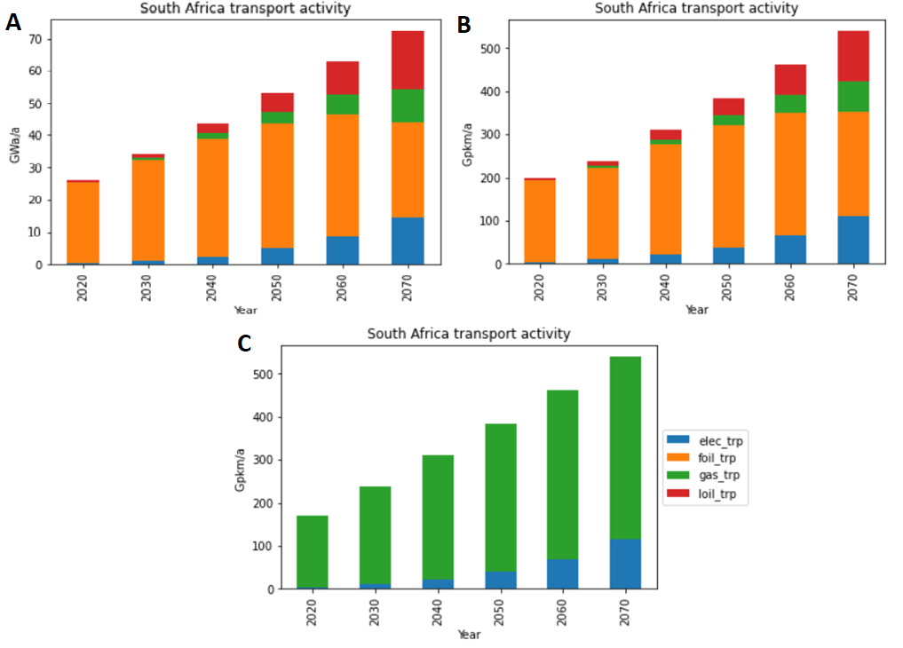

Figure 3: Transport activity in the original MESSAGE-ix South Africa (A), after changing the model to person-km (B), and after additionally excluding heavy fuel oil (C).

The marginal shadow prices of the transportation services (car passenger transport) also reflect the change of the units. Because the nominal value of the transport demand in the original model was lower than the demand of the modified model with p-km, the price per unit transport in the modified model is lower (Figure 4A and 4B). After changing the transportation to light oil-based, the prices increased (Figure 4C). In particular, year 2020 shows a significant marginal price increase, which is caused by a sudden increase in light oil demand, forcing the rest of the system to adjustments to more than double the production of light oil (visible when plotting the activity of loil_t_d technology).

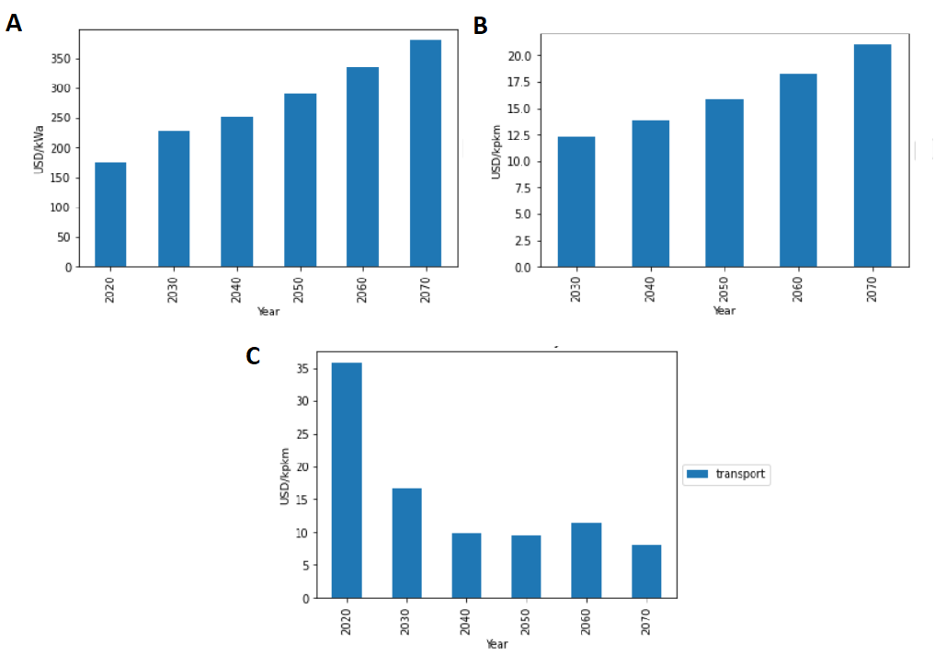

Figure 4: Marginal prices of the transport services in the original MESSAGE-ix South Africa (A), after changing the model to person-km (B), and after additionally excluding heavy fuel oil (C).

### Part 2: Transport capacity

The introduction of vehicles as transportation capacity was the next step in the model development. This step did not change anything in the %-contribution of different technologies to supply the transportation demand (Figure 5A). This could be considered counterintuitive since various vehicles have various investment costs, and these differences should be reflected in the way that people choose vehicles. However, the bounds imposed on the model restrict sudden changes in the technology or capacity composition. In the first years of the simulation, light-oil (gasoline and diesel) vehicles are the cheapest, so they are used the most. Afterwards, the introduction of electric vehicles starts as they are getting cheaper – however, their growth is still restricted by activity bounds.

The marginal price of transportation increases after the introduction of vehicles (Figure 5B). This is expected, as the transportation cost includes not only the fuel costs, but also investment costs of the purchase of new vehicles.

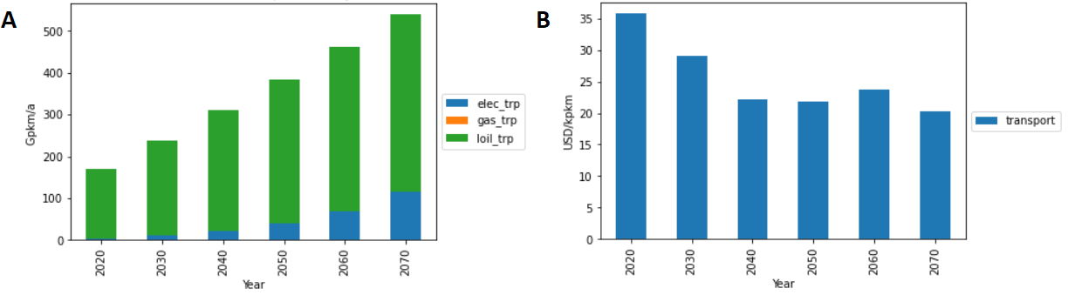

Figure 5: The model with p-km-based transportation and capacity: transport activity (A) and marginal prices (B).

### Part 3: Elements of behavioral realism in transport

The last stage of the model development included introduction of consumer groups. The demand has been disaggregated by settlement type and group-specific disutility costs were included. Consequently, the commodities (required for specifying the demand) and technologies (required for specifying investment costs) were also disaggregated. The aggregated results show that the importance of electric vehicles decreased in time (Figure 6A) while the marginal price of transport decreased (Figure 6B).

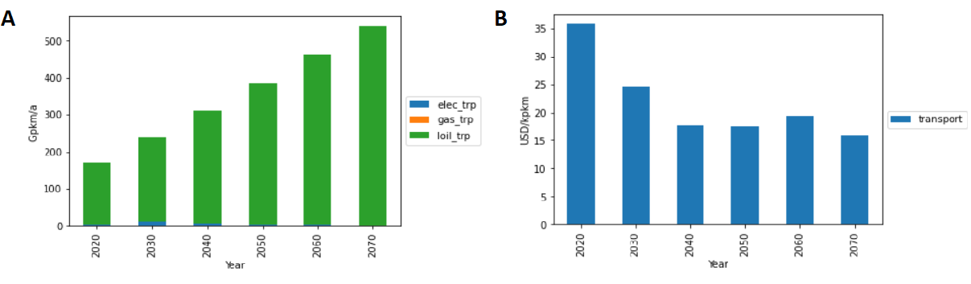

Figure 6: The model with p-km-based transportation, capacity, and consumer preferences: transport activity (A) and marginal prices (B). The values are sums (A)/means (B) of group-specific items.

The results show that the consumer groups also show some differences. The urban settlement type generally dominates the results, especially at the end of the simulation time. Still, the different consumer groups are characterized by different volumes of demand, so the results should be compared by using relative values. The differences are minor, yet they exist. Interestingly, rural population shows slighly higher utilization of electric vehicles despite higher disutility costs as compared with the urban population.

Table 3: The contribution of different technologies to supplying transport demand, by settlement type.

|  |  |  |  |  |  |  |
| --- | --- | --- | --- | --- | --- | --- |
|  | **elec_trp** |  |  | **loil_trp** |  |  |
| **Year** | **Rural** | **Suburban** | **Urban** | **Rural** | **Suburban** | **Urban** |
| 2020 | 2.4% | 2.4% | 2.4% | 97.6% | 97.6% | 97.6% |
| 2030 | 5.0% | 4.4% | 4.4% | 95.0% | 95.6% | 95.6% |
| 2040 | 2.6% | 1.9% | 1.9% | 97.4% | 98.1% | 98.1% |
| 2050 | 1.4% | 0.9% | 0.9% | 98.6% | 99.1% | 99.1% |
| 2060 | 0.8% | 0.4% | 0.4% | 99.2% | 99.6% | 99.6% |
| 2070 | 0.5% | 0.2% | 0.2% | 99.5% | 99.8% | 99.8% |

After including the elements of behavioral realism in this part of the work (referred to as Scenario 3), the importance of electric vehicles dropped as compared to the previous stage of the work (referred to as Scenario 2). This drop in electric vehicle use is reflected in slightly increased greenhouse gas emissions as compared to the scenario with no user behavior (Table 4).

Table 4: Greenhouse gas emissions in Scenario 2 and Scenario 3 (with elements of user behavior).

|  |  |  |
| --- | --- | --- |
|  | Emissions (MtCO2-eq) | |
|  | Scenario 2 (no behavior) | Scenario 3 (behavior) |
| 2020 | 521.45 | 521.45 |
| 2030 | 615.63 | 615.63 |
| 2040 | 699.96 | 701.97 |
| 2050 | 849.09 | 854.18 |
| 2060 | 987.28 | 1,002.39 |
| 2070 | 1,161.19 | 1,188.61 |

#### Validation by comparison with the baseline model

How do the model results correspond to the original MESSAGE-ix South Africa model, where the transport demand is expressed in energy units? To answer this question, the results of scenario 3 of the model (shown in Part 3) where summed and converted to energy units, by applying the efficiencies listed in Table 2. In addition, based on the total passenger transport and freight transport demand (Table 1), it was also possible to calculate the energy that would be needed to cover the demand for other modes of transport. The energy demand needed to cover all the transportation demand in Scenario 3 are of the same order of magnitude as in the baseline scenario (see Table 5). As the time horizon increases, Scenario 3 seems to overestimate the energy demand as compared to the baseline scenario, but even in 2070 the result is only 26% higher, which can be considered a small difference, considering vastly different methodologies used to derive these numbers.

Table 5: Energy demand for transport in baseline and Scenario 3.

|  |  |  |  |  |  |  |  |  |
| --- | --- | --- | --- | --- | --- | --- | --- | --- |
| **Year** | **Baseline (GWa/a)** | **Scenario 3**  **(GWa/a)** | |  |  |  |  |  |
|  | all transport | car | bus | rail | air | freight road | freight rail | Total |
| 2020 | 26.0 | 9.2 | 3.7 | 0.3 | 0.9 | 10.9 | 2.0 | 26.9 |
| 2030 | 34.5 | 12.7 | 5.1 | 0.4 | 1.2 | 15.7 | 2.9 | 38.0 |
| 2040 | 43.9 | 16.8 | 6.7 | 0.6 | 1.6 | 21.0 | 3.8 | 50.4 |
| 2050 | 53.4 | 20.9 | 8.2 | 0.7 | 2.0 | 26.6 | 4.8 | 63.3 |
| 2060 | 62.9 | 25.2 | 9.9 | 0.8 | 2.4 | 32.6 | 5.9 | 77.0 |
| 2070 | 72.4 | 29.6 | 11.6 | 1.0 | 2.8 | 39.0 | 7.1 | 91.1 |

## References

Deutsche Bahn. (2018). *Energy efficiency increased*. https://ibir.deutschebahn.com/ib2018/ib2018/en/group-management-report/environmental/progress-in-climate-protection/energy-efficiency-increased/

Eeden, J., Havenga, J., & Za, J. (2010). Identification of key target markets for intermodal freight transport solutions in South Africa. *Journal of Transport and Supply Chain Management*, *4*. https://doi.org/10.4102/jtscm.v4i1.71

European Environment Agency. (2013). *Freight transport volumes and GDP — European Environment Agency*. https://www.eea.europa.eu/data-and-maps/daviz/freight-transport-volumes-and-gdp

IEA. (2021). *Fuel economy in South Africa – Analysis*. IEA. https://www.iea.org/articles/fuel-economy-in-south-africa

IIASA Energy Program. (2018). *SSP Public Database (Version 1.1)*. https://tntcat.iiasa.ac.at/SspDb/

Kyle, P., & Kim, S. H. (2011). Long-term implications of alternative light-duty vehicle technologies for global greenhouse gas emissions and primary energy demands. *Energy Policy*, *39*(5), 3012–3024. https://doi.org/10.1016/j.enpol.2011.03.016

Mathiesen, B., Connolly, D., Lund, H., Nielsen, M., Schaltz, E., Wenzel, H., Bentsen, N., Felby, C., Kaspersen, P., Skov, I., & Hansen, K. (2014). *CEESA 100% Renewable Energy Transport Scenarios towards 2050*. https://doi.org/10.13140/RG.2.1.3217.2886

McCollum, D. L., Wilson, C., Pettifor, H., Ramea, K., Krey, V., Riahi, K., Bertram, C., Lin, Z., Edelenbosch, O. Y., & Fujisawa, S. (2017). Improving the behavioral realism of global integrated assessment models: An application to consumers’ vehicle choices. *Transportation Research Part D: Transport and Environment*, *55*, 322–342. https://doi.org/10.1016/j.trd.2016.04.003

Merven, B., Stone, A., Hughes, A., & Cohen, B. (2012). *Quantifying the energy needs of the transport sector for South Africa: A bottom‐up model*. 78.

Orthofer, C. L., Huppmann, D., & Krey, V. (2019). South Africa After Paris—Fracking Its Way to the NDCs? *Frontiers in Energy Research*, *7*. https://www.frontiersin.org/article/10.3389/fenrg.2019.00020

Schafer, A., & Victor, D. G. (2000). The future mobility of the world population. *Transportation Research Part A: Policy and Practice*, *34*(3), 171–205. https://doi.org/10.1016/S0965-8564(98)00071-8

Verny, J. (2007). The importance of decoupling between freight transport and economic growth. *European Journal of Transport and Infrastructure Research*, *7*, 105–120. https://doi.org/10.18757/ejtir.2007.7.2.3380