DEPARTMENT OF OPERATING SYSTEMS
PROJECT
Administering cloud solutions
Iva Bagarić
Zagreb, 2026.

Content
Content 2
1. Abstract 4
2. Introduction 5
3. Cloud object management 6
3.1. Project solved using IaC solution 6
3.2. Created a solution diagram 7
3.3. Listed all deployed resources by using Azure CLI 8
3.4. Listed all deployed resources by using Python 9
3.5. Created required tags on all objects 9
4. Security settings and subscriptions 11
4.1. Managed identities and least-privilege access 11
4.2. Key Vault, private access, and provider limitations 12
5. Compute management 13
5.1. Private AKS cluster and sample application 13
5.2. Function App and Azure Container Registry 14
5.3. Patching and operational controls 15
6. Advanced storage management 16
6.1. Storage Account and Azure File Sync limitation 16
6.2. PostgreSQL Flexible Server 16
7. Advanced virtual network management 17
7.1. Public exposure, VNets, and subnet separation 17
7.2. Private access and management controls 18
7.3. Application Gateway routing validation 18
8. Monitoring and backup 21
9. Conclusion 22
10. Evidence summary 23

Abstract
This project documents a secure Microsoft Azure environment deployed with Infrastructure as Code. The implementation provisions a private application platform in the existing resource group Iva-RG and combines Azure Kubernetes Service, Azure Function App, PostgreSQL Flexible Server, Azure Storage, Azure Key Vault, Azure Container Registry, Application Gateway, monitoring, and a restricted Windows jump VM. The main goal is to show that a cloud environment can be deployed repeatably, validated with command-line evidence, and secured with network isolation and least-privilege identities. Only two public IP addresses are exposed: one for the Application Gateway and one for the jump VM. Key platform services are accessed through private networking after the bootstrap phase.

Introduction
Manual cloud deployment often leads to inconsistent naming, missing tags, excessive public access, and unclear evidence. For that reason, this solution was implemented through Terraform and supporting scripts stored in a GitHub repository (https://github.com/iibagaric/ARUO). The project also includes small sample applications so that compute, networking, container registry, private endpoints, routing, and monitoring can be demonstrated end to end. The project was executed using the Azure account 'iva.bagaric@infigo'.is with the Microsoft Partner Network subscription because the student subscription connected to the 'ibagaric@algebra.hr' account had expired. The 'ibagaric@algebra.hr' address was still used as the required student tag and academic identifier throughout the deployment documentation.
Implementation note
The original target region was West Europe, but Azure Database for PostgreSQL Flexible Server was restricted for this subscription in that region. The deployment was therefore completed in North Europe while keeping the existing resource group Iva-RG.

Cloud object management

Project solved using IaC solution
The Azure environment is defined in Terraform under infra/terraform and deployed with PowerShell helper scripts. Terraform creates the platform resources, while separate scripts build the container image, deploy the AKS workload, deploy the Function App package, disable public access after bootstrap, and collect evidence.
Area | Implementation
Infrastructure | Terraform configuration in infra/terraform
Application packages | AKS sample app, Function App sample, and ACR build scripts
Deployment flow | PowerShell scripts in scripts/ for certificate generation, Terraform apply, app deployment, lockdown, and evidence collection
Version control | Repository: https://github.com/iibagaric/ARUO
Table 3.1. Infrastructure as Code project structure
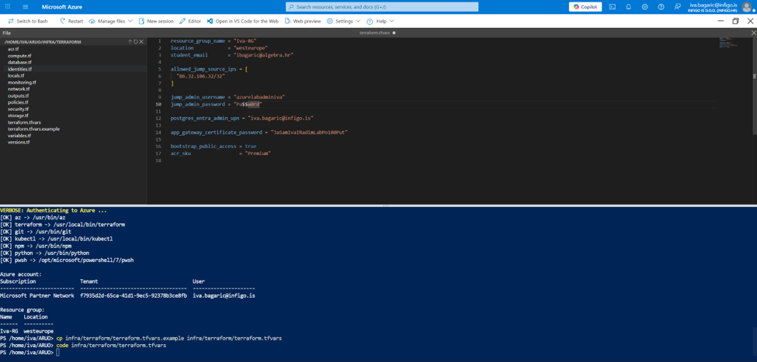
Picture 3.1. Terraform variables and preflight validation with sensitive values redacted
The screenshot confirms that the project variables were prepared in Cloud Shell, the required tooling was available, and the deployment was executed from the repository directory

Created a solution diagram
Two diagrams were prepared to document the deployed environment. The first diagram shows the high-level service flow, while the second diagram focuses on network segmentation and private access.
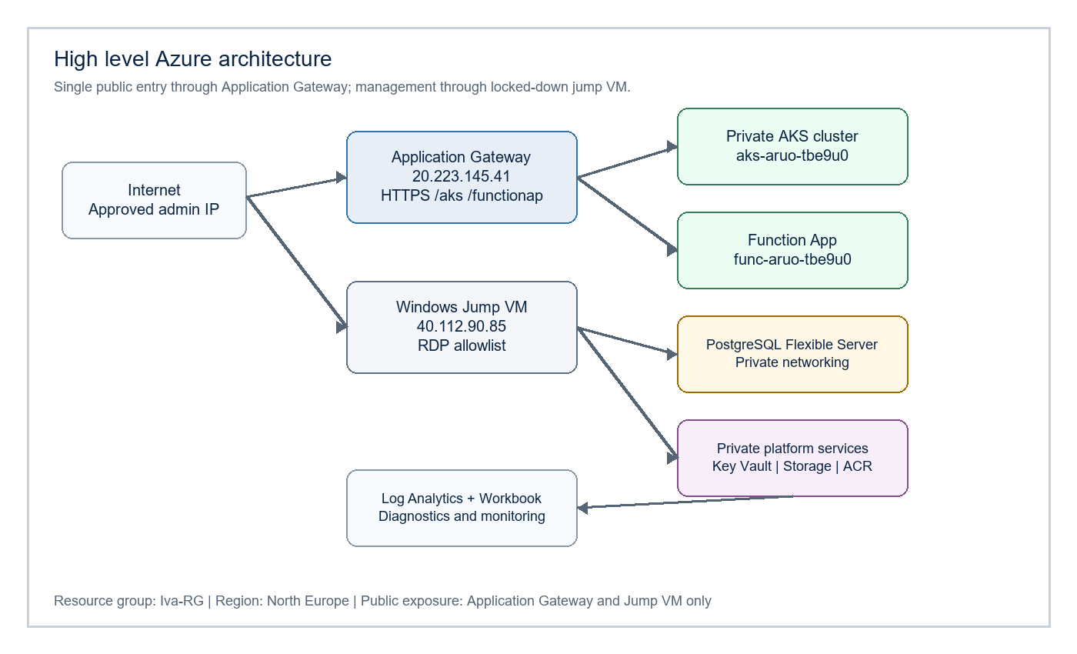
Picture 3.2. High level architecture diagram
The high-level architecture shows that the public entry point is intentionally limited to Application Gateway, while administrative access is separated through the jump VM. All supporting services are placed behind private access paths where the service type supports that model.
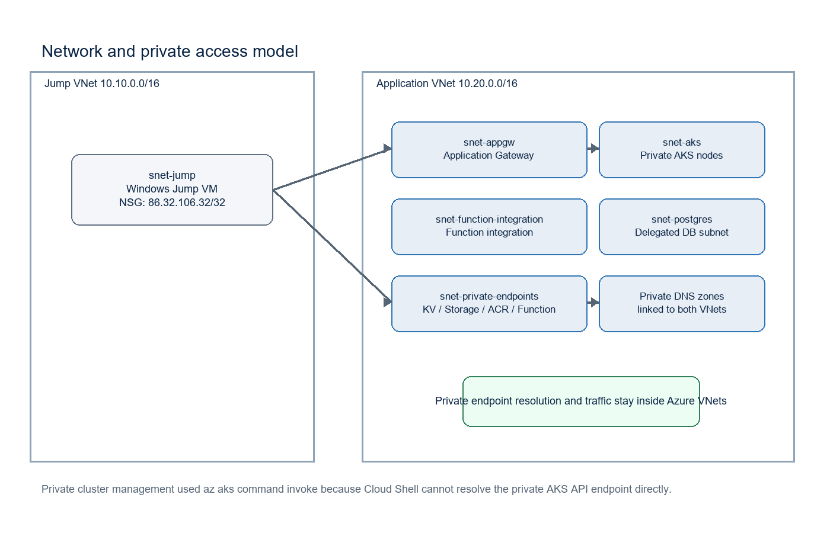
Picture 3.3. Network and private access diagram
The network diagram documents the separation between the jump network and the application network. This separation is important because it supports the requirement that management traffic, private endpoints, application routing, and database traffic are not mixed into one flat network design.

Listed all deployed resources by using Azure CLI
Resources were listed with Azure CLI and stored as evidence. The deployment output reported 83 resources added, and the evidence script generated a resource inventory for the Iva-RG resource group.
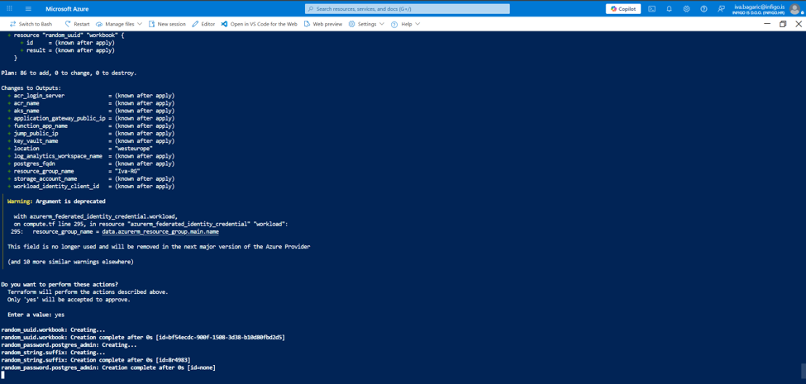
Picture 3.4. Terraform plan and apply confirmation
The plan confirms the Terraform-managed creation flow and contains the output values that are later used by deployment and validation scripts.

Listed all deployed resources by using Python
A Python script using Azure SDK libraries was included to enumerate deployed resources programmatically. This confirms that the environment can be audited outside of the Azure Portal and supports reproducible evidence collection.

Created required tags on all objects
Terraform applies a shared tag set to supported Azure resources. The required university and student tags were included so the deployment can be connected to the assignment and cost tracking requirements.

Tag | Value
project | aruo
env | dev
student | ibagaric@algebra.hr
university | Algebra
Table 3.2. Required and project tags
The tag structure provides a consistent ownership and academic identification layer across the supported Azure resources.

Security settings and subscriptions
The security model uses managed identities, Azure RBAC, Key Vault, and private networking. Credentials are not hardcoded in application code, and the services that contain sensitive data are made private after deployment bootstrap.

Managed identities and least-privilege access
User-assigned managed identities were selected because they are stable, reusable security principals that can be granted narrowly scoped permissions. Instead of giving one broad identity access to everything, the solution separates permissions for the AKS control plane, AKS workload identity, and Application Gateway.
Identity | Purpose | Least privilege reason
id-aruo-tbe9u0-aks-control | AKS control plane identity | Supports private DNS and network operations without subscription-wide ownership.
id-aruo-tbe9u0-workload | AKS workload identity | Allows pods to access only required Azure services.
id-aruo-tbe9u0-appgw | Application Gateway identity | Reads the TLS certificate from Key Vault.
Table 4.1. Managed identities and their purpose
This identity separation keeps the permissions aligned with the responsibility of each Azure component and avoids using one broad shared identity for the whole environment.
Application Gateway requires controlled access to the Key Vault certificate used for HTTPS termination. The gateway uses its user-assigned managed identity and is granted only the permissions required to retrieve the certificate.
Additional runtime permission fix
AGIC also required permissions to update Application Gateway and use the gateway identity. Managed Identity Operator was assigned on the Application Gateway identity, and Network Contributor was assigned on the application VNet so the ingress controller could update backend pools and listeners.

Key Vault, private access, and provider limitations
Key Vault is used as the central store for secrets and the Application Gateway TLS certificate. Access is controlled through Azure RBAC and managed identities instead of distributing secrets in files. The deployed vault is kv-aruo-tbe9u0.
Key Vault is integrated through a private endpoint and Private DNS. Public network access was disabled during the lockdown step, so browsing the vault from outside the private network is intentionally restricted. This is the expected behaviour for the selected private-access design.
The student account did not have permission to register all Azure resource providers at subscription scope. Terraform was therefore configured with resource_provider_registrations = none. In addition, Microsoft.StorageSync was not registered in the lab subscription, so Azure File Sync resources were kept optional and the limitation is documented transparently.

Compute management
The compute layer contains three main responsibilities: container workloads on AKS, serverless execution through Function App, and controlled administration through the Windows jump VM. This combination demonstrates both managed container hosting and platform-managed application hosting.

Private AKS cluster and sample application
The deployed AKS cluster is aks-aruo-tbe9u0. It is a private AKS cluster with workload identity enabled and Azure CNI networking. AKS runs in the application VNet and uses private DNS, while the sample workload is exposed internally through a Kubernetes service.
Because the API endpoint is private, direct kubectl access from Cloud Shell cannot resolve the private AKS DNS name. Administration and deployment were therefore performed through az aks command invoke, which is appropriate for a private-cluster deployment where the public shell is outside the private DNS path.
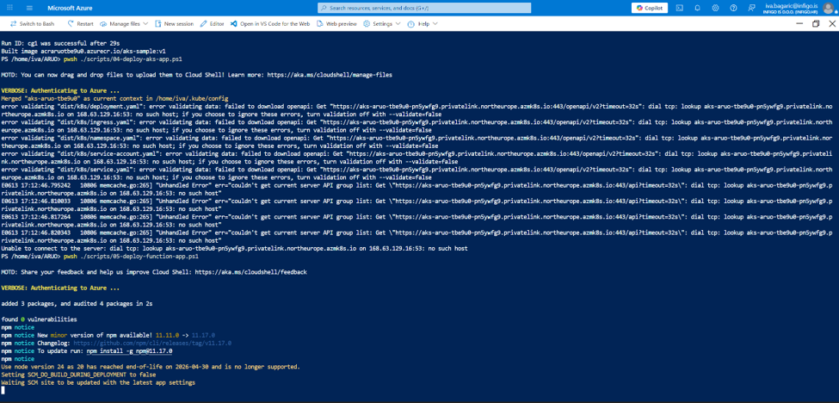
Picture 5.1. Private AKS API behaviour from Cloud Shell
This evidence supports the private-cluster design: direct Kubernetes validation from Cloud Shell fails on the private API DNS name, so deployment and administration were performed through the Azure-supported command invocation path.
The sample AKS application was deployed to the sample namespace. Validation showed the pod in Running state and the service exposed internally on port 80. The final external test through Application Gateway returned HTTP 200 with the AKS JSON status message.
AKS endpoint validation
curl -k https://20.223.145.41/aks
returned: {"service":"aks-sample","status":"ok","message":"AKS sample application reached through Application Gateway"}

Function App and Azure Container Registry
The deployed Function App is func-aruo-tbe9u0. It uses the Linux runtime with Node 24 because Node 20 reached end of life on 2026-04-30 and is no longer a supported target for this project. The sample function exposes the /functionap route and was deployed from a ZIP package.
The Function App was initially validated through its deployment logs and then through Application Gateway. The runtime package and trigger configuration were corrected so that the route appeared and returned the expected JSON response
Function endpoint validation
curl -k https://20.223.145.41/functionap
returned: {"service":"function-sample","status":"ok","message":"Function App reached through Application Gateway"}
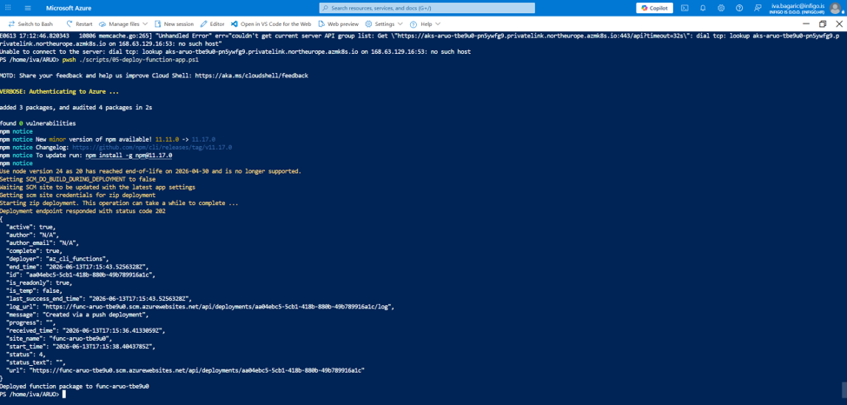
Picture 5.2. Function App package deployment
The deployment output shows that the Function package was accepted and published to the Azure Function App runtime.
The deployed Azure Container Registry is acraruotbe9u0 with Premium SKU so that Private Link can be used. The AKS sample container image was built using az acr build, which avoided a dependency on a local Docker installation and kept the image build process inside Azure.

Patching and operational controls
AKS is configured with automatic patch upgrades and node OS upgrade channel settings through Terraform. This supports the requirement for automated patching of the cluster platform and reduces the amount of manual maintenance required after deployment.
The Windows jump VM is configured with platform-managed patching and automatic update settings. Since the jump VM is only needed for controlled management access, it should be stopped or deallocated when the lab environment is not being demonstrated to reduce cost.

Advanced storage management
The storage layer covers both general storage services and the managed database service. The design focuses on private access, platform-managed backup, and clear documentation of subscription limitations.

Storage Account and Azure File Sync limitation
The deployed storage account is staruotbe9u0. It provides blob storage and Azure Files capability for the project and is connected to Log Analytics through diagnostic settings. Storage is configured with private endpoints for blob and file services, and public network access is disabled after bootstrap.
The Terraform configuration includes optional Azure File Sync resources. During the lab deployment, Microsoft.StorageSync was not registered and the account did not have permission to register it. Because of that platform limitation, File Sync was disabled through the enable_file_sync variable and the storage/file-share portion remains documented as an available configuration path.
Documented lab limitation
This is not a design omission: the deployment was adapted because the subscription could not create Microsoft.StorageSync resources. The limitation is documented here so the final submission clearly separates implemented services from subscription constraints.

PostgreSQL Flexible Server
The deployed PostgreSQL Flexible Server is pg-aruo-tbe9u0.postgres.database.azure.com. It was deployed in North Europe because the subscription was restricted from provisioning PostgreSQL Flexible Server in West Europe. PostgreSQL is deployed with private networking and Private DNS. It is not intended to be reachable directly from the public internet. The jump VM and private network are used for database administration and validation. The PostgreSQL deployment configures a local administrator and an Entra administrator with UPN 'iva.bagaric@infigo.is'. Automated backups are configured through the managed PostgreSQL service, and the validation script scripts/09-postgres-login-tests.ps1 is included for database login checks.

Advanced virtual network management
The network design is the most important control boundary in the solution. It limits public exposure, separates management from application workloads, and uses private endpoints and Private DNS for protected Azure services.

Public exposure, VNets, and subnet separation
The deployment exposes only two public IP resources: the Application Gateway public IP and the jump VM public IP. All other resources are private or Azure platform resources without public entry points.
Public IP | Purpose | Value
pip-aruo-tbe9u0-appgw | Single public application entry point | 20.223.145.41
pip-aruo-tbe9u0-jump | Restricted administrative access | 40.112.90.85
Table 7.1. Public IP addresses used
The table confirms that the public exposure requirement is met: only the Application Gateway and jump VM have public IP addresses.
The solution uses one application VNet and one jump VNet. The two-network design separates workload resources from administrative access and reduces the blast radius of the jump host.
Subnet | Purpose
snet-appgw | Application Gateway
snet-aks | AKS nodes and private cluster workload traffic
snet-function-integration | Function App VNet integration
snet-postgres | PostgreSQL delegated subnet
snet-private-endpoints | Private endpoints for ACR, Storage, Key Vault, and Function App
snet-jump | Windows jump VM
Table 7.2. Subnet separation by resource purpose
This subnet separation supports clearer routing, simpler access control, and easier validation of the private access model.

Private access and management controls
Private DNS zones were linked to the relevant VNets for Key Vault, Storage, ACR, Function App, PostgreSQL, and AKS. Public network access was disabled for Key Vault, Storage, ACR, and Function App after deployment.
The jump VM NSG permits RDP only from 86.32.106.32/32. This is a narrow allowlist rule and prevents broad public RDP exposure. Management is therefore concentrated through the jump host instead of exposing every service publicly.

Application Gateway routing validation
Application Gateway is the only public HTTP/HTTPS entry point for the workloads. A self-signed certificate with CN aruo.local was generated for the lab and stored in Key Vault, and Application Gateway uses this certificate for HTTPS termination.
Both workloads were validated through the Application Gateway public IP. The AKS endpoint returned HTTP 200 after AGIC permissions were corrected. The Function endpoint was also validated through the gateway after updating the Function App package and runtime.

Endpoint | Expected result | Validation
https://20.223.145.41/aks | AKS JSON status | HTTP 200 OK
https://20.223.145.41/functionap | Function JSON status | HTTP 200 OK during validation
Table 7.3. Application Gateway endpoint validation
The endpoint validation table defines the expected routing result for both workloads before the command-line evidence is shown.
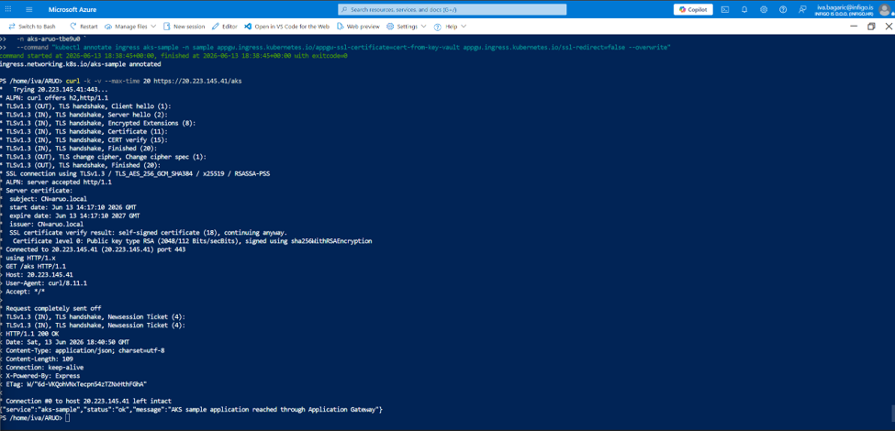
Picture 7.1. AKS endpoint validated through Application Gateway
The AKS response proves that the ingress, Application Gateway backend pool, TLS listener, and sample application were connected successfully.
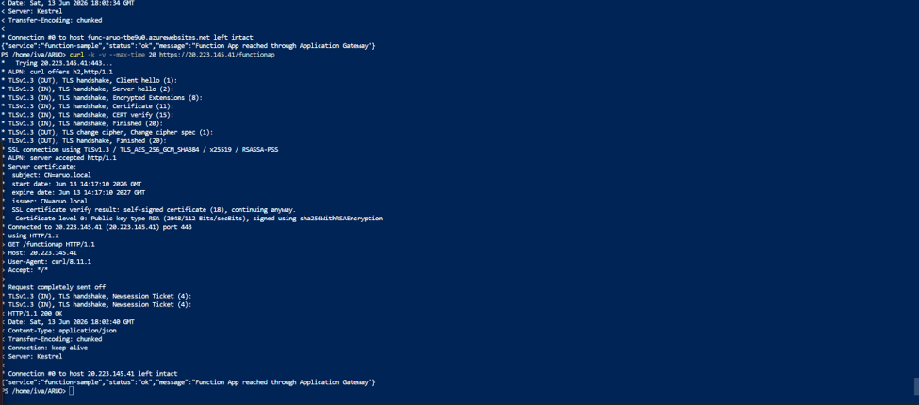
Picture 7.2. Function endpoint validated through Application Gateway
The Function App response proves that the serverless workload was reachable through the same public Application Gateway entry point.

Monitoring and backup
The deployed Log Analytics workspace is law-aruo-tbe9u0. It is the central location for platform diagnostic logs, container insights, VM security logs, and workbook queries.
The solution includes Azure Monitor Agent and Data Collection Rule resources so Windows security logs from the jump VM can be collected into Log Analytics. AKS monitoring is connected to Log Analytics through Container Insights, which supports validation of container logs, pod status, and cluster-level observability.
Diagnostic settings are also configured for Key Vault and Storage so access and audit events can be sent to Log Analytics. This creates a common operational view across infrastructure, security-sensitive services, and compute workloads.
PostgreSQL Flexible Server includes automated backups with retention configured in Terraform. This provides managed database backup without custom backup scripts.
The deployment includes a workbook resource linked to Log Analytics, and Kusto queries are stored in docs/queries.kql for repeatable monitoring checks. CPU usage for the jump VM can be viewed from Azure Monitor metrics, which validates that compute telemetry is available and can be used during operations.

Conclusion
The project delivered a repeatable Azure environment using Terraform, scripts, private networking, managed identities, and monitoring. The deployment met the main security requirement by limiting public exposure to exactly two public IP addresses and by moving Key Vault, Storage, ACR, and Function App access behind private endpoints after bootstrap.
The implementation also demonstrates realistic troubleshooting: PostgreSQL had to be moved from West Europe to North Europe because of subscription restrictions, Azure provider registration had to be disabled in Terraform because the student account lacked registration permissions, and AGIC required additional identity permissions before it could update Application Gateway. These changes were committed to the project repository so the final state is reproducible.

Evidence summary
The following list summarizes the evidence used to support the implementation. The inserted screenshots prove the main deployment, routing, and private-access checks, while the remaining items describe configuration areas that are documented through Terraform and Azure CLI outputs.
- Resource group Iva-RG with all deployed resources filtered by project tag or aruo naming.
- Terraform apply output showing successful deployment.
- Azure CLI and Python resource inventory output.
- Tags showing university=Algebra and student=ibagaric@algebra.hr.
- Two public IP resources only: Application Gateway and jump VM.
- Jump VM NSG rule allowing RDP only from 86.32.106.32/32.
- Private endpoints and public network access disabled for Key Vault, Storage, ACR, and Function App.
- AKS private cluster, sample namespace, pod, service, ingress, and successful /aks curl.
- Function App runtime Node 24 and successful /functionap curl.
- Application Gateway listeners, certificate, backend pools, and routing rules.
- PostgreSQL Flexible Server private networking and backup settings.
- Log Analytics workspace, diagnostic settings, workbook, and CPU chart.
- Note about Microsoft.StorageSync provider limitation if Azure File Sync is discussed.

