Simulation of Robot systems
Task: 2
Mass–Spring–Damper Rotational Pendulum
By: Nagham Sleman 476937

- Introduction:
This report analyzes a rotational mass–spring–damper pendulum system using the Lagrangian method. The equation of motion was derived, then solved using both analytical (linearized) and numerical methods: Forward Euler, Backward Euler, and Runge–Kutta 4th order (RK4). The results are compared, and conclusions are drawn about the validity of linearization and the accuracy of different numerical methods.
The goal is to study how the pendulum behaves and how well numerical methods approximate the analytical solution.

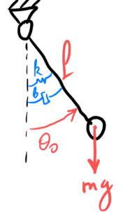
- System Description:

The system consists of:
- A point mass $m=0.1 kg$ kg attached to a massless rigid rod of length $l=0.9 m$
- A rotational spring $k=18.8 Nm/rad$
- A rotational damper $b=0.04 Nm⋅s/rad$
- Motion occurs in a vertical plane, with coordinate $θ(t)$
- Gravity produces a restoring torque $mglsin⁡θ$

Initial conditions:
$$θ_{0}​=0.848 rad ,θ_{0}˙=0 rad/s , g=9.81 m/s2$$
Constants:
$$I=ml^{2}=0.081 kg⋅m^{2} , mgl=0.8829 Nm/rad$$
- Equation of Motion (ODE):
- Kinetic energy:
$$K=\frac{1}{2}​ml^{2}{θ˙}^{2}$$
- Potential energy:
$$P=mgl(1-cosθ)+\frac{1}{2}​kθ^{2}$$
- Lagrangian:
$$L=K-P=\frac{1}{2}​ml^{2}{θ˙}^{2}-(\frac{1}{2}​kθ^{2}+mgl(1-cosθ))$$
- With damping $Q=-bθ˙$, the Lagrange equation gives:
$$Iθ¨+bθ˙+kθ+mglsinθ=0$$
- Numeric ODE:
$$0.081 θ¨+0.04 θ˙+18.8 θ+0.8829 sinθ=0$$
This is nonlinear due to the $sin⁡θ$term.

- Analytical Solution Attempt:
The nonlinear ODE cannot be solved analytically because of the $sin⁡θ$ term. Even an undamped pendulum requires elliptic integrals, and adding damping and a rotational spring makes the system non-integrable in closed form.
In this example, the small-angle approximation $(sin⁡θ≈θ)$ is applied to obtain an analytical solution. This approximation is reasonable because the initial angle is relatively small $(θ_{0}=0.8482563619 )$, allowing the linearized solution to capture the general behavior of the pendulum. However, it is important to note that the approximation is not exact, and deviations from the full nonlinear solution can occur, especially for larger angles. Therefore, the analytical solution serves primarily as a reference to evaluate the accuracy of numerical

To obtain an analytical solution, we linearize the system using the small-angle approximation:
$$sinθ≈θ$$
This gives the linear ODE:
$$Iθ¨+bθ˙+(k+mgl)θ=0$$
Numeric values:
$$0.081θ¨+0.04θ˙+19.6829θ=0$$

  - General Damped System Solutions:
A second-order linear system can have three types of solutions depending on the damping ratio $ζ=​\frac{b}{2\sqrt{I(k+mgl)}}​$
- Overdamped $(ζ>1):$
$$θ(t)=C_{1}​e^{r_{1}​t}+C_{2}​e^{r_{2}​t},r_{1,2}​=-ζωn​±ωn\sqrt{​ζ^{2}-1}​$$
- Critically damped $(ζ=1)$:
$$θ(t)=(C_{1}​+C_{2}​t)e^{-ω_{n}​t}$$
- Underdamped $(0<ζ<1$):
$$θ(t)=e^{-ζω_{n}​t}[Acos(ω_{d}​t)+Bsin(ω_{d}​t)],ω_{d}​=ω_{n}\sqrt{​1-ζ^{2}​}$$
  - Specific Solution for Our System:

- Damping ratio:
$$ζ=​\frac{b}{2\sqrt{I(k+mgl)}}​=\frac{​0.04}{2\sqrt{0.081⋅19.6829}}​≈0.0158<1$$
System is underdamped.
- Natural frequency:
$$ω_{n}​=\sqrt{\frac{k+mgl​​}{I}}≈15.59 rad/s$$
- Damped frequency:
$$ω_{d}​=ω_{n}\sqrt{​1-ζ^{2}​}≈15.558 rad/s$$
- Specific solution with initial conditions $(θ_{0}=0.8482563619 , \dot{θ_{0}}=0$)
$$θ(t)=e^{-0.246t}[0.8482563619 cos(15.558t)+0.0133sin(15.558t)]$$

- Numerical Solution
The full nonlinear ODE is solved numerically using:
- Forward Euler (explicit) – simple, conditionally stable
- Backward Euler (implicit) – stable for stiff systems
- Runge-Kutta 4 (RK4) – accurate and stable

The nonlinear state system:
$$x_{1}​=θ$$
$$x_{2}​=θ˙$$
$${x˙}_{1}​=x_{2}​$$
$${x˙}_{2}​=-\frac{b}{I}​x_{2}​-\frac{k}{I}{​x}_{1}​-\frac{mgl}{I}​sin(x_{1​})$$
Initial conditions:
$$x_{1​}(0)=0.8482563619 , x_{2}​(0)=0$$
Simulation parameters: $Tf=10 s,dt=0.001 s$

- Error Comparison:
The analytical linear solution was used as a reference to compute numerical error:
$$e(t)=∣θ_{num}​-θ_{analytic}​∣$$
Maximum angular deviation for each method:
- Forward Euler: 0.20781 rad
- Backward Euler: 0.12510 rad
- RK4: 0.02040 rad

- Discussion:
- Forward Euler showed the highest error and noticeable numerical instability.
- Backward Euler was more stable but introduced additional artificial damping, which deviated from the true oscillation.
- RK4 produced results very close to the analytical solution and had the smallest maximum error, making it the most accurate method.
Since damping is very small, the pendulum oscillates almost indefinitely as predicted by the analytical solution, but numerical errors appear clearly in Euler methods.
Note:
RK4 is the recommended numerical integrator for simulating this system.
  - Code Description:
This code simulates the dynamics of a damped pendulum with an elastic restoring torque. It includes both the nonlinear pendulum model and its linear approximation, allowing comparison between numerical methods and the analytical solution.
Main components of the code:
- System Parameters:
Defines pendulum properties (mass, length, stiffness, damping, gravity) and initial conditions for angle and angular velocity.
- Dynamics Function:
Implements the nonlinear pendulum dynamics as a system of first-order differential equations:
$$θ˙=θ_{dot}​, {θ˙}_{dot}​=-\frac{b}{I}​θ_{dot}​-\frac{k​}{I}θ-\frac{mgl​}{I}sin(θ)$$
- Numerical Integration Methods:
- Forward Euler: Explicit first-order method.
- Backward Euler: Implicit first-order method solved iteratively.
- Runge-Kutta 4 (RK4): Classical fourth-order method for high accuracy.
Note:
Backward Euler is included because it is an implicit method that is unconditionally stable, making it suitable for stiff systems or when larger time steps are needed. Although it introduces some artificial damping, it provides a stable alternative to the Forward Euler method.
- Analytical Linear Solution:
Computes the exact solution of the linearized pendulum for underdamped, critically damped, and overdamped cases.
- Simulation:
Runs all three numerical methods and the analytical solution over a defined time interval.
- Error Analysis:
Calculates the maximum deviation of each numerical method from the analytical linear solution.
--- Maximum Angular Deviation Table ---
Method Max Error [rad]
Forward Euler 0.20787
Backward Euler 0.12514
RK4 0.02041

- Plots:
- Figure 1: Analytical solution only, showing the time evolution of angle and angular velocity.
- Figure 2: Numerical solutions (Forward Euler, Backward Euler, RK4) displayed side by side for angle, angular velocity, and phase portrait.
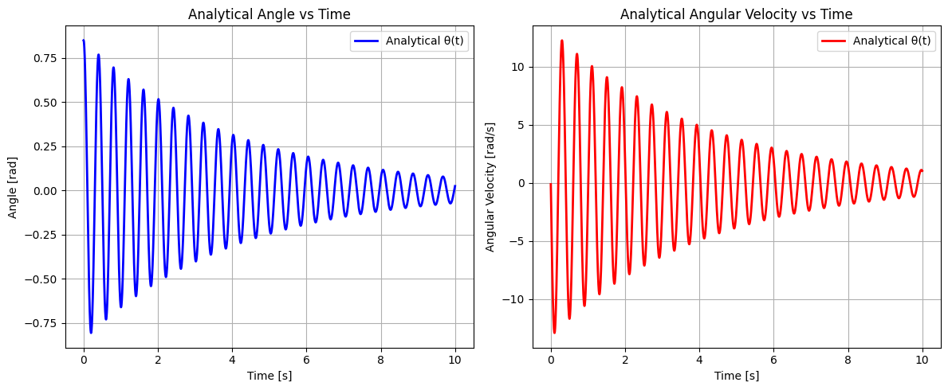

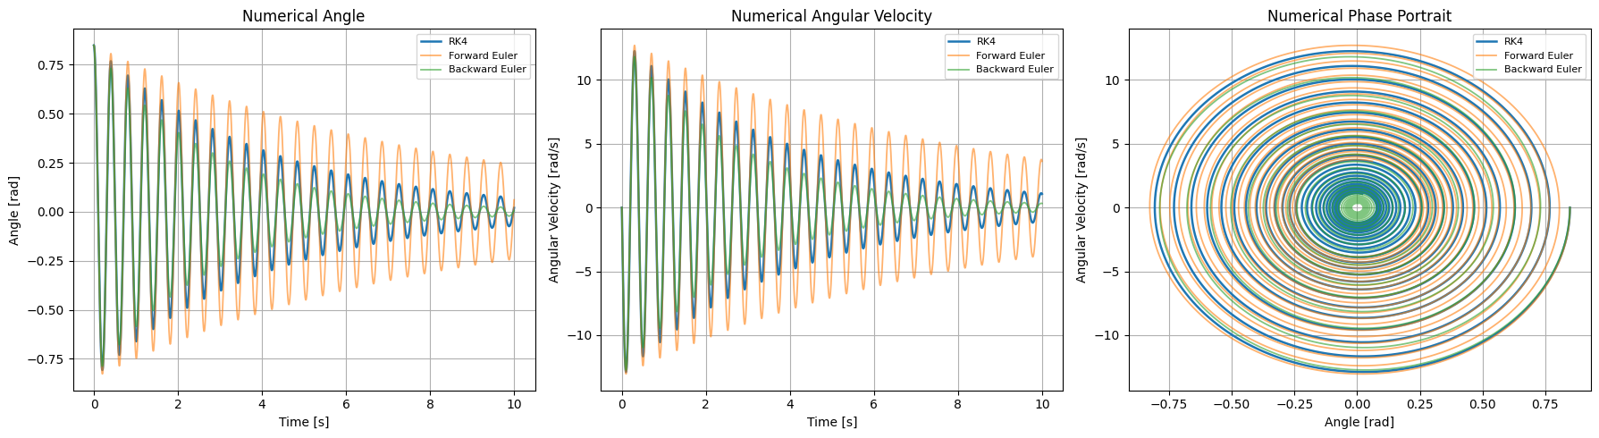

7.2 Plots Description
Figure 1 – Analytical Solution:
- Left subplot: Shows the analytical angular displacement θ(t) versus time.
- Right subplot: Shows the analytical angular velocity θ̇(t) versus time.
This figure demonstrates the ideal linear pendulum response.
Figure 2 – Numerical Solutions:
- Left subplot: Compares the angular displacement from RK4, Forward Euler, and Backward Euler with each other.
- Middle subplot: Compares the angular velocities from all three numerical methods.
- Right subplot: Phase portrait (θ vs θ̇) for all numerical methods, illustrating trajectory differences.
These plots show the accuracy and stability of different numerical integration methods compared to the analytical solution.
Observations:
- RK4 provides the closest match to the analytical solution.
- Forward Euler tends to diverge for larger time steps, while Backward Euler is more stable but less accurate.
- The phase portrait illustrates how damping and numerical errors influence the pendulum’s trajectory over time.

- Conclusion:
The pendulum exhibits underdamped oscillations due to its small damping ratio. Among the numerical methods, RK4 was the most accurate and stable, closely matching the analytical solution, while Forward Euler showed noticeable errors and Backward Euler introduced extra damping. This demonstrates that RK4 is the preferred method for simulating nonlinear pendulum dynamics, and that linearization provides a reasonable approximation only for small angles.

