Note: Tasks are listed in priority order — please work through Task 1 first, since it changes the project structure the other tasks build on. Items marked "optional" or "his call" are entirely up to your judgment; no need to check back with me on those.

Task 1 (project structure for more readability)
- Use angular CLI to create all the component to reduce the code in each file
  - ng g c Features/intake/Pages/componentName --skip-tests
  - This command creates only three files >> com.html, com.ts, com.css no testing file
  - All these components must be handled like that 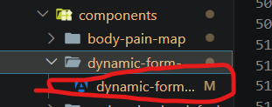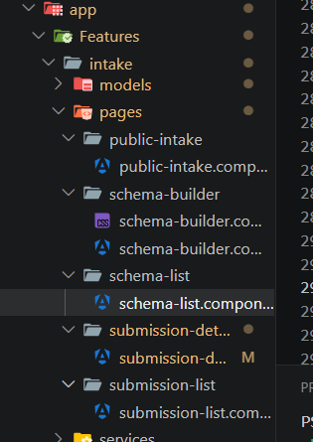
  - Expected Output example 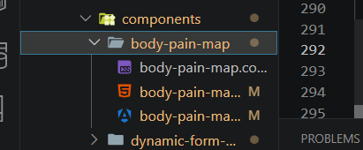
- Divide all the big components into smaller ones, keeping the same route for the parent component
  - Use @input & @output decorator to communicate between parent and children
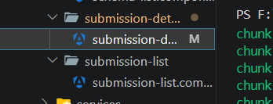
  - Do it on these two files
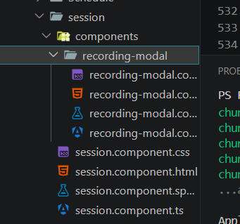
  - The expected output should be like this >> the idea is since the component is an only child of its parent, it can live inside the parent's folder like this

Task 2 (schema list and Qr Code)
- Fix intake schemas ui and make it responsive over mobile phones 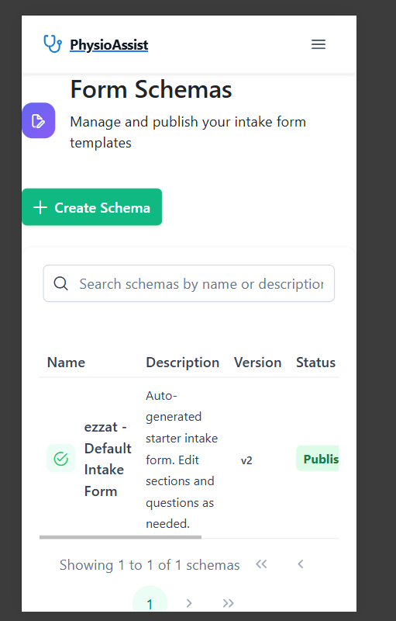
- Get UI inspiration from the link below — match the layout and field styling shown there, but don't redesign beyond that (e.g. don't change colors/branding or restructure the form fields):
  - You don’t need to add all the functionality in this link current functionality is nice it’s just a UI fix
  - https://patient-focus-pro.lovable.app/forms
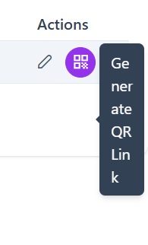
- Qr code label is not in the right format
- More flexibility to set qr code time it must be calculated in months at least not hours
  - The logic is that this qrcode will be at the receptionist so the patient can scan it to access doctor schema so doctor may use this qr code for all his live without changing it so it must have longer duration 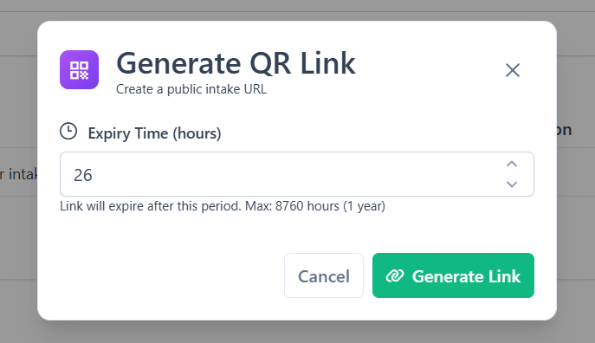
- After generate the link he should have an option to print qr code as a pdf so he can put it at his clinic as a physical link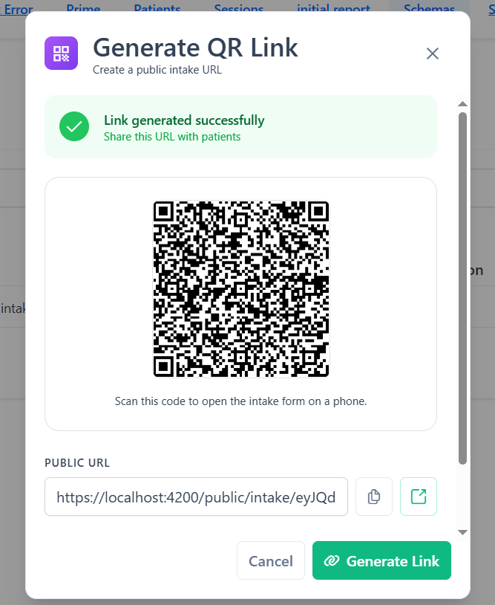

Task 3 (submission and receptionist)
- We have two pages for submission but they both follow the same logic
- The first one is the submission page, which shows all the patients this doctor has treated in the clinic, along with their status >> submission page
  - https://patient-focus-pro.lovable.app/submissions
- The second one is the receptionist page, which shows only the pending patients, so the receptionist can click one to open their form and submit it
  - https://patient-focus-pro.lovable.app/reception
- Current logic is for submission page and it work just fine what we need to add is receptionist page that shows pending patients only
- Any small UI decisions needed to build this are your call — just keep styling consistent with the existing submission page rather than introducing a new pattern.

Task 4 (portal)
- Here this page is a portal for the patients so the clinic name should be very highlighted not the website name
- So, we can add clinic name in the top and just say it’s powered by physio assist 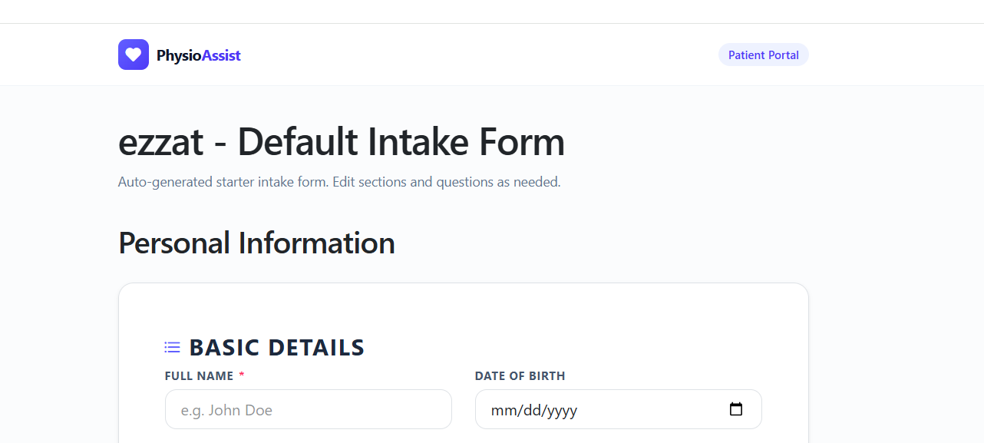
- Remove the payload box it was for only testing 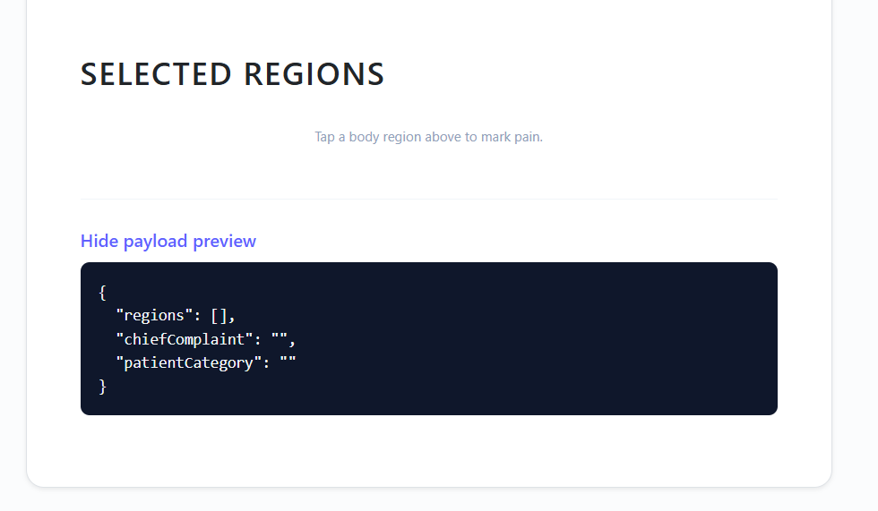

- Make selection of date to be more user friendly 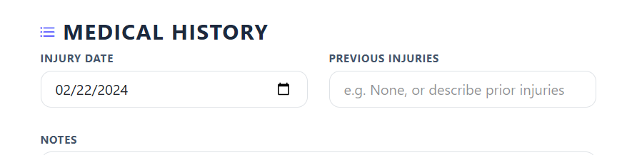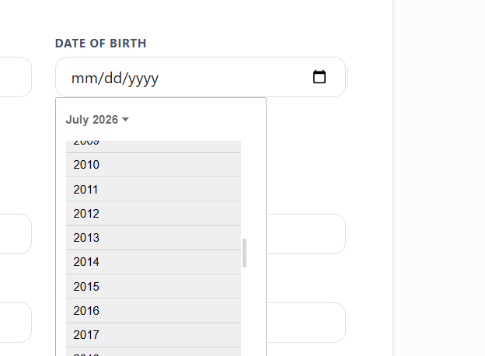

Task 5 (submit patient details page)
- Here the medical history was a group not a section and I made it a section in code to make the ui better but here it had been rendered like this so we need a work around to fix the shape of ui to be like portal ui 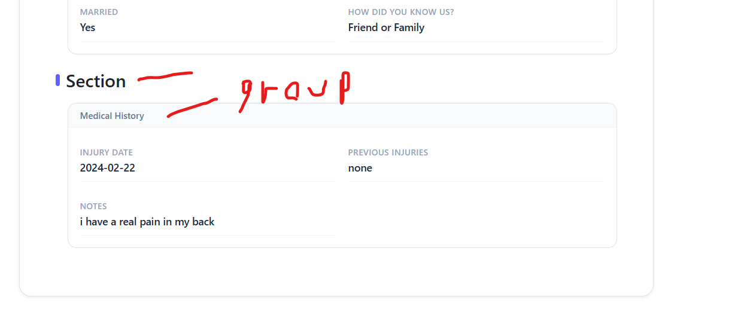
- I didn’t put a title for the section in the data seeding so this is the place you need to look at what I need in the public form are three sections >> best ui from my opinion
  - Personal info
  - Medical history
  - Pain point diagram 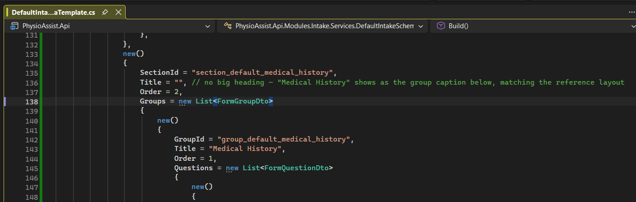
- Convert to patient should be responsive 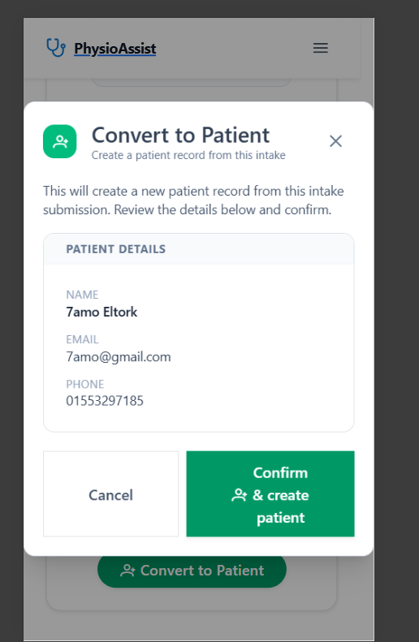

Task 6 (edit form)
- The code was too big, so after separating it into components, we now have a problem: the update functionality isn't being saved to the DB.
  - Optional — your call whether to fix it or leave it for me, no need to check back either way.
- Make the page responsive 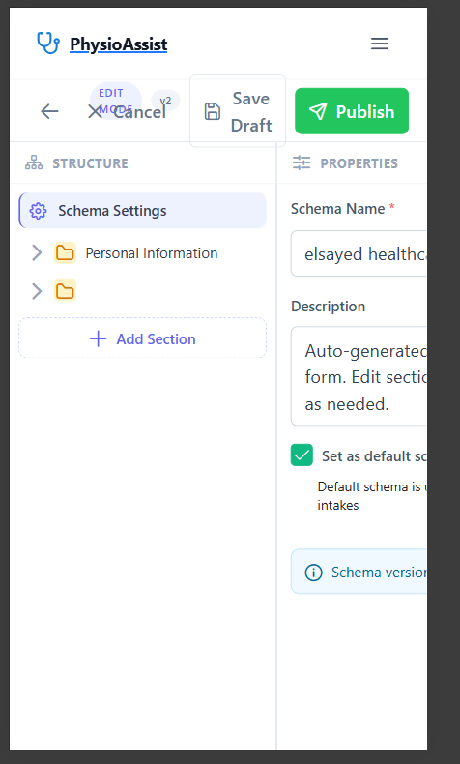
- We will talk in ux in this page because it was very confusing for me in the beginning and ui is a way far from the application styling, this was ui in lovable template 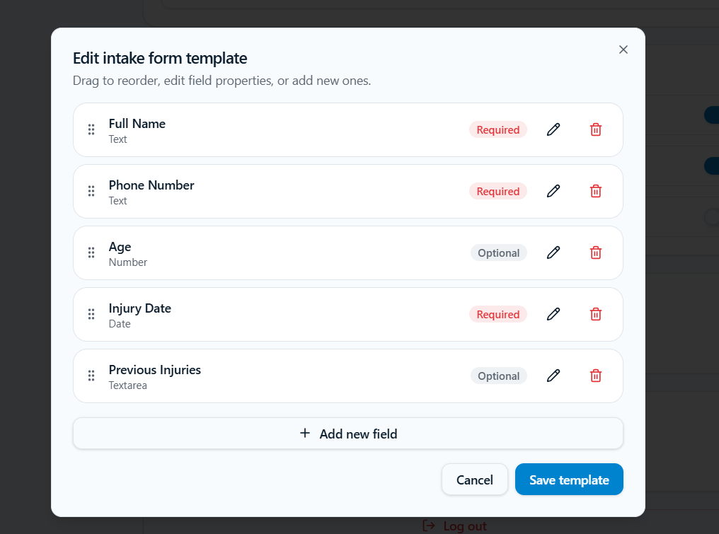
- You have added sections and groups which is a nice thing but it makes things more confusing so doctor will ask
  - What does section even mean ?
  - What does group mean ?
  - Until he reach for the question then he can understand
  - So try to improve the ux
- I added show pain map field in patient form schema entity
  - This field is responsible for showing the pain point diagram or hide it
  - This option should be in the form when edit or create it
  - Add a button for it (your call on placement/style) — leave the actual show/hide functionality for me to wire up or you can do it either.
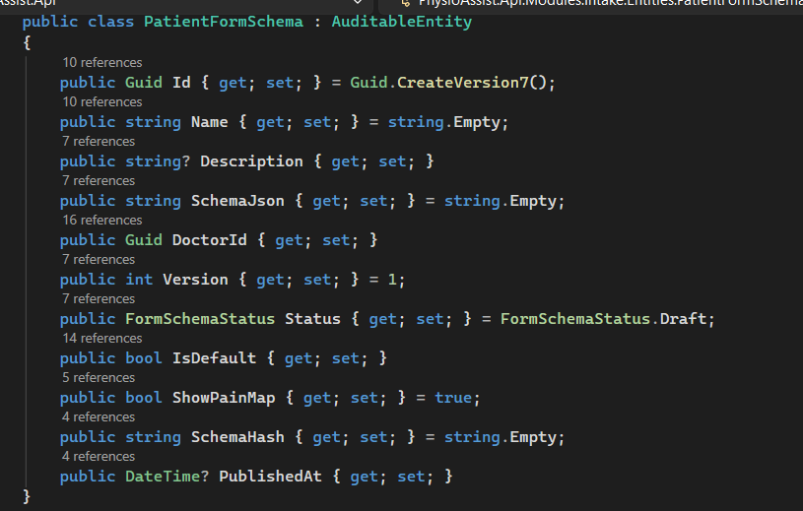
- Finally, we will need to add mandatory fields to each form — fields the doctor can't remove — because other entities will depend on them.
  - We can also have "recommended" inputs — not required, but keeping them filled in will help elsewhere in the system.
  - Mandatory / recommended fields — I haven't decided which fields yet, so please hold off on this specific item until I confirm the field list. In the meantime, you can build the mandatory/recommended field functionality generically so it's ready to plug in once I send the list.

