**The 21st International Conference on**

**Intelligent Information Hiding and Multimedia Signal Processing**

**(IIHMSP 2025)**

October 15-17, 2025, The Splendor Hotel, Taichung, Taiwan

**Special Session on Graph Algorithms and Applications**

**Call for Papers**

**Organizers:** Prof. Ruo-Wei Hung andProf. Ling-Ju Hung

This Special Session is dedicated to creating a vibrant forum for the presentation, exchange, and discussion of the latest methodological advances in graph algorithms and their extensive applications. Graph theory has rapidly evolved into a cornerstone of mathematical research and computer science, providing foundational insights and tools essential for tackling complex problems across a wide spectrum of fields. Today, graph algorithms are indispensable for structuring and solving real-world issues in areas as diverse as computer network architecture, electronic circuit design, social network analysis, biological modeling, and data mining. The increasing need for high-performance, efficient algorithms that can address various optimization problems has positioned graph theory as a critical component in both theoretical studies and practical implementations.

For this Special Session, we invite researchers, mathematicians, and practitioners to contribute original research papers that delve into the mathematical underpinnings, computational techniques, and applied innovations in graph theory. We encourage submissions that push the boundaries of current knowledge, whether through pioneering theoretical developments, state-of-the-art algorithmic designs, or novel applications that demonstrate the versatility and impact of graph algorithms in tackling both established and emerging challenges. Papers focused on cross-disciplinary approaches and those proposing scalable solutions to real-world optimization issues are particularly welcome.

The topics covered in this Special Session include, but are not limited to, the following areas:

**Topics of interest include but are not limited to the following:**

1. Graph Algorithms and Theory
2. Discrete Applied Mathematics
3. Theoretical Computer Science
4. Interconnection Networks
5. Time Complexity Analysis
6. Big Data Model and Analysis
7. Information Technology Related Issues

**Submissions:**

Papers should follow the template announced on the IIHMSP 2025 conference website (https://iihmsp25.csie.cyut.edu.tw), and be submitted via [**Microsoft CMT**](https://cmt3.research.microsoft.com/IIHMSP2025) system and then select SUBJECT AREAS: **SS-01:Graph Algorithms and Applications** for submission (please refer to the following captured figure).

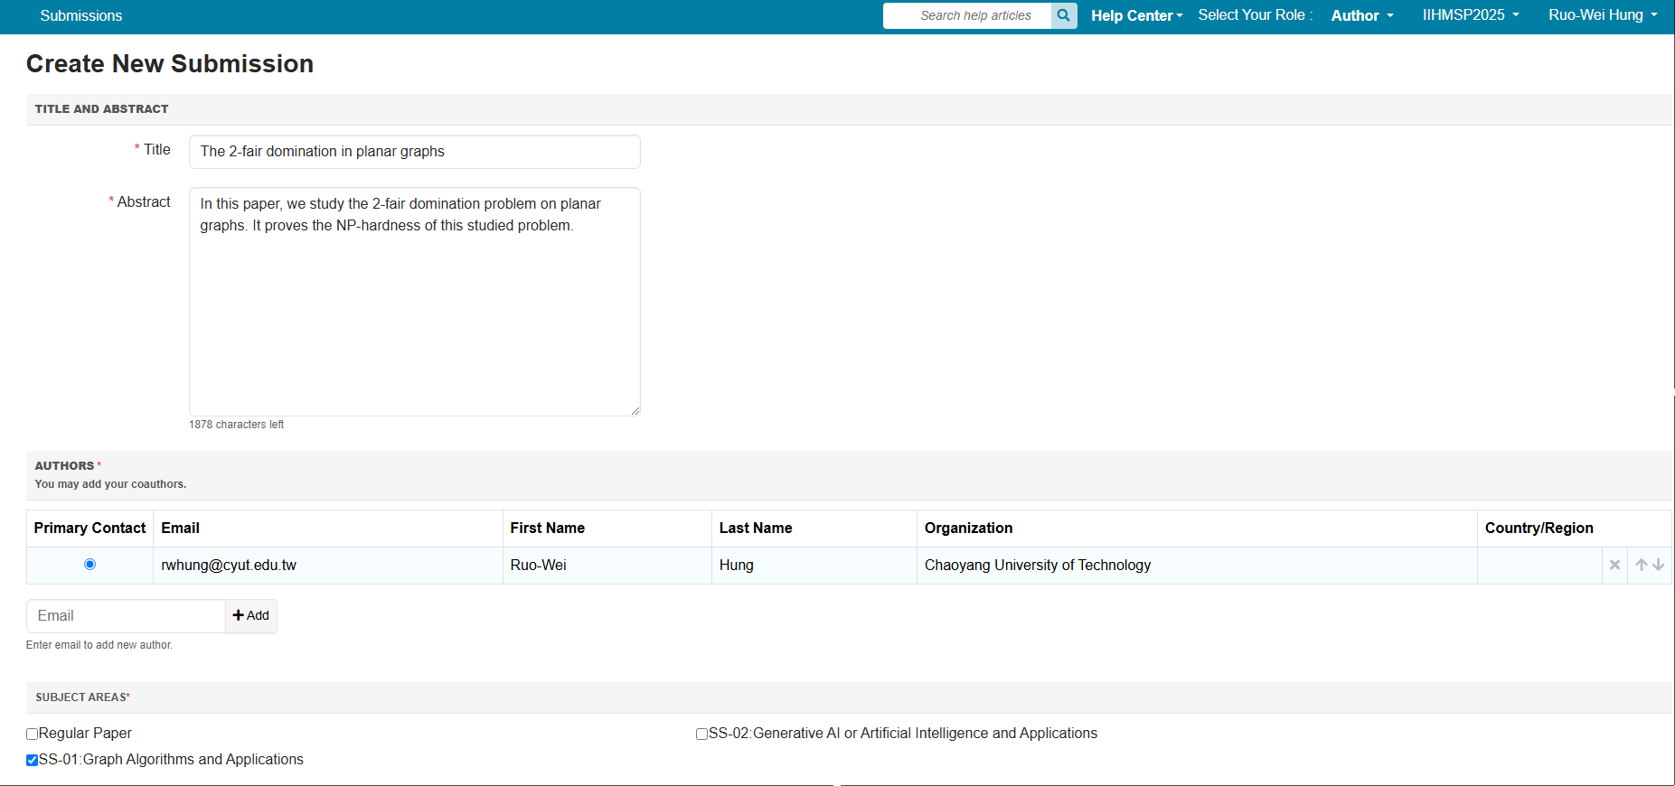

**Conference Proceeding Information:**

Papers that are presented orally at the conference and meet the publication requirements of IIHMSP-2025 conference proceedings will be published in Springer’s book series titled “Smart Innovation, Systems and Technology”. Normally, this series will be indexed by Scopus and EI Compendex.

**Important Dates: (**If IIHMSP 2025 extends the dates, follow those dates announced on the website)

Paper submission deadline: **May 30, 2025**

Acceptance notification: **July 30, 2025**

Camera-ready copy and registration: **July 15, 2025**

**For more information:**

Please visit the IIHMSP 2025 official websites (<https://iihmsp25.csie.cyut.edu.tw> or [https://iihmsp25.github.io/](https://iihmsp24.github.io/)) or contact the organizers of this special session as follows:

Prof. Ruo-Wei Hung

Department of Computer Science and Information Engineering,

Chaoyang University of Technology, Wufeng, Taichung 413310, Taiwan

E-mail: rwhung@cyut.edu.tw

Prof. Ling-Ju Hung

Department of Creative Technologies and Product Design,

National Taipei University of Business, Pingzhen City, Taoyuan, 324, Taiwan

E-mail: ljhung@ntub.edu.tw