**IEEE PDF eXpress Instructions for the Authors**

**The 8th International Conference on Awareness Science and Technology (iCAST 2017)**

* **CAMERA-READY PAPER AND COPYRIGHT SUBMISSION GUIDELINES**

The following information is provided to help you in the preparation and submission of your final paper for the iCAST 2017 conference. Please follow all STEPs to insure that the camera-ready submission process is completed successfully.

**Step 1: iCAST 2017 Paper Specifications**

1. Paper Page Limit:
   * Regular and Special Session Papers: 4-6 pages, including all figures, tables, and references.
   * One-page Presentation-only Paper: 1 pages, including all figures, tables, and references.
2. Purchasing Extra Pages:
   * A maximum of 2 extra pages is permitted with overlength payment, USD$40 (NTD$1,200) per page.
3. Paper Format:

Your final papers **MUST** be formatted to IEEE eXpress Conference Publishing format. Please refer to the following information:

* + Regular and Special Session Paper:
* The MS Word Template (in A4 size and the IEEE two-column format) can be downloaded here (<https://www.ieee.org/conferences_events/conferences/publishing/templates.html>).

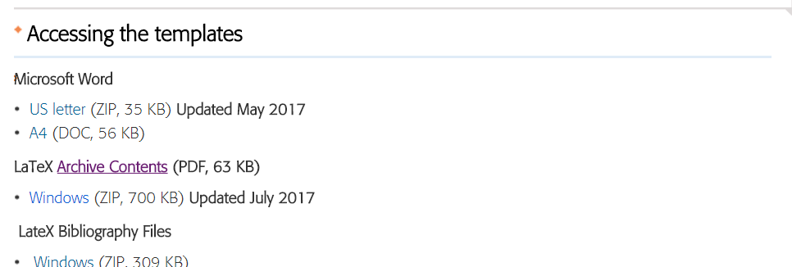

* + The LaTeX Template can be downloaded here (<https://www.ieee.org/conferences_events/conferences/publishing/templates.html>).



* + One-page Presentation-only Paper:
  + The MS Word Template (in A4 size and the IEEE two-column format) can be downloaded here (<http://icast2017.csie.cyut.edu.tw/file/iCAST2017_PaperTemplate_page.docx>).
  + Other paper setting:
  + No cover page/ blank page.
  + No unnecessary blank area.
  + The margin area should be blank. Anything in the margin cannot be printed properly. Don’t put anything such as paper title, page numbers, headers, footers, texts, figures, tables, etc. Remove any header/footer. Even it seems to be blank, its space and etc will make the margin wider.
  + No page number.

**Step 2: PDF eXpress Online File Conversion/PDF Validation Tool**

After carefully amending your manuscript according to the reviewers’ recommendations, please print out your paper and proofread it. The final manuscript must be submitted as an IEEE Xplore-compatible PDF file. The iCAST 2017 through IEEE offer conferences free access to PDF eXpress, the IEEE’s online file conversion/PDF validation tool, to assist authors in preparing suitable electronic files of their final papers.

**IMPORTANT:** Authors must check their final PDF files before submission to verify that all fonts have been properly embedded and subset. Some font manufacturers now flag their fonts to not embed. These fonts must be avoided.

The steps of creating your final PDF file is listed as follows:

**Step 2-1: Creating your PDF eXpress Account**

1. Log in to the IEEE PDF eXpress TM site: [https://www.pdf-express.org[](https://www.pdf-express.org)](https://www.pdf-express.org)
2. First-time users should do the following:

(2-1) Select the New Users (if you first use this system)

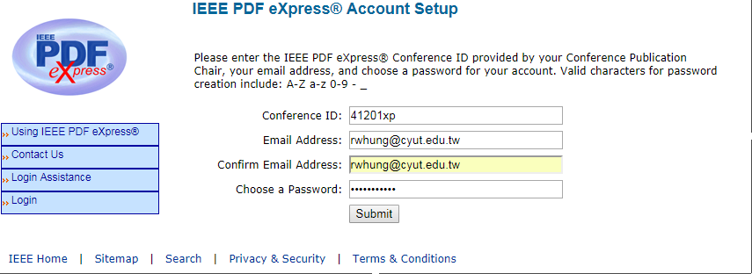

(2-2) Enter the following:

Conference ID = **41201XP**

**your** email address

a **password**

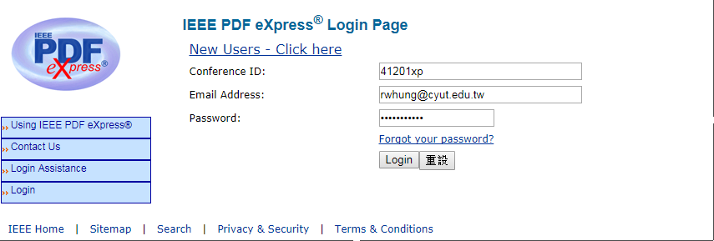

(2-3) Continue to enter information as prompted.

(2-4) An Online confirmation will be displayed and an email confirmation will be sent verifying your account setup.



***Previous users*** of PDF eXpress need to follow the above steps, but should enter the same password that was used for previous conferences. Verify that your contact information is valid.

**Step 2-2: Upload PDF or Source file to Check or Convert**

1. Create New Title: (you can check 10 PDF files with one Paper ID)

(1-1) Enter Title Info: (enter your paper title – the format is shown as follows)

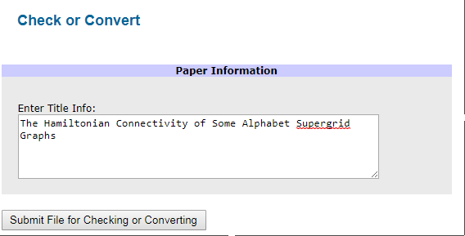

(1-2) Submit File for Checking or Conversion (upload your checking PDF file or Source file to convert – PDF eXpress can convert the following file types to PDF: Microsoft Word / PostScript / Freelance / PageMaker / FrameMaker / Word Pro / WordPerfect / Rich Text Format / (La)TeX (DVI and all support files required))

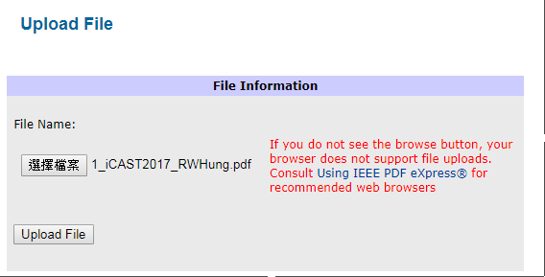

1. File Upload Results

(2-1) The results will be sent via email shortly. The following email shows a certification for your upload paper.



Notice that you will receive a failed PDF check email if your paper format does not match the IEEE conference format. In this time, you can download the report from the eXpress site for find its report. The following shows a fail PDF checking email:



(2-2) **Approve for Collection**. (Congratulation, you have completed the checking steps)

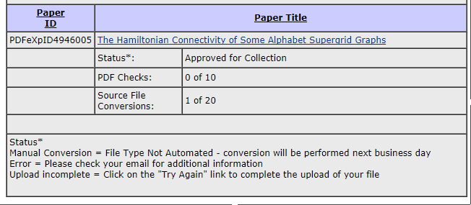

**Step 3: Submitting a Copyright Release Form**

To publish your paper in IEEE Xplore digital library, the author must sign a copyright release form. Note that if your paper does **NOT** submit to IEEE Xplore digital library, then the following steps can be ignored and you must download the Copyright Form from the website (http://icast2017.csie.cyut.edu.tw/file/iCAST2017-Copyright_(non-IEEE).doc), sign it and transfer it to icast2017pcs@gmail.com.

The IEEE copyright form signed process is to visit iCAST 2017 submission system, and please execute the following steps to complete the signed process:

**Step 3-1: Login the ISAS Conference Management System (Paper Submission)**

1. <http://eform.iis.sinica.edu.tw/url/icast2017/submit>

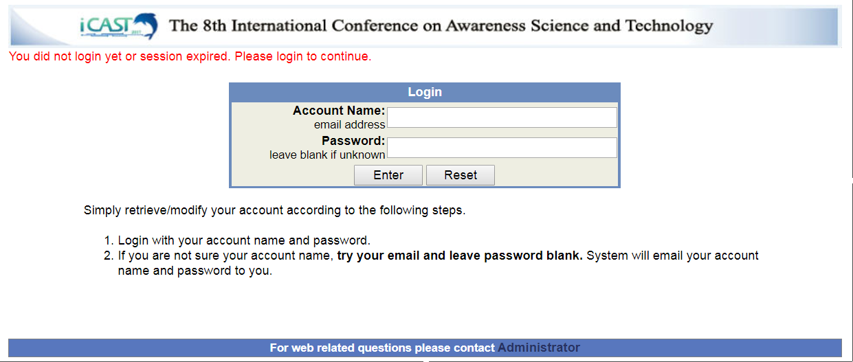

1. Press “**eCopyright**” or “**IEEE eCopyright Submission**” of your paper

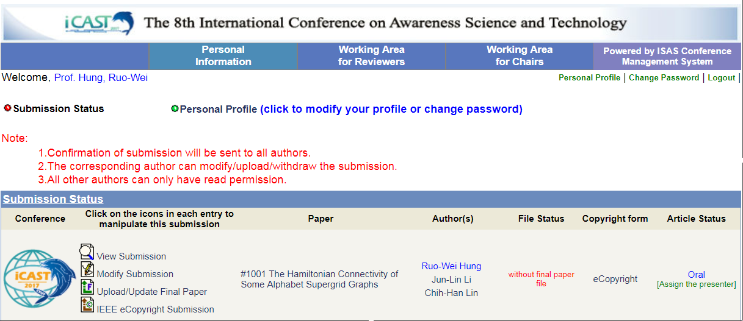

**Press**

1. Sign IEEE Copyright (there are 5 steps)

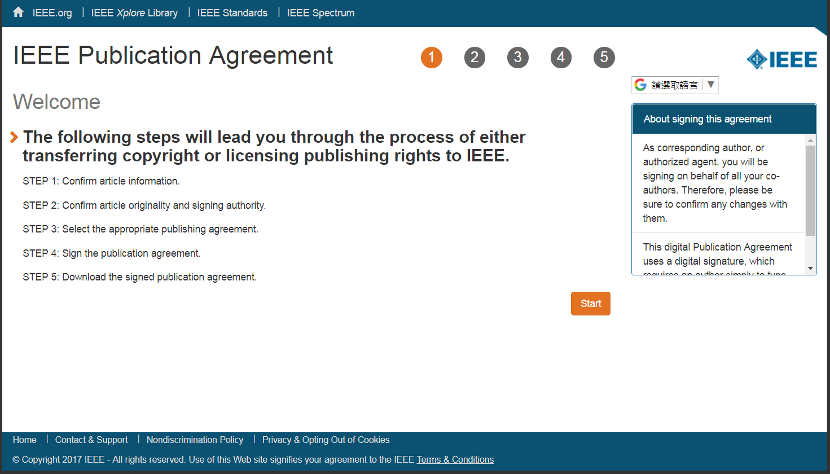

Step 4:

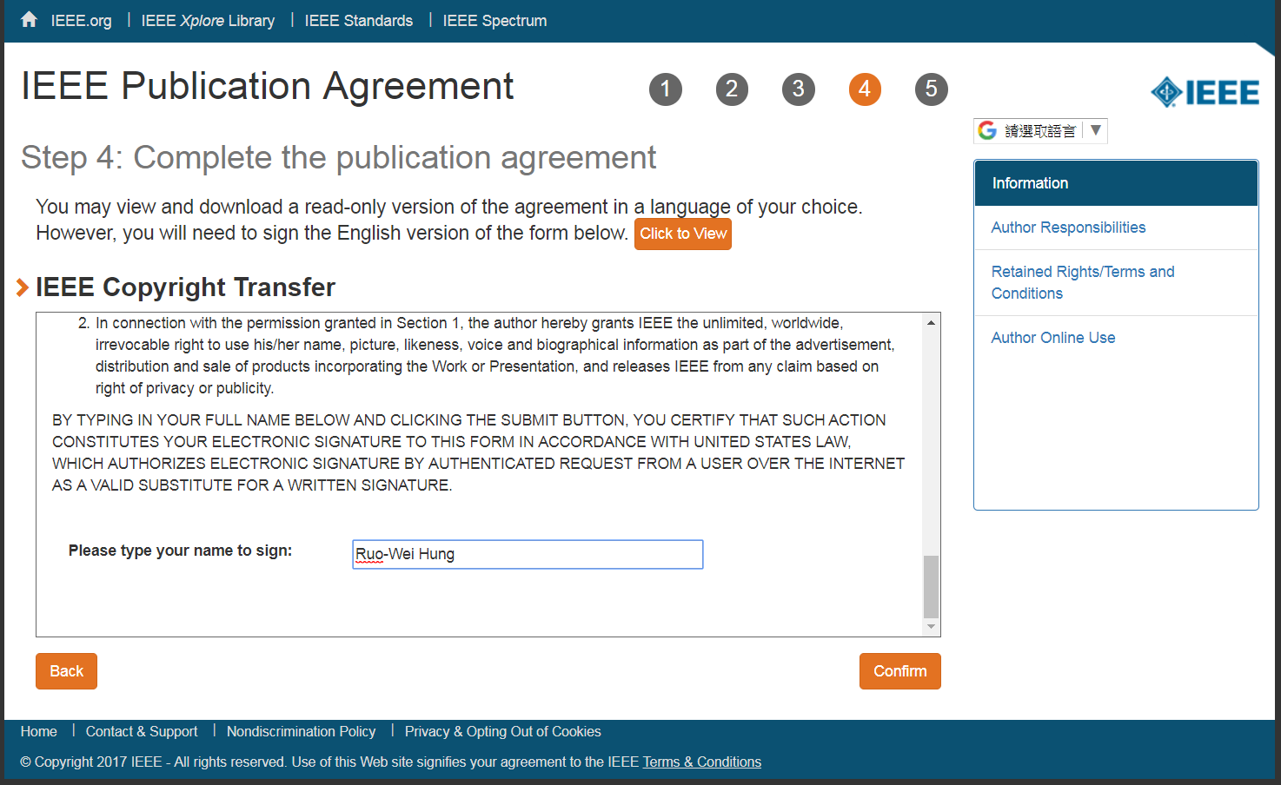

Final step: (you can download the copyright)

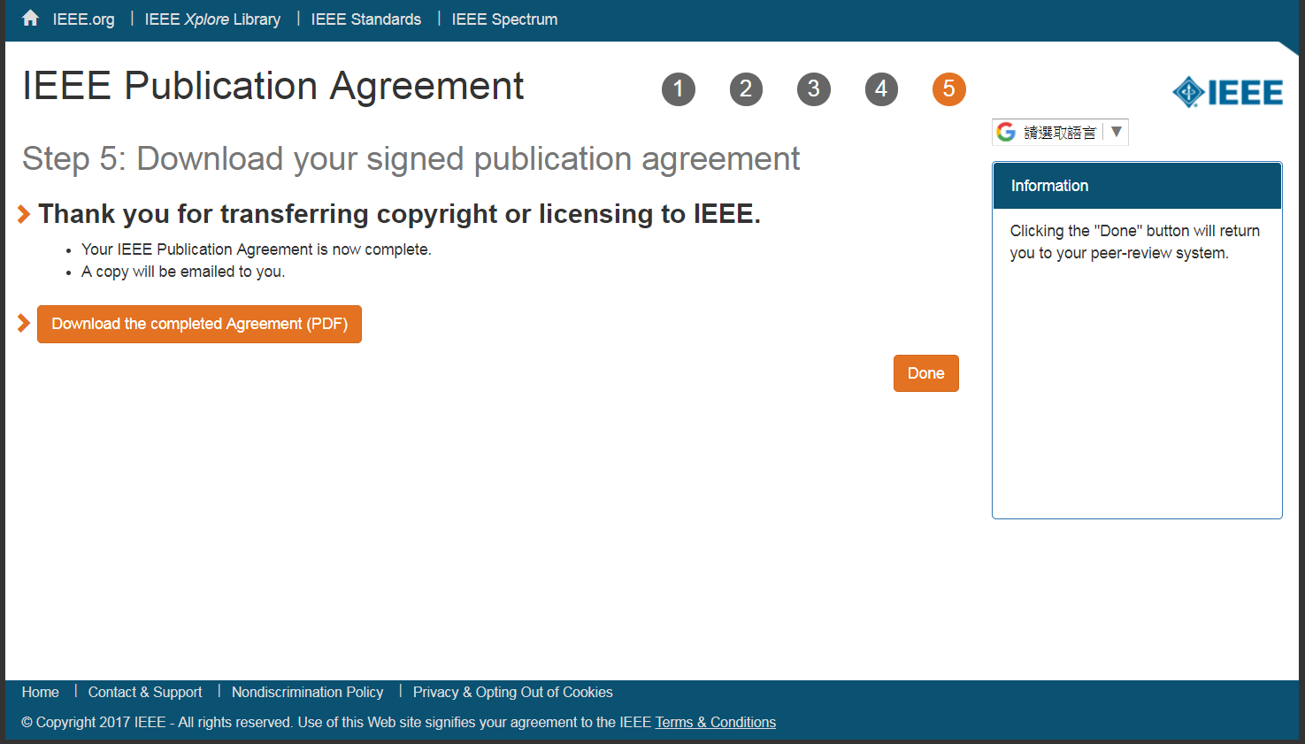

After completing the above steps, you can view the status of your paper with “IEEE eCopyright Submission”. And you will receive a confirmation email from IEEE as follows:

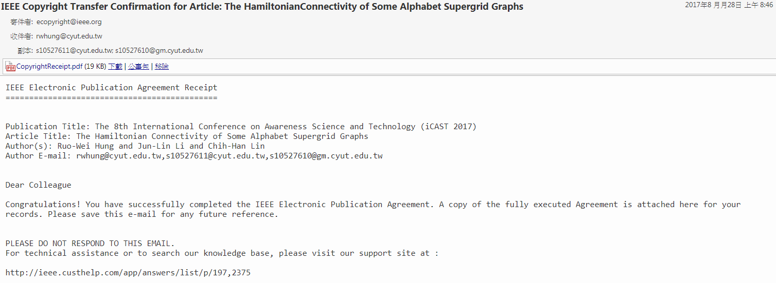

**Step 4: Submission of Your Final Camera Ready Paper PDF File to the Conference Submission Site**

1. Submit your camera-ready paper PDF file in Step 2 to [ISAS submission system](http://eform.iis.sinica.edu.tw/url/icast2017/submit) (<http://eform.iis.sinica.edu.tw/url/icast2017/submit>)

Enter “Upload/Update Final Paper”: (You can update the final camera-ready paper until **Sep. 15**, 2017)

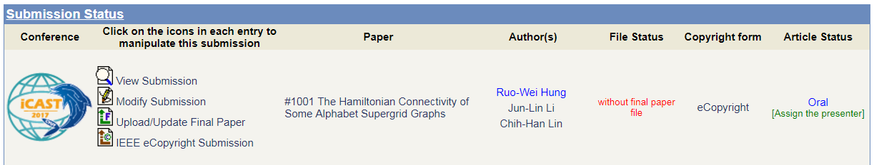

1. Assign the presenter of the paper in iCAST 2017

Enter “Assign the presenter” and select the presenter:

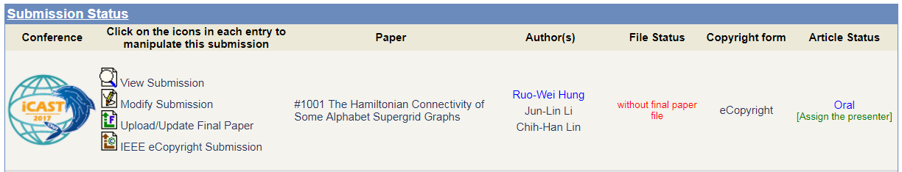

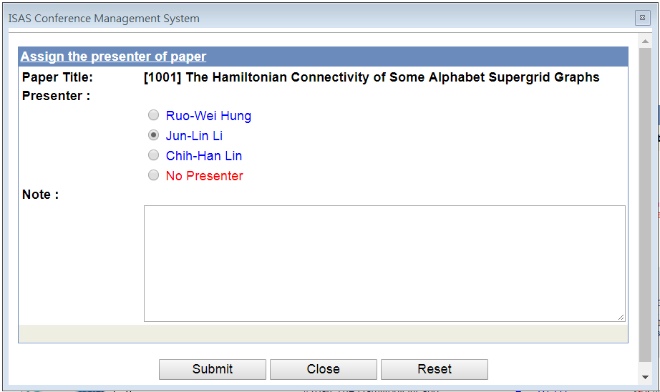

1. Forward the e-mail in Step 2-2 (2-1) to the Conference e-mail address ([icast2017pcs@gmail.com](mailto:icast2017pcs@gmail.com)) and add your paper ID to the subject of this forwarding email.



Paper ID

After completing the above steps, please remember to **registration** for iCAST 2017. We appreciate your attendance in iCAST 2017 and we believe you have a wonderful and exciting stay in Taichung City, Taiwan. We are looking forward to your presence at the conference. Thanks again.

**Important Dates**:

Submission deadline of final camera-ready papers: **September 15, 2017**

Deadline for registration: **October 01, 2017**

iCAST 2017: **Nov. 8-10, 2017**