**iCAST 2017 Registration Instructions for the Authors**

**The 8th International Conference on Awareness Science and Technology (iCAST 2017)**

* **REGISTRATION GUIDELINES**

The following steps are provided to help you in the registration for the iCAST 2017 conference. Please follow all STEPs to ensure that the registration process is completed successfully.

**Step 1: About iCAST 2017 Registration Fee**

1. The author may pay the registration fee by either US dollar or NT dollar, and the exchange rate is fixed at USD : NTD = 1 : 30.
2. Notices:
   * For each paper, at least **one author** should register with “**Regular Registration**” by October 1, 2017 accompanied with paper ID#, which shall be obtained upon the submission of papers.
   * Each regular registration includes 1 conference digest, 1 USB drive proceeding, and access to all sessions, coffee breaks, and banquet.
   * Each student registration (non-author) includes all of the items in regular registration except the banquet.
   * IEEE/TACE/TESII/TAWIC/CCISA/TAAI member registration: To qualify for the member rate your IEEE/TACE/TESII/TAWIC/CCISA/TAAI membership will be required.
   * Student registration: To qualify for the student rate, a proof of current full-time student status (i.e., the system will request a copy of student card or certification from university) will be required. In addition, student registration means that he/she is **not** an author.
3. **Registration Fee**

| **Category** | **Sub-Category** | **Early Registration (until Sep. 15, 2017)** | **Standard Registration (until Sep. 20, 2017)** | **Late Registration(until Oct. 01, 2017)** |
| --- | --- | --- | --- | --- |
| **Regular registration** | Non-IEEE/TACE/TESII/TAWIC/  CCISA/TAAI member | US$500  (NT$15,000) | US$550  (NT$16,500) | US$600  (NT$18,000) |
| IEEE/TACE/  TESII/TAWIC/CCISA/TAAI member | US$450  (NT$13,500) | US$500  (NT$15,000) | US$550  (NT$16,500) |
| **Student registration**  **(non-author)** | US$300 (NT$9,000) | | | |
| Additional publication fee | Each additional paper charge is US$400 (NT$12,000).  Note that one author is limited to register at most **three** papers. | | | |
| Over-length page charge  (max **2** pages/paper) | For papers of more than 6 pages, the page charge is US$40 (NT$1,200) per additional page. | | | |
| Additional banquet ticket | Each additional ticket banquet is charged US$30 (NT$900). | | | |

**Step 2: iCAST 2017 Registration System**

Please complete the following steps for registration:

**Step 2-1: Enter the registration system**

1. Enter the iCAST 2017 registration site: [**http://eform.iis.sinica.edu.tw/url/icast2017/reg**](http://eform.iis.sinica.edu.tw/url/icast2017/reg)

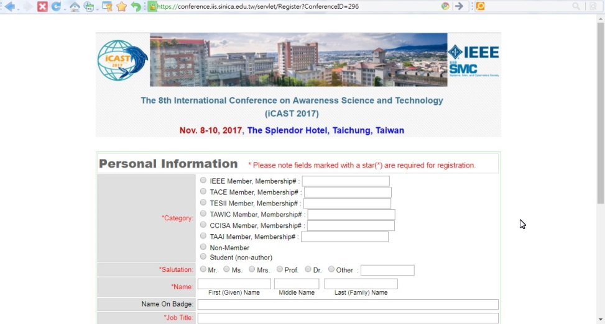

1. Fill in **Personal Information**

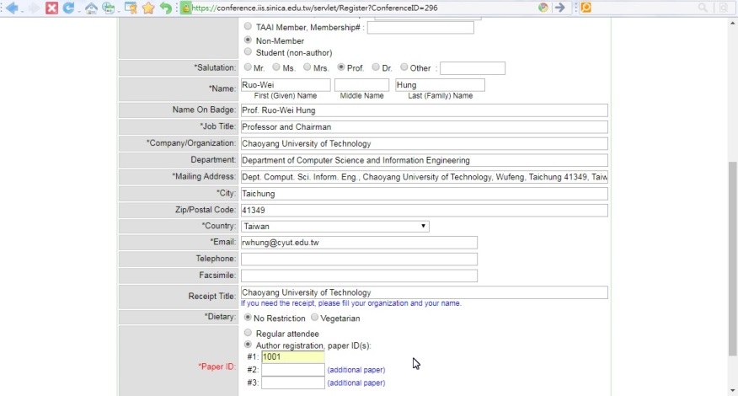

**Note:** An author registration should select “Author registration, paper ID(s):” and enter the paper ID.

1. Display **Registration Information**

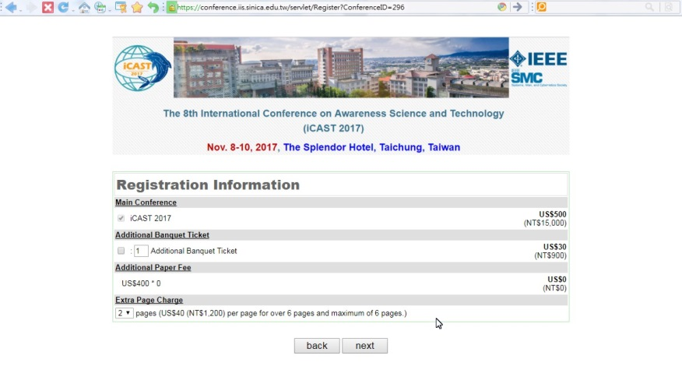

(2-1) Display **Registration fee**

(2-2) Fill in additional banquet ticket if it is necessary

(2-3) Display “**Additional Paper Fee**” (each additional paper charge is USD$400 (NTD$12,000) and one author is to register at most three papers)

(2-4) Select the **total extra** over-length page size in “Extra Page Charge”:

* each additional paper charge is US$400 (NT$12,000).
* the length of each final camera-ready paper is 4-6 pages.
* a maximum of 2 extra pages is permitted with over-length payment, US$40 (NT$1,200) per page.
* if the author registers 3 papers, then the maximum total extra over-length page size is 6. Note that the size of each paper is at most 8.

1. **Data Confirmation** and **Payment Method selection**

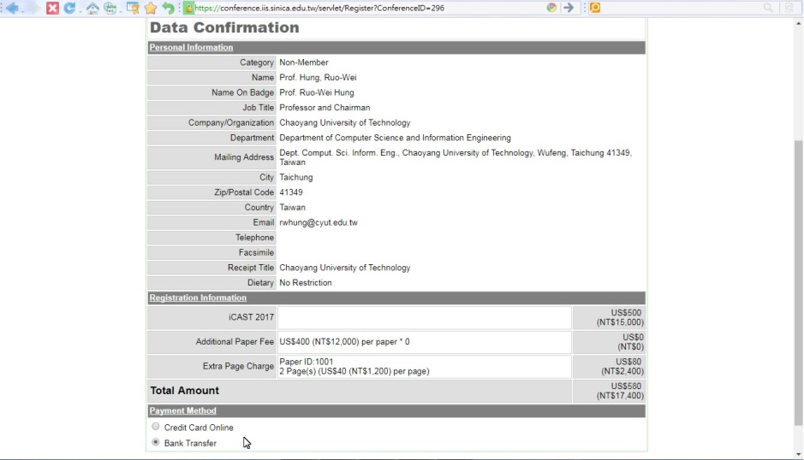

**Step 2-2: Payment Method**

1. **Credit Card** Online:

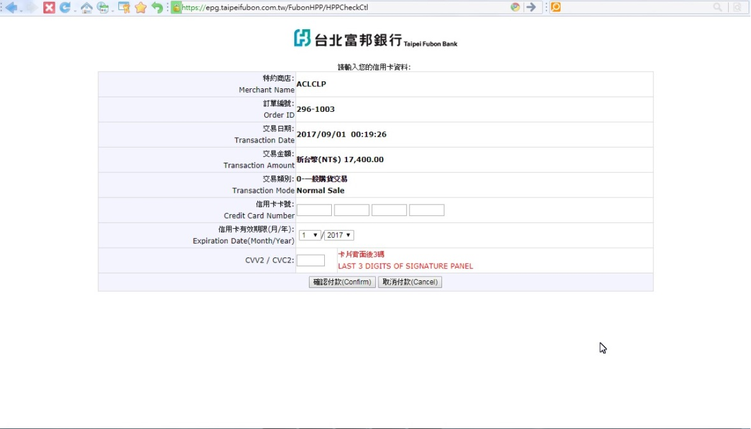

* **Fill in** your credit card information and **confirm** the payment.
* After confirming the payment by credit card, you we will see the following “Registration Sheet” on your browser:



* Then you will receive a confirmation email as follows:



* After iCAST 2017 Finance Committee verify your payment, you will receive an email as follows:

In this time, you have completed the registration for iCAST 2017.

1. **Bank Transfer**: (This payment method is more suitable for **Taiwan authors**)

* iCAST 2017 Registration Sheet: (The completion of registration)

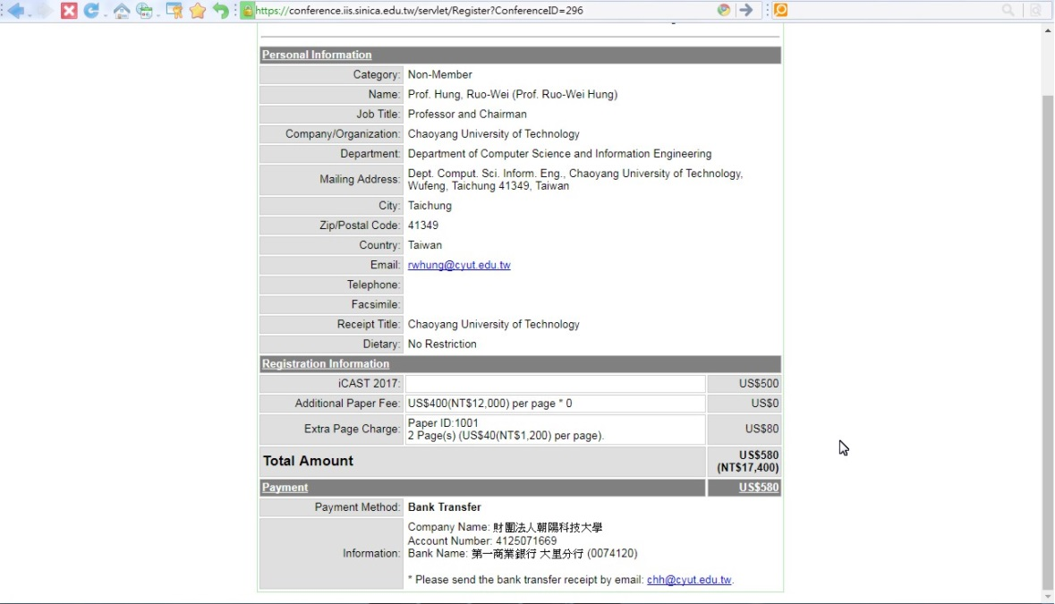

6

* The iCAST 2017 bank information is shown as follows:
* Company Name: **財團法人朝陽科技大學**
* Account Number: **41250716696**
* Bank Name: **第一商業銀行 大里分行 (0074120)**
* Please remark the “**Paper ID**” when you pay the register fee by bank transfer.
* After paying the registration fee by bank transfer, please email the **receipt of remittance** to **chh@cyut.edu.tw** in **5** days.
* When you complete the above registration steps, you will receive an email from the finance committee as follows:



6

After completing the above steps, please remember to **upload the final camera-ready paper** for iCAST 2017 ([**http://eform.iis.sinica.edu.tw/url/icast2017/submit**](http://eform.iis.sinica.edu.tw/url/icast2017/submit)).

We appreciate your attendance in iCAST 2017 and we believe you have a wonderful and exciting stay in Taichung City, Taiwan. We are looking forward to meeting you at the conference. Thanks again.

**Important Dates**:

Submission deadline of final camera-ready papers: **September 15, 2017**

Deadline for registration: **October 01, 2017**

iCAST 2017 conference: **Nov. 8-10, 2017**