**Unit Test Electron using Mocha(& Chai for Assertion)**

Below is document describing how to Unit Test Electron Applications using Electron & Mocha(& Chai for Assertion)

**Procedure to run:**

Step 1: Under the folder, first given below command just to run the app normally and check, also this step compiles .ts to .js

**npm start**

Step 2: Command to Run Unit Test

**npm run test:unittest**

**Folder Structure:**

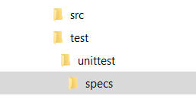

Above is folder structure, where unittest spec ts files reside.

In real projects having multiple folders, its better to have same folder structure under unittest folders which has corresponding unittest spec files.

The path of folders & spec filename pattern are in test/unittest/mocha.opts file, as shown below, so you can change as per your need.

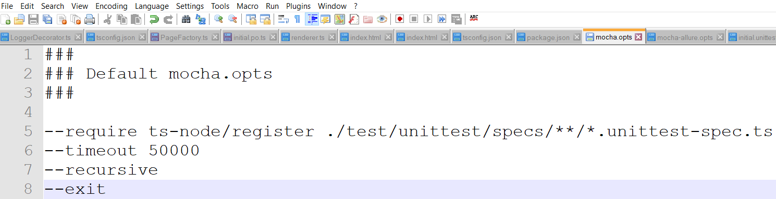

**Changes in packages.json:**

Have included below libraries in dependency/devdependency

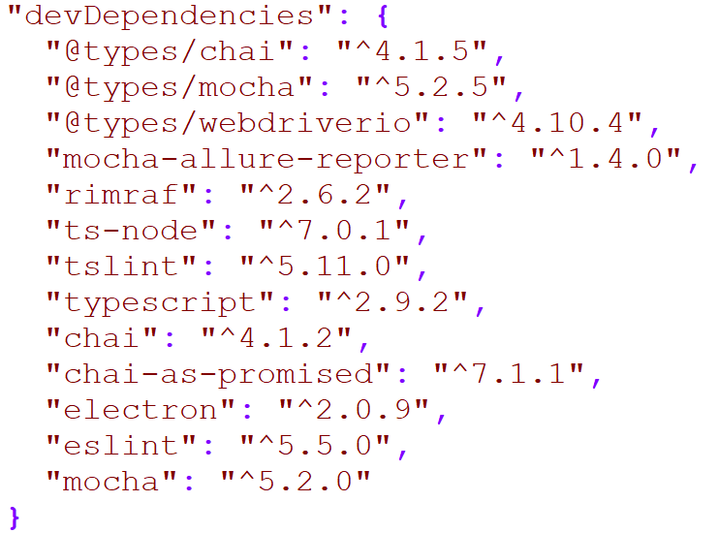

Specify unittest command in packages.json



Note:

Along with unittest we can also have e2e(end to end) test. You can have e2e Test specs under e2e folder, and can have different command, to run e2e test specs.