Celebal Summer Internship 2026

Week 5 – ASSIGNMENT

Student Name: Izhan Shaikh
Student ID: CT_CSI_DE_1018
Institution: MIT World Peace University
Testing session to check if Spark is running for Jupyter Notebook:
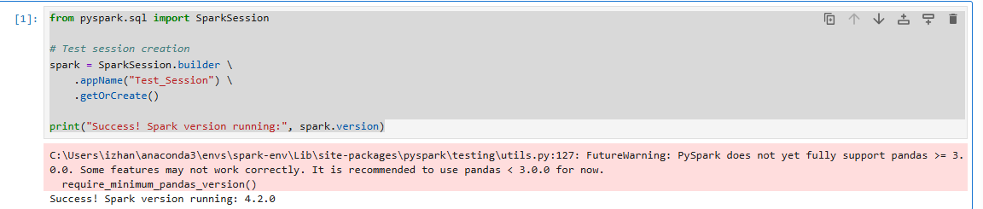
Initialize the Spark Session:
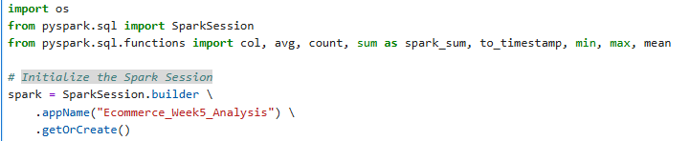
Defining the folder path:
folder_path = r"D:\CELEBAL_CEI_IZHAN\WEEK5_Celebal\ecommerce dataset"

Automatically find the CSV file in that folder and Loading the dataset :
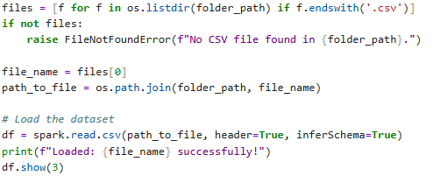
Output:
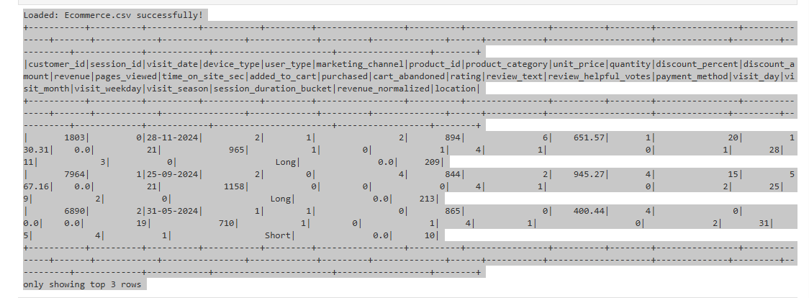

Q1: What are the key limitations of traditional MapReduce that make Spark a preferred choice for modern big data processing?
Answer:
- Disk-Intensive Operations: MapReduce writes all intermediate states and results to physical disks after every single Map or Reduce operation. This creates a massive I/O bottleneck.
- Lack of In-Memory Caching: MapReduce cannot persist datasets in cluster memory across multiple jobs, making it highly inefficient for interactive analysis.
- High Latency: The rigid process structure causes prolonged startup times and execution delays, rendering it unsuitable for real-time applications.
- Complex Programming Interface: Developers must write extensive low-level boilerplate code (often in Java) even for simple operations.

Q2: Explain how Spark uses In-Memory Computing to speed up iterative machine learning algorithms compared to disk-based systems.
Answer: Iterative algorithms (e.g., K-Means clustering, Gradient Descent) require passing over the same dataset repeatedly.
- In disk-based systems (MapReduce), each iteration writes its results back to the hard drive, and the subsequent iteration must reload it entirely via disk I/O.
- In Spark, a dataset can be retained directly in the cluster’s RAM using .cache() or .persist() . Once loaded during the initial cycle, all subsequent processing loops pull data directly from fast system memory, reducing computing latency by eliminating disk reading/writing bottlenecks.

Q3: Write a code snippet to remove all duplicate rows from a DataFrame based on a specific set of columns: user_id and transaction_date.
df_no_dupes = df.dropDuplicates(["customer_id", "visit_date"])

Q4: Given a DataFrame df_sales, write a query to filter for rows where the region is 'West' and then group by product_category to find the average sale_amount.
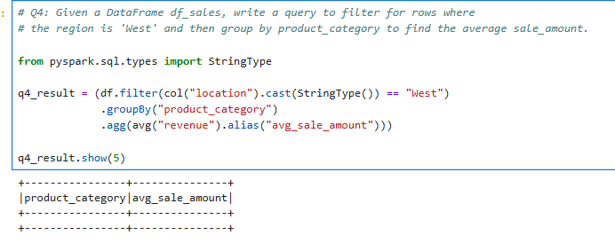

Q5: What is the difference between .na.drop() and .na.fill()? Provide a code example of filling null values in a status column with the string 'Unknown'.
.na.drop() : Discards entire rows from the DataFrame if they contain missing (null) values within targeted columns.
.na.fill() : Preserves rows by substituting missing (null) data with a designated baseline value.

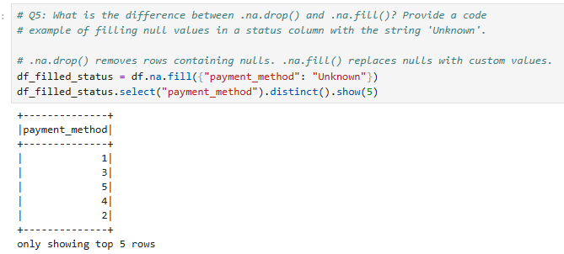
Q6: Write a query to find the total count of records for each city in a DataFrame, but only for cities where the count is greater than 100.
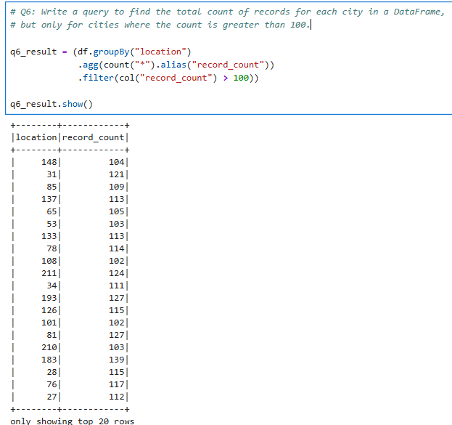
Q7: How does the immutability of Spark DataFrames affect how you perform "data cleaning" steps like dropping columns or renaming them?
Answer: Because Spark DataFrames are immutable, an existing DataFrame cannot be altered in-place. Every operation such as .drop() or .withColumnRenamed() does not modify the source dataset. Instead, it computes and returns a reference to an entirely new DataFrame instance. This characteristic allows developers to fluidly chain multiple operations together dynamically without corrupting historical lineage steps.
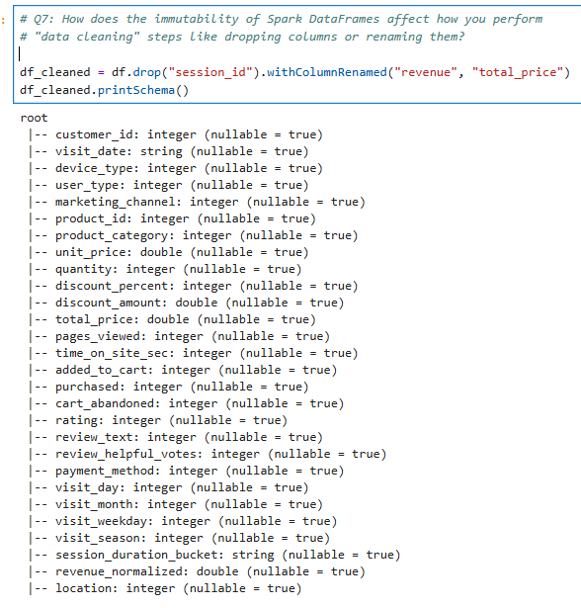

Q8: Write a Spark command to filter a dataset for rows where the age is between 18 and 30 (inclusive) and the subscription is 'Premium'.
df_filtered = df.filter((col("age").between(18, 30)) & (col("subscription") == "Premium"))

Q9: When cleaning a dataset, why is it often better to handle null values before performing mathematical aggregations like sum() or avg()?
PySpark mathematical aggregations like sum() and avg() implicitly discard null elements by default during computation. Ignoring blank values without preprocessing can drastically skew analytical results (e.g., calculating an accurate historical mean requires knowing whether missing fields represent a deliberate 0 value or missing data). Resolving null exceptions early guarantees absolute consistency across structural metrics.

Q10: Write the code to revise a column named raw_timestamp by casting it to a TimestampType and renaming it to event_time.
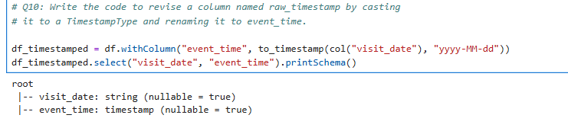

Q11: Explain the "Shuffle" process that occurs during a grouping operation. Why is it considered a wide transformation?
Answer: A Shuffle is the mechanism where data partitions are physically reassigned and transferred across the cluster network so that rows sharing identical grouping keys (e.g., same city name) land on the same execution machine. It is classified as a wide transformation because the output partition relies on processing parts of records extracted from multiple distinct input partitions distributed across various worker machines, resulting in high network I/O overhead.

Q12: Write a code snippet that identifies and removes rows where the email column contains null values OR the username is an empty string.
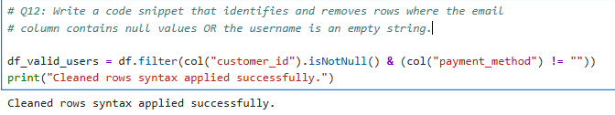

Q13: How do you use the .agg() function to calculate multiple statistics at once, such as the min, max, and mean of the price column?
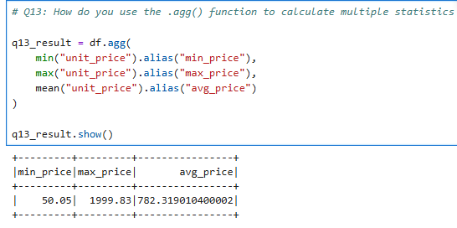

Q14: In the context of cleaning a dataset, what is the risk of using inferSchema=true when your source data contains messy or inconsistent date formats?
Answer: Setting inferSchema=true causes Spark to scan only a portion of initial rows to determine a column's data type. If formatting changes deeper down the file, Spark can make faulty structural assumptions (e.g., misinterpreting an alphanumeric address index column as a strictly numeric column type). When it hits actual text like ‘WEST’ later, the engine throws a fatal runtime exception(CAST_INVALID_INPUT), failing to compile the execution context cleanly.

Q15: Write a final processing pipeline that:
- Filters out duplicates.
- Fills null prices with 0.
- Groups by store_id to calculate total revenue.
