Celebal Summer Internship 2026
Week 3 Task
Name- Izhan Shaikh
Student ID : CT_CSI_DE_1018
College: MIT-WPU

Task:
Step 1: Setup Data
- Import the Superstore dataset into a table named superstore_raw.
- Create these 3 tables from it:
- customers
- orders
- products
- Insert data into these tables using SELECT DISTINCT.

Queries:

- Customers Table

CREATE TABLE customers (
customer_id VARCHAR(20) PRIMARY KEY,
customer_name VARCHAR(100) NOT NULL,
segment VARCHAR(50),
country VARCHAR(50),
city VARCHAR(50),
state VARCHAR(50),
postal_code INT,
region VARCHAR(50)
);

INSERT INTO customers
(
customer_id,
customer_name,
segment,
country,
city,
state,
postal_code,
region
)
SELECT DISTINCT
`Customer ID`,
`Customer Name`,
Segment,
Country,
City,
State,
`Postal Code`,
Region
FROM superstore_raw;

- Products Table

INSERT INTO products
(
product_id,
category,
sub_category,
product_name
)
SELECT DISTINCT
`Product ID`,
Category,
`Sub-Category`,
`Product Name`
FROM superstore_raw;

- Orders Table

CREATE TABLE orders (
row_id INT PRIMARY KEY,
order_id VARCHAR(30),
order_date DATE,
ship_date DATE,
ship_mode VARCHAR(50),
customer_id VARCHAR(20),
product_id VARCHAR(30),
sales DECIMAL(10,2),
quantity INT,
discount DECIMAL(5,2),
profit DECIMAL(10,2)
);

INSERT INTO orders
(
row_id,
order_id,
order_date,
ship_date,
ship_mode,
customer_id,
product_id,
sales,
quantity,
discount,
profit
)
SELECT DISTINCT
`Row ID`,
`Order ID`,
STR_TO_DATE(`Order Date`, '%m/%d/%Y'),
STR_TO_DATE(`Ship Date`, '%m/%d/%Y'),
`Ship Mode`,
`Customer ID`,
`Product ID`,
Sales,
Quantity,
Discount,
Profit
FROM superstore_raw;

Step 2: Perform Required Queries
Write and execute SQL queries for each of the following:

- Find all orders where sales are greater than the average sales. (Subquery)
Query:
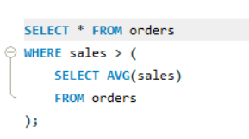
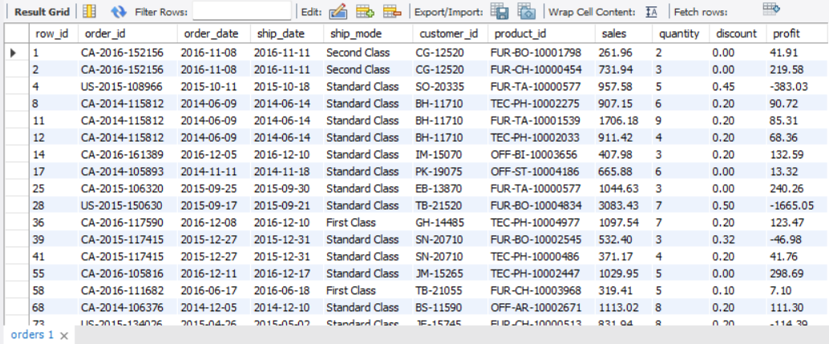
- Find the highest sales order for each customer. (Subquery)
Query:
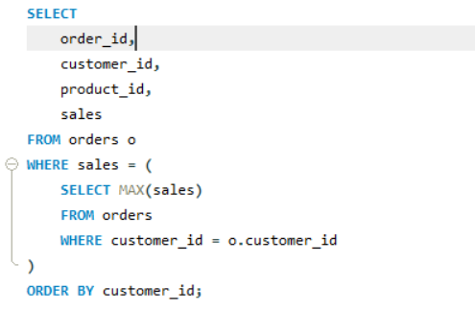
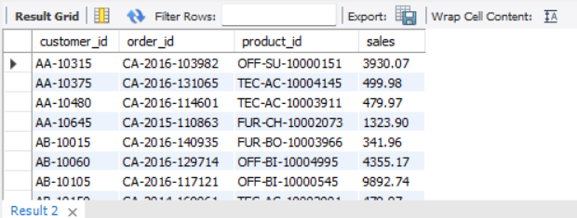

- Calculate total sales for each customer. (CTE)
Query
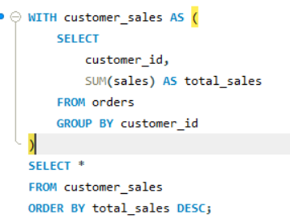
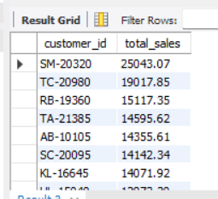

- Find customers whose total sales are above average. (CTE + Subquery)
Query
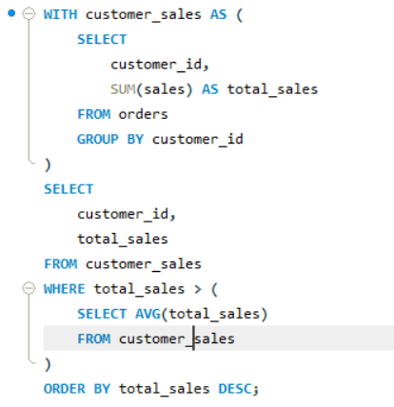

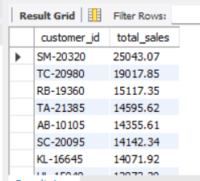

- Rank all customers based on total sales. (Window Function)
Query
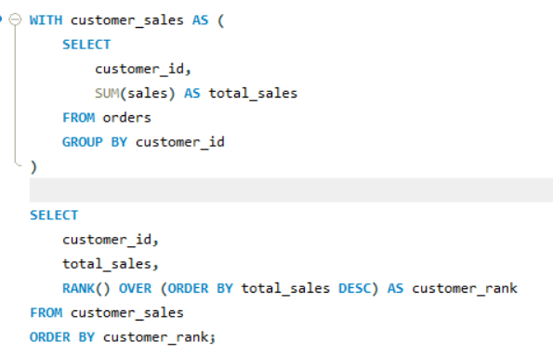
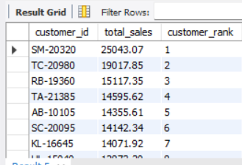

- Assign row numbers to each order within a customer. (Window Function + PARTITION BY)
Query
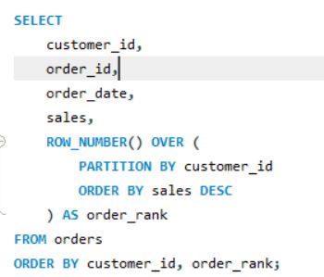
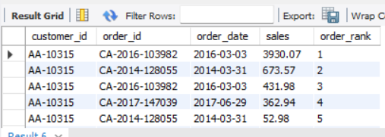

- Display top 3 customers based on total sales. (Window Function)
Query:
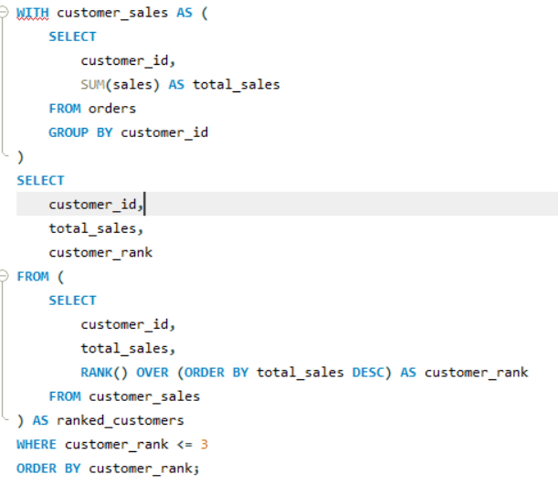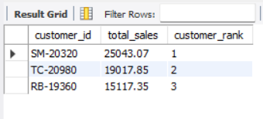

Step 3: Final Combined Query

Write one final query that shows:
- Customer Name
- Total Sales
- Rank

Query:

