Celebal Summer Internship 2026
Week 2 Task: E-Commerce Sales Database

Name- Izhan Shaikh
StudentId:CT_CSI_DE_1018
College: MIT-WPU

Section A — SQL Basics

USE superstore_db;

-- Q1. Write a query to display all columns and rows from the customer's table.

SELECT * FROM customers;

Output:
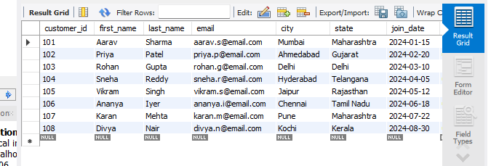

-- Q2. Retrieve only the first_name, last_name, and city of all customers.

SELECT first_name, last_name, city
FROM customers;

Output:
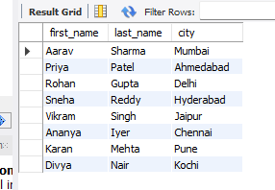

-- Q3. List all unique categories available in the products table.

SELECT DISTINCT `Category`
FROM `sample - superstore`;

Output:
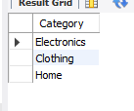

-- Q4. Identify the Primary Key of each table in the schema. Explain why a Primary Key must be unique and NOT NULL.

SELECT TABLE_NAME, COLUMN_NAME
FROM INFORMATION_SCHEMA.KEY_COLUMN_USAGE
WHERE TABLE_SCHEMA = 'superstore_db'
AND CONSTRAINT_NAME = 'PRIMARY';

Output:
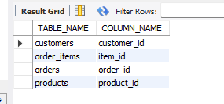

Explanation:
A Primary Key serves as a unique identifier for each row in a database table.
It must be UNIQUE to guarantee that individual records can be cleanly targeted without any ambiguity or mix-ups.
It must be NOT NULL because an absent or unknown identifier cannot reliably map to or represent a real entity in the database.

-- Q5. What constraints are applied to the email column in the customers table? What would happen if you tried to insert a duplicate email?

Constraints applied: VARCHAR(100), UNIQUE, and NOT NULL.
If an attempt is made to insert a duplicate email address, MySQL will reject the query and trigger an Error Code 1062 (Duplicate entry).The engine aborts the insert statement to keep the dataset valid.

-- Q6. Try inserting a product with unit_price = -50. What happens and which constraint prevents it? Write both the INSERT statement and explain the error.

Explanation:
Running the query below causes a constraint violation because of the rule `CHECK (unit_price > 0)` defined inside our table design. MySQL drops the execution with Error Code 3819 (Check constraint is violated).

To test this error yourself, you can uncomment and run the lines below:

-- INSERT INTO products (product_id, product_name, category, brand, unit_price, stock_qty)
-- VALUES (209, 'Negative Price Test Product', 'Electronics', 'TestBrand', -50.00, 10);

Output:

Section B — Filtering & Optimization (WHERE, Indexes)

USE superstore_db;

-- Q7. Retrieve all orders with status = 'Delivered'.

SELECT *
FROM orders
WHERE status = 'Delivered';

Output:
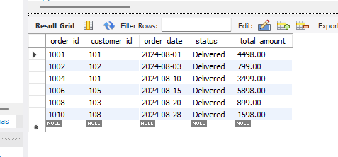

-- Q8. Find all products in the 'Electronics' category with a unit_price greater than ₹2000.

SELECT *
FROM products
WHERE category = 'Electronics' AND unit_price > 2000;

Output:
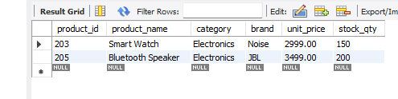

-- Q9. List all customers who joined in the year 2024 and belong to the state 'Maharashtra'.
SELECT *
FROM customers
WHERE join_date BETWEEN '2024-01-01' AND '2024-12-31'
AND state = 'Maharashtra';

Output:
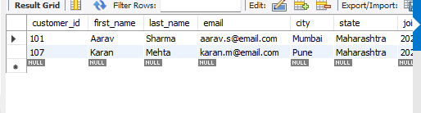

-- Q10. Find all orders placed between '2024-08-10' and '2024-08-25' (inclusive) that are NOT cancelled.

SELECT *
FROM orders
WHERE order_date BETWEEN '2024-08-10' AND '2024-08-25'
AND status <> 'Cancelled';

Output:
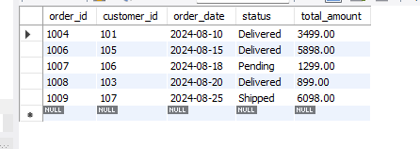

-- Q11. Explain what the index idx_orders_date does. How would it improve the performance of a query that filters orders by order_date? Write a sample query that would benefit from this index.

Explanation:
The index `idx_orders_date` creates a separate, ordered lookup structure mapping dates to row locations.
Instead of checking every row in the orders table line-by-line (Full Table Scan), MySQL jumps directly to the relevant dates.
This drastically decreases disk I/O operations and response times on large tables.

Sample Query:

SELECT * FROM orders WHERE order_date = '2024-08-15';

Output:
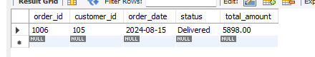

-- Q12. If you run: SELECT * FROM customers WHERE YEAR(join_date) = 2024; — would the index on join_date be used? Explain why or why not, and rewrite the query to be index-friendly (SARGable).

Explanation:
No, the index on join_date would NOT be used effectively. Wrapping an indexed column inside a scalar function like YEAR() forces the database engine to compute the function value for every single row in the table, rendering the predicate non-SARGable.

Index-Friendly (SARGable) Rewrite:

SELECT *
FROM customers
WHERE join_date >= '2024-01-01' AND join_date <= '2024-12-31';

Output:
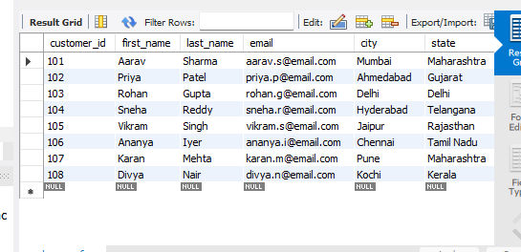

Section C — Aggregation (GROUP BY, SUM, COUNT, AVG, MIN, MAX)

USE superstore_db;

-- Q13. Count the total number of orders in the orders table.

SELECT COUNT(*) AS total_orders
FROM orders;

Output:
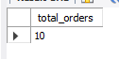

-- Q14. Find the total revenue (SUM of total_amount) from all 'Delivered' orders.

SELECT SUM(total_amount) AS total_delivered_revenue
FROM orders
WHERE status = 'Delivered';

Output:
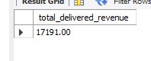

-- Q15. Calculate the average unit_price of products in each category.

SELECT category, AVG(unit_price) AS average_unit_price
FROM products
GROUP BY category;

Output:
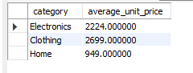

-- Q16. For each order status, find the count of orders and the total revenue. Sort the result by total revenue in descending order.

SELECT status,
COUNT(order_id) AS order_count,
SUM(total_amount) AS total_revenue
FROM orders
GROUP BY status
ORDER BY total_revenue DESC;

Output:
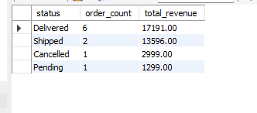

-- Q17. Find the most expensive (MAX) and cheapest (MIN) product in each category.

SELECT category,
MAX(unit_price) AS most_expensive_product,
MIN(unit_price) AS cheapest_product
FROM products
GROUP BY category;

Output:
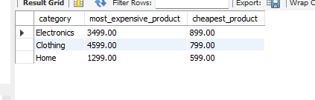

-- Q18. List all product categories where the average unit_price is greater than ₹2000. (Hint: Use HAVING clause)

SELECT category, AVG(unit_price) AS average_unit_price
FROM products
GROUP BY category
HAVING AVG(unit_price) > 2000;

Output:

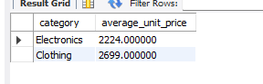

Section D — Joins & Relationships

USE superstore_db;

-- Q19. Write an INNER JOIN query to display each order along with the customer's first_name and last_name. Show: order_id, order_date, first_name, last_name, total_amount.

SELECT o.order_id, o.order_date, c.first_name, c.last_name, o.total_amount
FROM orders o
INNER JOIN customers c ON o.customer_id = c.customer_id;

Output:
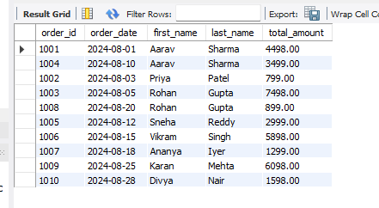

-- Q20. Using a LEFT JOIN, list ALL customers and their orders (if any). Customers with no orders should still appear with NULL values for order columns.

SELECT c.customer_id, c.first_name, c.last_name, o.order_id, o.order_date, o.total_amount
FROM customers c
LEFT JOIN orders o ON c.customer_id = o.customer_id;

Output:
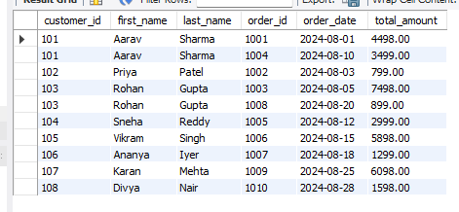

-- Q21. Write a query using JOINs across three tables (orders → order_items → products) to show: order_id, product_name, quantity, unit_price, and discount_pct for each order item.

SELECT oi.order_id, p.product_name, oi.quantity, oi.unit_price, oi.discount_pct
FROM orders o
INNER JOIN order_items oi ON o.order_id = oi.order_id
INNER JOIN products p ON oi.product_id = p.product_id;

Output:

-- Q22. Explain the difference between LEFT JOIN and RIGHT JOIN with an example from this schema. When would you use a FULL OUTER JOIN?

Explanation:
- LEFT JOIN: Keeps all rows from the left table (e.g., customers) even if there is no match in the right table (e.g., orders). Unmatched fields from the right table display as NULL.
Example: `customers LEFT JOIN orders` lists all registered customers, including those who haven't ordered yet.

- RIGHT JOIN: Keeps all rows from the right table (e.g., orders) even if there is no match in the left table (e.g., customers).
Example: `customers RIGHT JOIN orders` would list all orders, ensuring no transaction row is left out.

- FULL OUTER JOIN: Keeps all records from both tables, filling blanks with NULL on either side where a match is missing. It is typically used during data auditing to locate completely disconnected entries across both operational tables.

-- Q23. Identify all Foreign Key relationships in the schema. Explain what would happen if you tried to insert an order with customer_id = 999 (which doesn't exist in customers).

Foreign Keys Identified:
1. `orders.customer_id` references `customers.customer_id`
2. `order_items.order_id` references `orders.order_id`
3. `order_items.product_id` references `products.product_id`

Explanation:
If you attempt to insert a record into the `orders` table with a `customer_id` of 999, MySQL will block the operation and throw an Error Code 1452 (Foreign key constraint violation). This safeguard protects referential integrity by preventing "orphan" rows that point to non-existent parent records.

Section E — Advanced Concepts (CASE, ACID, Transactions)

USE superstore_db;

-- Q24. Write a query using CASE to classify products into price tiers:

-- • 'Budget' → unit_price < 1000
-- • 'Mid-Range' → unit_price BETWEEN 1000 AND 3000
-- • 'Premium' → unit_price > 3000

SELECT product_name,
unit_price,
CASE
WHEN unit_price < 1000 THEN 'Budget'
WHEN unit_price BETWEEN 1000 AND 3000 THEN 'Mid-Range'
ELSE 'Premium'
END AS price_tier
FROM products;

Output:
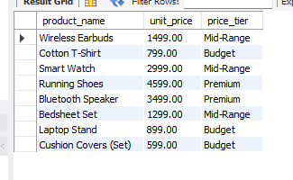

-- Q25. Using a CASE statement inside an aggregate function, count how many orders are 'Delivered' vs 'Not Delivered' (all other statuses). Display the result in a single row.

SELECT
SUM(CASE WHEN status = 'Delivered' THEN 1 ELSE 0 END) AS Delivered,
SUM(CASE WHEN status <> 'Delivered' THEN 1 ELSE 0 END) AS Not_Delivered
FROM orders;

Output:


-- Q26. Explain each letter of ACID: A – Atomicity, C – Consistency, I – Isolation, D – Durability. Give a real-world example (e.g., bank transfer) showing why each property is important.

Real-World Example: A bank transfer of ₹500 from Account A to Account B. This involves two steps:
1. Deduct ₹500 from Account A.
2. Credit ₹500 to Account B.

- A – Atomicity ("All or Nothing"): Ensures that either both steps succeed or both fail. If the system crashes after step 1 but before step 2, the transaction rolls back so money doesn't vanish into thin air.

- C – Consistency: Ensures the database moves from one valid state to another, respecting all constraints. For instance, account balances cannot drop below zero if a negative balance constraint exists.

- I – Isolation: Ensures concurrent transactions execute independently without interfering with one another. If someone else transfers money to Account B at the exact same millisecond, the two transactions are isolated and processed cleanly.

- D – Durability: Ensures that once a transaction is committed, its changes are permanently written to disk. Even if a total power outage occurs right after completion, the ledger remains securely updated.

-- Q27. Write a SQL transaction that does the following atomically:

-- 1. Insert a new order (order_id=1011, customer_id=102, today's date, 'Pending', 1598.00)
-- 2. Insert two order items for that order
-- 3. Update the stock_qty of the purchased products
-- 4. If any step fails, ROLLBACK the entire transaction. Otherwise, COMMIT.

START TRANSACTION;

Output:

-- Step 1: Insert the new order
INSERT INTO orders (order_id, customer_id, order_date, status, total_amount)
VALUES (1011, 102, CURDATE(), 'Pending', 1598.00);

Output:

-- Step 2: Insert two order items for that order
INSERT INTO order_items (item_id, order_id, product_id, quantity, unit_price, discount_pct)
VALUES (5016, 1011, 206, 1, 1299.00, 0);

INSERT INTO order_items (item_id, order_id, product_id, quantity, unit_price, discount_pct)
VALUES (5017, 1011, 208, 1, 599.00, 0);

Output:

-- Step 3: Update the stock_qty of the purchased products
UPDATE products
SET stock_qty = stock_qty - 1
WHERE product_id = 206;

UPDATE products
SET stock_qty = stock_qty - 1
WHERE product_id = 208;

Output:

-- Step 4: Commit all structural operations cleanly to disk

COMMIT;

Output:

