Project Description

This project is pretty straight foward. The menu bar is clickable. Portfoilo is leading to landing page(index.html)



Projects is leading to a new page with a project I have done on the other course. Bio leads to the biography page.

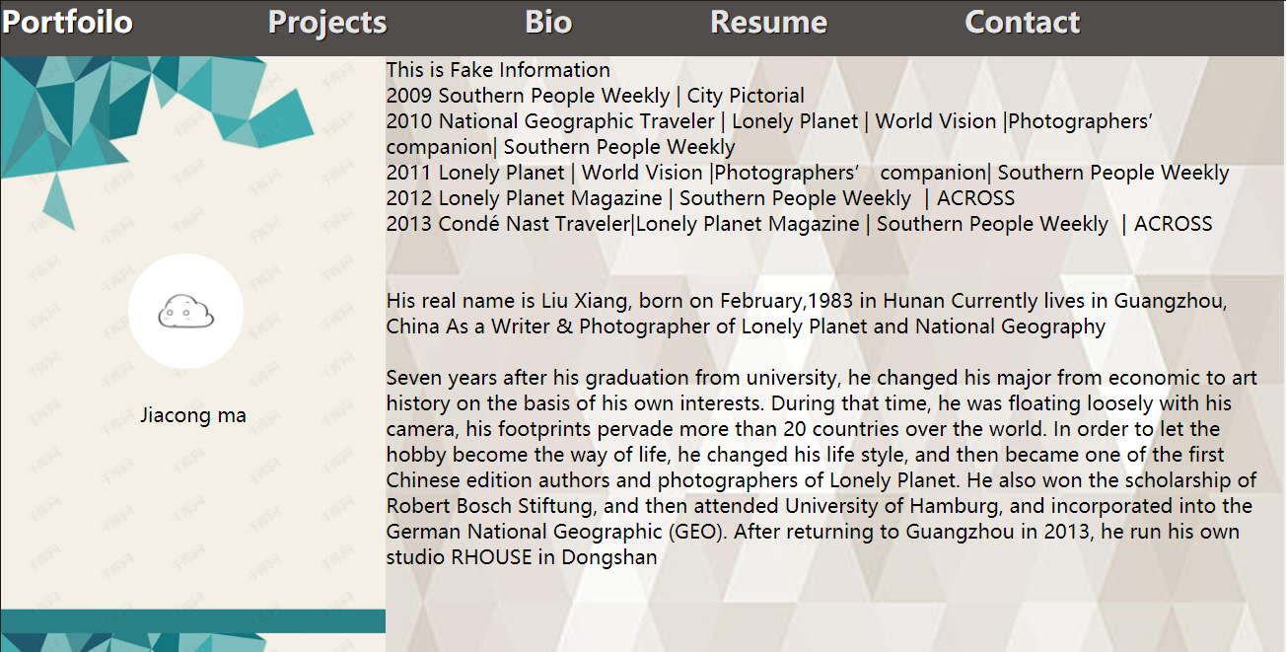

This is all fake information.

Resume is the other external link to the resume. It is reserved in github as resume.doc. I am not sure if it can show in America Internet.

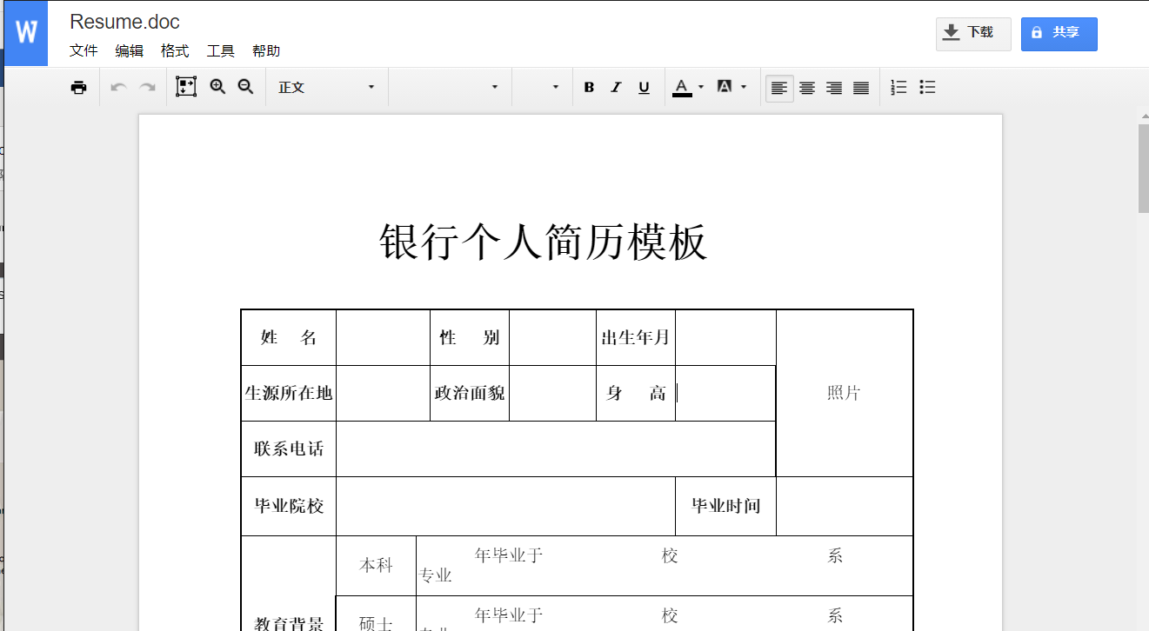

Finally is the contact page.

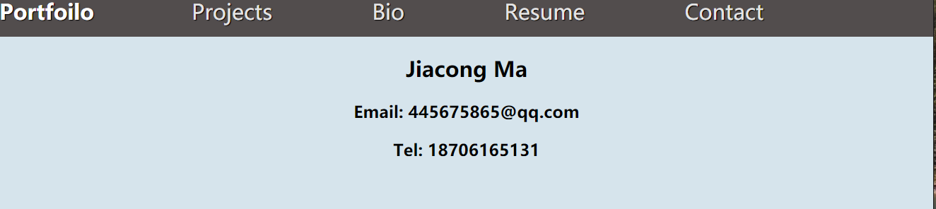

In landing page, the left project is clickable and leading to the showcase project on github.

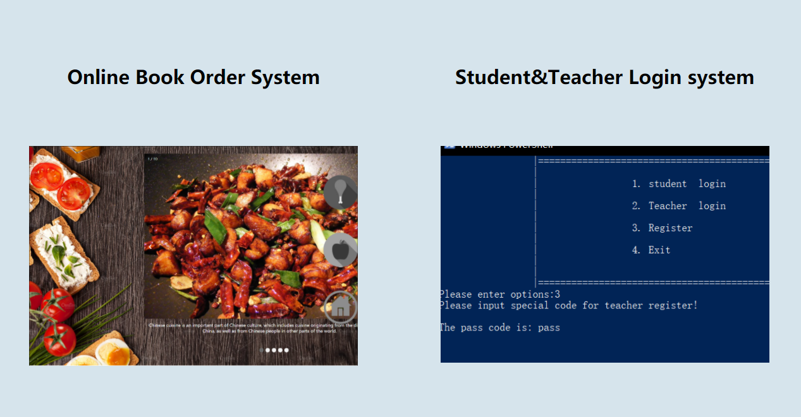

Below is visualization of the past two years’ trip map.

