ABOUT ME
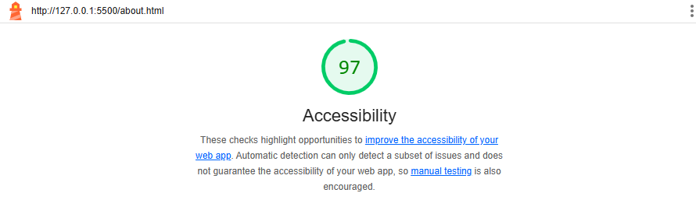

Index
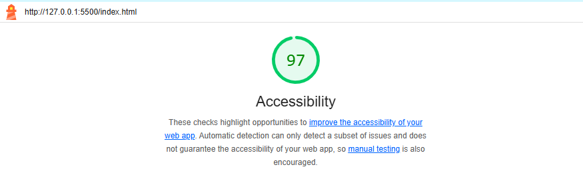
Services
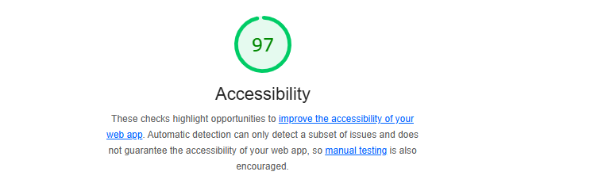
Contact
