

**INDIAN INSTITUTE OF INFORMATION TECHNOLOGY, NAGPUR**

C/o Regional Telecom Training Centre (RTTC) BSNL, Seminary Hills, Nagpur-440006 091-0712-2801369, Email: registrar@iiitn.ac.in

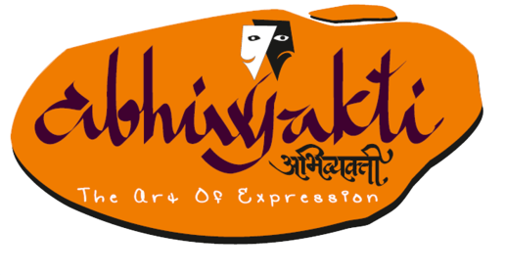---------------------------------------------------------------------------------------------------------------------------------------------------

Presents Kavyanjali

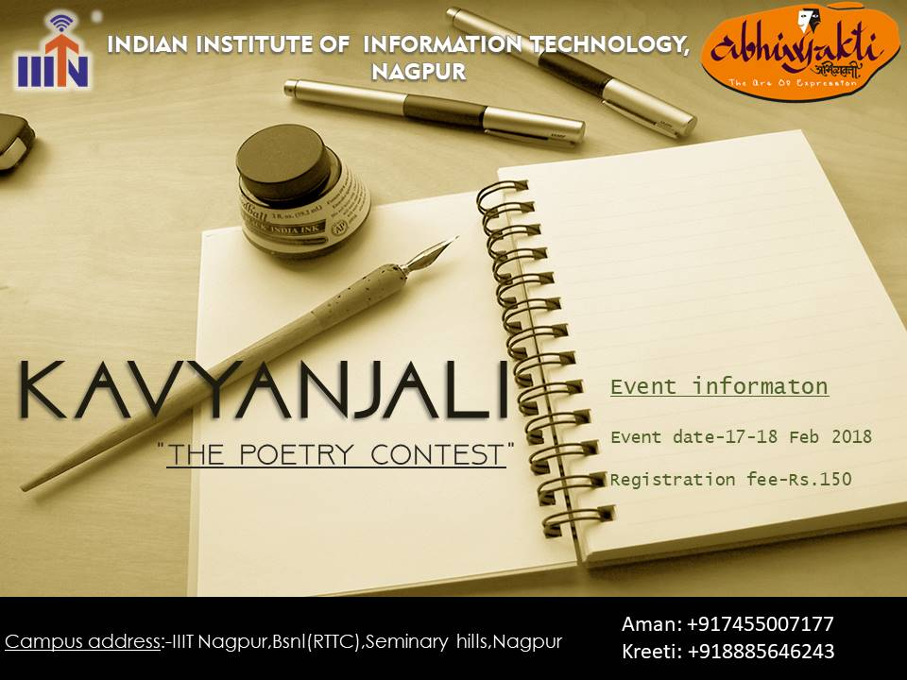

**About the Event:**

kavyanjali is the poetry competition of the annual cultural fest of IIIT Nagpur,Abhivyakti.

**Rules:**

* Participants have to register online by filling up the Google forms provided on the official website [www.abhivyakti.ga.](http://www.abhivyakti.ga/)
* Participants have to register at the registration desk at Students’ Activity Centre.
* Participants must have a valid college identity card.
* Only one or two poems per poet.
* Poems can be on any subject and in any style.
* Poem can be in **HINDI** only.
* Each poet must perform their original work.
* No props. Generally, poets are allowed to use their given environment and the accoutrements it offers — microphones, mic stands, the stage itself, chairs on stage, a table or bar top, the aisle — as long as these accoutrements are available to other competitors as well. The rule concerned to props is not intended to squelch the spontaneity, unpredictability, or on-the-fly choreography that people love about the slam; its intent is to keep the focus on the words rather than poets who inadvertently use a prop (for example, a timely yet unwitting grab at a necklace).
* Poets may not use musical instruments or pre-recorded music.
* No costumes. Further clarification of this rule was considered, but rejected as being niggling and ultimately unnecessary. The rule stands as is: **no costumes**.
* The time allotted will be a maximum of 5 minutes.
* Karaoke/background score would not be allowed.
* One should not copy the creation of any other poet; it may be a subject to copyright and will lead to the cancellation of participation and consequences will not be borne by Team Abhivyakti.
* Every participant(s) is/are required to fill up the “undertaking”.
* **Please, do collect your identity cards available at the registration desk on the day of the event.**

**Note:**

* In case of any discrepancy, decision made by the Team Abhiyakti’18 will be final.
* The event may be held as various rounds as per the convenience of Team Abhivyakti.

**Registration Fee:**

**INR 150 per individual.**

\***Prizes:**

**1st prize – INR 2000**

**2nd prize – INR 1500**

**Contact Us:**

Ambar Tayde: 8888364377

Aruna Mallela: 9440615831

\**prizes can be changed*