cd /home/z/apps/hbase-1.2.0/conf/

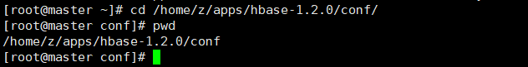

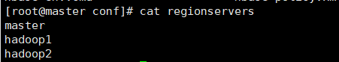

vim hbase-site.xml

<property>

<name>hbase.tmp.dir</name>

<value>/home/z/apps/hbase-1.2.0/tmp/hbase</value>

</property>

<property>

<name>dfs.replication</name>

<value>2</value>

</property>

<property>

<name>hbase.rootdir</name>

<value>hdfs://master:9000/hbase</value>

</property>

<property>

<name>hbase.cluster.distributed</name>

<value>true</value>

</property>

<property>

<name>hbase.zookeeper.property.clientPort</name>

<value>2181</value>

</property>

<property>

<name>hbase.zookeeper.quorum</name>

<value>master,hadoop1,hadoop2</value>

</property>

<property>

<name>hbase.zookeeper.property.dataDir</name>

<value>/home/z/apps/zookeeper-3.4.5/tmp/zookeeper</value>

</property>

<property>

<name>hbase.master.info.port</name>

<value>60010</value>

</property>

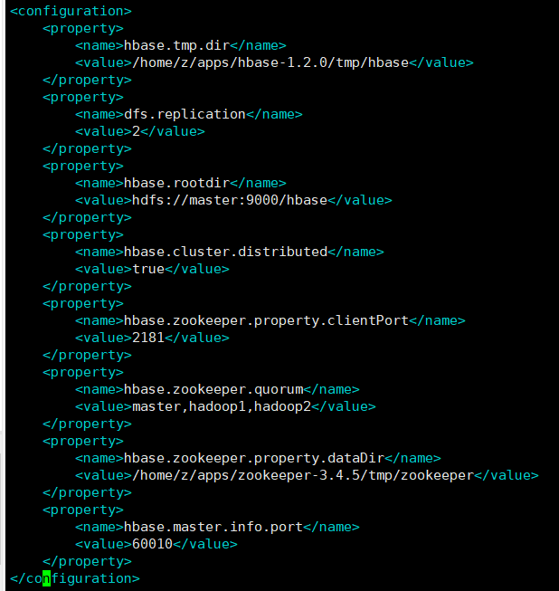

vim hbase-env.sh







拷贝hbase文件夹到其他节点。

1.首先需要启动hadoop

start-dfs.sh

start-yarn.sh

2.启动zookeeper

bin/zkServer.sh start

3.启动hbase

start-hbase.sh

<http://192.168.120.50:60010>

<http://192.168.120.50:16010>

