[(41条消息) kafka0.8的安装_张老kkkk的博客-CSDN博客](https://blog.csdn.net/weixin_39926871/article/details/92005031?ops_request_misc=&request_id=&biz_id=102&utm_term=kafka%200.8%E5%AE%89%E8%A3%85%E6%95%99%E7%A8%8B&utm_medium=distribute.pc_search_result.none-task-blog-2~all~sobaiduweb~default-3-92005031.nonecase&spm=1018.2226.3001.4187)

**解压文件夹**

tar -zxvf kafka_2.8.0-0.8.0.tar.gz



vim server.properties

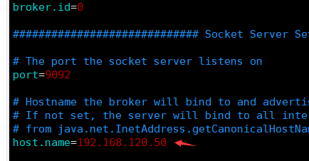

拷贝到其他机器上，

scp -r /home/z/apps/kafka_2.8.0-0.8.0 hadoop1:/home/z/apps/

scp -r /home/z/apps/kafka_2.8.0-0.8.0 hadoop2:/home/z/apps/

修改如下配置

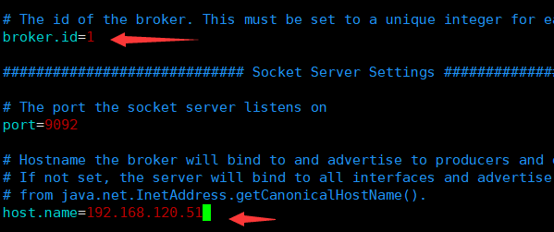

**启动kafka前请先启动zookeeper集群**

**bin/zookeeper-server-start.sh -daemon config/zookeeper.properties**

3.先启动zookeeper

再启动kafka   bin/kafka-server-start.sh config/server.properties

4.创建topic：  
bin/kafka-topics.sh --create --zookeeper localhost:2181 --replication-factor 3 --partitions 1 --topic mykafka

查看Topic：  
bin/kafka-topics.sh --list --zookeeper localhost:2181