解压：

tar -zxvf apache-maven-3.5.4-bin.tar.gz



#maven

export MAVEN_HOME=/home/z/apps/apache-maven-3.5.4

export PATH=${MAVEN_HOME}/bin:${PATH}

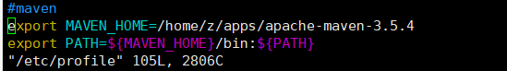

mvn -v

