Quotation - Massivit 1800 3D Printer

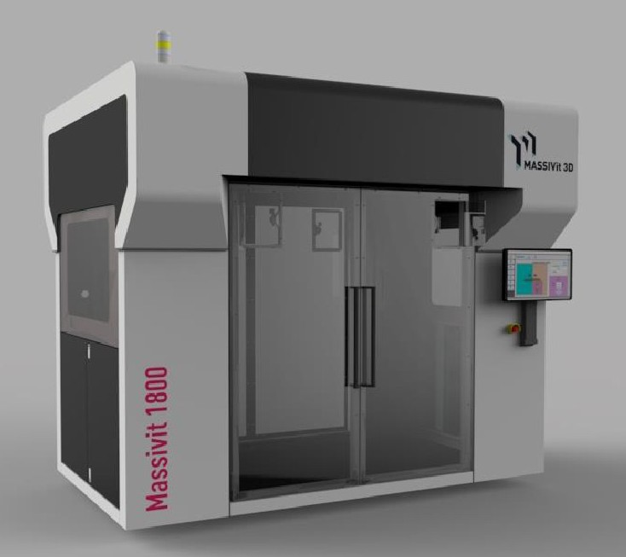
Date | 05/04/16
Company name | Matset

Dear Can,

Thank you for your interest in our products. We are pleased to offer you a 3D-printing system for the building of 3D objects directly from digital data. Following you will find our quotation and our general terms and conditions. We would be happy to discuss the quotation in more detail. For further questions please do not hesitate to contact me.

Kind regards,

Michael Denisov
Sales Director EMEA
michael.denisov@massivit.com
Mobile: +32 473 959154

To: __________ Date: ______

Item | Qty | Description |  | Unit Price | Total
 |  | System
1 | 2 | Massivit 1800 3D printer – reseller's price + DEMO discnt |  | 230000 | 460000
2 | 1 | 12 Month Manufacturer Warranty |  | Included | Included
3 | 2 | Massivit Smart (Slicer software / a pre-press)* |  | 5,000 | 10000
4 | 1 | Operator training on site – 3 working days |  | 3000 | Included
5 | 1 | Installation |  | Included | Included
6 | 2 | Dimengel® Start-Up for Installation (1 pail x 19kg) |  | 1900 | Included
7 | 10 | Dimengel® Printing resin - Shipped in 19kg pails |  | 1900 | Included
8 | 2 | Uptime Kit |  | 8750 | 14000
Sub Total 3XX,XXX |  |  | 484 000 Euro

Payment Terms
30% upon order confirmation 60% prior to shipment
10% upon completion of installation

General Terms
- This offer is valid for a period of 30 days from the date above.
- All prices are in EURO and do not include any applicable tax or VAT.
- Shipping Terms: Ex-Works – Lod, Israel. Insurance by customer. Shipping prices not included.
- Estimated Delivery: between 60 to 90 days from receiving a signed order and down payment
- No CAD or 3D modeling software is supplied with the machine.
- Manufacturers’ warranty covers all parts and labor except print heads. Printing heads are expected to require about 4 replacements per year and are available as new or refurbished parts. (Refurbish print head 1,800 euro, New print head 5,600 euro)
- The uptime kit includes a printing head and a Dimengel pump, nozzle tip and other parts.
- No additional equipment or devices are supplied other than items specifically listed in this quote.

Note
For estimating site preparations, please consult your local providers, based on the attached site preparation guide.

Printer Specifications

Print configuration | 2 printing heads capable of printing 2 different objects simultaneously
Print volume | W x L x H: 1.18 x1.5 x 1.8m / ~4 x 5 x 6 feet
Maximum Object Weight | Max. object weight 150kg /330 lbs
Productivity | Up to 35cm/14 inch per hour on z-axis  Print speed dependent on object's geometric shape, object size & print mode
Printing material | Dimengel® - Massivit proprietary UV LED Curing Gel
Workflow and software | Software on machine: Massivit proprietary front end software  Massivit Smart*: Massivit proprietary software for file preparation  Features: Scale, rotate, slice, support generation**  Input format: STL
System Dimensions | W x L x H: 3.1 x 2.2 x 2.8 meters / 10.17 x 7.2 x 9.1 feet
System weight | Unpacked ~2500kg / 5511 lbs.  Packed ~3000kg / 6613 lbs.

* Computer not included
** Features not included – file repair & healing, object design & editing, cut; solution may include several steps and several tools and not necessarily one integrated solution. Some features may be delivered through online tools.

