Attached is the STL and STEP for the ”Waterpark Arch”. It is around 15 m long and connected in four places. The connections aren’t included in the files as they will be made of steel. Here are some shots of it “in place”:

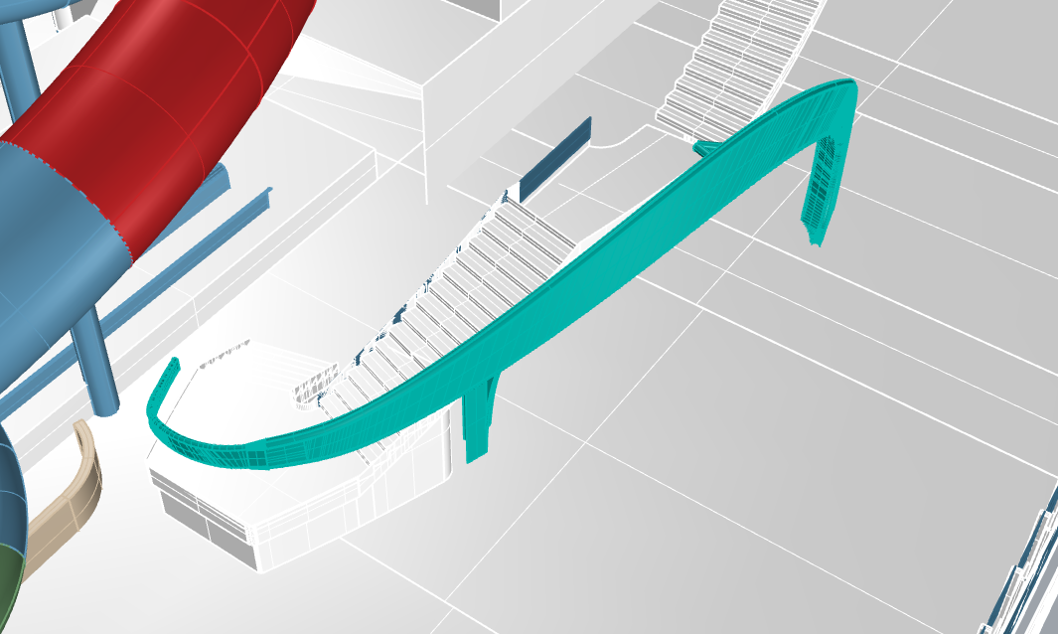

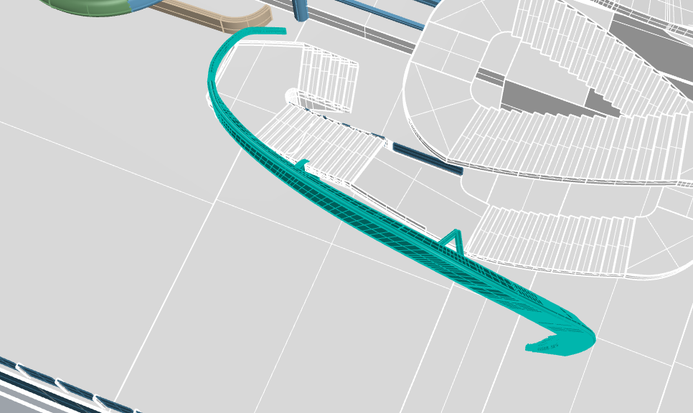

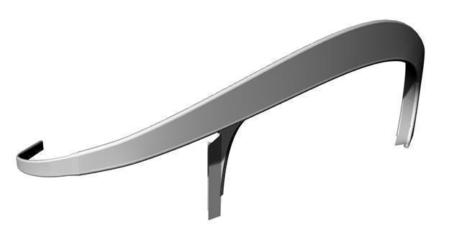

Here are some specification regarding the case. I don’t think they are much use for you on this very preliminary print simulation, but can perhaps help you think about the feasibility material-wise for the wind loads and mechanical fatigue from wind and vibrations to maybe see if it requires a skeleton inside or fiberglass shell.

Design criteria applicable for the water park arch derived from Water park criteria:

# **1 Design criteria**

The slides and the supporting structures will be designed for the use on an outside deck on a modern cruise vessel. The slides and supporting structures need to be designed with following dimensions:

## **1.1 Design loads**

- Max. side load 2.5 kN/m2

- Wind load 50 m/s

## **1.2 Max accelerations**

- ax = 1.84 m/s2 (longitudinal)

- ay = -2.56 m/s2 (transverse)

- az = 2.00 m/s2 (vertical)

## **1.3 Reaction forces**

- Fu-x = mu ax (longitudinal)

- Fu-y = mu ay (transverse)

- Fu-z = mu az+mu g (vertical)

mu = mass of the unit in ton

g = 9.81 m/s2

## **1.4 Ambient temperature**

The ship will be designed for summer and winter conditions. Also the tropical conditions must be taken in consider.

- The ships outside temperature: -7°C to +35°C

## **1.5 Noise**

- The maximum noise level on public open decks is 65 db(A).The noise limits are for structural noise. Air noises caused by the customers are exluded

## **1.6 Vibration**

Special attention is to be given that any harmful dynamic excitation of the slide and/or its parts is avoided, like wind excitations and other forces common on a cruise vessel in such area, like:

- Sea excitation, limit 0 – 4.0 Hz

- Propeller blade frequencies, limit 8.0 – 11.5 Hz

- 1st order engine frequency 10.0 Hz (limit 9.0 – 11.0 Hz)

Let me know what you think and if you need anything!