Signal & Noise 2026 — findings
How social media talked about LLMs, Jan–Sep 2026 · Northbank Media Lab research desk
Illustrative report. All numbers come from a synthetic sample of 387 fictional posts. The report quotes no real people and describes no real product releases.

Summary
Agentic coding is now the main topic in the LLM conversation. Its share of the conversation grew from 9% in January to 20% in September. Reasoning & test-time compute fell from 18% to 6%. The focus moved from how models think to what models do.
- Agentic coding grew most: 9% of the conversation in January, 20% in September. It is the largest theme, with 15% of all posts.
- Reasoning & test-time compute fell: 18% to 6%. It went from the largest theme to one of the smallest.
- Benchmarks & evals also fell: 12% to 6%.
- Three themes grew slowly: Compute & energy and Multimodal & voice each went from 9% to 12%. On-device AI went from 6% to 8%.
- Prices & tokens is the most negative theme: 53% of its posts are negative. That is more than twice the 23% average.
- Regulation & policy peaked in July: 12% of the conversation.

Sample and method
The sample has 387 hand-coded posts from 6 platforms. The sample represents a much larger stream of posts. Each post has 1 of 10 themes and 1 sentiment label: positive, neutral or negative.
- Share of the conversation: the percentage of a month's posts that have a given theme.
- % negative: the percentage of a theme's posts that have a negative label.
- Tools: GridCraft calculated all percentages with COUNTIFS formulas. WordCraft typed and formatted this report.

Share of the conversation by theme
Table 1. Share of the conversation in January, September and overall, and % negative per theme. Synthetic data.
Theme | Jan | Sep | Change | Jan–Sep | % negative
Agentic coding | 9% | 20% | +11 pts | 15% | 10.3%
Open-weight models | 12% | 12% | 0 pts | 12% | 20.8%
Multimodal & voice | 9% | 12% | +3 pts | 11% | 18.6%
Compute & energy | 9% | 12% | +3 pts | 11% | 41.5%
Reasoning & test-time compute | 18% | 6% | −12 pts | 10% | 12.5%
Prices & tokens | 12% | 8% | −4 pts | 9% | 52.8%
Regulation & policy | 6% | 8% | +2 pts | 8% | 12.5%
Benchmarks & evals | 12% | 6% | −6 pts | 8% | 3.1%
Safety & trust | 6% | 8% | +2 pts | 8% | 46.7%
On-device AI | 6% | 8% | +2 pts | 7% | 22.2%
All themes | 100% | 100% |  | 100% | 23.3%
Figure 1 shows the monthly share of the conversation for 4 key themes. Agentic coding (coral) rises. Reasoning (violet) and Benchmarks (pink) fall.
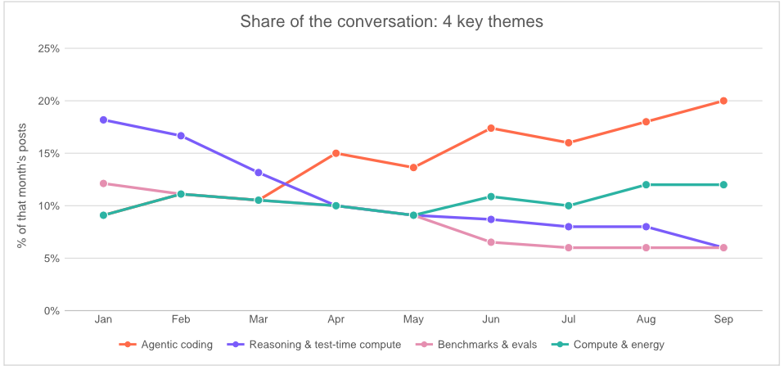
Figure 1. Share of the conversation for 4 key themes, Jan–Sep 2026. GridCraft made the chart from the workbook.

Findings

1. Agentic coding became the main topic
Agentic coding grew from 9% of the conversation in January to 20% in September. It is also one of the most positive themes: 48% positive, 10% negative. Posts describe agents that open pull requests. The test suite becomes the real specification.

2. Reasoning became routine
Reasoning & test-time compute fell from 18% of the conversation to 6%. More than half of its posts are neutral (53%). Posts treat longer thinking as a paid setting, not as news.

3. Benchmarks & evals fell
Benchmarks & evals fell from 12% of the conversation to 6%. It is also the least negative theme: only 3% of its posts are negative.

4. Compute, devices and voice grew slowly
Compute & energy grew from 9% to 12% of the conversation. On-device AI grew from 6% to 8%. Multimodal & voice grew from 9% to 12%. Energy posts lean negative (41%): power contracts, not GPU waitlists, are now the main complaint.

5. Prices & tokens: price per token down, bill up
Prices & tokens is the most negative theme. 53% of its posts are negative, more than twice the 23% average. Safety & trust (47%) and Compute & energy (41%) also lean negative.
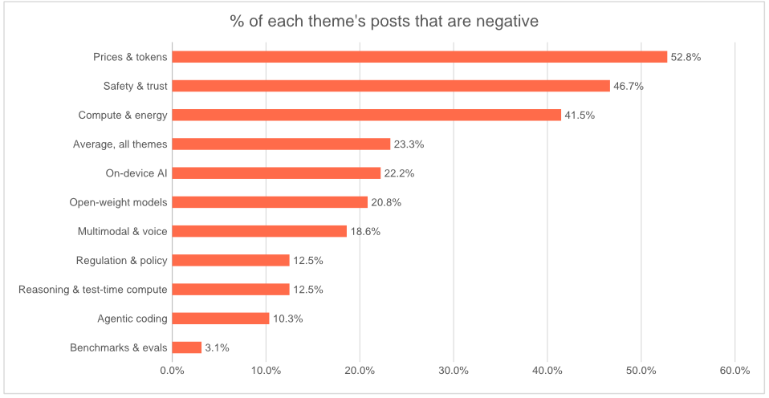
Figure 2. % of each theme's posts that are negative. The average for all themes is 23%.

6. Regulation & policy peaked in July
Regulation & policy grew from 6% of the conversation in January to 12% in July. It then dropped to 8% in August and September.

Platforms
- Bluesky, Mastodon, Hacker News and Threads: about 18% of the sample each.
- Reddit and LinkedIn: about 14% of the sample each.

Limitations and next steps
- The data is synthetic. Use the numbers to see the workflow, not as evidence.
- The sample is small. One post more or less changes a monthly share by 2 to 3 points.
- Each post has only 1 theme and 1 sentiment label. Real posts often mix themes.
- Next: track the share of agentic coding each month. Add a cost-per-task view to Prices & tokens.
Signal & Noise 2026 is an illustrative project of the fictional Northbank Media Lab. All data is synthetic.

