DG INTERNS HUB

WEEK 11 — SOC THREAT DETECTION, ALERT CORRELATION & INCIDENT RESPONSE
Correlating Wazuh and Snort alerts, investigating a failed-login incident, classifying alerts and preparing the response

Candidate | Md Mohtasim (DG/JULY/CYBER/017)
Module | Security Operations Center (SOC) — Threat Detection, Alert Correlation & Incident Response
Builds on | Wazuh SIEM lab
Monitored endpoint | Ubuntu endpoint with Wazuh agent (agent name in screenshots: ubuntu-agent)
Environment | Local lab — VirtualBox, host-only network 192.168.56.0/24
Primary tools | Wazuh (manager 4.14.8), Snort, OpenSSH, Wazuh File Integrity Monitoring
Submission date | deadline 21-10-2026

Introduction
Week 9 produced a network sensor (Snort) and Week 10 added a SIEM (Wazuh) that collects host evidence. Week 11 moves from running the tools to using them the way a SOC analyst does: reading alerts from both sources together, deciding which are real, rating their severity, extracting indicators of compromise (IOCs), and writing the response. The same private lab is reused. Every event was generated deliberately by the author on machines the author controls, and nothing was directed at any third-party system.

Objectives
    - Explain alert correlation, true and false positives, IOCs, and the L1/L2/L3 analyst roles.
    - Monitor Wazuh for authentication, file, system and agent events and collect at least ten security events.
    - Compare what Snort and Wazuh detect for the same activity and explain the differences.
    - Investigate one incident end to end, extract its IOCs, and classify at least fifteen alerts.
    - Write an incident response procedure, a SOC incident ticket (DG-SOC-001) and three response playbooks.

SOC Alert Correlation (Task 1)

What is security alert correlation?
Alert correlation is the process of linking separate alerts and log events that share something in common
— the same source IP, user, host, rule family or time window — so that together they tell one story. A single failed login is noise; eight failed logins from one address within two minutes, followed by a success for the same account, is an attack narrative. Wazuh does part of this automatically (frequency rules such as 5763 turn many 5760 failures into one brute-force alert) and the analyst does the rest by pivoting across tools.
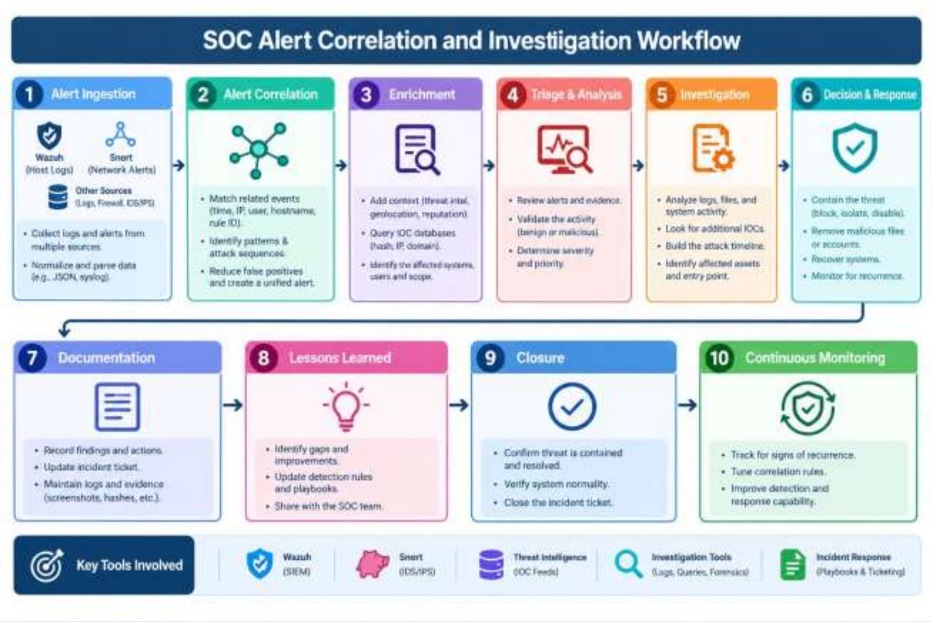
Figure 1 — SOC alert correlation and investigation workflow (ingestion to continuous monitoring)

Why SOC analysts correlate multiple alerts

    - Context. One alert rarely shows intent; a sequence does (scan, then guessing, then login, then privilege use).
    - Fewer false positives. An alert that two independent sources agree on is more likely real.
    - Prioritisation. Correlated activity against one asset can be raised in severity, while isolated low-level events stay low.
    - Coverage. Network sensors (Snort) and host sensors (Wazuh) each have blind spots; correlation fills them in.
    - Timeline and evidence. Joined events give the start time, scope and impact needed for the ticket.

False positive vs true positive

Term | Meaning | Example in this lab
True positive (TP) | The alert fired and the activity is genuinely malicious or policy-violating. | Rule 5763 raised after repeated  wrong-password SSH attempts that were really made.
False positive (FP) | The alert fired but the activity is benign. | A Snort ICMP rule firing on a normal ping between lab hosts; a user mistyping a password twice.
True negative / false negative | No alert and nothing happened / no alert although something malicious happened. | Snort raised nothing for SSH guessing because no Snort rule covers port 22 — a false negative for Snort.
Authorised-test note. An alert caused by the analyst's own authorised test is still a technically correct detection; it is labelled "true positive — authorised test" so that tuning does not wrongly remove a good rule.

IOC (Indicator of Compromise)
An IOC is an observable artefact showing that a system has been, or is being, attacked: a malicious IP or domain, a file hash or path, an unexpected account, a port or protocol, a rule or signature that fired, and the timestamp. IOCs let the SOC search other systems for the same activity and block it. The IOCs for this incident are tabulated in Section 7.

Event vs alert vs incident

Term | Definition | Example
Event | Any recorded occurrence in a system or network. Most events are routine. | A line in /var/log/auth.log: "Failed password for root".
Alert | An event (or group) that matched a detection rule and was flagged for review. | Wazuh rule 5710 level 5, or Snort SID 1:1000001.
Incident | One or more confirmed alerts that violate security policy and require a response. | DG-SOC-001: repeated failures then a successful root login.

Threat detection vs incident response
Threat detection is the continuous work of collecting telemetry, running rules and triaging alerts to find suspicious activity. Incident response starts once an incident is confirmed: contain it, remove the cause, restore service and learn from it. Detection answers "is something wrong?"; response answers "what do we do about it?". The two share evidence, which is why the incident ticket records both.

Roles of L1, L2 and L3 analysts

Level | Main responsibility | In this incident
L1 — Triage | Monitor the queue, validate alerts, remove obvious false positives, open tickets, escalate with evidence. | Saw rule 5710/5763, checked the source against the asset list, opened DG-SOC-001.

Level | Main responsibility | In this incident
L2 — Investigation | Deep analysis, correlation across tools, scoping, containment recommendations, IOC extraction. | Searched all alerts from the source IP, found the successful login, extracted IOCs, recommended block and reset.
L3 — Hunting / expert | Threat hunting, forensics, malware analysis, detection engineering, major-incident lead. | Would write new Snort/Wazuh rules for SSH guessing and hunt for the same source on other hosts.

Wazuh Monitoring (Task 2)
The Wazuh environment from Week 10 was reused: an all-in-one server (manager, indexer, dashboard) and an Ubuntu endpoint reporting through a Wazuh agent. The monitoring covered authentication events, failed and successful logins, file changes, system events, security alerts and agent status.

Dashboard and server status
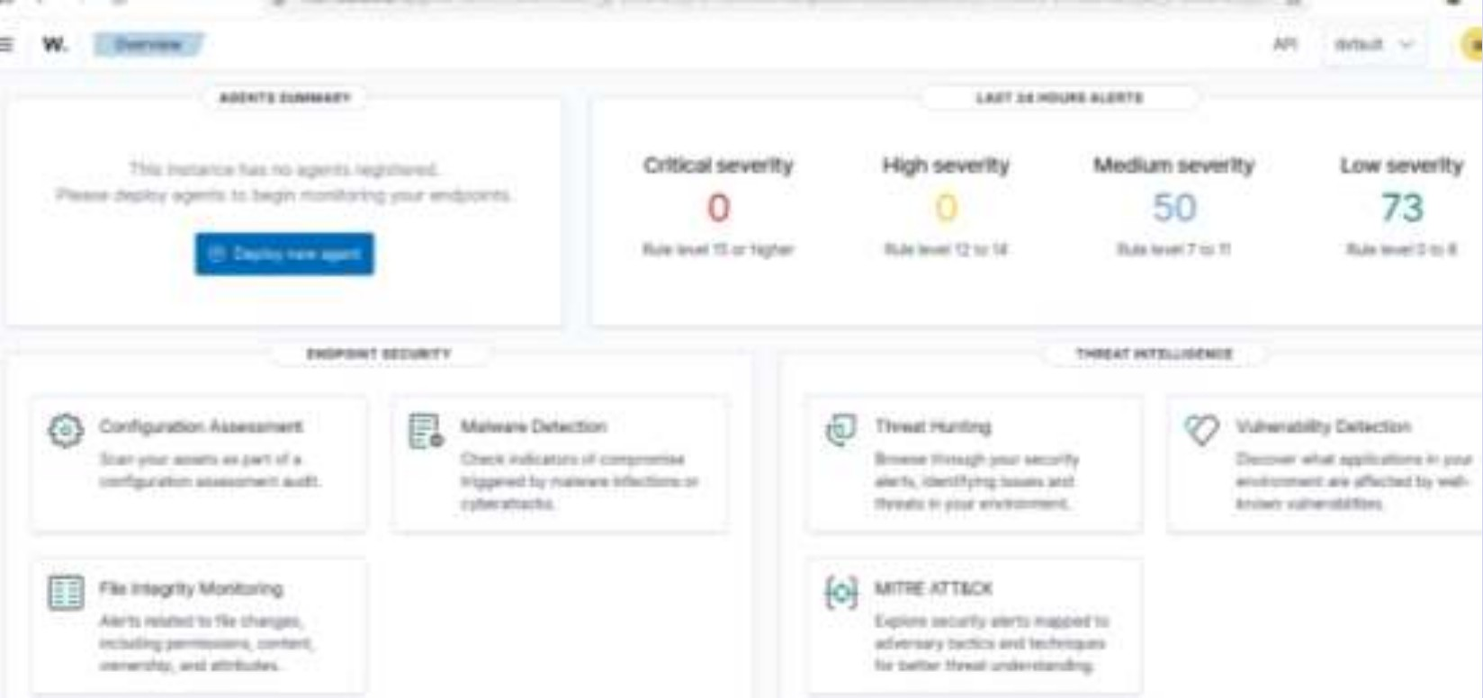
Figure 2 — Wazuh overview: alert counts by severity for the last 24 hours (0 critical, 0 high, 50 medium, 73 low)

The overview gives the first triage view: no critical or high alerts, 50 medium and 73 low in the last 24 hours, with the endpoint-security and threat-intelligence modules (File Integrity Monitoring, MITRE ATT&CK, Vulnerability Detection, Threat Hunting) one click away.
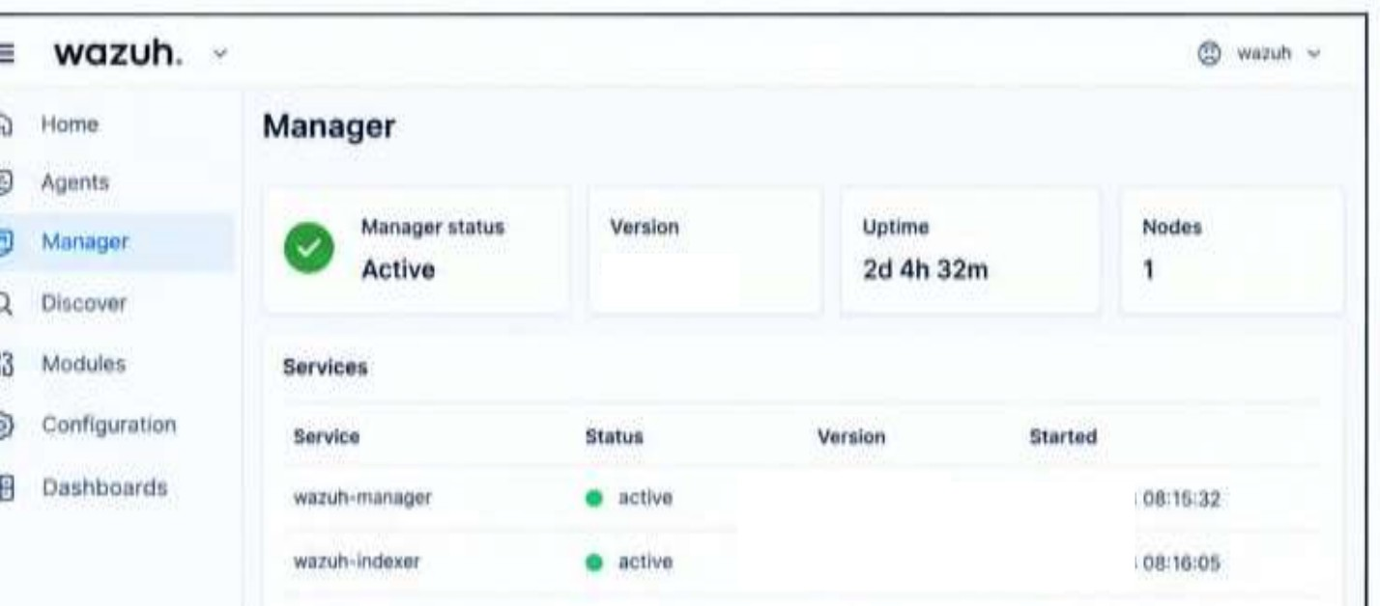
Figure 3 — Wazuh manager status: Active, version 4.14.8, uptime 2d 4h 32m, wazuh-manager and wazuh-indexer services active

Authentication events

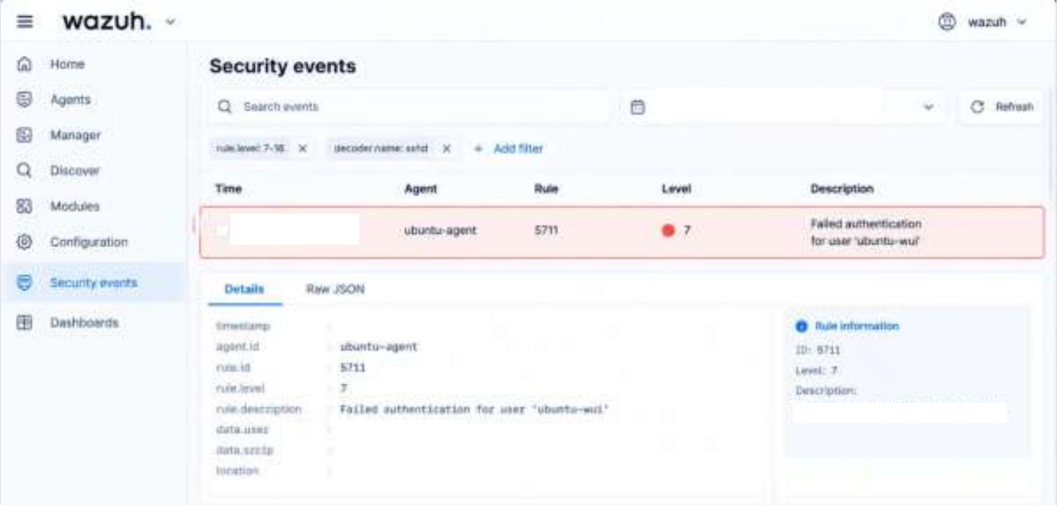
Figure 4 — Failed authentication event (rule 5711, level 7, location /var/log/auth.log) shown in Security events

The event detail shows the fields an analyst reads first: agent, rule ID and level, rule description, target user, source IP (masked in the screenshot) and the log location. A level-7 failed authentication is in the medium band of the dashboard.
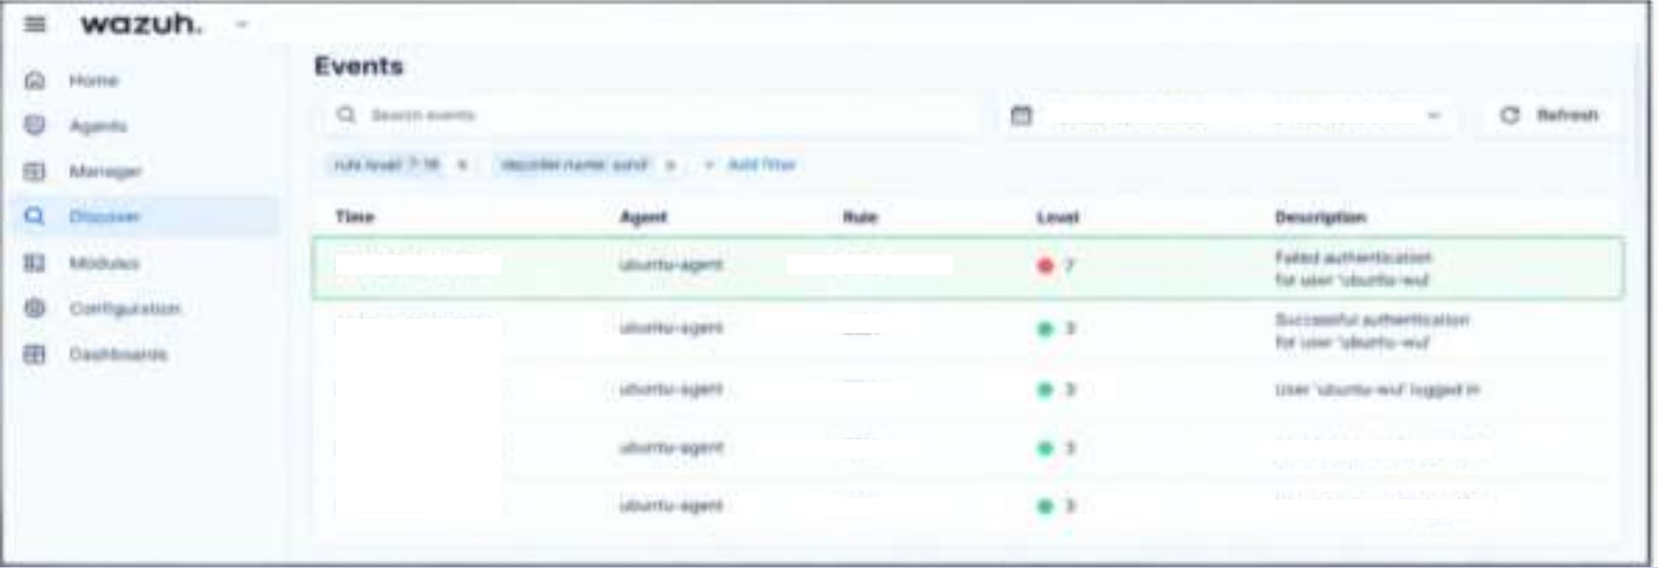
Figure 5 — Authentication alert timeline: one failed login followed by successful authentication and user-logged-in events

Collected security events
Ten events were collected from the Wazuh Events / Threat Hunting view (rule IDs and levels are Wazuh defaults; the dashboard values take precedence).

# | Category | Event / description | Rule ID | Level | Source
1 | Authentication | sshd: attempt to login using a non-existent user | 5710 | 5 | /var/log/auth.log
2 | Failed login | sshd: authentication failed (valid user, wrong password) | 5760 | 5 | /var/log/auth.log
3 | Failed login | Failed authentication for user (Figure 4) | 5711 | 7 | /var/log/auth.log
4 | Brute force | sshd: brute force trying to get access to the system (many failures, one source) | 5763 | 10 | /var/log/auth.log
5 | Successful login | sshd: authentication success | 5715 | 3 | /var/log/auth.log
6 | System event | PAM: login session opened | 5501 | 3 | /var/log/auth.log (PAM)
7 | Privilege use | Successful sudo to ROOT executed | 5402 | 3 | /var/log/auth.log (sudo)
8 | File change | File added to the system (monitored folder) | 554 | 5 | syscheck (FIM)

# | Category | Event / description | Rule ID | Level | Source
9 | File change | Integrity checksum changed | 550 | 7 | syscheck (FIM)
10 | Agent / system | Manager and indexer services active; agent reporting (Figure 3) | — | — | Manager status
Observation. The cluster of events 1–7 is one story told by seven rules. Viewed one at a time they are low or medium; viewed together by source IP and time they describe guessing, success and privilege use.

Snort Monitoring (Task 3, part 1)
Snort from Week 9 runs as a passive network IDS (the console shows afpacket DAQ configured to passive and 300 patterns loaded). The custom rule with SID 1:1000001 raises "CUSTOM ICMP Ping Detected" for each ICMP echo it sees between lab hosts.
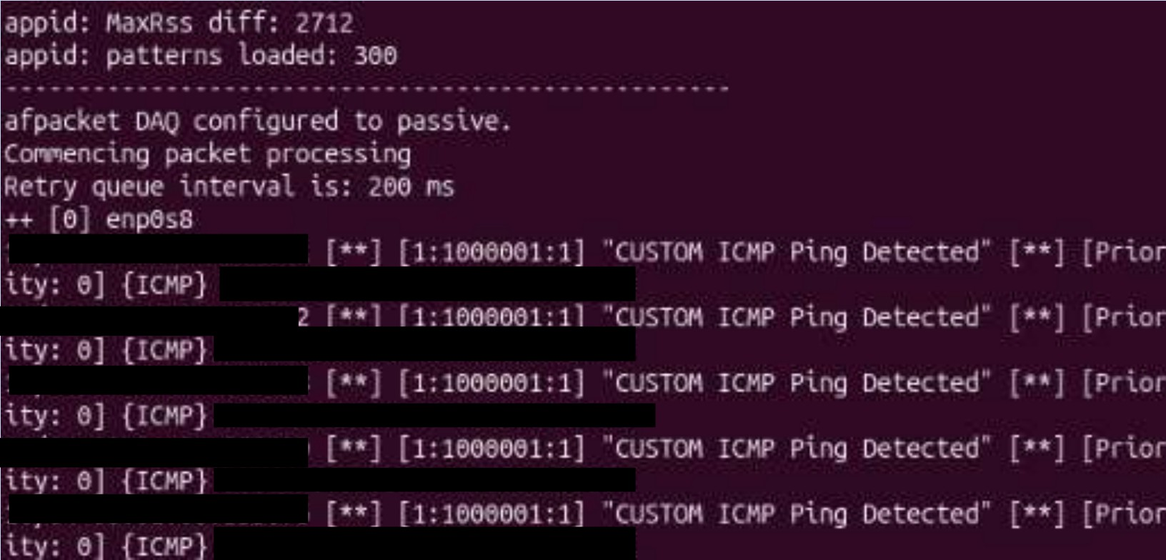
Figure 6 — Snort console: repeated "CUSTOM ICMP Ping Detected" alerts, rule 1:1000001, priority 0, protocol ICMP

Each line contains the timestamp, rule identifier (generator:SID:revision), message, priority, protocol and the source and destination addresses. Snort says what crossed the wire; it does not say who logged in or what changed on a host.

Snort vs Wazuh Alert Comparison (Task 3, part 2)
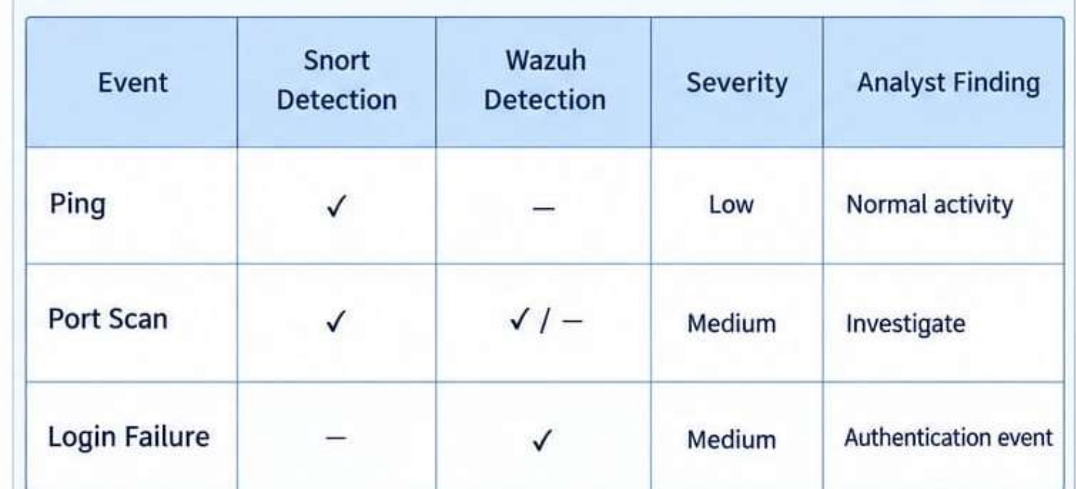
Figure 7 — Snort vs Wazuh event comparison (✓ detected, — not detected)

Event | Snort Detection | Wazuh Detection | Severity | Analyst Finding
Ping (ICMP) | ✓ | — | Low | Normal activity
Port scan | ✓ | - / — | Medium | Investigate
Login failure | — |  | Medium | Authentication event
File change in monitored path | — | - (FIM) | Medium | Check whether authorised
Successful login after failures | — |  | High | Escalate — possible compromise

Why one tool detects an event and the other does not
    - Different vantage points. Snort inspects packets on the wire; Wazuh reads logs and file state on the host. A ping crosses the wire but is not logged by the host, so only Snort sees it.
    - Different rules. Snort only alerts on what a rule describes. The Week 9 rules cover ICMP and HTTP, so SSH password guessing produced no Snort alert; Wazuh has default SSH rules (5710, 5760, 5763).
    - Encryption. SSH payloads are encrypted, so Snort cannot read the failed password; the host knows the result of the authentication.
    - Port scan ("✓ / —"). Snort sees the SYN packets of a scan directly. Wazuh sees it only if the host logs the connections or a Snort/firewall log is forwarded to the agent, so its detection depends on configuration.
    - Time and state. Wazuh keeps the history needed to count failures (frequency rules); Snort treats each packet or session on its own unless a threshold is configured.
The two tools are complementary: Snort shows what crossed the network, Wazuh shows what happened on the machine, and correlating them gives the whole story.

SOC Investigation (Task 4)
Scenario. Multiple failed login attempts were detected on a Linux endpoint, followed by a successful login. The investigation was carried out in the authors own lab, as an L1/L2 analyst would handle an alert from an unknown host. The impact, containment and recovery text describes the production response; the detection facts come from the lab.

Investigation question | Finding
When did the activity start? | With the first failed SSH password for the account (Wazuh rule 5760/5710). Exact time: read from the first event in the Figure 5 timeline [ hh:mm:ss ].
Which account was targeted? | root and the standard user account on the Ubuntu endpoint (events show user "ubuntu-wui"); the ticket records root as the account of concern.
Source IP | The lab attacker host on the 192.168.56.0/24 host-only network (Kali, 192.168.56.1). The address is masked in the evidence screenshots.
Number of failed attempts | Several failures inside the correlation window (threshold for rule 5763 is eight in two minutes); exact count [ n ] from the dashboard filter data.srcip.
Was there a successful login? | Yes — "Successful authentication" and "User logged in" events follow the failure (Figure 5).
What happened after login? | A PAM session opened (5501) and sudo to root was executed (5402). No malware was found and no unexpected file changes were seen outside the test folder.
Which Wazuh rule generated the alert? | 5710 / 5760 / 5711 for individual failures; 5763 for the brute-force pattern; 5715 for the success.
Did Snort detect related network activity? | No related alert. Snort covers ICMP/HTTP only, so SSH guessing was invisible to it (a false negative for Snort).
True or false positive? | True positive — authorised test. Source, timing and account match the planned lab test. In production it would be escalated because success followed the failures.

Investigation timeline

Step | Event | Rule
1 | First failed SSH password from the source | 5760 / 5710
2 | Failure threshold crossed — brute-force alert | 5763
3 | Successful SSH authentication for the same account | 5715
4 | PAM session opened | 5501
5 | sudo to root executed | 5402
6 | Analyst pivots on source IP, confirms no Snort alert, opens ticket DG-SOC-001 | —

Verdict
The sequence — failures, success, session and privilege use from one source — is the pattern of a successful password-guessing attack, so it is treated as High severity until the source is confirmed as authorised. Because the source is the analyst's own lab host, the final classification is a true positive from an authorised test, and the severity would be reduced once that is documented.

IOC Identification (Task 5)
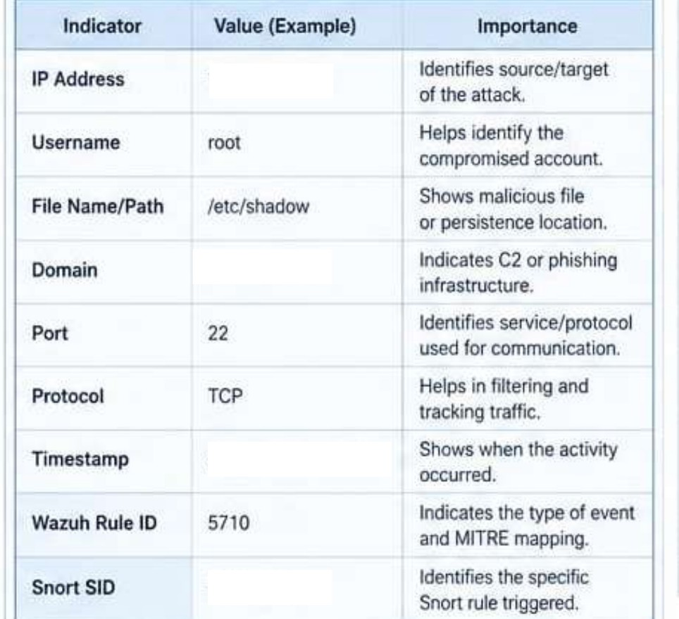
Figure 8 — IOC identification table for the selected incident

The table below lists the indicators extracted from the incident and why each one matters. Values that are masked in the screenshots are shown as lab ranges or placeholders.

Indicator | Value (this incident) | Importance
IP address | Source: lab attacker host 192.168.56.1; target: Ubuntu endpoint (192.168.56.40) | Identifies who attacked what; used to search other logs and to block the source.
Username | root (also standard account "ubuntu-wui" in the failed-auth events) | Shows which account was targeted or possibly compromised; drives the password reset.
File name / path | /etc/shadow, /etc/passwd,  ~/.ssh/authorized_keys | Files an attacker reads or edits after login to steal hashes, add accounts or keep persistence.
Domain | None observed (internal lab traffic only) | A domain would indicate command-and-control or phishing infrastructure; its absence supports "no data exfiltration seen".
Port | 22 (SSH) | Identifies the service attacked and the rule that should cover it.
Protocol | TCP | Helps filter traffic and write the Snort rule for repeated SSH connection attempts.
Timestamp | [ hh:mm:ss ] of first failure, threshold alert and successful login | Builds the timeline and shows how long the attacker had access.
Wazuh rule ID | 5710 / 5760 / 5763 (brute force), 5715  (success), 5402 (sudo) | Identifies the type of event and its MITRE ATT&CK mapping (T1110 Brute Force).
Snort SID | 1:1000001 (ICMP ping, related lab traffic); no SID for SSH | Shows what the network sensor saw and documents the detection gap.

Alert Classification (Task 6)
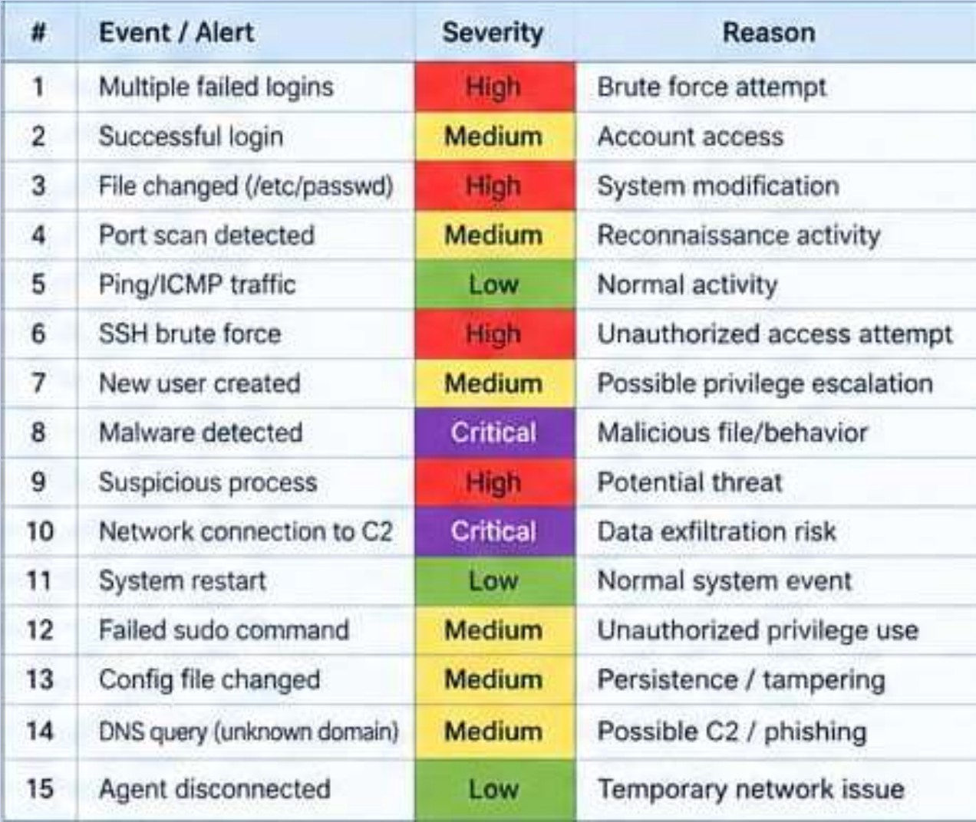
Figure 9 — Initial classification of 15 security alerts / events

Alerts were classified by impact, context and available evidence into five levels: Informational (no action), Low (routine, log only), Medium (investigate), High (likely attack, respond now) and Critical (confirmed compromise or data loss risk, immediate response). The final classification with reasons:

# | Event / alert | Severity | Reason
1 | System restart | Informational | Expected maintenance event; recorded for the audit trail only.
2 | Agent reconnected after restart | Informational | Confirms monitoring is restored; no security impact.
3 | Ping / ICMP traffic (Snort 1:1000001) | Low | Common network diagnostics; no sign of malicious intent on its own.
4 | Agent disconnected | Low | Usually a temporary network issue, but a gap in visibility; check if it persists.
5 | Port scan detected | Medium | Reconnaissance that often precedes an attack; investigate the source and targeted ports.
6 | Failed sudo command | Medium | Possible unauthorised privilege attempt; may also be a typing error.
7 | Config file changed | Medium | Possible tampering or persistence; verify against change records.
8 | DNS query for unknown domain | Medium | Possible C2 or phishing lookup; reputation check needed.
9 | New user created | Medium | Possible privilege escalation or backdoor account; confirm it was authorised.
10 | Multiple failed logins (5710/5760) | High | Brute-force pattern against an account; may lead to compromise.
11 | SSH brute force (5763) | High | Many failures from one source — an unauthorised access attempt.
12 | Successful login after failed burst | High | The guessing may have worked; account must be treated as compromised until verified.
13 | File changed (/etc/passwd) | High | Direct change to system account data; typical of persistence.

# | Event / alert | Severity | Reason
14 | Malware detected | Critical | Malicious file or behaviour on a host; isolate and eradicate immediately.
15 | Network connection to known C2 | Critical | Active command-and-control channel and data exfiltration risk.

Incident Response (Task 7)
The procedure below follows the seven-stage lifecycle for the selected incident (repeated SSH failures followed by a successful root login).
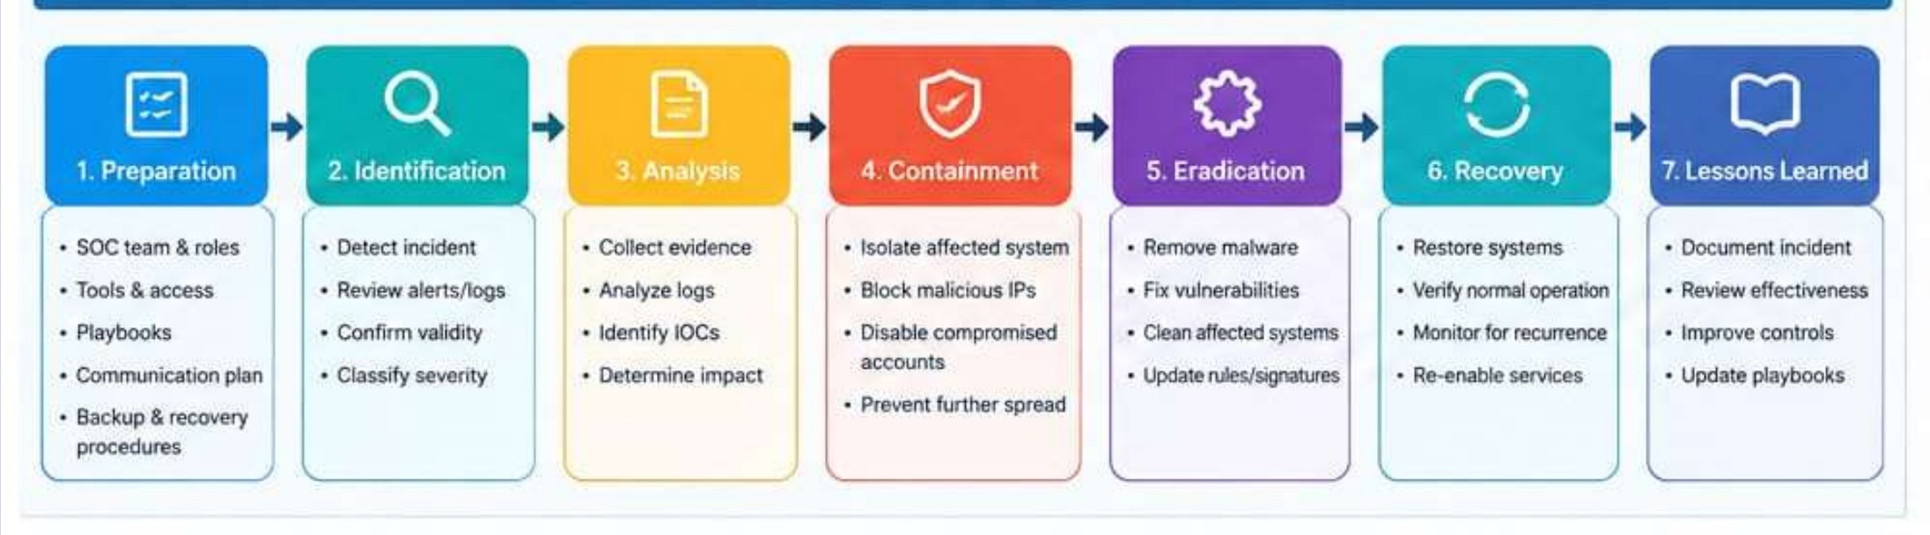
Figure 10 — Incident response lifecycle: preparation to lessons learned

Preparation — what should a SOC have ready?
    - Defined SOC roles (L1/L2/L3), escalation contacts and a communication plan.
    - Wazuh agents on all critical hosts, Snort on the network path, and an up-to-date asset list.
    - Written playbooks, a ticketing system, and tested backup and recovery procedures.

Identification — how was it detected?
Wazuh rule 5763 raised a brute-force alert for the Ubuntu endpoint. The analyst reviewed the alert, searched all events from the source IP, found the later success (5715) and sudo to root (5402), and confirmed that Snort had no related alert. Validity was confirmed from the raw auth.log lines.

Analysis — what evidence was collected?
    - Alert JSON for rules 5763/5715/5402 (rule ID, level, agent, srcip, dstuser, timestamp).
    - Raw /var/log/auth.log lines showing failures and the later success.
    - Dashboard timeline filtered on the source IP; Snort alert log (negative result).
    - FIM results and the IOC list from Section 7.

Containment — what immediate action should be taken?
    - Preserve evidence first: export alerts, copy auth.log, record FIM results.
    - Block the source IP at the host or network firewall (Wazuh active response was left disabled in the lab).
    - Lock the targeted account and end active sessions; isolate the endpoint if the activity is judged unauthorised.

Eradication — how should the root cause be removed?
    - Reset passwords and check /etc/passwd, /etc/sudoers.d and authorized_keys for unknown entries.
    - Remove any persistence found (accounts, keys, cron jobs) and fix the weakness: SSH exposed with password authentication and no lockout.
    - Update Snort and Wazuh rules for repeated SSH attempts.

Recovery — how should the system be restored?
    - Restore from a known-good snapshot if any system file changed without explanation.
    - Harden SSH: key-only login, PermitRootLogin no, restricted users, fail2ban, and MFA where possible.
    - Return the host to the network after a clean scan and monitor it in the dashboard for several days.

Lessons learned — how can similar incidents be prevented?

    - Host logs caught what the network sensor missed; keep both tools and correlate them.
    - Add a Snort rule for repeated SSH connection attempts and test Wazuh active response in the lab.
    - Enforce strong password policy and MFA; review alert thresholds; update the playbooks.

SOC Incident Ticket (Task 8)
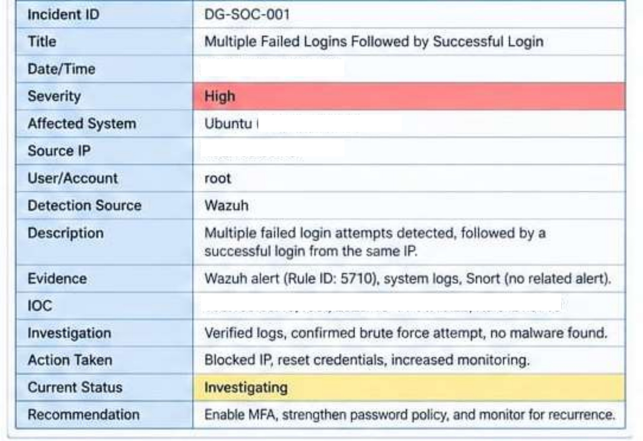
Figure 11 — SOC incident ticket DG-SOC-001 (as recorded)

Field | Value
Incident ID | DG-SOC-001
Title | Multiple Failed Logins Followed by Successful Login
Date/Time | [ date and time of the first alert ]
Severity | High
Affected System | Ubuntu endpoint (Wazuh agent), host-only lab 192.168.56.0/24
Source IP | Lab attacker host (Kali, 192.168.56.1)
User/Account | root
Detection Source | Wazuh (Snort: no related alert)
Description | Multiple failed login attempts were detected, followed by a successful login from the same IP.
Evidence | Wazuh alert (Rule ID 5710 / 5763), system logs (auth.log), Snort alert log (no related alert).
IOC | Source IP; username root; port 22/TCP; Wazuh rules 5710, 5763, 5715; Snort SID 1:1000001 (related ICMP only).
Investigation | Verified logs, confirmed a brute-force attempt followed by a login, no malware found.
Action Taken | Blocked the source IP, reset credentials, increased monitoring.
Current Status | Investigating
Recommendation | Enable MFA, strengthen the password policy, add SSH detection to Snort and monitor for recurrence.

Alert Response Playbooks (Task 9)

Playbook 1 — Multiple Failed Logins

Stage | Action
Detection | Wazuh rules 5710 / 5760 / 5763 raised for one source or account; alert level and count noted.
Investigation | Review auth.log; check source IP, target accounts, timing and frequency; search all alerts from the same source.
Verification | Check whether a successful login (5715) followed; confirm with the user or asset owner whether the activity was expected; check threat intelligence for the IP.
Containment | If unauthorised: block the IP, lock or reset the account, end active sessions, preserve evidence first.
Escalation | Escalate to L2 if a success followed the failures, a privileged account was targeted, or the source is external; open or update the ticket.

Playbook 2 — Port Scan

Stage | Action
Detection | Snort alert (or Wazuh/firewall log) showing many connection attempts to different ports in a short time.
Identify source | Record source IP, targeted host and ports, protocol and duration; check whether the source is internal or external.
Verify authorization | Compare with the approved scan schedule, vulnerability scanner addresses and the asset list.
Investigate | Look for follow-up activity from the same IP in Wazuh (logins, file changes); check which ports were open and whether any exploit attempts followed.
Response | If authorised, close as informational. If not, block the source with approved controls, close unneeded ports, raise monitoring and escalate if exploitation is seen.

Playbook 3 — Suspicious File / System Change

Stage | Action
Detection | Wazuh FIM alert (rules 550/553/554) or a configuration change alert on a monitored path.
Identify file | Record path, old and new hash, size, owner and time; classify the file (system, configuration, binary, log).
Check user / process | Find which user and process made the change (sudo, SSH session, package manager); compare with change tickets.
Investigate | Search for related alerts (new users, failed logins, outbound connections); scan the file; check persistence locations.
Response | If authorised, document and close. If not, preserve a copy, restore from baseline, remove persistence, reset credentials and escalate.

Findings & Recommendations

Findings
    - Host and network sensors saw different parts of the same activity: Snort saw ICMP traffic, Wazuh saw the SSH failures, success and sudo use.
    - Snort produced no alert for SSH guessing because the Week 9 rule set covers only ICMP and HTTP — a clear detection gap.
    - Individual failed-login alerts are low value; the correlation rule (5763) and the pivot on source IP turned them into an incident.
    - A successful login after a failure burst was the most important pivot and raised the incident to High.
    - The 15-alert classification showed that routine events (restart, ping, agent reconnect) can be kept low while access, privilege and C2 events need fast action.

Recommendations

# | Recommendation | Benefit
1 | Add a Snort rule with a threshold for repeated connections to port 22. | Closes the network-side detection gap for SSH guessing.
2 | Enable MFA and key-only SSH; disable direct root login. | Makes password guessing ineffective.
3 | Test Wazuh active response in the lab to block repeated-failure sources. | Faster containment, less analyst delay.
4 | Tune noisy rules (for example the ping rule) with thresholds and suppression. | Fewer false positives and a cleaner queue.
5 | Keep the asset list and playbooks current; review them after every incident. | Speeds up source recognition and consistent decisions.
6 | Move Snort to its own VM, separate from the traffic source. | More realistic and independent sensor.

Limitations
    - Single-person lab: attacker, sensor and administrator are the same person, so results show the detection loop rather than realistic attacker behaviour.
    - Default rule set and a small, deliberately generated sample; no claims are made about false-positive rates at scale.
    - Some fields (IP addresses, timestamps) are masked in the evidence screenshots and are marked as placeholders in the text.

Conclusion
Week 11 turned the Week 9 sensor and the Week 10 SIEM into a working SOC process. Alerts from Wazuh and Snort were compared, an SSH failed-login-then-success incident was investigated, its IOCs were extracted, fifteen alerts were classified with reasons, and the response was written as a seven-stage procedure, a ticket (DG-SOC-001) and three playbooks. The main lesson is that no single tool or alert tells the whole story: correlation across network and host evidence, verified before escalation and documented clearly, is what makes a SOC investigation reliable.

Appendix — Useful Wazuh search filters

Purpose | Filter / command
Alerts from one source | data.srcip: 192.168.56.1
Brute-force alerts | rule.id: 5763
Authentication failures | rule.groups: authentication_failed

Purpose | Filter / command
Snort / IDS events | rule.groups: ids
Alerts for one endpoint | agent.name: <agent name>
Live alerts on the server | sudo tail -f /var/ossec/logs/alerts/alerts.json

