YogaFlow
Software Design Document (SDD)
CSCI 5520 - AI-Driven Software Development
Prepared By | Shubham Pandey
Date | October 8, 2026
Document Version | v1.0 Final Design
Project Repository / URL | Figma Make prototype included in Section 6.2

1 Problem & Users

1.1 Problem Description
People who are new to yoga often have difficulty finding clear, trustworthy, and well-organized guidance that matches their current ability and goals. Information about yoga poses, breathing exercises, and meditation is spread across videos, social media posts, blogs, and fitness apps. A beginner may find useful information, but it is often inconsistent, too advanced, difficult to search, or presented without enough context to help the person decide what is appropriate.
This creates several problems. Users may waste time switching between different sources, may repeat the same limited exercises because they cannot easily discover alternatives, and may have difficulty building a consistent wellness routine. Generic search results also do not always make it obvious whether a pose is beginner-friendly, what body area it focuses on, or whether the user should avoid it because of a limitation.
The core problem is the lack of a simple, focused, and beginner-friendly digital experience that helps users discover yoga and wellness practices, understand them, and organize practices that fit their needs without overwhelming them with unnecessary complexity.

1.2 Target Users & Stakeholders
Primary User - Beginner Yoga Practitioner: A person with little or no yoga experience who wants easy-to-understand instructions, simple filtering, and confidence that the selected practice matches their current level.
Primary User - Regular Wellness User: A person who already practices yoga, breathing, or meditation and wants a faster way to discover practices, save favorites, and create a repeatable routine.
Stakeholder - Yoga Instructor / Wellness Coach: A professional who may recommend practices to students and benefits from clear, consistent terminology and organization.
Stakeholder - Content Administrator: A future administrator responsible for maintaining pose, breathing, and meditation content so information remains accurate and organized.
Stakeholder - Project Owner / Developer: Responsible for maintaining the application, protecting user data, keeping the design consistent with requirements, and preventing unnecessary scope expansion.

2 Proposed Solution & Scope

2.1 Proposed Solution
YogaFlow is a responsive web application that organizes yoga poses, breathing exercises, and meditation practices into one simple wellness library. Users can browse or search practices, filter them by useful categories such as difficulty or practice type, open detailed practice pages, save favorite items, and assemble a simple personal routine.
The experience is designed around clarity rather than feature overload. Each practice will use consistent titles, descriptions, difficulty labels, instructions, and safety notes where appropriate. Users should be able to move from discovery to a selected practice in only a few steps.
The expected value is a more approachable starting point for beginners and a more organized experience for regular users. The product is not intended to replace a qualified yoga teacher, medical professional, or individualized health advice.

2.2 Minimum Viable Product (MVP) Scope
- Responsive home page with clear navigation.
- Yoga practice library with a curated set of poses.
- Search by practice or pose name and keyword.
- Filters by difficulty and category/body focus where data is available.
- Detailed practice pages with title, image/visual, difficulty, instructions, benefits, and basic caution notes.
- Breathing exercise library with beginner-friendly practices.
- Meditation library with a small set of guided-practice descriptions.
- Favorites capability to save and remove preferred practices.
- Simple routine builder to collect several practices into one sequence.
- Basic persistence for Favorites and Routine, either local or account-backed, based on the later implementation decision.
- Navigation between Home, Yoga, Breathwork, Meditation, Favorites, and Routine.
- Clear empty states and basic error states.

2.3 Out of Scope / Non-Goals
- Live video classes or one-to-one coaching.
- AI-generated medical diagnosis, injury diagnosis, or treatment recommendations.
- Personalized medical or rehabilitation programs.
- Wearable-device integration.
- Payment processing, subscriptions, or marketplace features.
- Social networking, messaging, comments, or public profiles.
- Native iOS and Android apps for the MVP.
- Real-time instructor scheduling or booking.
- Large-scale user-generated content uploads.
- Automated pose correction using camera/computer vision.
- Full multilingual localization.

3 User Stories & Acceptance Criteria

3.1 Discovery and Navigation
US-01 - Browse Yoga Library
User Story: As a user, I can browse a library of yoga poses so that I can discover practices without knowing a specific pose name.
Pass/Fail Check: Pass if the Yoga Library displays pose cards with at least a title and difficulty level and a user can open a pose detail view from a card; fail otherwise.
US-02 - Search Practices
User Story: As a user, I can search for yoga practices by name or keyword so that I can quickly find something relevant.
Pass/Fail Check: Pass if a matching keyword returns relevant results and a non-matching term displays a clear no-results state; fail if search has no visible effect or returns unrelated results only.
US-03 - Filter Yoga Poses
User Story: As a user, I can filter yoga poses by difficulty and available category so that I can narrow the library to practices appropriate for me.
Pass/Fail Check: Pass if selecting a filter updates the visible list to matching items and clearing the filter restores the full list; fail otherwise.
US-04 - View Practice Details
User Story: As a user, I can open a detailed practice page so that I can understand how to perform the practice before trying it.
Pass/Fail Check: Pass if a selected practice shows title, type, difficulty when applicable, instructions/steps, benefits/purpose, and applicable caution; fail if core instructions are missing.

3.2 Wellness Categories
US-05 - Browse Breathwork
User Story: As a user, I can browse breathing exercises so that I can choose a simple breath practice for relaxation, focus, or awareness.
Pass/Fail Check: Pass if the Breathwork area lists exercises and each opens to usable instructions; fail otherwise.
US-06 - Browse Meditation
User Story: As a user, I can browse meditation practices so that I can select a simple practice that matches my current need.
Pass/Fail Check: Pass if the Meditation area lists practices and a selected item opens to a purpose and basic instructions; fail otherwise.

3.3 Personal Organization
US-07 - Save Favorites
User Story: As a user, I can add or remove a practice from my favorites so that I can quickly return to practices I like.
Pass/Fail Check: Pass if favorite state is visible, the item appears in Favorites, and removing it deletes it under the persistence model chosen for the MVP; fail otherwise.
US-08 - Build a Simple Routine
User Story: As a user, I can add practices to a personal routine so that I can organize several practices into one sequence.
Pass/Fail Check: Pass if the user can add at least three practices, view them together in Routine, and remove an item; fail otherwise.
US-09 - Responsive Use
User Story: As a user, I can use the core YogaFlow experience on mobile-size and desktop-size screens so that I am not limited to one device type.
Pass/Fail Check: Pass if main navigation, library, details, Favorites, and Routine remain usable without horizontal page overflow at common mobile and desktop widths; fail otherwise.

3.4 Content Safety and Clarity
US-10 - See Clear Safety Context
User Story: As a user, I can see brief caution or safety context where relevant so that I understand the application provides general wellness information rather than medical advice.
Pass/Fail Check: Pass if relevant practice details include concise caution text and the application contains a visible general wellness disclaimer; fail otherwise.

4 Requirements, Constraints & Design Rules
RC-01 - Wellness Information Boundary: YogaFlow provides general educational wellness information only. It must not claim to diagnose, treat, cure, or prevent medical conditions and must not present itself as a substitute for professional medical advice.
RC-02 - Safety Language: Content should use neutral, non-alarmist language and include brief safety/caution guidance where a reasonable beginner could benefit from it. The interface should encourage users to stop a practice if they experience pain or concerning symptoms.
RC-03 - Privacy Minimization: The MVP should not require unnecessary personal health information. If accounts are later used, only data needed for authentication, favorites, and routines should be collected.
RC-04 - Authentication and Secrets: If user accounts are implemented, authentication must use a managed authentication system. Passwords, service credentials, API keys, and privileged secrets must never be stored in application source code or exposed to the browser.
RC-05 - Authorization: User-specific saved data must be isolated so one signed-in user cannot access or modify another user's favorites or routines.
RC-06 - Accessibility: Core screens must use readable typography, sufficient contrast, keyboard-accessible controls where practical, visible focus states, and labels that do not depend on color alone.
RC-07 - Responsive Design: The web interface must support current desktop and mobile browsers and adapt navigation and content layout for smaller screens.
RC-08 - Performance: Library and detail views should provide responsive feedback during normal use. Static content and images should be optimized so ordinary navigation does not require unnecessarily large downloads.
RC-09 - Failure and Empty States: Search, filters, favorites, and routine views must provide clear empty, loading, and failure states instead of a blank interface.
RC-10 - Consistent Terminology: User-facing labels must consistently use Yoga, Breathwork, Meditation, Favorites, and Routine. Technical database or implementation terms must not appear in normal user-facing copy.
RC-11 - Content Source and Attribution: Externally sourced instructional content or images used in implementation must have appropriate permission, licensing, or attribution. The prototype may use clearly identified placeholder content where licensing is not finalized.
RC-12 - No Unapproved Scope Expansion: AI development tools must not silently add social networking, payments, medical diagnosis, live coaching, or other out-of-scope features without an explicit SDD update.

5 Platform & Architecture

5.1 System Components & Technology Choices
YogaFlow will use a browser-based client with a lightweight managed backend/data service. The architecture is intentionally simple enough for a student project while leaving a clear path to persistent user data later.
Technology | Rationale | Usage | Residency
Next.js / React | Component-based responsive web development and straightforward deployment. | UI, routing, libraries, search/filter, details, Favorites, and Routine. | Browser + cloud-hosted app runtime.
TypeScript | Type checking clarifies data structures and component interfaces. | Primary language for front-end and server-side Next.js code. | Repository; compiled to browser/cloud runtime.
Supabase PostgreSQL | Managed relational data service with optional row-level security. | Practice content and, if enabled, favorites/routine data. | Supabase cloud.
Supabase Authentication | Avoids custom password handling and integrates with authorization. | Optional sign-in for cross-device persistence. | Supabase cloud.
Vercel | Simple Next.js deployment and previews. | Hosts the YogaFlow web application. | Vercel cloud.
Figma Make | AI-assisted design workflow required/approved for the assignment. | Creates and iteratively refines the interactive prototype. | Third-party SaaS; design-time only.

5.2 Architecture Diagram & Explanation
A user accesses YogaFlow through a modern web browser. The Next.js/React application renders the interface and handles navigation, search, filter, favorite, and routine interactions. Public practice content is requested from the application data layer. If persistent accounts are enabled, Supabase Authentication supplies user identity and Supabase PostgreSQL stores user-specific favorites and routine records under authorization rules. Vercel hosts the web application. Figma Make is not part of the runtime architecture; it is a design-time tool used before implementation.
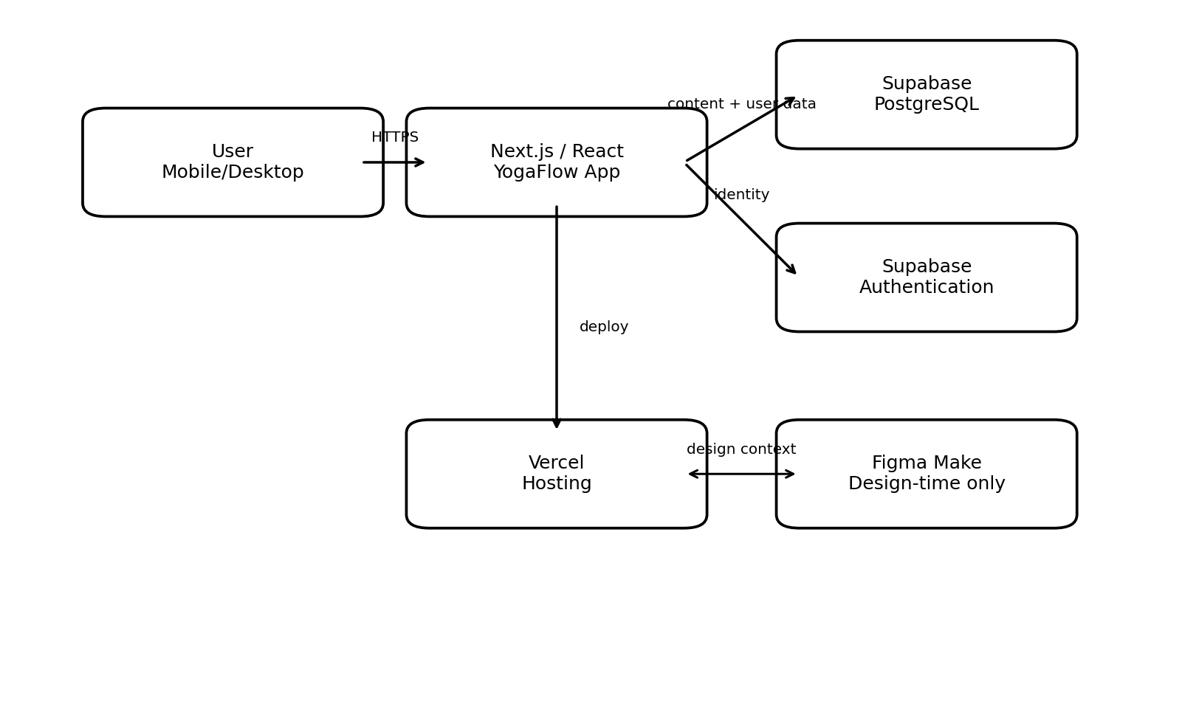
Figure 1: Logical architecture of YogaFlow.

6 UI/UX Design

6.1 Application / Experience Flow
The main YogaFlow experience begins at Home. From Home, users can enter Yoga, Breathwork, or Meditation. The Yoga library provides search and filter controls. Selecting any practice opens Practice Details. From a detail view, a user can add the practice to Favorites or to the Routine. Favorites and Routine are also directly accessible from primary navigation so users can return to saved content without browsing again.
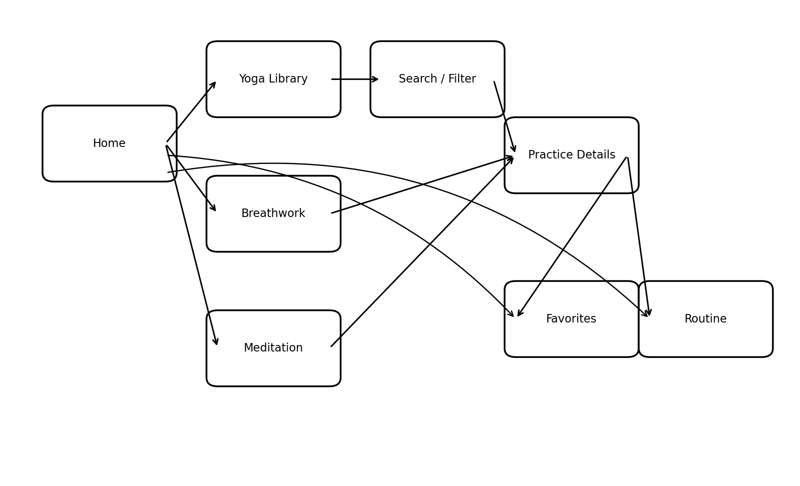
Figure 2: Major user/experience flow for YogaFlow.

6.2 Interactive UI/UX Prototype
Prototype Status: COMPLETE - generated, reviewed, refined, and live-tested in Figma Make.
The interactive prototype represents the major MVP screens defined in this SDD. The first AI-generated version was treated as a draft and manually reviewed against the user stories and design constraints. Three meaningful refinements were then requested to improve search/filter feedback, safety visibility, and Favorites/Routine state feedback. The resulting prototype was tested through the three required user flows below.
- Flow 1 (verified): Home -> Yoga Library -> Search/Filter -> Practice Details.
- Flow 2 (verified): Practice Details -> Add to Favorites -> Favorites -> reopen/remove the saved practice and recover from the empty state.
- Flow 3 (verified): Practice Details -> Add to Routine -> Routine -> review summary and remove an item.
Prototype / Figma Make Link: https://www.figma.com/make/4hOesY7SCk5K9yLGvl4c1Q/YogaFlow-interactive-prototype?t=u23BoWOnMakzJlcW-1

6.3 Design Alignment & Human Refinement
The first Figma Make draft was intentionally reviewed and redirected rather than accepted as a one-shot output. The refinements below document the specific human steering performed and how each change traces back to the written requirements.
Design Refinement | Why It Was Changed | Related Story / Requirement
Improved search and filter feedback, including matching-result count, active-state clarity, reset controls, and a no-results recovery action. | The first AI draft already contained search and filters, but active filtering and recovery from zero results were not obvious enough. The refinement made the state of the library easier to understand and recover from. | US-02, US-03, RC-06, RC-09
Made Safety & Caution guidance prominent before the step-by-step practice instructions and reinforced the general-wellness-not-medical-advice boundary. | The original detail page contained caution text, but it was visually secondary and easy for a beginner to overlook. The refinement improved safety visibility and information hierarchy before practice begins. | US-04, US-10, RC-01, RC-02
Improved Favorites and Routine feedback with clearer saved/added states, remove actions, confirmations, useful empty states, and a direct path back to practice discovery. | The initial flow stored items, but the state transitions and recovery path were not sufficiently explicit. The refinement made saving, removing, and returning to discovery more understandable. | US-07, US-08, RC-09, RC-10
All three refinements below were implemented and visually verified in the live prototype.

7 Key Design Decisions & Open Questions

7.1 Key Design Decisions
DD-01 - Responsive Web Application: YogaFlow will begin as a responsive web application rather than native apps, reducing complexity while supporting laptop, tablet, and mobile users.
DD-02 - Small Curated Content Library: The MVP uses a deliberately limited, curated practice library so content volume does not distract from software design goals.
DD-03 - Search and Filtering as Core Navigation: Search and meaningful filtering are core capabilities because the main problem includes difficulty discovering appropriate practices.
DD-04 - Separate Practice Types, Consistent Detail Pattern: Yoga, Breathwork, and Meditation use separate library entry points but a consistent detail-page pattern.
DD-05 - Safety Without Medical Personalization: YogaFlow includes general caution context but does not request self-diagnosis or generate medical recommendations.
DD-06 - Figma Draft Is Not Authoritative: The written SDD remains authoritative if Figma Make invents features, terminology, medical claims, or flows that conflict with requirements.
DD-07 - Managed Backend Services Preferred: If persistent accounts are implemented, a managed service such as Supabase will be used rather than custom password storage or a complex self-hosted backend.

7.2 Open Questions, Assumptions & Risks
OQ-01 - Account Requirement: The MVP can demonstrate Favorites and Routine with local browser storage, but cross-device persistence requires accounts. Decide before implementation whether accounts are important enough for the course MVP.
OQ-02 - Content Source: Final production-quality pose instructions and imagery require a clearly licensed or author-created source. Prototype placeholders are acceptable until this is resolved.
OQ-03 - Routine Ordering: The first routine builder can use simple add/remove behavior. Drag-and-drop ordering is optional unless it materially improves the MVP.
ASSUMPTION-01 - Target Audience: Primary design assumes adult beginners and general wellness users rather than children, clinical rehabilitation patients, or advanced teacher-training users.
ASSUMPTION-02 - Connectivity: The MVP assumes an internet connection for normal use; offline-first synchronization is not required.
RISK-01 - Health Interpretation: Users could interpret general wellness content as individualized advice. Mitigation: disclaimer, concise cautions, and no diagnostic/prescriptive language.
RISK-02 - AI Scope Creep: Figma or coding agents may invent features. Mitigation: treat this SDD as authoritative and reject unapproved features.
RISK-03 - Inconsistent Content Quality: Mixing content sources could create inconsistent instructions and terminology. Mitigation: use a consistent schema and curated source set.
RISK-04 - Prototype vs. Implementation Mismatch: A visually attractive prototype may imply functionality not planned for the MVP. Mitigation: trace major screens/interactions to US-## and RC-## identifiers before implementation.

8 References & Supporting Links
- Next.js Documentation - https://nextjs.org/docs
- React Documentation - https://react.dev/
- TypeScript Documentation - https://www.typescriptlang.org/docs/
- Supabase Documentation - https://supabase.com/docs
- Vercel Documentation - https://vercel.com/docs
- Figma Education - https://www.figma.com/education/
- WCAG Overview - https://www.w3.org/WAI/standards-guidelines/wcag/

Document Status
Challenge #1 and Challenge #2 design work are complete for submission. The written SDD, experience flow, interactive Figma Make prototype, verified user flows, and documented human refinements are aligned with the project user stories and constraints. The public/shareable prototype link is included in Section 6.2.

