RaceDay - Event Management System

System Overview
RaceDay is a web-based event management platform designed for South Africa's road running, walking, and cycling communities. It modernizes paper-based registration by enabling organizers to create and manage events, categories, and results, while participants can browse events, register, and track their performance history.

The system is built progressively across three parts:
Part 1: Planning documents (ERD, API endpoint plan, SQL database script).
Part 2: RESTful Web API implementation (ASP.NET Core, EF Core, JWT Auth, xUnit tests, and CI/CD).
Part 3: Final containerised, cloud-aware deployment.

User Roles & System Permissions
Organiser
Create, update, and delete events across sports (Run, Walk, Cycle).
Define age and distance categories.
View all participant registrations for managed events.
Record and publish race results (finish times and positions).

Participant
Register for an account and log in via JWT authentication.
View and update personal profile details.
Browse upcoming events and register under specific categories.
View personal and public event results.

Part 1 Refinements & Architecture Improvements
Based on initial feedback, the system schema was updated prior to API implementation:
- Multi-Sport Event Support: Expanded event domain entities beyond running to support cycling, walking, and multi-discipline race events.
- Unified User Entity: Consolidated separate user types into a single User entity referencing a Role entity via foreign key (RoleId), cleanly separating Organiser and Participant permissions.
- Normalized Primary Keys: Assigned dedicated primary keys (PaymentId) across entities for database normalization.
Part 2
- Framework: ASP.NET Core 9.0 / .NET 10 Web API
- ORM: Entity Framework Core (Code-First Approach)
- Database: Microsoft SQL Server
- Authentication: JWT (JSON Web Tokens) with BCrypt Password Hashing
- Documentation: Swagger / OpenAPI UI
- Testing: xUnit Framework with EF Core InMemory Database
- CI/CD: GitHub Actions Automation Pipeline
Unit Testing
The solution includes an automated xUnit test suite (RaceDay.Tests) covering:
- User registration logic and data validation.
- Duplicate email conflict handling.
- Event retrieval and query verification.
- Role-based access restriction checks.
All unit tests execute against an in-memory database instance to ensure rapid, isolated validation.
Screenshot Of Successful Tests
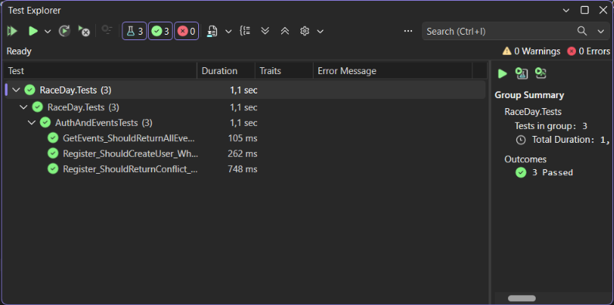

CI/CD Workflow
Configured with GitHub Actions in .github/workflows/ci.yml. On every push and pull request, the workflow:
- Restores project dependencies.
- Compiles the ASP.NET Core solution in Release mode.
- Executes all unit tests in RaceDay.Tests.
Screenshot of successful build:
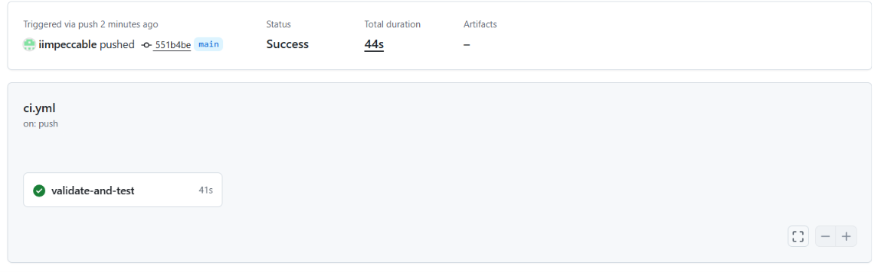
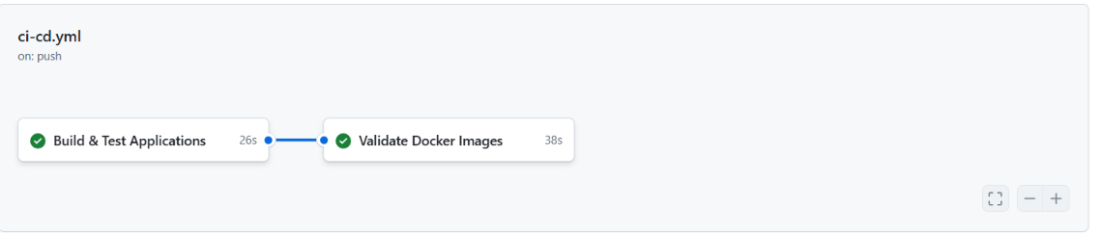
Video Walkthrough
- Unlisted YouTube Link Part 1: https://youtu.be/9dEouBo3yCO
- Unlisted YouTube Link Part 2: https://youtu.be/LwcqEs_oa0o
- Unlisted YouTube Link Part 3: https://youtu.be/W8M-1BxqCqc
Walkthrough Topics Covered:
- ERD architecture and design decisions.
- ASP.NET Core project structure, Controllers, and DTOs.
- Live endpoint demonstration and JWT authorization in Swagger UI.
- Unit test execution in Visual Studio Test Explorer.
- GitHub Actions CI/CD pipeline validation.
Part 3: Containerization, Cloud Services & Azure Deployment
Core Technologies & Architecture
- Frontend Application: ASP.NET Core MVC (RacingDays.Web) with custom dark-themed UI and Razor View engine.
- Backend Web API: ASP.NET Core Web API (RacingDays.API) with RESTful endpoints, JWT authorization middleware, and EF Core ORM.
- Cloud Database: Azure SQL Database hosting relational schema (dbo.Users, dbo.Events, dbo.Categories, dbo.Registrations, dbo.Results).
- Cloud Asset Storage: Azure Blob Storage for hosting and serving event banner images via direct stream uploads.
- Containerization: Docker multi-stage builds with individual Dockerfile configurations and docker-compose.yml local environment orchestration.
Key Feature Implementations & Technical Resolutions
1. Database Schema & Foreign Key Constraints
- CategoryId Integrity: Resolved relational insert conflicts (FK_Registrations_Categories_CategoryId) by guaranteeing that registration payloads receive valid category mappings or default fallback categories.
- Automatic Migrations: Integrated dbContext.Database.Migrate() on application startup to ensure schema changes deploy automatically across cloud environments.
2. Full-Stack Data & ViewModel Alignment
- API Payload Binding: Aligned DTO mappings between RacingDays.Web and RacingDays.API to eliminate property mismatches and ensure created events immediately populate the Organiser Dashboard roster.
- UI High-Contrast Theme Fixes: Enhanced high-contrast accessibility in MyEnrolments.cshtml and Details.cshtml, resolving background-color and text-color overlaps to ensure clear text visibility across all race details.
3. Azure Cloud Asset Pipeline
- Multipart Stream Uploads: Configured UploadsController to stream banner media directly into Azure Blob Storage containers, serving public CDN image URLs back to the MVC frontend.
- Image Fallbacks: Integrated default asset fallbacks for events without custom images to maintain UI consistency across all view cards.
Containerization Details
Each application component utilizes a multi-stage Dockerfile targeting the .NET Runtime and SDK images:
- RacingDays.API/Dockerfile: Builds and publishes the RESTful API runtime container exposed on ports 80 and 443.
- RacingDays.web/Dockerfile: Compiles the MVC Razor interface container configured with backend API service routing.
- docker-compose.yml: Orchestrates local environment startup, mapping network bridge connections between the web frontend, API backend, and local database emulators.

