Mpendulo Ngomane

Web Development

ST10493659

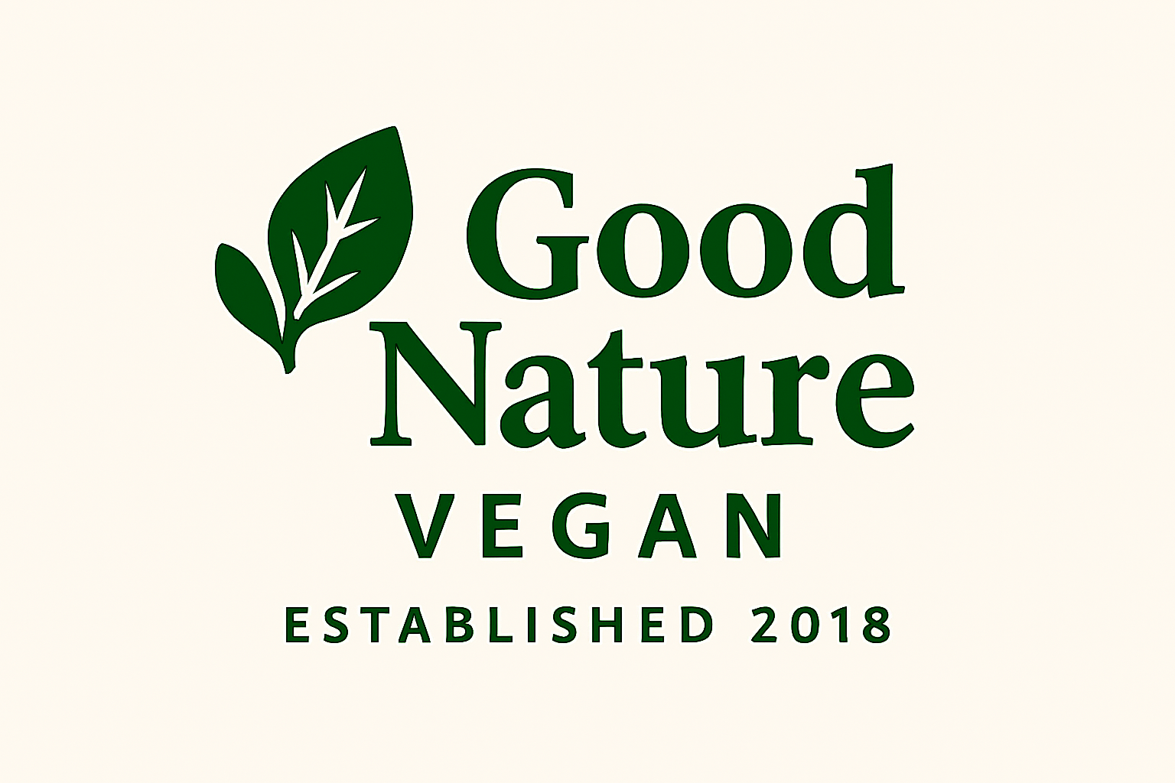

Good Nature Vegan

Website Proposal



Contents

Good Nature Vegan Food: A Brief History 3

Mission Statement 3

Vision Statement 3

Target Audience 3

Website Goals 4

Website Objectives 4

Key Performance Indicators (KPIs) 5

Website Features and Functionality 5

Design and User Experience 7

Technical Requirements 7

Timeline And Milestones 8

Budget Estimate 9

# Good Nature Vegan Food: A Brief History

**Founded:** 2018

**Location:** Johannesburg, South Africa

Good Nature Vegan Food began as a single vegan restaurant in Johannesburg, committed to serving fresh, locally sourced plant based meals. From the start, it aimed to make ethical eating both accessible and enjoyable for the local community.

When the COVID-19 pandemic struck, the business quickly adapted to the changing landscape. It introduced online booking systems to ensure safe, contactless service and launched a digital recipe-sharing platform. This allowed customers to recreate their favourite dishes at home, fostering a sense of connection and continuity during lockdown.

Through innovation and community engagement, Good Nature Vegan Food not only survived the pandemic but also strengthened its brand. It became a local pioneer in blending sustainability with digital convenience, inspiring other small businesses to follow suit.

## Mission Statement

To nourish communities with wholesome, plant-based meals that celebrate sustainability, wellness, and compassion—while empowering individuals to embrace ethical eating through accessible dining, digital innovation, and shared culinary knowledge

## Vision Statement

To become South Africa’s leading vegan lifestyle brand, transforming the way people eat, cook, and connect by blending conscious cuisine with community driven experiences, both in store and online

## Target Audience

* **Health-Conscious Individuals:** Seeking nutritious, plant-based meals to support wellness and lifestyle goals.
* **Ethical Eaters:** Motivated by sustainability, animal welfare, and ecofriendly choices.
* **Urban Professionals:** Busy Joburg residents who value convenience, online bookings, and quick access to healthy food.
* **Home Cooks & Foodies:** Interested in experimenting with vegan recipes and learning new culinary skills.
* **Digital Natives:** Tech savvy users who engage with brands online, especially during lockdowns or remote work.
* **Flexitarians & Curious Eaters:** Exploring plant-based options without fully committing to the lifestyle.
* **Community-Oriented Locals:** Supporting local businesses and enjoying socially conscious movements.

## Website Goals

* **Promote Plant-Based Living** Educate visitors on the benefits of veganism through engaging content, recipes, and lifestyle tips.
* **Drive Online Bookings & Orders** Provide a seamless platform for customers to reserve tables, place orders, or schedule pickups.
* **Share Signature Recipes** Offer curated vegan recipes to inspire home cooking and deepen customer engagement.
* **Build a Community** Foster a sense of belonging through blog posts, newsletters, and interactive features like reviews or forums.
* **Showcase Brand Values** Highlight the store’s commitment to sustainability, wellness, and ethical food practices.

## Website Objectives

* Increase monthly traffic through search engine optimization and social media promotion.
* Boost conversion rates for bookings and orders with intuitive design and clear calls-to-action.
* Expand recipe engagement by tracking downloads, shares, and user feedback.
* Grow the subscriber base for newsletters and updates to maintain long-term customer relationships.
* Enhance mobile experience to ensure accessibility and usability across all devices.

## Key Performance Indicators (KPIs)

1. **Website Traffic**
   * Total monthly visitors
   * Unique visitors
   * Traffic sources
2. **Online Bookings & Orders**
   * Number of reservations made through the site
   * Number of online orders completed
   * Conversion rate from visitor to customer
3. **Recipe Engagement**
   * Number of recipe views
   * Shares on social media
   * User comments or ratings on recipes
4. **User Experience Metrics**
   * Average time spent on site
   * Bounce rate
   * Mobile responsiveness score
5. **Sales & Revenue**
   * Total revenue from online orders
   * Average order value
   * Repeat customer rate

## Website Features and Functionality

1. **Homepage Highlights**
   * Eye-catching banner with featured dishes or promotions
   * Quick links to bookings, recipes, and latest blog posts
   * Mission and vision statement snippet for brand identity
2. **Online Booking System**
   * Real-time table reservations
   * Confirmation emails and reminders
   * Optional pre-ordering for dine-in
3. **Online Ordering & Delivery Integration**
   * Menu with images, prices, and dietary info
   * Cart and checkout functionality
   * Integration with local delivery services or pickup scheduling
4. **Recipe Hub**
   * Searchable database of vegan recipes
   * Step-by-step instructions with images or videos
   * User ratings, comments, and share options
5. **About Us Page**
   * Brand story, team bios, and sustainability values
   * Timeline of growth from 2018 to present
   * Community impact and COVID-19 adaptations
6. **Contact Page**
   * Contact form for inquiries
   * Map and address of physical location
   * Social media links and business hours
7. **Mobile Responsiveness**
   * Optimized layout for phones and tablets
   * Fast loading and intuitive navigation
8. **Accessibility Features**

* Alt text for images
* Keyboard navigation and screen reader compatibility

1. **Customer Reviews & Testimonials**

* Display of feedback from diners and recipe users
* Star ratings and featured comments

## Design and User Experience

1. **Overall Design Aesthetic and Branding**
   * **Colour Scheme:** Earthy tones like leafy greens, warm browns, and soft neutrals to reflect freshness and sustainability.
   * **Typography:** Clean, modern fonts with clear hierarchy
   * **Layout and Design***:* Minimalist and intuitive, with generous white space and visual cues to guide navigation.
2. **User Experience Considerations**
   * Simple, consistent navigation across all pages
   * Mobile-friendly layout with responsive design
   * Colour contrast and accessibility for all users
   * Clear calls-to-action for bookings, orders, and recipe downloads
3. **Wireframes and Information Hierarchy**
   * Develop low-fidelity wireframes to visualize page structure
   * Prioritize homepage, menu/ordering, recipe hub, and booking flow
   * Ensure logical grouping of content and easy access to key features

## Technical Requirements

1. **Hosting & Domain Name:**
   * **Hosting Provider:** GoDaddy Airo Plus – includes SSL, email, and scalable performance for small business websites
   * **Domain Name:** www.goodnaturevegan.co.za registered via GoDaddy
2. **Frontend Technologies:**
   * **HTML:** For semantic structure (W3Schools, n.d.)
   * **CSS:** For styling and responsive design (W3Schools, n.d.)
   * **JavaScript:** For interactivity and dynamic content (W3Schools, n.d.)
   * **Bootstrap:** For mobile-first layout and UI components (W3Schools, n.d.)
3. **Backend Technologies:**
   * **Java:** Using Spring Boot framework for RESTful API development
   * **MySQL:** For structured data storage (recipes, bookings, user info)
   * **Spring Security:** For authentication and secure access
   * **Apache Tomcat:** Embedded server for deployment
4. **Additional Tools:**
   * **GitHub:** For version control
   * **Postman:** For API testing
   * **GoDaddy Control Panel:** For DNS, email, and SSL management

## Timeline And Milestones

|  |  |  |
| --- | --- | --- |
| Phase | Milestone | Estimated Date |
| Week 1 | **Finalize requirements & sitemap** | **August 24–29** |
| Week 2 | **Design wireframes and UI mockups** | **September 1–6** |
| Week 3–4 | **Develop frontend and backend logic** | **September 8–20** |
| Week 5 | **Integrate content and test APIs** | **September 22–26** |
| Week 6 | **Perform QA and mobile testing** | **September 29–October 3** |
| Week 7 | **Final review and deployment** | **October 6–10** |
| Week 8 | **Website launch and performance check** | **October 13–17** |

## Budget Estimate

|  |  |
| --- | --- |
| Item | Estimated Cost |
| GoDaddy Airo Plus Hosting | **R1,200/year** |
| Domain Registration | **R150/year** |
| SSL Certificate (included) | **R0** |
| Java Development | **R2,000** |
| Content Creation (recipes) | **R500–R1,000** |
| Maintenance & Updates | **R1000/month** |
| Optional Marketing Tools | **R500–R1,500** |

(Ravensadale, 2025)

## Sitemap

### Wire Frame Description

**1. Home Page**

* **Top Navigation Bar**: Logo, menu links, search icon, login
* **Hero Section**: Rotating banner with featured dishes or promotions
* **Mission Snippet**: Short intro to brand values
* **Quick Links**: Buttons to Bookings, Recipes, Blog
* **Footer**: Contact info, social media icons

**2. About Us**

* **Header**: Our Story
* **Timeline Section**: Visual journey from founding to present
* **Team Grid**: Photos + bios of key staff
* **Values Icons**: Sustainability, ethics, community

**3. Menu**

* **Filter Bar**: Vegan, gluten-free, seasonal
* **Menu Grid**: Dish cards with image, name, price, description
* **Order Button**: Redirect to ordering platform

**4. Bookings**

* **Calendar Widget**: Select date and time
* **Form Fields**: Name, email, party size, special requests
* **Confirmation Message**: “Thanks for booking!”
* **Reminder Option**: Checkbox for SMS/email reminder

**5. Recipes**

* **Search Bar**: Keyword or ingredient search
* **Category Tabs**: Breakfast, mains, desserts, etc.
* **Recipe Cards**: Image, title, rating, short description
* **Recipe Page**: Step-by-step instructions, ingredients list, user comments

**6. Blog & Community**

* **Featured Article**: Large banner with latest post
* **Article List**: Titles, thumbnails, excerpts
* **Comment Section**: User rating and comments
* **Share Buttons**: Facebook, Instagram, WhatsApp

**7. Contact**

* **Contact Form**: Name, email, message
* **Map Embed**: Google Maps location
* **Business Info**: Address, phone, hours
* **Social Icons**: Instagram, Facebook

**8. Admin Dashboard *(Staff Only)***

* **Login Screen**: Secure access
* **Sidebar Navigation**: Bookings, Orders, Recipes, Blog, Feedback
* **Content Manager**: Upload/edit posts, recipes, menu items
* **Analytics Panel**: Traffic, engagement, KPIs
* **Feedback Inbox**: User messages and reviews

# References

Ravensadale, 2025. *How much does a website cost in South Africa.* [Online]   
Available at: https://www.ravensdale.co.za/how-much-does-a-website-cost-in-south-africa/  
[Accessed 23 August 2025].

W3Schools, n.d. *Bootstrap Get Started.* [Online]   
Available at: https://www.w3schools.com/bootstrap/bootstrap_get_started.asp  
[Accessed 26 August 2025].

W3Schools, n.d. *CSS Turorial.* [Online]   
Available at: https://www.w3schools.com/Css/default.asp  
[Accessed 24 August 2025].

W3Schools, n.d. *HTML Tutorial.* [Online]   
Available at: https://www.w3schools.com/html/default.asp  
[Accessed 22 August 2025].

W3Schools, n.d. *Javascript Tutorial.* [Online]   
Available at: https://www.w3schools.com/js/default.asp  
[Accessed 26 August 2025].