**RELIANCE OIL AND GAS INDUSTRY**

***“This is not merely a refinery and petrochemical complex. It is not just another large plant. It is an inspiring temple of resurgent India.”*** - ***Dhirubhai Ambani***

**INDUSTRY OVERVIEW**

Covid-19 restrictions lowered the demand from transport and other sectors which in turn created turbulence for global oil and gas industries. April 2020 witnessed an oversupply of ~20 MMb/d that pushed Brent prices to US$18.5/bbl before the year-end saw a recovery to US$63.5/bbl. The market observed an overall collapse of 8.7MMb/d demand in 2020. Brent and West Texas Intermediate (WTI) crude averaged at US$42.0/bbl and US$39.2/bbl respectively which was lower than that of 2019 price by US$15/bbl. The emerging trends and business response includes *Clean**Energy* that focuses on green energy to address environmental concerns to reduce GHG emissions, *Brownfield Developments* to reduce costs and *Digital Technologies* for improved efficiencies.

RIL petroleum focuses on building a gas-based portfolio. The company attempts to leverage its infrastructure in the KG Basin to develop three projects in Block KG D6. Through adoption of latest technologies and enhancing capabilities in Digital Twin, Autonomous Fields, Virtual Command Centres, and other cutting-edge technologies. Though the resurgence in COVID-19 cases is slowing the rebound to normalcy, widespread vaccination, acceleration in economic activity coupled with OPEC+ decision to delay further easing of cuts and Saudi Arabia’s additional supply reduction of 1 MMb/d is expected to spur stronger growth in coming time and the demand is expected to recover.

**RELIANCE OIL AND GAS E&P**

In 2000, Reliance commissioned the world's largest grassroots refinery in a record 36 months: the Jamnagar petrochemicals and integrated refinery complex, that positioned India on the Global Refining Map. 2009 witnessed the production of hydrocarbons in its KGD6 block - against all odds - in just over two years of its discovery, making it the world’s fastest green-field deep-water oil development project. With this development, Reliance completes an unprecedented backward integration journey. Reliance Oil and Gas E&P envisions to be India’s Leading Player and a major contributor to its Gas based economy supplying >25% of India’s production.

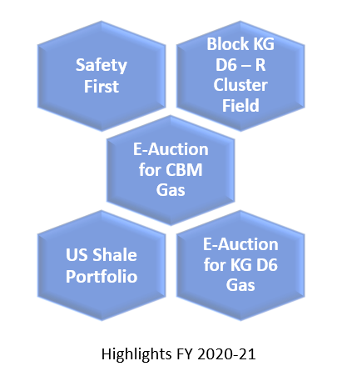 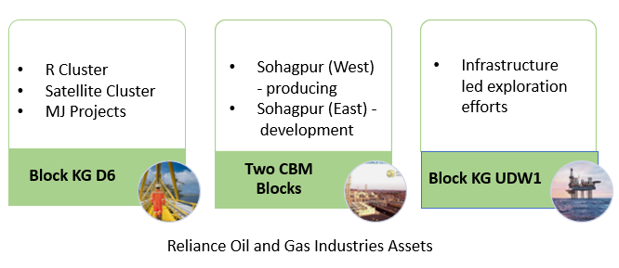

Reliance aims to conduct business in a manner that protects the environment as well as the health and safety of employees, contractors, and the local communities in which they do the business. The strategical and competitive strengths of RIL such as deep-water hub infrastructure in the East Coast, Gas based portfolio as well as Block KG UDW1 and partnership with BP revitalised RIL’s Oil and Gas E&P.

**PERFORMANCE HIGHLIGHTS**

***Financial Performance****:* The revenue for the financial year 2020-21 was lower by 33.4% y-o-y to Rs.2140 crore due to lower volumes from conventional fields and overall lower commodity price realisation. EBITDA for the year declined by 26.9% to Rs.258 crore.

***Operational Performance****:* Domestic production was at 27.8BCFe, lowered by 28.4% y-o-y due to expiry of Panna Mukta production Sharing Contract and cessation of production from KG D6 field. The share of RIL in US Shale went up by 22.9% on a y-o-y basis.

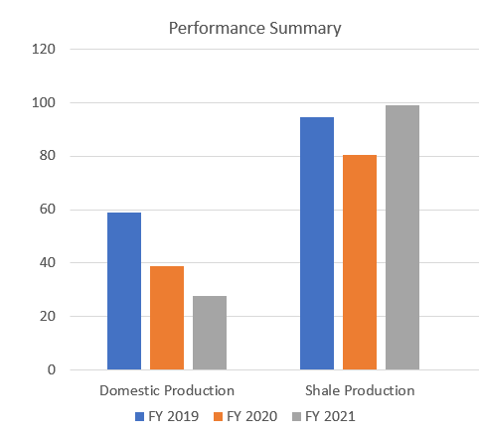

**BUSINESS PERFORMANCE**

KGD6, R Cluster Field, Development Status, Exploration Strategy, Coal Bed Methane and US Shale constitutes the Key Business Performance Indicators of Reliance Oil and Gas Industries.

* KGD6 Block has produced 3 TCFe of gas, oil and condensate while establishing several global benchmarks in terms of operational performance, including 99.9% uptime and 100% incident-free operations.
* R Cluster field located at a water depth of greater than 2000 meters is Asia’s deepest and India’s first ultra-deep-water gas field. The field is expected to reach plateau gas production of about 12.8 MMSCMD in 2021.
* Development status of MJ Field is underway with its first installation campaign commenced in 4Q FY 2021 and final installation campaign planned in 4Q FY 2022. D1D3 field ceased production in February 2020 and field decommissioning plan subject to OISD’s approval.
* 3D Seismic Acquisition Campaign and licensing for RIL-BP joint venture are the key indicators in exploration strategy.
* Coal Bed Methane production from RIL’s Block SP aims to sustain plateau production along with Reliance Gas Pipelines Limited by connecting the CBM gas fields with the Indian gas grid.
* Reliance sold its interest in Marcellus JV to EQT Aurora LLC and Northern OIL & Gas in 4Q FY 2021.
* As Ensign JV exited during 2Q FY 2021, Reliance and Ensign acquired its participating interest proportionately.
* Shale Gas subsidiaries have impaired their assets, including unavoidable costs based on contractual commitments.
* Though the pandemic struck down development activities in joint ventures its effects were minimalized by maintaining strict capital discipline and curtailing developmental activities.

**TREASURY MANAGEMENT**

Though FY 2021 was a year of unprecedented volatility in financial market and liquidity conditions, Reliance Oil and Gas could mitigate its treasury insecurities to a greater extent. The company completed one of the largest equity capital raise programmes. The debt liability of US$7.8 billion ECB borrowings was repaid. Strong liquidity position of Rs.2.5 lakh crore of cash was maintained. RIL raised its capital equity in fuel retailing business by entering a partnership with BP. Above mentioned facts enabled Reliance to significantly deleverage its balance sheet and deliver on its promise of attaining zero net debt status.

***Challenges:*** Market volatility, large scale destruction of demand in the economy, significant fall in interest rates, weakening of Rupee

***Managerial Adaptations:***

* Slowdown in hydrocarbons was compensated by strong growth in consumer business
* Ensured liquidity to the business at the optimal risk adjusted cost
* Sustained investment in low-risk liquid instruments
* Execution of innovatively structured trade products
* Recovery of crude oil price by the second half
* Use of appropriate instruments and currencies
* Actively leveraged trade financing solutions
* Access to finance from different markets
* Strong credit rating

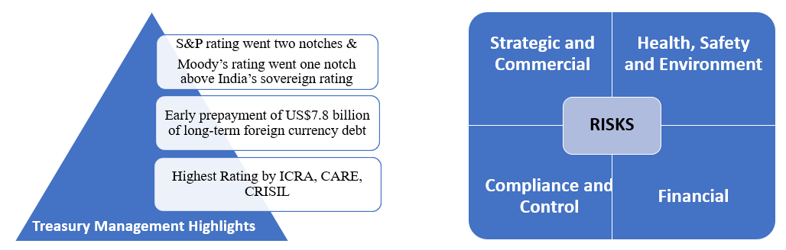

**RISK MANAGEMENT**

The four major risks either separately or in combination could adversely affect the business ecosystem. Structured and proactive discussions within the risk management framework covers risk management at three levels ensuring three lines of defence along with identification of a new risk and its mitigation. Day-to-day risk management functions on a continuous basis while the Business and Strategic risk management integrates risks with key business processes. Oversight to the identification and management of the most significant risks, improving risk management framework and ensuring compliance are carried out by Oversight and Governance tier.

***Industry Specific Risks:***

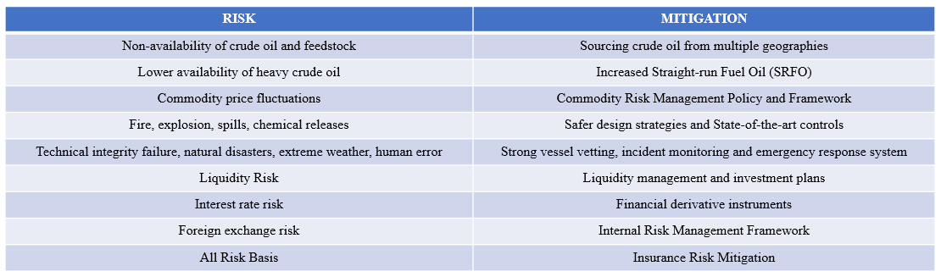

**AWARDS**

Jamnagar Manufacturing Division refinery awarded the ‘Refinery of the Year’ Award by the Federation of Indian Petroleum Industry

**THE FUTURE AHEAD**

Oil and Gas is an important transition fuel. The share of gas expected to increase from 6% to 15% by 2030. Developments in deep-water gas projects in KG D6 and Coal Bed Methane projects is expecting to reach the zenith of production of 30MMSCMD by 2023 which is 25% of India’s production and 15% of India’s demand. RIL with its foundations based on a strong vision and mission is foreseeing a promising future ahead by overcoming the challenges, preserving its assets, and exploring new opportunities.

**REPORT SUMMARY**

The contributions of Reliance Oil and Gas Exploration and Production has always been world class. The single entity meets one-fourth of India’s gross oil and gas assets and 15% of India’s demand. The company’s managerial decisions and risk mitigation strategies enabled them to showcase a better performance even during the unpredictable pandemic situation. Though the numbers could not outperform the set targets, liquidity maintenance through optimal risk adjusted cost mechanism and sustained investment in low-risk liquid instruments were proactive decisions that retained the company’s integrity. The overall performance of RIL’s Oil and Gas E&P for FY 2020-21 was satisfactory.