Part 1: Capturing HTTP Traffic.
Task 1: Start Wireshark and capture packets.
Ok.

Task 2: Filter HTTP packets and analyze them.
HTTP Request and Response Analysis.

HTTP Request:

Method: GET

URI: /

HTTP Version: HTTP/1.1
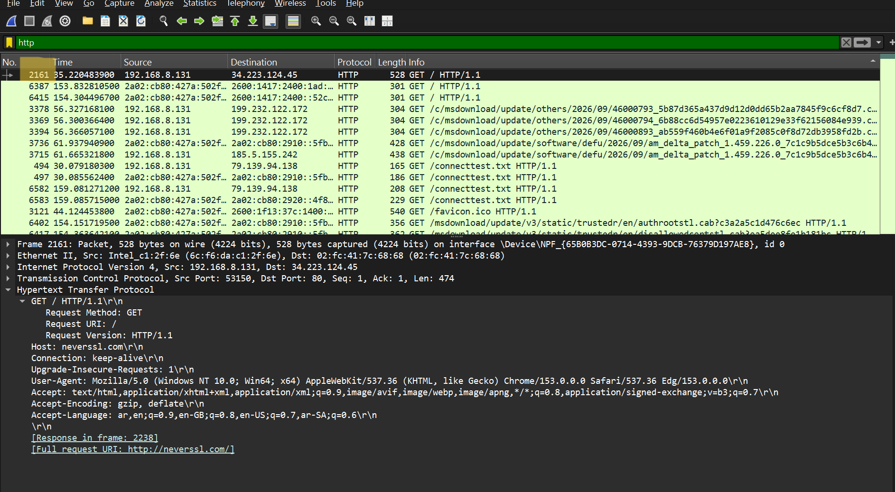

HTTP Response:

Status Code: 200 OK
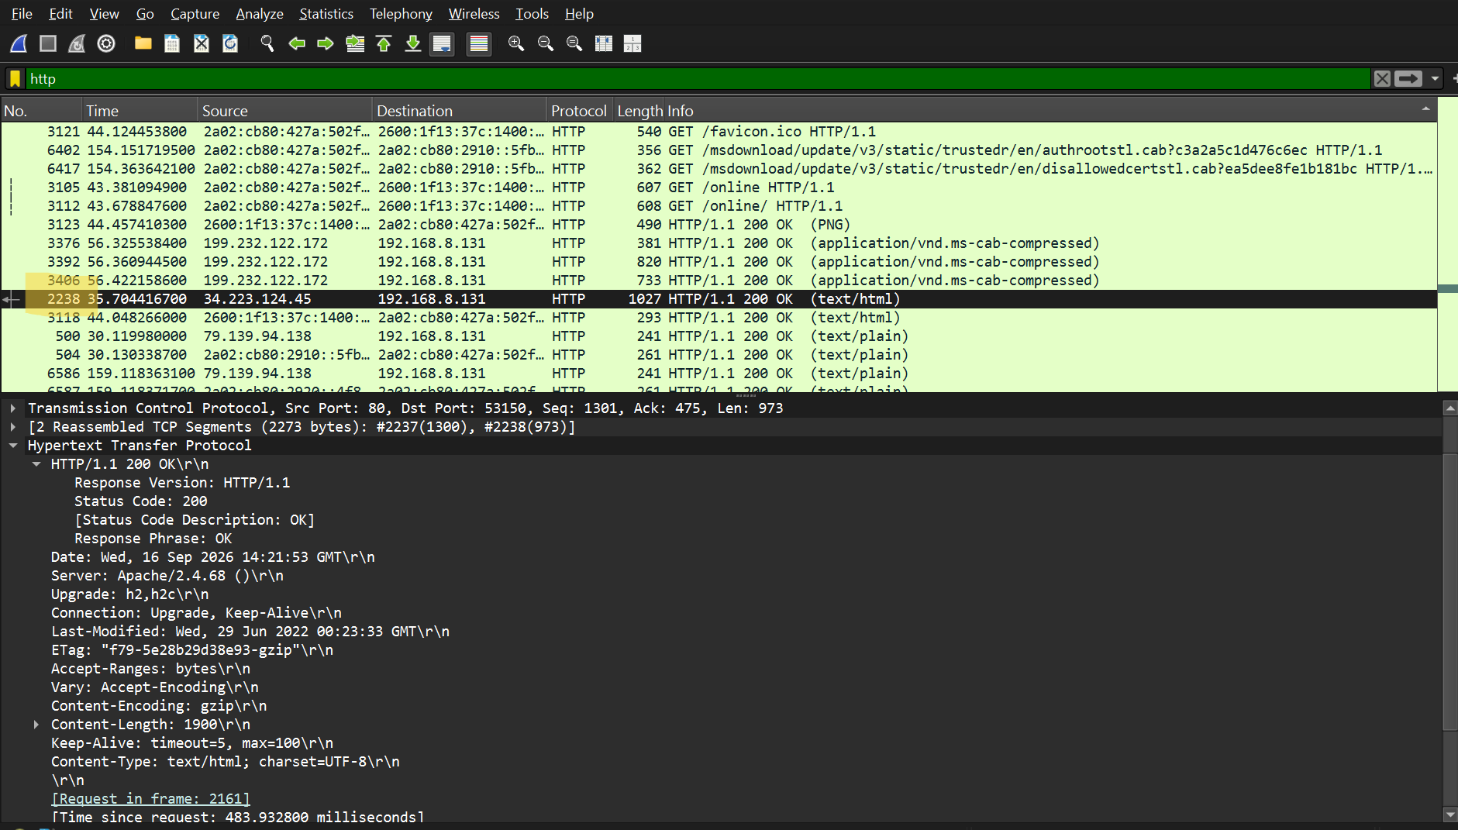

Part 2: Analyzing TCP/IP Traffic.
Task 1: Filter TCP packets
TCP Stream Analysis
The TCP Stream shows the communication between the client and the server. It displays the data exchanged during the TCP connection.
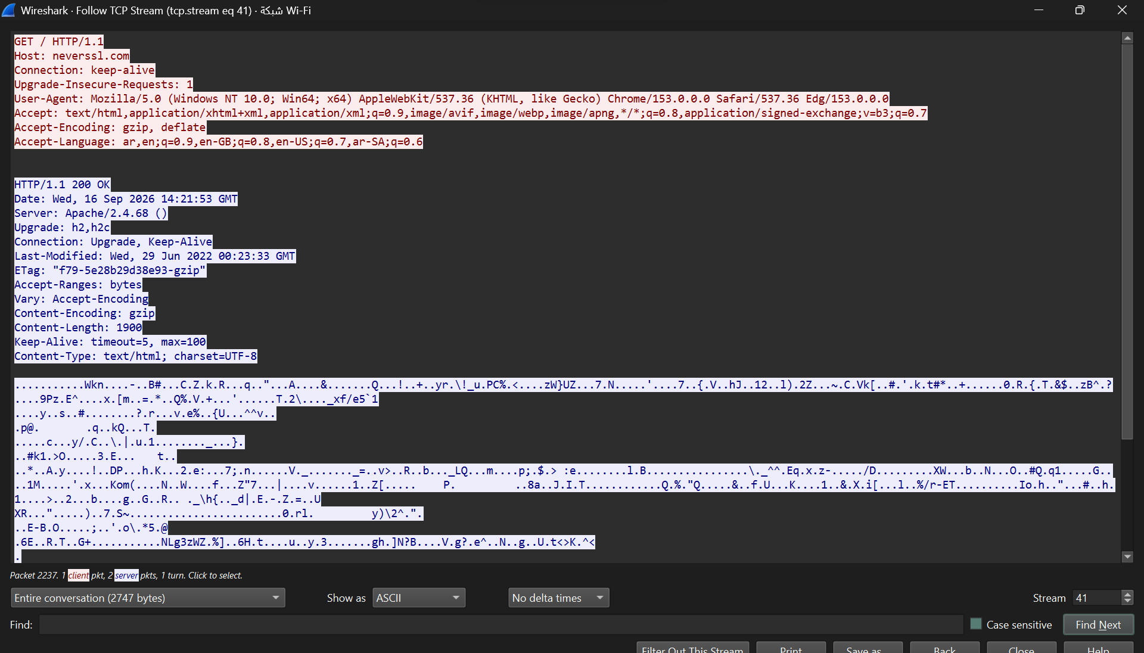

Task 2: Analyze TCP handshake and investigate Data Transfer and Termination
TCP Three-Way Handshake
- SYN: Source Port 53150 → Destination Port 80, Seq = 0, Ack = 0.
- SYN-ACK: Source Port 80 → Destination Port 53150, Seq = 0, Ack = 1.
- ACK: Source Port 53150 → Destination Port 80, Seq = 1, Ack = 1.

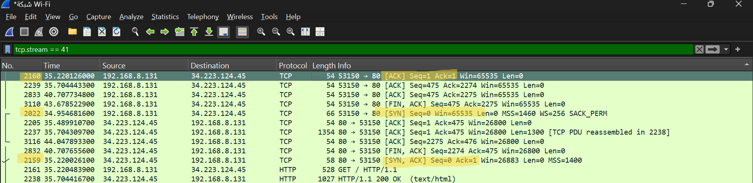

TCP Data Transfer
- The client sent an HTTP GET request to the server.
- The server responded with HTTP/1.1 200 OK.
- TCP sequence and acknowledgment numbers were used during the data transfer.

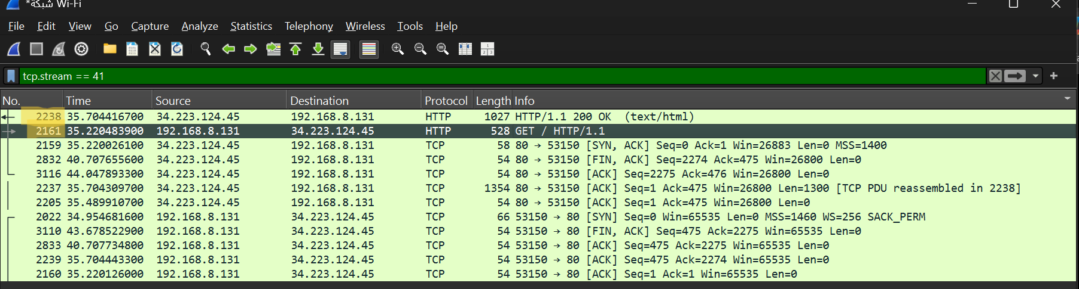

TCP Termination
- The server sent a FIN, ACK packet to start closing the connection.
- The client responded with an ACK.
- The client then sent a FIN, ACK.
- The server sent the final ACK.

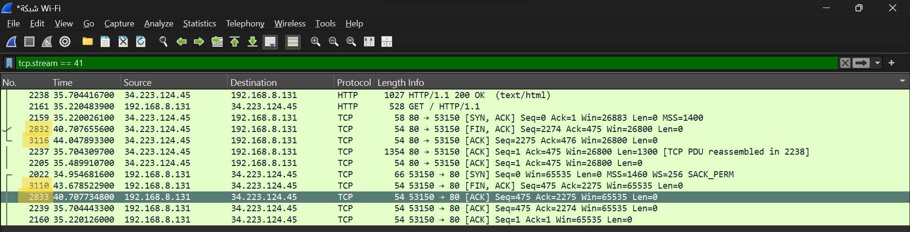

Part 3: Capturing and Analyzing UDP Traffic
Task 1: Generate UDP traffic and capture packets
Ok.

Task 2: Filter and analysis UDP Packets

UDP Packet Analysis
UDP Packet Details:
- Source Port: 50118
- Destination Port: 443
- Length: 1125 bytes
- UDP Payload: 1117 bytes
Comparison with TCP:
UDP has a simpler header than TCP. UDP has fewer header fields and does not use a connection establishment process, acknowledgments, or sequence numbers like TCP. Therefore, UDP has lower overhead than TCP.
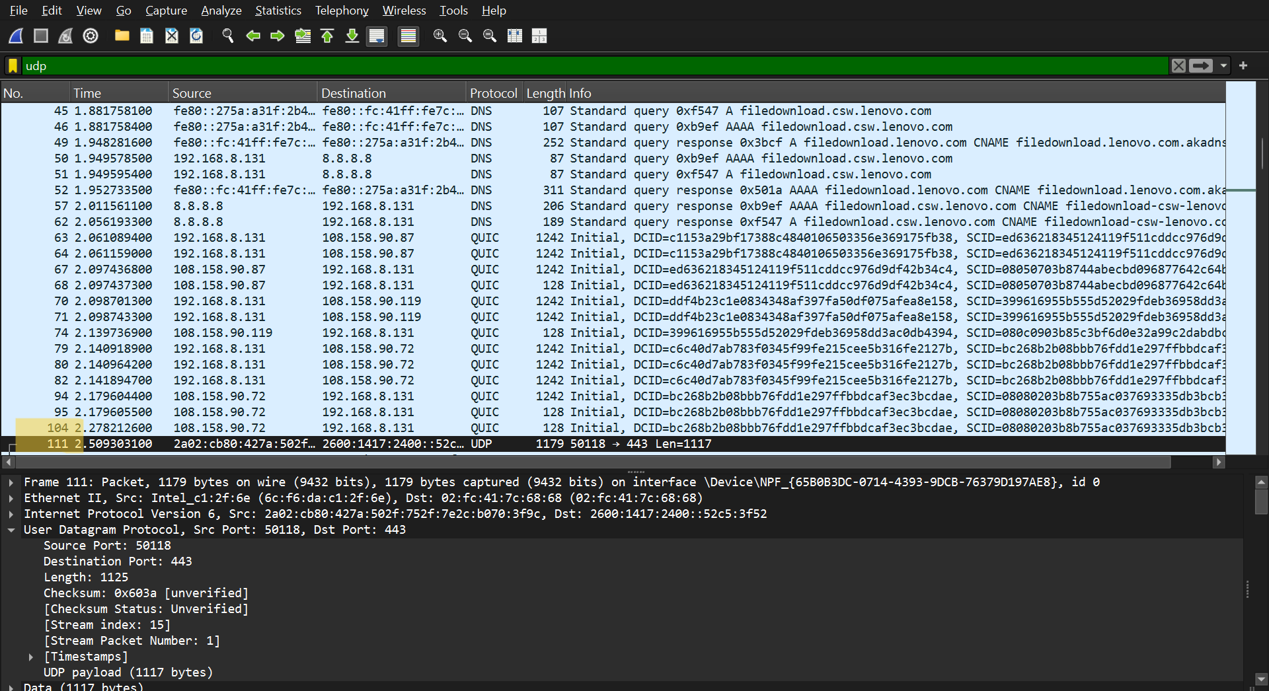

Part 4: Comparing TCP and UDP by filling in the following tables. Save your work (e.g., in an MS Word document), and upload it to your online git repo.
Task 1: Fill in the following table and provide reasons.

 | TCP or UDP | Reasons
Reliability and Connection Establishment | TCP | TCP is connection-oriented and establishes a connection using a three-way handshake. It provides reliable data delivery through acknowledgments and retransmission.
Data Integrity and Ordering | TCP | TCP uses sequence numbers and acknowledgments to ensure that data is delivered reliably and in the correct order.

Task 2: Identify the use Cases and Performance of TCP and UDP.

 | TCP | UDP
Use cases | Web browsing, file transfer, and email. | Online gaming, live streaming, VoIP, and DNS.
Performance | TCP has higher overhead because it uses connection establishment, acknowledgments, retransmission, and ordered delivery. | UDP has lower overhead and can provide lower latency because it does not establish a connection or retransmit lost packets.

