Implementation Code Report

Module: 2024-SPR-MAT-5CM505 Software Engineering
Spring 2025
Student ID: 100735054



Overview
The installation of a software solution based on the planned restaurant management scenario is covered in this project.

Conventions For Coding
- Naming conventions:
To provide uniformity throughout the codebase, the team employed naming rules. PascalCase, which applies the initial letter of each word, is used for class names. Functions and methods follow the camelCase standard, which capitalizes the initial letter of each successive word after a lowercase letter. When words need to be separated for readability, variables utilize underscores and lowercase letters.

- Organization:
To maintain control and organization within the codebase, the code is logically divided into modules like, <utils.py> and <models.py>. Clarity and modular design are ensured by grouping functions and classes that belong together in a manner that adheres to the Model View Controller (MVC) pattern of design.

- Code Quality Practices:
The group placed a strong emphasis on writing code that was cohesive and had low coupling. In accordance with the separation of concerns approach, all class and method innovations were designed such that each person only performed one duty. The purpose of the parameters was made evident by their names, and periodic reworking was done to guarantee clear and effective code.

- Security:
By confirming all user inputs at the appropriate layers, namely the model and the controller, security considerations were incorporated into the development process. Because of this, the program is secure and resistant to any possible flaws.

- Comments:
Each method and function have a remark outlining its purpose for future readability and maintainability. This keeps developers, both present and future, up to date on the features and intent of every code block.

Design Pattern Code

Model (Data Layer)

The reservation class stores significant details related to booking, including the name of the customer, specific table, date of reservation and status (booked, pending or cancelled). The order class which manages customer order details by monitoring ordered items from the menu, their quantities and special instructions (customizations). Furthermore, the inventory class supports the tracking of stock quantities, calculation of reorder levels for timely reordering and storage of supplier information for efficient procurement. Finally, the staff class maintains employee records in terms of shift schedules and total hours worked to ensure efficient personnel management and payroll processing.

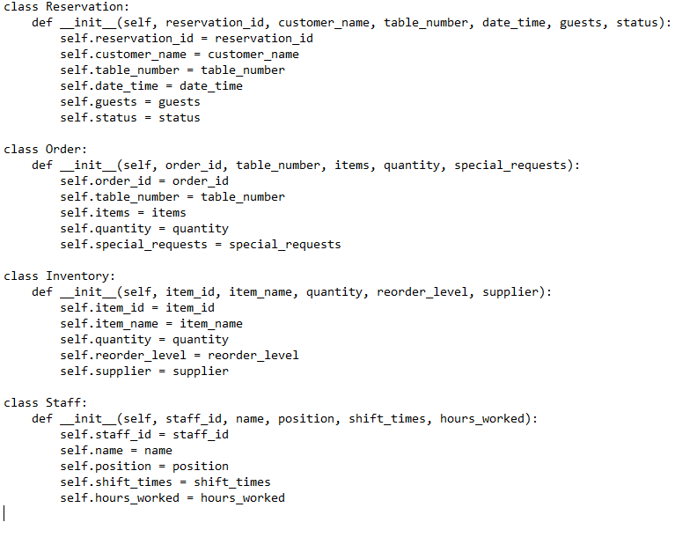

Controller (Logic Layer)

The controller has several components that oversee controlling the user interface and data layer interaction. The ReservationContoller manages the logic which is required to make, modify, cancel and get reservations, so that reservations are properly processed and economically. The OrderController accomplishes the same for the workflow regarding the entry and modification of customer orders, like processing menu selection, quantities and special requests. Additionally, the InventoryContoller controls inventory operations such as updating inventory quantities, monitoring reorder levels and interacting with suppliers. And the StaffController controls staff operations such as scheduling shifts, keeping track of working hours and updating staff details all of which are essential to efficiently operate a restaurant.

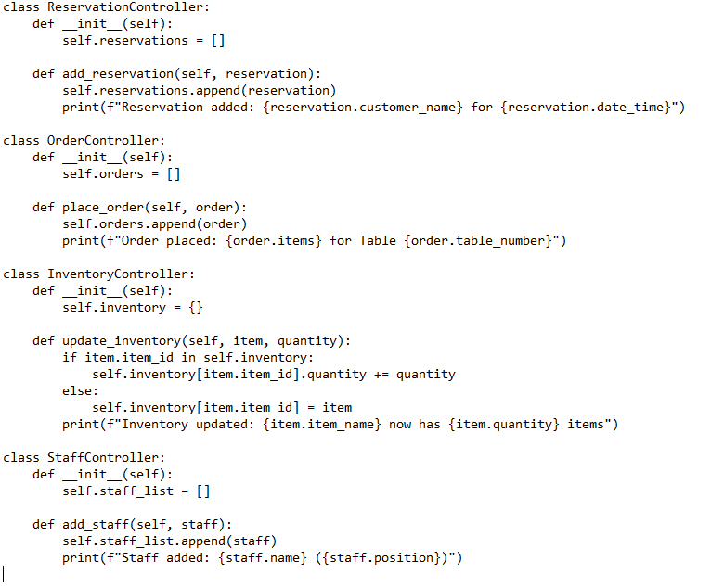

View (Presentation Layer)

The view has the responsibility of displaying information to users in a clear and well organised manner. The show_reservations component presents all the relevant reservation data, such as customer names, table number allocations, dates, and statuses for easy viewing and management of reservations by staff. Likewise, the show_orders view displays customer orders, such as menu items ordered, quantity and special requests, so that kitchen staff and servers are informed. Besides this, the show_inventory interface also provides an overview of existing stock levels, reordering needs and suppliers’ details to support monitoring and management of inventory. Lastly, the show_staff view provides employee information, including shift rosters and work duration, which helps supervisors manage the workforce efficaciously.

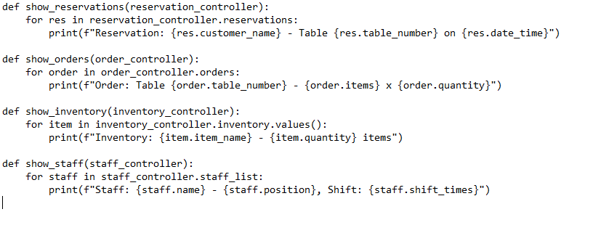

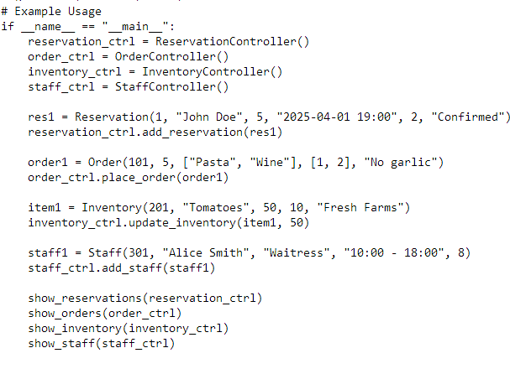

GitHub commits
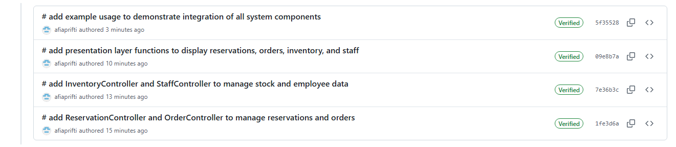

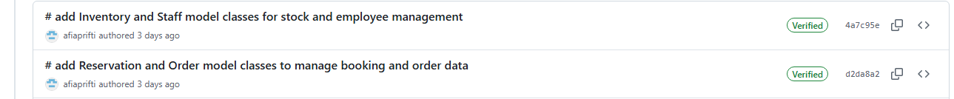

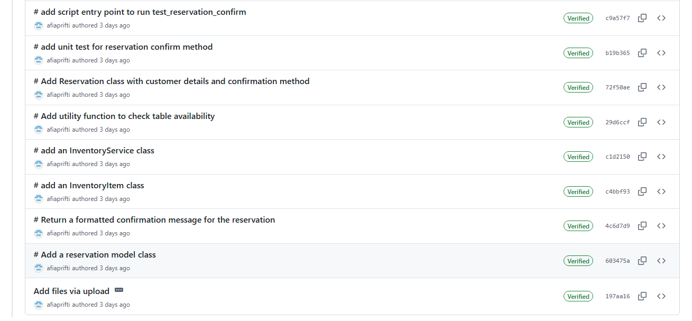

Object- Oriented Principles
Several object-oriented programming (OOP) principles have been used in the system design to promote clarity, maintainability, and scalability. Encapsulation is achieved through classes like Reservation and InventoryItem, where the data and behavior pertaining to them are wrapped together into one and the same self-contained unit. This enables each class to manage its own state and logic internally. Abstraction is achieved through methods like confirm() in the Reservation class and check_stock() in the InventoryItem class. These designs hide complex inner logic and have a straightforward interface that allows other elements within the system to use them without necessarily being aware of their internal workings. The design also enforces low coupling and high cohesion principles. For example, the Reservation class deals with reservation information only, and the InventoryService deals with inventory-specific operations. Such clear segregation of concerns improves modularity and allows the system to be managed and extended more easily.
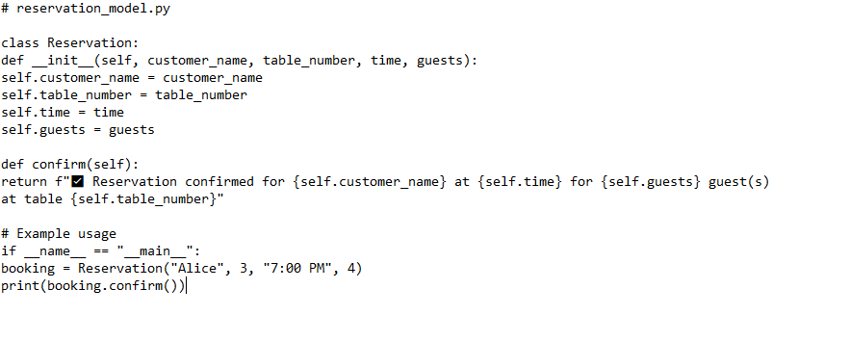

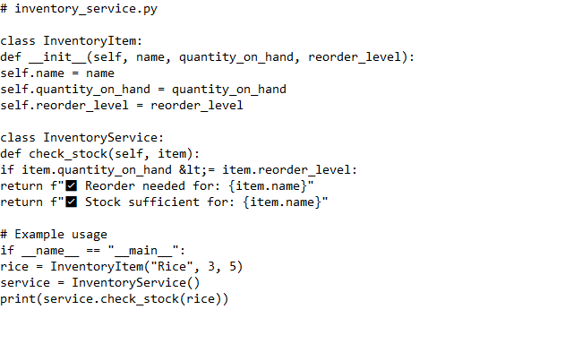

Refactoring
Without altering the outward behaviour, refactoring is the process of making existing code more efficient, legible, and manageable.
The reservation flow was where the availability check logic was first written. Code became more complex and more difficult to test as a result. Testability and reusability are attained through reworking using <utils.py's> utility function.

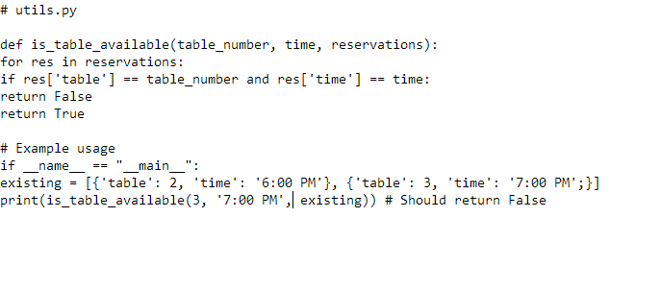

Entire Code:
Implementation code (implementation sw)

class InventoryService:
def check_stock(self, item):
if item.quantity_on_hand <= item.reorder_level:
return f"⚠️ Reorder needed for: {item.name}"
return f"✅ Stock sufficient for: {item.name}"

# Example usage
if __name__ == "__main__":
rice = InventoryItem("Rice", 3, 5)
service = InventoryService()
print(service.check_stock(rice))

Refactoring with Utility Function
# utils.py

def is_table_available(table_number, time, reservations):
for res in reservations:
if res['table'] == table_number and res['time'] == time:
return False
return True

# Example usage
if __name__ == "__main__":
existing = [{'table': 2, 'time': '6:00 PM'}, {'table': 3, 'time': '7:00 PM'}]
print(is_table_available(3, '7:00 PM', existing)) # Should return False

Testing the Code
# reservation_model_test.py

# --- MODEL ---
class Reservation:
def __init__(self, customer_name, table_number, time, guests):
self.customer_name = customer_name
self.table_number = table_number
self.time = time
self.guests = guests

def confirm(self):
return f"✅ Reservation confirmed for {self.customer_name} at {self.time} for {self.guests} guest(s) at table {self.table_number}"

# --- TEST FUNCTION ---
def test_reservation_confirm():
try:
r = Reservation("John", 1, "6:30 PM", 2)
result = r.confirm()
assert "John" in result
assert "6:30 PM" in result
print("✅ test_reservation_confirm passed")
print(result)
except AssertionError:
print("❌ test_reservation_confirm failed")
raise

# --- RUN THE TEST ---
if __name__ == "__main__":
test_reservation_confirm()

Design Pattern Code (mvc.sw)
# Restaurant Management System - MVC Pattern
# Model (Data Layer)
class Reservation:
def __init__(self, reservation_id, customer_name, table_number, date_time, guests, status):
self.reservation_id = reservation_id
self.customer_name = customer_name
self.table_number = table_number
self.date_time = date_time
self.guests = guests
self.status = status

class Order:
def __init__(self, order_id, table_number, items, quantity, special_requests):
self.order_id = order_id
self.table_number = table_number
self.items = items
self.quantity = quantity
self.special_requests = special_requests

class Inventory:
def __init__(self, item_id, item_name, quantity, reorder_level, supplier):
self.item_id = item_id
self.item_name = item_name
self.quantity = quantity
self.reorder_level = reorder_level
self.supplier = supplier

class Staff:
def __init__(self, staff_id, name, position, shift_times, hours_worked):
self.staff_id = staff_id
self.name = name
self.position = position
self.shift_times = shift_times
self.hours_worked = hours_worked

# Controller (Business Logic Layer)
class ReservationController:
def __init__(self):
self.reservations = []

def add_reservation(self, reservation):
self.reservations.append(reservation)
print(f"Reservation added: {reservation.customer_name} for {reservation.date_time}")

class OrderController:
def __init__(self):
self.orders = []

def place_order(self, order):
self.orders.append(order)
print(f"Order placed: {order.items} for Table {order.table_number}")

class InventoryController:
def __init__(self):
self.inventory = {}

def update_inventory(self, item, quantity):
if item.item_id in self.inventory:
self.inventory[item.item_id].quantity += quantity
else:
self.inventory[item.item_id] = item
print(f"Inventory updated: {item.item_name} now has {item.quantity} items")

class StaffController:
def __init__(self):
self.staff_list = []

def add_staff(self, staff):
self.staff_list.append(staff)
print(f"Staff added: {staff.name} ({staff.position})")

# View (Presentation Layer)
def show_reservations(reservation_controller):
for res in reservation_controller.reservations:
print(f"Reservation: {res.customer_name} - Table {res.table_number} on {res.date_time}")

def show_orders(order_controller):
for order in order_controller.orders:
print(f"Order: Table {order.table_number} - {order.items} x {order.quantity}")

def show_inventory(inventory_controller):
for item in inventory_controller.inventory.values():
print(f"Inventory: {item.item_name} - {item.quantity} items")

def show_staff(staff_controller):
for staff in staff_controller.staff_list:
print(f"Staff: {staff.name} - {staff.position}, Shift: {staff.shift_times}")

# Example Usage
if __name__ == "__main__":
reservation_ctrl = ReservationController()
order_ctrl = OrderController()
inventory_ctrl = InventoryController()
staff_ctrl = StaffController()

res1 = Reservation(1, "John Doe", 5, "2025-04-01 19:00", 2, "Confirmed")
reservation_ctrl.add_reservation(res1)

order1 = Order(101, 5, ["Pasta", "Wine"], [1, 2], "No garlic")
order_ctrl.place_order(order1)

item1 = Inventory(201, "Tomatoes", 50, 10, "Fresh Farms")
inventory_ctrl.update_inventory(item1, 50)

staff1 = Staff(301, "Alice Smith", "Waitress", "10:00 - 18:00", 8)
staff_ctrl.add_staff(staff1)

show_reservations(reservation_ctrl)
show_orders(order_ctrl)
show_inventory(inventory_ctrl)
show_staff(staff_ctrl)

