**Exercise 2**

1. **Starting point.**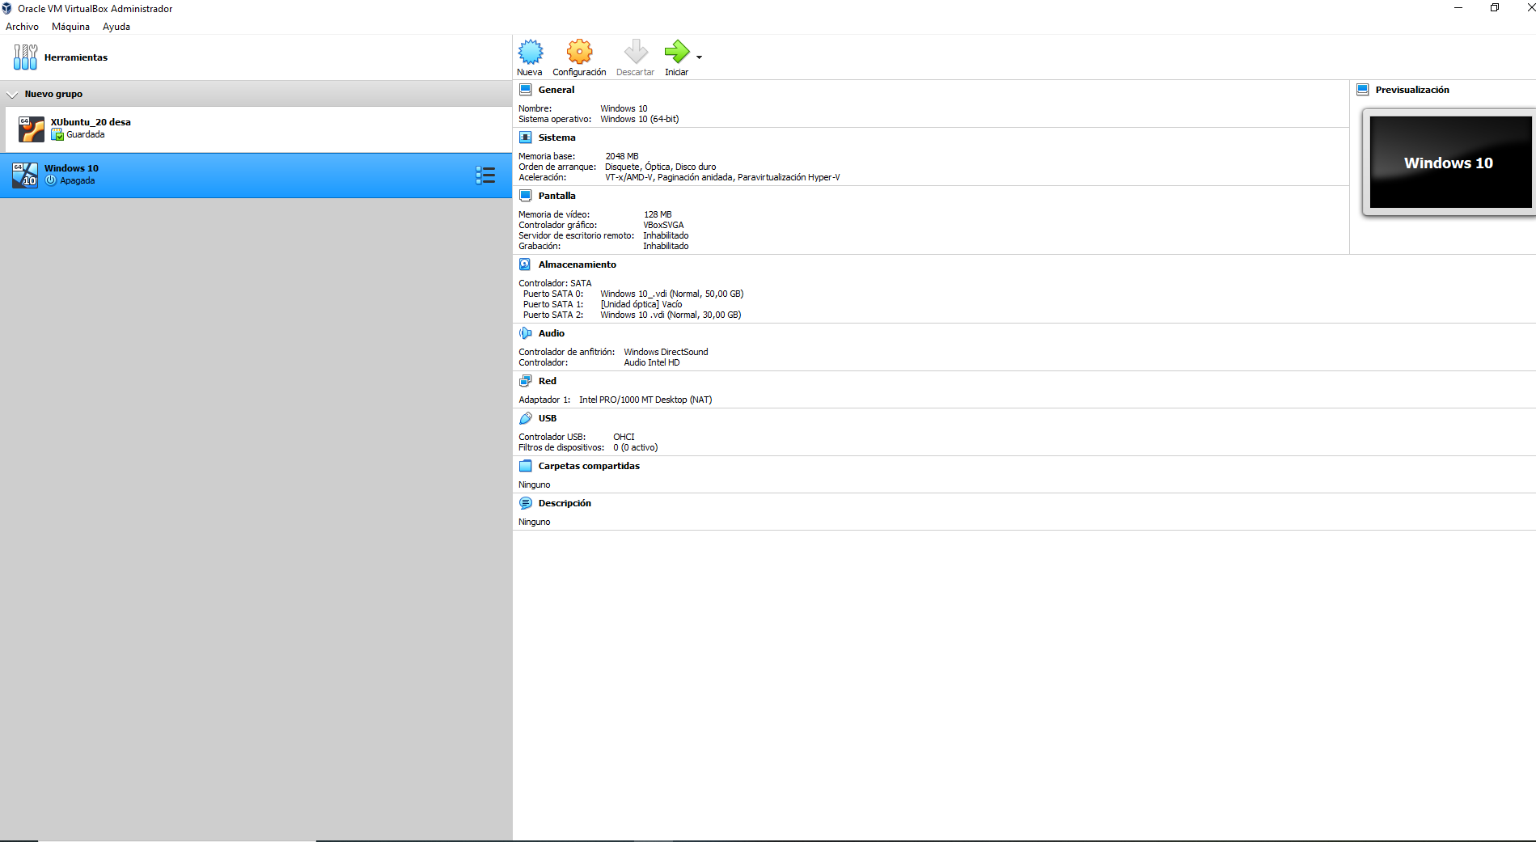
2. **USB setup. (Don´t know how to do it)**

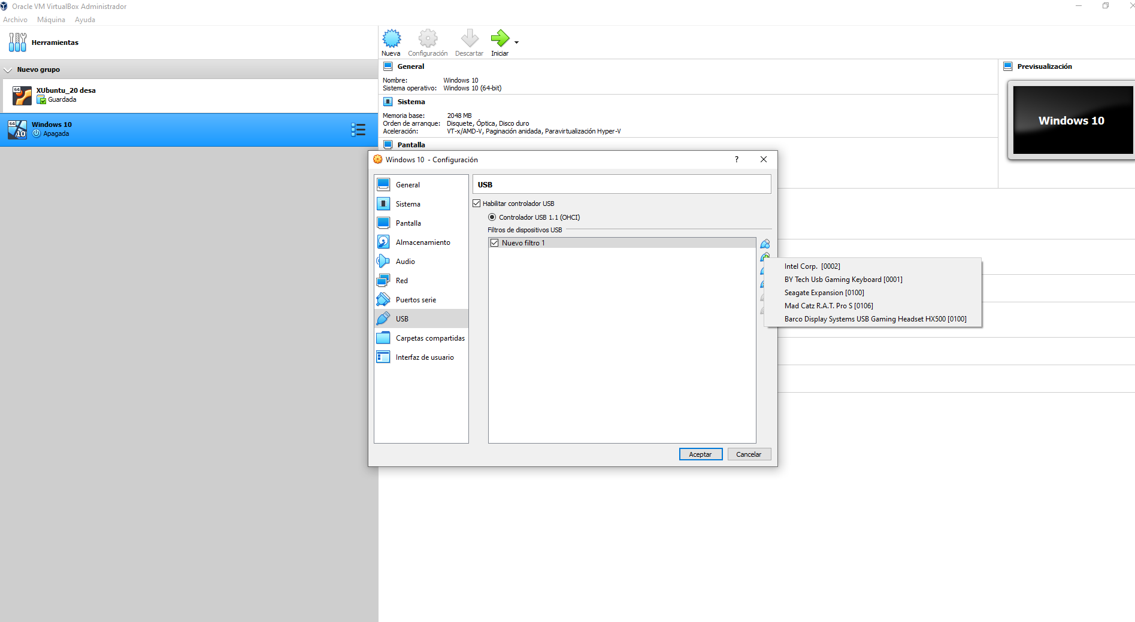

1. **Shared folder.**

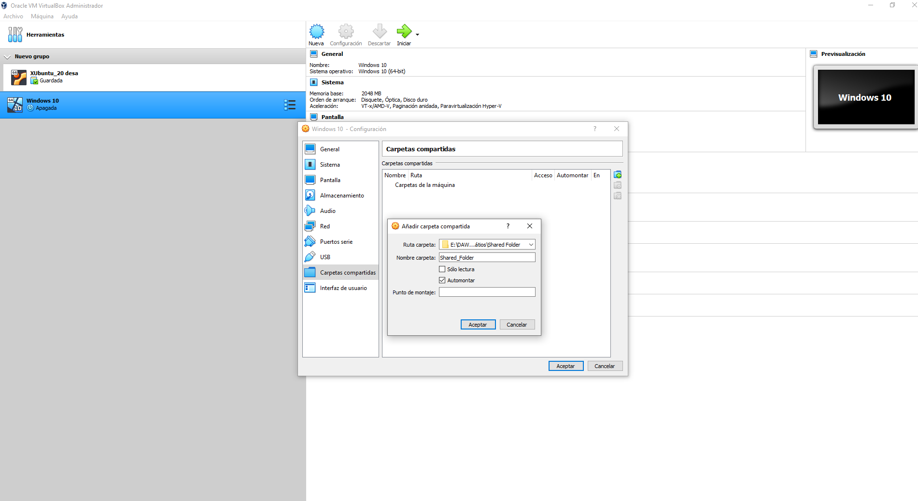

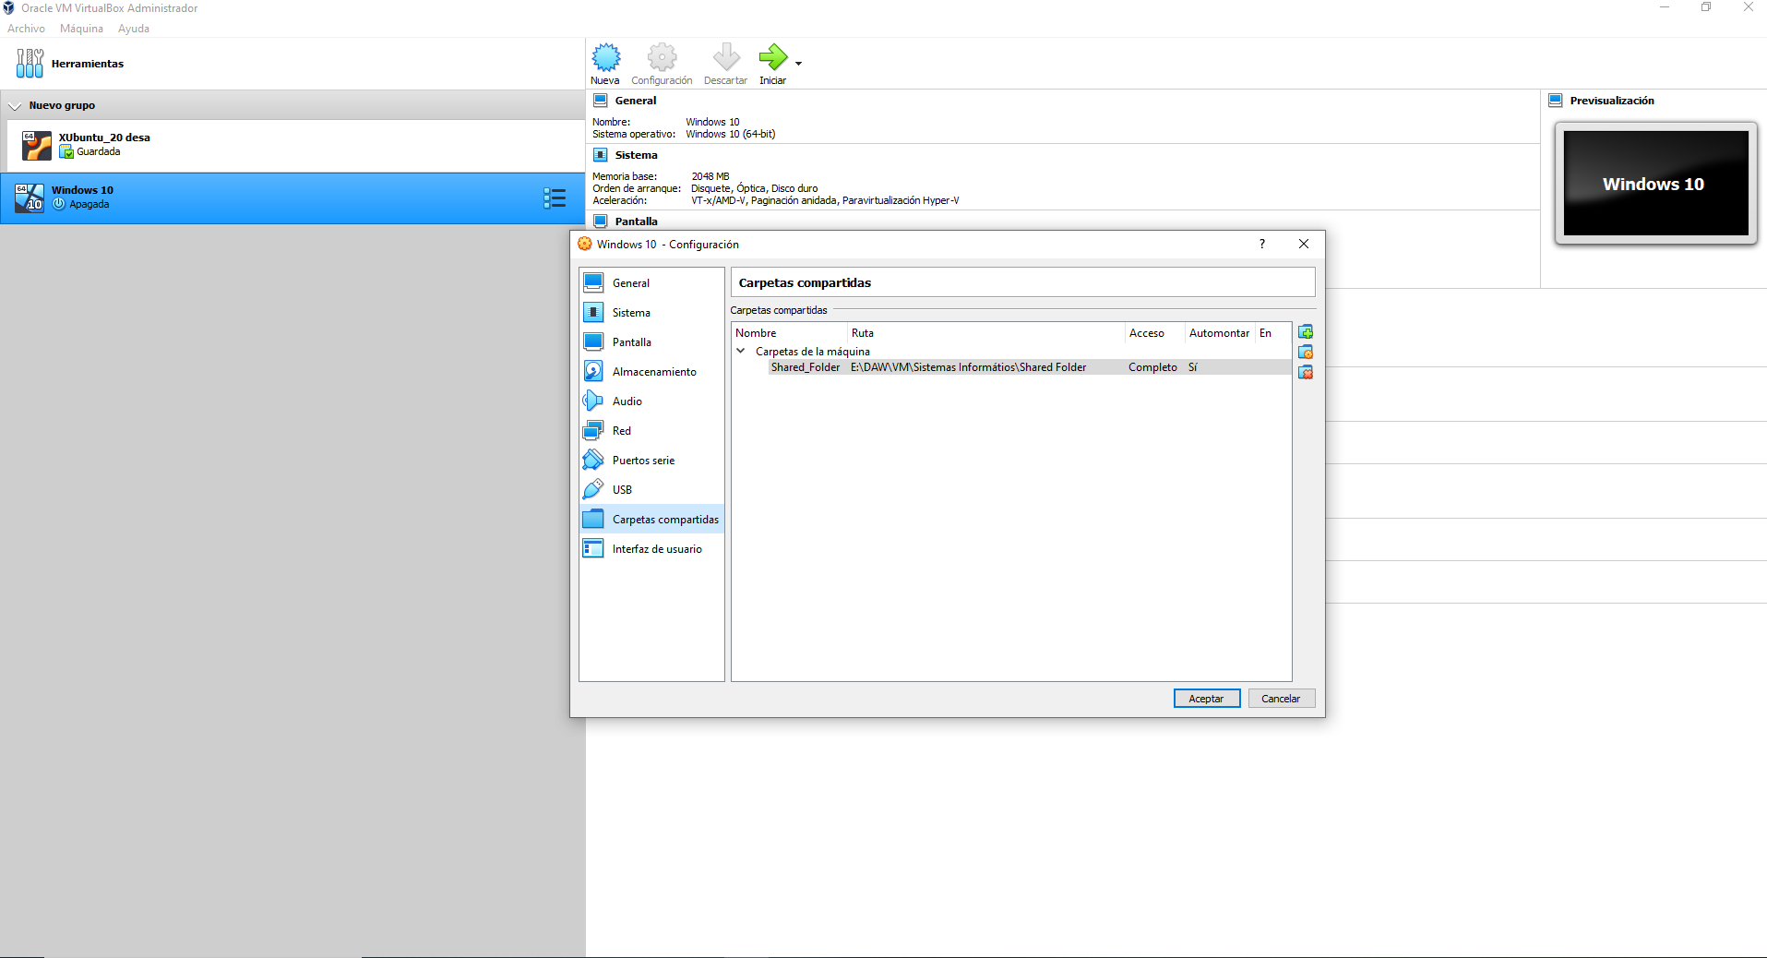

1. **Internet connection including access to the rest of the computers of the network.**

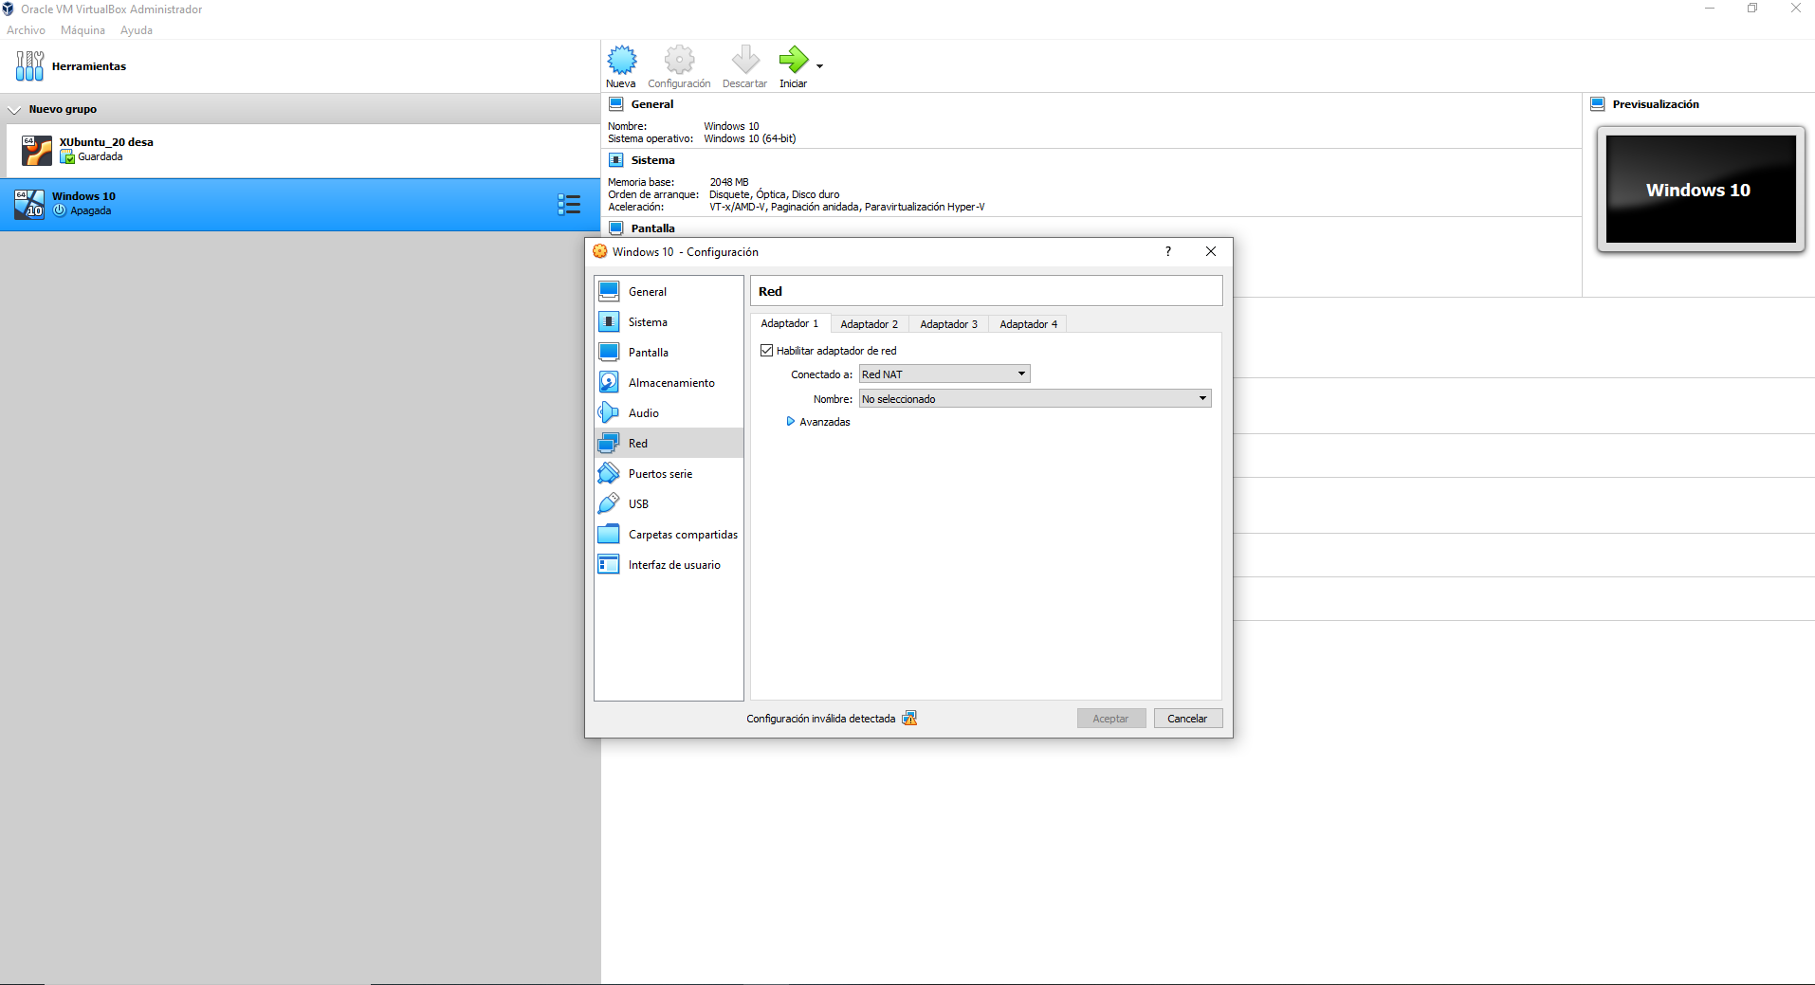

1. **Final look before OS installation.**

