**近接開關 (SS-05N) NPN type、開關(Dry Contact)**

**Wet Contact (external power)**

近接開關 (SS-05N) NPN type

<https://www.sunwu-power.com/products_detail/98.htm>

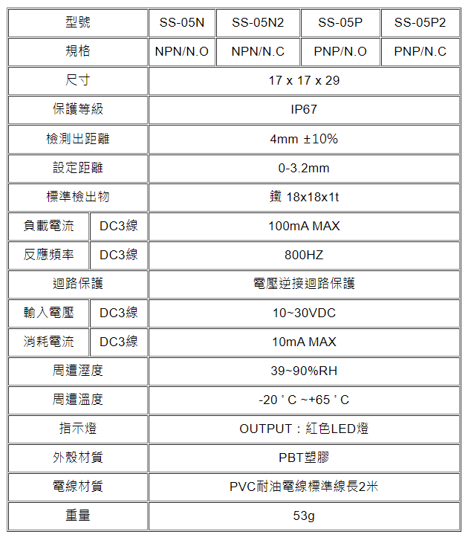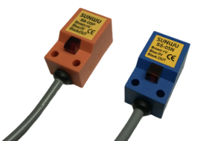

接線圖

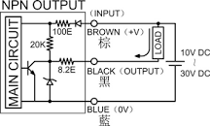

**Dry Contact**

<https://shopee.tw/%E5%8D%A1%E5%BC%8FDS-427-428%E5%9C%93%E5%BD%A2%E6%8C%89%E9%88%95%E9%96%8B%E9%97%9C-12mm%E7%84%A1%E9%8E%96%E8%87%AA%E5%BE%A9%E4%BD%8D%E6%9C%89%E9%8E%96%E8%87%AA%E9%8E%96%E4%BD%8D%E9%BB%9E%E5%8B%95%E9%96%8B%E9%97%9C-i.405745673.10796750389>

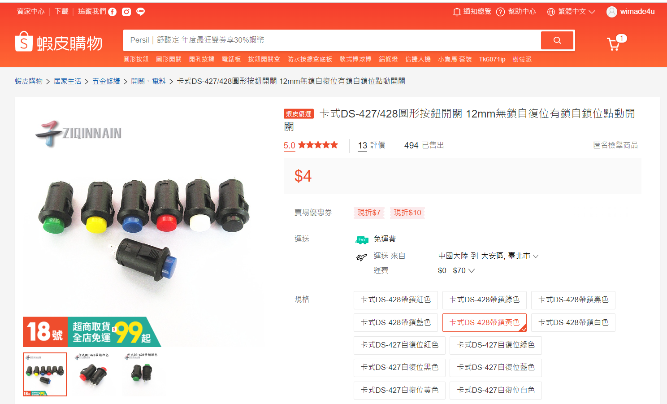

**Output**

24V Bulb

<https://shopee.tw/product/149365831/4047364196?gclid=CjwKCAjw2K6lBhBXEiwA5RjtCYrYPLsFPtnrWJz59qe6j1p3GtGxRLKePKmwjVVvOxnkdSIzGjI7SBoCEFgQAvD_BwE>

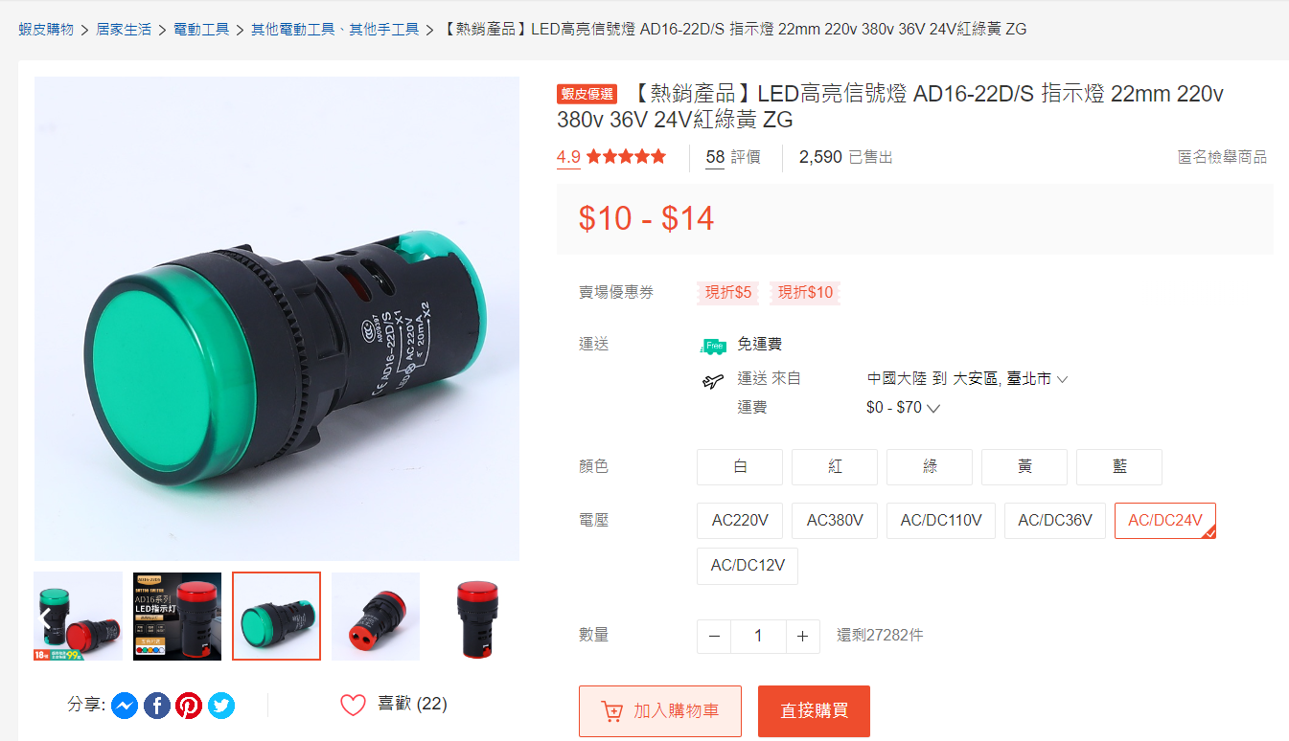

**ADAM 6717 Reference**

