

Table of Content

Registration…………………………………………………………………………………………………….3
Login Procedure………………………………………………………………………………………………3
Navigation Menu…………………………………………………………………………………………….3
Quick Links………………………………………………………………………………………………………6
About Developers……………………………………………………………………………………………6
Contact Us……………………………………………………………………………………………………….7
Feedback………………………………………………………………………………………………………… 7

IIPS Website User’s Guide

Registration

Login Procedure

- Open any web browser (Mozilla Firefox/Opera/Chrome/Internet Explorer), and type the following web address : http://iips.edu.in in URL bar.
- Click on top Navigation bar according to your type (e.g Student, Faculty, Alumni, Staff etc.)
See the red mark in the image.



- After clicking on your type you will be redirected to the login form where you have to fill following information to logged in the system:
- Username - Your IIPS username/Email address.
- Password – Your password for authorization.
Note : E-mail and passwords are case sensitive.

Navigating Menus
In the IIPS website you can find information about the IIPS institute by just navigating the Main Menu below the IIPS Header Image. See the red line in the below image:
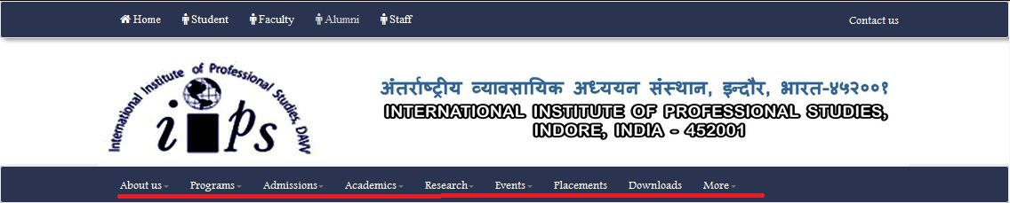
After clicking on each Menu it will open a dropdown menu containing submenus, after clicking on submenus you will be redirected to the new page which will content two section –
a) Sidebar Section and b) Content Section.
After clicking on sidebar options you will get appropriate information related to the option you clicked on sidebar.
See below image:
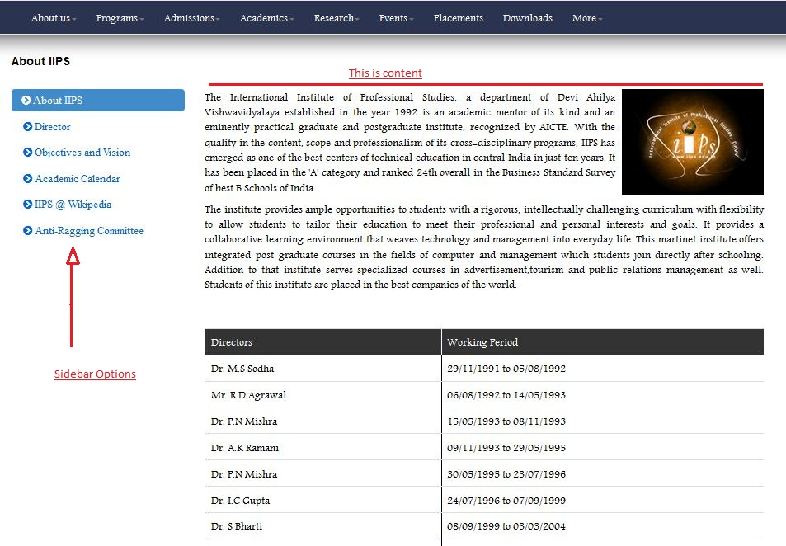
- About Us : It is the first menu option, which contains 6 submenu:

  - About University: This submenu opens a webpage containing information about Devi Ahilya University, Vice Chancellor, Various Departments, Auditorium and IT Center.
  - About IIPS: This submenu opens a webpage containing information about IIPS, Director, Objective & Visions, Academic Calendar and Anti-Ragging Committee.
  - Life @ Campus:
  - Infrastructure: This submenu opens a webpage containing information related to infrastructures of the institutes e.g. – Lecture Theatres, Computer Labs, Auditorium, Libraries and Hostels.
  - Gallery: This submenu opens a webpage containing images related to IIPS, Events, Activity, News, logos etc.
  - Reach Us: This submenu opens a webpage containing the address of IIPS along with the Google map to help you to reach the IIPS College.

- Programs : 2nd option in the menu, it has 5 submenus :

2.1 Under Graduate: This submenu contains information of under graduate programs of the institute, currently – B.com (Hons.).
2.2 Integrated: This submenu contains information of Integrated programs of the institute, currently – MCA (6years), MBA(MS-5years), M.Tech. (5 & 1/2 half years).
2.3 Post Graduated : This submenu contains information of post graduate programs of the institute, currently – MBA(MS-2years), MBA(APR-2years), MBA(TA-2years).
2.4 M. Phil / Ph.D : This submenu contains information of M. Phill/Ph.D programs of the institute.
2.5 Ph.D : This submenu contains information of Ph.D Course of the institute.

- Admission : 3rd option in the menu, it has 6 submenus and it contains information about Entrance Exam – CET, Eligibility, Criteria, Counseling, How to apply and Fees Structure.

- Academics : 4th option in the menu contains the information about Academic Calendar, Syllabus, Notice & Announcement and News of the Institute.
- Research : This is the 5th option in the menu, where you can find the information about the Research Center, Development Center & Publication of the Institute.
- Event : 6th option of the menu contains the information about the Events & activity in Institute – e.g. Xpressions, Synergy, Tourista.
- Placements : 7th option of the menu contains information about the placement officer, number of students placed in companies, Companies which believes in us.
- Downloads : 8th option of the menu contains information which can be downloaded, e.g. – Syllabus, Academic Calendar, Forms, Miscellaneous etc.
- More : This is 9th option in the menu which contain submenus – Library, Faculty Profile, Staff Profile, Student Verification, Video Channel, Recruitments @ IIPS and RTI.

Quick Links
Quick links is section, available on almost all pages to help you quickly navigate to the important links, without searching it on Dropdown menus. See the below image:
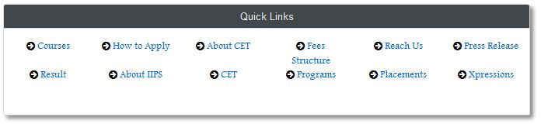

About Developers
- Link to the developers who have contributed to the IIPS website Project is available at the bottom of the page (in footer section).
- On “About Developers” page you will find the information about the developers with their images and roles.

Contact Us
- You can find the information on how to contact IIPS, by clicking on ‘Contact Us’ link available at the top navbar menu of the page (Gateway Menu for the IIPS users).
- You will get the E-mail address, Feedback link, Twitter/Facebook/Google+ link of the institute along with support team’s E-mail address.

Feedback

- After navigating through whole website using the menus you can easily give your feedback by click on link of feedback on the left side of the footer of the webpage. See In the below image:
- The feedback form contains two section , one for all the users of the website (including students, faculty, alumni, staff, visitors etc.), and second is only for the users who are authorized users of the IIPS ( Students, Faculty, Staff, Alumni), not for visitors.
- After Submitting/Skipping the Service form of feedback, user can click on submit button to submit their valuable experience with the IIPS website.

