**PIZZA SALEES SQL QUERIES**

**1.KPI’S**

**1.Total Revenue:**

select SUM(total_price)as TOTAL_REVENUE from pizza_sales;

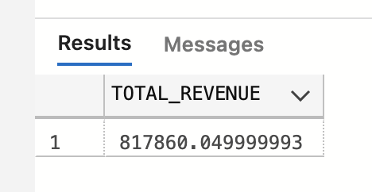

**2.Average order value:**

select SUM(total_price)/COUNT(Distinct order_id)as avg_order_valaue from pizza_sales;

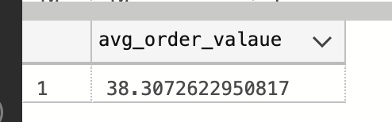

**3.Total pizza sold:**

select SUM(quantity) as Total_pizza_sold from pizza_sales;

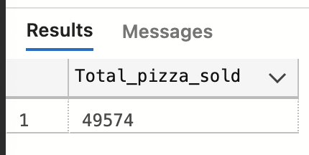

**4.Total order:**

select COUNT(distinct order_id)as Total_orders from pizza_sales;

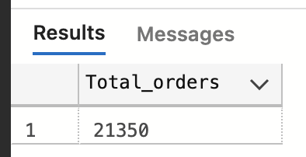

**5.Average pizza per order:**

select CAST(CAST(SUM(quantity)as decimal(10,2))/CAST(COUNT(distinct order_id)as decimal(10,2)) as decimal(10,2)) as Avvg_pizza_order from pizza_sales;

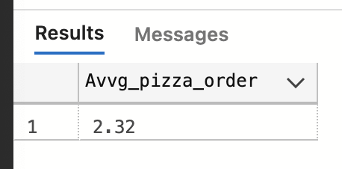

**6.Hourly trend for total pizza sold:**

select DATEPART(HOUR,order_time) as order_hour, SUM(quantity) as Total_pizza_sold from pizza_sales GROUP BY DATEPART(HOUR,order_time) ORDER BY DATEPART(HOUR,order_time);

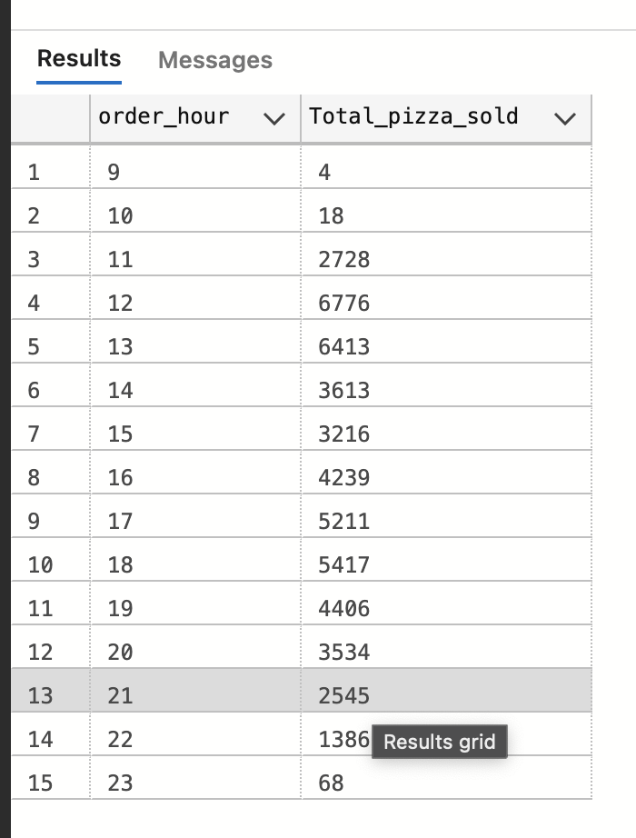

**7.Weekly trend for total pizza sold:**

select DATEPART(ISO_WEEK, order_date) as weeek_no, YEAR(order_date) as Order_year,

COUNT(distinct order_id) as Total_orders from pizza_sales

GROUP BY DATEPART(ISO_WEEK, order_date), YEAR(order_date)

ORDER BY DATEPART(ISO_WEEK, order_date), YEAR(order_date);

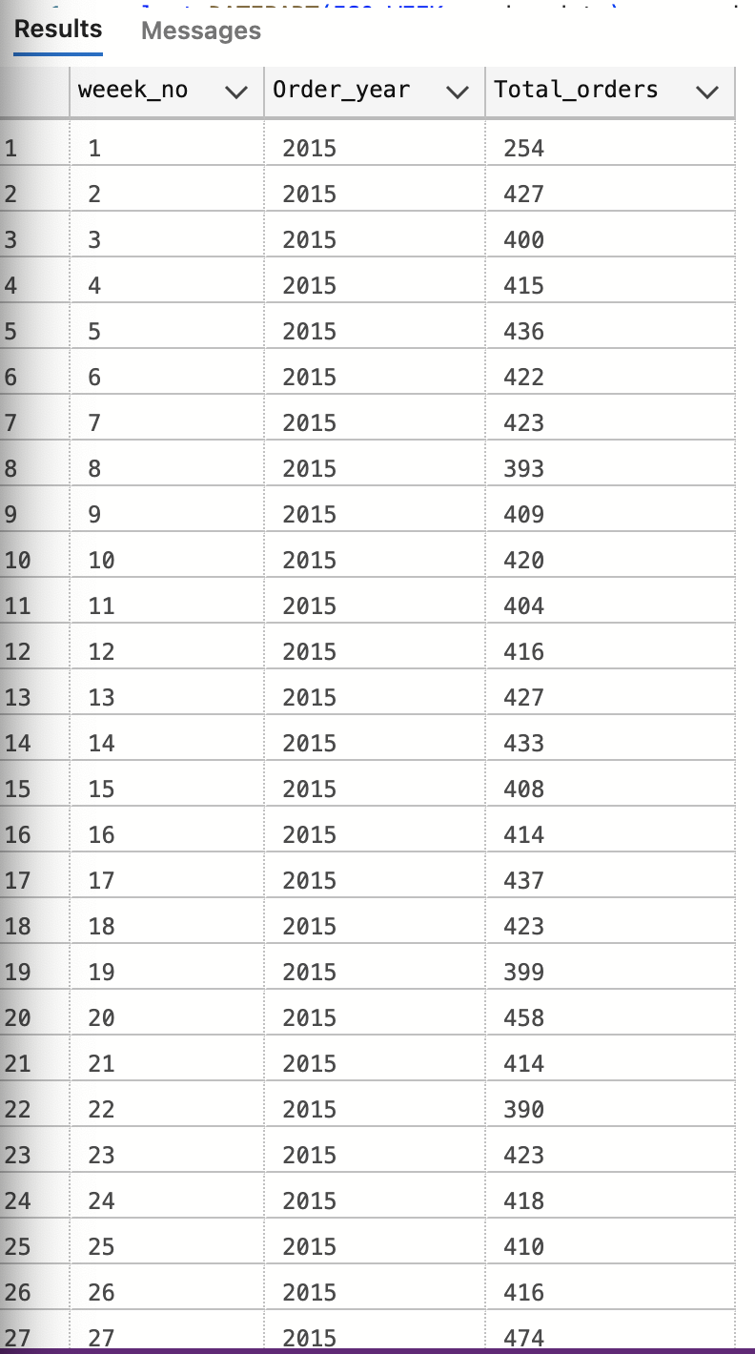

**8.Percentage of sales by pizza category:**

select pizza_category, SUM(total_price)*100/(select SUM(total_price) from pizza_sales) as pct from pizza_sales GROUP BY pizza_category;

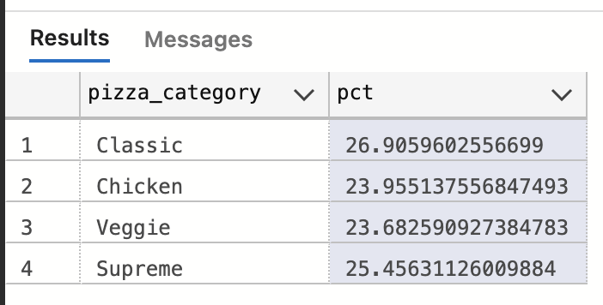

select pizza_category, SUM(total_price) as Total_sales ,SUM(total_price) *100/(select SUM(total_price) from pizza_sales where MONTH(order_date)=1) as pct from pizza_sales where MONTH(order_date)=1

GROUP BY pizza_category;

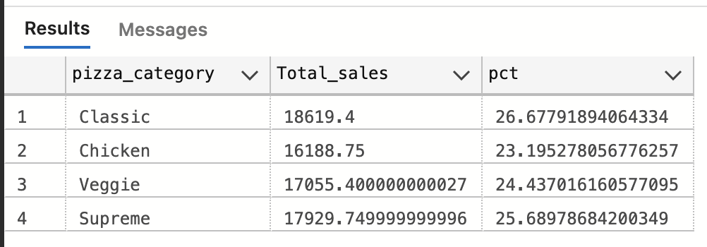

**9.Percentage of sales by pizza size:**

select pizza_size, SUM(total_price) as total_sales , SUM(total_price)*100/ (select SUM(total_price) from pizza_sales) as pct from pizza_sales GROUP BY pizza_size ORDER BY pct desc;

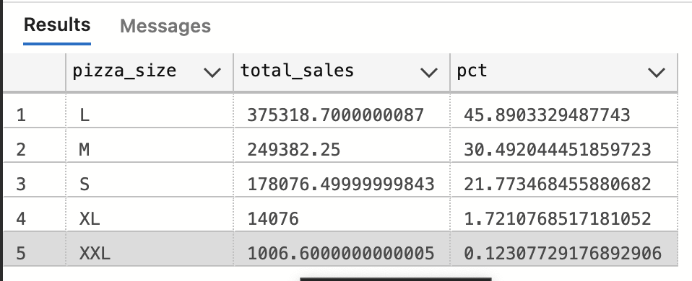

select pizza_size, CAST(SUM(total_price) as DECIMAL(10,2)) as total_sales, CAST(SUM(total_price) * 100/

(select SUM(total_price) from pizza_sales) as DECIMAL(10,2)) as pct from pizza_sales GROUP BY pizza_size ORDER BY pct desc;

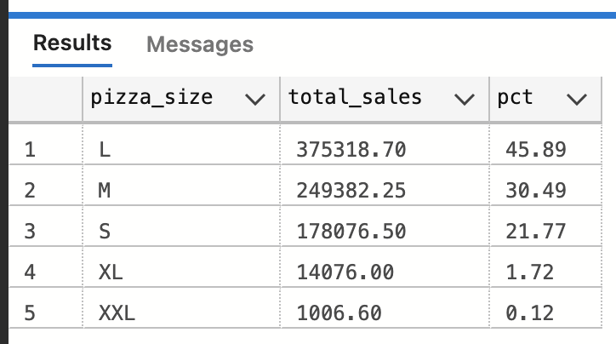

**10.Percentage of sales by pizza size(for 1st quarter):**

select pizza_size, CAST(SUM(total_price) as DECIMAL(10,2)) as total_sales, CAST(SUM(total_price) * 100/ (select SUM(total_price) from pizza_sales) as DECIMAL(10,2)) as pct from pizza_sales WHERE DATEPART(quarter, order_date) =1 GROUP BY pizza_size ORDER BY pct desc;

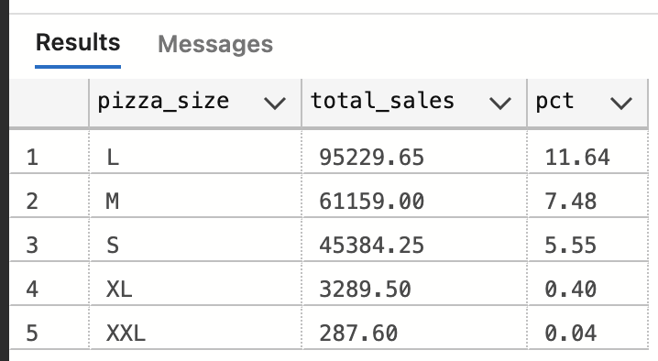

**11.Top 5 best sellers by revenue :**

select top 5 pizza_name,SUM(total_price) as total_revenue FROM pizza_sales GROUP BY pizza_name ORDER BY total_revenue DESC

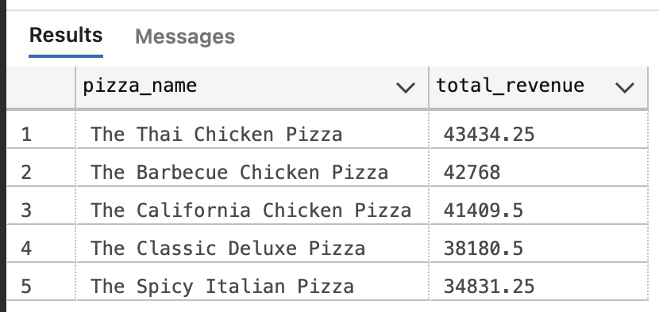

**12. Bottom 5 pizza seller:**

select top 5 pizza_name,SUM(total_price) as total_revenue FROM pizza_sales GROUP BY pizza_name ORDER BY total_revenue asc;

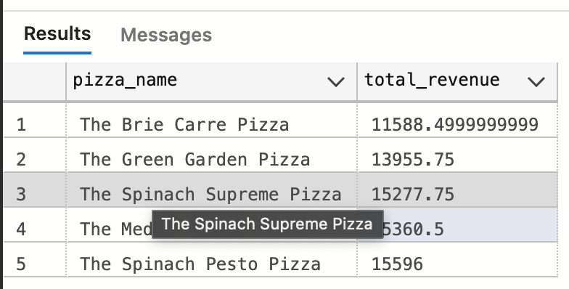

**13.Top 5 best sellers by quantity:**

select top 5 pizza_name,SUM(quantity) as total_quantity FROM pizza_sales GROUP BY pizza_name ORDER BY total_quantity DESC

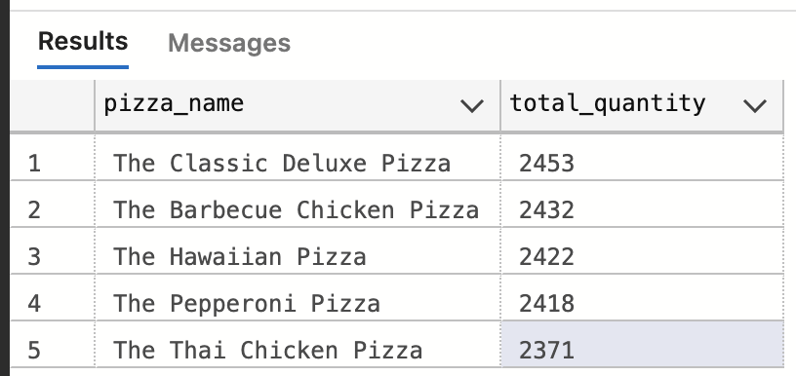

**14.Bottom 5 best sellers by quantity:**

select top 5 pizza_name,SUM(quantity) as total_quantity FROM pizza_sales GROUP BY pizza_name ORDER BY total_quantity ASC

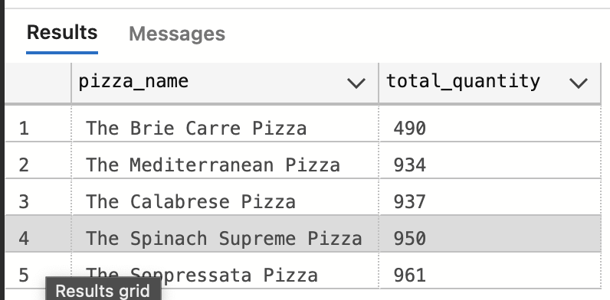

**15.Bottom 5 best sellers by Orders:**

select top 5 pizza_name,COUNT(distinct order_id) as total_orders FROM pizza_sales GROUP BY pizza_name ORDER BY total_orders ASC;

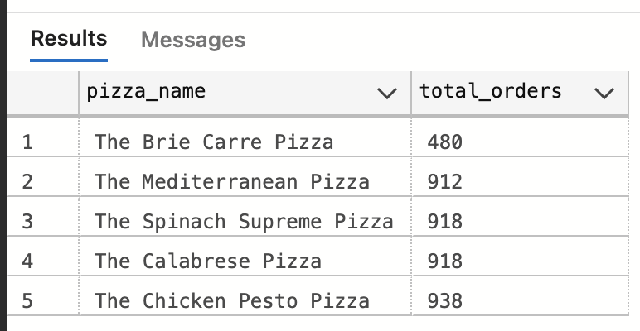

**16.Bottom 5 best sellers by Orders:**

select top 5 pizza_name,COUNT(distinct order_id) as total_orders FROM pizza_sales GROUP BY pizza_name ORDER BY total_orders desc;

