

2018

www.sufsalinternational.com

District Sialkot, Punjab Pakistan

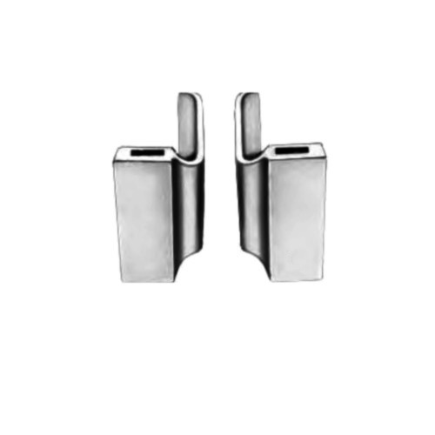

**Item# SI-1186**

**Name:** Ulrich Dressing Forceps

**Category:** THORAX & CARDIOVASCULAR

**OVERVIEW:**

Ulrich Dressing Forceps Curved 22.5 cm – 8 3/4″

**Material**: Stainless Steel

**Finish**: Satin Finish (Mirror finish available upon request)

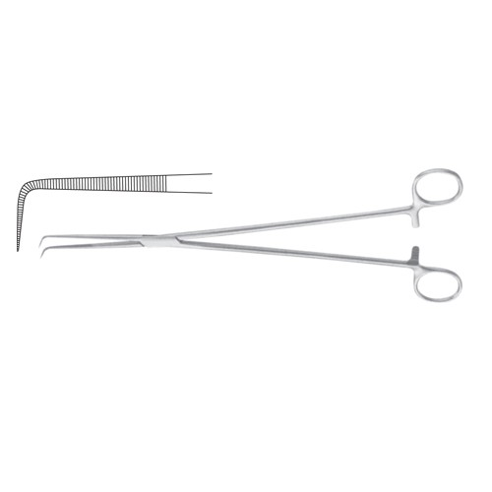

**Item# SI-1187**

**Name:** Barre Dissecting and Ligature Forcep

**OVERVIEW:**

Barre Dissecting and Ligature Forcep Extra Delicate 28 cm – 11″

**Material**: Stainless Steel

**Finish:** Satin Finish (Mirror finish available upon request)

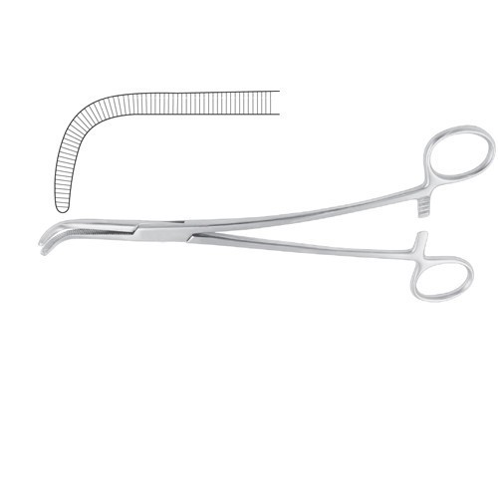

**Item# SI-1188**

**Name:** Gray Dissecting and Ligature Forcep

**OVERVIEW:**

Gray Dissecting and Ligature Forcep Curved S Shaped 22 cm – 8 3/4″

**Material**: Stainless Steel

**Finish:** Satin Finish (Mirror finish available upon request)

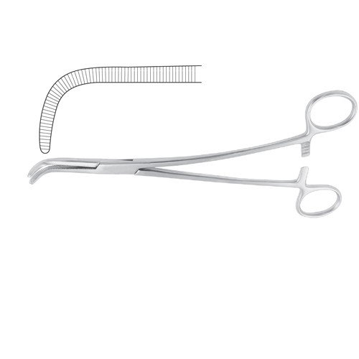

**Item# SI-1189**

**Name:** Gray Dissecting and Ligature Forcep

**OVERVIEW:**

Gray Dissecting and Ligature Forcep Curved

S Shaped 22 cm – 8 3/4″

**Material**: Stainless Steel

**Finish:** Satin Finish (Mirror finish available upon request)

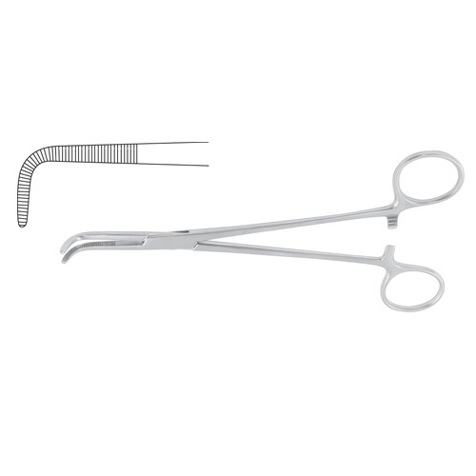

**Item# SI-1190**

**Name:** Kantrowitz Dissecting and Ligature Forcep

**OVERVIEW:**

Kantrowitz Dissecting and Ligature Forcep Right Angled 27.5 cm – 10 3/4″

**Material**: Stainless Steel

**Finish:** Satin Finish (Mirror finish available upon request)

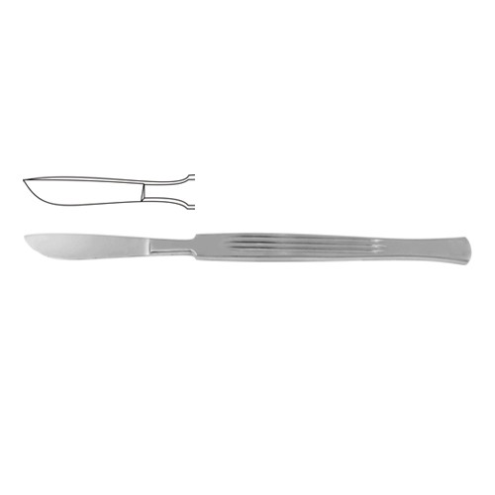

**Item# SI-1191**

**Name:** Dissecting Knife / Opreating Knife

**OVERVIEW:**

Dissecting Knife / Opreating Knife With

Metal Handle 15 cm – 6″ Blade Size 30 mm

**Material**: Stainless Steel

**Finish:** Satin Finish (Mirror finish available upon request)

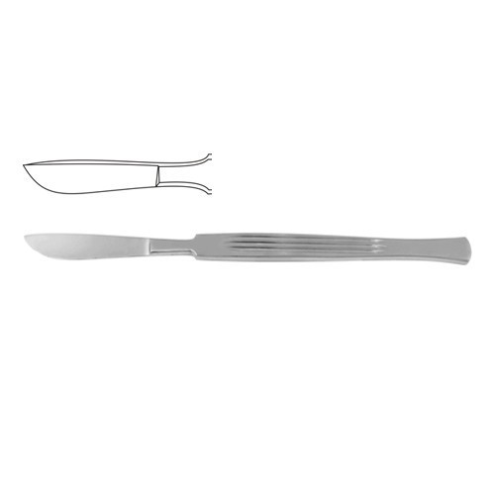

**Item# SI-1192**

**Name:** Dissecting Knife / Opreating Knife

**OVERVIEW:**

Dissecting Knife / Opreating Knife With Metal Handle 15 cm – 6″ Blade Size 36 mm

**Material**: Stainless Steel

**Finish:** Satin Finish (Mirror finish available upon request)

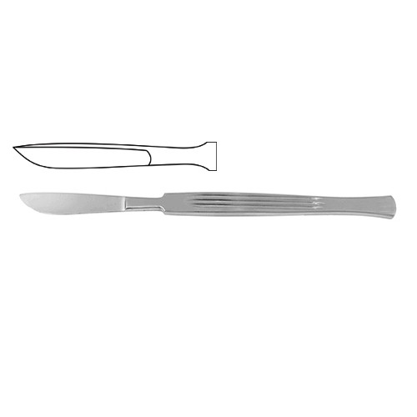

**Item# SI-1193**

**Name:** Dissecting Knife / Opreating Knife

**OVERVIEW:**

Dissecting Knife / Opreating Knife With Metal Handle 15.5 cm – 6″ Blade Size 40 mm

**Material**: Stainless Steel

**Finish:** Satin Finish (Mirror finish available upon request)

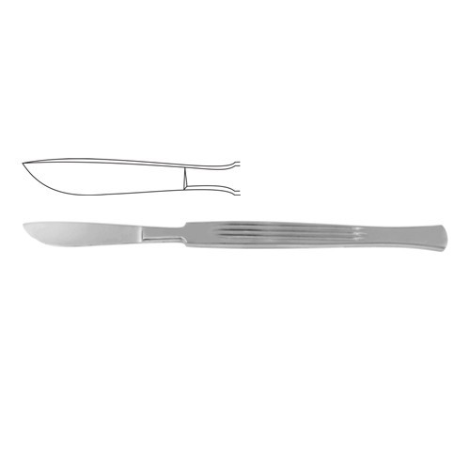

**Item# SI-1194**

**Name:** Dissecting Knife / Opreating Knife

**OVERVIEW:**

Dissecting Knife / Opreating Knife With Metal Handle 16 cm – 6 1/4″ Blade Size 45 mm

**Material**: Stainless Steel

**Finish:** Satin Finish (Mirror finish available upon request)



**Item# SI-1195**

**Name:** Dissecting Knife / Opreating Knife

**OVERVIEW:**

Dissecting Knife / Opreating Knife With

Metal Handle 16 cm – 6 1/4″ Blade Size 40 mm

**Material**: Stainless Steel

**Finish:** Satin Finish (Mirror finish available upon request)

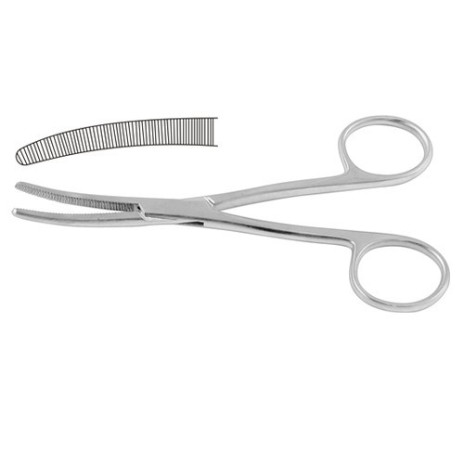

**Item# SI-1196**

**Name:** Bryant Dressing Forceps

**OVERVIEW:**

Bryant Dressing Forceps Curved 13 cm – 5″

**Material**: Stainless Steel

**Finish:** Satin Finish (Mirror finish available upon request)

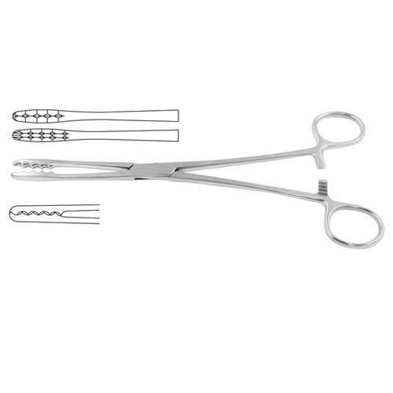

**Item# SI-1197**

**Name:** Ulrich Dressing Forceps

**OVERVIEW:**

Ulrich Dressing Forceps Straight 22.5 cm – 8 3/4″

**Material**: Stainless Steel

**Finish:** Satin Finish (Mirror finish available upon request)

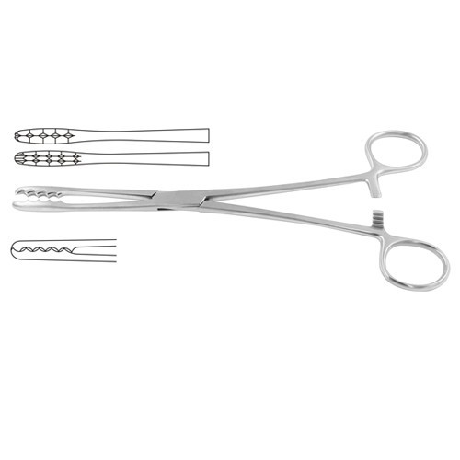

**Item# SI-1198**

**Name:** Ulrich Dressing Forceps

**OVERVIEW:**

Ulrich Dressing Forceps Straight 26.5 cm – 10 1/2″

**Material**: Stainless Steel

**Finish:** Satin Finish (Mirror finish available upon request)



**Item# SI-1199**

**Name:** Ulrich Dressing Forceps

**OVERVIEW:**

Ulrich Dressing Forceps Curved 22.5 cm – 8 3/4″

**Material**: Stainless Steel

**Finish:** Satin Finish (Mirror finish available upon request)

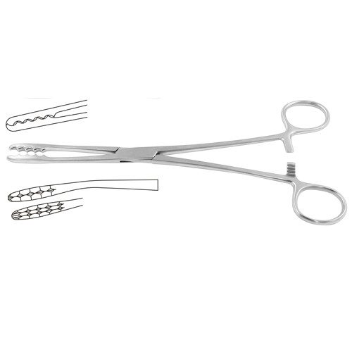

**Item# SI-1200**

**Name:** Ulrich Dressing Forceps

**OVERVIEW:**

Ulrich Dressing Forceps Curved 26.5 cm – 10 1/2″

**Material**: Stainless Steel

**Finish:** Satin Finish (Mirror finish available upon request)

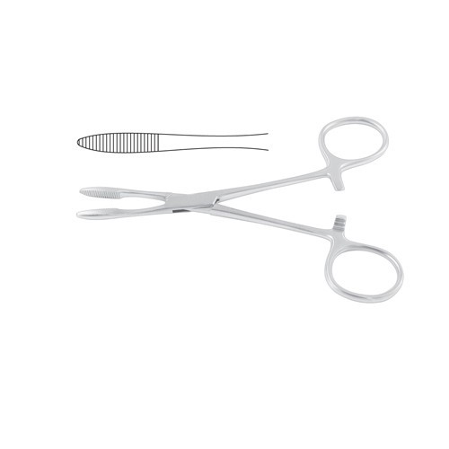

**Item# SI-1201**

**Name:** HEMOSTATIC FORCEPS

**OVERVIEW:**

Pean Haemostatic Forcep 14.5 cm – 5 3/4″

**Material**: Stainless Steel

**Finish:** Satin Finish (Mirror finish available upon request)

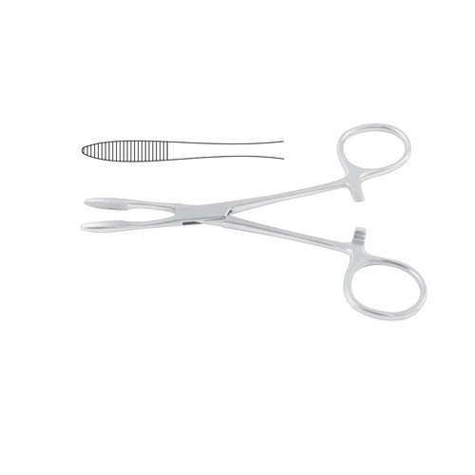

**Item# SI-1202**

**Name:** HEMOSTATIC FORCEPS

**OVERVIEW:**

Pean Haemostatic Forcep 16 cm – 6 1/4″

**Material**: Stainless Steel

**Finish:** Satin Finish (Mirror finish available upon request)

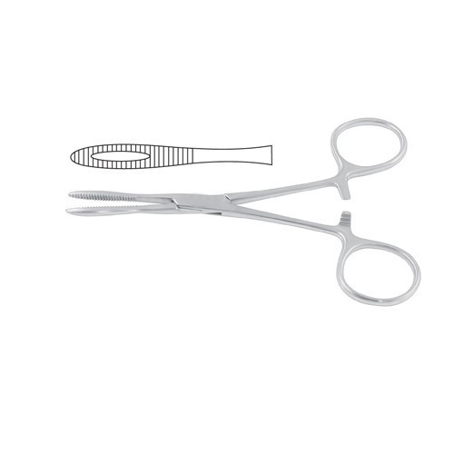

**Item# SI-1203**

**Name:** HEMOSTATIC FORCEPS

**OVERVIEW:**

Kroenlein Haemostatic Forcep 13 cm – 5″

**Material**: Stainless Steel

**Finish:** Satin Finish (Mirror finish available upon request)

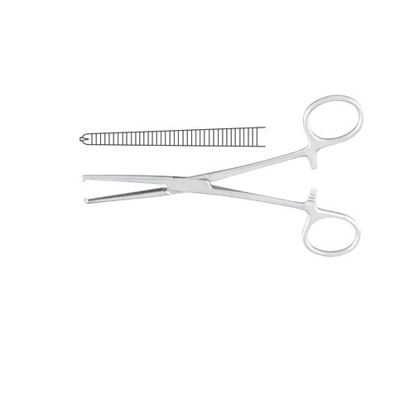

**Item# SI-1204**

**Name:** HEMOSTATIC FORCEPS

**OVERVIEW:**

Kocher Haemostatic Forcep Straight – 1 x 2 Teeth 15 cm – 6″

**Material**: Stainless Steel

**Finish:** Satin Finish (Mirror finish available upon request)

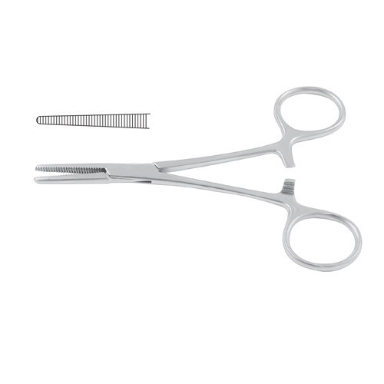

**Item# SI-1205**

**Name:** HEMOSTATIC FORCEPS

**OVERVIEW:**

Spencer-Wells Haemostatic Forcep Straight 20 cm – 8″

**Material**: Stainless Steel

**Finish:** Satin Finish (Mirror finish available upon request)

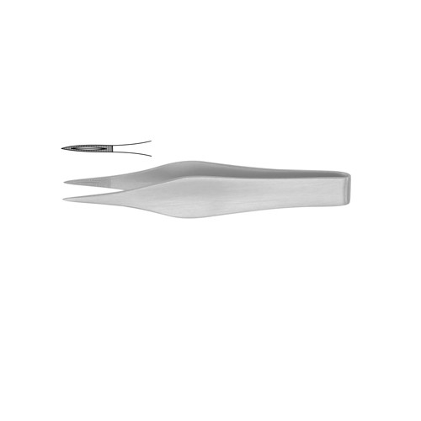

**Item# SI-1206**

**Name:** Feilchenfeld Splinter Forcep

**OVERVIEW:**

Feilchenfeld Splinter Forcep 11.5 cm – 4 1/2″

**Material**: Stainless Steel

**Finish:** Satin Finish (Mirror finish available upon request)

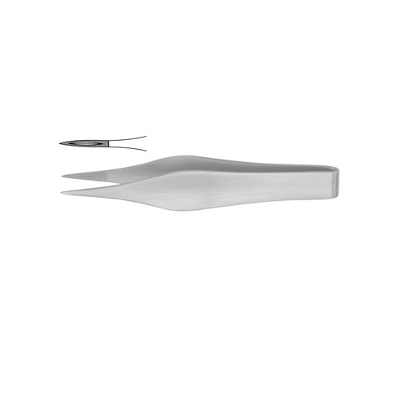

**Item# SI-1207**

**Name:** Feilchenfeld Splinter Forcep

**OVERVIEW:**

Feilchenfeld Splinter Forcep 9 cm – 3 1/2″

**Material**: Stainless Steel

**Finish:** Satin Finish (Mirror finish available upon request)

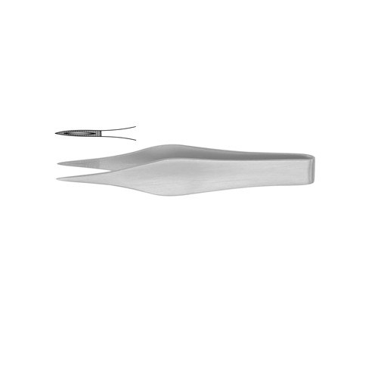

**Item# SI-1208**

**Name:** Feilchenfeld Splinter Forcep

**OVERVIEW:**

Feilchenfeld Splinter Forcep 7.5 cm – 3 1/4″

**Material**: Stainless Steel

**Finish:** Satin Finish (Mirror finish available upon request)

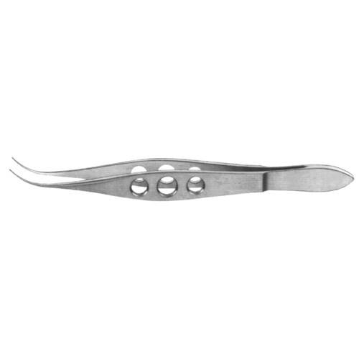

**Item# SI-1209**

**Name:** Feilchenfeld Splinter Forcep

**OVERVIEW:**

Fine Suture Tying Forcep Curved

10.5 cm – 4″

**Material**: Stainless Steel

**Finish:** Satin Finish (Mirror finish available upon request)

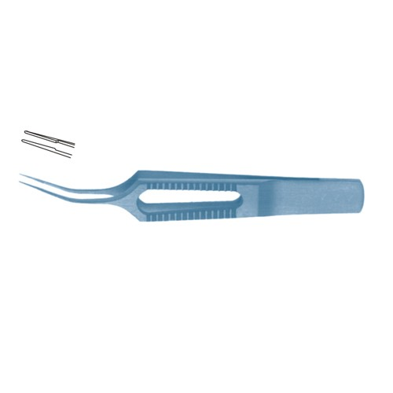

**Item# SI-1210**

**Name:** Gerl Suture Tying Forcep

**OVERVIEW:**

Gerl Suture Tying Forcep Smooth Jaws and Curved Shanks 8.5 cm – 3 1/4″ Jaws Length 6mm

**Material**: Stainless Steel

**Finish:** Satin Finish (Mirror finish available upon request)

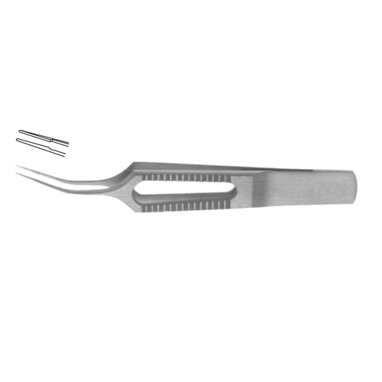

**Item# SI-1211**

**Name:** Gerl Suture Tying Forcep

**OVERVIEW:**

Gerl Suture Tying Forcep Smooth Jaws and Curved Shanks 8.5 cm – 3 1/4″ Jaws

Length 6 mm

**Material**: Stainless Steel

**Finish:** Satin Finish (Mirror finish available upon request)

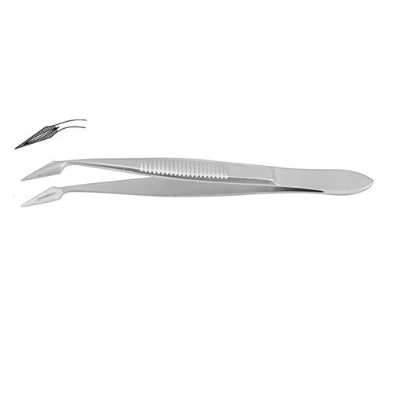

**Item# SI-1212**

**Name:** Hunter Splinter Forcep

**OVERVIEW:**

Hunter Splinter Forcep 10.5 cm – 4″

**Material**: Stainless Steel

**Finish:** Satin Finish (Mirror finish available upon request)

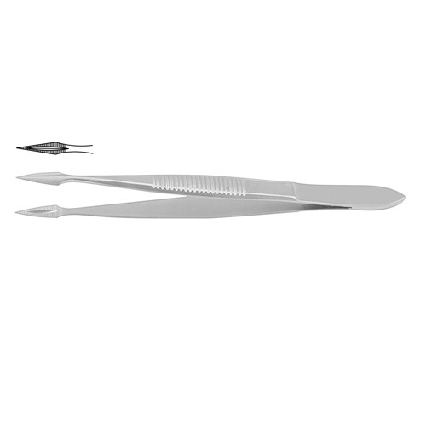

**Item# SI-1213**

**Name:** Hunter Splinter Forcep

**OVERVIEW:**

Hunter Splinter Forcep 10.5 cm – 4″

**Material**: Stainless Steel

**Finish:** Satin Finish (Mirror finish available upon request)

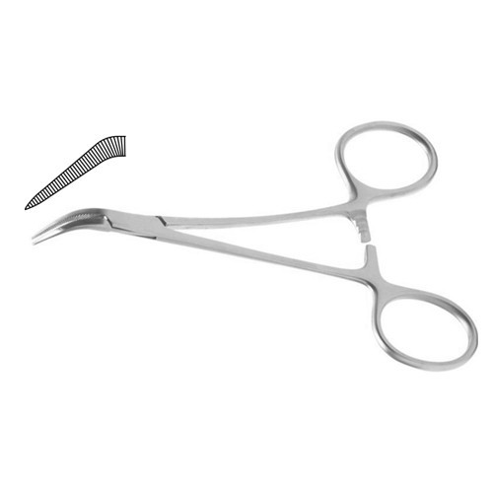

**Item# SI-1214**

**Name:** Peet Splinter Forcep

**OVERVIEW:**

Peet Splinter Forcep 12.5 cm – 5″

**Material**: Stainless Steel

**Finish:** Satin Finish (Mirror finish available upon request)

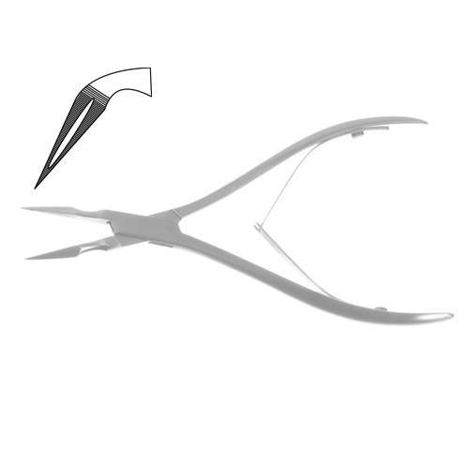

**Item# SI-1215**

**Name:** Ralk Splinter Forcep

**OVERVIEW:**

Ralk Splinter Forcep 15 cm – 6″

**Material**: Stainless Steel

**Finish:** Satin Finish (Mirror finish available upon request)

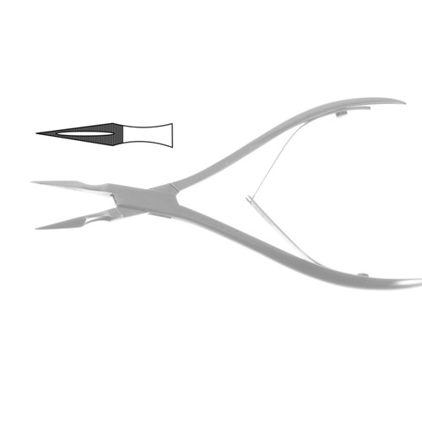

**Item# SI-1216**

**Name:** Peet Splinter Forcep

**OVERVIEW:**

Ralk Splinter Forcep 15 cm – 6″

**Material**: Stainless Steel

**Finish:** Satin Finish (Mirror finish available upon request)

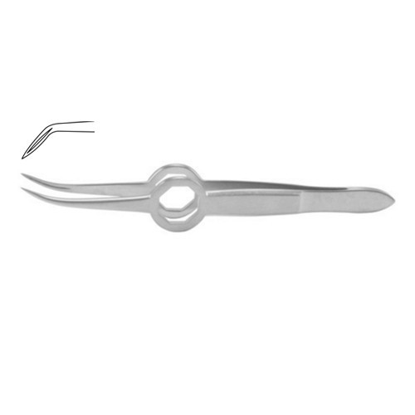

**Item# SI-1217**

**Name:** Shaaf Splinter Forcep

**OVERVIEW:**

Shaaf Splinter Forcep 9.5 cm – 3 3/4″

**Material**: Stainless Steel

**Finish:** Satin Finish (Mirror finish available upon request)

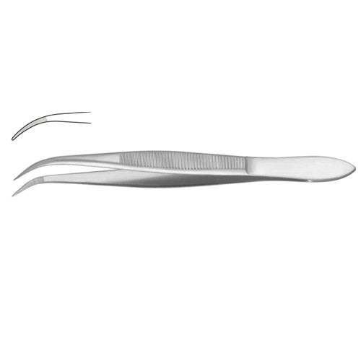

**Item# SI-1218**

**Name:** Splinter Forcep

**OVERVIEW:**

Splinter Forcep Curved – Serrated Jaws 14.5 cm – 5 3/4″

**Material**: Stainless Steel

**Finish:** Satin Finish (Mirror finish available upon request)

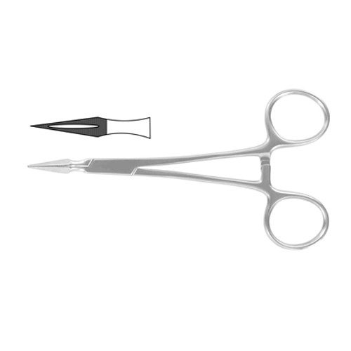

**Item# SI-1219**

**Name:** Stieglitz Splinter Forcep

**OVERVIEW:**

Stieglitz Splinter Forcep 14 cm – 5 1/2″

**Material**: Stainless Steel

**Finish:** Satin Finish (Mirror finish available upon request)



**Item# SI-1220**

**Name:** Splinter Forcep

**OVERVIEW:**

Stieglitz Splinter Forcep 13.5 cm – 5 1/4″

**Material**: Stainless Steel

**Finish:** Satin Finish (Mirror finish available upon request)

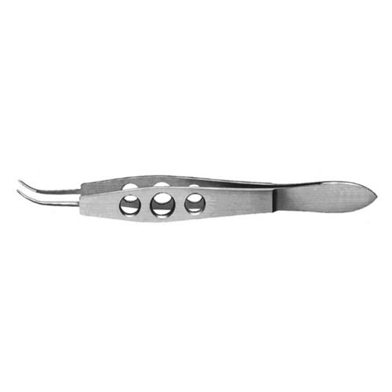

**Item# SI-1221**

**Name:** Suture Tying Forcep

**OVERVIEW:**

Harms Suture Tying Forcep Curved 10.5 cm – 4″

**Material**: Stainless Steel

**Finish:** Satin Finish (Mirror finish available upon request)

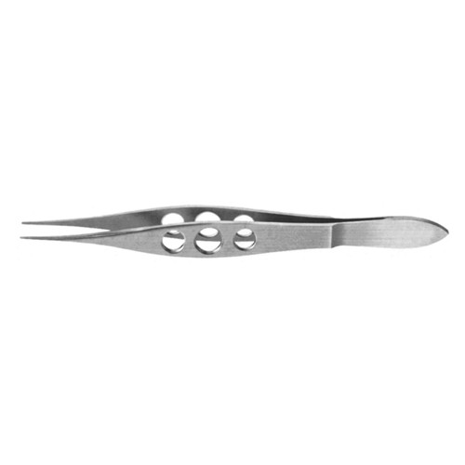

**Item# SI-1222**

**Name:** Suture Tying Forcep

**OVERVIEW:**

Helveston Suture Tying Forcep Straight 10.5 cm – 4″

**Material**: Stainless Steel

**Finish:** Satin Finish (Mirror finish available upon request)

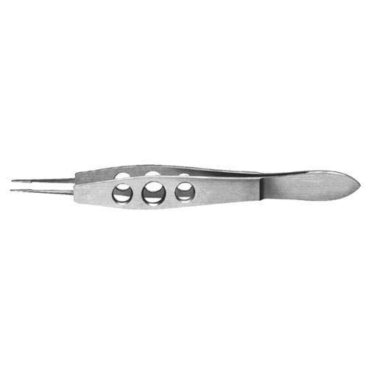

**Item# SI-1223**

**Name:** Suture Tying Forcep

**OVERVIEW:**

Harms Suture Tying Forcep Straight 10.5 cm – 4″

**Material**: Stainless Steel

**Finish:** Satin Finish (Mirror finish available upon request)

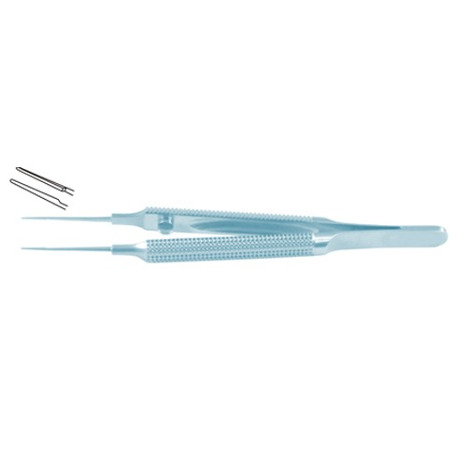

**Item# SI-1224**

**Name:** Suture Tying Forcep

**OVERVIEW:**

Tennant Suture Tying Forcep Curved – Round Handle with Guide Pin – Extra Delicate Smooth Jaws 10.5 cm – 4″ Jaws Length 6 mm

**Material**: Stainless Steel

**Finish:** Satin Finish (Mirror finish available upon request)

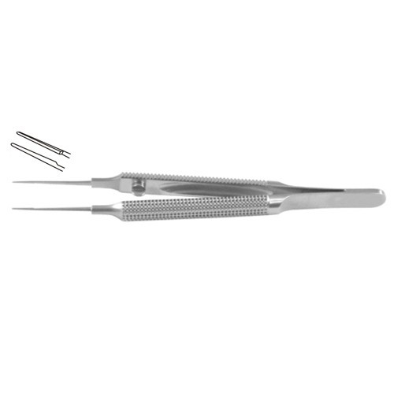

**Item# SI-1225**

**Name:** Suture Tying Forcep

**OVERVIEW:**

Tennant Suture Tying Forcep Curved – Round Handle with Guide Pin – Extra Delicate Smooth Jaws 10.5 cm – 4″ Jaws Length 6 mm

**Material**: Stainless Steel

**Finish:** Satin Finish (Mirror finish available upon request)

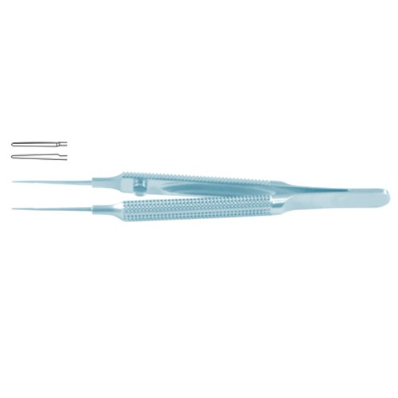

**Item# SI-1226**

**Name:** Suture Tying Forcep

**OVERVIEW:**

Tennant Suture Tying Forcep Straight – Round Handle with Guide Pin – Extra Delicate Smooth Jaws 10.5 cm – 4″ Jaws Length 6 mm

**Material**: Stainless Steel

**Finish:** Satin Finish (Mirror finish available upon request)

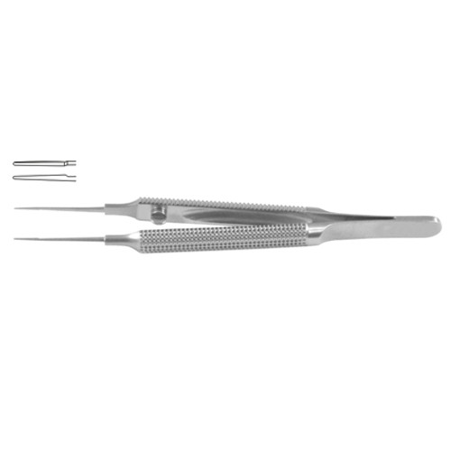 **Item# SI-1227**

**Name:** Suture Tying Forcep

**OVERVIEW:**

Tennant Suture Tying Forcep Straight – Round Handle with Guide Pin – Extra Delicate Smooth Jaws 10.5 cm – 4″ Jaws Length 6 mm

**Material**: Stainless Steel

**Finish:** Satin Finish (Mirror finish available upon request)

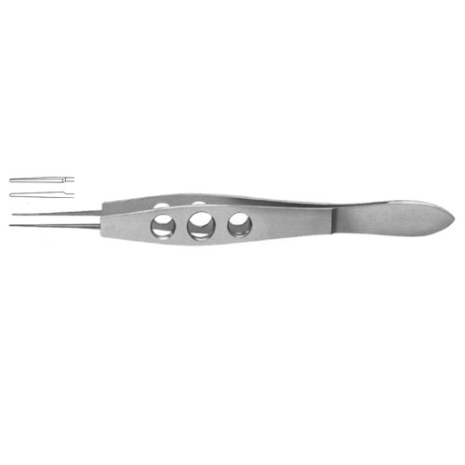

**Item# SI-1228**

**Name:** Suture Tying Forcep

**OVERVIEW:**

Jaffe Suture Tying Forcep Curved – Very Delicate Smooth Jaws 10.5 cm – 4″ Jaws Length 6 mm

**Material**: Stainless Steel

**Finish:** Satin Finish (Mirror finish available upon request)

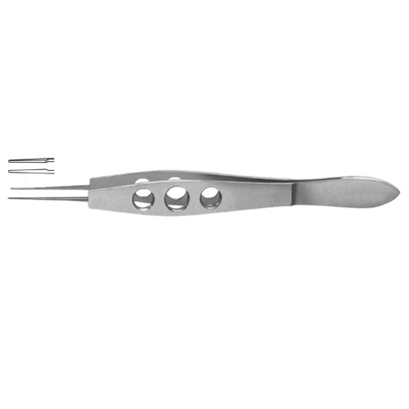

**Item# SI-1229**

**Name:** Suture Tying Forcep

**OVERVIEW:**

Jaffe Suture Tying Forcep Straight – Very Delicate Smooth Jaws 10.5 cm – 4″ Jaws Length 6 mm

**Material**: Stainless Steel

**Finish:** Satin Finish (Mirror finish available upon request)

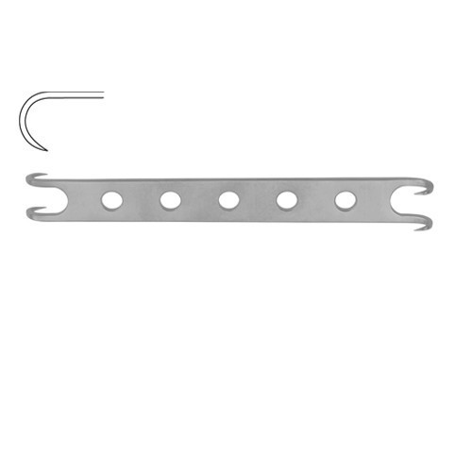

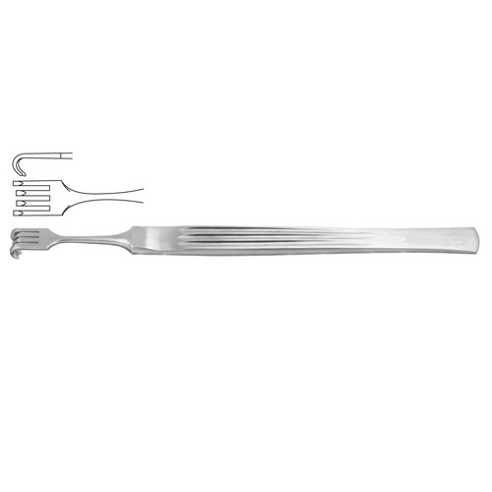 **Item# SI-1230**

**Name:** Converse Alar Hook Sharp

**OVERVIEW:**

Converse Alar Hook Sharp 11.5 cm – 4 1/2″

**Material**: Stainless Steel

**Finish:** Satin Finish (Mirror finish available upon request)

**Item# SI-1231**

**Name:** Cottle Alar Hook 4 Semi Sharp

**OVERVIEW:**

Cottle Alar Hook 4 Semi Sharp Prongs 14 cm – 5 1/2″

**Material**: Stainless Steel

**Finish:** Satin Finish (Mirror finish available upon request)

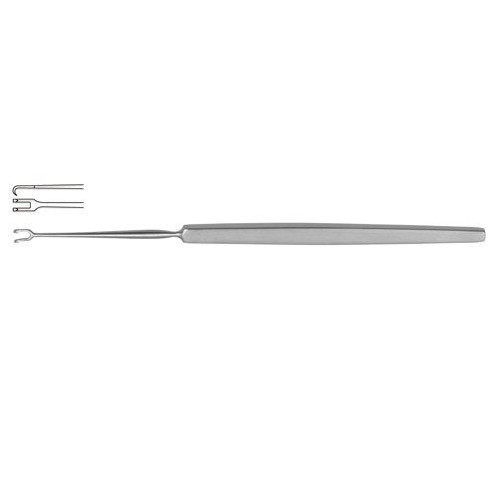

**Item# SI-1232**

**Name:** Freer Mucosa Hook Sharp

**OVERVIEW:**

Freer Mucosa Hook Sharp 15 cm – 6″ Width 3.2 mm

**Material**: Stainless Steel

**Finish:** Satin Finish (Mirror finish available upon request)

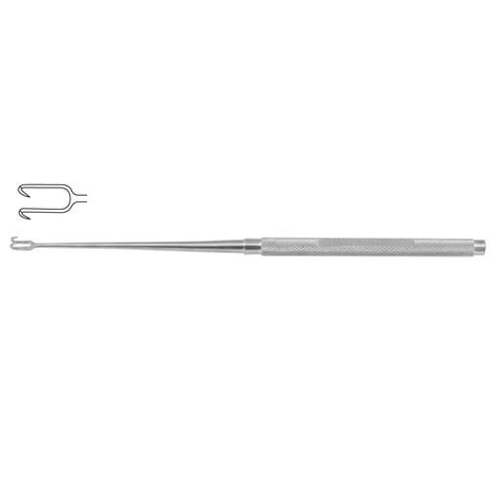

**Item# SI-1233**

**Name:** Joseph Mucosa Hook

**OVERVIEW:**

Joseph Mucosa Hook 16.5 cm – 6 1/2″ Width 5.0 mm

**Material**: Stainless Steel

**Finish:** Satin Finish (Mirror finish available upon request)

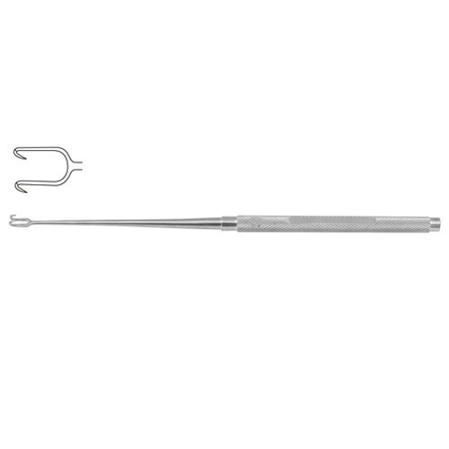

**Item# SI-1234**

**Name:** Joseph Mucosa Hook

**OVERVIEW:**

Joseph Mucosa Hook 16.5 cm – 6 1/2″ Width 7.0 mm

**Material**: Stainless Steel

**Finish:** Satin Finish (Mirror finish available upon request)

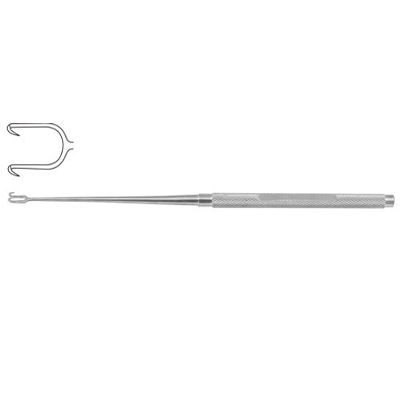

**Item# SI-1235**

**Name:** Freer Mucosa Hook Sharp

**OVERVIEW:**

Joseph Mucosa Hook 16.5 cm – 6 1/2″ Width 10.0 mm

**Material**: Stainless Steel

**Finish:** Satin Finish (Mirror finish available upon request)

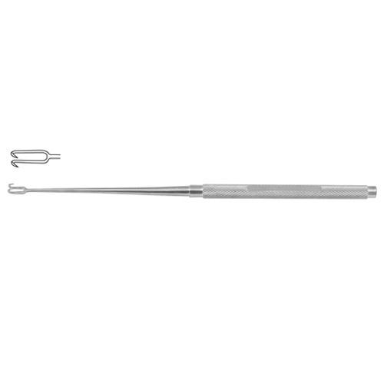

**Item# SI-1236**

**Name:** Joseph Mucosa Hook

**OVERVIEW:**

Joseph Mucosa Hook 16.5 cm – 6 1/2″ Width 2.0 mm

**Material**: Stainless Steel

**Finish:** Satin Finish (Mirror finish available upon request)

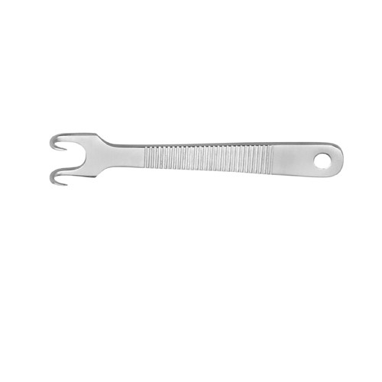

**Item# SI-1237**

**Name:** Kilner Alar Hook Sharp

**OVERVIEW:**

Kilner Alar Hook Sharp 8 cm – 3 1/4″

**Material**: Stainless Steel

**Finish:** Satin Finish (Mirror finish available upon request)

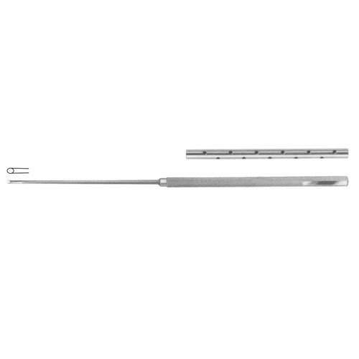

**Item# SI-1238**

**Name:** Tissue Picker 2 Twisted Sharp

**OVERVIEW:**

Tissue Picker 2 Twisted Sharp Prongs 18.5 cm – 7 1/4″ Diameter 1.8 mm Ã˜

**Material**: Stainless Steel

**Finish:** Satin Finish (Mirror finish available upon request)

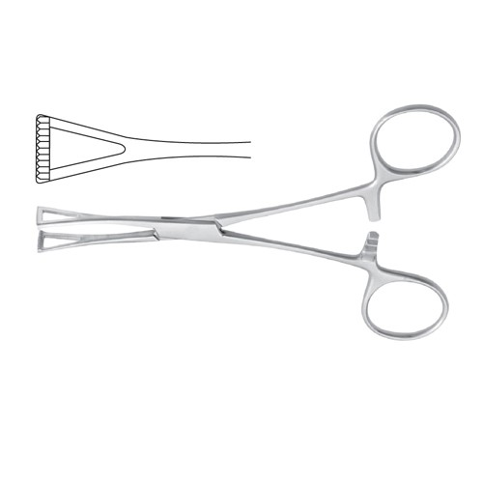

**Item# SI-1239**

**Name:** Collin Organ Grasping Forcep

**OVERVIEW:**

Collin Organ Grasping Forcep 14 cm – 5 1/2″

**Material**: Stainless Steel

**Finish:** Satin Finish (Mirror finish available upon request)

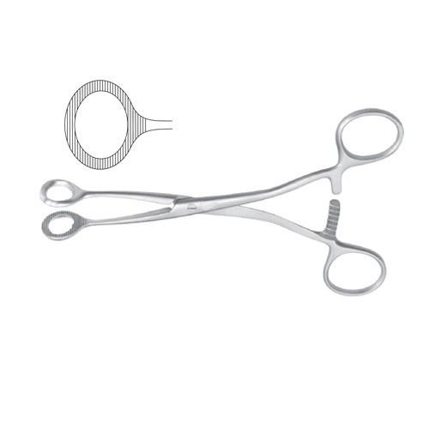

**Item# SI-1240**

**Name:** Collin Tumor Grasping Forcep

**OVERVIEW:**

Collin Tumor Grasping Forcep 17 cm – 6 3/4″

**Material**: Stainless Steel

**Finish:** Satin Finish (Mirror finish available upon request)

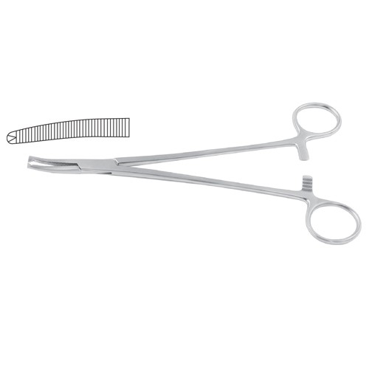

**Item# SI-1241**

**Name:** Faure Peritoneum Forcep

**OVERVIEW:**

Faure Peritoneum Forcep Curved – 1 x 2 Teeth 21 cm – 8 1/4″

**Material**: Stainless Steel

**Finish:** Satin Finish (Mirror finish available upon request)

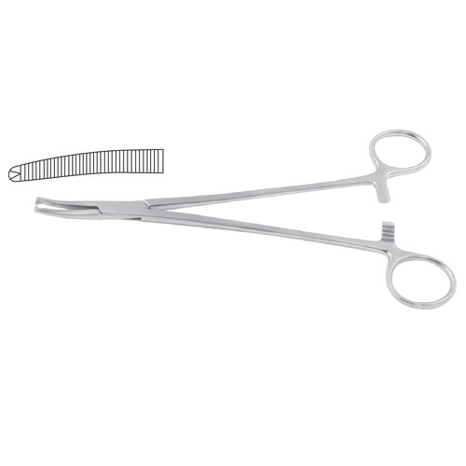**Item# SI-1242**

**Name:** Faure Peritoneum Forcep

**OVERVIEW:**

Faure Peritoneum Forcep Curved – 1 x 2 Teeth 21 cm – 8 1/4″

**Material**: Stainless Steel

**Finish:** Satin Finish (Mirror finish available upon request)

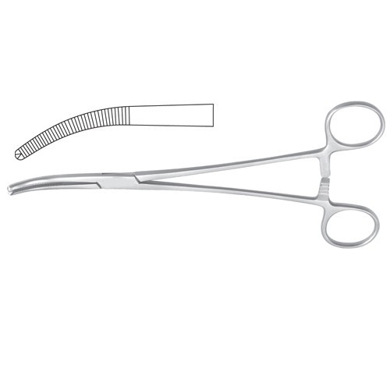

**Item# SI-1243**

**Name:** Mikulicz Peritoneum Forcep

**OVERVIEW:**

Mikulicz Peritoneum Forcep Curved – 1 x 2 Teeth 20.5 cm – 8″

**Material**: Stainless Steel

**Finish:** Satin Finish (Mirror finish available upon request)

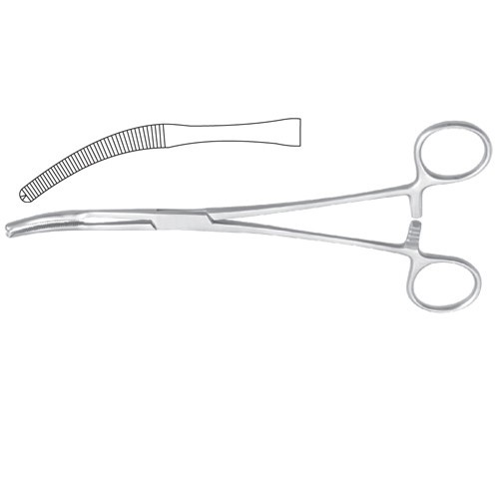

**Item# SI-1244**

**Name:** Mikulicz-Baby Peritoneum Forcep

**OVERVIEW:**

Mikulicz Peritoneum Forcep Curved – 1 x 2 Teeth 20 cm – 8″

**Material**: Stainless Steel

**Finish:** Satin Finish (Mirror finish available upon request)

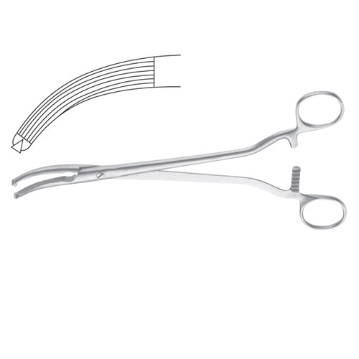

**Item# SI-1245**

**Name:** Mikulicz-Baby Peritoneum Forcep

**OVERVIEW:**

Mikulicz Peritoneum Forcep Curved –

Longitudinal Serrations – 1 x 2 Teeth 24.5 cm – 9 3/4″

**Material**: Stainless Steel

**Finish:** Satin Finish (Mirror finish available upon request)

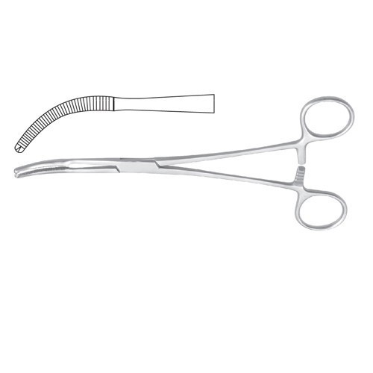

**Item# SI-1246**

**Name:** Mikulicz-Baby Peritoneum Forcep

**OVERVIEW:**

Mikulicz Peritoneum Forcep Curved – 1 x 2 Teeth 20 cm – 8″

**Material**: Stainless Steel

**Finish:** Satin Finish (Mirror finish available upon request)

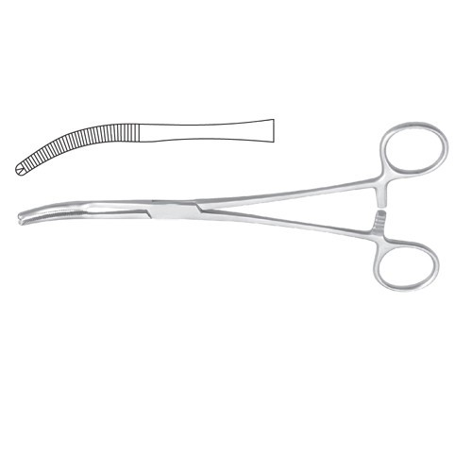

**Item# SI-1247**

**Name:** Mikulicz-Baby Peritoneum Forcep

**OVERVIEW:**

Mikulicz Peritoneum Forcep Curved – 1 x 2

Teeth 18.5 cm – 7 1/4″

**Material**: Stainless Steel

**Finish:** Satin Finish (Mirror finish available upon request)

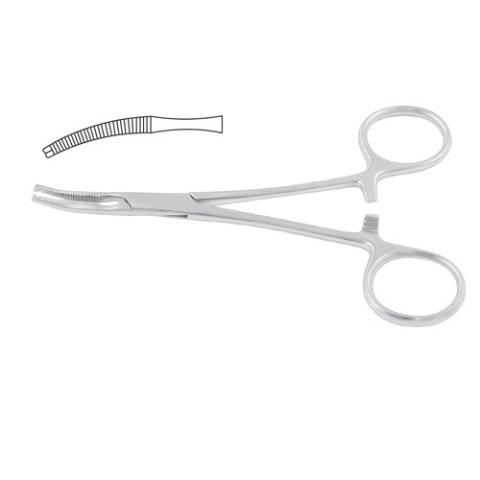 **Item# SI-1248**

**Name:** Mikulicz-Baby Peritoneum Forcep

**OVERVIEW:**

Mikulicz-Baby Peritoneum Forcep Curved – 1 x 2 Teeth 14.5 cm – 5 3/4″

**Material**: Stainless Steel

**Finish:** Satin Finish (Mirror finish available upon request)

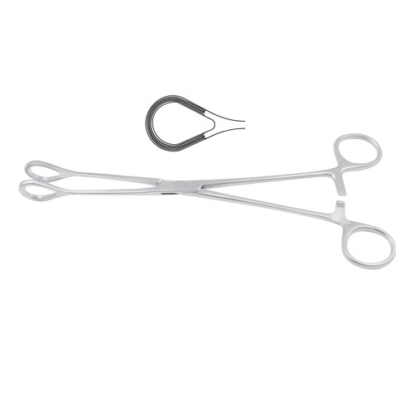

**Item# SI-1249**

**Name:** Organ Grasping Forcep

**OVERVIEW:**

Atrauma Organ Grasping / Haemorrhoidal

Forcep 25 cm – 9 3/4″

**Material**: Stainless Steel

**Finish:** Satin Finish (Mirror finish available upon request)

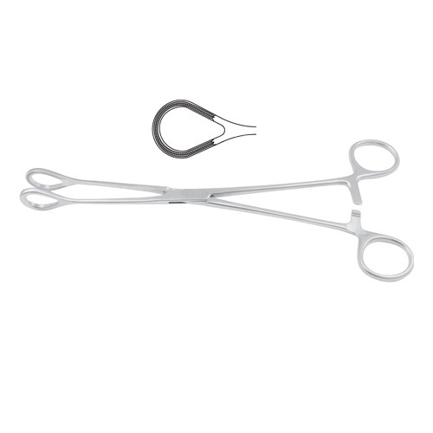

**Item# SI-1250**

**Name:** Organ Grasping Forcep

**OVERVIEW:**

Atrauma Organ Grasping / Haemorrhoidal Forcep 26 cm – 10 1/4″

**Material**: Stainless Steel

**Finish:** Satin Finish (Mirror finish available upon request)

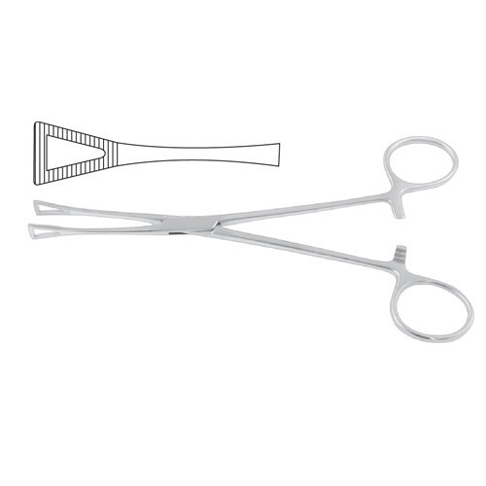

**Item# SI-1251**

**Name:** Pennington Organ Grasping Forcep

**OVERVIEW:**

Pennington Organ Grasping Forcep 21 cm – 8 1/4″

**Material**: Stainless Steel

**Finish:** Satin Finish (Mirror finish available upon request)

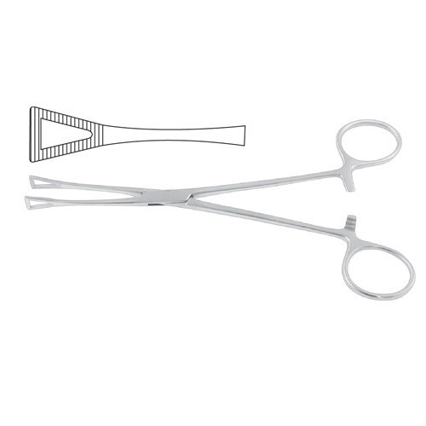

**Item# SI-1252**

**Name:** Pennington Organ Grasping Forcep

**OVERVIEW:**

Pennington Organ Grasping Forcep 15.5 cm – 6″

**Material**: Stainless Steel

**Finish:** Satin Finish (Mirror finish available upon request)

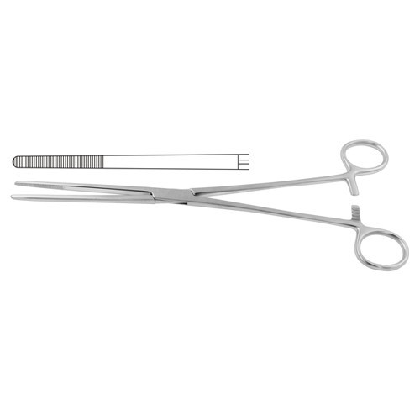

**Item# SI-1253**

**Name:** Bozemann Sponge Holding Forcep

**OVERVIEW:**

Bozemann Sponge Holding Forcep

Straight 26 cm – 10 1/4″

**Material**: Stainless Steel

**Finish:** Satin Finish (Mirror finish available upon request)

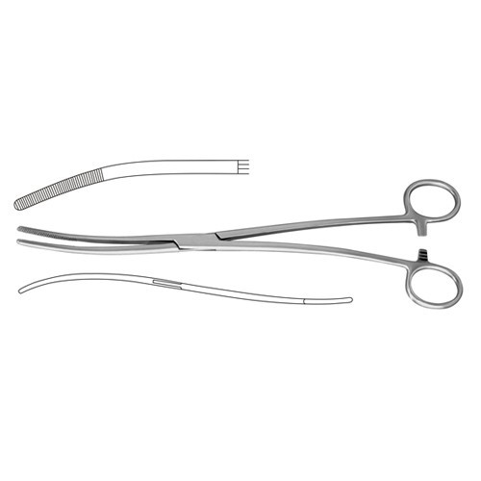

**Item# SI-1254**

**Name:** Bozemann Sponge Holding Forcep

**OVERVIEW:**

Bozemann Sponge Holding Forcep Curved S Shaped 26 cm – 10 1/4″

**Material**: Stainless Steel

**Finish:** Satin Finish (Mirror finish available upon request)

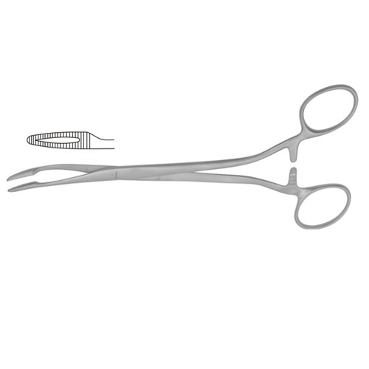

**Item# SI-1255**

**Name:** Duplay Sponge Holding Forcep

**OVERVIEW:**

Duplay Sponge Holding Forcep Curved 21 cm – 8 1/4″

**Material**: Stainless Steel

**Finish:** Satin Finish (Mirror finish available upon request)

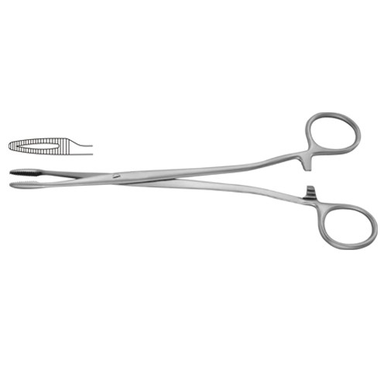

**Item# SI-1256**

**Name:** Duplay Sponge Holding Forcep

**OVERVIEW:**

Duplay Sponge Holding Forcep Straight 21 cm – 8 1/4″

**Material**: Stainless Steel

**Finish:** Satin Finish (Mirror finish available upon request)

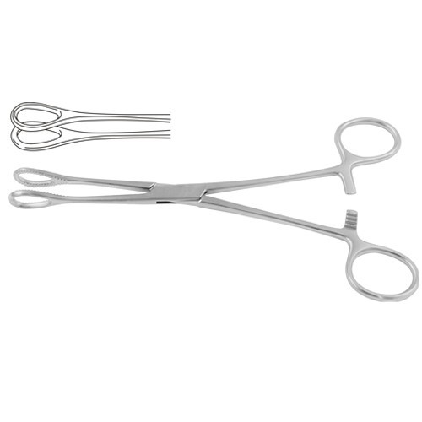

**Item# SI-1257**

**Name:** Foerster Sponge Holding Forcep

**OVERVIEW:**

Foerster Sponge Holding Forcep Straight –

Smoth Jaw 25 cm – 9 3/4″

**Material**: Stainless Steel

**Finish:** Satin Finish (Mirror finish available upon request)

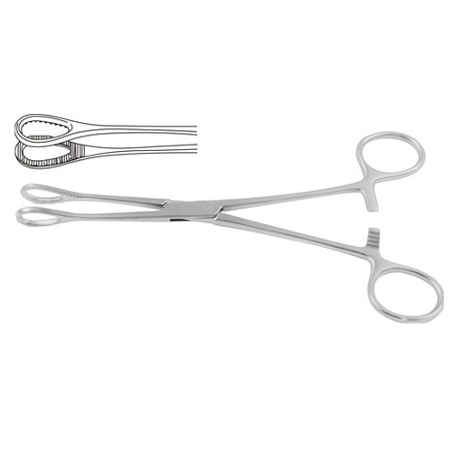

**Item# SI-1258**

**Name:** Foerster Sponge Holding Forcep

**OVERVIEW:**

Foerster Sponge Holding Forcep Straight 18 cm – 7″

**Material**: Stainless Steel

**Finish:** Satin Finish (Mirror finish available upon request)

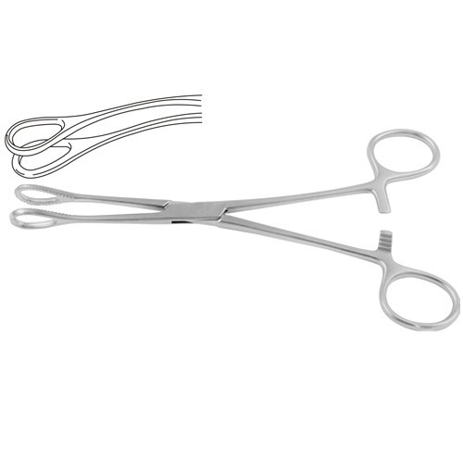

**Item# SI-1259**

**Name:** Foerster Sponge Holding Forcep

**OVERVIEW:**

Foerster Sponge Holding Forcep Curved –

Smoth Jaw 24.5 cm – 9 3/4″

**Material**: Stainless Steel

**Finish:** Satin Finish (Mirror finish available upon request)

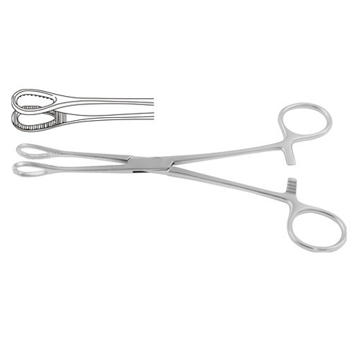

**Item# SI-1260**

**Name:** Foerster Sponge Holding Forcep

**OVERVIEW:**

Foerster Sponge Holding Forcep Straight 20.5 cm – 8″

**Material**: Stainless Steel

**Finish:** Satin Finish (Mirror finish available upon request)

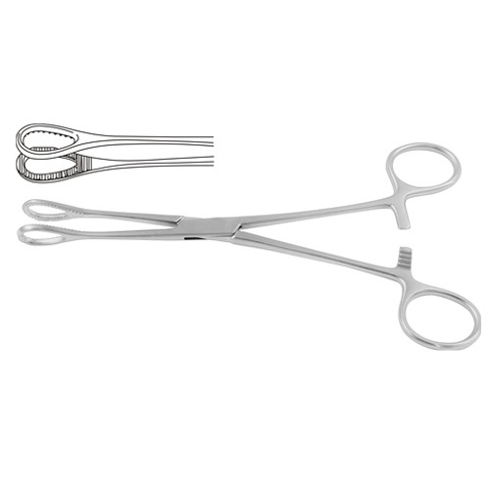

**Item# SI-1261**

**Name:** Foerster Sponge Holding Forcep

**OVERVIEW:**

Foerster Sponge Holding Forcep Straight 25 cm – 9 3/4″

**Material**: Stainless Steel

**Finish:** Satin Finish (Mirror finish available upon request)

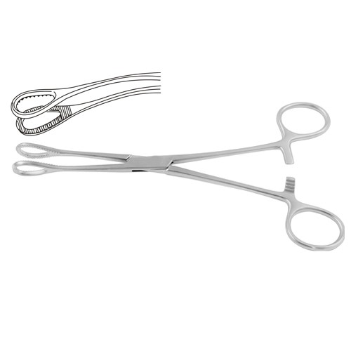

**Item# SI-1262**

**Name:** Foerster Sponge Holding Forcep

**OVERVIEW:**

Foerster Sponge Holding Forcep Curved 17.5 cm – 7″

**Material**: Stainless Steel

**Finish:** Satin Finish (Mirror finish available upon request)

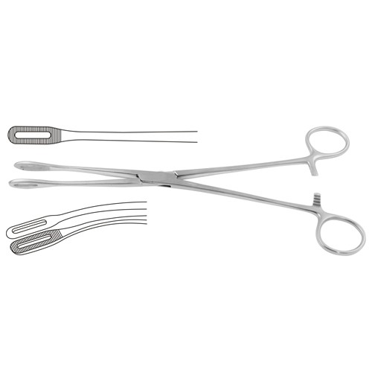

**Item# SI-1263**

**Name:** Foerster Sponge Holding Forcep

**OVERVIEW:**

Foerster Sponge Holding Forcep Curved 24.5 cm – 9 3/4″

**Material**: Stainless Steel

**Finish:** Satin Finish (Mirror finish available upon request)

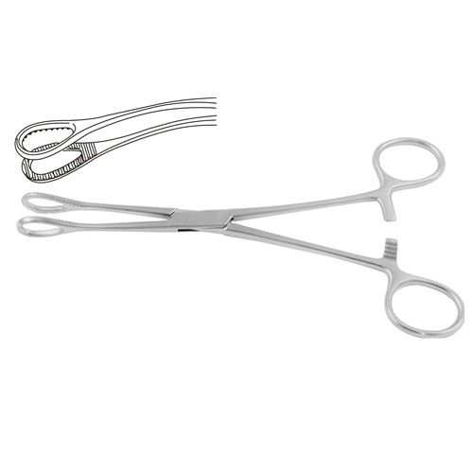

**Item# SI-1264**

**Name:** Foerster Sponge Holding Forcep

**OVERVIEW:**

Foerster Sponge Holding Forcep Curved 20 cm – 8″

**Material**: Stainless Steel

**Finish:** Satin Finish (Mirror finish available upon request)

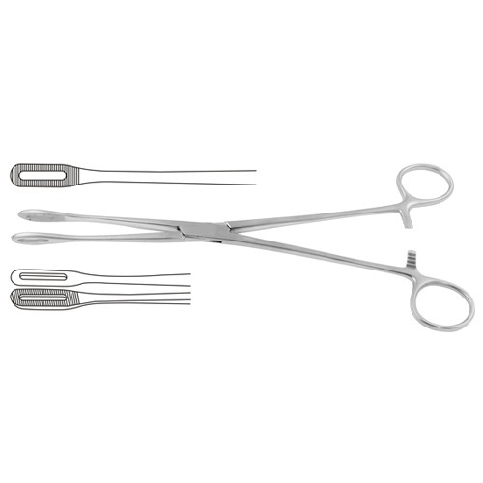

**Item# SI-1265**

**Name:** Foerster Sponge Holding Forcep

**OVERVIEW:**

Foerster Sponge Holding Forcep Straight 25 cm – 9 3/4″

**Material**: Stainless Steel

**Finish:** Satin Finish (Mirror finish available upon request)

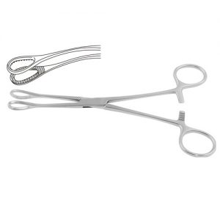

**Item# SI-1266**

**Name:** Foerster Sponge Holding Forcep

**OVERVIEW:**

Foerster Sponge Holding Forcep Curved 24.5 cm – 9 3/4″ **Material**: Stainless Steel

**Finish:** Satin Finish (Mirror finish available upon request)

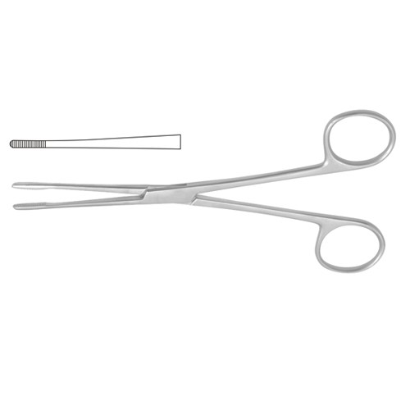

**Item# SI-1267**

**Name:** Lister Sinus Forceps

**OVERVIEW:**

Lister Sinus Forceps Straight 13 cm – 5″

**Material**: Stainless Steel

**Finish:** Satin Finish (Mirror finish available upon request)

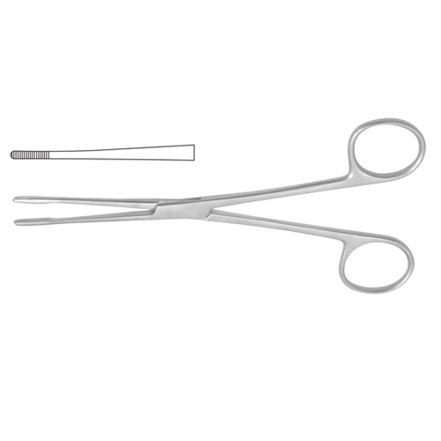

**Item# SI-1268**

**Name:** Lister Sinus Forceps

**OVERVIEW:**

Lister Sinus Forceps Straight 18 cm – 7″

**Material**: Stainless Steel

**Finish:** Satin Finish (Mirror finish available upon request)

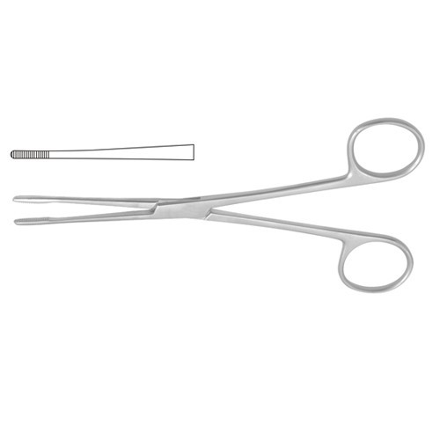

**Item# SI-1269**

**Name:** Lister Sinus Forceps

**OVERVIEW:**

Lister Sinus Forceps Straight 16 cm – 6 1/4″

**Material**: Stainless Steel

**Finish:** Satin Finish (Mirror finish available upon request)

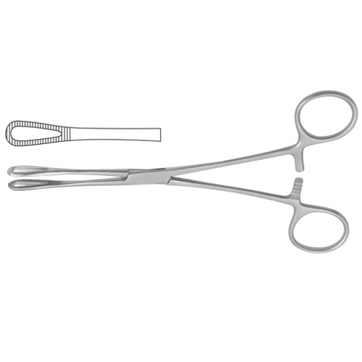

**Item# SI-1270**

**Name:** Rampley Sponge Holding Forcep

**OVERVIEW:**

Rampley Sponge Holding Forcep Straight 18.5 cm – 7 1/4″

**Material**: Stainless Steel

**Finish:** Satin Finish (Mirror finish available upon request)

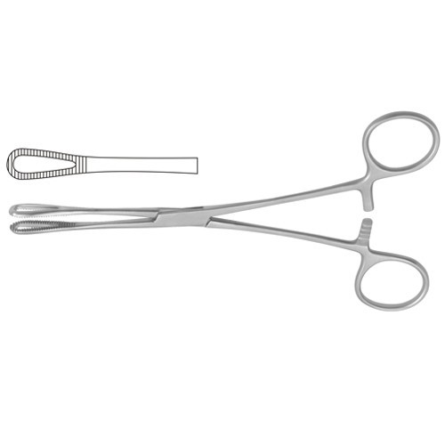

**Item# SI-1271**

**Name:** Rampley Sponge Holding Forcep

**OVERVIEW:**

Rampley Sponge Holding Forcep Straight 24.5 cm – 9 3/4″

**Material**: Stainless Steel

**Finish:** Satin Finish (Mirror finish available upon request)

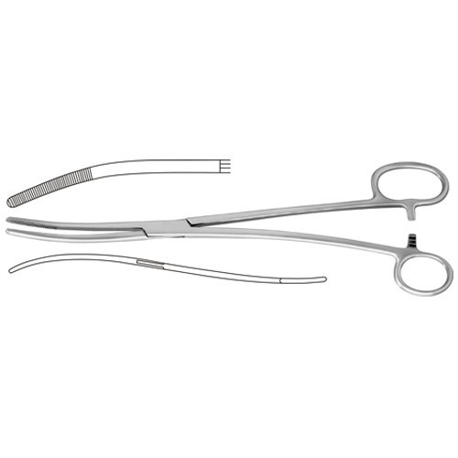

**Item# SI-1272**

**Name:** Sponge Holding Forcep

**OVERVIEW:**

Bozemann-Douglas Sponge Holding Forcep Curved S Shaped – One Large Ring 26 cm – 10 1/4″

**Material**: Stainless Steel

**Finish:** Satin Finish (Mirror finish available upon request)

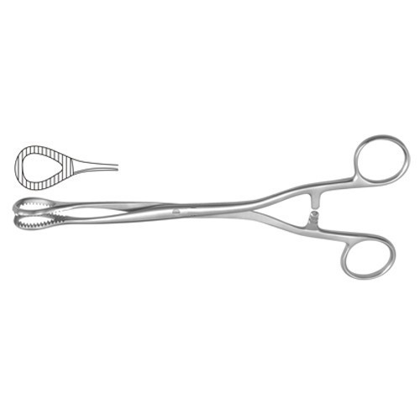

**Item# SI-1273**

**Name:** Sponge Holding Forcep

**OVERVIEW:**

Heywood-Smith Sponge Holding Forcep Straight 20 cm – 8″

**Material**: Stainless Steel

**Finish:** Satin Finish (Mirror finish available upon request)

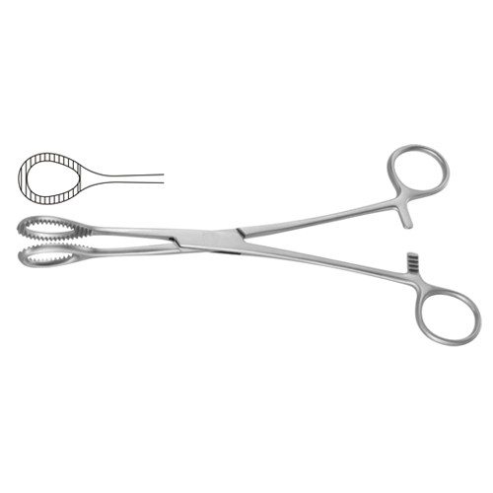

**Item# SI-1274**

**Name:** Sponge Holding Forcep

**OVERVIEW:**

Heywood-Smith Sponge Holding Forcep Straight 21 cm – 8 1/4″

**Material**: Stainless Steel

**Finish:** Satin Finish (Mirror finish available upon request)

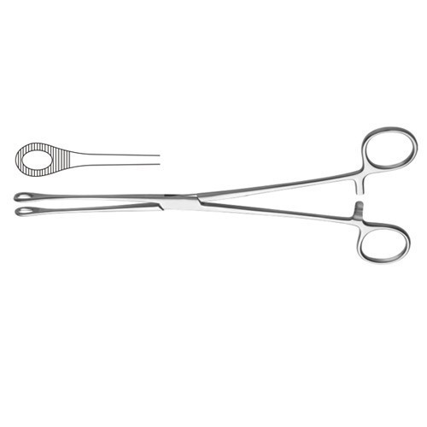

**Item# SI-1275**

**Name:** Sponge Holding Forcep

**OVERVIEW:**

Bergmann Sponge Holding Forcep

Straight 24 cm – 9 1/2″

**Material**: Stainless Steel

**Finish:** Satin Finish (Mirror finish available

upon request)

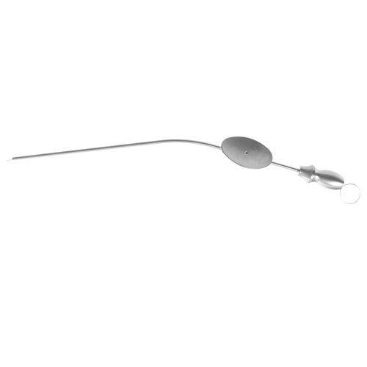

**Item# SI-1276**

**Name:** Baron-Schuknecht Suction Tube

**OVERVIEW:**

Baron-Schuknecht Suction Tube With Finger Cutt Off Working Length – Diameter 75 mm – 2.0 mm Ã˜

**Material**: Stainless Steel

**Finish:** Satin Finish (Mirror finish available upon request)

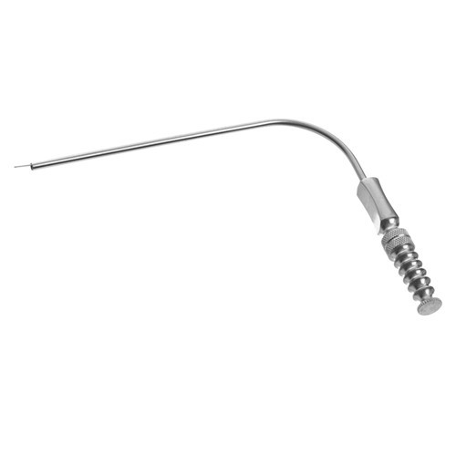

**Item# SI-1277**

**Name:** Fergusson Suction Tube

**OVERVIEW:**

Fergusson Suction Tube 8 Charr. 18 cm – 7″ Diameter 2.6 mm Ã˜

**Material**: Stainless Steel

**Finish:** Satin Finish (Mirror finish available upon request)

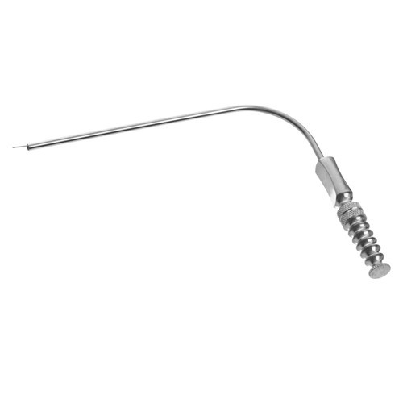

**Item# SI-1278**

**Name:** Fergusson Suction Tube

**OVERVIEW:**

Fergusson Suction Tube 6 Charr. 18 cm – 7″ Diameter 2.0 mm Ã˜

**Material**: Stainless Steel

**Finish:** Satin Finish (Mirror finish available upon request)

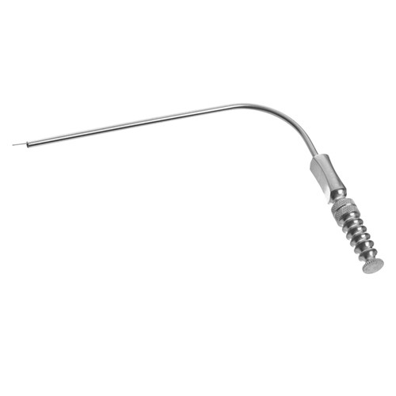

**Item# SI-1279**

**Name:** Fergusson Suction Tube

**OVERVIEW:**

Fergusson Suction Tube 9 Charr. 18 cm – 7″ Diameter 3.0 mm Ã˜

**Material**: Stainless Steel

**Finish:** Satin Finish (Mirror finish available upon request)

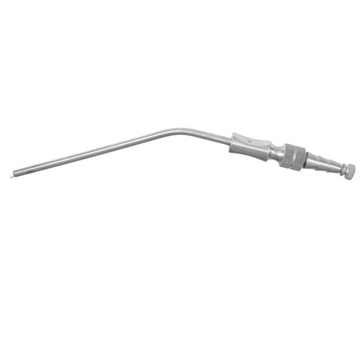

**Item# SI-1280**

**Name:** Frazier Suction Tube

**OVERVIEW:**

Frazier Suction Tube 7 Charr. 19.5 cm – 7 3/4″ Diameter 2.3 mm Ã˜

**Material**: Stainless Steel

**Finish:** Satin Finish (Mirror finish available upon request)

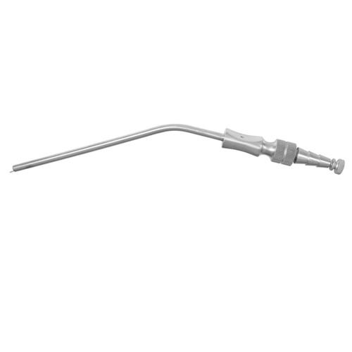 **Item# SI-1281**

**Name:** Frazier Suction Tube

**OVERVIEW:**

Frazier Suction Tube 6 Charr. 19.5 cm – 7 3/4″

Diameter 2.0 mm Ã˜

**Material**: Stainless Steel

**Finish:** Satin Finish (Mirror finish available upon request)

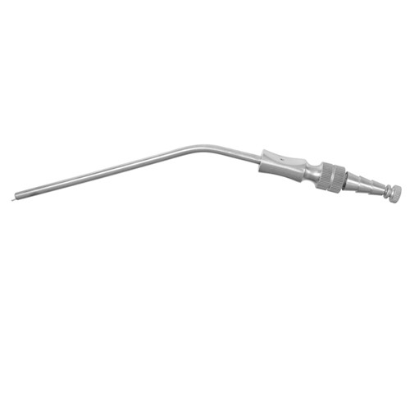

**Item# SI-1282**

**Name:** Frazier Suction Tube

**OVERVIEW:**

Frazier Suction Tube 8 Charr. 19.5 cm – 7 3/4″ Diameter 2.6 mm Ã˜

**Material**: Stainless Steel

**Finish:** Satin Finish (Mirror finish available upon request)

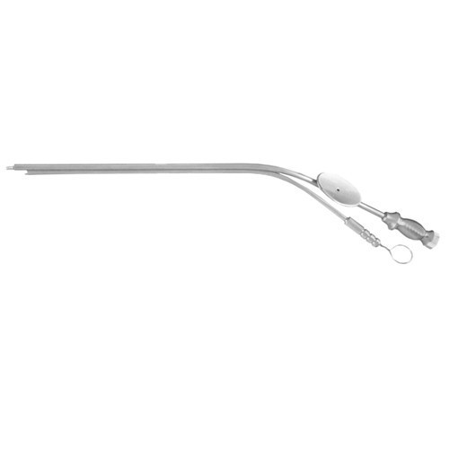

**Item# SI-1283**

**Name:** House Suction Tube

**OVERVIEW:**

House Suction Tube With Finger Cutt Off Suction

Diameter – Irrigation Diameter 0.9 mm Ã˜ – 0.7 mm Ã˜

**Material**: Stainless Steel

**Finish:** Satin Finish (Mirror finish available upon request)

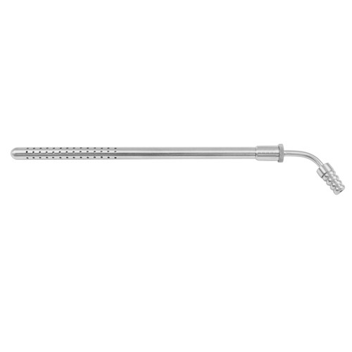

**Item# SI-1284**

**Name:** Poole Suction Tube

**OVERVIEW:**

Poole Suction Tube 22.5 cm – 8 3/4″ Diameter 8.0 mm Ã˜

**Material**: Stainless Steel

**Finish:** Satin Finish (Mirror finish available upon request)

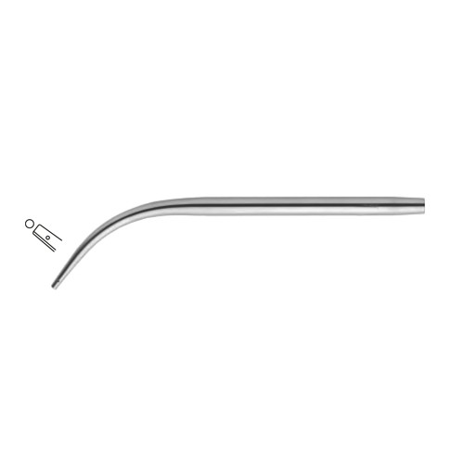

**Item# SI-1285**

**Name:** Suction Tube

**OVERVIEW:**

Suction Tube 14 cm – 5 1/2″ Diameter 1.5 mm Ã˜

**Material**: Stainless Steel

**Finish:** Satin Finish (Mirror finish available upon request)

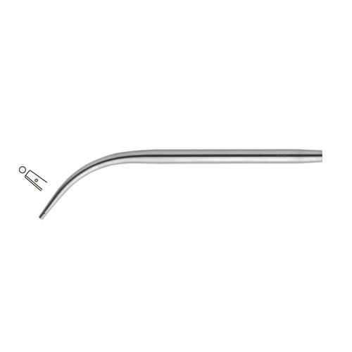

**Item# SI-1286**

**Name:** Suction Tube

**OVERVIEW:**

Suction Tube 18 cm – 7″ Diameter 1.5 mm Ã˜

**Material**: Stainless Steel

**Finish:** Satin Finish (Mirror finish available upon request)

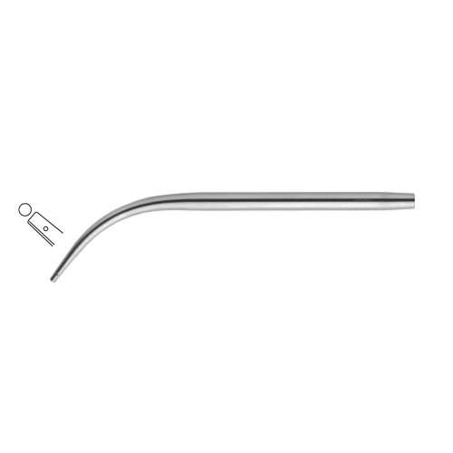

**Item# SI-1287**

**Name:** Suction Tube

**OVERVIEW:**

Suction Tube 14 cm – 5 1/2″ Diameter 2.5 mm Ã˜

**Material**: Stainless Steel

**Finish:** Satin Finish (Mirror finish available upon request)

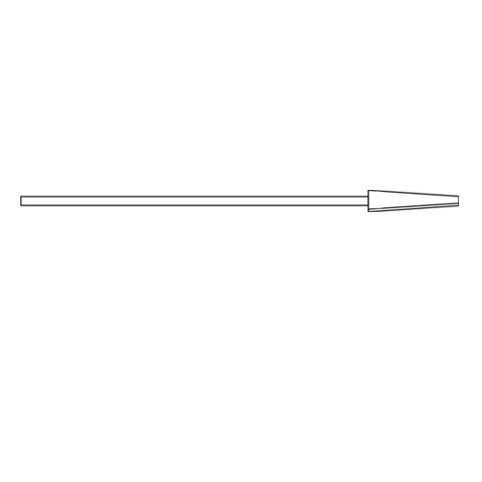

**Item# SI-1288**

**Name:** Wullstein Micro Suction Tube

**OVERVIEW:**

Wullstein Micro Suction Tube 4.5 cm – 1 3/4″ Diameter 0.4 mm Ã˜

**Material**: Stainless Steel

**Finish:** Satin Finish (Mirror finish available upon request)

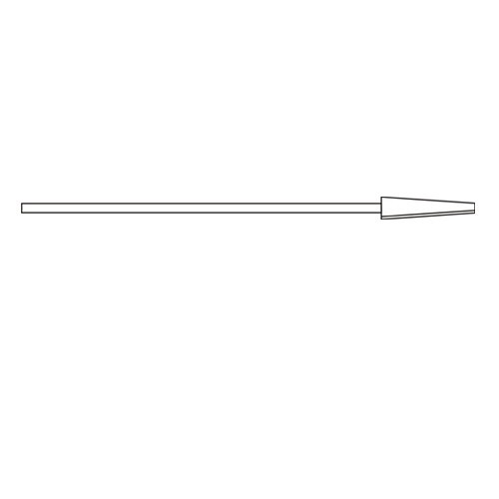

**Item# SI-1289**

**Name:** Wullstein Micro Suction Tube

**OVERVIEW:**

Wullstein Micro Suction Tube 4.5 cm – 1 3/4″

Diameter 0.6 mm Ã˜

**Material**: Stainless Steel

**Finish:** Satin Finish (Mirror finish available upon equest)

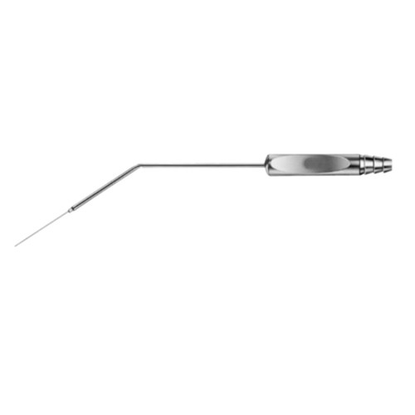

**Item# SI-1290**

**Name:** Wullstein Suction Handle

**OVERVIEW:**

Wullstein Suction Handle 14 cm – 5 1/2″

**Material**: Stainless Steel

**Finish:** Satin Finish (Mirror finish available upon request)

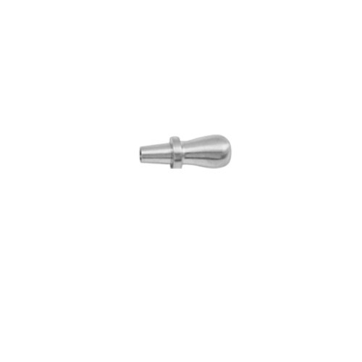

**Item# SI-1291**

**Name:** Yankauer Suction Tip

**OVERVIEW:**

Yankauer Suction Tip

**Material**: Stainless Steel

**Finish:** Satin Finish (Mirror finish available upon request)

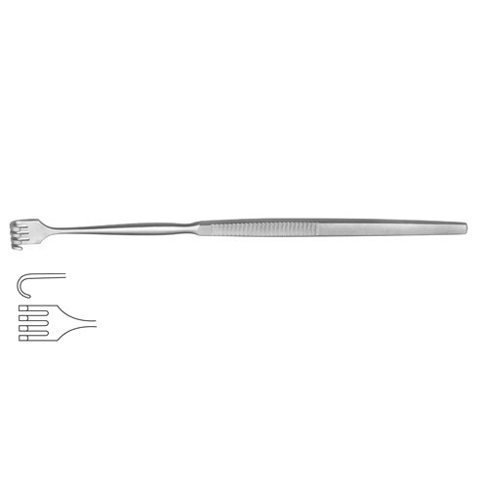

**Item# SI-1292**

**Name:** Wound Retractor 4 Blunt

**OVERVIEW:**

Wound Retractor 4 Blunt Prongs 16.5 cm – 6 1/2″

**Material**: Stainless Steel

**Finish:** Satin Finish (Mirror finish available upon request)

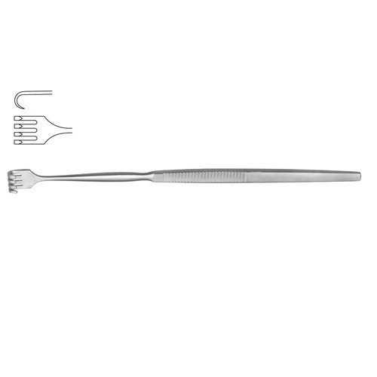

**Item# SI-1293**

**Name:** Wound Retractor 4 Blunt

**OVERVIEW:**

Wound Retractor 4 Sharp Prongs 16.5 cm – 6 1/2″

**Material**: Stainless Steel

**Finish:** Satin Finish (Mirror finish available upon request)

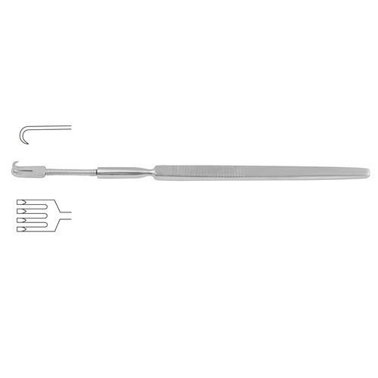

**Item# SI-1294**

**Name:** Wound Retractor Flexible

**OVERVIEW:**

Wound Retractor Flexible – 4 Sharp Prongs 16 cm – 6 1/4″

**Material**: Stainless Steel

**Finish:** Satin Finish (Mirror finish available upon request)

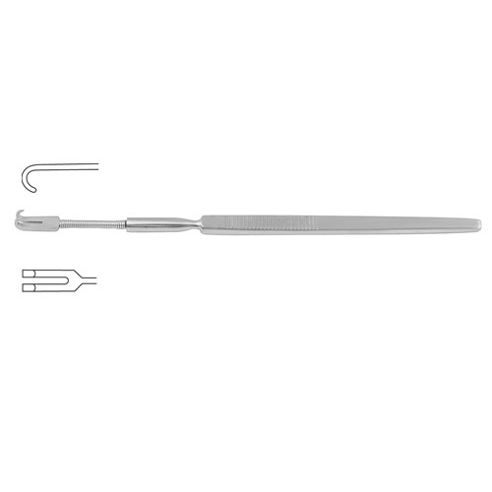

**Item# SI-1295**

**Name:** Wound Retractor Flexible

**OVERVIEW:**

Wound Retractor Flexible – 2 Blunt Prongs 16 cm – 6 1/4″

**Material**: Stainless Steel

**Finish:** Satin Finish (Mirror finish available upon request)

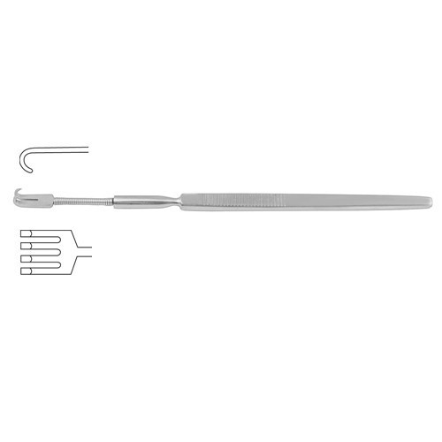

**Item# SI-1296**

**Name:** Wound Retractor Flexible

**OVERVIEW:**

Wound Retractor Flexible – 4 Blunt Prongs 16 cm – 6 1/4″

**Material**: Stainless Steel

**Finish:** Satin Finish (Mirror finish available upon request)