IIRS Daily Space Digest Friday, 22/05/2026

1. Jitendra Singh congratulates ISRO for successful completion of IADT-02 for Gaganyaan Mission - DD News
"ISRO OR NRSC OR IIRS after:2026-05-21" - Google News
Read more

Union Minister Dr Jitendra Singh on Friday congratulated Indian Space Research Organisation (ISRO) for the successful completion of the Second Integrated Air Drop Test (IADT-02) for Gaganyaan, India's first human spaceflight mission scheduled for launch in 2027. He described the achievement as a significant milestone in preparing for the ambitious mission. Taking to social media platform X, Singh wrote, "Congratulations ISRO for the successful accomplishment of Second Integrated Air Drop Test (IADT-02) for Gaganyaan, India's first Human Space flight scheduled next year." He further noted, "The second Integrated Air Drop Test (IADT-02) was successfully conducted at Satish Dhawan Space Station, Sriharikota. This marks an important milestone towards the readiness for the Gaganyaan mission." India's first human spaceflight will be launched from Sriharikota in 2027. Although the mission has faced multiple delays due to its technological complexity, India has been developing the capabilities indigenously. Notably, such critical spaceflight technologies are closely guarded, and no country shares them. The government has allocated approximately Rs 10,000 crore for the Gaganyaan programme. The mission is now in its final phase, with the first crewed flight expected in the first quarter of 2027. Earlier, on April 8, ISRO Chairman V. Narayanan stated that all preparations for the uncrewed Gaganyaan missions are progressing smoothly. Speaking at the inaugural session of the 2nd International Conference on Smart Spacecraft Mission Operations, he said, "We are meeting just before the first uncrewed Gaganyaan mission. This is no ordinary mission but a crucial one for India. There will be three uncrewed missions before the final crewed launch. All activities for the first mission are progressing well, though challenges remain." The conference was also attended by former ISRO chiefs A.S. Kiran Kumar and S. Somanath, along with ISRO centre directors, students, and representatives from space startups. Meanwhile, India's human spaceflight preparations advanced further on April 4, as four selected astronauts began a high-altitude experiment in Ladakh under the "Mission Mitra" (Mapping of Interoperable Traits and Reliability Assessment). The programme aims to evaluate human performance in extreme environments. The astronauts, including Group Captain Shubhnashu Shukla and P. Balakrishnan Nair, arrived in Leh earlier this week for acclimatisation. The mission is supported by a multidisciplinary team of scientists, engineers, medical experts, and psychologists, marking another crucial step in India's journey towards human space exploration. -IANS

2. ISRO to open Gaganyaan astronaut selection to civilians as India expands space plans - MSN
"ISRO OR NRSC OR IIRS after:2026-05-21" - Google News
Read more

ISRO to open Gaganyaan astronaut selection to civilians as India expands space plans MSN

3. India's Chandrayaan-3 Mission Gets Goddard Astronautics Award From AIAA - NDTV Profit
"ISRO OR NRSC OR IIRS after:2026-05-21" - Google News
Read more

India's Chandrayaan-3 Mission Gets Goddard Astronautics Award From AIAA NDTV Profit

4. Video | Chandrayaan-3 Receives 2026 AIAA Goddard Astronautics Award - NDTV
"ISRO OR NRSC OR IIRS after:2026-05-21" - Google News
Read more

Video | Chandrayaan-3 Receives 2026 AIAA Goddard Astronautics Award NDTV

5. Even before 1st industry PSLV flies, IN-SPACe offers full PSLV tech transfer - The Times of India
"ISRO OR NRSC OR IIRS after:2026-05-21" - Google News
Read more


BENGALURU: Nearly four years after space PSU NewSpace India Limited (NSIL) awarded the first private-sector contract worth Rs 860-crore to manufacture five Polar Satellite Launch Vehicles (PSLVs), space regulator Indian National Space Promotion and Authorisation Centre (IN-SPACe) is offering full transfer of technology (ToT) of the rocket to industry.If the industry takes up on the offer, this will be the second rocket developed by Isro whose technology will be transferred. Last year, IN-SPACe completed the ToT for Isro's Small Satellite Launch Vehicle (SSLV).The PSLV ToT move is striking because the first PSLV being manufactured under the earlier industry contract awarded to Hindustan Aeronautics Limited-Larsen & Toubro (HAL-L&T) consortium in 2022 by NSIL is yet to launch. The first rocket was to be ready in 24 months, but it has been nearly double that time.In its EoI accessed by TOI, IN-SPACe said: the technology transfer is aimed at enabling Indian industry to "realise, operate and commercialise PSLV launches in the global medium-lift satellite market". As per IN-SPACe: "To ensure seamless technology absorption, infrastructural and hand-holding support will be provided by Isro for a 'defined period' of 30 months or until realisation and launch of two PSLV vehicles by the selected party, whichever is earlier.The EoI is restricted to Indian-owned non-govt entities with significant industrial and aerospace capability. Eligible firms must have at least seven years of operations, five years of space or aerospace experience, and either an average turnover above Rs 400 crore or a valuation exceeding Rs 1,000 crore.At the time of NSIL's 2022 contract, officials had described the arrangement as a gradual outsourcing model. The rocket's stages would increasingly be realised by industry, even though sensitive systems such as separation mechanisms, inertial systems and mission operations would continue under Isro oversight during the initial phase.The PSLV EoI raises questions of industry readiness to build and operate rockets. While the consortium's first PSLV has not yet flown, a similar pattern appears to be visible with the SSLV programme: Nearly a year ago, HAL won the full ToT bid at Rs 511 crore, becoming the first Indian company to receive complete launch vehicle technology from Isro.Unlike the PSLV manufacturing contract, the SSLV deal gives HAL ownership of the rocket after the technology absorption phase. The company is expected to build, market and launch SSLV missions independently after initial support from Isro and IN-SPACe.But the first HAL-operated SSLV launch is not even close to being ready. The PSLV remains India's most dependable launcher, with more than 50 missions since its first flight in 1993. It has launched major missions including Chandrayaan-1, the Mars Orbiter Mission and Astrosat, besides deploying hundreds of foreign satellites.For India's space sector reforms, the latest EoI signals that the govt wants to accelerate the transition from an Isro-led production model to an industry-driven launch ecosystem. Yet the slow progress of the first two privatisation experiments - PSLV manufacturing and SSLV technology transfer - also highlights the complexity involved in moving launch vehicle capability from a state-run programme into commercial hands.

6. India's Chandrayaan-3 mission gets Goddard Astronautics Award from AIAA - The Economic Times
"ISRO OR NRSC OR IIRS after:2026-05-21" - Google News
Read more


Synopsis The Indian Space Research Organisation has received the prestigious 2026 Goddard Astronautics Award from the American Institute of Aeronautics and Astronautics. This recognition is for the Chandrayaan-3 mission's successful landing near the lunar south pole. India's Ambassador to the US accepted the award. The honor highlights ISRO's achievements and India's future space ambitions.

7. Join ESA for a total solar eclipse on 12 August 2026
ESA Space Science
Read more
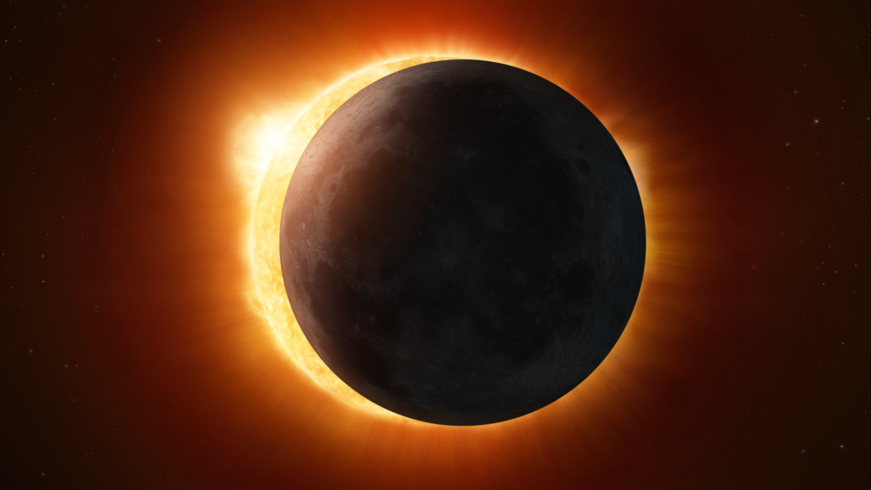

Science & Exploration Join ESA for a total solar eclipse on 12 August 2026 21/05/2026 3379 views 18 likes Follow the total solar eclipse with the European Space Agency (ESA), in person or online. On 12 August 2026, a solar eclipse will be visible across parts of Europe and the north Atlantic. The path of totality will cross Greenland, Iceland, Spain and a small area of northeastern Portugal. Other parts of Europe will see a partial solar eclipse. ESA is organising a range of activities around the eclipse, combining scientific expertise, public engagement, and educational outreach - see programme below. During a total solar eclipse, the Moon passes directly in front of the Sun, blocking out most of its light and allowing us to see the Sun's fiery-looking atmosphere. It is an impressive spectacle, last visible from mainland Europe in 2006. During the upcoming eclipse, Spain will experience the largest area of totality in Europe, offering favourable viewing conditions as the eclipse crosses the country from west to east and continues over the Balearic Islands. This will be the first total solar eclipse visible from mainland Spain since 1905, and the first of three solar eclipses visible from the country between 2026 and 2028. As a shared experience across Europe, the eclipse represents a unique moment for millions of people to witness this rare natural phenomenon together. It also offers a chance to experience first-hand the leading solar and space science underway in Europe, including ESA missions studying the Sun and its interaction with Earth. Such missions include Solar Orbiter, Smile and Proba 3. Professor Carole Mundell, ESA Director of Science, commented: "A total solar eclipse is one of those rare moments when millions of people can look up together and feel both wonder and curiosity. It is a shared moment that connects us to the Universe and reminds us that the desire to explore and understand is one of humanity's greatest strengths. "At ESA, our science missions have ventured deep into space to directly probe the physics of the Sun and its effects on Earth: we use moments like this to bring space science and technology closer to society, to inspire future generations and bring people across Europe together through the excitement of discovery." Text continues after image slider ESA activities on 12 August International live broadcast ESA will host a live broadcast from the Observatorio Astrofísico de Javalambre in Teruel (Spain), a top-class astronomical facility located within the band of totality, bringing together experts to explain the science behind the eclipse and its wider relevance. The broadcast will be available in English via ESA Web TV and YouTube. It will be hosted by Dame Dr. Maggie Aderin, award-winning space scientist and science communicator, and feature Professor Carole Mundell (ESA's Director of Science) amongst other special guests. Public observation in León In parallel, ESA is preparing a free public observation programme in the city of León, Spain, in collaboration with the University of León and the city council. The initiative is designed to engage citizens directly with the science of the eclipse. It will offer engaging talks about solar science and space missions from ESA experts, alongside educational activities and connect with ESA's live broadcast. The whole programme will be conducted in Spanish. Further details on the programme and how to join us will be shared closer to the date. Educational resources for schools and the public Solar eclipses educational kit (cover image) ESA has produced a dedicated educational kit, available in English and Spanish via ESA platforms. The materials are designed for teachers and outreach professionals, with content adapted to different educational levels. They include clear explanations of the eclipse, guidance on safe observation, and ready-to-use resources to support activities with students and the general public. The educational kit will be complemented in the coming months by a series of articles and videos, including information on how to safely observe the eclipse. Collaboration with national initiatives ESA is pleased to have contributed to the official Spanish eclipse website Trio of Eclipses, an initiative led by the Spanish government. Together with partners from the Spanish Scientific and Advisory Committee for the Trio of Eclipses, ESA has developed the scientific outreach section of the site, providing clear and accurate content to support public understanding of the eclipses. Watching an eclipse Getting ready for 12 August Whether you are observing the eclipse in person or following it remotely, ESA's activities aim to help you experience this unique event and better understand the science behind it. Further information, updates and resources related to the eclipse will be available on www.esa.int/solareclipse. From the main ESA website, audiences can also explore ESA missions studying the Sun and its interaction with Earth, including Solar Orbiter, Smile and Proba 3. Important: Looking directly at the Sun without proper protection can cause serious eye damage. Regular sunglasses are not safe for observing a solar eclipse. To watch the eclipse safely, always use certified eclipse glasses that meet the appropriate safety standards and wear them at all times during the partial phases. Only during totality - when the Moon completely covers the Sun - is it safe to briefly look without protection. As soon as the Sun begins to reappear, eclipse glasses must be worn again.

8. Watch Rocket Lab launch private Japanese Earth-observing satellite this morning
Latest from Space.com
Read more
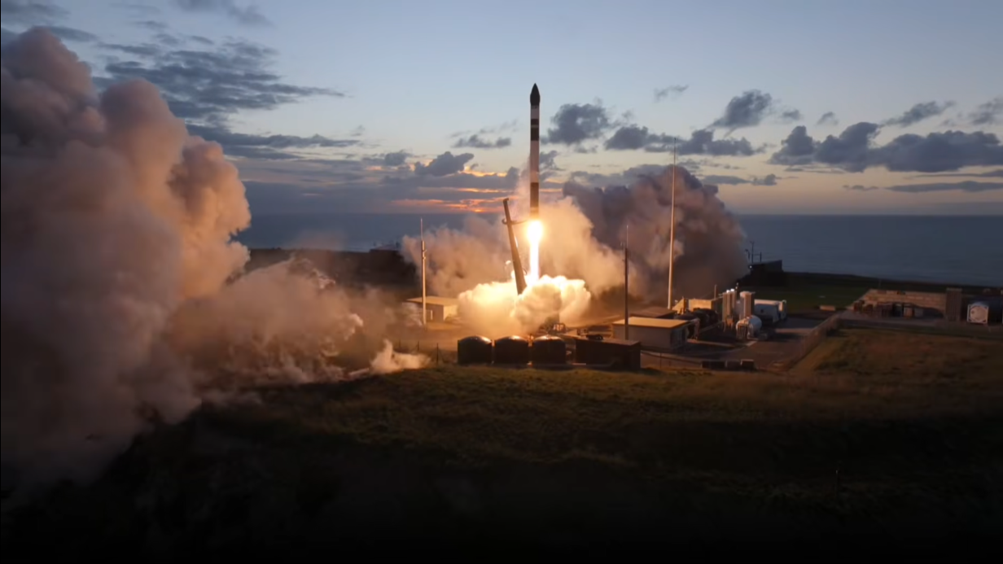

Click for next article Rocket Lab - 'Viva La StriX' Launch - YouTube Watch On Rocket Lab will launch an Earth-observing radar satellite for the Japanese company Synspective early Friday morning (May 22), and you can watch the action live. An Electron rocket carrying one of Synspective's Strix satellites is scheduled to lift off from Rocket Lab 's New Zealand site on Friday at 5:30 a.m. EDT (0930 GMT; 9:30 p.m. local New Zealand time), on a mission called "Viva La Strix." You can watch it live via Rocket Lab beginning at about 5:00 a.m. EDT (0900 GMT). Space.com will carry the feed if, as expected, the company makes it available. The patch for Rocket Lab's "Viva La Strix" mission. (Image credit: Rocket Lab) Synspective is building out a "synthetic aperture radar (SAR) imaging constellation over Japan that provides data for urban development planning, construction and infrastructure monitoring, and disaster response," Rocket Lab wrote in a description of Friday's mission . SAR satellites can peer through cloud cover and observe Earth in all lighting conditions, even darkness. That latter fact may explain the name that Tokyo-based Synspective gave to these satellites - Strix is a widespread genus of owls. "Viva La Strix" will be the ninth mission that Rocket Lab flies for Synspective. And many more are on the docket. "Rocket Lab has been the sole launch provider for Synspective's constellation since 2020, with another 18 missions booked to deliver the rest of their constellation to orbit before 2030," Rocket Lab wrote in the mission description. If all goes according to plan on Friday, Electron will deploy the Strix satellite in low Earth orbit , at an altitude of 355 miles (572 kilometers). The 59-foot-tall (18-meter-tall) Electron gives small satellites dedicated rides to Earth orbit and beyond. The rocket debuted with a test flight in May 2017 and has 77 liftoffs under its belt to date. Rocket Lab has also flown seven missions with a suborbital version of Electron called HASTE , which allows customers to test hypersonic technologies in the space environment. "Viva La Strix" will be the 78th launch to date for the 59-foot-tall (18-meter-tall) Electron, which debuted with a test flight in May 2017.

9. This exoplanet weather forecast by the James Webb Space Telescope calls for sandy skies and a clear (alien) sunset
Latest from Space.com
Read more
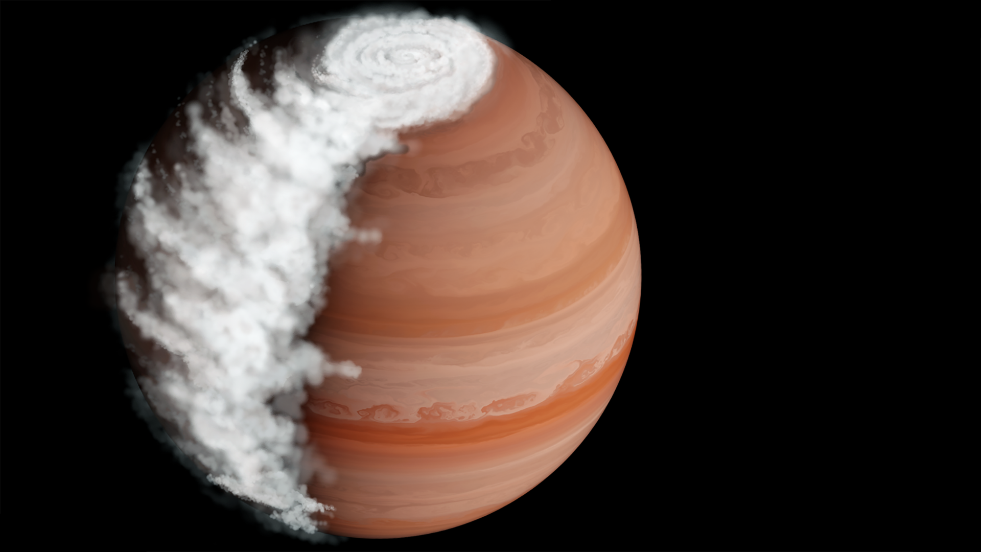

Click for next article An artist's impression of WASP-94Ab, with magnesium silicate clouds appearing on the terminator between night and day, where it is "morning." The James Webb Space Telescope (JWST) has made a weather forecast for the exoplanet WASP-94Ab, a world with clouds of sand in the morning that gradually give way to a clear sky at sunset. It is the first time that the daily cycle of weather has been observed on a hot Jupiter exoplanet . Furthermore, the clear evening sky has provided astronomers with an unobscured view of WASP-94Ab's atmospheric composition, finding it to be closer to that of our own Jupiter than previous inaccurate measurements had suggested. WASP-94Ab is located about 690 light-years from Earth and orbits one of two stars in a wide binary system . The planet is a gas giant 1.7 times larger than Jupiter and orbits its star every four days at a distance of 5.1 million miles (8.2 million kilometers) - close enough to be hotter than over 2,200 degrees Fahrenheit (1,200 degrees Celsius). Hence, we call such worlds "hot Jupiters." Previous attempts to get a handle on the composition of hot Jupiters has been stymied by the fact that they are often very cloudy, which obscures much of the atmosphere. Unlike Earth's clouds of water vapor, a hot Jupiter's clouds are made of vaporized metals and rock, like giant flying sandstorms. In the case of WASP-94Ab, the clouds are composed of vaporized magnesium silicate. "I've been looking at exoplanets for 20 years and general cloudiness has been a thorn in our side," David Sing of Johns Hopkins University said in a statement . "We've known for quite a while that clouds are pervasive on hot Jupiter planets, which is annoying because it's like trying to look at the planet through a foggy window." But are hot Jupiters cloudy all of the time? Astronomers led by Sing put this to the test by watching WASP-94Ab with the James Webb Space Telescope (JWST) as the planet transited, or crossed the face of, its star from the spacecraft's point of view. Using a technique called transit spectroscopy, the astronomers were able to watch as the light from the star was filtered through the atmospheric gases and clouds on the leading and trailing limbs of WASP-94Ab as it transited. Some of this light is blocked by gases in the atmosphere, and the wavelengths at which that light is absorbed gives away the identity of those gases. Sing's team saw that on the leading edge, where it was considered "morning" with air flowing from the nightside to the dayside, there were plenty of magnesium silicate clouds. However, on the trailing edge where it was "evening" with air flowing back to the nightside, the clouds had disappeared, leaving an unencumbered view of the hydrogen-dominated atmosphere. Previous Hubble Space Telescope observations had not been able to split the absorption effects of the leading and trailing limbs, so it seemed as though WASP-94Ab had hundreds of times more oxygen and carbon than Jupiter does. Given what we know about how gas giants form, this seemed improbable. However, by detecting the cloudless sky of the trailing edge the JWST was able to get a more accurate reading by removing the effect of the clouds, finding that oxygen and carbon were only five times more abundant than on our Jupiter. So WASP-94Ab seems like a fairly ordinary gas giant planet after all, but why are the clouds clearing? According to Sing and his colleagues there are two possibilities. WASP-94Ab is tidally locked, meaning that it always shows the same face to its star, so it has one hemisphere of permanent daylight and one hemisphere of permanent darkness. Strong winds at the terminator between day and night could be blowing the magnesium silicate high into the atmosphere, where it forms clouds over the nightside. Winds then blow these clouds around to the dayside, where they gradually descend deeper into the planet where they can no longer be seen, only to be dredged back up when the magnesium silicate circulates back around to the nightside. The alternative is that the magnesium silicate clouds are like morning fog on Earth, steadily dissipating over the course of the day in 2,200-degree-Fahrenheit heat. "Not only have we been able to clear the view, but we can finally pin down what the clouds are made out of and how they're condensing and evaporating as they move around the planet," said Sing. He and his team then used the JWST to follow up on another eight hot Jupiters, finding a similar cycle of clouds on two of them, WASP-17b, which is a large but very low density world with a bloated atmosphere and orbiting backwards around its star, and WASP-39b, which is another low density world with an atmosphere unusually rich in water vapor as well as carbon and sulfur dioxide. The next step is to expand the search for cloudy weather on exoplanets by looking at a greater variety of worlds, including one gas giant that is on a highly eccentric orbit that takes it from its star's habitable zone to much closer in and then back out again. The dramatic changes in heating could drive all manner of powerful weather systems that could be visible to the JWST.

10. 'Stop lying!' Conspiracy theorist confronts Artemis 2 astronauts, accuses them of faking their moon mission
Latest from Space.com
Read more


Click for next article The Artemis 2 astronauts on Capitol Hill on May 12, 2026. The Artemis generation has to deal with conspiracy theorists, too. The four astronauts of NASA's Artemis 2 mission were accosted on Capitol Hill earlier this month by an aggressive man, who accused them of faking their moon mission. "Stop lying! Stop acting! You all never went to space," the man said from just a few feet away during the incident, which was recorded on video. "Follow Jesus! God's watching you all." A man at the Capitol accused the Artemis astronauts of lying about going to space pic.twitter.com/7mqBQEMpWKMay 20, 2026 It was reminiscent of Apollo 11 astronaut Buzz Aldrin 's encounter with the moon-landing denier Bart Sibrel in September 2002. Aldrin, who was 72 at the time, punched Sibrel in the face . The Artemis 2 crew - NASA's Reid Wiseman, Victor Glover and Christina Koch, and Jeremy Hansen of the Canadian Space Agency - showed much more restraint. They mostly ignored their accuser, though Glover did give him a slight wave and a smile. "Take care," the Artemis 2 pilot said as he walked away. Artemis 2 launched on April 1 , sending the quartet on a 10-day loop around the moon and back to Earth. It was the first crewed flight beyond Earth orbit since Apollo 17 put astronauts on the lunar surface in December 1972. It takes some mental gymnastics to believe that this highly anticipated, incredibly well-documented mission was a hoax. NASA livestreamed the entire thing, from liftoff to splashdown, and thousands of people watched the launch in person on Florida's Space Coast. Denying the reality of the Apollo moon missions is just as silly. Robotic moon orbiters have spotted the Apollo landing sites on the lunar surface. And, if you think that's all part of the same psy-op: Scientists still bounce lasers off reflectors that the Apollo astronauts implanted in the gray dirt , using the data to calculate the distance between Earth and the moon with incredible precision. In addition, the United States' Cold War rival, the Soviet Union, was capable of tracking the Apollo spacecraft through the final frontier. If those craft didn't make it to the moon as advertised, the Soviets certainly would have called out the deception. There's also the small matter of keeping the thousands of people involved in the Apollo "hoax" quiet - surely at least one of them would have blown the whistle to get a book or movie deal?

11. NASA exoplanet-hunting spacecraft TESS reveals its most complete look at the night sky yet
Latest from Space.com
Read more
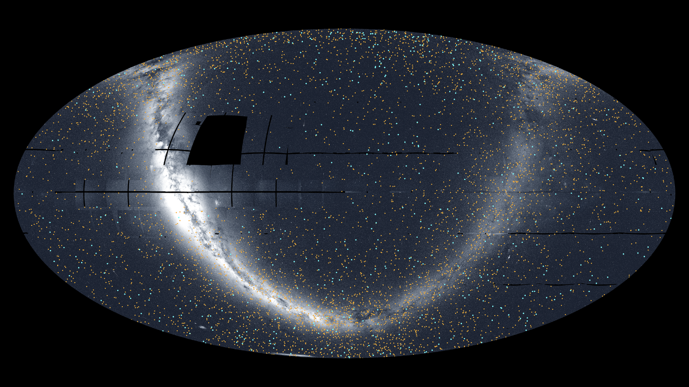

Click for next article This view of the whole sky was constructed from 96 TESS sectors. By Sept 2025, TESS had discovered 679 exoplanets (blue dots) and 5,165 candidates (orange dots). NASA's exoplanet-hunting spacecraft TESS, or Transiting Exoplanet Survey Satellite, has released its most complete view of the sky over Earth - the map reveals the location of 6,000 potential worlds beyond the solar system. The mix of possible and confirmed extra-solar planets, or exoplanets , were identified by the mission prior to Sept. 2025. That's the month that marked the conclusion of TESS 's second mission extension. (The exoplanet-hunting spacecraft launched from Space Launch Complex 40 at Cape Canaveral in April 2018.) "Over the last eight years, TESS has become a fire hose of exoplanet science," Rebekah Hounsell, a TESS associate project scientist at NASA's Goddard Space Flight Center in Greenbelt, Maryland, said in a statement . "It's helped us find planets of all different sizes, from tiny Mercury-like ones to those larger than Jupiter . Some of them are even in the habitable zone, where liquid water might be possible on the surface, an important factor in our search for life beyond Earth." TESS searches for exoplanets using the tiny dips in brightness they cause as they cross, or "transit," the face of their parent star and block starlight. The total area of sky the mission searches is broken down into sectors, containing tens of thousands of stars. TESS uses its four cameras to observe each sector for around a month, looking for minuscule brightness dips before moving on. The new TESS all-sky mosaic is made up of 96 sectors seen between April 2018 and Sept. 2025. The blue dots represent around 700 confirmed exoplanets, including exotic objects like planets being destroyed by their own host stars to worlds ravaged by global volcanoes. The orange dots represent candidate exoplanets detected by TESS that are yet to be confirmed. And these extraordinary discoveries continue with discoveries not yet worked into this new mosaic. Just this year , TESS discovered a planetary system unlike any seen before, consisting of a super-Earth and a companion planet that possesses a highly elliptical and tilted orbit. Also this year , TESS discovered evidence of two planets smashing together, leaving a cloud of debris in front of their parent star; studying that cataclysmic collision could help us investigate a possible smash-up between Earth and a planetary body billions of years ago. It is such a smash-up that scientists believe may have birthed the moon. "The more we dig into the large TESS dataset, especially using automated algorithms, the more surprises we find," Allison Youngblood, the TESS project scientist at NASA Goddard, said. "In addition to planets, TESS has helped us study rivers of young stars, observe dynamic galactic behavior, and monitor asteroids near Earth. "As TESS fills in more of the night sky, there's no knowing what it might see next."

12. SpaceX will launch its 1st-ever Starship V3 megarocket today. The stakes couldn't be higher
Latest from Space.com
Read more
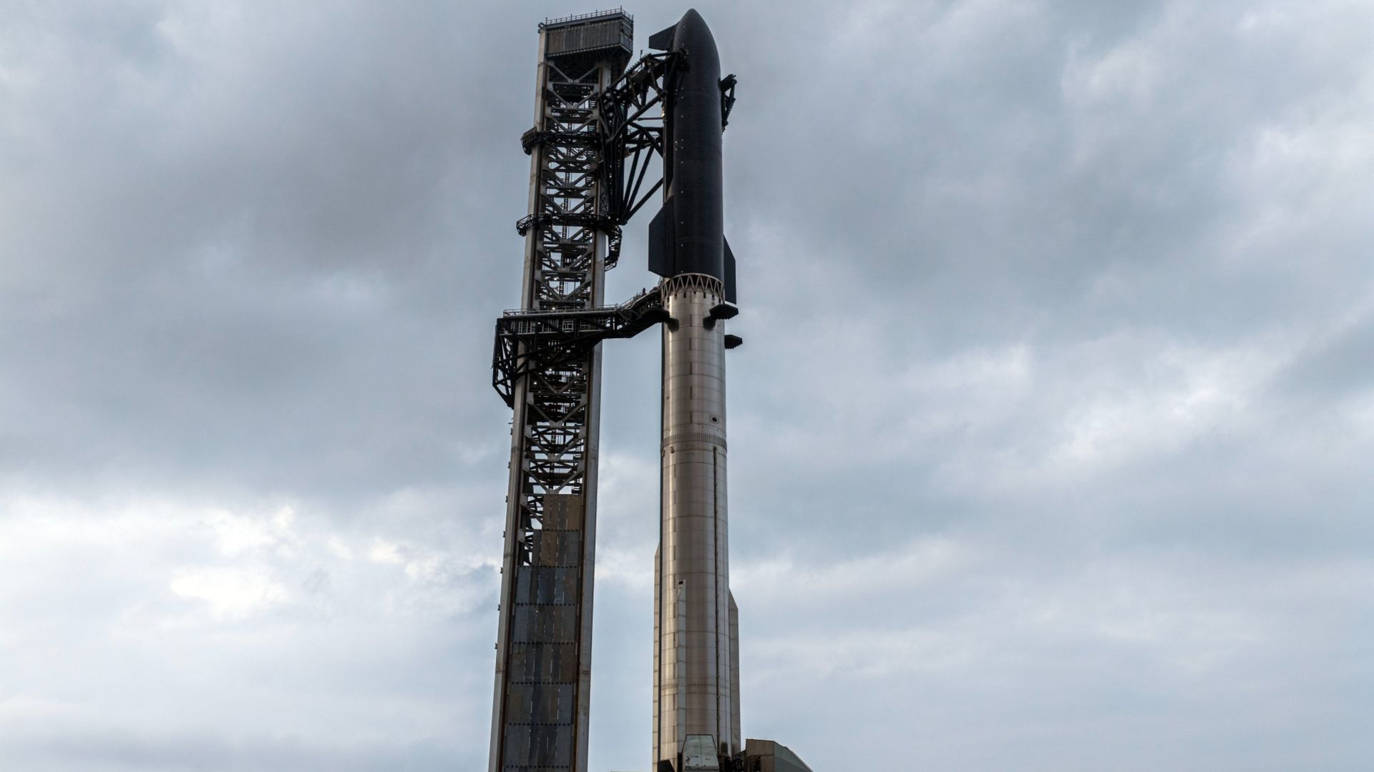

Click for next article Update for 7:51 p.m. ET: SCRUB! SpaceX has called off the attempted launch of its first Starship V3 megarocket due to a technical issue in the last minute before liftoff. The next launch attempt of Starship Flight 12 could occur on Friday, May 22, at 6:30 p.m. EDT (2230 GMT), SpaceX says. See our latest Starship V3 launch updates There's a lot riding on the debut flight of SpaceX's Starship V3 megarocket - not the least of which are NASA's Artemis moon landing ambitions. The Starship launch is scheduled to take place today (May 21) from SpaceX's Starbase test site in South Texas, during a 90-minute window that opens at 6:30 p.m. EDT (2230 GMT; 5:30 p.m. local Texas time). You can watch it here at Space.com when the time comes and see our latest Starship V3 launch updates for more. The flight will be the 12th overall for Starship, and it will be broadly similar to previous efforts - a suborbital jaunt that ends with controlled ocean splashdowns of Starship's Super Heavy booster and its Ship upper stage. But the vehicle involved is quite new, and SpaceX expects a lot out of it. $39.99 at Amazon Starship Die Cast Rocket Model Was $47.99 Now $39.99 on Amazon. Even if you can't see SpaceX's Starship in person, you can score a model of your own. Standing at 13.77 inches (35 cm), this is a 1:375 ratio of SpaceX's Starship as a desktop model. The materials here are alloy steel and it weighs just 225g. A bigger (and better?) Starship megarocket The 408-foot-tall (124 meters) V3 ("Version 3") is bigger and more powerful than previous Starship iterations, which were already the biggest and most powerful rockets ever built, and it sports a number of other important upgrades as well. For starters, it's outfitted with the new V3 Raptor engine - 33 of them on Super Heavy and six on Ship - which provides more heft, and a far more streamlined design, than its predecessors. The V3 Super Heavy also now has just three grid fins (which help it steer its way back to Earth for recovery and reuse) instead of four. And the "hot stage ring" - the structure that marks the meeting point of Super Heavy and Ship - is now attached to the booster, meaning it can be reused, whereas previously it had fallen away during flight. (Starship engages in "hot stage" separation, meaning Ship fires its engines before it has detached from Super Heavy.) Super Heavy's fuel transfer tube, which funnels propellant from its main tank to all 33 Raptors, "has been completely redesigned and is now roughly the size of a Falcon 9 first stage," SpaceX wrote in an update last week . This change allows all 33 engines to start up simultaneously and will improve the speed and reliability of in-flight maneuvers, according to the company. V3 of Ship, meanwhile, "incorporates a clean-sheet redesign of its propulsion systems," SpaceX wrote. "These changes enable a new Raptor startup method, increase propellant tank volume and improve the reaction control system used for steering while in flight. The propulsion updates also reduce contained volumes in the aft end of the vehicle that could trap propellant leakage." Ship's PEZ-dispenser-like deployment mechanism has been upgraded as well, enabling speedier ejection of payloads. We'll see this mechanism in action on today's flight: Ship will deploy 20 dummy Starlink satellites , as well as two actual Starlinks equipped with special cameras that will scan Ship's heat shield . (On previous flights, Ship has deployed just eight to 10 dummy Starlinks.) There are other significant Ship changes as well, the update relates. The V3 vehicle "is now designed to be capable of long-duration flights with more efficient reaction control systems, isolation valves for high-pressure gases, 100% vacuum jacketing coverage of the header feed system, a high-voltage electrically actuated cryogenic recirculation system, and a dedicated system for managing cryogenic propellant interactions with the engines during extended coasts in space." V3 Ship also features four "docking drogues" - small receptacles that allow it to link up with specially modified (and not yet built) "tanker" Ships - as well as propellant line connections enabling those tankers to transfer their fuel . This upgrade is a very big deal, for every Ship headed to the moon , Mars and other deep-space locales will need to be fueled up in space a dozen times or more. Today's flight will also mark the debut of the second launch pad at Starbase, which features advances of its own. For instance, its propellant farm can load fuel into the megarocket faster, according to SpaceX. And the "chopstick arms" of Pad 2's launch tower, which are designed to catch returning Super Heavy boosters and Ships, are shorter and nimbler. "Together, these new elements are designed to enable a step-change in Starship capabilities and aim to unlock the vehicle's core functions, including full and rapid reuse, in-space propellant transfer, deployment of Starlink satellites and orbital data centers , and the ability to send people and cargo to the moon and Mars ," SpaceX wrote in the update. Will it really land on the moon? And the moon is a destination for Starship V3 in the not-too-distant future. If all goes to plan, the vehicle will land astronauts on the lunar surface during NASA's Artemis 4 mission, which the agency aims to launch in late 2028. Starship will have to check a lot of boxes before it flies that mission, however. For example, the vehicle has yet to reach Earth orbit; all 11 of its test flights to date ( Flight 1 launched in April 2023 ) have been suborbital, as today's will be. It also needs to demonstrate off-Earth refueling and be outfitted with a life-support system and other astronaut accoutrements. Such milestones must be met soon if SpaceX wants to stay on NASA's Artemis program timeline. The agency plans to launch its crewed Artemis 3 mission to Earth orbit in mid- to late 2027. This will be a docking test between Artemis' Orion crew capsule and one or both of the program's privately developed lunar landers - Ship (by itself, without Super Heavy) and Blue Origin's Blue Moon vehicle. If Ship isn't ready and Blue Moon is, NASA will presumably go with the latter on Artemis 3, putting the Blue Origin vehicle in pole position for the moon a year later. Blue Moon has a lot of work to do as well, of course; it has yet to get off the ground. But that could change soon: Blue Origin plans to launch an uncrewed test flight to the lunar south pole with a prototype lander called Blue Moon Mark 1 later this year. It will launch on a Blue Origin New Glenn rocket, which is also facing its own hurdles. New Glenn's recent NG-3 launch suffered an upper-stage failure , leading to the loss of its satellite payload. Blue Origin will need to fix that issue before Blue Moon Mark 1 can fly. What if Starship V3 doesn't work? NASA has picked SpaceX's Starship spacecraft, seen here in an artist's depiction, to land Artemis astronauts on the moon. (Image credit: SpaceX) Failure on V3's debut launch could therefore be a big deal - especially if the fix requires significant modification of a key Starship system or subsystem. SpaceX needs to move quickly at this point in Starship's development and cannot afford many more long delays. (Getting V3 to the pad took a while; Starship hasn't flown since October 2025 .) A subpar flight could also have short-term financial consequences. SpaceX is gearing up for its initial public offering next month , which is expected to value the company at a record $1.75 trillion or so. A catastrophic Starship failure in the leadup to the market debut could affect that valuation, given how central the vehicle is to SpaceX's future: The company has said that Starship will be its workhorse over the long haul, doing everything from satellite launches to crewed Mars missions to "point-to-point" transportation around Earth. If SpaceX CEO and founder Elon Musk is nervous about V3's debut, however, he isn't showing it.

13. NASA's AWE instrument completes mission to study Earth's effect on space weather
Space News - Space, Astronomy, Space Exploration
Read more
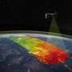

On May 21, ground controllers powered down NASA's AWE (Atmospheric Waves Experiment) instrument, bringing the data collection phase of the mission to a successful and scheduled end, surpassing its planned two-year mission.

14. Musk's SpaceX bonus comes with unique condition: Colonize Mars
Space News - Space, Astronomy, Space Exploration
Read more


SpaceX's blockbuster IPO filing included some out-of-this-world details, including a provision that founder Elon Musk's massive bonus only kicks in if one million humans settle on Mars.

