 |  | 

🌌 अंतरिक्ष समाचार | Space News
शुक्रवार, १८/०९/२०२६ | Friday, 18/09/2026

1. Private space push must not weaken ISRO, employee groups warn against 'throwaway prices' - Moneycontrol.com
Read more
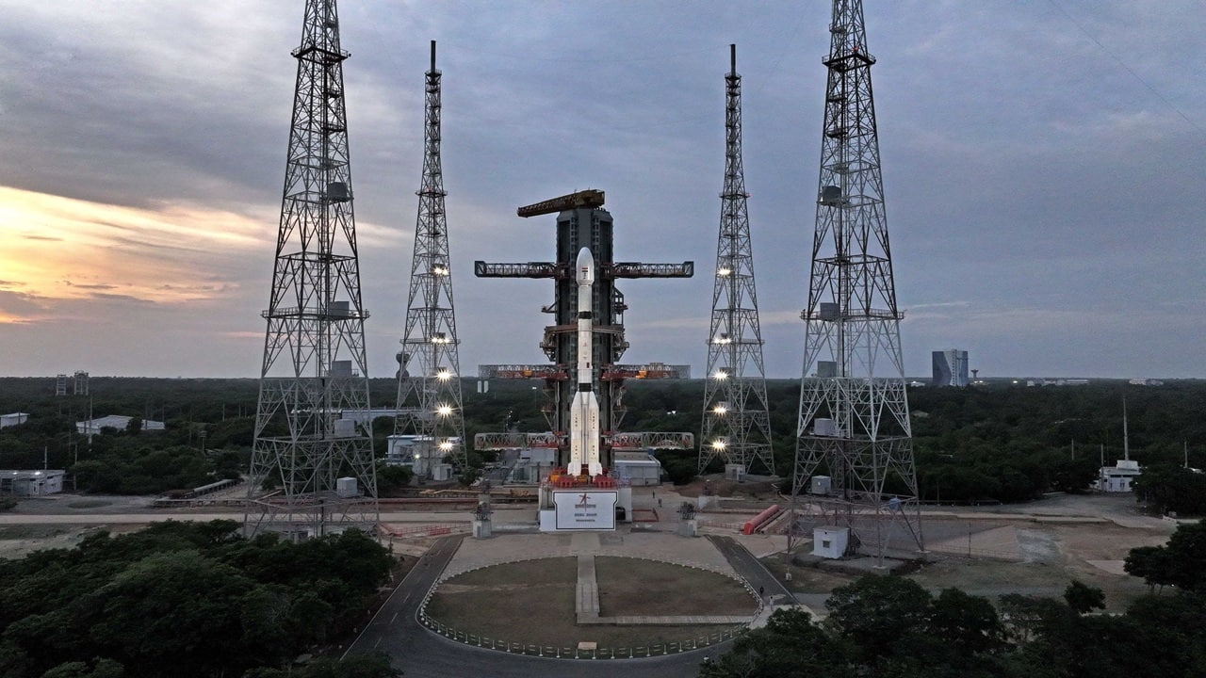
The Joint Action Council said it supports industry participation but wants ISRO to retain end-to-end control over key launch systems, including LVM3 and NGLV. ISRO employee groups said private participation must not weaken the agency or transfer taxpayer-funded technology at throwaway prices. A group representing employee associations at the Indian Space Research Organisation has warned that India's push to expand private participation in the space sector must not weaken the agency's capabilities or allow taxpayer-funded technology to be transferred at "throwaway prices". The Joint Action Council, or JAC, said it supported a larger role for Indian companies, public-sector undertakings and start-ups but wanted ISRO to retain its core research, development and launch capabilities, The Indian Express reported on Friday. The newspaper said the undated four-page statement was circulated among ISRO employees on Thursday. It obtained a copy and confirmed its authenticity with two serving employees. ISRO did not respond to the newspaper's request for comment. The JAC called for transparency, accountability and a level playing field when technologies and facilities developed using public money are opened to private entities. Publicly funded assets should not become a source of private profit without an adequate return to the country, it said. The employee body acknowledged that private companies would be needed to increase the number of launches undertaken by India. However, it argued that this did not require every mature technology developed by ISRO to be transferred to industry. JAC seeks safeguards for LVM3, NGLV The statement specifically named the LVM3 heavy-lift rocket and the Next Generation Launch Vehicle, or NGLV, which is under development. The JAC said both systems should remain with ISRO and that the agency must retain the entire chain of capability covering research, development, production, integration, testing and launch. The fresh statement follows a September 4 letter from the employee associations to ISRO Chairman V Narayanan, issued a day after the successful GSLV-F17 mission. The associations had sought clarity on ISRO's future role following reports that the agency could concentrate on a smaller number of strategic missions while transferring other activities to private companies. Narayanan subsequently told employees that there was no proposal to privatise ISRO and that the agency would continue to build and strengthen its capabilities while working with industry to expand India's space economy. He also addressed employees through a video conference. ISRO separately said it would remain India's principal institution for advanced space research, strategic missions, space science and frontier technologies, and that its importance would not be diminished. IN-SPACe Chairman Pawan Goenka also said ISRO would remain the foundation of India's space programme. Did our AI summary help? Market Mastery Webinar by Vishal Malkan Find the weak links in your portfolio by Vishal Malkan Register for FREE Webinar Register for FREE ISRO separately said it would remain India's principal institution for advanced space research, strategic missions, space science and frontier technologies, and that its importance would not be diminished. IN-SPACe Chairman Pawan Goenka also said ISRO would remain the foundation of India's space programme.

2. Private participation not at the cost of ISRO's capabilities: Staff in fresh note - indianexpress.com
Read more
Private participation not at the cost of ISRO's capabilities: Staff in fresh note indianexpress.com

3. ISRO Staff Raise Concerns Over Private Sector Role, Seek Clarity On Agency's Future: 'Must Strengthen Natio - News18
Read more
ISRO Staff Raise Concerns Over Private Sector Role, Seek Clarity On Agency's Future: 'Must Strengthen Natio News18

4. Isro staff for probe into PSLV sabotage allegations, raise cadre review, other concerns - The Times of India
Read more

Isro staff for probe into PSLV sabotage allegations, raise cadre review, other concerns The Times of India

5. Modi At 76: How India's Space Reforms Are Recasting ISRO, Private Industry And The Road To Space Power - BW Businessworld
Read more
Modi At 76: How India's Space Reforms Are Recasting ISRO, Private Industry And The Road To Space Power BW Businessworld

6. NASA Awards Launch Services for StarBurst Gamma-Ray Detector
Read more
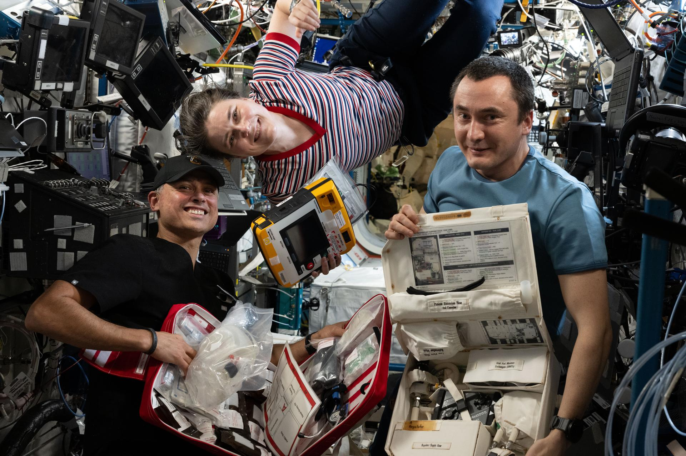
Credit: NASA NASA has selected SpaceX to provide launch services for the agency's StarBurst mission, a small satellite designed to investigate neutron star mergers and the origins of short gamma-ray bursts. StarBurst will launch aboard a Bandwagon rideshare mission on a Falcon 9 rocket from Space Launch Complex 40 at Cape Canaveral Space Force Station in Florida no earlier than 2028. The selection is a firm-fixed-price task order under NASA's VADR (Venture-Class Acquisition of Dedicated and Rideshare) launch services contract. This indefinite-delivery/indefinite-quantity contract allows NASA to acquire launch services during a 10-year ordering period, with a maximum total value of $1 billion across all contracts. The StarBurst mission is designed to observe the entire portion of the sky not blocked by Earth to search for brief, powerful explosions called gamma-ray bursts. The satellite will focus on detecting the initial high-energy emission from short gamma-ray bursts, which occur when dense stellar remnants called neutron stars merge. By combining StarBurst's observations with gravitational-wave measurements and follow-up observations from other telescopes, researchers will study these events through multiple types of signals, an approach known as multimessenger astronomy. StarBurst is part of NASA's Astrophysics Pioneers Program, which supports lower-cost investigations using small spacecraft and other platforms. NASA's Launch Services Program Office, based at the agency's Kennedy Space Center in Florida, manages the VADR contract. For more information about NASA's StarBurst, visit: https://science.nasa.gov/mission/starburst -end- Joshua Finch / Jimi Russell Headquarters, Washington 202-358-1100 joshua.a.finch@nasa.gov / james.j.russell@nasa.gov Leejay Lockhart Kennedy Space Center, Fla. 321-747-8310 leejay.lockhart@nasa.gov

7. NASA Invites Media to SpaceX's 35th Resupply Launch to Space Station
Read more
A SpaceX Falcon 9 rocket launches on May 15, 2026, carrying about 6,500 pounds of science, supplies, and equipment to the International Space Station during the company's 34th commercial resupply mission for NASA. Credit: NASA Media accreditation is open for the next cargo launch that will deliver NASA science investigations, supplies, and equipment to the International Space Station. The 35th SpaceX commercial resupply services mission to the orbital laboratory for NASA will lift off on a Falcon 9 rocket. NASA and SpaceX are targeting no earlier than October to launch the SpaceX Dragon spacecraft from Cape Canaveral Space Force Station in Florida. Credentialing to cover prelaunch and launch activities is open to U.S. media only. The application deadline is 11:59 p.m. EDT, Thursday, Oct. 1. All accreditation requests must be submitted online at: https://media.ksc.nasa.gov Media will receive a confirmation email upon approval. NASA's media accreditation policy is available online. For questions about accreditation, or to request special logistical support, email: ksc-media-accreditat@mail.nasa.gov. For other questions, please contact NASA's Kennedy Space Center newsroom at: 321-867-2468. Each resupply mission to the station delivers scientific investigations in biology and biotechnology, Earth and space science, physical sciences, and technology development and demonstrations. Cargo resupply from U.S. companies ensures a national capability to deliver scientific research to the space station, significantly increasing NASA's ability to conduct new investigations aboard humanity's laboratory in space. In addition to food, supplies, and equipment for the crew, Dragon will deliver the final sets of International Space Station Roll-Out Solar Arrays, called IROSA, which astronauts will install during future spacewalks to complete station's power augmentation. Once installed, the arrays will provide additional power to support critical station operations, including its safe and controlled deorbit. The mission also will transport several new experiments to the orbital complex, including hardware to manufacture artificial retinas in microgravity that could help restore vision for patients on Earth and 3D heart cell models to advance large-scale drug testing on future space missions. Dragon also will carry materials to study how a new type of glass is formed in microgravity, and brain organoids that could uncover potential treatment targets for neurodegenerative diseases like Alzheimer's, Parkinson's, and multiple sclerosis. For more than 25 years, people have lived and worked continuously aboard the International Space Station, advancing scientific knowledge and making research breakthroughs not possible on Earth. The space station helps NASA understand and overcome the challenges of human spaceflight, expand commercial opportunities in low Earth orbit, and build on the foundation for long-duration missions to the Moon, as part of the Artemis program, and to Mars. Learn more about NASA's commercial resupply missions at: https://www.nasa.gov/station -end- Josh Finch / Jimi Russell Headquarters, Washington 202-358-1100 joshua.a.finch@nasa.gov / james.j.russell@nasa.gov Steven Siceloff Kennedy Space Center, Fla. 321-876-2468 steven.p.siceloff@nasa.gov Sandra Jones / Joseph Zakrzewski Johnson Space Center, Houston 281-483-5111 sandra.p.jones@nasa.gov / joseph.a.zakrzewski@nasa.gov

8. NASA spacecraft discovers a huge new crater on the moon
Read more

Scientists have discovered a crater on the moon that's bigger than the Roman Colosseum and is the result of a powerful impact two years ago that initially went undetected.

9. US ramps up 120+ mile strike range AIM-260 missile production with $736M Australia deal
Read more
Lockheed Martin is preparing to ramp up production of the AIM-260 Joint Advanced Tactical Missile as the U.S. expands its next-generation air-to-air arsenal. The defense giant signed a framework agreement with the U.S. Department of War to accelerate manufacturing and deliveries of the missile. The arrangement could eventually support a multiyear procurement deal, though Congress must approve that contract. Longer reach, new threats The AIM-260 is designed to extend the reach of U.S. fighter aircraft against airborne threats. Its development addresses a key challenge in modern air combat, where aircraft can detect and engage targets from increasingly greater distances. Lockheed Martin says the missile offers greater range and effectiveness than existing air-to-air weapons. The company describes JATM as a major air-dominance capability for confronting current and emerging threats. The missile can integrate with several U.S. fighter platforms. Those include the F-22 Raptor and F-35 Lightning II. That compatibility gives U.S. forces another option for deploying the weapon across different fighter fleets. It also places the missile within a broader effort to improve long-range engagement capabilities. The AIM-260 program involves Lockheed Martin, the U.S. Air Force and the U.S. Navy. The three organizations have worked together on the weapon's development and production. Lockheed Martin Missiles and Fire Control President Tim Cahill said the company will increase deliveries to meet demand from the United States and its allies. "We will deliver JATM at the speed our nation and allies demand," Cahill said. Scaling missile production Increasing JATM deliveries will require more than additional orders. Lockheed Martin says it will make investments needed to expand production capacity under the new arrangement. The planned procurement structure could also give manufacturers greater visibility into future demand. That matters for a missile program requiring specialized components, production equipment and skilled labor. A multiyear purchase could provide that longer-term certainty. Congressional approval remains necessary before the planned procurement contract can proceed. The arrangement also reflects changes in how the Pentagon wants to acquire weapons. The Department of War has identified faster acquisition and higher production capacity as central parts of its acquisition transformation strategy.

