 |  | 

🌌 अंतरिक्ष समाचार | Space News
बुधवार, १७/०६/२०२६ | Wednesday, 17/06/2026

1. ISRO Experts Highlight Role of Quantum Technologies in Future Space and Security Systems - The Quantum Insider
Read more
Insider Brief Chandigarh University has launched the KCC Space Technology & Research Program 2026 and Summer Internship Program 2026 with participation from ISRO, IIST, SCL, and other leading scientific institutions. The month-long initiative will provide students with training, mentoring, workshops, and exposure to emerging technologies in space, semiconductors, AI, and quantum communications. ISRO, IIST, and SCL leaders highlighted the importance of indigenous technology development, quantum technologies, semiconductors, and AI for India's future growth and security. PRESS RELEASE - In a major step towards strengthening space technology education and research, Chandigarh University, through its Kalpana Chawla Centre (KCC) has launched the KCC Space Technology & Research Program 2026 and the KCC Summer Internship Program 2026 at its campus on Monday. The month-long national-level programme, running from June 15 to July 11, 2026, has brought together leading space scientists, satellite technologists and semiconductor experts from the Indian Space Research Organisation (ISRO), the Indian Institute of Space Science and Technology (IIST), the Semiconductor Laboratory (SCL) and other premier scientific institutions to mentor the next generation of innovators and researchers. The initiative will provide students with valuable insights into emerging space technologies and hands-on exposure to cutting-edge developments shaping India's rapidly evolving space sector. The inaugural ceremony was graced by Dr S Sudhakar, Deputy Director, U R Rao Satellite Centre (URSC), ISRO as the Chief Guest while Prof. Priyadarshnam, Head and Project Director, SSPACE, Indian Institute of Space Science and Technology (IIST) attended as the Guest of Honour. Distinguished guests included Dr. Kamaljeet Singh, Director General, Semiconductor Laboratory (SCL), Chandigarh, and Sri Jothy Soman, Group Director, URSC, ISRO. Speaking on the occasion, Dr S Sudhakar, Deputy Director, U R Rao Satellite Centre (URSC), ISRO said, "As India works towards becoming a developed nation by 2047, science and technology will play a defining role in shaping the future. Science is going to govern the world and space technology will be one of the most important drivers of that transformation. One of the most important lessons young engineers and researchers can learn from ISRO's journey is the value of developing indigenous technologies. We have achieved world-class results by building our own capabilities and relying on the talent of our people. Technology does not come free and acquiring it from elsewhere often comes at a significant cost. When we develop technologies ourselves, we not only reduce costs but also gain strategic advantages and self-reliance. This approach has enabled India to perform exceptionally well despite resource constraints." Dr S Sudhakar added, "Communication, navigation, scientific exploration and strategic applications will increasingly depend on advancements in the space sector. The coming decades will witness growing demand for space-based services, including surveillance, communication and navigation systems. The defence sector is also expanding its space-based capabilities, both independently and in collaboration with ISRO. At the same time, there will be increasing requirements for scientific research, exploration missions and technology development across multiple domains." "ISRO has already charted out an ambitious roadmap extending to 2047, including major programmes ranging from advanced exploration missions to long-term human spaceflight missions. To remain technologically ahead in an increasingly competitive global environment, India must continue to invest in indigenous technologies and strengthen its infrastructure," added Dr Sudhakar. Speaking on the occasion, Prof. Priyadarshnam, Head & Project Director, SSPACE, Indian Institute of Space Science and Technology (IIST) said, "ISRO has always been at the forefront of achieving maximum impact with limited resources. One of the key lessons from its journey is the importance of precision, rigorous testing and human expertise. While automation has its place, mission success ultimately depends on meticulous development, validation and the dedication of scientists and engineers. This culture of frugal innovation and uncompromising testing has been central to ISRO's achievements over the years." On the role emerging technologies can play in strengthening the security systems in the country, Prof. Priyadarshnam said, "Quantum technology will be a major thrust area in the future. If we do not adapt to quantum systems, many of the present security mechanisms could eventually become vulnerable. Research organizations across India, including ISRO, are already working on quantum technologies, particularly quantum cryptography and quantum communications. Artificial intelligence is another technology that will have a profound impact on the space sector. While its adoption in satellite systems is still evolving, the enormous volume of data being generated by modern space missions will make AI indispensable for analysis, decision-making and future space applications. These areas will play a crucial role in securing communications, protecting critical infrastructure and strengthening national security in the years ahead." On space technology's role in driving economic growth, he said, "Space technology is going to play a major role in India's future development. Unless we are quick enough to adopt and integrate space technologies across the domains, the pace of development will not be sufficient. There is certainly a threat perception arising from the growing role of space-based technologies in security and strategic affairs. However, India has the capability to overcome such challenges through indigenous innovation and technological self-reliance. India's greatest strength lies in its talent, and we must increase our workforce in this critical sector. Innovation in areas such as small satellite technologies and advanced space systems will be important in enhancing our preparedness and resilience." Dr Kamaljeet Singh, Director General, Semiconductor Laboratory (SCL) said, "Semiconductors are the foundation of the digital economy and will play a crucial role in India's journey towards becoming a developed nation by 2047. Under the India Semiconductor Mission, significant progress is already being made with multiple manufacturing and assembly plants being established across the country. Our objective is to build a robust, full-stack semiconductor ecosystem that reduces import dependence and strengthens India's technological capabilities. Semiconductors are critical for strategic sectors including space, telecommunications, defence, artificial intelligence and advanced computing." "The next step is to strengthen manufacturing, deployment and application ecosystems. As artificial intelligence becomes a key driver of future growth, India must leverage its vast data resources to develop indigenous technologies and sovereign AI models. Building strong capabilities in semiconductors and AI will not only boost economic growth but also enhance national security, technological independence and India's competitiveness in the global innovation landscape," added Dr Kamaljeet. Over the next four weeks, nearly 15 eminent scientists, directors, senior researchers and technical experts from premier national institutions including ISRO, IIST, NewSpace India Limited (NSIL), Indian Institute of Remote Sensing (IIRS), Ministry of Earth Sciences (MoES), Semiconductor Laboratory (SCL) and other leading organizations will engage with Chandigarh University students and faculty through an intensive series of technical training sessions, expert lectures, laboratory demonstrations, mentoring programmes, research discussions and interactive workshops.

2. ISRO scientists launch space research programmes at Chandigarh University - Awaz The Voice
Read more

Representational Image Chandigarh In a significant initiative aimed at advancing space education and research in India, Chandigarh University, through its Kalpana Chawla Centre (KCC), on Monday launched the KCC Space Technology & Research Program 2026 and the KCC Summer Internship Program 2026. The month-long national programme, running from June 15 to July 11, has brought together experts from leading scientific institutions, including Indian Space Research Organisation, Indian Institute of Space Science and Technology, and the Semiconductor Laboratory, to mentor students and research scholars in emerging technologies shaping India's growing space sector. The initiative seeks to provide participants with practical exposure, technical insights and opportunities to engage with cutting-edge developments in satellite systems, semiconductors, space applications and advanced research. The inaugural ceremony was attended by senior scientists and technologists, including Dr S. Sudhakar, Deputy Director of ISRO's U R Rao Satellite Centre, who served as the chief guest. Prof. Priyadarshnam, Head and Project Director of SSPACE at IIST, was the guest of honour. Dr Kamaljeet Singh, Director General of SCL, and Sri Jothy Soman, Group Director at URSC, were also present. Addressing the gathering, Dr Sudhakar said that science and technology would be central to India's aspiration of becoming a developed nation by 2047. "Science will increasingly shape the future, and space technology will be among the most important drivers of that transformation," he said. Drawing from ISRO's own experience, he highlighted the importance of developing indigenous technologies. "Technology does not come free. Acquiring it externally often involves significant costs. When we build our own capabilities, we gain strategic advantages, reduce expenses and strengthen self-reliance. This approach has enabled India to achieve world-class outcomes despite limited resources," he noted. Dr Sudhakar pointed out that sectors such as communication, navigation, surveillance and scientific exploration would become increasingly dependent on space-based systems in the coming decades. He also noted the growing role of the defence sector in developing space capabilities, both independently and in collaboration with ISRO. He added that ISRO had already outlined an ambitious roadmap extending to 2047, encompassing advanced exploration initiatives and long-term human spaceflight missions. Prof. Priyadarshnam emphasised that one of ISRO's greatest strengths has been its ability to maximise outcomes with limited resources. He said mission success depends not only on automation but also on rigorous testing, precision and the commitment of scientists and engineers. "This culture of frugal innovation and uncompromising validation has been integral to ISRO's achievements," he said. Speaking about future technologies, he identified quantum systems and artificial intelligence as areas that would significantly influence national security and space applications. "Quantum technologies, particularly cryptography and communications, will become increasingly important. Similarly, the vast amount of data generated by space missions will make artificial intelligence indispensable for analysis and decision-making," he said. Prof. Priyadarshnam also underlined the role of space technology in economic development, stating that India must accelerate the integration of such technologies across sectors to maintain growth momentum. Dr Kamaljeet Singh described semiconductors as the backbone of the digital economy and a critical component of India's development ambitions. "Under the India Semiconductor Mission, multiple manufacturing and assembly facilities are being established. The objective is to build a comprehensive ecosystem that reduces import dependence and strengthens domestic technological capabilities," he said. He noted that semiconductors are essential for sectors ranging from defence and telecommunications to artificial intelligence, advanced computing and space technologies. Highlighting the growing importance of AI, Dr Singh said India should leverage its vast data resources to develop indigenous solutions and sovereign AI models. According to university officials, the programme will feature nearly 15 eminent scientists, researchers and technical experts from institutions such as ISRO, IIST, NewSpace India Limited, Indian Institute of Remote Sensing, the Ministry of Earth Sciences and SCL. Participants will take part in technical sessions, laboratory demonstrations, mentoring programmes, expert lectures, workshops and research interactions designed to nurture innovation and strengthen India's future workforce in the space and semiconductor domains.

3. ISRO Scientists Mentor Students At Chandigarh University Space Programme 2026 - The Morning Voice
Read more

In a significant step towards advancing space technology education and research , Chandigarh University has launched the KCC Space Technology & Research Programme 2026 and the KCC Summer Internship Programme 2026 at its campus under the Kalpana Chawla Centre (KCC). The month-long national programme, running from June 15 to July 11, 2026 , brings together leading scientists and experts from the Indian Space Research Organisation (ISRO), the Indian Institute of Space Science and Technology (IIST), the Semiconductor Laboratory (SCL), and other premier national institutions. The initiative aims to provide students and research scholars with hands-on exposure to emerging space technologies, satellite systems, and semiconductor applications. The inaugural ceremony was attended by Dr S Sudhakar, Deputy Director, U R Rao Satellite Centre (URSC), ISRO , as Chief Guest, and Prof. Priyadarshnam, Head & Project Director, SSPACE, IIST , as Guest of Honour. Senior officials including Dr Kamaljeet Singh, Director General, SCL Chandigarh, and Sri Jothy Soman, Group Director, URSC, ISRO, also participated. Speaking at the event, Dr Sudhakar highlighted the importance of indigenous technology development , stating that India's progress in space missions has been driven by self-reliance and talent. He noted that space-based services such as communication, navigation, surveillance, and defence applications will expand significantly in the coming decades, aligning with India's roadmap towards 2047. Prof. Priyadarshnam emphasised ISRO's culture of precision engineering, rigorous testing, and human expertise , describing them as key factors behind mission success. He also underlined the growing relevance of quantum technology and artificial intelligence in strengthening space communication systems and data-driven decision-making. Dr Kamaljeet Singh of SCL highlighted semiconductors as the backbone of the digital and strategic economy , noting India's push under the India Semiconductor Mission to build a self-reliant ecosystem for advanced computing, AI, and space applications. Over the next four weeks, around 15 scientists and experts from ISRO, IIST, NSIL, IIRS, MoES, and SCL will conduct lectures, workshops, laboratory demonstrations, and mentoring sessions for students and faculty.The initiative aims to strengthen India's future talent pipeline in space science, semiconductor technology, and advanced research domains .

4. NASA's Webb Catches Exoplanet Getting Roasted
Read more
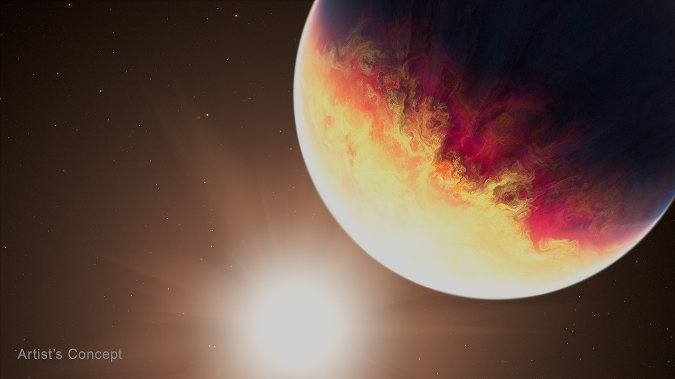
One well-done gas giant, coming right up! That's the latest from researchers analyzing NASA's James Webb Space Telescope's observations of HD 80606 b, an exoplanet four times the mass of Jupiter with an extremely elliptical orbit that sweeps close by its Sun-like star. The research team is presenting their study and preliminary findings Tuesday at the 248th meeting of the American Astronomical Society in Pasadena, California. "Hot Jupiters are already considered some of the most extreme exoplanets we know of, but even among that population, HD 80606 b is one of the most extreme," said Tiffany Kataria, the study's principal investigator at NASA's Jet Propulsion Laboratory in Southern California. "We typically think of hot Jupiters as hot gas giants sitting right next to their stars, but this planet's highly eccentric orbit creates a completely different beast." As the planet plunges close to its star, Webb shows its temperature skyrockets by 1,100 degrees Fahrenheit. Previous studies have shown that radical temperature swings can cause an exoplanet's chemistry and clouds to change in real time. According to the research team, the dynamic conditions of HD 80606 b make the planet an ideal target to observe these changes with Webb's powerful instruments. Image: Artist's concept exoplanet HD 80606 b This artist's concept shows exoplanet HD 80606 b being "roasted" as its orbit approaches periastron, the point at which it is closest to its host star, which is similar to our Sun. Artwork: NASA, ESA, CSA, Joseph Olmsted (STScI) "Observing a planet like HD 80606 b is actually very efficient because its unusual orbit, with the corresponding swings in temperature and chemical composition, allow us to gather data under varying conditions in just hours and apply those findings to other hot Jupiters or more conventional exoplanets," said Laura C. Mayorga, co-investigator on the study and an exoplanet astronomer at the Johns Hopkins Applied Physics Laboratory in Laurel, Maryland. Measurements of temperature and chemical composition were done with spectroscopy, a technique scientists use to break light into its component colors to reveal information about the composition, temperature, motion, and physical properties of objects in space. The team used Webb's MIRI (Mid-Infrared Instrument) for an extended observation of HD 80606 b before, during, and after its periastron, or closest pass by its star. During periastron, the planet also passed behind the star from Webb's perspective in what's known as a secondary eclipse. The observation was years in the planning, as scheduling the time to catch the planet at this point was complex given its extremely elliptical 111-day orbit, and Webb's own restrictions on where it can look during specific times of the year, based on Earth's position in orbit around the Sun. Researchers say they have only begun to peel back the layers of an incredibly rich dataset, but they can clearly see a dramatic shift in the exoplanet's temperature. "Webb has shown that the planet's increase in temperature was even more extreme than we anticipated based on Spitzer data," said Kataria. In fact, the planet had already been dubbed the "roasted exoplanet" and even got its own poster in NASA's popular series. NASA's now-retired Spitzer Space Telescope laid the groundwork of infrared observations of HD 80606 b, showing that more detailed spectroscopic data from Webb would be especially compelling. "Spitzer did amazing work on this exoplanet, and now Webb is building on that legacy by enabling us to drill down to distinguish specific chemical signatures like methane and carbon dioxide, which is just amazing progress," said Ryan Challener, co-author and research associate at the Cornell Center for Astrophysics and Planetary Science. "There's so much to learn from this one dataset here - we really are just getting started deciphering what Webb has to tell us." The James Webb Space Telescope is the world's premier space science observatory. Webb is solving mysteries in our solar system, looking beyond to distant worlds around other stars, and probing the mysterious structures and origins of our universe and our place in it. Webb is an international program led by NASA with its partners, ESA (European Space Agency) and CSA (Canadian Space Agency). For more information on Webb, visit: science.nasa.gov/webb Downloads & Related Information The following sections contain links to download this article's images and videos in all available resolutions followed by related information links, media contacts, and if available, research paper and Spanish translation links.

5. Astronaut Jessica Meir Assists With Hardware Updates for NASA's Cold Atom Lab
Read more
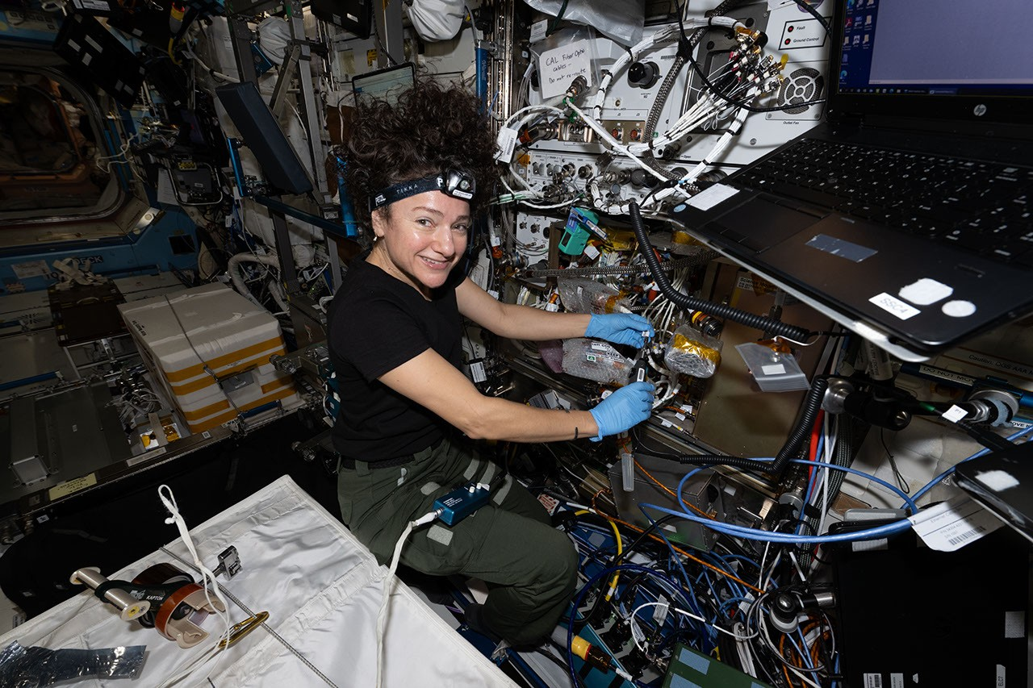
Description NASA astronaut Jessica Meir inspects optical fibers while installing hardware updates to the agency's Cold Atom Lab, or CAL, aboard the International Space Station on May 8, 2026. About the size of a minifridge and operated from Earth, CAL chills atoms to temperatures below minus 459 degrees Fahrenheit (minus 273.15 degrees Celsius), so close to absolute zero that they form a large quantum object called a Bose-Einstein condensate (BEC) - a fifth state of matter distinct from solids, liquids, gases, and plasma. In a BEC, scientists can observe the quantum properties of atoms at a scale visible to the naked eye. For instance, atoms and particles sometimes behave like solid objects and sometimes behave like waves, a quantum property called "wave-particle duality." Managed by Caltech in Pasadena, NASA's Jet Propulsion Laboratory designed, built, and operates Cold Atom Lab, which is sponsored by the Biological and Physical Sciences (BPS) division of NASA's Science Mission Directorate at the agency's headquarters in Washington. The BPS division pioneers scientific discovery and enables exploration by using space environments to conduct investigations that are not possible on Earth. Studying biological and physical phenomena under extreme conditions allows researchers to advance the fundamental scientific knowledge required to go farther and stay longer in space, while also benefiting life on Earth. To learn more about Cold Atom Lab, visit: https://coldatomlab.jpl.nasa.gov/

6. NASA Webb, Hubble Reveal History of Relic of Milky Way's Formation
Read more
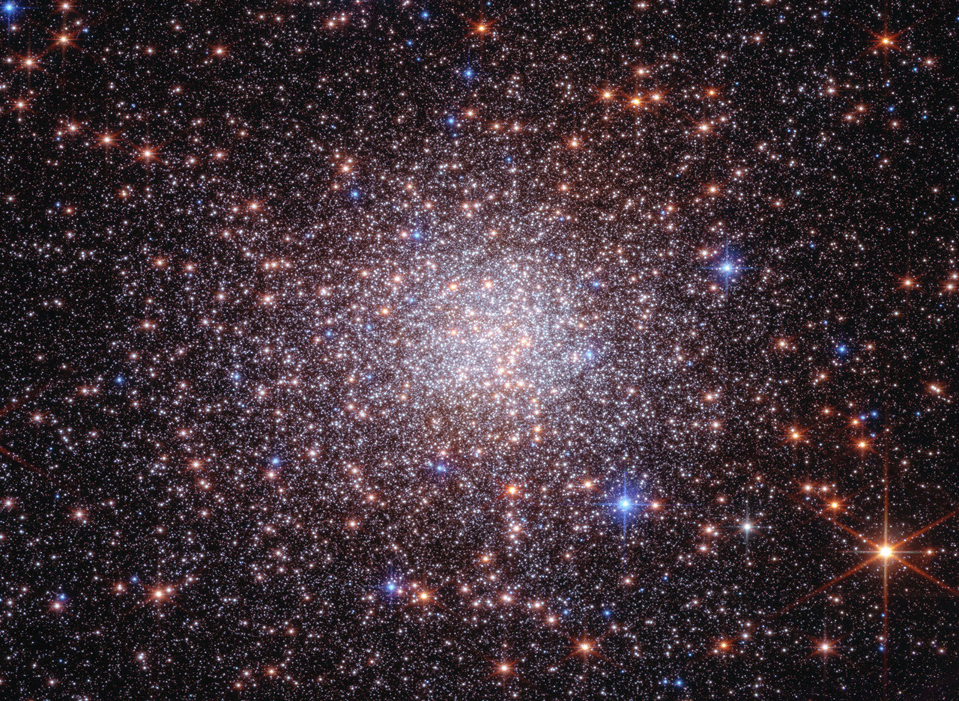
Researchers using two of humanity's most powerful observatories - NASA's James Webb and Hubble Space Telescopes - have definitively shown that Terzan 5 is not a globular star cluster as it was once classified, offering new insight into how galaxies like our own form and evolve over time. A globular star cluster typically has only one ancient star population. New data not only confirms the existence of two distinct populations of stars in Terzan 5, but also provides evidence for two more recent rounds of star formation. Although located within the crowded bulge of our Milky Way, our galaxy's central, spherical region of older stars, Terzan 5 was massive enough to maintain its separate identity while lighter weight systems spread out and mixed to form the bulge billions of years ago. It's like a lump in an otherwise well-mixed cake batter. "Webb's new near-infrared observations, cross-referenced with Hubble's archival observations, have given us a much clearer picture of the history of Terzan 5," said Giorgia Zullo, who led the research and is a PhD student at the University of Bologna in Italy. These results were presented at a press conference Tuesday at the 248th meeting of the American Astronomical Society in Pasadena, and were published in Astronomy & Astrophysics. Image: Bulge Fossil Fragment Terzan 5 (Webb and Hubble Image) New observations from Webb combined with multiple observations from Hubble prove that Terzan 5 is a self-contained, self-enriching stellar system that contains up to four distinct star populations. It orbits within our Milky Way galaxy's central bulge. Image: NASA, ESA, CSA, STScI, Giorgia Zullo (University of Bologna), Francesco Ferraro (University of Bologna); Image Processing: Alyssa Pagan (STScI) Four generations of stars Discovered in 1968 by astronomer Azop Terzan, Terzan 5 resembles a globular cluster in many ways. However, in 2009 this system was discovered to harbor two distinct populations of stars. In 2016 Hubble provided the first estimate of their ages, showing that one formed roughly 12 billion years ago - as the Milky Way itself was assembling - and the other about 5 billion years ago, just before Earth started forming. This pointed to a more complex history than a typical globular cluster. Studying Terzan 5 is complicated by its location in a region of our galaxy crowded with stars and heavily obscured by dust. This is where Webb stepped in. Its infrared view allowed the research team to peer through the dust and catalog many more stars, and fainter stars, than previous work. By measuring star colors and brightnesses, astronomers can classify them into populations of different ages and chemistries. Webb was able to measure these key properties for every star within the field of view in the sky - both stars within Terzan 5 and unrelated foreground stars. To isolate the stars of Terzan 5, the team relied on the power and longevity of Hubble. The 12-year separation allowed the team to measure very small movements of individual stars, known as proper motions, to determine which stars belong to Terzan 5 and which are part of the Milky Way bulge. By combining data from both Webb and Hubble, the researchers found strong evidence for two more stellar populations, one that formed 3.8 billion years ago and another only 2.5 billion years ago. They also were able to determine the ages of the previously known stellar populations with unprecedented precision, finding that they formed 12.5 billion and 4.7 billion years ago. With the previously known two generations of stars, astronomers could not rule out the possibility that Terzan 5 interacted with another object, like a globular cluster or a giant molecular cloud, becoming enriched with new gas and dust that set off a second round of star formation. With four stellar generations, those explanations are ruled out. Measurements of the stellar composition of Terzan 5 populations made at the W. M. Keck Observatory and European Southern Observatory's Very Large Telescope also point toward very distinct populations. "Along with the ages of these populations, the cluster preserves a fossil record of progressive enrichment of heavy elements by supernovae," said co-author R. Michael Rich, a research astronomer at the University of California, Los Angeles. Terzan 5 formed multiple generations of stars because it was able to retain the necessary raw materials. There is evidence of powerful supernova explosions in Terzan 5 that forged heavier elements that were swept up by subsequent generations of stars. In lighter weight systems, the force of the explosions themselves could have ejected the resulting elements as well as sweeping out leftover gas and dust. The progenitor of Terzan 5 had enough mass to retain those stars' ejections, allowing new generations of stars to form over billions of years. 'Bulge fossil fragment' The results show that Terzan 5 is most likely the remnant of a much more massive stellar system that initially formed 12.5 billion years ago. Terzan 5 is extraordinary because it survived - and never merged or fully "mixed in" with the Milky Way's bulge. "For some reason, this peculiar clump of stars formed separately from the bulge and was not destroyed as the bulge itself formed," said Francesco R. Ferraro, a professor at the University of Bologna and principal investigator of the Webb observations. "Terzan 5 is what we now call a bulge fossil fragment because it resembles the primordial clumps that contributed to the formation of the bulge." To date, there's one other known cosmic object like Terzan 5. Liller 1 was the second to be reclassified from a globular star cluster to a bulge fossil fragment. It also contains multiple generations of stars. There may be more objects like it. Between 40 to 50 additional globular clusters that orbit within the bulge will be examined by Ferraro's team to determine if their stellar populations are all the same, like globular clusters, or have several generations, like bulge fossil fragments. Video: Zoom to See Terzan 5 Near Our Milky Way Galaxy's Bulge To view this video please enable JavaScript, and consider upgrading to a web browser that supports HTML5 video Zoom in to Terzan 5, a star cluster that lies within the crowded central region of our Milky Way galaxy known as the bulge. The scene starts with a ground-based image of our Milky Way bulge and zooms in on and circles Terzan 5, ending with the composite image of the star system from the James Webb and Hubble Space Telescopes. Video: NASA, ESA, CSA, Alyssa Pagan (STScI); Acknowledgment: ESO, Pan-STARRS, DSS2, Akira Fujii Potential parallels for galaxy formation near, far Ultimately, this research may improve what we know about how the central bulges of galaxies form over hundreds of millions of years. "Based on observations and in-depth simulations, we think that galaxies in the early universe had huge disks of gas that fragmented into clumps and formed stars. These clumps migrated to the center of the galaxies, and many merged to form their bulges," said Barbara Lanzoni, a co-author and associate professor at the University of Bologna. For example, Webb has turned up several examples of "clumpy" galaxies that were actively forming when the universe was only a few hundred million years old, like the clumps in the Firefly Sparkle galaxy. "Terzan 5 may provide direct evidence that can help explain how bulges formed in galaxies throughout the universe," Lanzoni said. The James Webb Space Telescope is the world's premier space science observatory. Webb is solving mysteries in our solar system, looking beyond to distant worlds around other stars, and probing the mysterious structures and origins of our universe and our place in it. Webb is an international program led by NASA with its partners, ESA (European Space Agency) and CSA (Canadian Space Agency). The Hubble Space Telescope has been operating for over three decades and continues to make ground-breaking discoveries that shape our fundamental understanding of the universe. Hubble is a project of international cooperation between NASA and ESA (European Space Agency). NASA's Goddard Space Flight Center in Greenbelt, Maryland, manages the telescope and mission operations. Lockheed Martin Space, based in Denver, also supports mission operations at Goddard. The Space Telescope Science Institute in Baltimore, which is operated by the Association of Universities for Research in Astronomy, conducts Hubble science operations for NASA. To learn more about Webb, visit: https://science.nasa.gov/webb To learn more about Hubble, visit: https://science.nasa.gov/hubble Downloads & Related Information The following sections contain links to download this article's images and videos in all available resolutions followed by related information links, media contacts, and if available, research paper and Spanish translation links.

7. NASA's Quantum Lab Aboard Space Station Gets Chilly Upgrade
Read more

Astronaut Jessica Meir inspects optical fibers while installing hardware updates to NASA's Cold Atom Lab, or CAL, aboard the International Space Station on May 8, 2026. About the size of a minifridge, CAL enables researchers to explore quantum physics. NASA Astronauts aboard the International Space Station have switched on NASA's newly upgraded Cold Atom Lab, a one-of-a-kind facility designed to improve how scientists explore the fundamental workings of matter and develop new quantum technologies. By leveraging the unique environment of microgravity in space, the lab can accomplish cutting-edge science impossible to do anywhere else. Quantum science is the study of matter at the smallest scales, like atoms, electrons, and single particles of light. While it's easy to imagine atoms as billiard balls bouncing off one another, they also exhibit wave-like behavior, can exist simultaneously in two places at once, and may even pass through one another. About the size of a minifridge and operated from Earth, the Cold Atom Lab chills atoms to temperatures below minus 459 degrees Fahrenheit (minus 237 degrees Celsius). At this extreme cold, just above absolute zero, atoms form a large quantum object called a Bose‑Einstein condensate, or BEC, a collection of matter waves that is a fifth state of matter beyond solids, liquids, gases, and plasma. This object follows the rules of quantum mechanics despite being much larger than subatomic particles, and the microgravity of low Earth orbit helps make the waves even larger. "At the coldest temperatures, matter behaves drastically different from anything we have experienced," said Jason Williams, project scientist for Cold Atom Lab at NASA's Jet Propulsion Laboratory in Southern California, which built the facility. "The wavelike nature of matter dominates, and ultracold matter can behave in ways that are not only unexpected, but that also enable extremely precise measurements of time, gravity, and motion. The lab has lots of tools - especially with this latest upgrade - to let us probe the nature of the universe." The project supports five international teams studying fundamental physics. It also tests the space-readiness of quantum tools that could support future Earth science and space exploration missions. How it works The heart of the Cold Atom Lab is a complex set of instruments called its science module. An upgraded module launched on April 11 as part of a Commercial Resupply Services mission to the space station, enabling new kinds of experiments. For each experiment, a strip of rubidium or potassium metal is heated to as high as 750 F (400 C) - hot enough to form a gas within the facility's vacuum chamber. Lasers tuned to specific frequencies are then fired at the gas, draining the energy from these atoms, and cooling them by slowing them down. Once this gas has completed the laser-cooling stage, a magnetic trap captures and holds the gas in place. Through a series of complex techniques, the laboratory reduces an atom cloud's energy further, bringing it close to a standstill and maximizing its time in microgravity. While facilities for studying ultracold gases exist on Earth, the Cold Atom Lab can study quantum gases in microgravity for longer periods of time and at even lower temperatures. Conducting these experiments in low gravity allows scientists to study larger quantum waves that also interact for longer times with gravity. To harness these benefits, the Cold Atom Lab essentially shrinks an atom physics lab, typically the size of an entire room filled with lasers and tabletop mirrors, to fit within an experiment rack aboard the space station. "As the first project to create Bose-Einstein condensates in orbit, we're demonstrating that we can make quantum technology work reliably in space," said Ethan Elliott, deputy project scientist for Cold Atom Lab at JPL. "In the previous century, there was a quantum revolution that led to lasers, cellphones, and MRIs for medical imaging. We're performing quantum 2.0 - direct manipulation of large quantum states - and we hope for similar gains in quantum tech by advancing this science in orbit." The latest upgrade is the fourth since the Cold Atom Lab arrived at the space station in 2018. Key improvements include a newly designed magnetic trap that changes the shape of the quantum gas clouds, allowing scientists to test different properties related to their atoms. The upgrade also features redesigned metal strips that act as sources for those gas clouds. "It's the closest thing we have to controlling the boundary of the quantum world," said Kamal Oudrhiri, project manager of Cold Atom Lab at JPL, referring to those low temperatures. "This new upgrade pushes that boundary even further." The upgrade, Oudrhiri added, "demonstrates NASA's ability to maintain U.S. leadership in space-based quantum technologies while maturing future quantum instruments, such as matter-wave interferometers for fundamental physics missions, positioning, navigation, timing, and gravity sensing of Earth, the Moon, and beyond." More about Cold Atom Lab Managed by Caltech in Pasadena, JPL designed, built, and operates the Cold Atom Lab, which is sponsored by the Biological and Physical Sciences division of NASA's Science Mission Directorate at the agency's headquarters in Washington. The division pioneers scientific discovery and enables exploration by using space environments to conduct investigations that are not possible on Earth. Studying biological and physical phenomena under extreme conditions allows researchers to advance the fundamental scientific knowledge required to go farther and stay longer in space, while also benefiting life on Earth. To learn more about Cold Atom Lab, visit: https://nasa.gov/cold-atom-laboratory/ Media Contact Andrew Good Jet Propulsion Laboratory, Pasadena, Calif. 818-393-2433 andrew.c.good@jpl.nasa.gov 2026-039

8. NASA Uses Machine Learning to Enhance Flash Flood Warnings
Read more
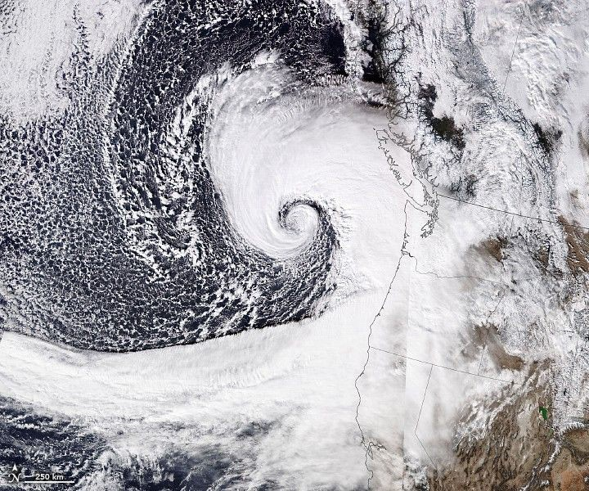
The Transient Artifact and Continuous Learning System (TACLS) leverages data from continuously operating satellite networks coupled with machine learning models to help meteorologists at the National Weather Service forecast flash floods more efficiently. This new software is the result of a collaboration between NASA's Jet Propulsion Laboratory, the University of California, San Diego (UCSD), and the National Oceanic and Atmospheric Administration (NOAA) National Weather Service (NWS). Show downloads TACLS test prediction run TACLS test prediction run (Original) MP4 Close To view this video please enable JavaScript, and consider upgrading to a web browser that supports HTML5 video A visual analysis from a TACLS test prediction run using data from flash floods the week of Christmas, 2025. The image shows flash flood warning (FFW) probabilities generated by TACLS (in shades of red) and overlaid on areas that received flash flood warnings from the National Weather Service (in blue). Credit: UCSD Scripps Institution of Oceanography Created with support from NASA's Earth Science Technology Office (ESTO), TACLS leverages machine learning to automatically locate evidence (unusual increases in atmospheric moisture) of impending flash flooding that meteorologists may otherwise miss as they analyze large amounts of data. TACLS flags that evidence, indicates where flash flooding could likely occur, and displays that information via a user-friendly visualization for human analysts to interpret. Those analysts can then decide whether to issue a flash flood warning or weather advisory. This novel framework for tracking extreme weather events and predicting imminent flash floods operates in near real-time, producing forecasts in as little as fifteen minutes. "That's really what we wanted to do, to give meteorologists a tool to help decision making for flash flood warnings," said Yehuda Bock, Distinguished Researcher at the UCSD Scripps Institution of Oceanography and principal investigator for TACLS. In simulations testing, TACLS used data from diverse severe weather events-including atmospheric rivers, monsoonal convection, and tropical cyclone remnants-between 2017 and 2023 and successfully captured 93% of the issued flash-flood warnings. Meteorologists from the National Weather Service are currently working to incorporate TACLS into their existing systems for forecasting flash floods in Southern California. A cyclone makes landfall across the California coast on November 19, 2024. TACLS will help give communities more time to prepare for impending severe weather. Credit: NASA This learning system has two main components. First, an analytic back-end software suite uses machine learning algorithms to process satellite data and determine areas at risk for flooding. Second, user-friendly visualization software highlights those areas for further analysis by humans. The ACLS back-end software analyzes data from satellites in the Global Navigation Satellite System (GNSS), a constellation of satellite networks that drive navigation services around the world. Water vapor in the troposphere delays signals from these satellites as they travel to Earth. This signal delay can be analyzed to calculate the amount of water vapor in the atmosphere over a particular location on Earth. The TACLS analytic back-end software suite features a machine learning model trained using more than 30 years of past GNSS data. This model is an anomaly detector that tracks unusual increases in atmospheric moisture. The model then carefully examines that atmospheric moisture data and determines whether it's either an artifact (a false feature or distortion in the data) or a transient (a time-sensitive physical event, like heavy precipitation) that requires interpretation by human analysts. If TACLS determines the data represents a transient, such as an extreme weather event that warrants a flash flood warning, it will forward that data to the TACLS visualization software (MGViz) for further evaluation by humans. The analysts use their judgement and experience to interpret these events and determine whether the flagged data indicates a flash flood is likely, and, if necessary, issue a flash flood warning. Several past innovations developed at JPL are leveraged by TACLS to process GNSS data and present the results. The analytic back-end software suite incorporates elements from JPL's Domain-agnostic Outlier Ranking Algorithms program and the Time-series Forecasting, Evaluation, and Deployment program. The TACLS visualizer is based on the Multi-Mission Geographic Information System, originally developed at JPL for NASA's Mars missions. The TACLS software binds all these components within a novel system that enhances existing methods to reduce the amount of time it takes for a human analyst to determine whether to issue a flash flood warning. Both the TACLS software and the data used to train it will be open-source, allowing scientists to either tailor this model in response to their unique research needs or create their own model from scratch. For additional details, see the entry for this project on NASA TechPort. Project Lead: Dr. Yehuda Bock, University of California, San Diego. Sponsoring Organization(s): NASA's Earth Science Technology Office Advanced Information Systems Technology Program; JPL; NOAA; National Weather Service.

9. NASA X-ray spacecraft catches jet erupting from 1st supermassive black hole imaged by humanity
Read more
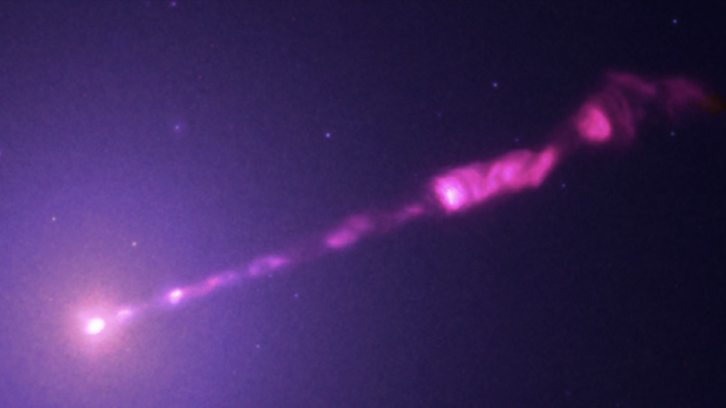
Click for next article Astronomers using NASA's Chandra X-ray spacecraft have obtained the most detailed image yet of the jet erupting from the supermassive black hole at the heart of the galaxy Messier 87 (M87). If this black hole sounds familiar, that is because it made history in 2019 when it was revealed as the first black hole to be imaged by humanity . M87* is located around 55 million light-years from Earth and is ravenously feeding on infalling gas and dust. As it does so, matter is channeled to the poles of this black hole, which has a mass 6.5 billion times that of the sun . This matter is blasted out at speeds approaching the speed of light as powerful jets that stretch out for thousands of light-years. Jets of M87* have been imaged before in other wavelengths of light , such as optical light and infrared, but this is our most detailed look at these jets in X-rays. And the X-rays revealed a complex flow of material through the jets that's more dynamic than previously seen. "We could already see changes in the jet, but never with this level of detail in X-rays," Camille Poitras, a Ph.D. student in the Faculty of Science and Engineering at Laval University and lead of the study, said in a statement . "Structures that previously appeared blended together can now be distinguished, allowing us to better follow the jet's evolution over more than a decade of observations." Some structures in the jets appeared to be moving at speeds five times faster than the speed of light. Of course, that isn't possible; according to Albert Einstein's theory of special relativity , nothing with mass can move at the speed of light or faster. This so-called superluminal motion isn't a universe-breaking discovery, but rather an optical illusion created when matter moves at near-light speed directly toward Earth. The Event Horizon Telescope captured this image of the supermassive black hole in the center of the galaxy M87 and its shadow. (Image credit: EHT Collaboration) The Chandra observations of the jet of M87* are a major step forward in understanding the physics of these outflows and how the particles that comprise them are accelerated to such high speeds and great energies. Additionally, because these jets are how supermassive black holes pour energy back into their surroundings, the observations could also help build a better picture of how these cosmic titans influence the evolution of their home galaxies. "These results demonstrate how uniquely powerful Chandra remains for tracking the evolution of extreme phenomena over long timescales," team member Gerrit Schellenberger, an astrophysicist at the Center for Astrophysics | Harvard & Smithsonian (CfA), said in the statement. "They help us better understand how energy released near a supermassive black hole is carried through its jet and deposited into the surrounding galaxy."

10. Watch European rocket launch record-breaking mission for Amazon on June 17
Read more
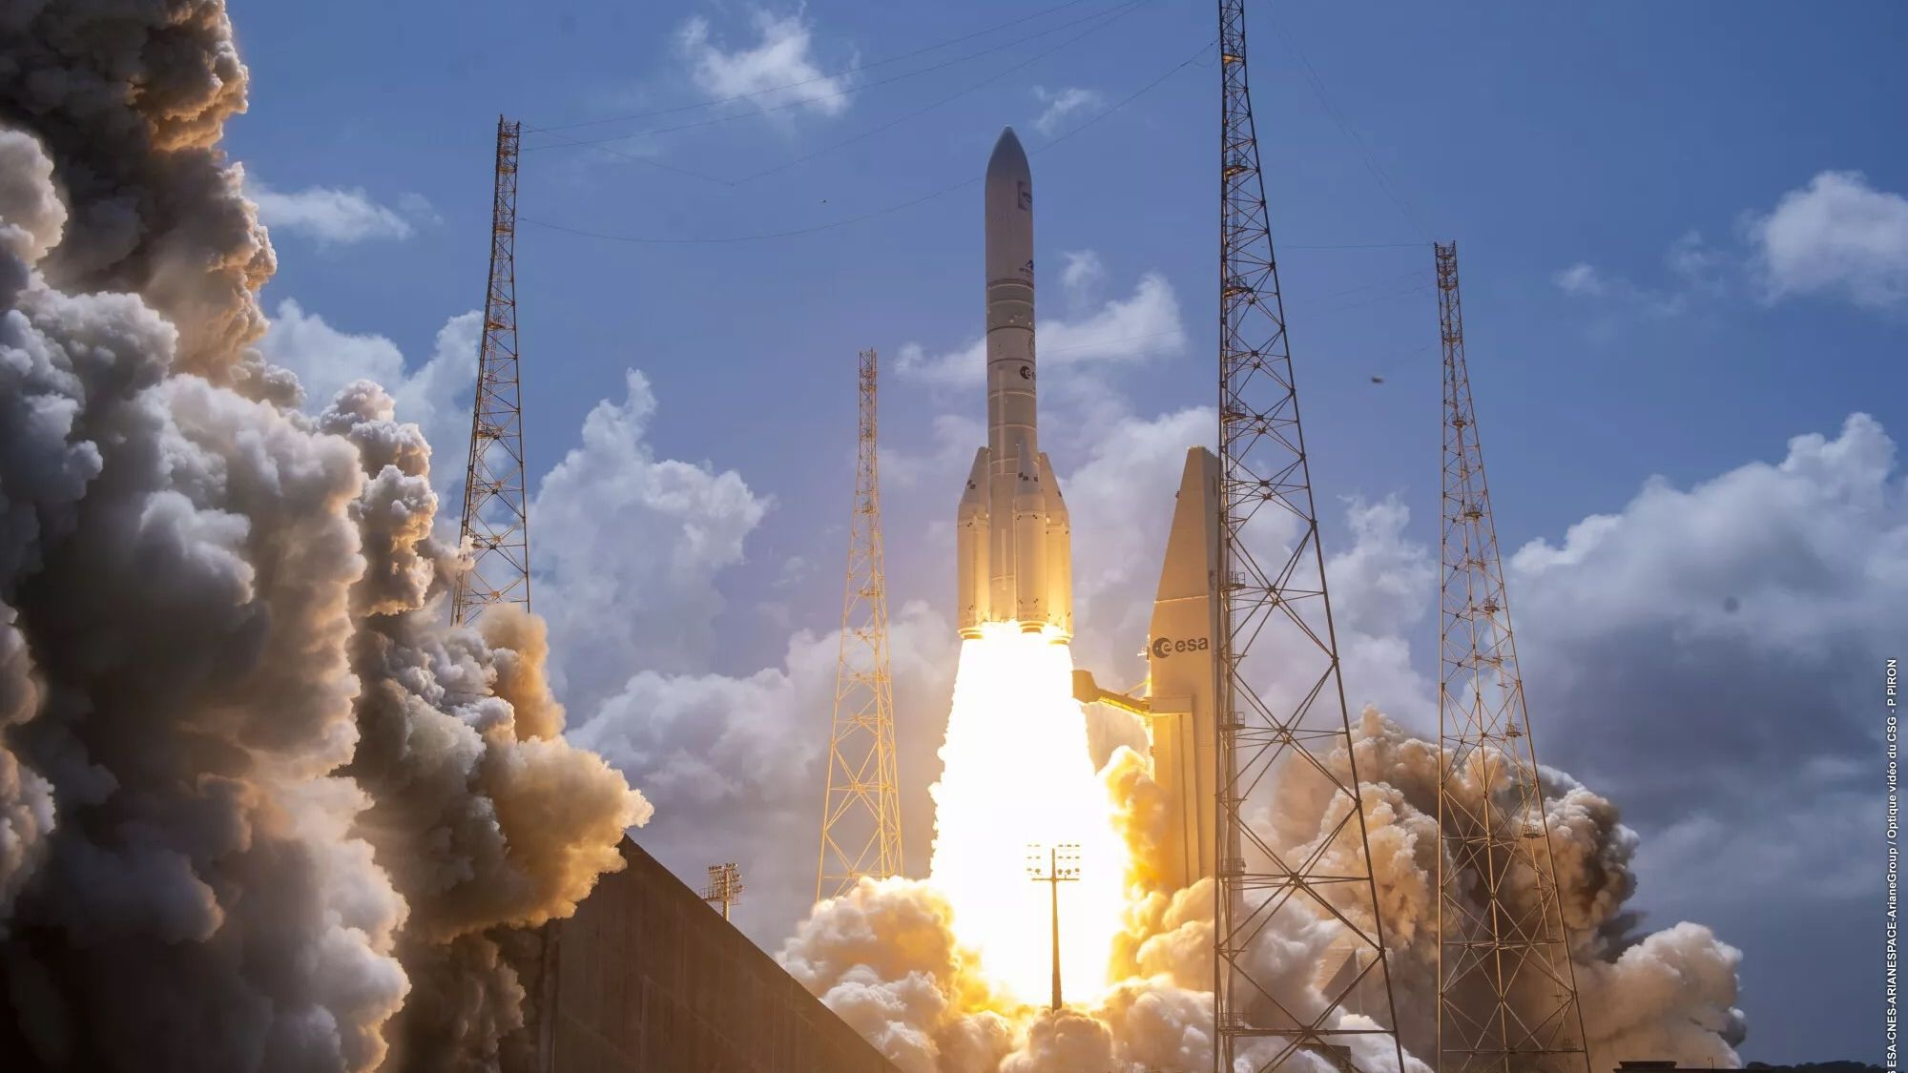
Click for next article A European rocket will launch a record-breaking load to orbit on Wednesday morning (June 17), and you can watch the action live. An Ariane 6 launcher is scheduled to lift off from Europe's Spaceport in Kourou, French Guiana on Wednesday, during a 29-minute window that opens at 7:53 a.m. EDT (1153 GMT; 8:53 a.m. local Kourou time). The rocket is topped with 36 Amazon Leo broadband satellites , which together weigh more than any payload ever lofted by an Ariane vehicle. You can watch it live via Arianespace , the French company that operates the Ariane 6, beginning at 7 a.m. EDT (1100 GMT). Space.com will carry the feed as well, if Arianespace makes it available. Amazon Leo, previously known as Project Kuiper, is the broadband megaconstellation that Amazon is assembling in low Earth orbit (LEO). It will eventually consist of more than 3,200 satellites , which will be lofted over the course of more than 80 launches by a variety of different rockets. That's a lot of satellites, but Amazon Leo's scope is dwarfed by that of SpaceX's Starlink , a competitor network that's already up and running in LEO. Starlink currently consists of more than 10,500 spacecraft, and that number is growing all the time. Wednesday's mission will be the 14th Amazon Leo launch overall (counting the flight of two prototype spacecraft in October 2023), and the third performed by an Ariane 6. But this one will break new ground; the first two Ariane 6 Amazon Leo flights carried 32 satellites apiece, while Wednesday's will send up 36 of them. The mission will therefore be "the biggest stack configuration and heaviest payload ever launched by an Ariane launcher," Arianespace representatives wrote in the flight's press kit, which you can find here . The press kit doesn't say exactly how heavy that payload is. But we know from other documentation that 29 Amazon Leo satellites tip the scales at 37,000 pounds (16,800 kilograms), yielding a per-spacecraft weight of about 1,275 pounds (578 kg). So 36 of them weigh roughly 45,900 pounds (20,820 kg). The Ariane 6 is getting some extra oomph on this flight from four strap-on, solid-propellant P160C boosters. The rocket has flown with four solid rocket boosters before, but Wednesday's launch will mark the debut of this particular, more powerful SRB variant. "The P160C upgrade will increase Ariane 6 payload capacity to low Earth orbit (LEO) by more than two tons, supporting the deployment and early orbit operations of large satellite constellations," Arianespace representatives wrote in the press kit. "It also delivers substantial performance improvements for geostationary, scientific, and exploration missions, expanding the range of missions that Ariane 6 can serve." If all goes according to plan on Wednesday, the Ariane 6 will deploy the Amazon Leo satellites about 289 miles (465 kilometers) above Earth. All 36 should be flying freely by one hour and 51 minutes after liftoff, according to the press kit.

11. Don't miss the moon lead a dazzling mini 'planet parade' on June 17
Read more
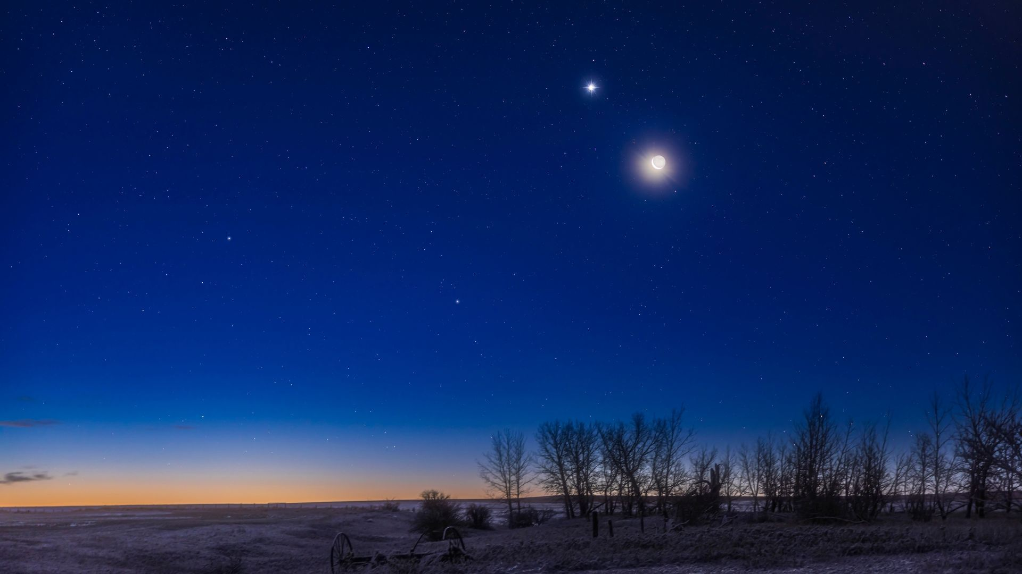
Click for next article The moon shines with Venus in the skies above southern Alberta, Canada. Look west sky after sunset on June 17 to witness a slender crescent moon gleaming alongside the stars of the Beehive Cluster at the head of a dazzling planetary parade. Mercury 's steady light will shine low on the western horizon in the glow of the setting sun, as while Jupiter glistens close to its upper left, with Venus and the moon lining up beyond to create a spectacular planetary display. You may notice the soft glow of earthshine infusing the night side of the moon on June 17, as light bounces off our planet to illuminate the lunar crescent while it glides silently through the 1,000-strong stellar population of the Beehive cluster. A pair of 10x50 binoculars will reveal dozens of the brilliant, young stars surrounding the three-day-old moon, while a 4-inch telescope will provide the magnification needed to highlight the cloud bands of Jupiter and its four large Galilean moons . Mercury will be the first of the parade members to slip from view, less than two hours after sunset, while the moon will remain visible for another hour after that for stargazers in the U.S., before it dips below the western horizon. The following night sees the waxing moon leave Venus and the Beehive Cluster behind, as it sweeps towards the blue-white light of Regulus - a multi-star system that glistens at the heart of the constellation Leo. Mercury, meanwhile, will sink closer to the horizon with each passing night in the weeks that follow, as Venus rises away from Jupiter to chart a course through the constellation Cancer , before passing just 1 degree from Regulus on July 9. Interested in snapping your own photos of the night sky? Then be sure to read our roundups of the best cameras and lenses for astrophotography , along with our beginner's guide to imaging the post sunset realm . Editor's Note: Want to share your planetary photos with Space.com's readers? Then please send your image(s) and comments, along with your name and location to spacephotos@space.com.

