 |  | 

🌌 अंतरिक्ष समाचार | Space News
मंगलवार, १४/०७/२०२६ | Tuesday, 14/07/2026

1. ISRO clears three critical crew module safety tests for Gaganyaan - MSN
Read more
ISRO clears three critical crew module safety tests for Gaganyaan MSN

2. Isro accomplishes 3 key qualification tests for crew module systems for Gaganyaan mission - The Times of India
Read more

Isro accomplishes 3 key qualification tests for crew module systems for Gaganyaan mission The Times of India

3. Kerala's one district is linked to ISRO, NASA and SpaceX astronauts - India Today
Read more
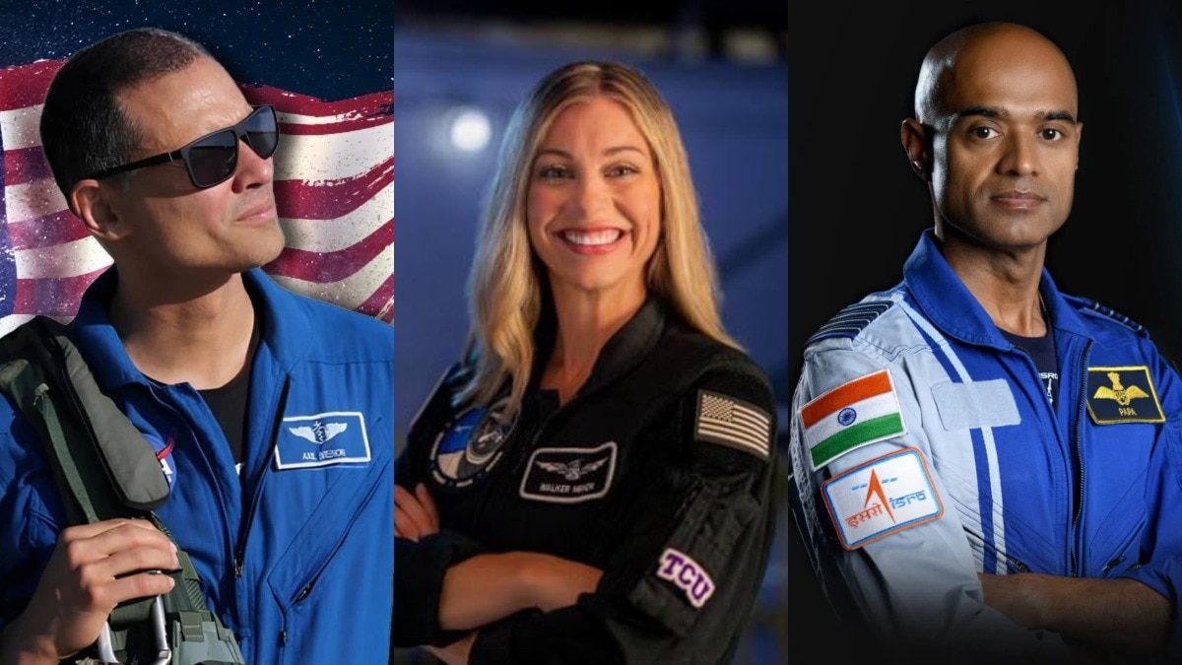
India's God-Owned Land, as it is called, Kerala has a connection with ISRO, NASA, and SpaceX. Three astronauts, Dr Anil Menon, Anna Menon, and Air Commodore Prasanth Balakrishnan Nair, share something in common: an enduring connection with a district known as the Granary of Kerala. We are talking about Kerala's Palakkad district, where the literacy rate is 93%, way above the national average of 81% as per the latest data of the government. The connection of three astronauts with one Indian district is one of the rarest phenomena, and this has happened for the first time. In two days, Indian-origin scientist Dr Anil Menon is all set to fly to the International Space Station aboard Russia's Soyuz MS-29 spacecraft, where he will spend time in a microgravity environment. His wife, Anna Menon, an American engineer who previously worked with SpaceX and flew on the memorable Polaris Dawn mission, is now associated with Palakkad district. Prasanth Balakrishnan Nair, one of India's astronauts selected for the Gaganyaan mission, was also part of the preparations for the Axiom-4 mission. The Kerala district's contribution to spaceflight cannot be overlooked. It is a feat that the locals are celebrating with great pride. It should also be remembered that ISRO was born in the fishing village of Thumba in Kerala. The fact that astronauts Menon and Nair have trained together makes this connection even more special and emotional. (Image: Prasanth B Nair/Instagram) Menon's mission is scheduled for this month, while Nair is preparing for India's next major milestone. Gaganyaan is an ambitious Indian space programme that is expected to take flight in the coming years. Dr Anil Menon was born to an Indian father and a Ukrainian mother in Minneapolis in 1976 and was raised there. His connection with Kerala is enough to inspire many aspiring astronauts. He also spent considerable time in India as a Rotary Ambassadorial Scholar, where he supported polio vaccination efforts. The many facets of Menon's career include being a medical doctor, mechanical engineer, aerospace medicine specialist, flight surgeon, military officer, pilot, and researcher. NASA's official website describes him as an emergency medicine physician, a colonel in the US Air Force, and a NASA flight surgeon whose invaluable support has helped many astronauts during their spaceflight missions. Menon, along with Russian cosmonauts Pyotr Dubrov and Anna Kikina, will board Soyuz MS-29 for the International Space Station. The eight-month mission is expected to play a significant role in scientific research and technological advancement. Anna Menon came into the spotlight after flying on SpaceX's Polaris Dawn mission in September 2024. Before joining NASA's Astronaut Group in 2025, she worked as a lead space operations engineer and mission director at SpaceX. During the Polaris Dawn mission, led by entrepreneur Jared Isaacman, Menon served as the mission's medical officer. The mission marked a milestone in private spaceflight by carrying out the world's first commercial spacewalk. Menon and fellow astronaut Sarah Gillis also became among the women who travelled farther from Earth than any women before them. Menon and Prasanth Balakrishnan Nair's association reflects the growing collaboration among astronauts across agencies, with personnel from NASA, ISRO, Roscosmos and private space companies often training together. For Kerala's Palakkad district, the achievements of three space professionals stand out. Anna Menon was part of a landmark private space mission, Anil Menon is preparing for his mission to the International Space Station, and Prasanth Balakrishnan Nair is among the astronauts selected for India's Gaganyaan programme. - Ends

4. ISRO successfully tests 3 key Gaganyaan crew module systems - connectedtoindia.com
Read more
The Indian Space Research Organisation (ISRO) on Sunday, July 12, said it had successfully carried out three major tests of the Gaganyaan crew module systems. Crew Module systems of Gaganyaan mission. Photo courtesy: ISRO The first test pertained to ensuring an upright position for the crew module after splashdown in the sea, considered one of the most important crew safety requirements. To do this, a stored cold-gas-based uprighting system was developed and tested. "A system-level qualification test setup consisting of all the elements of CMUS (crew module uprighting system) was realised and successfully conducted inflation tests for the primary inflation module wherein stored gas in the high-pressure gas bottle was made to inflate the floatation by operating the control valves," the ISRO said. The second test involved examining the separation of the umbilical mechanism that serves as a link between the crew module, where astronauts live, and the service module, which provides power and propulsion. The mechanism consists of two parts, each located at the crew module side, called CSU-1, and the service module side, called CSU-2. During the crew module's Earth re-entry stage, the service module first separates from the crew module after the CSU-1 disconnects. Subsequently, just before re-entry, the CSU-2 is also separated. "Separation test of CSU-2 from simulated crew module was carried out. The test demonstrated the clean separation of CSU-2 as well as structural stability of the crew module panel and their interfaces," the space agency said. The third test validated the structural integrity of the crew module during the apex cover separation event. The apex cover protects the parachutes and associated subsystems during the mission. It is separated before parachutes are deployed to decelerate the crew module.

5. NASA Study Points to Smoother Air Taxi Rides
Read more

Matt Kamlet, an employee at NASA's Armstrong Flight Research Center in Edwards, California, sits atop the virtual reality passenger ride quality simulator during a study of air taxi motion Monday, Dec. 15, 2025. NASA recently completed a multi-year study to understand how large, sudden air taxi motion affects ride comfort. NASA/Christopher LC Clark No one wants to get into an uncomfortable aircraft. NASA research could help the emerging industry of air taxis -small, vertical-takeoff-and-landing aircraft meant for short trips - understand the relationship between comfort and willingness to fly. That's where NASA comes in, with data that can help identify how to plan air taxi rides that can keep travelers feeling good. NASA was able to gather that data by putting its own employees through some rough virtual flights. At the agency's Armstrong Flight Research Center in Edwards, California, volunteers have been strapping into a virtual reality motion simulator to experience the sudden shifts and tilts that tomorrow's air taxis could encounter, showing researchers those moments feel from a passenger's point of view. Their reactions are giving NASA new insight into how aircraft motion influences comfort and confidence in flight - for instance, that certain kinds of large, sudden motions can be especially bothersome. Using that data, the team developed new models linking those sudden motions to passengers' willingness to fly. The models can help guide future aircraft design and flight operations, letting producers know what maneuvers will be too jarring for future air taxi riders. Large, sudden movements can also come from gusting winds or landings. The NASA data allows researchers to estimate when passengers may begin to feel uncomfortable as motion increases, giving them the ability to shape aircraft designs and operations to minimize the impact of those situations. "Through this study and others, we are starting to identify passenger comfort thresholds for aggressive flight motion," said Curtis Hanson, NASA Armstrong lead researcher for this effort. "We can begin to make predictions about how air taxis should fly so that most passengers will find the experience enjoyable and want to ride again, which will benefit the public and the industry." In the simulator, each participant experienced four levels of their aircraft pitching up and down, tilting from side-to-side, rotating, or accelerating quickly into a climb or a dive during flights from downtown San Francisco to Alcatraz Island in California. Even moderate changes in these motions reduced comfort for some participants, while others remained comfortable at higher levels. Participants rated each flight on a five-point scale and identified which motions felt uncomfortable. Participants were asked whether they would take a real air taxi flight with motion they find uncomfortable. Their answers suggested that today's travelers may be less tolerant of rough motion than airline passengers 50 years ago, based on comparisons with earlier NASA ride-quality research. This latest feedback builds on a multiyear NASA study to better understand air taxi passenger comfort. The overall research effort found clear relationships between specific aircraft motions and how comfortable people feel during flight. This work is currently led under the Subsonic Vehicle Technologies and Tools project in NASA's Research and Technology Mission Directorate and contributes to the agency's advanced air mobility research.

6. NASA Astronaut Anil Menon
Read more

NASA/Robert Markowitz NASA astronaut Anil Menon poses in a spacesuit for a portrait at NASA's Johnson Space Center in Houston, Texas on Jan. 8, 2026. Menon will launch aboard the Roscosmos Soyuz MS-29 spacecraft to the International Space Station on Tuesday, July 14, accompanied by cosmonauts Pyotr Dubrov and Anna Kikina, where they will join the Expedition 74 crew advancing scientific research. During his stay on the station, Menon will conduct scientific research and technology demonstrations aimed at advancing human space exploration and benefiting life on Earth. Learn more about the launch, including where and when to watch. Image credit: NASA/Robert Markowitz

7. SpaceX Starship Flight 13 launch updates: SpaceX sets target date for next Starship rocket launch
Read more
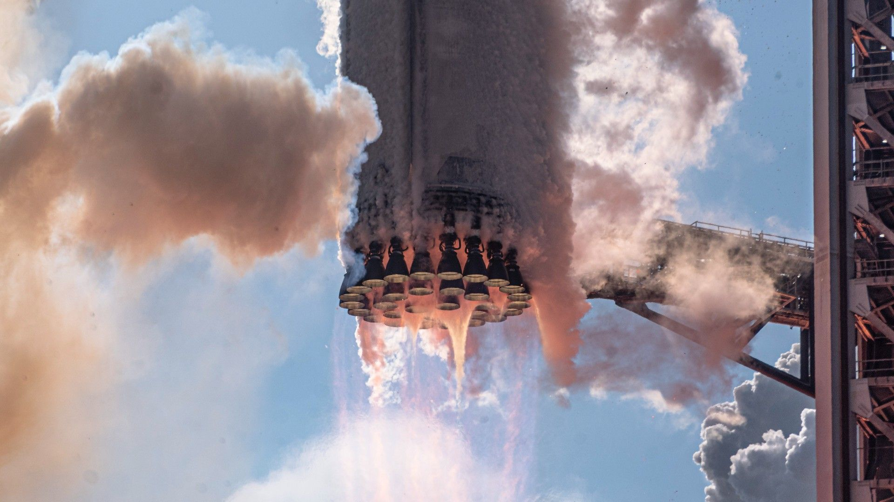
Get notified of updates SpaceX targeting July 16 for Starship Flight 13 The next Starship launch has arrived! SpaceX is targeting no earlier than July 16 for the next launch of its massive Starship rocket, the company announced on in a post on X . Flight 13 will be the second launch of the vehicle's Version 3 configuration and will be similar in profile to Flight 12. It will be the second launch for Starship "Version 3" (V3), a bigger, more powerful upgrade from previous Starship designs, and will come a little less than two months after V3's debut . A 90-minute launch window will begin on Thursday at 6:45 p.m. EDT (2245 GMT). A livestream of the mission will begin about 30 minutes prior to liftoff and stream on the company's mission page , profile on X and here on Space.com. Full story: SpaceX targets July 16 for Starship Flight 13, reveals what went wrong on previous launch

8. Russia's launching a NASA astronaut and 2 cosmonauts to the International Space Station on July 14: Watch it live
Read more
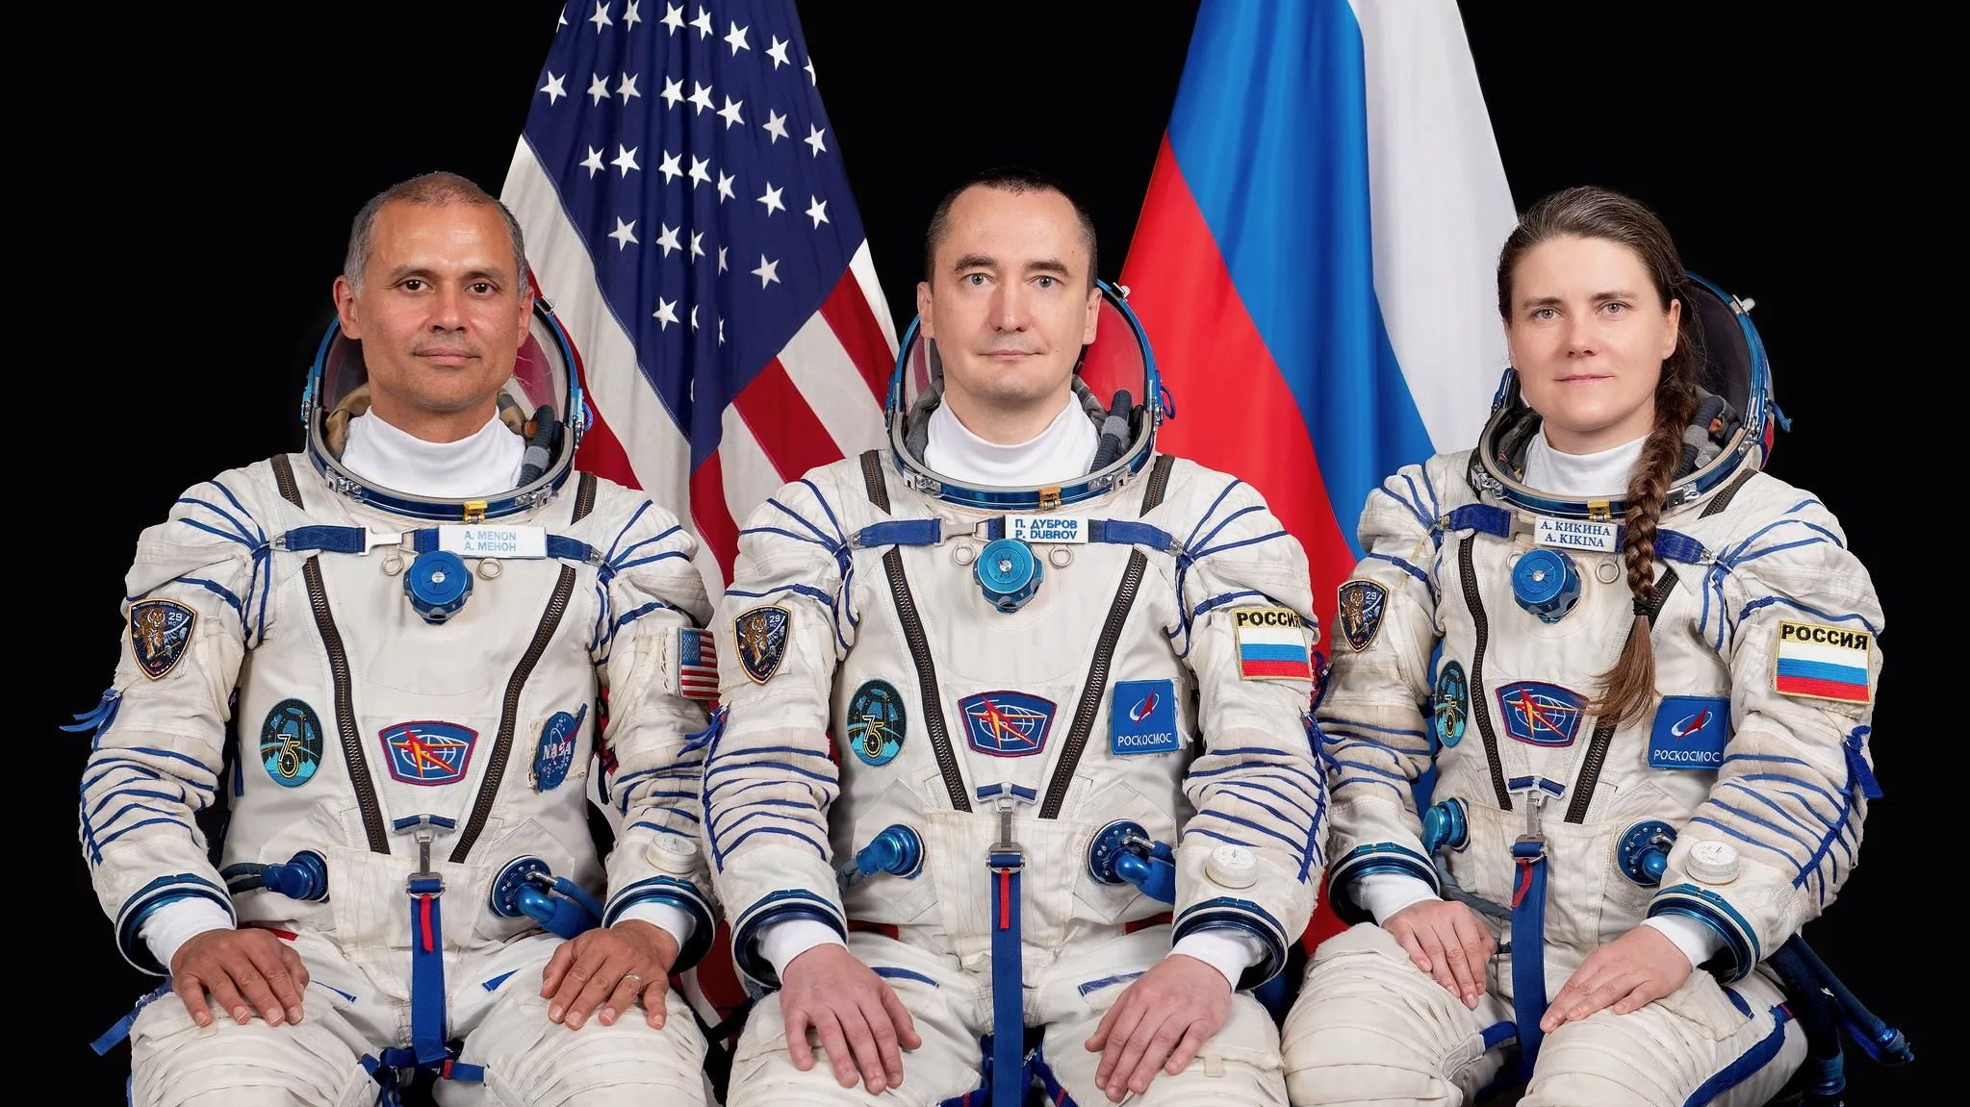
Click for next article NASA Astronaut Anil Menon Soyuz MS-29 Launch - YouTube Watch On Three people will launch toward the International Space Station on Tuesday (July 14), and you can watch the action live. NASA's Anil Menon and cosmonauts Pyotr Dubrov and Anna Kikina are scheduled to lift off atop a Russian Soyuz rocket from Baikonur Cosmodrome in Kazakhstan on Tuesday at 10:47 a.m. EDT (1347 GMT; 7:47 p.m. local time in Baikonur). You can watch it live here at Space.com, courtesy of NASA, or directly via the space agency's YouTube channel . Coverage will begin at 9:45 a.m. EDT (1245 GMT). NASA astronaut Anil Menon (left) and Roscosmos cosmonauts Pyotr Dubrov and Anna Kikina, Soyuz MS-29 prime crew members, pose for a portrait at the Gagarin Cosmonaut Training Center in Russia. (Image credit: GCTC) The trio, flying in Russia's Soyuz MS-29 spacecraft, will catch up to the International Space Station (ISS) after just two orbits, docking with the outpost at about 1:56 p.m. EDT (1746 GMT). You can watch rendezvous and arrival here at Space.com as well, beginning at 1:10 p.m. EDT (1710 GMT). There will be a bit of a break after docking, then coverage will resume at 3:30 p.m. EDT (1930 GMT) ahead of the opening of the hatches between the Soyuz and the ISS, which is expected around 3:55 p.m. EDT (1955 GMT). The MS-29 trio will join the seven astronauts already living aboard the ISS - NASA's Jessica Meir, Jack Hathaway, and Chris Williams, the European Space Agency's Sophie Adenot, and Sergey Kud-Sverchkov, Sergei Mikaev, and Andrey Fedyaev of the Russian space agency Roscosmos . This will be the first spaceflight for Menon, who was selected as a NASA astronaut candidate in December 2021, in the agency's Group 23. He's married to Anna Menon, who was picked in the next astronaut candidate class, Group 24, in September 2025. Anna Menon has already been to space, though not with NASA. In September 2024, while an employee of SpaceX , she flew on the company's Polaris Dawn mission to Earth orbit. That five-day flight, which was funded and commanded by current NASA Administrator Jared Isaacman, featured the first-ever commercial spacewalk and reached a maximum altitude of 870 miles (1,400.7 kilometers) - higher than any previous crewed Earth-orbiting mission had gotten . Anil Menon is a former SpaceX-er as well; he was the company's first-ever flight surgeon. MS-29's flight will be the second-ever space mission for both Dubrov and Kikina. Dubrov lived aboard the ISS from April 2021 to March 2022, and Kikina spend five months on the outpost, from October 2022 to March 2023. Kikina, the only female member of Russia's active astronaut corps, flew to and from the ISS back then on SpaceX's Crew-5 mission . That was a big deal: She was the first Russian ever to fly on a private U.S. spacecraft, and the first cosmonaut to fly on any American space vehicle since December 2002, when cosmonauts Valery Korzun and Sergey Treshchov came back to Earth from the ISS aboard the space shuttle Endeavour . The MS-29 trio will spend about eight months living and working on the orbiting lab. Menon will help conduct a wide variety of scientific experiments during that stretch. "He will continue research to refine in-space production of semiconductor crystals to enable the large-scale manufacturing of components needed for high-performance computers, artificial intelligence, and improved medical devices," NASA officials wrote in a July 9 media advisory . "Menon also will perform ultrasound using augmented reality and artificial intelligence methods that could eliminate the need for medical support from Earth on future space missions," they added.

9. NASA begins stacking rocket ahead of 2027 Artemis III astronaut launch (photos)
Read more
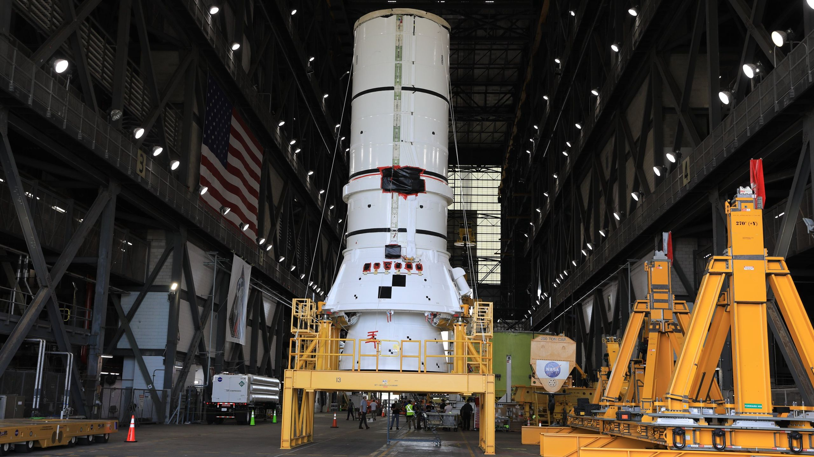
Click for next article The assembly of NASA's next Artemis rocket is well underway, with the recent arrival of one of the launch vehicle's solid fuel booster sections to the agency's integration facility at Kennedy Space Center in Florida. The bottom segment of the left-hand solid rocket booster (SRB) that will help launch Artemis III was transported to KSC's Vehicle Assembly Building (VAB) this week, according to a NASA social media post . It's one of two SRBs that will be affixed to either side of NASA's Space Launch System (SLS) rocket, which together provide a combined 7.2 million pounds of force - more than 75% of the rocket's power at liftoff. "Soon, assembly of the rocket will begin as we prepare to send crew aboard Orion to test the rendezvous and docking capabilities needed for future lunar landings," the NASA post said. It took about one year for NASA to stack the Artemis II SLS once each of the rocket's components were delivered to the VAB. The same timeline gives Artemis III a small amount of wiggle room, as it progresses toward a targeted launch in mid-to-late 2027 - and stacking of the entire rocket may not begin immediately. The Artemis III SLS core stage arrived in the VAB in May . Unlike the core stage's arrival for Artemis II, Artemis III's was delivered without the engine section. Once that's attached, it may be some time before other components are stacked onto the main vehicle. NASA Administrator Jared Isaacman has said that the agency aims to complete a wet dress rehearsal on the rocket before the end of the year. In the meantime, other SLS components and SRB segments will continue arriving at the VAB. Each SRB stands about 177 feet (54 meters) tall. They're packed with polybutadiene acrylonitrile (PBAN), ammonium perchlorate, and aluminum powder, which bring their combined weight to 3.2 million pounds (1.45 million kg). Unlike liquid-fueled rocket engines, once the SRBs' solid propellants ignite, they cannot be turned off. Without them, the four RS-25 engines on SLS's core stage would not be powerful enough to lift the rocket off the launch pad. Image 1 of 3 (Image credit: NASA) (Image credit: NASA) (Image credit: NASA) Artemis III will be the second crewed mission of the Artemis program - NASA's next-generation push to return astronauts to the moon . And, while Artemis III itself won't actually fly to the moon, it will help progress the hardware and spacecraft technologies the space agency needs to ensure success on future missions to the lunar surface. Like Artemis II, which flew four astronauts on a 10-day mission around the moon in April, the Artemis III astronauts will launch on SLS aboard the Orion spacecraft - but they won't fly beyond low Earth orbit this time. Instead, the four-person crew will spend about two weeks testing out rendezvous and docking procedures with prototypes for the two Artemis moon landers, both of which have been privately contracted by NASA. Big move for @NASAArtemis III!The left-hand aft assembly solid rocket booster segment for NASA's Space Launch System arrived at the Vehicle Assembly Building at Kennedy Space Center. This segment is part of one of two boosters that will provide more than 75% of the rocket's… pic.twitter.com/L7k4Qh3Jn9July 8, 2026 The space agency has partnered with SpaceX and Blue Origin for those vehicles, each of which is expected to launch once the Artemis III crew are on orbit. They'll first meet up with Blue Origin's lander, Blue Moon. After docking, the astronauts will have the opportunity to enter Blue Moon's crew cabin, where they will also have the chance to test parts of the Artemis extravehicular activity (EVA) suit designed for astronauts to wear on the lunar surface. A rendezvous with SpaceX's Starship will follow Orion's stint with Blue Moon. SpaceX has indicated it will fly a boilerplate Starship V3 (Version 3) vehicle equipped with a docking adapter, but it will not have a crew cabin. V3 is SpaceX's newest version of Starship, which has been upgraded for high launch efficiency and capacity, but it will lack a fully developed life support system in time for the Artemis III launch next year.

10. SpaceX targets July 16 for Starship Flight 13, reveals what went wrong on previous launch
Read more
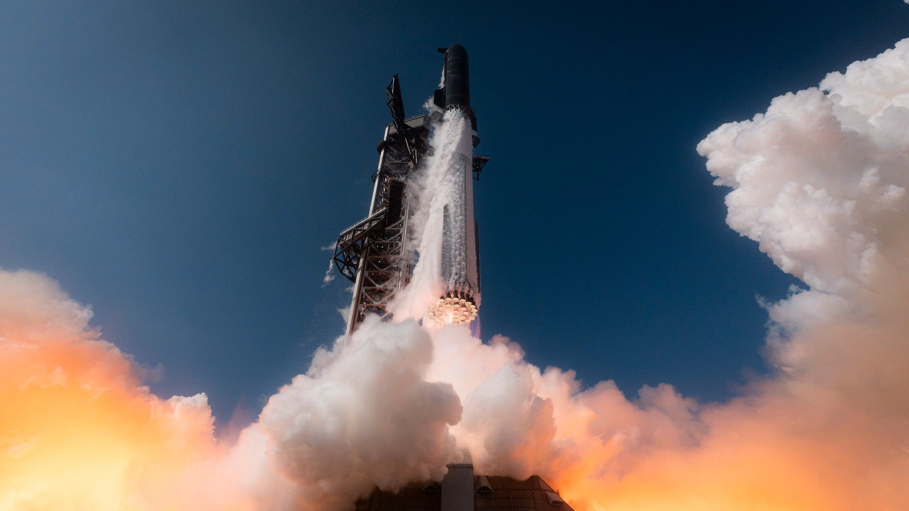
Click for next article SpaceX is targeting this week for the next launch of its massive Starship vehicle. Following engine tests on both Starship stages in the last two weeks - igniting all six Raptor 3s on the "Ship" upper stage and all 33 Raptor 3s on the "Super Heavy" first stage - SpaceX is proceeding with the launch of Starship Flight 13, which is scheduled for no earlier than Thursday (July 16), according to a July 11 SpaceX social media post . It will be the second launch for Starship "Version 3" (V3), a bigger, more powerful upgrade from previous Starship designs, and will come a little less than two months after V3's debut on Flight 12 . To validate those upgrades, SpaceX didn't add any major objectives to Starship Flight 12 that hadn't already been proven on the spacecraft's previous V2 configuration. But the new design didn't quite check all the necessary boxes last time around, so Flight 13 will largely attempt an improved outcome of the same mission. Though still in its development phase, Starship is designed for full reusability. Unlike SpaceX's Falcon 9 first-stage booster, which is equipped with legs capable of touching the rocket down on coastal landing zones or one of the company's droneships at sea, both Ship and Super Heavy are designed for a return directly to the launch site, where chopstick-like arms on the "Mechazilla" tower catch the stages out of mid-air. SpaceX has yet to attempt such a recovery with Ship but has succeeded in doing so with Super Heavy three times so far. Two of those caught boosters were then reflown on subsequent launches. When flying the new V3 hardware during Flight 12, though, SpaceX opted for Super Heavy to perform a soft splashdown in the Gulf of Mexico, rather than risk launch pad infrastructure on an unproven vehicle, but Super Heavy didn't make it to the planned touchdown zone. According to a new SpaceX analysis , a sequence change in Ship's engines, which ignite before the two rocket halves physically detach in a maneuver known as "hot staging," led to a 90-degree error in Super Heavy's orientation after separation. Super Heavy's boostback burn was also cut short when five of its 33 engines failed to relight. SpaceX says it has introduced a modified startup sequence for Ship and hardware updates to Super Heavy to address the orientation anomaly and ignition issues, respectively, "along with updates to engine alarms and aborts to match the conditions seen in the multi-engine flight environment." Ship ran into a bit of trouble during Flight 12 but also managed to pull off some firsts. One of the spacecraft's three vacuum-optimized Raptors was lost 40 seconds after stage separation, but it still reached its designated suborbital trajectory, demonstrating its "engine out" capabilities, according to the SpaceX update. The loss did, however, prevent Ship's in-space engine relight attempt. SpaceX traced the failure to "interconnected causes" and has introduced a number of fixes for the upcoming Flight 13, "with additional reliability improvements planned in upcoming versions of the Raptor engine." Flight 12 also featured the first deployment of two of SpaceX's Starlink internet satellites equipped with cameras for inspecting Ship's heatshield tiles and exterior conditions while in space . They were deployed with several Starlink V3 mass simulators, a payload that's getting an upgrade of its own for Flight 13. SpaceX conducts a static fire test with Ship 40, the upper-stage spacecraft slated to fly Starship's 13th test flight. (Image credit: SpaceX) Stowed inside Ship's payload bay for Flight 13 are the first functional Starlink V3 satellites that Starship will deliver to space. SpaceX plans to eventually launch perhaps 100,000 of the upgraded version of its internet satellite constellation spacecraft, which it says will increase the capacity and speed of its wireless network services. SpaceX is including 20 Starlink V3 satellites aboard Flight 13, which will be released for functionality testing while in space. Six of those will be outfitted with cameras for the same type of heatshield inspection performed during Flight 12. Ultimately, due to Starship's suborbital trajectory on this launch, all of these satellites are expected to burn up in Earth's atmosphere about 20 minutes after they are deployed. For Flight 13, Super Heavy's main objectives will be the successful launch and separation from the Ship upper stage, a complete boostback burn and a soft splashdown in the Gulf of Mexico. In addition to the deployment of Ship's 20 Starlink V3 payloads, SpaceX is also planning the in-space relight of one of the spacecraft's Raptor engines, followed by the successful descent and soft splashdown of the stage in the Indian Ocean. $39.99 at Amazon Starship Die Cast Rocket Model Was $47.99 Now $39.99 on Amazon. Even if you can't see SpaceX's Starship in person, you can score a model of your own. Standing at 13.77 inches (35 cm), this is a 1:375 ratio of SpaceX's Starship as a desktop model. The materials here are alloy steel and it weighs just 225g. The Federal Aviation Administration (FAA) announced the closure of its investigation into SpaceX's Flight 12 mishaps this morning (July 13), approving the compnay's corrective actions and clearing the way for Flight 13. SpaceX is targeting the launch of Flight 13 during a 90-minute window beginning on Thursday at 6:45 p.m. EDT (2245 GMT). A livestream of the mission will begin about 30 minutes prior to liftoff and stream on the company's mission page , profile on X and here on Space.com. If everything goes smoothly, it's very likely that SpaceX will attempt the first Starship V3 recovery back at its Starbase, Texas, launch site for either Super Heavy or both stages on the following mission, Flight 14, but there are a number of other technical achievements Starship has left on its checklist before the vehicle can become fully operational. Those include launching into a stable orbit, demonstrating successful rendezvous and docking with other spacecraft, and conquering the technological hurdle of transferring and maintaining cryogenic fuels for long-term use in zero-g.

11. Space junk debris cloud discovered in high-traffic orbit 'is a potential minefield' for the costliest satellites
Read more

Click for next article Tiny pieces of space junk only 2 inches (5 centimeters) in size are cluttering a valuable orbital region where some of the costliest satellites reside, a new study has found. Researchers from the University of Warwick in the U.K. found that the geostationary orbit - a region of space at the altitude of 22,000 miles (36,000 kilometers) - is full of dangerous, previously unseen bits of space junk that could destroy satellites . The geostationary orbit is quite unique. Satellites at this altitude circle Earth in sync with the planet's rotation, appearing permanently suspended above a fixed spot on the equator. A single satellite in the geostationary ring has a constant view of a vast portion of the globe. This feature has been taken advantage of for decades for things like TV broadcasting, internet delivery, Earth observation and weather monitoring. But, as it appears, those satellites might not be safe up there at all. "The debris in geosynchronous orbit is a potential minefield," Stuart Eves, the study's co-author and space consultant at SJE Space, said in a statement . "No one in their right mind would enter a terrestrial minefield without a mine detector. Similarly, no one in their right mind should launch a satellite to GEO without an adequate debris survey." The researchers uncovered the previously invisible debris by re-examining a dataset from an earlier space debris survey conducted by astronomers using the 8.3-foot (2.54-meter) Isaac Newton Telescope in La Palma, Canary Islands. They ran the data through new image processing algorithms to distinguish smaller and much fainter fragments than was previously possible in the distant geostationary orbit. "The blind stacking technique is a very powerful method for improving the sensitivity limit of astronomical datasets," Ben Cooke, a research fellow at the University of Warwick's Center for Space Domain Awareness and co-author of the paper, said in the statement. "It involves testing many potential paths in an image sequence along which hidden targets might be moving and stacking the images to help bring those targets above the noise floor. This project shows a successful, real-world application of the method." The researchers found 25 previously missed debris tracks in the images, 80% of which were caused by previously unknown objects. The finding is concerning as space debris at such high altitudes behaves differently from that circling closer to Earth. The residual atmosphere at 22,000 miles is almost non-existent, meaning there is no air drag to force the orbital clutter spiral into the atmosphere and burn up. A still image from the short documentary film "Space Debris: Is it a Crisis?" on the state of space debris. (Image credit: ESA) "Debris in the neighborhood of the geostationary belt is particularly concerning," James Blake, also a Warwick research fellow and the study's co-author, said in the statement. "It's very far away, well above the Earth's atmosphere , so small objects tend to be incredibly faint and difficult to detect, and any debris that's generated will stick around indefinitely." While orbits near Earth naturally clear up as the residual air at these altitudes slows the junk fragments down, at the higher altitude, the concentrations of such fragments will forever keep rising, making the region ever more tricky to operate in. Moreover, the satellites that reside in this unique orbital region tend to be very large and expensive, designed for much longer missions than those making up megaconstellations in low Earth orbit. These satellites, frequently fitted with solar panels spanning 100 feet (30 meters) or more, can suffer substantial damage from a collision with the tiniest piece of junk. "Pieces of space junk can be moving very quickly relative to one another, as much as several kilometers every second," Blake said. "The energies involved are really high, and even small debris can cause a lot of damage to very expensive satellites, so small things really matter." The researchers are now looking to analyze additional images obtained by other telescopes around the world to get a fuller understanding of the scale of the debris contamination in the region.

12. Live coverage: SpaceX to launch a flight-proven Falcon booster for 600th time
Read more
Update July 13, 4:12 p.m. EDT (2012 UTC): SpaceX pushed back the T-0 liftoff time. SpaceX will perform the 600th reuse of one of its Falcon rocket boosters when it launches the Starlink 10-45 mission from Cape Canaveral Space Force Station Tuesday morning. The predawn flight will add another 29 broadband internet satellites to SpaceX's low Earth orbit constellation. The company has more than 10,7000 spacecraft in low Earth orbit. Liftoff from Space Launch Complex 40 is scheduled for 5:10 a.m. EDT (0910 UTC). The rocket will fly on a north-easterly trajectory upon leaving the pad. Spaceflight Now will have live coverage beginning about an hour prior to liftoff. <span data-mce-type="bookmark" style="display: inline-block; width: 0px; overflow: hidden; line-height: 0;" class="mce_SELRES_start"></span> The 45th Weather Squadron forecast a 90 percent chance for favorable weather at the opening of the window, which improves to 95 percent as time goes on. Meteorologists are watching out the slight possibility of the rocket flying through thick clouds, which could generate lightning. "Some lingering thick clouds left over by the evening convection may be present at the beginning of the launch window but should gradually dissipate through the window," launch weather officers wrote. "As a result, we have raised the POV slightly at the beginning of tonight's launch window, but overall good weather is expected." SpaceX will launch the Starlink 10-45 mission using the Falcon 9 first stage booster with the tail number B1080. This will be its 28th flight following the launches of two crew flights for Axiom Space, the European Space Agency's Euclid observatory, and Northrop Grumman's NG-21. Nearly 8.5 minutes after liftoff, B1080 will target a landing on the droneship, 'A Shortfall of Gravitas', positioned in the Atlantic Ocean. If successful, this will be the 161st landing on this vessel and the 638th booster landing for the company to date.

