संकलन
SANKALAN
10th August 2026 to 16th August 2026
ई-न्यूज़लेटर | e-Newsletter

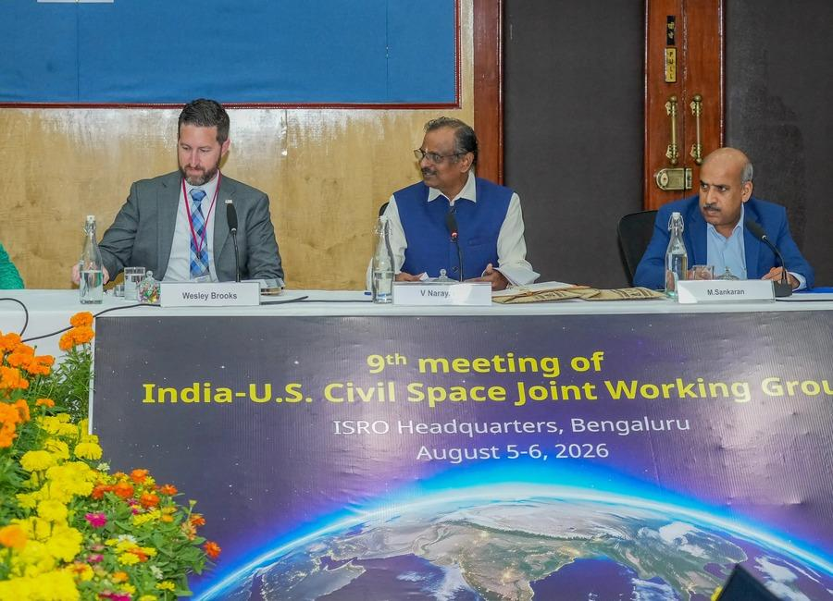 | 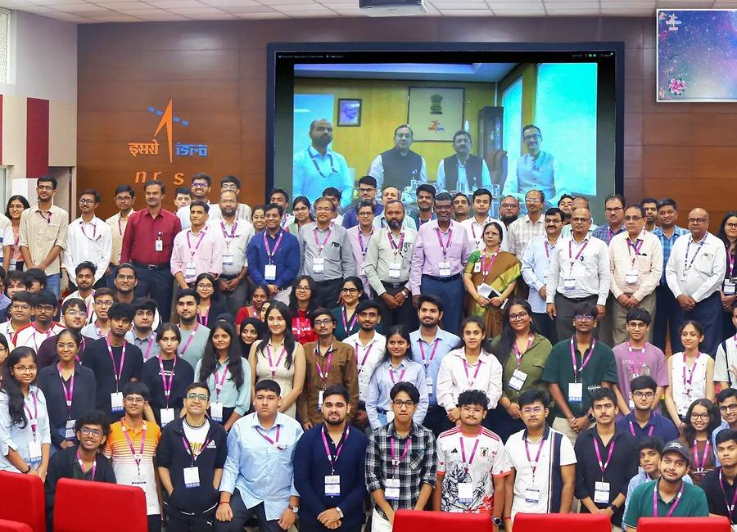 | 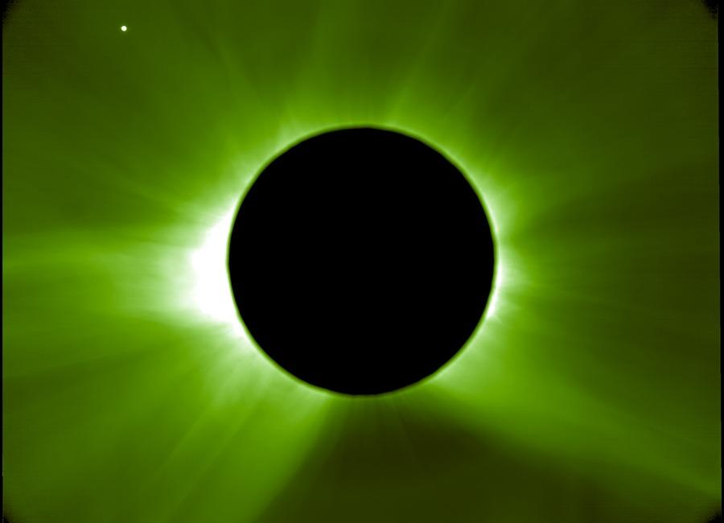
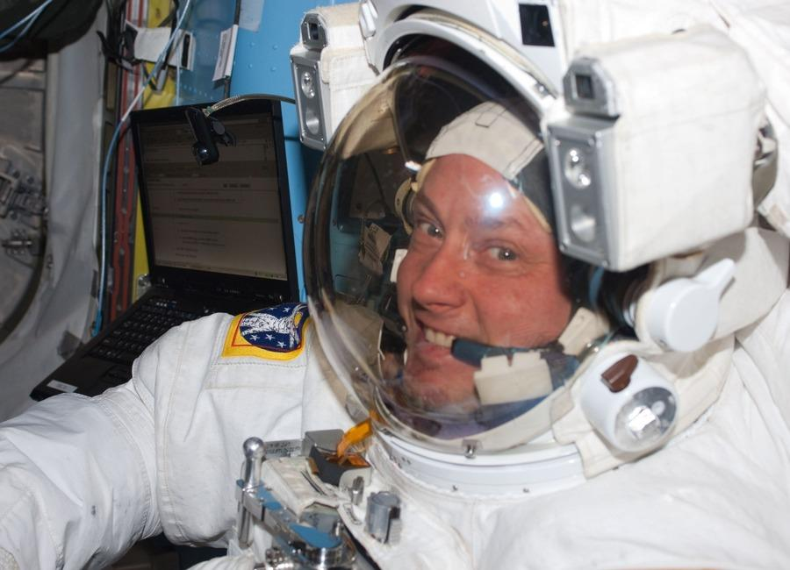 | 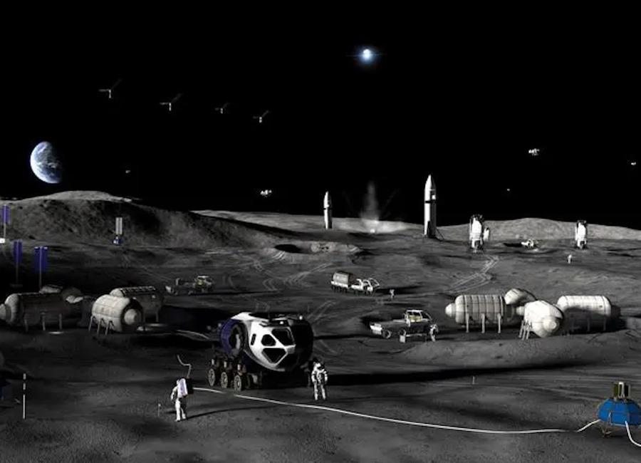 | 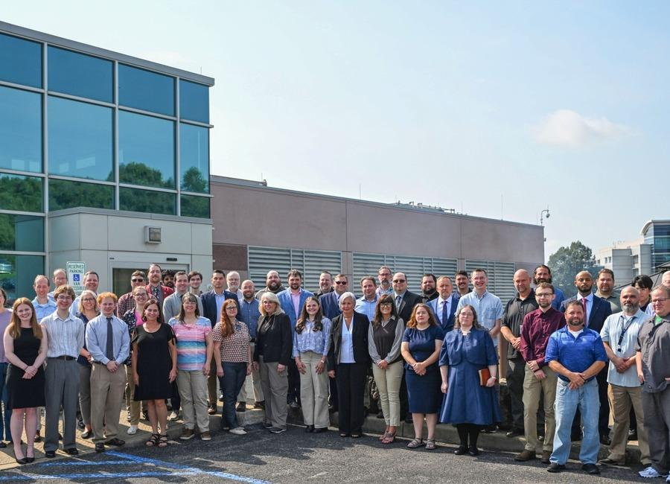
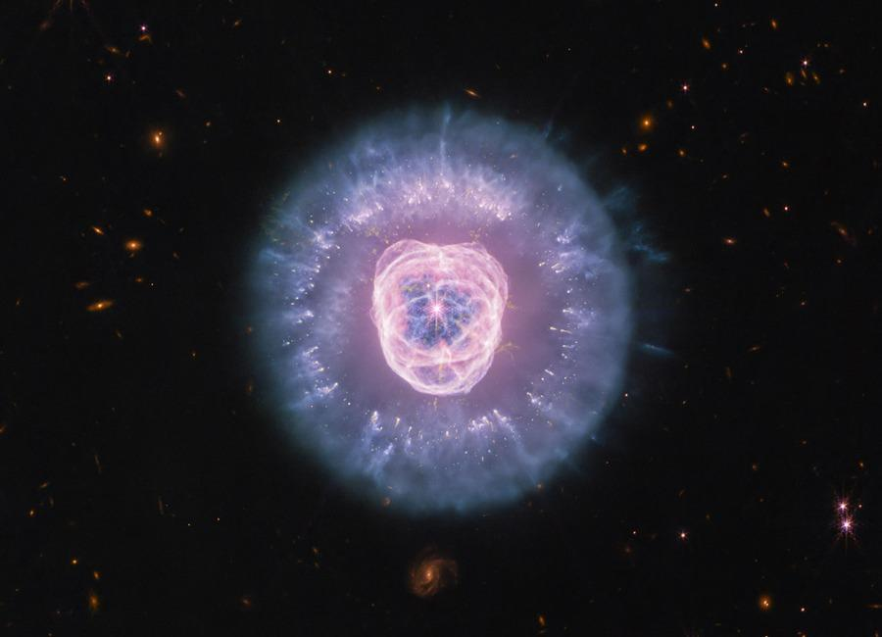 | 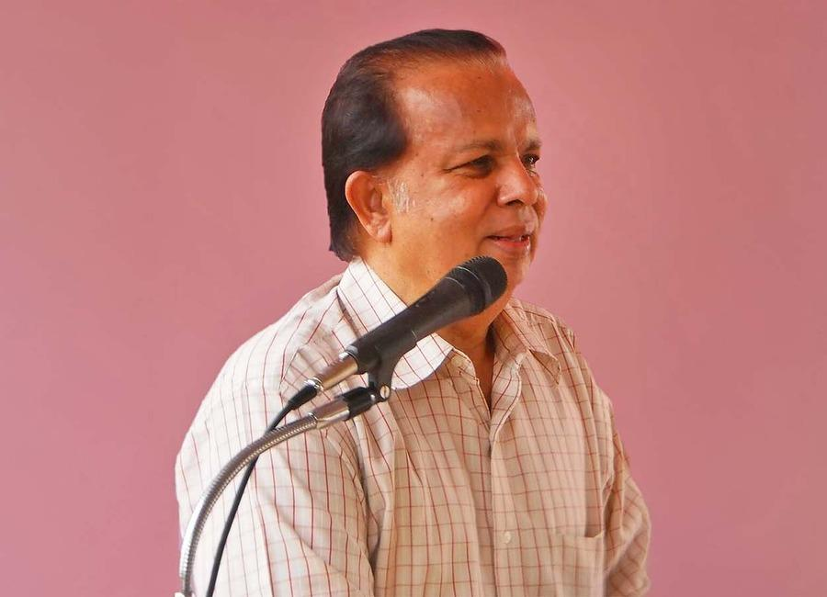 | 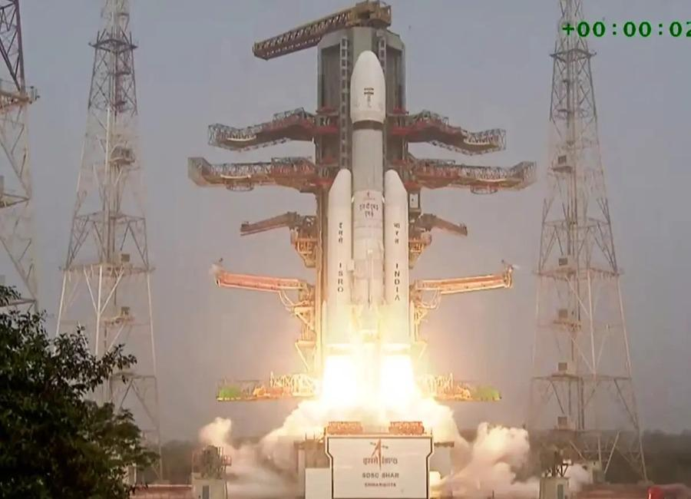

Indian Institute of Remote Sensing (ISRO), Dehradun
Collection of recent developments in the realms of Space Technology

Table of Contents
S. No. | Title
1 | Isro eyes 300 satellites in six years, space station by 2035: Chairman - Business Standard
2 | IN-SPACe moves to hand over Isro's new Rs 986 crore small rocket launch complex to private sector - The Economic Times
3 | Gaganyaan Mission Achieves Critical Milestones Ahead of Uncrewed Launch - nktv.in
4 | On this day in space! Aug. 9, 1976: Soviet Luna 24 sample return probe launches to the moon
5 | Exploring 'very low Earth orbit': The world's 1st air-breathing satellite thruster could soon get a test run
6 | Bharatiya Antariksh Hackathon 2026 - Grand Finale Concludes Successfully - ISRO
7 | ISRO Scientist Recruitment 2026: Apply for 92 Posts - educationtoday.co
8 | Never-before-seen ozone layer detected over Bay of Bengal. Isro tracking it - India Today
9 | Up to ₹2.08 Lakh/Month Salary! Multiple Life Sciences Jobs at ISRO - BioTecNika
10 | How ESA mimics and models the 2026 total solar eclipse
11 | NASA+ Debuts on discovery+, Coming Soon to HBO Max
12 | Lion Nebula Roars to Life With NASA's Webb
13 | Launch Into a New School Year With NASA
14 | 'Launching anywhere, anytime and without compromise': Rocket Lab unveils new 'GHOST' portable spaceport system
15 | Japanese H3 rocket launches 10,800-pound navigation satellite to high Earth orbit (video)
16 | SpaceX scrubs planned Monday launch of its Falcon 9 rocket; targets Tuesday morning
17 | 'Deepen India-US space partnership': NASA invites ISRO to join Moon Base project under Artemis Accords | India News - Hindustan Times
18 | SpaceX could make $500 billion in 2028, Elon Musk says
19 | SpaceX launches 29 Starlink satellites to orbit from Florida (video, photos)
20 | NASA will chase the Aug. 12 total solar eclipse with balloons and a high-altitude jet
21 | SpaceX wants to put 1 million AI satellites in orbit. What would that do to Earth's climate?
22 | Live coverage: SpaceX to launch 24 Starlink satellites on Falcon 9 rocket from Vandenberg SFB
23 | The ESCAPE mission will study the evolution of exoplanet atmospheres
24 | A smarter way to track satellites beyond Earth's orbit
25 | Up to ₹2.08 Lakh/Month Salary! Multiple Life Sciences Jobs at ISRO - BioTecNika
26 | Moon base invite a golden ticket for Isro, startups - The New Indian Express
27 | Cheap, fast, successful: Why NASA wants ISRO on the Moon - WION
28 | NASA invites ISRO to join its Moon Base programme - Manorama Yearbook
29 | India - U.S. Civil Space Joint Working Group meeting at ISRO Headquarters, Bengaluru - ISRO
30 | NASA Data Helps Commercial Space Plan Living Off Our Moon
31 | NASA Upgrades Vertical Motion Simulator for Modern Mission Needs
32 | NASA Astronaut Mike Fincke Leaves NASA, Career Includes 4 Spaceflights
33 | Radiation-shielding vest aced Artemis I lunar test, could protect astronauts on moon and Mars missions
34 | Farthest 'black hole star' ever found could help solve the James Webb Space Telescope's little red dot mystery
35 | On this day in space! Aug. 12, 2005: Mars Reconnaissance Orbiter launched
36 | SpaceX wraps Starlink double header day with the launch of 24 Starlink satellites from California
37 | IN-SPACe overreach threatens ISRO's strategic future: G Madhavan Nair - The Federal
38 | ISRO taking steps to tackle space debris, rising satellite congestion: Dr Jitendra Singh - Greater Kashmir
39 | LS Speaker, Defence Minister, Science and Technology Minister pay tribute to former ISRO Chairman Dr Vikram Sarabhai | Akashvani News - News On AIR
40 | NASA Invites ISRO to Join Moon Base Programme, Significance - Vajiram & Ravi
41 | Kerala University recommends honorary doctorates on former ISRO chief, others - The New Indian Express
42 | Chandigarh University joins ISRO to host National Space Technology Conclave on 17th-18th August; Group Capt Shubhanshu Shukla among 30 Space Scientists to attend - UNITED NEWS OF INDIA
43 | NASA's 737 Reveals New Paint
44 | For West Virginia Engineer, Home Is Where the Heart Is… and NASA, Too
45 | NASA astronaut Mike Fincke retires after 30 years at the space agency
46 | NASA's canceled lunar space station tech will help build the Artemis moon base
47 | On this day in space! Aug. 13, 2014: Game-changing WorldView-3 Earth-observing satellite launches to orbit
48 | New private 'Perceptor' probes will keep an eye on satellites high above Earth
49 | Chinese missiles autonomously spot F-22, F-35 heat signatures with 90 percent accuracy
50 | CM reaches Chamoli to check on disaster victims
51 | Up to ₹2.08 Lakh/Month Salary! Multiple Life Sciences Jobs at ISRO - BioTecNika
52 | India-US space ties deepen as NASA invites ISRO to join moon base program - Space
53 | ISRO's LVM3 upper stage re-enters atmosphere in 9 months. Here's why it matters - theprint.in
54 | Indian astronauts no longer need to rely on overseas training: ISRO building 'Gaganyatri Nivas' to support ... - Bhaskar English
55 | 'Strap yourself in and feel the Gs': NASA announces 'Max Power' aerospace expo
56 | Water can survive surprisingly close to the Milky Way's supermassive black hole, James Webb Space Telescope finds
57 | ISS photobombs the sun during solar eclipse | Space photo of the day for Aug. 14, 2026
58 | India-US space ties deepen as NASA invites ISRO to join moon base program
59 | SpaceX rocket's moon crash highlights 'a tangible operational risk' of lunar settlement
60 | NASA Administrator 'extremely confident' in Artemis 3 mission in 2027
61 | Constipation is common in astronauts-blood tests provide new answers
62 | ISRO Scientist Recruitment 2026: Apply for 92 Posts - Education Today
63 | Skyroot Aerospace: How Two ISRO Engineers Built India's Space-Tech Unicorn | Independence Day 2026 - news18.com
64 | 80 years of Independence: From Mangalyaan to Chandrayaan-3, India's rise as a space power - WION
65 | Live coverage: SpaceX to launch satellite replenishment mission for Globalstar from Cape Canaveral

 |  | 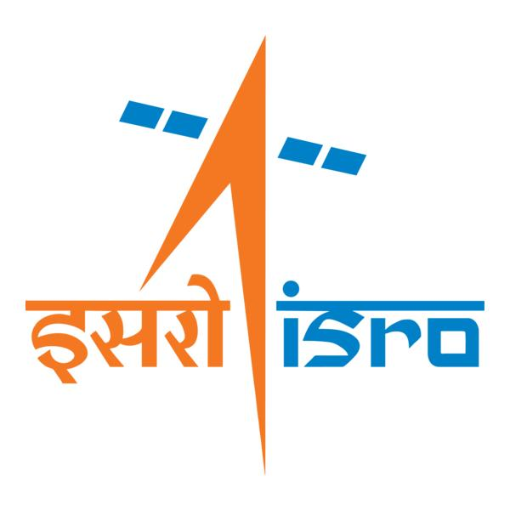

🌌 अंतरिक्ष समाचार | Space News
सोमवार, १०/०८/२०२६ | Monday, 10/08/2026

1. Isro eyes 300 satellites in six years, space station by 2035: Chairman - Business Standard
Read more
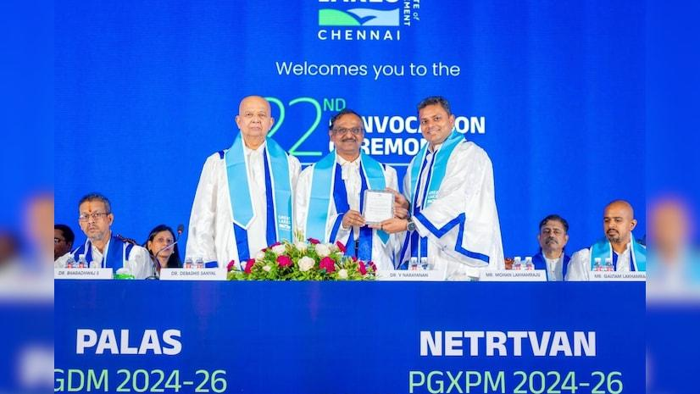
Isro eyes 300 satellites in six years, space station by 2035: Chairman Business Standard

2. IN-SPACe moves to hand over Isro's new Rs 986 crore small rocket launch complex to private sector - The Economic Times
Read more

ETtech IN-SPACe seeks private partners to manage ISRO's new launch complex. This facility will support small rocket launches and enhance launch efficiency. Private entities will handle end-to-end operations and maintenance of the complex Space regulator and promoter IN-SPACe has begun the process of handing over the operations and management of Isro 's Rs 986-crore Small Satellite Launch Complex (SLC) at Kulasekarapattinam in Tamil Nadu to the private sector, Times of India reported, in another step towards opening up the country's launch infrastructure to industry. IN-SPACe has invited expressions of interest from eligible Indian entities to operate and manage the new launch complex, which is being developed primarily to support small rocket launches . Also Read: IN-SPACe re-entry rules expose insurance crunch The SLC is part of the new spaceport being built by Isro at Kulasekarapattinam, India's second launch site. Spread across about 2,233 acres, the spaceport is expected to handle launches of Isro's Small Satellite Launch Vehicle (SSLV) as well as equivalent launch vehicles developed by private companies. Under the government's initial plans, launches from the facility were to be carried out by private launch vehicle operators after the spaceport was commissioned. IN-SPACe's latest move takes the private-sector role further by seeking an industry partner to take charge of the complex's operations and maintenance. Live Events The selected entity will be responsible for the end-to-end management of the facility, including launch campaign operations, maintenance of infrastructure and systems, safety and security, mission readiness, asset management, logistics and coordination with Isro, IN-SPACe and launch customers. Isro will initially provide technical and operational support to help the private operator build the required capabilities. "To facilitate a smooth transition and capability development, Isro will provide the selected party with the necessary technical guidance, operational support, training, and handholding assistance for a defined period up to the completion of three launch services provided by the selected party to launch vehicle operators, or one year, whichever is earlier," as per IN-SPACe. Also Read: India plans safe space for local satellite communications players Located on the Tamil Nadu coast, about 55 km from Thoothukudi, the Kulasekarapattinam site has been designed with small satellite launches in mind and offers a more efficient trajectory for missions to polar and Sun-synchronous orbits. Unlike launches from Sriharikota, rockets launched from Kulasekarapattinam can head directly south over the Indian Ocean without having to undertake a dog-leg manoeuvre to avoid flying over Sri Lanka. The more direct trajectory can improve payload capacity and reduce fuel requirements, making launches more efficient, particularly for the SSLV. The facility is also designed to support a higher launch cadence, with shorter turnaround times between missions. This complements the SSLV, which was developed by Isro for on-demand launches of small satellites and requires fewer personnel and shorter integration times than larger launch vehicles. Together, the SSLV and the new launch complex are expected to support the growing demand in India and overseas for dedicated small satellite launches. The move is part of a broader effort by IN-SPACe to transfer Isro-developed technologies and infrastructure to private industry. In recent months, the agency has invited industry participation for the transfer of technologies related to Isro's PSLV and LVM-3 launch vehicles. Technology for the SSLV has already been procured by defence public sector undertaking Hindustan Aeronautics Ltd (HAL) for Rs 511 crore. IN-SPACe is also opening up access to Isro's ground infrastructure. In June, it invited private companies to establish and operate ground stations within the National Remote Sensing Centre (NRSC) campus at Shadnagar on the outskirts of Hyderabad. The agency plans to select up to three Indian companies for the facility. The regulator is also preparing new schemes aimed at supporting private space companies and other non-government entities, including subsidies ranging from 30% to 100% for areas such as launch services, technology transfer, satellite data and access to Isro facilities. The push reflects the government's broader strategy of shifting more space activities and infrastructure towards private operators, while retaining Isro's role in providing technical expertise and supporting the development of India's commercial space ecosystem. (With inputs from Times of India) Add as a Reliable and Trusted News Source Add Now! (You can now subscribe to our Economic Times WhatsApp channel ) ISRO Small Satellite Launch Complex Kulasekarapattinam small rocket launches Private sector involvement in space Commercial space ecosystem in India Prime Exclusives Investment Ideas Stock Report Plus ePaper Wealth Edition - The umbrella seller as economic forecaster - Bigger or Better: Tata Power - the hard part is done. Will the paying part start? Part 3 - ET Prime special series: Bigger or Better ? FY13 to FY26. Not years, but evidence: Tata Power - Part 1 - Did dollar bail out yen or vice-versa? - How Future Consumer insolvency professional selection slipped from SBI's control - More troubles brewing, is SpiceJet flying too close to the sun? - 1 - 2 - 3 View all Stories

3. Gaganyaan Mission Achieves Critical Milestones Ahead of Uncrewed Launch - nktv.in
Read more

India's maiden human spaceflight program, Gaganyaan, has completed major technological validations across its human-rating systems, launch infrastructure, and emergency escape mechanisms. Updating the Rajya Sabha, Union Minister of State for Space Dr. Jitendra Singh confirmed that ISRO is on track for its first uncrewed experimental mission featuring the half-humanoid "Vyommitra" in late 2026, paving the way for full human spaceflight by 2027. Technical Progress & Validation Highlights Launch & Module Propulsion: Ground testing and development are complete for all propulsion stages of the Human Rated Launch Vehicle (HLVM3), alongside propulsion systems for the Crew and Service Modules. Ground testing and development are complete for all propulsion stages of the Human Rated Launch Vehicle (HLVM3), alongside propulsion systems for the Crew and Service Modules. Life Support & Safety: Development and qualification have wrapped up for critical subsystems, including the Environmental Control and Life Support System (ECLSS) Engineering Model, Thermal Protection System, and all five static-tested Crew Escape System (CES) motor types. Development and qualification have wrapped up for critical subsystems, including the Environmental Control and Life Support System (ECLSS) Engineering Model, Thermal Protection System, and all five static-tested Crew Escape System (CES) motor types. Flight Testing: Successful completions include the TV-D1 Test Vehicle Mission for in-flight escape validation, alongside Integrated Air Drop Tests (IADT-01 and 02) for the deceleration system. Preparations for the TV-D2 mission are currently underway. Successful completions include the TV-D1 Test Vehicle Mission for in-flight escape validation, alongside Integrated Air Drop Tests (IADT-01 and 02) for the deceleration system. Preparations for the TV-D2 mission are currently underway. Infrastructure & Tracking: Specialized facilities-including the Orbital Module Preparation Facility, Gaganyaan Control Centre, and modified Second Launch Pad-are fully operational. Communication networks (IDRSS-1 feeder stations) and recovery protocols are established. Mission Roadmap & Long-Term Space Station Vision The Cabinet approved a ₹20,193 crore allocation in September 2024 to support eight missions under the Human Spaceflight Programme. Timeline Target Milestone / Objective Q4 2026 First uncrewed experimental flight carrying humanoid Vyommitra By 2027 Two additional uncrewed flights to fully validate crew-flight configuration Post-2027 Maiden indigenous crewed orbital spaceflight 2035 Operational target for the 5-module Bharatiya Antariksh Station (BAS) (BAS-01 module development approved) Global Partnerships ISRO is leveraging international expertise to strengthen mission operations:

4. On this day in space! Aug. 9, 1976: Soviet Luna 24 sample return probe launches to the moon
Read more
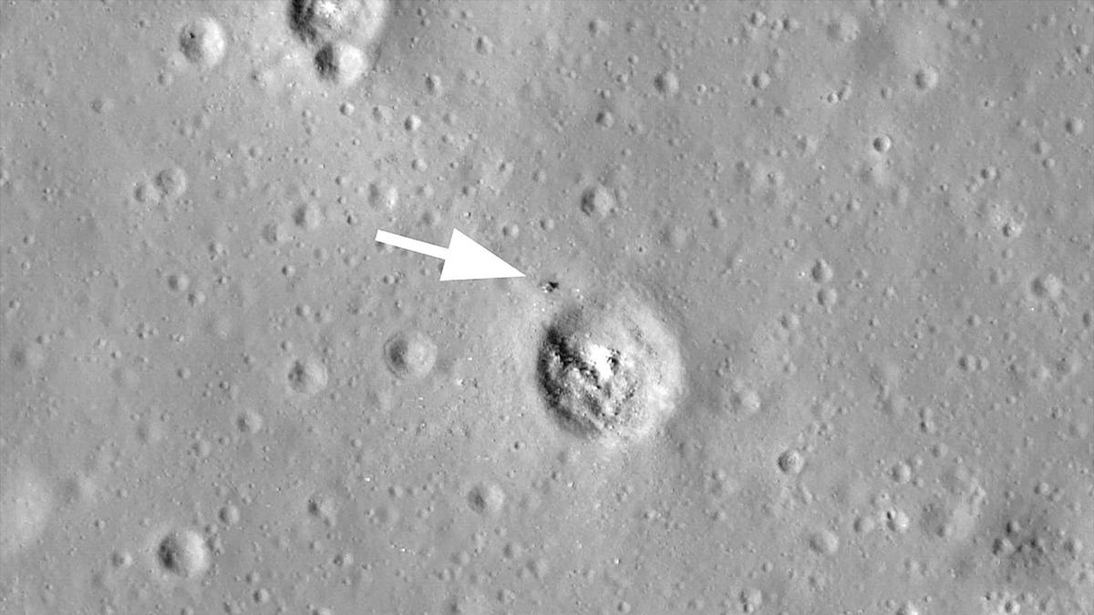
Click for next article On Aug. 9, 1976, the Soviet space program launched its last moon mission. Luna 24 was a robotic sample return mission and the third of its kind. It lifted off on a Proton-K rocket from the Baikonur Cosmodrome in Kazakhstan and safely landed on the lunar surface nine days later. The probe landed in a dark plain of the moon known as Mare Crisium, or the "Sea of Crises" and collected 6 ounces (170.1 grams) of soil samples, which it brought back to Earth on Aug. 22, 1976. Scientists then found that the samples from Luna 24 contained tiny traces of water - about 0.1% by mass. This photo, taken by NASA's Lunar Reconnaissance Orbiter, shows the location of the Soviet Luna 24 moon lander on Mare Crisium near a crater. (Image credit: NASA/GSFC/Arizona State University) Why it mattered The Soviet Union lost the Space Race to land the first humans on the moon, but its Luna program of robotic probes was prolific. The country's Luna 2 was the first spacecraft ever to land on the moon (it slammed into the lunar surface in 1959), with the more advanced Luna 9 making the first-ever soft-landing on the moon in February 1966, beating NASA's Surveyor 1 by about 4 months. By 1976, 12 NASA astronauts had walked on the moon, the last two on Apollo 17 in 1973 and the Space Race was over. But the Soviet moon program was not, with Luna probes and Lunakhod rovers . A Roscosmos illustration of the Luna 24 lunar sample return capsule launching from its lander to return pieces of the moon to Earth in August 1976. (Image credit: Roscosmos) The Luna sample return missions consisted of a lander equipped with a descent stage, ascent stage and Earth return capsule. The probes could collect samples of the moon, place them in the return capsule on the ascent stage, then rocket it from the moon for the trip back to Earth. NASA's Lunar Reconnaissance Orbiter has captured photos of the descent stages of Luna 16, Luna 20 and Luna 24 still on the moon. The Luna 23 spacecraft remained on the moon entirely, as it was damaged during landing and wasn't able to return a sample. NASA's LRO images later revealed Luna 23 likely fell on its side . But Luna 24, the last of the series, worked as planned, landing on Mare Crisium on Aug. 16, 1976, collecting a sample of the lunar regolith and launching back into space less than 24 hours later. While Luna 24 was the last Soviet moon sample return mission, it was not the last for Russia. In August 2023, Russia's Roscosmos space agency launched the Luna 25 mission , its first in 47 years, toward the lunar south pole. Luna 25 was planned to be the first in a new fleet of moon probes, but ultimately crashed into the moon after an orbital maneuver went wrong.

5. Exploring 'very low Earth orbit': The world's 1st air-breathing satellite thruster could soon get a test run
Read more
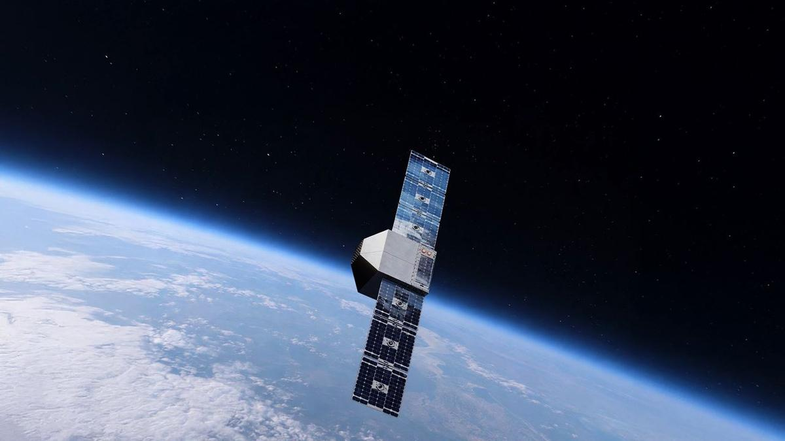
Click for next article Artist's illustration of a satellite operating in very low Earth orbit. Kreios Space is partnering with Kongsberg NanoAvionics to develop such a satellite mission. A new way to move around Earth's outer atmosphere could soon get a field test. The Spanish company Kreios Space plans to launch into orbit the world's first satellite that uses scooped-up air to push it forward, the company announced on Tuesday (Aug. 4). The technology Kreios Space has been developing is called air-breathing electric propulsion (ABEP). It relies on air sourced from Earth's atmosphere, which is then heated up, ionized and expelled to generate thrust. Diagram showing the different types of orbit around Earth. (Image credit: ESA) This method will allow satellites in very low Earth orbit (VLEO) - the region from roughly 60 miles to 250 miles (100 to 400 kilometers) above our planet - to counteract atmospheric drag without the aid of liquid fuel. "Kreios is building the satellites that make sustained operations in very low Earth orbit possible," Kreios Space CEO Adrián Senar said in the Aug. 4 announcement. "By enabling satellites to fly lower, longer and more efficiently, we are enabling higher-resolution Earth observation, much better satellite communications, more responsive and accurate missions and a more sustainable orbital infrastructure," he continued. Kreios Space chose Lithuanian-based Kongsberg NanoAvionics to provide the satellite bus that will carry the ABEP system into orbit for the test run. "Kreios is tackling one of the most demanding operating environments in space, and this mission joins a very short list of European VLEO initiatives," Kongsberg NanoAvionics CEO Atle Wøllo said in the same statement. "Our engineering team has worked closely with Kreios to configure the MP42 satellite bus to the mission's specific requirements and support the integration of Kreios' technology," he added. Kreios Space did not give a target launch date for the mission in Tuesday's statement, saying that the company will launch it "at a time when interest in and development of VLEO technologies has accelerated." But the company's website identifies 2027 as a notional target for its first space mission. A new, very low frontier Satellites in low Earth orbit (LEO) - altitudes of roughly 100 miles to 1,200 miles (160 to 2,000 km) - generally don't need constant propulsion. Usually, a small boost from traditional thrusters here and there is enough to keep a LEO satellite on the right track. To power the thrusters, these satellites usually have some form of fuel built in. VLEO works differently. It's low enough that there's still some atmosphere present, which generates drag on spacecraft. If you want a satellite to move around VLEO, it'll need to employ propulsion most or all of the time to counteract that drag. Any fuel that the satellite brings with it therefore won't last long. So, if satellites are going to operate in VLEO, it would be very helpful to have a method of propulsion that doesn't require traditional fuel - a method like ABEP. Satellites in VLEO have a few advantages over those operating in LEO, like sharper imagery thanks to the closer vantage point. One of the biggest advantages is that VLEO is much less crowded. There are thousands of satellites in LEO - most of them SpaceX's Starlink broadband spacecraft - and the number is growing all the time. But VLEO has plenty of room. If ABEP technology works and companies start outfitting satellites with this new propulsion method, then we might start seeing satellites operate quite close to Earth, zooming through the atmosphere and using the air around it to stay on course.
6. Bharatiya Antariksh Hackathon 2026 - Grand Finale Concludes Successfully - ISRO
Read more
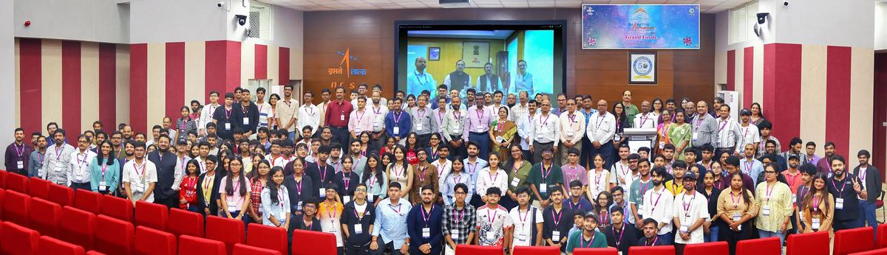
August 10, 2026 The third edition of Bharatiya Antariksh Hackathon (BAH), a national level hackathon, was launched on 10 June 2026, and the Grand Finale was held from 6th - 7th August 2026. This programme is a flagship initiative of ISRO, which aims to inspire and engage young minds across the country and foster creativity, innovation, and problem-solving in the field of space technology. BAH 2026 featured 15 carefully curated problem statements covering critical domains such as Geospatial Technology, Space Science, Image Processing, and Artificial Intelligence/Machine Learning (AI/ML). More than 1,00,000 students pursuing undergraduate, postgraduate, and Ph.D. programmes registered for the hackathon. A total of 15,104 teams, each comprising 3-4 members, submitted innovative solutions to the given problem statements. After evaluation of the ideas submitted, the top 34 teams were selected to compete in the Grand Finale, representing some of the brightest young talent from across the country. The Grand Finale was held at the National Remote Sensing Centre (NRSC), Hyderabad, and comprised an intensive 30-hour event. During the finale, the participating teams developed their solutions and presented to a Jury Panel chaired by Dr. Prakash Chouhan, Director, NRSC. The top three teams were selected based on the creativity, technical excellence, and feasibility of their solutions.

7. ISRO Scientist Recruitment 2026: Apply for 92 Posts - educationtoday.co
Read more
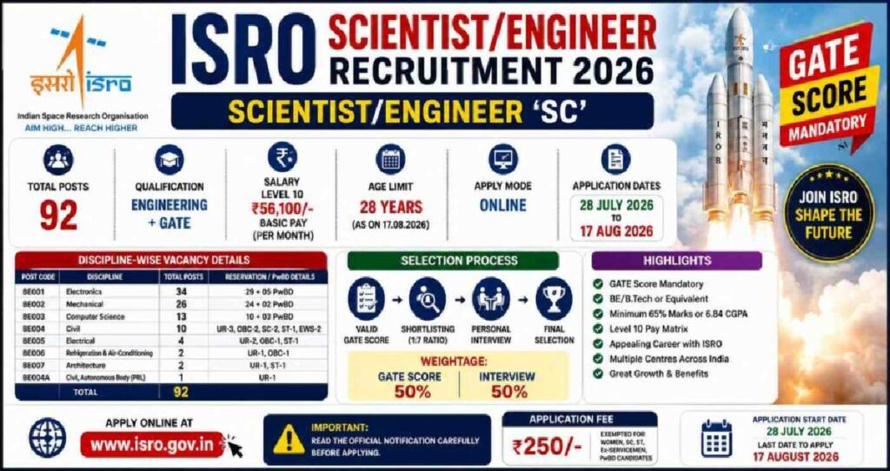
ISRO Scientist Recruitment 2026: Applications Open for 92 Posts, Check Eligibility and Selection Process Leave a Comment / Daily News Table of Contents - 92 Scientist and Engineer Vacancies Announced - Academic Eligibility for Applicants - Age Limit and Application Fee - Selection Based on GATE Score and Interview - How Candidates Can Apply - Why the Recruitment Matters for Engineering Graduates - Engineering Skills Meet Space Technology - A Career Opportunity Within India's Space Programme The Indian Space Research Organisation (ISRO) has opened applications for 92 Scientist/Engineer 'SC' positions across multiple engineering disciplines, offering qualified candidates an opportunity to build a career with India's premier space research organisation. The recruitment is being conducted through the ISRO Centralised Recruitment Board (ICRB), with candidates required to hold a valid GATE score in the relevant discipline. The recruitment comes at a time when opportunities in space science, engineering and advanced technology are expanding alongside India's growing space programme. For engineering graduates with the required academic qualifications and GATE scores, the vacancies provide an opportunity to enter a highly specialised technical environment. Candidates interested in the posts must complete the online application process by 17th August 2026. Applicants are advised to verify their eligibility and submit their forms well before the deadline rather than waiting until the final day. 92 Scientist and Engineer Vacancies Announced The vacancies have been distributed across several engineering disciplines. Electronics has the highest number of positions, followed by Mechanical and Computer Science. The discipline-wise distribution is: - Electronics: 34 vacancies - Mechanical: 26 vacancies - Computer Science: 13 vacancies - Civil: 10 vacancies - Electrical: 4 vacancies - Refrigeration and Air Conditioning: 2 vacancies - Architecture: 2 vacancies - Civil at PRL: 1 vacancy - Total: 92 vacancies The distribution highlights the range of technical expertise required across ISRO's operations. Engineers from conventional disciplines as well as specialised areas can therefore find opportunities within the recruitment process. Academic Eligibility for Applicants Candidates applying for the Scientist/Engineer 'SC' positions must possess a BE, BTech or equivalent degree in the relevant engineering discipline. Applicants are required to have secured at least 65% aggregate marks or a CGPA of 6.84 on a 10-point scale. Another important requirement is the GATE score. Candidates must have a valid score from either GATE 2025 or GATE 2026 in the corresponding paper. This requirement makes the recruitment particularly relevant for engineering graduates who have recently appeared for the national-level examination. The eligibility criteria are designed to ensure that applicants possess both the required academic foundation and a recognised national-level assessment score before moving to the next stage of recruitment. Age Limit and Application Fee Age is another important criterion that applicants must consider before submitting their forms. Candidates must be 28 years of age or below as on 17th August 2026, subject to the applicable provisions and relaxations specified by ISRO. Candidates belonging to the unreserved category are required to pay an application fee of ₹250. Applicants should carefully review the official notification for applicable provisions before completing the payment and final submission. Since recruitment applications involve document verification at later stages, candidates should ensure that the information entered in the application form matches their educational records and other supporting documents. Selection Based on GATE Score and Interview The selection process combines the candidate's performance in GATE with an interview. According to the recruitment notification, the final merit list will be based on the interview and GATE score. This makes the recruitment particularly important for candidates who have already invested significant preparation in the GATE examination. A strong GATE performance can provide the academic foundation for progressing through the recruitment process, while the interview offers ISRO an opportunity to assess candidates beyond their examination performance. The combination of a national-level examination score and a specialised interview also reflects the technical nature of the positions. Successful candidates are expected to contribute to highly specialised engineering and scientific work within the organisation. How Candidates Can Apply Eligible candidates can complete their applications through the official ISRO recruitment portal. The application process involves several stages, and applicants should carefully follow the instructions provided in the notification. The broad application process includes: - Visiting the official ISRO website and accessing the Careers section - Opening the relevant Scientist/Engineer recruitment notification - Registering with an email ID and mobile number - Entering personal and educational details - Uploading the required documents - Paying the applicable application fee - Submitting the completed application form - Downloading and retaining a copy of the submitted form for future reference Candidates should check every detail before final submission, particularly their educational qualifications, GATE information and personal particulars. Why the Recruitment Matters for Engineering Graduates A Scientist/Engineer position at ISRO represents more than a conventional engineering career. The organisation works across areas involving spacecraft, launch vehicles, satellite systems, electronics, communication, propulsion, remote sensing and other advanced technologies. The recruitment therefore provides qualified engineers with an opportunity to work in an environment where engineering knowledge is applied to complex national space missions. The diversity of disciplines in the latest vacancies also demonstrates that India's space programme requires expertise extending well beyond aerospace engineering alone. For engineering students and recent graduates, the recruitment can also underline the importance of building strong fundamentals alongside preparation for examinations such as GATE. Click below to watch the video. Engineering Skills Meet Space Technology Engineering careers are increasingly extending into specialised sectors such as space technology, satellite systems and advanced research. EducationToday views the ISRO recruitment drive as a notable example of how strong engineering fundamentals, combined with national-level examinations such as GATE, can open pathways into highly specialised careers. The opportunity is particularly relevant for graduates who want to apply their technical knowledge to projects with national significance. It also highlights the growing importance of interdisciplinary engineering capabilities as India's space programme expands into increasingly sophisticated areas of research and technology. For aspiring engineers, such recruitment drives can serve as a reminder that career opportunities are not limited to conventional corporate roles. Public-sector research and technology institutions can also offer pathways into specialised technical work. A Career Opportunity Within India's Space Programme The 92 vacancies offer engineering graduates an opportunity to enter a demanding technical environment and contribute to India's space programme. With recruitment spanning Electronics, Mechanical, Computer Science, Civil, Electrical and other disciplines, the drive reflects the broad engineering expertise required to support complex space missions. For eligible candidates, the immediate priority is to focus on the application deadline. With 17th August 2026 approaching, applicants should verify the eligibility requirements, keep the necessary documents ready, and complete the online registration carefully. The selection process also requires candidates to prepare beyond the application stage. Since the final merit list takes into account both GATE performance and the interview, applicants should be prepared to demonstrate not only academic knowledge but also their understanding of engineering concepts and their suitability for specialised work. The latest recruitment drive provides a significant opportunity for qualified engineering graduates seeking a technically challenging career within India's space sector. Candidates who meet the prescribed requirements should make use of the application window and approach the selection process with careful preparation. 1. How many vacancies are available in ISRO Scientist Recruitment 2026? ISRO has announced 92 vacancies for Scientist/Engineer posts under the 2026 recruitment drive. 2. Who is eligible for ISRO Scientist Recruitment 2026? Eligibility depends on the post and discipline. Candidates generally need the prescribed engineering or relevant technical qualification with the required academic performance specified in the official recruitment notification. 3. What is the age limit for ISRO Scientist/Engineer Recruitment 2026? The age limit varies according to the recruitment notification and applicable category-based relaxations. Candidates should check the official notification before applying. 4. How can candidates apply for ISRO Scientist Recruitment 2026? Eligible candidates can submit their applications online through the official ISRO recruitment portal by completing the form, uploading required documents, and paying the applicable fee, if required. 5. What is the selection process for ISRO Scientist Recruitment 2026? The selection process generally involves shortlisting based on the prescribed criteria, followed by the relevant written test and/or interview, depending on the post and recruitment notification. Post Views: 218 UP Board's Derecognition of 465 Non-Functional Schools Signals a Strong Push for Educational Accountability Daily News

8. Never-before-seen ozone layer detected over Bay of Bengal. Isro tracking it - India Today
Read more

Scientists have detected an unusually thick layer of ozone high above the North Bay of Bengal, offering new clues about how ozone-rich air is transported and redistributed through Earth's upper atmosphere. The unusual ozone enhancement was found at an altitude of around 21-23 kilometres, in the lower stratosphere, during a nationwide atmospheric observation campaign. Researchers found that the concentration was significantly higher than normally observed over eastern India, with the unusual layer persisting for more than a day. Read Full Story The ozone layer is a region of Earth's stratosphere, roughly 15-35 km above the surface, containing relatively high concentrations of ozone (O). It acts as Earth's natural shield, absorbing most of the Sun's harmful ultraviolet (UV) radiation, protecting humans, animals, plants and marine ecosystems from radiation damage. The discovery was made as part of the Phase-I NetRAD-ASMA campaign, a coordinated effort involving atmospheric research institutions across India. Scientists used an extensive network of instruments, including atmospheric radars, weather balloons, satellites and advanced atmospheric models, to track the movement of ozone and air masses across the country. A key role was played by the Aryabhatta Research Institute of Observational Sciences (ARIES). The enhanced ozone layer was detected during both day and night. (Photo: Reuters) During the campaign, ARIES' indigenously developed 206.5 MHz Stratosphere-Troposphere (ST) Radar at Nainital collected observations alongside similar radars at Haringhata, Gadanki and Kochi. Weather balloons equipped with instruments were also launched to measure atmospheric conditions and ozone concentrations. Scientists further used observations from the Aura MLS and INSAT-3DR satellites, allowing them to track the unusual ozone structure from space and compare it with ground-based measurements. The observations revealed something particularly intriguing. The enhanced ozone layer was detected during both day and night, suggesting that sunlight-driven chemical reactions were unlikely to be the main reason for its formation. Researchers instead examined atmospheric convection, wind shear, horizontal transport and vertical air movements. Their analysis showed persistent downward air motion in the lower stratosphere above the region. By combining observations from the radars, balloons, satellites and atmospheric models, scientists concluded that the unusual ozone enhancement was primarily caused by the transport of ozone-rich air, followed by downward movement and compression of the air mass. The ozone layer normally reaches its highest concentration around 25-30 kilometres above Earth and plays a crucial role in shielding life from harmful ultraviolet radiation. The findings, published in Earth and Space Science by the American Geophysical Union, provide new quantitative evidence of how atmospheric circulation can redistribute stratospheric ozone over the Indian subtropical region. - Ends

9. Up to ₹2.08 Lakh/Month Salary! Multiple Life Sciences Jobs at ISRO - BioTecNika
Read more

Multiple Vacancies at ISRO-HSFC | Life Sciences Role Are you looking for high-paying Life Sciences Jobs in India's space research sector? The Human Space Flight Centre has announced Multiple Vacancies under ISRO Careers 2026 for Scientist/Engineer-SD positions. Candidates with a PhD in Biotechnology, Molecular Biology, Bioinformatics, Biomedical Sciences and related disciplines can apply online by 30 August 2026. About the Institute The Human Space Flight Centre (HSFC), Bengaluru, was formed as a new centre in ISRO to realise the vision of the Human Space Flight Programme. As the lead centre for human space activities, HSFC undertakes multidisciplinary research and development in human science and technology while maintaining high standards of reliability and human safety. - Get Jobs Faster - Job Overview Multiple Vacancies Post Code Discipline Vacancies 01 Bioinstrumentation OR Biophysics OR Medical Physics 01 UR 02 Developmental Biology OR Biotechnology 01 UR 03 Cellular & Molecular Biology OR Cell Biology 01 UR 04 Computational Biology OR Systems Biology OR Bioinformatics 01 UR 05 Biomedical Engineering OR Biomedical Sciences 01 UR 06 Biomedical Engineering OR Biomedical Sciences 01 UR Key Responsibilities Post Code 01 Design and validate wearable health monitoring sensors and systems and instrumentation of biomedical sensors. Bio-signal data acquisition and processing. Medical Imaging and informatics. Development of portable diagnostic devices and wearable sensors. Post Code 02 Radiation biology and exposure models. Develop regenerative approaches to preserve musculoskeletal integrity during training and in space. Mammalian and stem cell culture; primary cell lines; 3D/organoid culture systems. In vivo and ex vivo animal physiological studies. Working on disease biology models relevant to astronaut health. Host-pathogen interaction studies under stress/microgravity. Post Code 03 Study immune and cellular adaptation across the astronaut health cycle. Bioinformatics analysis of proteomic data for biomarker identification for spaceflight application. Molecular cloning, confocal microscopy, live-cell imaging and gene editing for spaceflight application. Large-scale proteomic dataset analysis, gene expression and statistical workflows. Post Code 04 In silico models to anticipate astronaut adaptation, assess countermeasures and guide rehabilitation. Development of therapeutics and space-grade diagnostics. Multi-omics integration for spaceflight stressors studies. Modelling cellular pathways, host-microbe interactions and metabolic networks under spaceflight conditions. Computational simulation of closed-loop life support systems. Generative models for predictive simulation of astronaut physiology and disease states through Digital Twin Biology, including neural networks and deep learning. Post Code 05 Gait analysis, exercise countermeasures, motion capture and force-plate studies and rehabilitation programme development. Biomechanical analysis of the musculoskeletal system. Analyse human performance data from wearables. Collaborate on rodent/human analogue design for spaceflight experiments. Post Code 06 Develop and validate bio-imaging systems for microgravity tissue changes. Implement DSP algorithms for ECG/EEG/EMG from wearables, noise reduction and feature extraction. Analyse bioinformatics datasets for space radiation effects on cells and tissues. Development of portable diagnostic devices, biosensors, point-of-care testing and real-time astronaut health monitoring tools. Integration of biomedical devices, wearable sensors and lab-on-chip technologies. Integrate AI/ML for real-time signal and imaging analysis in human/rodent spaceflight experiments. Qualifications Post Discipline Qualification 01 Bioinstrumentation/Biophysics/Medical Physics Relevant PhD + relevant ME/MTech/MS (60%/6.5 CGPA) + BE/BTech (65%/6.84 CGPA). 02 Developmental Biology/Biotechnology Relevant PhD + relevant ME/MTech/MS and BE/BTech, or BS-MS in Biological Sciences/Biology. 03 Cellular & Molecular Biology/Cell Biology Relevant PhD + relevant MSc and BSc, or BS-MS in Biological Sciences/Biology. 04 Computational Biology/Systems Biology/Bioinformatics Relevant PhD + relevant ME/MTech/MS and BE/BTech, or BS-MS in Biological Sciences/Biology. 05 Biomedical Engineering/Sciences Relevant PhD with thesis in biomechanics/human movement/musculoskeletal modelling + relevant ME/MTech/MS and BE/BTech. 06 Biomedical Engineering/Sciences Relevant PhD with thesis in bio-imaging/signal processing/bioinformatics + relevant ME/MTech/MS and BE/BTech. Selection Process Initial screening will be conducted based on applications submitted through the ISRO Live Register portal. The prescribed qualifications are minimum requirements and do not automatically make candidates eligible for an interview. Final selection will be based only on performance in the Personal Interview. How to Apply Applications will be accepted only through the ISRO Live Register portal. These Multiple Vacancies under ISRO Careers 2026 offer an exceptional opportunity for PhD candidates seeking high-paying Life Sciences Jobs in bioastronautics, biomedical research and human spaceflight science. Eligible candidates should complete their online application before 30 August 2026.

10. How ESA mimics and models the 2026 total solar eclipse
Read more
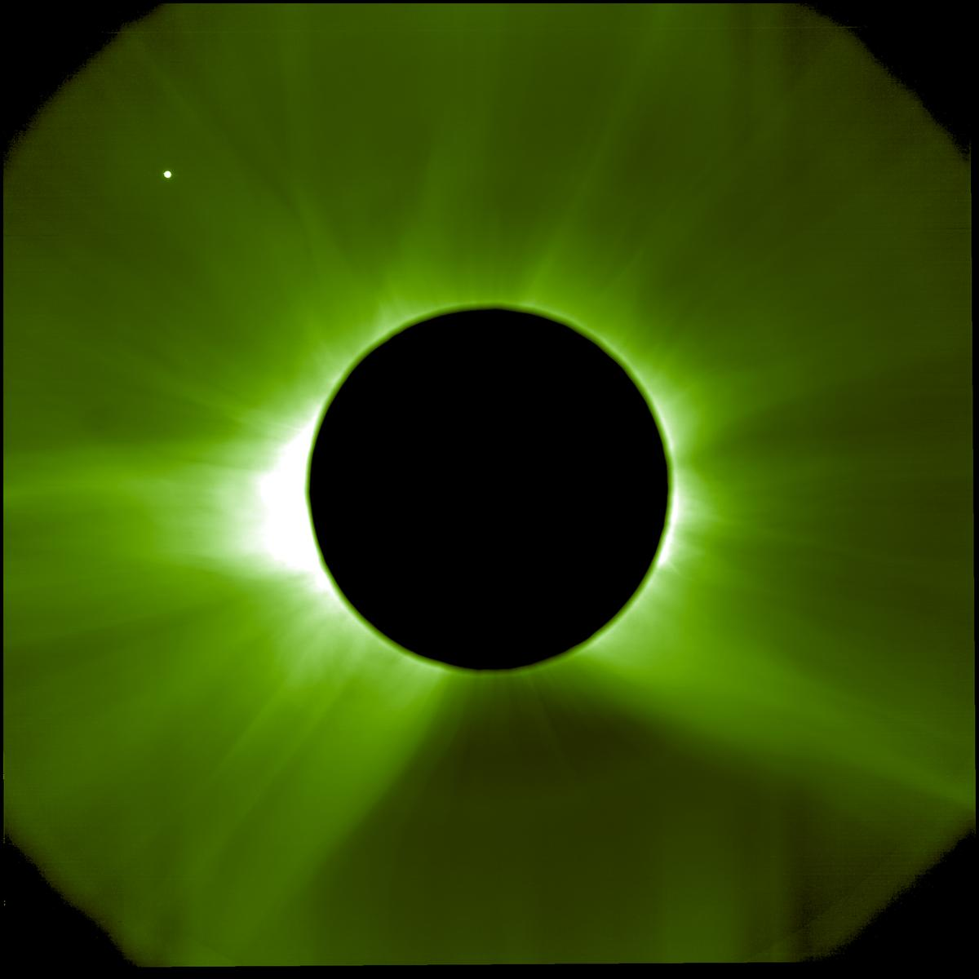
Enabling & Support How ESA mimics and models the 2026 total solar eclipse 10/08/2026 3157 views 17 likes On 12 August 2026, parts of Europe will experience a total solar eclipse. With the Sun's bright disc covered, its surrounding atmosphere - the solar corona - will become visible to the naked eye. Unfortunately, total solar eclipses are rare and last at most a few minutes, giving scientists little time to study the Sun's enigmatic halo. This is why ESA developed missions that create eclipses artificially, and why experts use computer models to create digital simulations. So how do we do it, and why is it important? In two days, the Moon will completely shield the Sun for parts of Greenland, Iceland, Spain and Portugal, creating a total solar eclipse. For up to just over two minutes, the brightness of day will turn into twilight and reveal the solar corona, normally kept invisible by the Sun's glare. The corona is where space weather originates: where the solar wind gains speed before streaming out into the Solar System, and where coronal mass ejections arise. Space weather can disrupt our satellite networks, communication infrastructure, power grids and other technologies that modern society relies on. Until recently, the full corona could only be observed from Earth during the short periods of total eclipses. These occur around once, very rarely twice a year, in different places across the globe, and last at most a few minutes. A solar eclipse is an example of a natural 'solar occultation' - when an object (in this case the Moon) blocks the Sun's disc from an observer's perspective. To stretch the short observation window that natural eclipses offer, scientists invented ways to create occultations artificially, using an instrument called a 'coronagraph': a telescope incorporating a disc to occult the Sun. Seeing another side of the Sun While Proba-3's mimicry of solar eclipses is unique, other solar missions are taking this eclipse just as seriously. In the days leading up to 12 August, the ESA-led Solar Orbiter mission is running a special observation campaign with its various remote-sensing instruments. Totality reveals structures in the corona that are shaped by the Sun's magnetic field. This means that eclipses provide a rare opportunity to test whether computer simulations accurately capture the Sun's magnetic environment. "A total solar eclipse lets us verify that our models are correct by comparing forecasts with actual observations," says Jorge Amaya, ESA Space Weather Modelling Coordinator. Most solar observations are made from near Earth, providing only a limited view of a vast three-dimensional system. Luckily, Solar Orbiter follows a different path around the Sun than other solar observatories. Today, the spacecraft is facing the side of the Sun that will soon roll into Earth's view, giving observers on the ground the opportunity to decide which targets to focus on during the eclipse. Magnetogram using data from Solar Orbiter's PHI instrument Particularly useful are the magnetic maps (magnetograms) of the Sun's visible surface, recorded by Solar Orbiter's Polarimetric and Helioseismic Imager (PHI). With the spacecraft's unique vantage point, these data provide modellers with a much more complete picture of the Sun's magnetic field today. For example, PHI is seeing a newly emerging active region on the Sun, which is likely to affect what the corona will look like during the 12 August eclipse. Spotting this active region would not have been possible without Solar Orbiter. "The magnetic field lines that we see in simulations are like hairs in a fuzz ball," adds Jorge. "Observing the Sun from multiple viewpoints allows us to determine their orientation in three dimensions. That is the key to dramatically improving forecasts of how solar activity will affect our technology." Solar Orbiter's location today gives us a sneak preview of what ESA's space weather forecasting mission Vigil will see. Planned for launch in 2031, Vigil will tail Earth to provide continuous, near real-time observations of the Sun's side. "With Proba-3 and Solar Orbiter, we have an unprecedented view of our star," comments Miho Janvier, ESA project scientist for the two missions. "Both missions are contributing to our understanding of the Sun, from its surface to its extended atmosphere. The upcoming total solar eclipse offers a chance to see how this knowledge comes together, comparing observations with modelling."

11. NASA+ Debuts on discovery+, Coming Soon to HBO Max
Read more
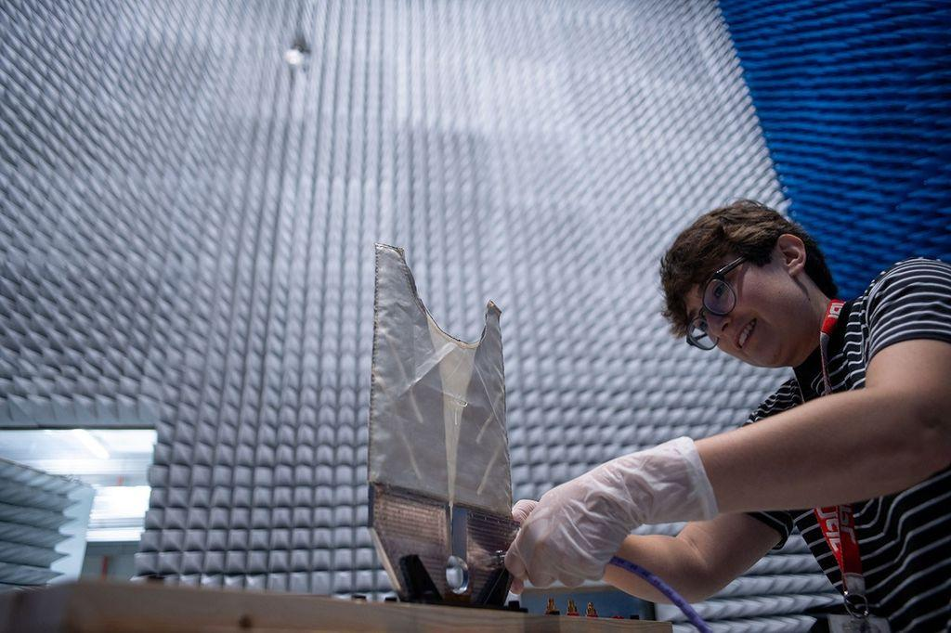
Credit: NASA As NASA+ continues its expansion across multiple streaming platforms to bring space closer to home, NASA announced Monday programming is next heading to discovery+ and HBO Max. A continuous live feed of NASA+ programming is streaming on discovery+ live channels, while HBO Max will stream NASA's special events, including the Artemis III mission in 2027. Viewers on those platforms can stream NASA+ content in Dolby Vision on supported devices, which will bring space exploration to life with vivid colors, sharper contrast, brighter imagery, and richer detail. This enhanced streaming experience will help viewers experience space coverage in a uniquely immersive way. Future programming may include science mission launches, a test flight for rendezvous and docking with human landing systems, robotic lunar deliveries, the first crewed mission to the Moon under Artemis, and more. As always, NASA+ also remains available for free, with no ads, through the NASA app and on the agency's website. "The National Aeronautics and Space Act of 1958 calls on us to share our story of space exploration with the broadest possible audience and we continue to honor that commitment," said Rebecca Sirmons, general manager of NASA+ at the agency's Headquarters in Washington. "Artemis II captured the hearts and minds of viewers globally, inspiring the Artemis generation. As we return to the Moon to stay, our goal is to provide transparent, engaging content coverage every step of the way." Earlier this year during its Ignition event, NASA shared plans for a bold path forward for the agency, including increasing its cadence of Artemis missions to the lunar surface, and building the first Moon Base, among other agency priorities. These continuous streaming agreements strengthen NASA's promise to public engagement, making the agency's mission and educational content available on multiple devices for viewers on their preferred channels For more about NASA's missions, visit: https://www.nasa.gov -end- Jennifer Dooren / Lauren Low Headquarters, Washington 202-358-1600 jennifer.m.dooren@nasa.gov / lauren.e.low@nasa.gov

12. Lion Nebula Roars to Life With NASA's Webb
Read more

Observing across the starry "plains" of space, NASA's James Webb Space Telescope has taken new images of NGC 2392, nicknamed the Lion Nebula. NASA's Hubble Space Telescope previously viewed this planetary nebula in 2000, imaging the lion face-shaped target in visible light and revealing features such as the "mane" of hazy, comet-shaped objects. Now Webb has captured a clearer, more detailed view of the Lion Nebula due to its high-resolution imaging. Lion Nebula (NIRCam and MIRI Image) NASA's James Webb Space Telescope imaged the planetary nebula NGC 2392, the Lion Nebula, using the observatory's NIRCam and MIRI instruments. The central star's remains are responsible for the nebula's structure, including a lion face-shaped bubble of ionized gas and dust "mane." Image: NASA, ESA, CSA, STScI; Image Processing: Alyssa Pagan (STScI) At first glance the nebula's overall structure in Webb's infrared images, with both the NIRCam (Near Infrared Camera) and MIRI (Mid Infrared Instrument) instruments, may look quite similar to Hubble's earlier visible-light view. However, Webb's infrared vision highlights features like compact clumps of dust and a haze of ionized gas. It's taken several thousand years for this collection of gas and dust to reach its current shape, and the nebula's components continue to be altered. The source of these constant changes and the reason for the Lion Nebula's distinct appearance is located at the center: the remains of a dying star. Though it looks like the button nose of the lion, its energy and radiation are powering the intricate structures seen here. Lion Nebula (MIRI Image) NASA's James Webb Space Telescope's mid-infrared image of planetary nebula NGC 2392, nicknamed the Lion Nebula, highlights the varying dust structures. Some dust is being destroyed by the dying central star's radiation, while some dust filaments manage to survive. Image: NASA, ESA, CSA, STScI; Image Processing: Alyssa Pagan (STScI) Massive stars undergo supernova explosions at the end of their lives, but these kinds of events are few and far in between. Most of the universe's stars have lower masses, like the one belonging to NGC 2392. When a lower-mass star can no longer sustain itself with nuclear reactions in its core, the star becomes unstable and pulsates, losing its mass by shedding its outer layers, which then turn into shells of gas and dust called a planetary nebula. (Stars at this life stage are responsible for producing much of the universe's observable dust.) The star's radiation drives the ejected material away, leaving behind the very hot stellar core, also known as a white dwarf. In the Lion Nebula's case, the death of the oxygen-rich central star has left behind a white dwarf that is "cooking" everything from the inside and producing a bubble of ionized gas as it does. The gas bubble, which forms the lion's face, is expanding over time and destroying dust that is in its path. Understanding why the swept-up gas has a complex structure of rings and shells, a common feature in planetary nebulae, is an ongoing endeavor. The mane of the lion is the interior of a dust shell that is being illuminated by the white dwarf at the center. The tufts of hair, which look like cometary tails of material, are compact clumps of dust that have survived the stellar core's radiation and protect the material that lies behind them. Webb's imagery "freezes" this planetary nebula in time, though the star's death, and its tumultuous effects, go on. NGC 2392 will continue to undergo changes as its gas and dust migrate away from the stellar core. Astronomers estimate the lion will eventually disperse in approximately 10,000 years - a relatively short period in astronomical terms. The James Webb Space Telescope is the world's premier space science observatory. Webb is solving mysteries in our solar system, looking beyond to distant worlds around other stars, and probing the mysterious structures and origins of our universe and our place in it. Webb is an international program led by NASA with its partners, ESA (European Space Agency) and CSA (Canadian Space Agency). To learn more about Webb, visit: https://science.nasa.gov/webb Downloads & Related Information The following sections contain links to download this article's images and videos in all available resolutions followed by related information links, media contacts, and if available, research paper and Spanish translation links.

13. Launch Into a New School Year With NASA
Read more
A new school year brings fresh opportunities to get involved with NASA. Whether you're curious about space or eager to build real STEM skills, NASA offers a world of experiences putting you close to the action. As we enter a new golden age of exploration, there's no better time to jump in, try something bold, and see where your curiosity takes you. Gain Hands-On NASA Experience NASA opens the door to authentic mission experiences through internships and student challenges. As members of the NASA team, interns work on genuine agency projects and gain industry-ready skills, all with the guidance of NASA mentors. Visit NASA's internships website to learn more about current vacancies, deadlines, eligibility requirements, and more. Through NASA's student challenges and competitions, student teams tackle some of the critical technical hurdles facing mission planners. Flex your innovative muscles and sharpen your collaborative and problem-solving skills while developing, prototyping, and testing your team's designs. Check out the full list of NASA STEM challenges and opportunities, choose one that fits your interests, and assemble your team. Students cross the finish line in their human-powered rover during the 2025 Human Exploration Rover Challenge at NASA's Marshall Space Flight Center in Huntsville, Alabama USSRC/Emily Riddle Discover Technical Careers at NASA The future of aerospace depends on a steady pipeline of skilled technical experts ready to make missions and ideas a reality. NASA invites students in high school, community college, and career technical education programs to join in-person and virtual events to explore these important career paths. NASA Career Technical Education Days bring students on-site to meet NASA skilled technical workers who share what their jobs are like, how they built their careers, and the skills, training, and certifications that have helped them succeed. During NASA's Next Gen STEM Virtual Career Connections , students interact live with technical experts supporting the agency's missions. Students and teachers can learn more on the Next Gen STEM for Careers website. A technician performs welding on a spacecraft transporter at NASA's Kennedy Space Center in Florida. NASA/Ben Smegelsky Contribute to NASA Science as a Citizen Scientist NASA's Science Mission Directorate invites you to help make real discoveries through science projects powered by volunteers. Join from anywhere, whenever it fits your schedule, and start working with authentic mission data. Help identify comets and asteroids, hunt for binary star systems, and more. Find the project that's right for you on the list of current citizen science projects. Keep Up With NASA Missions and Discoveries Don't miss out on NASA's biggest mission milestones this school year! Up first is the Nancy Grace Roman Space Telescope, scheduled to launch no earlier than 7:20 a.m. EDT on Sunday, Aug. 30. This powerful new observatory has a field of view at least 100 times larger than the Hubble Space Telescope. Be a virtual guest for launch and learn more about the telescope with fun activities provided by NASA's Science Mission Directorate. You can also sign up to be a virtual guest for NASA's next crewed launch to the International Space Station, SpaceX Crew-13, set to launch in September. And be sure to follow NASA's continuing crew training and hardware preparations for Artemis III. Set to launch into Earth orbit in 2027, the flight will test rendezvous and docking capabilities with commercial human landing systems - landers that will carry astronauts to the lunar surface on Artemis IV and future missions to the Moon. NASA astronauts Jack Hathaway and Jessica Meir answer questions inside the International Space Station's Kibo laboratory module during a live downlink event in May 2026. NASA Stay Engaged With NASA Schools, classrooms, and community-based student groups have further options to engage with NASA and its people. Through In-Flight STEM Downlinks, students have their pre-recorded questions answered live by astronauts aboard the International Space Station, demonstrating how STEM careers reach far beyond Earth. Additionally, the NASA Engages public outreach program connects agency experts with student audiences to share mission and science updates, helping people discover how NASA's work unfolds and how they can be part of the journey. This school year, whether you're interested in aerospace jobs or eager to dive into authentic STEM challenges, you'll find an array of activities and career exploration tools on NASA's Learning Resources website. Explore exciting NASA student opportunities and subscribe to the weekly NASA EXPRESS email newsletter for the latest NASA STEM opportunities and updates!

14. 'Launching anywhere, anytime and without compromise': Rocket Lab unveils new 'GHOST' portable spaceport system
Read more
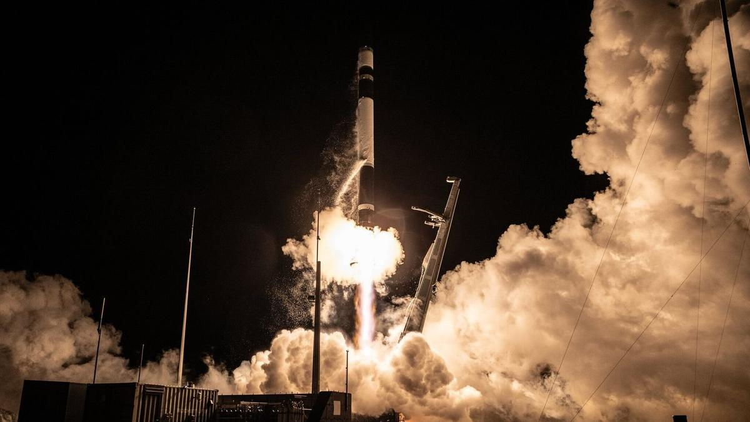
Click for next article A Rocket Lab Electron rocket launches "The Grain Goddess Provides" mission for the Japanese company iqps from New Zealand on Aug. 6, 2026. Rocket Lab plans to start launching even more frequently and flexibly, thanks to a new portable spaceport system called "GHOST." GHOST - short for "Global Hypersonic & Orbital Spaceport Technology" - turns the company's " Electron and HASTE rockets into a launch-anywhere, launch-anytime capability for multi-launch flight campaigns and critical national security missions," Rocket Lab representatives said in a statement today (Aug. 10). "Packaged entirely within standard shipping containers, GHOST deploys complete rockets, launch infrastructure, ground support and range control systems anywhere in the world," they added. Electron is Rocket Lab's workhorse orbital rocket, giving small satellites dedicated rides to the final frontier. The expendable 59-foot-tall (18-meter-tall) launcher debuted with a test flight in 2017 and has 83 missions under its belt to date. As its full name suggests, HASTE ("Hypersonic Accelerator Suborbital Test Electron") is a suborbital version of Electron that customers use to test various technologies in the hypersonic flight environment. HASTE first flew in June 2023 and has flown nine times to date, most recently in June of this year. Rocket Lab currently flies from two different launch sites - one on the North Island of company founder and CEO Peter Beck's native New Zealand and one at Wallops Island in Virginia. But the company recently announced plans to fly out of Alaska's Pacific Spaceport Complex as well, and GHOST will expand its launch footprint even further. "Electron and HASTE revolutionized small orbital launch and hypersonic testing. Now we're making it easier to deploy them wherever they're needed most, whether that's for missile defense testing or sovereign orbital launch capability," Beck said this afternoon during Rocket Lab's second-quarter 2026 earnings call. "We've mastered the art of building launch sites," he added. "Now we're making them deployable worldwide." Rocket Lab intends to deploy its two planned pads at the Pacific Spaceport Complex using GHOST, Beck said during the call. The company was inspired to develop the portable spaceport system, he added, to meet the needs of a HASTE customer, who expressed a desire for Rocket Lab to be "a little bit more mobile than we are." Rocket Lab currently flies out of two pads at its New Zealand site and one at Wallops, though it has built a second pad at the Virginia facility to accommodate launches of its coming Neutron rocket . Neutron will be bigger and more powerful than Electron, and partially reusable as well; its first stage is designed to come back to Earth for recovery and reflight, like SpaceX's Falcon 9 . Rocket Lab originally wanted to fly Neutron for the first time in 2024, but the new launcher has yet to leave the ground. Such delays aren't uncommon in the case of new rockets , and the company is making considerable progress with Neutron, according to Beck. "Every part of the vehicle has now seen significant testing," he said during today's call. "As with any complex development program, we've had to tweak a few things along the way, but we're moving now into final checkout and assembly of all of our flight hardware before integrating them at the pad." The company is on target to deliver the first Neutron to that Wallops pad in the fourth quarter of this year, Beck added.

15. Japanese H3 rocket launches 10,800-pound navigation satellite to high Earth orbit (video)
Read more
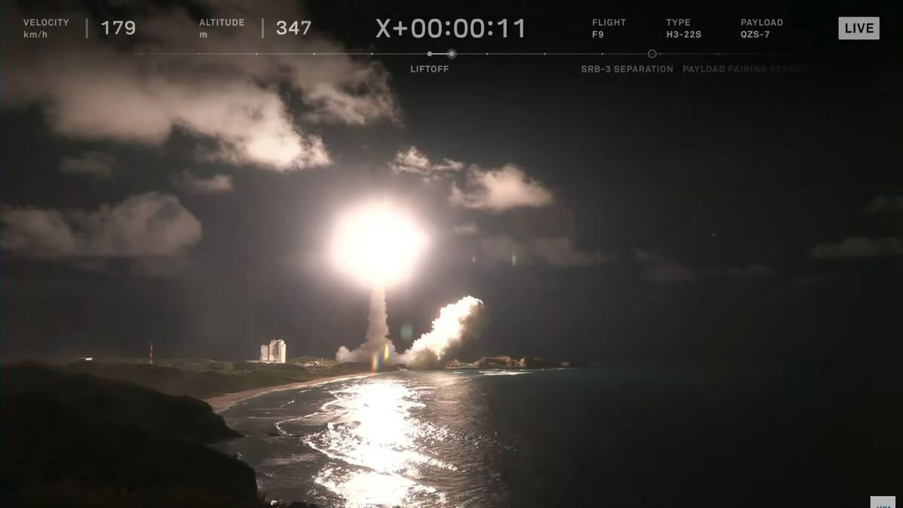
Click for next article Japan's H3 rocket flew for the ninth time ever this afternoon (Aug. 10). The H3 lifted off from Tanegashima Space Center today at 3:23 p.m. EDT (1923 GMT; 4:23 a.m. on Aug. 11 local time), carrying the Michibiki 7 navigation satellite aloft. The H3's upper stage deployed Michibiki 7 into its target orbit 29 minutes later, eliciting cheers from the folks in mission control. A closeup of the H3's first stage powering the rocket to orbit on Aug. 10, 2026. (Image credit: JAXA) The two-stage H3 is the successor to Japan's workhorse H-2A rocket, which retired last year after a total of 50 flights. The H3 - which stands 187 feet or 207 feet (57 or 63 meters) tall, depending on what type of payload fairing it employs - debuted in March 2023 and had eight liftoffs under its belt before today. Two of those eight were failures - the debut flight and the launch of Michibiki 5 in December of last year. But the H3 bounced back from that latter anomaly two months ago, successfully delivering six satellites to orbit on June 11 . Michibiki 7 will be part of Japan's Quasi-Zenith Satellite System (QZSS), a homegrown navigation system that operates high above Earth in geosynchronous orbit . "This system is compatible with GPS satellites and can be utilized with them in an integrated fashion," Japanese officials wrote in a description of the QZSS project . "QZSS can be used even in the Asia-Oceania regions with longitudes close to Japan, so its usage will be expanded to other countries in these regions as well." The QZSS network will eventually consist of 11 satellites , if all goes according to plan. There are five such spacecraft operating in orbit at the moment. Michibiki 7 is carrying a payload for the United States as well - the Situational Awareness Camera Hosted Instrument (SÃCHI), which was developed for the U.S. Space Force by the MIT Lincoln Laboratory. This is the second of two SACHIs to go up on a QZSS satellite; Michibiki 6, which launched atop an H3 in February 2025 , hosts the other one. (Yes, Michibiki 6 launched before Michibiki 5.) "This program will allow the United States to monitor satellite behavior within the GEO belt over a very interesting part of the world," Mark Huber, a technical staff member in the Lincoln Laboratory's Space Systems and Technology Division, said in a statement in December 2020. "It is also a pathfinder in several ways," he added. "The U.S. team is blueprinting methods to allow sensitive data sharing between the United States and Japan." Editor's note: This story was updated at 3:55 p.m. ET on Aug. 10 with news of successful launch and satellite deployment.

16. SpaceX scrubs planned Monday launch of its Falcon 9 rocket; targets Tuesday morning
Read more
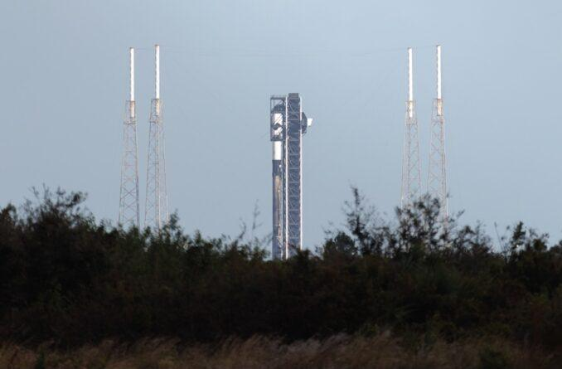
Update Aug. 10, 3:46 p.m. EDT (1946 UTC): Added updated forecast from the 45th Weather Squadron. SpaceX was set to kick off the work week with a Falcon 9 flight from Cape Canaveral Space Force Station to deliver another batch of its Starlink V2 Mini Optimized satellites to low Earth orbit. However, the mission was scrubbed hours before is scheduled liftoff at 12:20:09 p.m. EDT (1620:09 UTC) The Starlink 10-19 mission represents the 72nd flight of these broadband internet satellites this year. Following this launch, SpaceX will have flown 93 Falcon 9 rockets in 2026. Liftoff from Space Launch Complex 40 is scheduled for 10:26 a.m. EDT (1426 UTC) on Tuesday, Aug. 11. The rocket will fly on a northeasterly trajectory upon leaving the launch pad. <span data-mce-type="bookmark" style="display: inline-block; width: 0px; overflow: hidden; line-height: 0;" class="mce_SELRES_start"></span> The 45th Weather Squadron forecast an 85 percent chance for favorable conditions near the opening of the window, which decreases to 75 percent as the window progresses. "The Atlantic ridge axis will continue to slide southward over the Spaceport, shifting winds to a very light south-southwesterly flow," launch weather officers wrote on Monday. "With the relatively dry air mass remaining in place, conditions will be similar to Monday, with the Cumulus Cloud Rule remaining the primary concern and an increasing probability of violation towards the end of the window." SpaceX will launch this mission using the Falcon 9 first stage booster with the tail number B1085. This will be its 18th flight with a flight history that includes NASA's Crew-9, GPS III-7, and Fram2. Nearly 8.5 minutes after liftoff, B1085 will target a landing on the droneship, A Shortfall of Gravitas, positioned in the Atlantic Ocean off the coast of South Carolina. If successful, this will be the 163rd landing on this vessel and the 647th Falcon booster landing.
17. 'Deepen India-US space partnership': NASA invites ISRO to join Moon Base project under Artemis Accords | India News - Hindustan Times
Read more
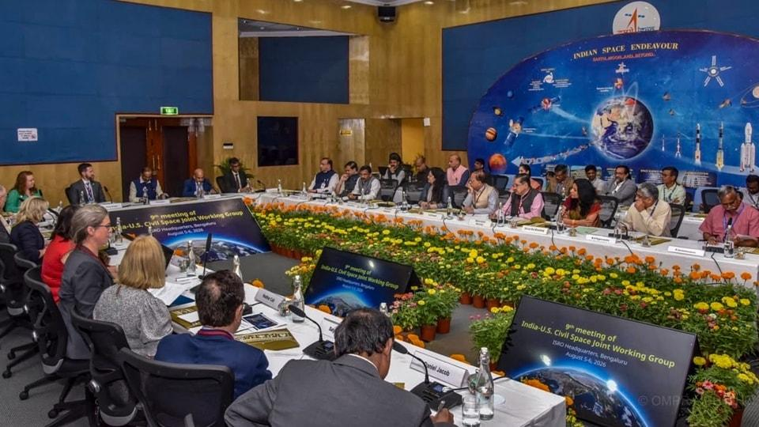
Nasa has invited the Indian Space Research Organisation (Isro) to join its Moon Base programme, deepening the US-India partnership in space exploration, the US Embassy in India said on Tuesday. Besides the Moon Base project, India and the US also agreed to advance discussions on cooperation in open scientific data sharing under the accords. (PTI) The invitation was announced after the ninth meeting of the India-US Civil Space Joint Working Group, held at Isro headquarters in Bengaluru on August 5-6, where the two sides discussed expanding cooperation in human spaceflight, space science, Earth observation and future space technologies. "Nasa invited Isro to join its Moon Base program, building on the two countries' partnership under the Artemis Accords," the US Embassy said in a statement. The two sides also agreed to advance discussions on cooperation in open scientific data sharing under the accords. 'Deepen India-US space ties' US Ambassador to India Sergio Gor announced the invitation in a post on X, saying it would deepen the "US-India deep space partnership". Nasa envisages the Moon Base as a phased programme aimed at establishing an enduring human presence on the lunar surface, particularly around the Moon's South Pole. The programme is intended to support scientific research and technology development and prepare for future crewed missions to Mars. ALSO READ | NASA chief Jared Isaacman declares 'boots will be on the moon in 2028', hails Elon Musk's SpaceX The two sides also reaffirmed their commitment to cooperation under the US-India Transforming the Relationship Utilizing Strategic Technology (TRUST) initiative, in line with the February 2025 Joint Leaders' Statement issued by Prime Minister Narendra Modi and US President Donald Trump. The meeting was chaired by Isro chairman V Narayanan and Ambassador Gor, and co-chaired by M Sankaran, director of Isro's UR Rao Satellite Centre, and US officials Wesley Brooks and Kathleen Karika. India and Artemis Accords India joined the Artemis Accords in June 2023, becoming the 27th signatory to the US-led framework for cooperation in lunar and other space exploration. ALSO READ | Space technology to shape India's next growth story: ISRO scientist The Moon Base programme, announced by Nasa in March, envisages a phased approach combining robotic and human missions. The first phase, through 2029, will focus on robotic missions to explore the lunar South Pole, demonstrate technologies and develop the foundations for a sustained presence. The second phase, from 2029 to 2032, will focus on building systems and infrastructure for a long-term presence, while the third phase will begin assembling a permanent lunar outpost where astronauts can live and work for extended periods.

18. SpaceX could make $500 billion in 2028, Elon Musk says
Read more
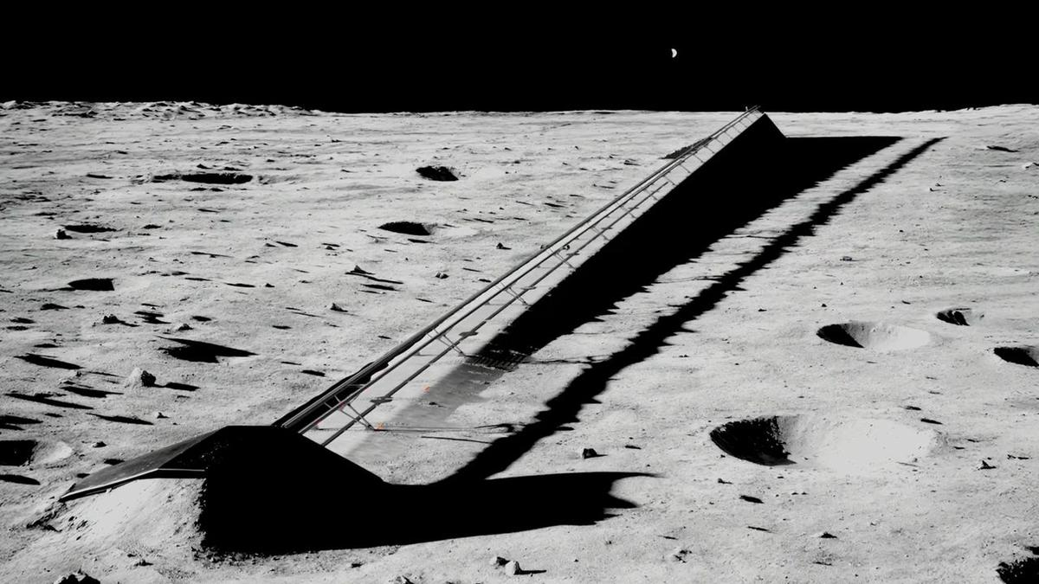
Click for next article Illustration of an electromagnetic mass driver on the moon, which SpaceX plans to use to launch AI satellites into space. SpaceX isn't a launch company anymore. SpaceX is famous for launching, and landing, its Falcon 9 and Falcon Heavy rockets and sending astronauts to space aboard its Dragon crew capsule. Recently, however, the company has been transitioning into an artificial intelligence (AI) outfit - and that journey is now mostly complete. "Our AI revenue will exceed all other SpaceX revenue probably in September - like, next month - and will significantly exceed all other SpaceX revenue in in the fourth quarter," company founder and CEO Elon Musk said during an address to employees that the company posted on X today (Aug. 11). "So, AI has become an extremely important part of SpaceX's future." Earlier this year, SpaceX bought xAI, a startup that Musk founded in 2023. xAI created the chatbot Grok and also operates a powerful supercomputer cluster in Tennessee called Colossus. But that was just the beginning. Musk laid out just how deeply SpaceX is diving into AI during his 29-minute talk, which came a week after SpaceX's first-ever quarterly earnings call as a public company. "Probably in four or five years, AI will be 99% of the value of SpaceX; I'd say five years for sure," Musk said. "And the value of SpaceX will be some astronomical number." Astronomical is right. According to Musk, the company aims to get 10 gigawatts of AI compute up and running by the end of next year. That's a big jump from its current 1.4 GW, which SpaceX sells to tech companies and AI labs. "The value per watt is probably going to be 30 to $50, which means if we bring 10 gigawatts of AI online by the end of next year, it will be 300 to $500 billion a year in revenue," he said. "Big numbers." And those numbers will get even bigger over time, if all goes according to plan. SpaceX just announced plans to build a gigantic complex in Texas called Terafab , a joint operation with Tesla that will manufacture advanced semiconductor chips for a wide range of applications. And the company aims to launch a million of its "Starmind" AI satellites to low Earth orbit in the coming years using its fully reusable Starship megarocket, which is still in development. Over the longer haul, the company plans to establish factories on the moon that will build these off-Earth data centers. The satellites will be launched into space from the lunar surface via electromagnetic mass drivers - basically, high-powered rail guns. SpaceX envisions Starmind and its other AI efforts as returning almost unimaginable profits down the road. For example, in paperwork the company filed just before its record-breaking IPO , SpaceX identified an eventual "total addressable market" of $28.5 trillion, nearly $23 trillion of it in the AI field. For some perspective: The gross domestic product of the entire United States last year was about $30.8 trillion. "The future is fundamentally AI and robots," Musk said during his address to employees. "Assuming civilization continues to progress, I think that AI will probably - the amount of digital intelligence will probably be more than a trillion times the amount of biological intelligence." He also said he's not just in this for the money. "It's important that we have an AI that cares about humanity, that fosters humanity and helps take us to other planets and other star systems ," Musk said. "This is why I think it's essential that SpaceX succeed not just with AI hardware but also with AI software," he added. "I think an AI that is sort of SpaceX's baby will be a very good AI. I think SpaceX is a collection of some of the very best humans on Earth, both in capability and morality and goodness." He urged SpaceX employees to aid the company's AI efforts in any way that they can, stressing that success could lead to some amazing vacations. "One of the nice benefits of this also is that anyone at SpaceX who wants to go to the moon or Mars will be able to go in the future," he said. "You have my word." Editor's note: The original headline of this story read "in 2027," which was incorrect, given that SpaceX aims to get 10 GW online by the end of that year. It was corrected at 8:20 p.m. ET on Aug. 11.

19. SpaceX launches 29 Starlink satellites to orbit from Florida (video, photos)
Read more
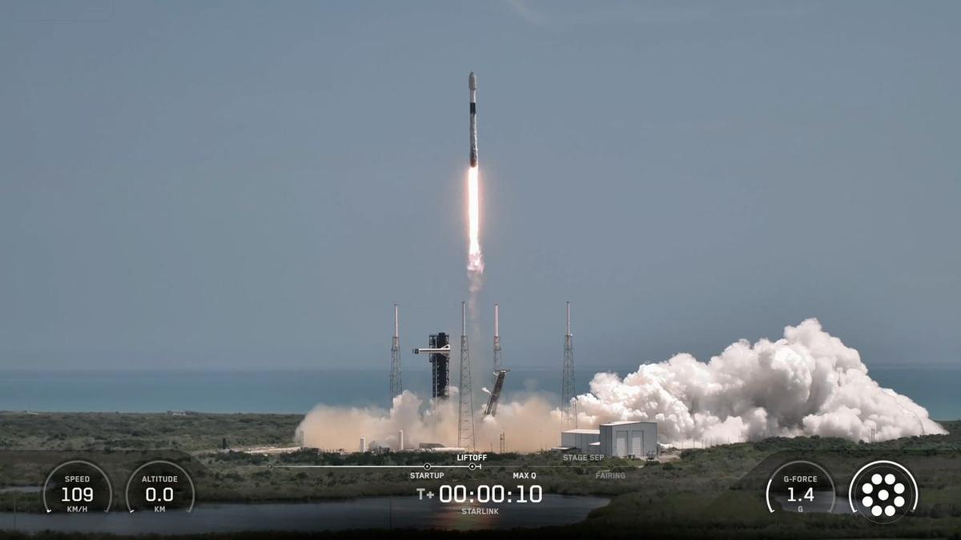
Click for next article SpaceX sent yet another batch of its Starlink internet satellites skyward today (Aug. 11). A Falcon 9 rocket lifted off from Florida's Cape Canaveral Space Force Station today at 11:58 a.m. EDT (1558 GMT), carrying 29 of the broadband spacecraft toward low Earth orbit (LEO). About 8.5 minutes later, the rocket's first stage made a pinpoint landing in the Atlantic Ocean atop the SpaceX droneship "A Shortfall of Gravitas." It was the 18th flight for this particular booster, which is designated B1085. The Falcon 9's first stage is seen just after its drone-ship landing on Aug. 11, 2026. (Image credit: SpaceX) Though more than half its liftoffs have been Starlink flights, B1085 also has some astronaut missions under its belt. The booster lofted SpaceX's Crew-9 flight to the International Space Station in September 2024, and it launched the Fram2 mission around Earth's poles six months later. The Falcon 9's upper stage, meanwhile, continued hauling the 29 Starlink satellites to LEO today. They'll be deployed there 64 minutes after liftoff, if all goes to plan. Today's liftoff was the 93rd Falcon 9 launch of the year already. Seventy-two of those missions have been devoted to building out Starlink, the largest satellite constellation ever assembled. Starlink currently consists of more than 10,900 active satellites , according to astrophysicist Jonathan McDowell. But SpaceX has even bigger megaconstellations in mind: Eventually, the company wants to operate 100,000 of its bigger, more capable Starlink V3 satellites, and Elon Musk has stated an ambition to launch a million AI data center satellites to Earth orbit as well.

20. NASA will chase the Aug. 12 total solar eclipse with balloons and a high-altitude jet
Read more
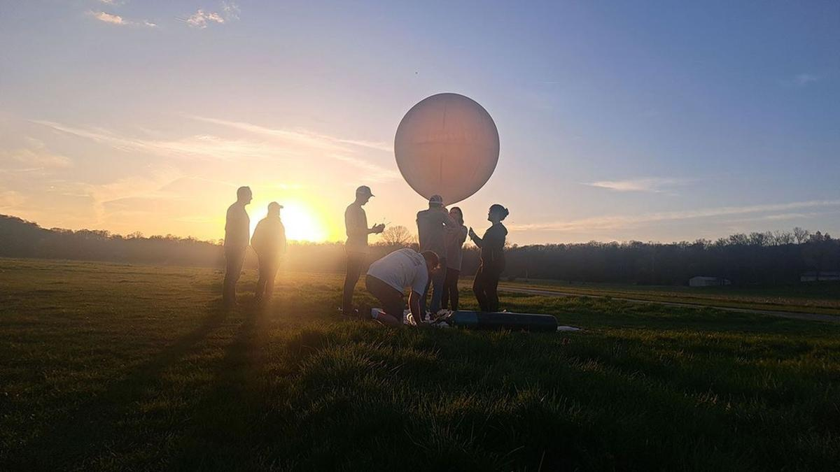
Click for next article A student team from the University of Kentucky prepares to launch a balloon from Bloomington, Indiana, to take atmospheric measurements on April 8, 2024, during the 2024 Nationwide Eclipse Ballooning Project campaign. A total solar eclipse isn't just a spectacular sight to witness for those lucky enough to lie in the path of totality (or travel to it, as many dedicated skywatchers do). It also gives scientists a rare chance to study the sun's outer atmosphere, or corona, during the day. As such, NASA plans to take full advantage of the opportunity for the upcoming total solar eclipse happening on Aug 12. The space agency's WB-57 high-altitude research jet will chase the moon's shadow across the globe, which will extend the agency's ability to capture data from the eclipse. The NASA-supported Nationwide Eclipse Ballooning Project will also coordinate teams to release balloons that will help us know how our atmosphere changes when an eclipse turns the sky dark during the day. "From our unique perspective on Earth during a total solar eclipse, scientists can study the sun's corona in a way we can't from anywhere else in the solar system," Kelly Korreck, eclipse program manager at NASA Headquarters in Washington, said in an official announcement . "The sun impacts our daily life, satellites, and astronauts in space, and we can take advantage of this moment to advance our understanding of that influence," she continued. NASA's WB-57 jet. (Image credit: NASA) Inside the research jet's nose cone, four cameras will capture images of the corona's structures, outflows, and changes. This data may help scientists gain a better understanding of how materials within the corona relate to solar winds. "The sun is always changing," Amir Caspi, principal investigator for the study at Southwest Research Institute in Boulder, Colorado, said in the announcement. "Every eclipse is different. So we could see things we didn't see before. And we learn from each eclipse how to better observe the next one." These images of the corona and solar prominences were taken in different wavelengths of visible and infrared light by imagers aboard a NASA's WB-57 jet during the April 8, 2024, total solar eclipse. The same cameras will fly on a NASA WB-57 jet again during the Aug. 12 eclipse. (Image credit: NASA / SwRI / William Ashfield) Angela Des Jardins at Montana State University will lead the Nationwide Eclipse Ballooning Project, with the help of students from universities in the U.S., Iceland and Spain. By releasing balloons in anticipation of the eclipse, scientists will be able to look at the ozone levels in the atmosphere during the eclipse and study how the eclipse impacts the "boundary layer" of the Earth, which shifts due to temperature and moisture in the air.

21. SpaceX wants to put 1 million AI satellites in orbit. What would that do to Earth's climate?
Read more
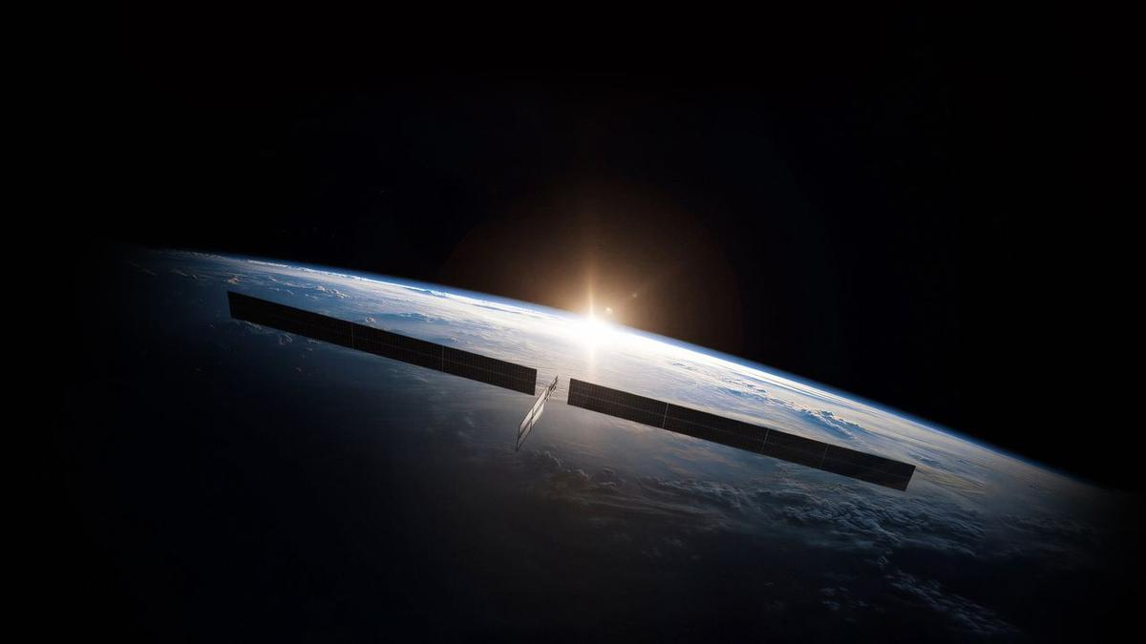
Click for next article Concentrations of dangerous pollutants from rocket launches and satellite reentries in Earth's upper atmosphere might reach treacherous tipping points if constellations of hundreds of thousands of orbiting data centers get deployed in the next decade, experts say. There's no question that Earth has an AI data center problem. By 2030, AI data centers may be responsible for up to 17% of electricity consumption in the U.S., according to a forecast by the Electric Power Research Institute. New fossil fuel power plants are being built to feed the growing demand for electricity, and aging ones are kept online despite decarbonization plans. On top of that, huge amounts of water are taken from already strained reservoirs to cool the computers. Companies such as SpaceX , Amazon and Blue Origin say they have a solution: moving the power-hungry data crunching infrastructure into space, where solar power is easy to produce, and heat can be radiated out into the frigid vacuum. Combined, those companies have filed applications to the U.S. Federal Communications Commission to launch more than a million orbiting data centers in the next 10 years. Most of those will belong to SpaceX, if all goes to plan; Elon Musk has said the company wants to operate a million-satellite AI constellation all by itself. The plans are making atmospheric scientists tear their hair out. If all these projects come to fruition, the number of satellites being launched to space and reentering the atmosphere will increase 100 times compared to today's numbers. Moreover, the data center satellites will be much larger than the spacecraft orbiting Earth today. This large mass will translate into higher quantities of polluting propellant needed to loft these systems off Earth and a much larger amount of metals vaporizing in Earth's atmosphere during reentry. Neither is good news for our planet's air. Pristine upper atmosphere "Launches and the reentries are really the only things that humans do that deposit material directly into the upper atmosphere," Aaron Boley, an astronomy professor and space sustainability researcher at the University of British Columbia, told Space.com. "And the way things mix in the upper atmosphere means that the launch and reentry emissions are by far more impactful." Most rockets emit black carbon, which could worsen global warming . Satellite bodies are mostly made of aluminum, which likely turns into aluminum oxide when burned in the presence of oxygen. Aluminum oxide is known for its ability to trigger ozone depletion , a hazardous process that was successfully thwarted by the Montreal Protocol of 1987. Currently, scientists don't have a precise understanding of the chemical reactions that occur between the pollutants and the atmospheric gases at high altitudes. They also don't understand the tipping points, which may mean the difference between minor and major impacts on the climate. What is worse, pollutants in the upper atmosphere remain much longer than those emitted by cars and factory chimneys close to the ground. "Close to the ground, we have rain and wind that removes pollution from the atmosphere within weeks," Eloise Marais, a professor of atmospheric chemistry at University College London, told Space.com. "If we put it into the higher layers of the atmosphere, we rely on very slow atmospheric processes to bring this pollution back down." Too many launches Black carbon from rockets , for example, can stay in the atmosphere for three years, scientists think, meaning its concentrations could dangerously rise in the near future. SpaceX's Starship megarocket is likely to play a key role in the deployment of data center constellations. Unlike SpaceX's current workhorse launcher Falcon 9 , which burns a form of the aviation fuel kerosene, Starship combusts the much cleaner combination of methane and liquid oxygen. But Marais cautions that Starship's size and the much more frequent launches that will be needed to deploy the vast constellations would result in an overall increase in the pollution injected into the upper atmosphere. "Starship is a bigger rocket burning more propellant," Marais said. "So, in terms of each rocket launch, the difference almost offsets. It has potential per launch to produce quite similar amounts of black carbon." Andrew Wilson, a space sustainability researcher at Glasgow Caledonia University in the U.K., told Space.com that every single Starship launch produces around 76,000 metric tons of carbon dioxide equivalent. That's about as much as 17,727 gasoline-powered passenger cars emit in a year. And up to 77,000 Starship launches - some 15,300 per year - might be needed, according to estimates by Ars Technica , to deploy SpaceX's planned million-data-center constellation. That's a lot of rocket pollution added into the atmosphere. For comparison, there were just 324 orbital rocket liftoffs globally in 2025, according to Space News . SpaceX's Starship megarocket launches on its 13th test flight, on July 24, 2026. (Image credit: SpaceX) The space junk rain Then there is the toxic ash from reentering satellites. Today, nearly 19,000 operational and defunct satellites orbit Earth, according to the European Space Agency . Currently, the most numerous type of satellite in Earth orbit is SpaceX's Starlink V2 Mini, each of which weighs about 1,760 pounds (800 kilograms). But SpaceX's orbital data centers are likely to be much more massive. Featuring solar arrays 246 feet (75 m) wide , every data center satellite might weigh up to 7.5 metric tonnes, according to available estimates. Industry insiders expect that SpaceX and other providers would want to replace their AI satellites every five years with newer technology, as they do with existing communications satellites. As a result, tens or even hundreds of tons of metal may be reentering the atmosphere every year in the future, exceeding the amount of natural space rock that hits the planet. The materials that satellites are made of are not naturally present in Earth's atmosphere, which means the consequences of such reentries can be unpredictable. "Only 10 years ago, the reentries were not really a concern, because there were much more natural meteorites entering the atmosphere per year," Wilson said. "But if you have hundreds of thousands or millions of satellites in space at any one time, you are essentially going to create a rain of man-made materials, electronic equipment and metals that otherwise wouldn't be coming into the atmosphere." He added that the situation is akin to ongoing climate change, which shows no signs of slowing down as humanity has so far failed to reduce carbon emissions. "This is the most objects we've ever had in space, and we're continuing to propose more and more and more and more and more," Wilson said. "And there seems, in my opinion, to be very little consideration for the environment." Not enough funding is currently flowing into research to answer the unknowns, Marais added. "We need way more observations and way more time to be able to look into that," she said. Boley concurred: "We absolutely have to understand, and we have to understand that before we actually launch a million satellites. Not that we launch them and wait [to see] what happens."

22. Live coverage: SpaceX to launch 24 Starlink satellites on Falcon 9 rocket from Vandenberg SFB
Read more
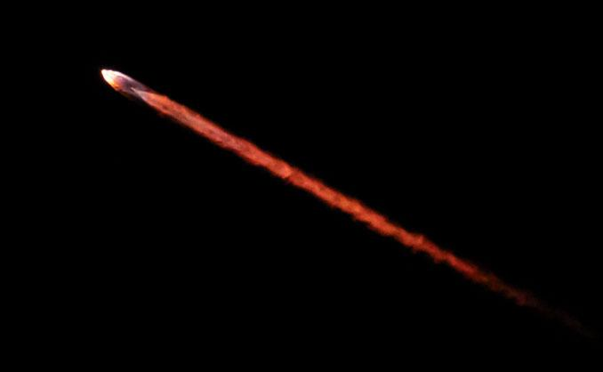
Update 11:19 p.m. EDT (0319 UTC): SpaceX updated the new T-0. SpaceX launched two dozen of its Starlink satellites to low Earth orbit from Vandenberg Space Force Base on Tuesday night. The Starlink 17-49 mission was SpaceX's 51st flight from the West Coast so far this year. Liftoff from Space Launch Complex 4 East happened at 9:46 p.m. PDT (12:46 a.m. EDT / 0446 UTC). The rocket took a south-southwesterly trajectory. <span data-mce-type="bookmark" style="display: inline-block; width: 0px; overflow: hidden; line-height: 0;" class="mce_SELRES_start"></span> SpaceX launched the mission using the Falcon 9 first stage booster with the tail number B1103. This was its fifth flight after previously launching SDA-T1TL-E, NROL-179, Starlink 17-35, and Starlink 17-42. Nearly 8.5 minutes after liftoff, B1103 landed on the droneship, Of Course I Still Love You, positioned in the Pacific Ocean. It was the 163rd landing on this vessel and the 648th Falcon booster landing to date.

23. The ESCAPE mission will study the evolution of exoplanet atmospheres
Read more

The habitable zone concept is useful for understanding which worlds might, possibly, maybe, be habitable. It highlights exoplanets at the right distances from their stars for liquid water to potentially exist on their surfaces. But that alone can't determine habitability.

24. A smarter way to track satellites beyond Earth's orbit
Read more

Most current space activities operate close to Earth in what is called near-Earth orbit. However, as more satellites and other infrastructure begin to extend beyond that region, maintaining situational awareness of those objects will be crucial.
25. Up to ₹2.08 Lakh/Month Salary! Multiple Life Sciences Jobs at ISRO - BioTecNika
Read more

Multiple Vacancies at ISRO-HSFC | Life Sciences Role Are you looking for high-paying Life Sciences Jobs in India's space research sector? The Human Space Flight Centre has announced Multiple Vacancies under ISRO Careers 2026 for Scientist/Engineer-SD positions. Candidates with a PhD in Biotechnology, Molecular Biology, Bioinformatics, Biomedical Sciences and related disciplines can apply online by 30 August 2026. About the Institute The Human Space Flight Centre (HSFC), Bengaluru, was formed as a new centre in ISRO to realise the vision of the Human Space Flight Programme. As the lead centre for human space activities, HSFC undertakes multidisciplinary research and development in human science and technology while maintaining high standards of reliability and human safety. - Get Jobs Faster - Job Overview Multiple Vacancies Post Code Discipline Vacancies 01 Bioinstrumentation OR Biophysics OR Medical Physics 01 UR 02 Developmental Biology OR Biotechnology 01 UR 03 Cellular & Molecular Biology OR Cell Biology 01 UR 04 Computational Biology OR Systems Biology OR Bioinformatics 01 UR 05 Biomedical Engineering OR Biomedical Sciences 01 UR 06 Biomedical Engineering OR Biomedical Sciences 01 UR Key Responsibilities Post Code 01 Design and validate wearable health monitoring sensors and systems and instrumentation of biomedical sensors. Bio-signal data acquisition and processing. Medical Imaging and informatics. Development of portable diagnostic devices and wearable sensors. Post Code 02 Radiation biology and exposure models. Develop regenerative approaches to preserve musculoskeletal integrity during training and in space. Mammalian and stem cell culture; primary cell lines; 3D/organoid culture systems. In vivo and ex vivo animal physiological studies. Working on disease biology models relevant to astronaut health. Host-pathogen interaction studies under stress/microgravity. Post Code 03 Study immune and cellular adaptation across the astronaut health cycle. Bioinformatics analysis of proteomic data for biomarker identification for spaceflight application. Molecular cloning, confocal microscopy, live-cell imaging and gene editing for spaceflight application. Large-scale proteomic dataset analysis, gene expression and statistical workflows. Post Code 04 In silico models to anticipate astronaut adaptation, assess countermeasures and guide rehabilitation. Development of therapeutics and space-grade diagnostics. Multi-omics integration for spaceflight stressors studies. Modelling cellular pathways, host-microbe interactions and metabolic networks under spaceflight conditions. Computational simulation of closed-loop life support systems. Generative models for predictive simulation of astronaut physiology and disease states through Digital Twin Biology, including neural networks and deep learning. Post Code 05 Gait analysis, exercise countermeasures, motion capture and force-plate studies and rehabilitation programme development. Biomechanical analysis of the musculoskeletal system. Analyse human performance data from wearables. Collaborate on rodent/human analogue design for spaceflight experiments. Post Code 06 Develop and validate bio-imaging systems for microgravity tissue changes. Implement DSP algorithms for ECG/EEG/EMG from wearables, noise reduction and feature extraction. Analyse bioinformatics datasets for space radiation effects on cells and tissues. Development of portable diagnostic devices, biosensors, point-of-care testing and real-time astronaut health monitoring tools. Integration of biomedical devices, wearable sensors and lab-on-chip technologies. Integrate AI/ML for real-time signal and imaging analysis in human/rodent spaceflight experiments. Qualifications Post Discipline Qualification 01 Bioinstrumentation/Biophysics/Medical Physics Relevant PhD + relevant ME/MTech/MS (60%/6.5 CGPA) + BE/BTech (65%/6.84 CGPA). 02 Developmental Biology/Biotechnology Relevant PhD + relevant ME/MTech/MS and BE/BTech, or BS-MS in Biological Sciences/Biology. 03 Cellular & Molecular Biology/Cell Biology Relevant PhD + relevant MSc and BSc, or BS-MS in Biological Sciences/Biology. 04 Computational Biology/Systems Biology/Bioinformatics Relevant PhD + relevant ME/MTech/MS and BE/BTech, or BS-MS in Biological Sciences/Biology. 05 Biomedical Engineering/Sciences Relevant PhD with thesis in biomechanics/human movement/musculoskeletal modelling + relevant ME/MTech/MS and BE/BTech. 06 Biomedical Engineering/Sciences Relevant PhD with thesis in bio-imaging/signal processing/bioinformatics + relevant ME/MTech/MS and BE/BTech. Selection Process Initial screening will be conducted based on applications submitted through the ISRO Live Register portal. The prescribed qualifications are minimum requirements and do not automatically make candidates eligible for an interview. Final selection will be based only on performance in the Personal Interview. How to Apply Applications will be accepted only through the ISRO Live Register portal. These Multiple Vacancies under ISRO Careers 2026 offer an exceptional opportunity for PhD candidates seeking high-paying Life Sciences Jobs in bioastronautics, biomedical research and human spaceflight science. Eligible candidates should complete their online application before 30 August 2026.

26. Moon base invite a golden ticket for Isro, startups - The New Indian Express
Read more
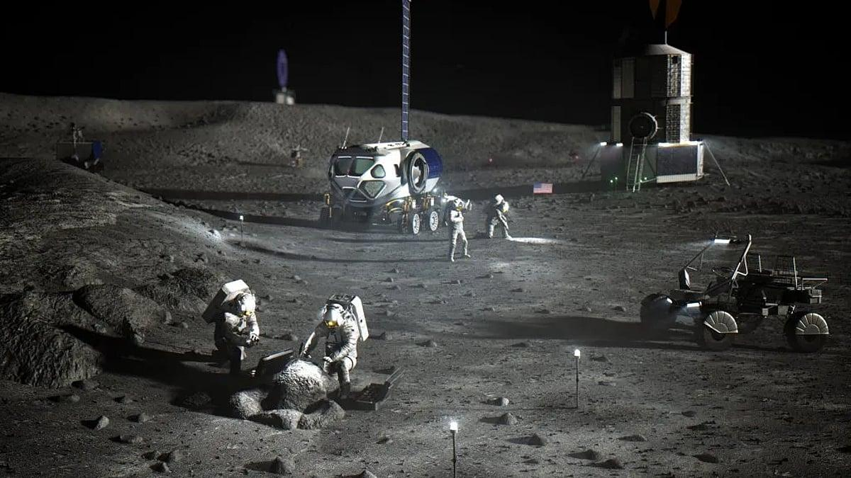
Nasa's invitation to Isro is a potentially significant development for India's space ambitions in the coming years. Although India was the 27th among 47 countries to sign the Artemis Accords (on June 21, 2023), it does not involve direct participation in specific Nasa-led Artemis missions. But the official invite could benefit India's space dreams by opening streams for a regular flow of precious scientific details and experiences, riding on successful past partnerships with the US in pursuit of space exploration and technologies. The timing could not have been better, as India is nurturing the dreams of sending its first astronauts into space in early 2027 on the indigenous Gaganyaan mission; building its own 52-tonne space station by 2035, of which the first, 10-tonne module is planned to be sent up in 2028; and sending its first astronauts to the moon by 2040. India's signing of the accords has already strengthened bilateral cooperation between Isro and Nasa, which paved the way for joint human spaceflight initiatives and advanced technology transfers, besides allowing Indian hardware and future crewed missions to connect smoothly with international lunar infrastructure, maximising scientific returns and cost-effectiveness. This holds promise for even the 400-odd Indian private space startups. Thus, Nasa's invite to participate in the moon base could be a golden ticket for many.

27. Cheap, fast, successful: Why NASA wants ISRO on the Moon - WION
Read more
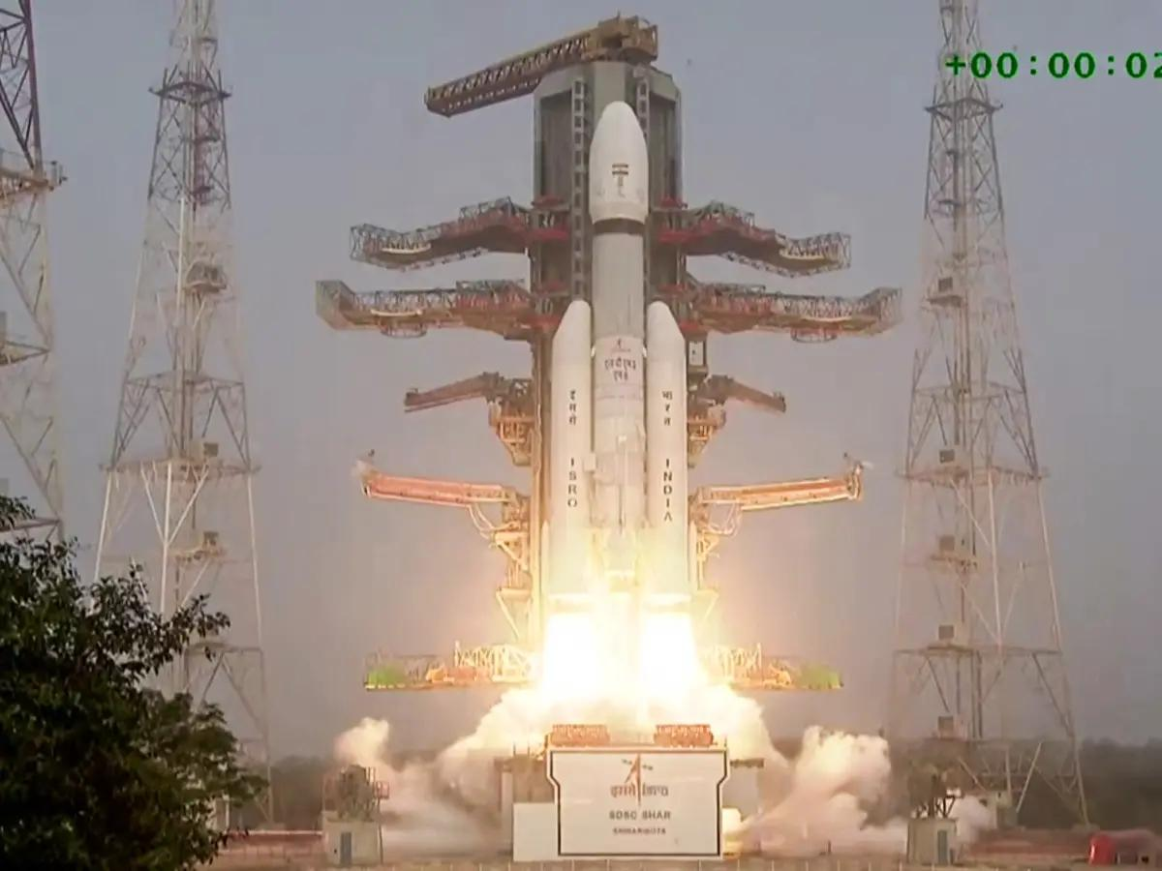
America wants to build a base on the Moon, and NASA wants ISRO on board. The reasons are clear. The United States needs to make the next era of lunar exploration bigger, faster and more cost-efficient. India has built its space programme around exactly that formula. Most importantly, it has already shown the world how to reach the Moon for a fraction of the cost. To sum it up in a nutshell, India has got more done, spent less, and above all, got the mission done, making India and ISRO extremely lucrative. NASA's Moon base programme invitation to ISRO is aimed at establishing a lasting human presence near the Moon's south pole by establishing humanity's first outpost. One that could prepare for crewed missions to Mars and drive lunar scientific breakthroughs. Add WION as a Preferred Source The invitation came during the ninth meeting of the India-US Civil Space Joint Working Group in Bengaluru. US Ambassador Sergio Gor called it a step towards deepening the US-India deep-space partnership. And Chandrayaan-3 explains why. In 2023, ISRO landed safely near the lunar south pole, a historic first, with a mission that cost roughly $75 million. Cheaper did not mean smaller. The mission delivered a landmark result and demonstrated the core strength of India's space model: engineering at a frugal cost, fast execution and the ability to turn limited resources into global-scale achievements. And that is exactly the kind of partner NASA perhaps needs now. Because a Moon base is not one mission. NASA envisions a permanent, habitable outpost where astronauts can live, work and conduct scientific research for extended periods. The base would be built through a series of crewed and uncrewed missions, with habitats, power systems, rovers and cargo operations developed over time. China also has a similar lunar ambition, targeting a crewed Moon landing before 2030 and the construction of an International Lunar Research Station at the Moon's south pole, running directly in a competitive space race alongside NASA's Artemis programme. And the development comes at a time when India is also building its first national space station, the Bharatiya Antariksh Station, with the first module planned for launch by 2028 and full completion targeted by 2035. India's maiden human spaceflight is targeted for 2027. And to ensure that Gaganyaan becomes a sustained space exploration mission, ISRO is also reportedly establishing a crew isolation facility and astronaut quarters in Sriharikota, where future astronauts will be trained and equipped for space travel. The location near the lunar south pole is also strategic. Scientists believe permanently shadowed craters there contain water ice, a potential source for life support and even future fuel production. Some elevated areas also receive near-continuous sunlight, making them valuable for solar power. But a permanent presence comes with a permanent bill. Also Read: CM Vijay makes Tamil Nadu State Song mandatory as first song at official events Habitats, power, rovers, cargo, life support, science and crewed flights will all have to work again and again. Every mission will cost money. Every failure will come at a high price. And that is where ISRO's experience becomes a strategic asset. India has shown it can build, launch and operate complex space missions without the budgets of the world's biggest space powers. It has also shown resilience. Chandrayaan-2 ended in partial success in 2019. Four years later, Chandrayaan-3 landed. NASA likely sees ISRO as a partner that brings technological sophistication but also something just as important for a long-term Moon programme: cost discipline and proven success. ISRO could also bring its experience in cost-effective mission design, reliable launch services and lunar science while in return gaining access to advanced expertise in habitats, life-support systems, in-situ resource utilisation and deep-space operations. India's participation would also push ISRO from robotic lunar exploration towards a role in sustained human presence on the Moon. So, the next space race may not be won simply by the country that can spend the most. It could also be won by the countries that can achieve the most with the least.

28. NASA invites ISRO to join its Moon Base programme - Manorama Yearbook
Read more
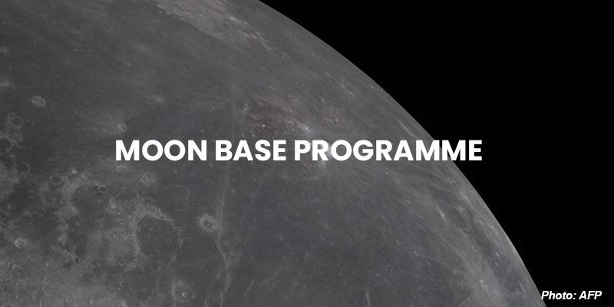
• NASA has invited the Indian Space Research Organisation (ISRO) to join its Moon Base programme, building on the two countries' partnership under the Artemis Accords. • The project is aimed at setting up a permanent habitat on the lunar surface for astronauts to live, work, and explore through a series of crewed and uncrewed missions. • The invitation was an outcome of the 9th meeting of the India-US Civil Space Joint Working Group (CSJWG) hosted at the headquarters of the ISRO in Bengaluru. Highlights of the meeting: • The meeting advanced civil and commercial space cooperation under the US-India Transforming the Relationship Utilizing Strategic Technology (TRUST) Initiative, in line with the February 2025 Joint Leaders' Statement issued by Prime Minister Narendra Modi and US President Donald Trump. • Both sides discussed expanding cooperation following the successful launch of the joint NASA-ISRO Synthetic Aperture Radar (NISAR) mission in 2025, as well as pursuing future science and human space flight technology collaborations. • They reaffirmed their commitment to advancing the United Nations Committee on the Peaceful Uses of Outer Space (COPUOS) guidelines on the long-term sustainability of outer space activities, as well as reviewed ongoing multilateral efforts for ensuring the Committee's effectiveness. Moon Base Programme • The Moon Base is humanity's first lunar outpost, a place where astronauts will live, work, and explore near the Moon's South Pole. • Through a series of crewed and uncrewed missions, NASA and its partners will build the infrastructure needed to support a sustained human presence on the Moon, unlock new scientific discoveries, and prepare for future exploration of Mars. • The South Pole region offers unique opportunities for exploration, discovery, and long-term human presence. • This remote frontier may hold resources that can help support future explorers and answer important questions about the history of the Moon, Earth, and our solar system. Three phases of development The Moon Base will be built step by step using a phased approach. Phase One (2026-2029): The first phase focuses on gaining reliable access to the lunar surface and building a deeper understanding of the environment. Robotic missions will explore the lunar South Pole, demonstrate new technologies, and gather the knowledge needed to guide future development. By expanding experience landing and operating on the Moon, NASA will identify promising locations for future infrastructure, improve mission capabilities, and reduce risk before astronauts arrive. Phase Two (2029-2032): Building on what is learned during Phase One, NASA will begin deploying the first infrastructure needed to support long-term operations on the Moon. Early power systems, cargo transportation, logistics, and communications capabilities will expand humanity's footprint on the Moon and enable increasingly complex missions. By establishing infrastructure across multiple locations, NASA will create a flexible and resilient foundation that can support continued exploration and future expansion of the Moon Base. Phase Three (2032 and Beyond): With the Moon Base's foundational infrastructure in place, NASA will begin assembling a permanent lunar outpost where astronauts can live and work for extended periods. Habitats, power systems, communications, transportation, and other critical capabilities will come together to support an enduring human presence near the Moon's South Pole. As the Moon Base grows and evolves, it will enable increasingly ambitious scientific research, technology demonstrations, and exploration, while helping prepare humanity for future journeys deeper into the solar system. (The author is a trainer for Civil Services aspirants.)

29. India - U.S. Civil Space Joint Working Group meeting at ISRO Headquarters, Bengaluru - ISRO
Read more
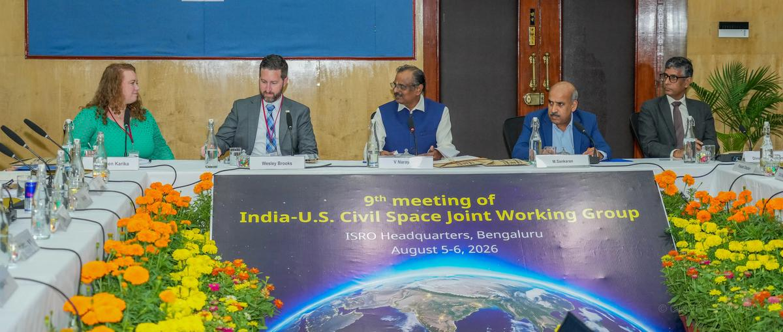
August 12, 2026 The 9th meeting of the India-U.S. Civil Space Joint Working Group (CSJWG) was hosted by India on 5-6 August 2026 at the headquarters of the Indian Space Research Organization (ISRO) in Bengaluru. Dr. V. Narayanan, Chairman, ISRO/ Secretary, Department of Space and H.E. Sergio Gor, the U.S. Ambassador to India addressed the opening segment and highlighted the significance of further strengthening the bilateral space cooperation. The meeting was co-chaired on the Indian side by Mr. M. Sankaran, Director, UR Rao Satellite Centre, ISRO and on the U.S. side by Dr. Wesley Brooks, Assistant Secretary of State for Oceans and International Environmental and Scientific Affairs and Ms. Kathleen Karika, NASA Associate Administrator for International and Interagency Relations. The meeting advanced civil and commercial space cooperation under the U.S.-India Transforming the Relationship Utilizing Strategic Technology (TRUST) Initiative, in line with the February 2025 Joint Leaders' Statement issued by Prime Minister Modi and President Trump. Both sides discussed expanding cooperation following the successful launch of the joint NASA-ISRO Synthetic Aperture Radar (NISAR) mission last year, as well as pursuing future science and human space flight technology collaborations. They reaffirmed their commitment to advancing the United Nations Committee on the Peaceful Uses of Outer Space (COPUOS) guidelines on the long-term sustainability of outer space activities, as well as reviewed ongoing multilateral efforts for ensuring the Committee's effectiveness. NASA invited ISRO to join its Moon Base programme, building on the two countries' partnership under the Artemis Accords. The two sides also agreed to advance discussions for cooperation on open scientific data sharing under the Accords.

30. NASA Data Helps Commercial Space Plan Living Off Our Moon
Read more
NASA has been taking pictures of the Moon for decades, collecting a wealth of data. This false-color picture is a composite of 15 images of the Moon taken through three color filters on NASA's Galileo solid-state imaging system. Credit: NASA The barren lunar landscape has some important resources, such as water and minerals like iron and titanium, but extracting and processing them will require special equipment. Where those resources can be found will dictate where to land and how to mine them. To help with that, Lunar Station Corp. is using a wealth of NASA data in multiple computer models. "With 60 years of lunar data available to us, we help our clients understand the environmental factors for any given location on the Moon," said Blair DeWitt, CEO of Lunar Station. Combining disparate data from different sensors used by NASA and other space agencies is a critical first step. One NASA resource the Cambridge, Massachusetts-based company used to build terrain maps is the Ames Stereo Pipeline. The open-source code automatically processes images captured from satellites, robotic rovers, historical images, and more to create a 3D model revealing features such as rock placement and elevation. But the availability of in-situ lunar water resources at any location is largely unknown, according to Gerry Sanders, in-situ resource utilization system capability lead at NASA's Johnson Space Center in Houston. To begin to fill that gap, the Lunar Crater Observation and Sensing Satellite was designed to crash its uppers stage into the Moon's South Pole in 2009. The examination of the resulting plume revealed the presence of water ice. Lunar Station is building on that work and more to help commercial space companies with mission planning, which includes scientific research for mining operations. The MoonHacker program uses proprietary geospatial analytics platform and advanced algorithms to fuse all the lunar data in NASA's Planetary Data System to help identify indicators for shallow pits of lunar water. "We can find sites for landing pads, for cultivating the best paths for roving, and inform our clients about communications. If you can't see Earth at a given location like in the polar regions or the far side of the Moon, you have to come up with a relay strategy," said DeWitt. "We can do this in part thanks to NASA data." In MoonHacker's Radiation Simulator, an electronic version of a company's rover or satellite, called a digital twin, can be subjected to the radiation en route or at the mission site to determine the protection required.

31. NASA Upgrades Vertical Motion Simulator for Modern Mission Needs
Read more
The Vertical Motion Simulator at NASA's Ames Research Center in California's Silicon Valley is capable of vertical and horizontal motion to simulate a range of flight experiences, such as lunar landers, helicopters, and commercial aircraft. NASA/Jesse Carpenter Imagine stepping into a machine that can make you feel like you're flying a spacecraft, piloting a next generation air taxi, or landing on the Moon, all without leaving the ground. NASA's Vertical Motion Simulator, the largest of its kind in the world, does exactly that. And now, with new upgrades, it's more powerful and realistic than before. The Vertical Motion Simulator, located at NASA's Ames Research Center in California's Silicon Valley, has shaped the future of aviation and spaceflight since 1979. It allows pilots and researchers to experience realistic aircraft motion due to its ability to travel 60 feet vertically and 40 feet horizontally, simulating vehicles ranging from helicopters to spacecraft with high accuracy. New improvements are making the simulator even more powerful. One of the biggest changes is the switch from analog systems to modern digital technology. This upgrade includes a dome surrounding the simulator's cockpit with advanced 4K projectors that create visuals with nearly 20/20 clarity, giving pilots clearer, sharper images and a larger field of view of the world outside the cockpit. The upgraded cab of the Vertical Motion Simulator at NASA's Ames Research Center in California's Silicon Valley provides researchers with near-20/20 visual clarity, providing clearer, sharper images. NASA/Brandon Torres-Navarrete "The new dome configuration and improved systems can support far more aggressive mission tasks while giving pilots and crews a more realistic environment to work in," said Diana Acosta, aerospace simulation research and development branch chief at NASA Ames. "It strengthens how teams coordinate, react, and manage challenging scenarios, exactly the kind of preparation we need for the missions coming next." The system also can automatically line up and color‑match images to integrate them into a simulated background, a process that used to take hours, or even days, to do by hand. In the past, changing simulation configurations from lunar lander to air taxi required swapping out the cab, a large, heavy structure that was time‑consuming and complex to move. Instead of replacing an entire cab, teams can use lighter, removable inserts that include only the controls, seats, and panels needed to stand in for a specific vehicle. The inserts drastically reduce physical labor and cut the time needed to configure a simulation in half. The upgrades to the Vertical Motion Simulator will enable tests of next-generation aircraft and spacecraft before they ever leave the ground, bringing us closer to safer skies, more efficient air travel, and successful human landings on the Moon and Mars.

32. NASA Astronaut Mike Fincke Leaves NASA, Career Includes 4 Spaceflights
Read more
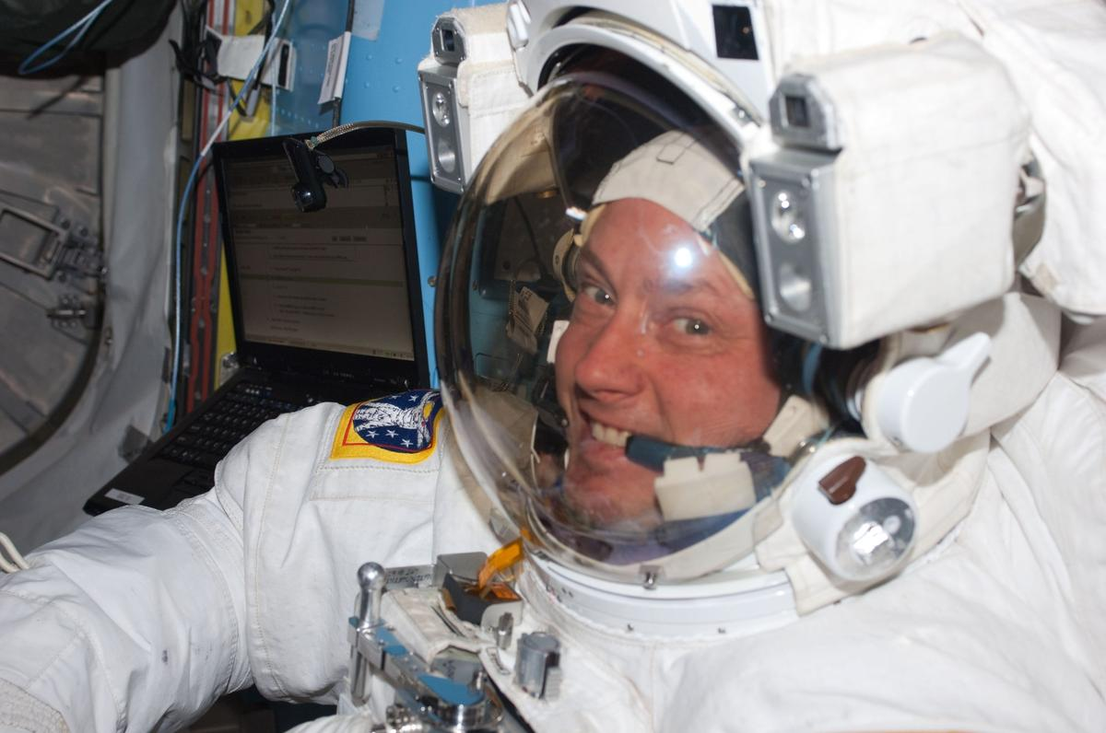
NASA astronaut Mike Fincke is pictured inside the International Space Station's Quest airlock prior to the start of the third spacewalk for the STS-134 mission. Credit: NASA NASA astronaut Mike Fincke is departing the agency on Wednesday after 30 years of service. Throughout his career, he flew four missions, spent 549 days in space, and completed nine spacewalks in support of the International Space Station. "Few people have had the opportunity to shape as many chapters of NASA's history as Mike Fincke," said NASA Administrator Jared Isaacman. "Over a remarkable career, Mike served our nation as a pilot, engineer, astronaut, and mentor. From long-duration missions aboard the International Space Station to helping prepare the Artemis generation, his contributions have helped position NASA for what comes next. The success we're building on today is possible because of people like Mike, who dedicated their careers to moving our space program forward and preparing the next generation to carry the mission even further. I'd like to congratulate Mike on an incredible career and thank him for his decades of service to NASA, our nation, and the countless people who had the opportunity to learn from and fly alongside him." He ranks fourth among NASA astronauts in accumulated time in space, and his spacewalks total 48 hours and 37 minutes. Most recently, Fincke piloted NASA's SpaceX Crew‑11 mission, which launched in August 2025 and returned in January. During the mission, he served as a flight engineer for International Space Station Expedition 73 and commander of Expedition 74. Fincke joined NASA's 16th astronaut class in 1996 and first flew to space in 2004 aboard Soyuz TMA‑4 in support of the space station's Expedition 9. Serving as a science officer and flight engineer, he helped maintain station systems and performed four spacewalks. He returned to space in 2008 on Soyuz TMA‑13 as commander of Expedition 18, preparing the space station for its transition to six‑person crews at the time and completing two more spacewalks. In 2011, Fincke flew on STS‑134, the final flight of space shuttle Endeavour. As mission specialist and robotic arm operator, he completed three spacewalks and helped deliver and install the Alpha Magnetic Spectrometer. "Mike's remarkable career reflects three decades of dedication to NASA's mission and the advancement of human spaceflight," said Vanessa Wyche, director of NASA's Johnson Space Center in Houston. "From his time aboard the International Space Station to his commitment to mentoring the next generation, Mike has made an immense impact across our agency. His legacy of service, mentorship, and dedication to exploration will continue to inspire the generations to come." Throughout his career, Fincke bridged spacecraft development, flight testing, and mission operations. Early in the International Space Station Program, he helped test and integrate several of the station's initial modules before launch. His flight experience spanned multiple generations of human spacecraft, including two missions aboard Soyuz, one aboard the space shuttle, and later piloting the SpaceX Dragon. Fincke was a foundational contributor to NASA's Commercial Crew Program. As chief of the Astronaut Office's Commercial Crew Branch, he worked to ensure astronaut needs, crew safety, and human spaceflight experience informed development of the nation's next generation of crewed spacecraft. He spent five years supporting Boeing's Crew Flight Test program training as a crew member and backup pilot, contributing to flight software, systems integration, integrated testing, and spacecraft interfaces. Fincke also supported station operations from the ground as a crew test support team member in Russia, a capsule communicator, or capcom, and crew procedures team lead. He helped translate complex engineering and operational requirements into clear instructions for crews working in orbit. His continuity across development, integration, mission support, and long‑duration flight gave him an end‑to‑end perspective on space station assembly and operation. "Mike approached every assignment with experience, humility, and an unwavering focus on the mission," said Scott Tingle, chief of the Astronaut Office at NASA Johnson. "Whether flying aboard the station, supporting crews from the ground, or helping shape the spacecraft that future crews will rely on, he consistently strengthened our team. His legacy is woven into the way we fly today." A native of Emsworth, Pennsylvania, Fincke holds bachelor's degrees in aeronautics and astronautics and in Earth, atmospheric, and planetary sciences from the Massachusetts Institute of Technology, where he also studied in the Soviet Union through an exchange program with the Moscow Aviation Institute. He earned master's degrees in aeronautics and astronautics from Stanford University and in planetary geology from the University of Houston, Clear Lake. Fincke is a retired U.S. Air Force colonel and distinguished graduate of the U.S. Air Force Test Pilot School. He served as a space systems engineer and flight test engineer at Edwards and Eglin Air Force Bases and later as the U.S. flight test liaison to the Japanese‑U.S. XF‑2 fighter program at Gifu Air Base in Japan. He accumulated more than 2,000 flight hours in more than 30 aircraft types. "After exactly 30 years, I am departing NASA, but I remain deeply committed to the work of exploration." Fincke said. "NASA gave me the extraordinary privilege of serving alongside remarkable people, flying and helping develop spacecraft, and contributing to the International Space Station from its earliest days through command in orbit. I am profoundly grateful to my crewmates, the teams on the ground, our international partners, and the families who make this work possible. I am excited to carry those lessons forward and help prepare the next generation of engineers, explorers, and leaders. Together, we will return humanity to the Moon, travel to Mars, journey outward to the planets and moons beyond Earth, and someday reach for the stars - all while caring for Earth, the most beautiful planet in our solar system." To learn more about NASA's astronauts and space exploration, visit: https://www.nasa.gov/astronauts -end- Jimi Russell Headquarters, Washington 202-358-1100 james.j.russell@nasa.gov Anna Schneider Johnson Space Center, Houston 281-483-5111 anna.c.schneider@nasa.gov

33. Radiation-shielding vest aced Artemis I lunar test, could protect astronauts on moon and Mars missions
Read more
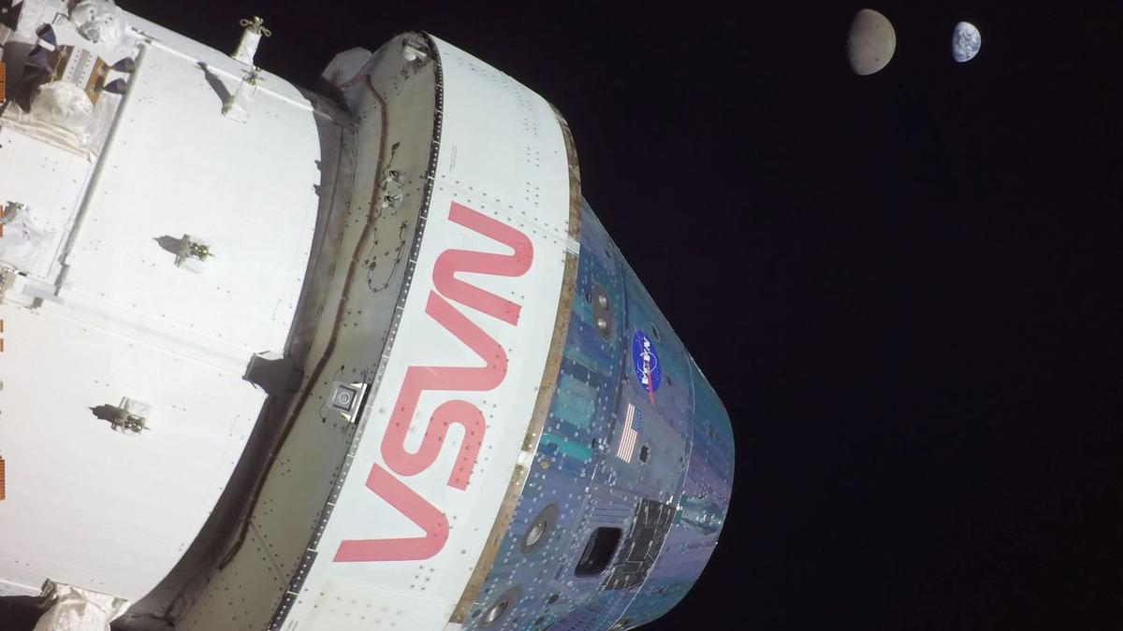
Click for next article A radiation-shielding vest might one day protect astronauts from dangerous, random outbursts from the sun, a new study finds. More than 50 years after the final Apollo mission, NASA's Artemis program aims to return humans to the moon . To succeed, this project must protect astronauts from solar radiation, especially the intense and unpredictable radiation from solar storms . Coating an entire spacecraft with a meaningfully thick layer of radiation shielding remains impractical due to weight constraints, but wrapping astronauts in protective garments may potentially be helpful. In the new study, researchers experimented with the AstroRad vest , which was designed by the Israeli startup StemRad with support from the Israel Space Agency and aerospace giant Lockheed Martin. The garment was created to protect astronauts from explosions from the sun known as solar particle events. The "phantoms" Helga and Zohar inside the Orion spacecraft at NASA's Vehicle Assembly Building prior to the launch of Artemis I. Zohar, right, wore the AstroRad vest while Helga did not. (Image credit: NASA/Lockheed Martin/DLR) " Radiation in space is unavoidable, and a single major solar particle event can make a substantial contribution to an astronaut's lifetime risk of radiation-induced cancer," study co-author Oren Milstein, CEO and co-founder of StemRad, told Space.com. "By significantly reducing that contribution, personal shielding could be particularly important for future lunar and Mars missions." When it comes to protection against radiation, lead is excellent at blocking hazardous forms of light, such as X-rays and gamma rays. However, lead is much less effective at defending against the kinds of dangerous particles that can hurtle through space. For instance, when fast high-energy electrons known as beta particles strike dense lead atoms, they can trigger a shower of X-rays that are more harmful than the beta particles themselves. And if neutrons strike lead atoms, they can knock loose a spray of neutrons from the atoms' nuclei, worsening the impact from the radiation. Instead, AstroRad relies on a high-density plastic rich in hydrogen. Among the elements, hydrogen possesses the highest density of electrons per atom, which can help create a dense shield to protect against incoming particles. At the same time, hydrogen atoms normally do not have neutrons, so if neutrons hit them, they cannot generate the kind of dangerous neutron sprays that can happen with lead atoms. Moreover, the plastic in AstroRad is much lighter than lead. This makes it easier to move around in garments incorporating the plastic, and more practical for space missions in which weight is a major limitation. The scientists combined thousands of hexagonal rods of the rigid plastic together like scales to create a flexible garment. All in all, each vest weighed about 57 pounds (26 kilograms). The scientists developed a vest rather than a full-body suit or a helmet because "different organs and tissues have very different sensitivities to radiation, so shielding every part of the body equally is not the most effective approach," study co-author Jordan Houri, lead scientist for space exploration at StemRad, told Space.com. "At the same time, a full-body suit would be much harder to put on and move around in." The shielding thickness of the AstroRad vest was based on how sensitive to radiation the underlying organs were. This strategy provides about a 30% greater reduction in the dose of radiation a person receives compared with distributing the same amount of shielding uniformly across the body, Houri said. The researchers tested their vest during NASA's uncrewed Artemis I moon mission in late 2022 using a pair of extraordinarily complex dummies called phantoms. These artificial torsos were constructed of plastics that mimicked the density of human tissue, bone and organs, and each was equipped with more than 5,600 radiation sensors on and in them. The two phantoms were designed to be adult females, since previous research found that breasts and ovaries are especially susceptible to radiation damage. "Women are predicted to face a higher risk of radiation-induced cancer," Milstein said. "Targeted shielding could help narrow that difference in risk between male and female astronauts." Since the phantoms mimicked women, they were given women's names, Zohar and Helga . "Helga was contributed to the experiment by the German Aerospace Center, and Helga is a traditional German name," Milstein said. "Zohar was contributed by the Israel Space Agency, which selected the name through a public outreach campaign. Zohar is a traditional Hebrew name meaning 'radiance,' which we thought was particularly fitting." Assembling the Zohar phantom with the AstroRad vest at Kennedy Space Center prior to launch of Artemis I. (Image credit: NASA/DLR) Zohar and Helga flew seated in NASA's Orion spacecraft; Zohar was equipped with an AstroRad vest, while Helga was not. Although Orion did not encounter a significant solar outburst during its 26-day mission to lunar orbit and back, the researchers were able to extrapolate how much solar radiation astronauts might experience based on what the phantoms encountered passing through the inner Van Allen belt of radiation surrounding Earth. When the scientists analyzed past solar particle events, they found the AstroRad vest would have significantly reduced the dose of radiation a person during those outbursts - for instance, by nearly 60% for a solar particle event that happened in August 1972. "We had originally anticipated something closer to 45%, so when we first saw the result, we thought we needed to go back and find an error," Houri said. "Instead, the detailed analysis showed that AstroRad's approach of providing targeted shielding to the most radiation-sensitive organs and tissues was even more effective than we had projected." Such a reduction could spare astronauts the equivalent of up to 193 days of deep-space radiation exposure. "The most important implication is that AstroRad could help overcome one of the major health challenges limiting long-duration human exploration beyond Earth ," Milstein said. 3D rendering of the Matroshka AstroRad Radiation Experiment (MARE) during NASA's Artemis I mission, showing the two radiation dosimetry phantoms, Helga and Zohar inside the Orion spacecraft. (Image credit: NASA/Lockheed Martin/DLR/StemRad) AstroRad is not something astronauts would wear continuously throughout an entire mission, Houri said. "AstroRad was developed as an emergency countermeasure for solar particle events, so astronauts would only wear it when radiation levels are elevated, typically for periods of hours or days," he explained. Still, "although it is not something astronauts would need to wear throughout an entire mission, we designed the vest to remain usable for many hours at a time," Milstein said. During tests with the vests on the International Space Station , "several crew members even slept with it on." The level of radiation protection the AstroRad vest provided was similar to that supplied by the Orion spacecraft's onboard storm shelter , "while allowing the astronaut wearing it to leave the shelter and continue mission-critical tasks," Houri said. "AstroRad can be used on its own or together with a shelter, but one of its main advantages is that an astronaut can remain protected while moving around the cabin and carrying out essential mission operations rather than remaining inside the shelter." The scientists are now investigating whether it is possible to manufacture radiation shielding in space using onboard materials. For instance, in collaboration with Florida aerospace company Redwire, "we have already demonstrated that it is possible to 3D-print AstroRad components from recycled polyethylene aboard the International Space Station," Milstein said.

34. Farthest 'black hole star' ever found could help solve the James Webb Space Telescope's little red dot mystery
Read more
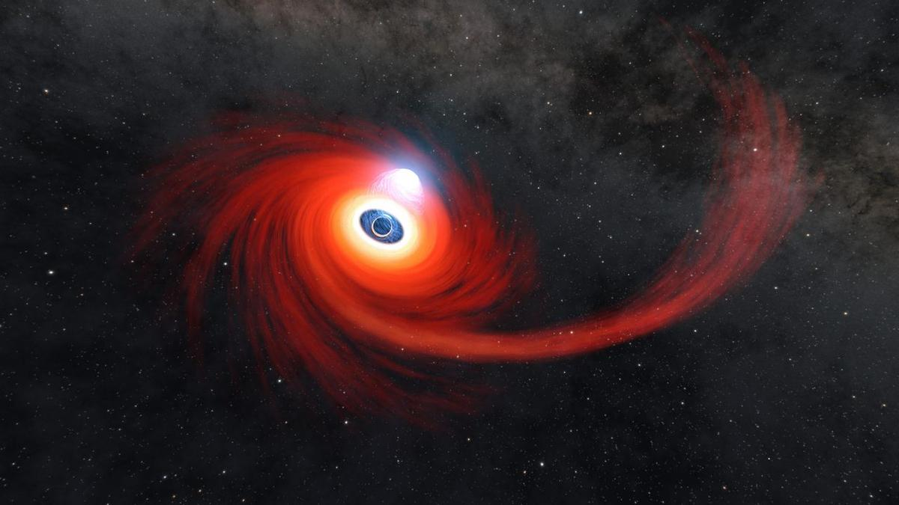
Click for next article The most distant 'black hole star' yet found, existing in the universe less than 660 million years after the Big Bang, has provided a vital clue as to the origin of the mysterious "little red dots" that populate the James Webb Space Telescope's images of the early universe. The consensus seems to be that these bizarre objects, which were first discovered in 2022, are growing supermassive black holes entombed within huge clouds of gas that have spectrums similar to cool, red stars, such as red giants . Recently, astronomers have been finding that some of these objects are placed within the center of young galaxies whose light has been traveling for about 12 billion years, give or take a billion, to reach us. Given their distance and faintness, black hole stars' light is difficult to disentangle from the light of a surrounding galaxy, especially when we know there is likely a galaxy there that's too faint for the JWST to resolve. However, a newly discovered black hole star, unearthed during a JWST program called the Mirage or Miracle (MoM) survey, is acting as a kind of a missing link. "The Mirage or Miracle survey was designed specifically to target sources considered 'risky,' meaning they could either be amazing discoveries or just interlopers, such as some cold nearby stars that look like distant galaxies," Jorryt Matthee of the Institute of Science and Technology Austria and a co-investigator on the MoM survey said in a statement. In particular, the survey focuses on objects that look like they could be very high redshift galaxies (around a redshift of 10 or more, which equates to having existed about at least 13.1 billion years ago). The black hole star found by the survey has been named MoM-BH*-1 and is the best example yet of a "naked" black hole star, meaning astronomers are fairly certain it exists in space on its own rather than inside a burgeoning galaxy. This means all of its light is generated by accretion onto the black hole at the center of the cloud. Though we cannot see this accretion because of the obscuring gas cloud, this light energizes the surrounding cloud from within, causing it to glow just as energy generated within the sun causes its outer layers to radiate. "The spectrum we detected is our best evidence of a cloak of gas feeding an early forming black hole," Rohan Naidu of the University of Hawaii, who led the team who discovered MoM-BH*-1 and is co-leader of the MoM survey, said in the statement. Some of the JWST's little red dot discoveries. (Image credit: NASA, ESA, CSA, STScI, Dale Kocevski (Colby College)) Intriguingly, MoM-BH*-1 lies close in space to a young galaxy at the same redshift, and estimates suggest that it will take another 100 million years for the black hole star to collide and merge with the galaxy. Naidu and Matthee's team modeled what the spectrum of the galaxy would look like after it has merged with MoM-BH*-1, and found that it would look very much like the little red dots already known to exist within galaxies. "Considering the black hole star as a template for the black hole component of little red dots helps clarify many of the uncertainties about them," said Matthee. "If embedded in similar host galaxies, black hole stars like MoM-BH*-1 might well serve as the central engines of baby quasars ." In this way, MoM-BH*-1 provides strong evidence for the object at the heart of faint galaxies encompassing little red dots as being a black hole star. Recent observations of some little red dots at lower redshifts have shown the cloud of gas around the black hole begin to disintegrate, exposing the black hole and the X-rays produced by the accretion of gas onto it. These black holes appear to be growing fast, and the environments surrounding such active black holes become highly luminous, creating a quasar. An artist's impression depicting the similarity between stars and black hole stars, except that black hole stars are at least 100,000 times larger than the sun. (Image credit: Rohan Naidu (University of Hawaii).) "Astronomers have never lacked imagination: since the discovery of quasars, there has been no dearth of theories to explain how these black holes grew so massive so fast," said Naidu. "Something spectacular must have happened in the early universe. Now with JWST, we can directly observe this era and see for ourselves which scenarios actually occur." Learning of the birth of supermassive black holes and whether they predate the galaxies that surround them was one of the primary science goals of the JWST before it launched. In this it has been tremendously successful so far. Despite little red dots having only been discovered four years ago, research into them and black hole stars is accelerating, with new findings coming out now almost on a weekly basis. "These are incredibly exciting times with nearly a thousand papers and preprints on little red dots in the past two to three years," said Matthee. "Far from a mirage, this might well be a cosmic miracle." The findings were published on Aug. 13 in the journal Nature.

35. On this day in space! Aug. 12, 2005: Mars Reconnaissance Orbiter launched
Read more
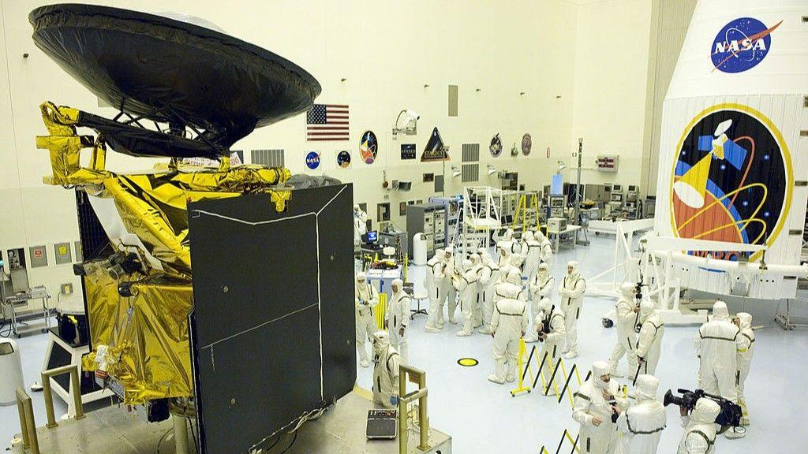
Click for next article On Aug. 12, 2005, NASA launched its Mars Reconnaissance Orbiter. The Mars Reconnaissance Orbiter (MRO) mission lifted off on a United Launch Alliance Atlas V-401 rocket from Space Launch Complex 41 at Cape Canaveral Air Force Station (now known as the Cape Canaveral Space Force Station) in Florida. Some of the best cameras ever launched into space are on MRO, and the spacecraft has taken some seriously amazing photos of Mars . The High-Resolution Imaging Science Experiment, or HiRISE camera , takes super-sharp photos of the Martian surface and has helped NASA scout the Red Planet for suitable landing sites for rovers like Curiosity . It also serves as a data relay station for other spacecraft on Mars that need to beam data back to Earth. MRO has also studied water and ice on Mars, and its cameras have revealed some pretty remarkable landscapes . The Mars Reconnaissance Orbiter (MRO) in the Hazardous Payload Service Facility at NASA's Kennedy Space Center on July 20, 2005 in Cape Canaveral, Florida. (Image credit: Matt Stroshane/Getty Images) Why it mattered Now operational for more than 20 years, MRO serves as one of NASA's oldest spacecraft in operation around the Red Planet. It has become instrumental in the space agency's ability to maintain communication with other probes in orbit around Mars and rovers on the planet's surface. The probe's HiRISE camera revolutionized scientists' understanding of Mars' diverse surface features, with resolution high enough to picture objects as small as 3 feet (1 meter) wide. Since its arrival in orbit around Mars on March 10, 2006 , MRO has snapped more than 100,000 images of the surface below and helped NASA track geologic activity like migrating dunes, impact craters, avalanches, dust storms and seasonal frost changes. And NASA is still finding ways to put the aging satellite's scientific instruments to good use. For example, the agency executed a 120-degree roll program last year designed to strengthen MRO's SHARAD radar signal by 10 times or more, allowing it to probe deeper than 1 mile (1.6 kilometers) underground to detect water ice. MRO's role as a communications relay for probes on and around Mars became even more important earlier this year, when NASA's MAVEN mission ended in June . Today, MRO returns around 80,000 megabits of data per day, according to Astronomy.com , and remains one of NASA's most critical assets in orbit around Mars.

36. SpaceX wraps Starlink double header day with the launch of 24 Starlink satellites from California
Read more
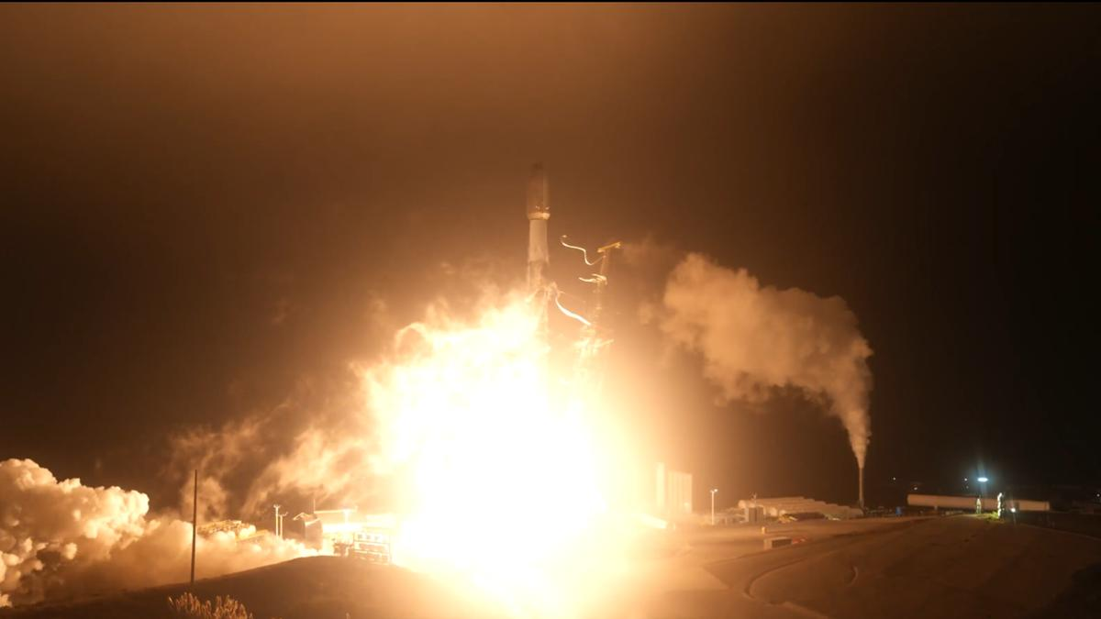
Click for next article Just over 12 hours after its first liftoff of the day out of Florida's Space Coast, SpaceX has delivered a second batch of Starlink internet satellites to orbit on a rocket lifting off from the company's California launch site. A Falcon 9 rocket lifted off from Vandenberg Space Force Base on Aug. 12, at 12:46 p.m. EDT (0346 GMT; 9:46 p.m. local time). The mission, Starlink Group 17-49, carried 24 of the broadband spacecraft to low Earth orbit (LEO) to join SpaceX's growing constellation of more than 10,000 satellites. About 8.5 minutes after clearing the tower, the Falcon 9's first stage, Booster 1103 successfully landed on SpaceX's "Of Course I Still Love You" droneship in the Pacific Ocean." It was the fifth flight for this particular booster. The Falcon 9's first stage is seen just after its drone-ship landing on Aug. 12, 2026. (Image credit: SpaceX) In addition to being its third Starlnk mission, B1103 also launched the NROL-179 and SDA-T1TL-E in support of U.S. national defense. Following separation from Falcon 9's main booster, the rocket's second stage flew onward to LEO, delivering its 24 Starlink satellites about one hour after liftoff. Today's liftoff was the 94th Falcon 9 launch of the year, 73 of which have delivered Starlink stacks to the growing constellation - the largest satellite constellation ever assembled. Starlink currently consists of more than 10,900 active satellites , according to astrophysicist Jonathan McDowell. But SpaceX has even bigger megaconstellations in mind: The company has filed to operate 100,000 of its bigger, more capable Starlink V3 satellites, and SpaceX CEO Elon Musk has also stated his intent to launch a million AI data center satellites to Earth orbit as well.
37. IN-SPACe overreach threatens ISRO's strategic future: G Madhavan Nair - The Federal
Read more
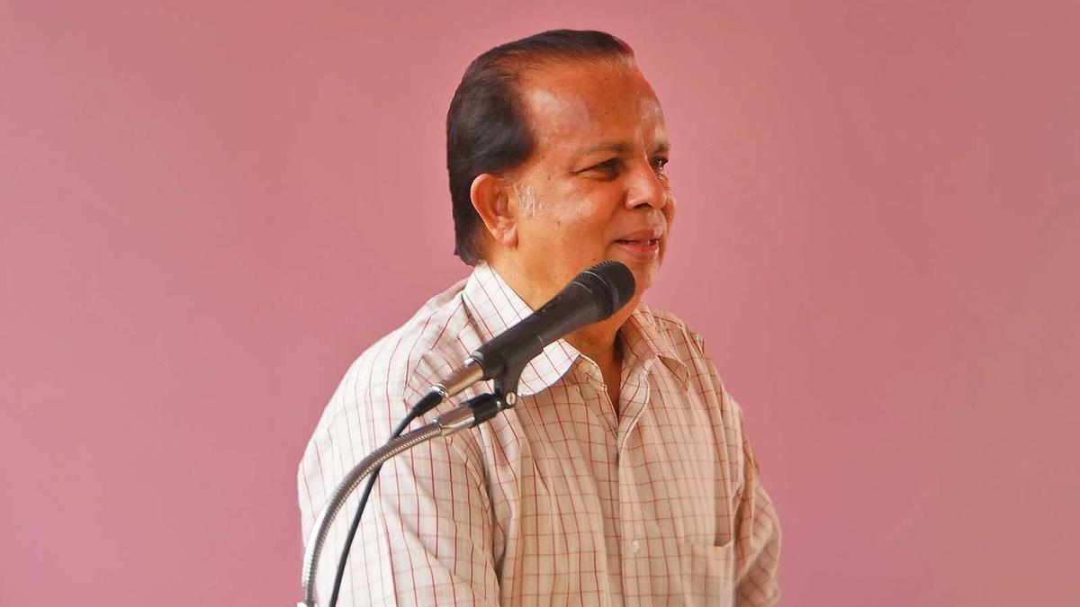
It appears that the Indian Space Research Organisation (ISRO) plunges into a crisis after achieving every major milestone. Is it a jinx or something that the Indian strategic organisation must contend with, wondered G Madhavan Nair, retired Secretary, Department of Space (DoS). and former Chairman, ISRO, in an interaction with The Federal. Nair also categorically said the Indian National Space Promotion and Authorisation Centre (IN-SPACe), the regulator for private space sector players, is acting beyond its mandate by calling bids from industries for ISRO's technologies and assets. First about the jinx Once is happenstance, twice is coincidence and three times is enemy action, goes the old saying. In ISRO's case, there appears to have been more than one such instance. Is it merely coincidence, a recurring institutional vulnerability, or something more deliberate? "There seems to be a pattern. Soon after ISRO achieves a major technological milestone, some controversy or action happens, putting the organisation into a sort of crisis to pull it down," Nair told The Federal. In support of his view, Nair said India successfully launched its Polar Satellite Launch Vehicle (PSLV) in October 1994, proving its ability to put satellites into orbit with its own rockets. Also Read: TN rocket port in private hands: Is IN-SPACe becoming Centre's space privatisation arm? Shortly after this achievement, the agency was rocked by an espionage scandal. But the Supreme Court ruled that the charges against a top ISRO scientist were fabricated. Antrix-Devas controversy "The next issue was the Antrix Corporation-Devas Multimedia issue that happened soon after India's first moon mission, or Chandrayaan-1, came to an end in 2009," Nair said. Also Read: Why are top scientists quitting ISRO? The Chandrayaan-1 mission was launched in October 2008. In August 2009, ISRO formally announced the mission's end, by which time several discoveries, including evidence of water on the Moon, had been made by the Indian payloads. ISRO's unique culture should be nurtured, and the golden egg-laying goose should not be killed. And soon after that, the Antrix-Devas Multimedia agreement blew up into a major controversy and the agreement was scrapped. LVM3 success and the new challenge The year 2014 saw the emergence of ISRO's heavy-lift rocket LVM3. Since then, the LVM3 rocket has been flown nine times for orbiting domestic and foreign satellites, including those of European player OneWeb and US company AST SpaceMobile. Also Read: Centre changes ISRO resignation rules amid exodus of experienced scientists After launching of the foreign communication satellites, Nair sees the current phase as posing a sort of existential challenge to ISRO, with not only its rockets and other technologies being tendered out but also its infrastructure assets, including the upcoming spaceport at Kulasekarapattinam in Tamil Nadu. IN-SPACe, set up as the regulator for private sector space players, has called for Expressions of Interest (EoI) for ISRO's PSLV and LVM3 rockets and for the about Rs 1,000 crore rocket port coming up in Tamil Nadu. "IN-SPACe is overacting, assuming roles not assigned to them. They are interfering with ISRO's and NewSpace India Ltd's (NSIL) activities. A sectoral regulator cannot be the executor of programmes," Nair said. Rocket tech transfers Adding a note of caution on the transfer of rocket technologies with dual-use applications, Nair said there should be an appropriate legal framework, and currently there is no safeguard for this. "There is no space law in India now. And many things are happening before it is enacted," he said. Citing India's other strategic sector, Nair said both space and nuclear power have a unified command structure. Also Read: ISRO's PSLV failure: Who pays when rocket missions go wrong? The chairman of the sectoral apex bodies - the Space Commission and the Atomic Energy Commission - and the respective Departments are headed by one person. "Any change will upset the balance," Nair said. Like the space sector, the Indian government has opened up the atomic power sector for private players. And it is only the Nuclear Power Corporation of India Ltd (NPCIL) that had invited bids for its small atomic reactors and not the sectoral regulator, Atomic Energy Regulatory Board (AERB). ISRO, NSIL and IN-SPACe According to Nair, the government-owned Indian space sector has three important organisations: 1) ISRO, which develops technologies and builds infrastructure, carries out space missions and, till date, remains India's only end-to-end integrated space sector player. 2) NSIL, formed to commercialise ISRO's services, its technologies and rockets. 3) IN-SPACe, a regulator, largely for the private sector. Also Read: ISRO to triple spacecraft output, target Chandrayaan-4 launch in 2028: Narayanan IN-SPACe is encroaching into the domain of NSIL and ISRO, Nair emphasised. "While the sectoral regulator can be independent, ISRO, NSIL and industrialisation should be under one roof, with the unity of direction and command being a must. NSIL can form a joint venture with the interested parties instead of transferring the technologies," he observed. He said earlier the industry was not willing to set up separate facilities to cater to ISRO's needs. "Nearly 60% of ISRO's budget was spent in favour of industries in sourcing various systems and components," he recalled. Private sector: hype vs reality Referring to private players in the sector, Nair said there is a lot of hype but nothing major has come out, barring Skyroot Aerospace's successful maiden orbital launch of its rocket. Nair also said the Indian space agency must check whether any of its intellectual property rights have been used without proper licence. IN-SPACe is overacting, assuming roles not assigned to them. They are interfering with ISRO's and NSIL's activities. A sectoral regulator cannot be the executor of programmes. He estimates that an outlay of about Rs 50,000 crore would be needed to realise India's plans to set up a space station, send humans to the Moon, build space capsules and pursue other ambitious programmes. It is only the government that can fund these programmes and not the private sector, he added. Also Read: ISRO's strategic satellite delays expose cracks in India's space readiness There is, however, another side to the debate. The opening up of the space sector to private players is a deliberate policy decision of the government, with IN-SPACe created precisely to facilitate and regulate private participation. The question, therefore, is not whether private participation is desirable, but whether a regulator should also determine which ISRO technologies and assets should be transferred or commercialised, and on what terms. 'Do not kill the goose...' The real test of India's space-sector reforms, therefore, may not be the number of private companies entering the sector or the number of ISRO technologies transferred to industry. It will be whether private participation strengthens India's overall space capability without weakening the institutional capacity, technological independence and strategic role of ISRO. Also Read: ISRO plans to send astronauts to Moon by 2040 "As compared to other R&D organisations in India, ISRO is the only organisation that has acquitted itself well and has taken the country to the skies. ISRO's unique culture should be nurtured, and the golden egg-laying goose should not be killed," Nair remarked. The government can set up committees or groups to chalk out the roadmap for the sector as there are a large number of retired ISRO officials and Chairmen, he suggested. "There is no dearth of space scientists in India. What is the logic of sending home space technologists at 60 while having much older and an expert in the automobile sector as the sectoral regulator?"

38. ISRO taking steps to tackle space debris, rising satellite congestion: Dr Jitendra Singh - Greater Kashmir
Read more
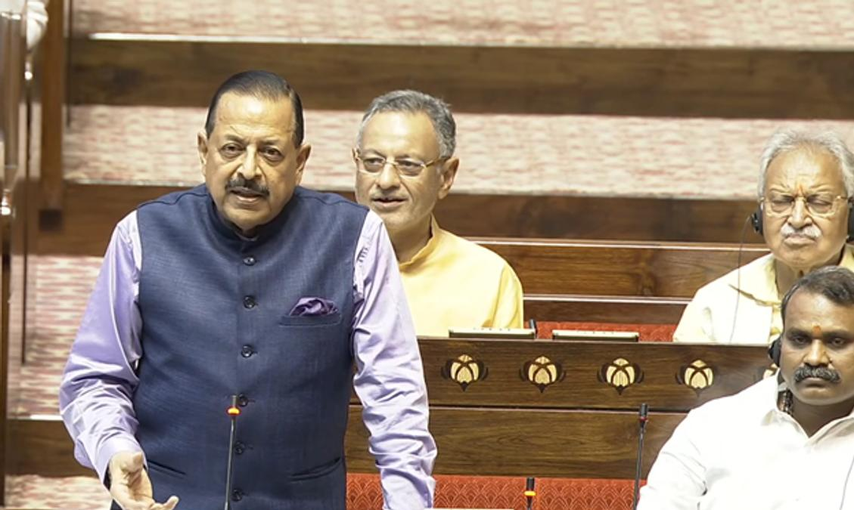
New Delhi, Aug 13: The Indian Space Research Organisation (ISRO) is seized of the issue of proliferation of a large number of Low Earth Orbit (LEO) satellite constellations or Satellite Internet constellations causing accumulation of Space debris and is taking all possible steps for its mitigation and prevention, Minister of State for Personnel, Public Grievances & Pensions and Prime Minister's Office, Dr. Jitendra Singh, said in a reply in the Rajya Sabha today. Advertisment ISRO's 'Debris Free Space Mission' will play a key role in safeguarding space assets and limiting further generation of debris through Active Debris Removal (ADR) and other means, the Minister added. Dr. Jitendra Singh stated that satellite constellations for internet connectivity typically consist of a few thousand satellites, significantly increasing collision risks in orbital regions around their respective orbital shells. While many large constellations have autonomous collision avoidance capabilities, some satellites may fail on-orbit and may not be capable of manoeuvring to avoid collisions. The Minister further noted that small-sized untrackable debris poses an additional risk, as such debris cannot be avoided through collision avoidance or adequately shielded against. An impact can cause mission-ending damage, rendering a satellite non-functional and generating further debris. Given the large number of satellites involved, the aggregate risk of debris creation is significant. He also pointed out that any fragmentation event, whether caused by a collision or accidental break-up near a populated orbital shell, could further escalate these risks. Highlighting India's institutional engagement on space debris monitoring and mitigation, Dr. Jitendra Singh informed that the Inter-Agency Space Debris Coordination Committee (IADC), formed in 1993, is considered the most recognised body dealing with space debris monitoring and mitigation matters. ISRO under the Department of Space has been a member of IADC since 1996. He also stated that the United Nations Committee on the Peaceful Uses of Outer Space (UN-COPUOS) addresses space debris mitigation and long-term sustainability matters, including the safety of space operations. India is represented in international fora dealing with space debris, including the IADC, UN Scientific and Technical Subcommittee (UN-STSC) Working Group on Long-Term Sustainability and Expert Group on Space Situational Awareness (SSA). Dr. Jitendra Singh stated that IADC members regularly deliberate on space debris-related matters and revise space debris mitigation guidelines in response to the evolving space debris environment. Space debris monitoring and spaceflight safety aspects are also discussed in the Long-Term Sustainability and Space Situational Awareness working groups. He further informed that other international platforms, including the IAA Space Debris Working Group and ISO Working Group 7, provide avenues for coordination between the Department of Space and international agencies on space debris monitoring and mitigation. On end-of-life disposal of satellites, Dr. Jitendra Singh said the Indian Space Policy mandates adoption of internationally recognised guidelines on space debris mitigation, including measures relating to end-of-life disposal, in the Indian space programme. The Debris Free Space Mission initiative, spearheaded by ISRO, is a proactive step towards implementing guidelines on end-of-life disposal of satellites. The Minister also stated that the Norms, Guidelines and Procedures released by IN-SPACe in 2024 encourage all Indian space actors to adopt adequate post-mission disposal measures or ensure that their space assets have very limited orbital life through natural orbital decay. Dr. Jitendra Singh identified Space Situational Awareness (SSA) as one of the most crucial enablers of long-term space sustainability. He said other important requirements include operators fulfilling technical requirements such as manoeuvrability and trackability, meeting basic obligations including registration and sharing of points of contact, and ensuring a robust regulatory framework. The Minister further stated that wider implementation of internationally recognised space debris mitigation measures and better compliance with the requirements of the Debris Free Space Mission will play a key role in safeguarding space assets and limiting further generation of debris. He also highlighted the importance of Active Debris Removal (ADR) in curtailing the growth of space debris. Activities serving as precursors to ADR have already been initiated through on-orbit demonstrations and are expected to mature over time. Emphasising the importance of both international cooperation and indigenous capabilities, Dr. Jitendra Singh said international collaboration and data sharing are essential for comprehensive Space Situational Awareness and long-term sustainability. At the same time, self-reliance through indigenous capacity building for space object monitoring will be pursued along with innovative measures and R&D to address emerging challenges. He also stressed the importance of raising awareness among space actors about the fragility of utilisable regions of the space environment to ensure long-term sustainability.

39. LS Speaker, Defence Minister, Science and Technology Minister pay tribute to former ISRO Chairman Dr Vikram Sarabhai | Akashvani News - News On AIR
Read more
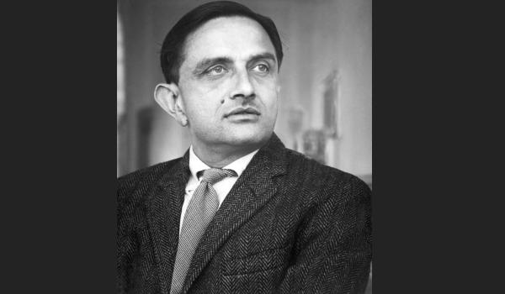
Lok Sabha Speaker Om Birla today remembered Scientist and Padma Vibhushan recipient Dr Vikram Sarabhai on his birth anniversary. In a social media post, Mr Birla said that Dr Sarabhai believed that science should not be confined merely to laboratories, but its purpose must be to improve the life of the common man. He noted that this visionary outlook of Dr Sarabhai laid a strong foundation for modern scientific research in India and transformed space science into an effective instrument of nation-building. The Lok Sabha Speaker highlighted that under Dr Sarabhai's leadership, Indian Space Research Organisation (ISRO) was established, guiding India toward becoming a self-reliant, capable, and credible space power. Mr Birla said that his ideals, thoughts, and scientific vision will continue to inspire upcoming generations. Defence Minister Rajnath Singh also paid tribute to former ISRO chairman Dr. Vikram Sarabhai on his birth anniversary. In a social media post, Mr Singh said, Dr Sarabhai's scientific imagination helped lay the foundations of India's space journey. The Minister noted that his conviction that science must serve the nation and improve people's lives, gave a new direction to India's pursuit of scientific excellence. He highlighted that the heights India's space programme has reached today are a profound vindication of Dr Sarabhai's vision, determination and pioneering spirit. Union Science and Technology Minister Dr Jitendra Singh also paid tribute via a social media post. Dr Singh said that the ambitious dream for India that Sarabhai saw sitting in his primitive scientific set-up stands gloriously vindicated today. The Minister described Dr Sarabhai as one of the founding fathers of India's Space programme.

40. NASA Invites ISRO to Join Moon Base Programme, Significance - Vajiram & Ravi
Read more
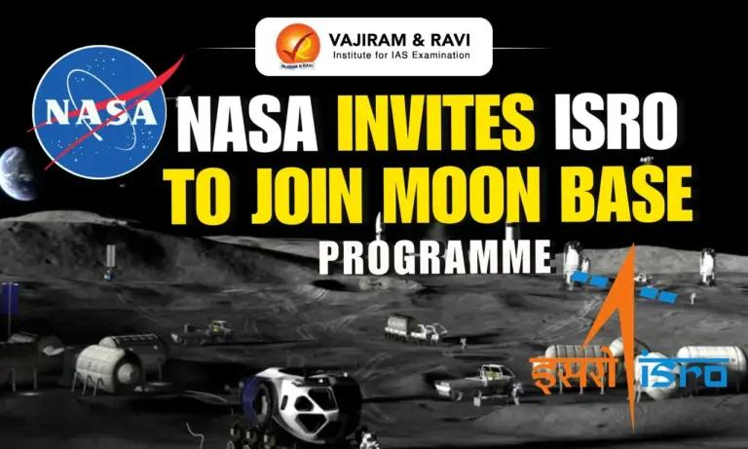
NASA Invites ISRO to Join Moon Base Programme, Significance Vajiram & Ravi

41. Kerala University recommends honorary doctorates on former ISRO chief, others - The New Indian Express
Read more
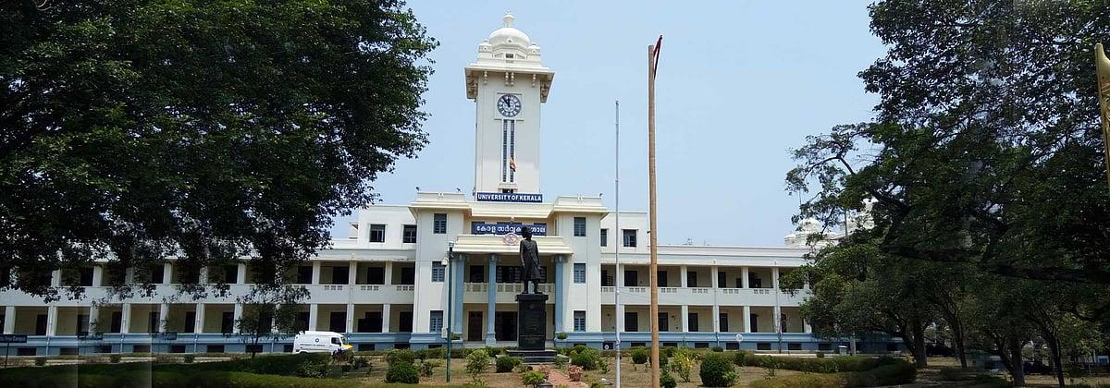
THIRUVANANTHAPURAM: Former ISRO chairman Dr K Radhakrishnan, veteran film actor Madhu, poet-filmmaker Sreekumaran Thampi and former Indian hockey team captain and Olympian P R Sreejesh are set to receive honorary doctorate degrees from the University of Kerala. The University Syndicate, which met on Thursday, decided to recommend to Governor Rajendra Arlekar, the Chancellor of the University, that the honours be conferred on the four. While K Radhakrishnan will receive an honorary Doctor of Science (DSc) degree, Madhu, Sreekumaran Thampi and P R Sreejesh will be conferred honorary Doctor of Letters (DLitt) degrees. In 2019, the University of Kerala had conferred honorary doctorates in science on scientist CNR Rao, astrophysicist Jayant Narlikar and Infosys co-founder Kris Gopalakrishnan.

42. Chandigarh University joins ISRO to host National Space Technology Conclave on 17th-18th August; Group Capt Shubhanshu Shukla among 30 Space Scientists to attend - UNITED NEWS OF INDIA
Read more
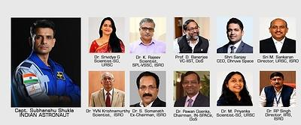
30 Eminent Scientists & Mission Leaders from ISRO, IIST, IN-SPACe & NSI to be part of 'Chandigarh University Declaration on Space Technology for Viksit Bharat CHANDIGARH, India, Aug. 13, 2026 /PRNewswire/ -- Giving fresh impetus to India's growing space ambitions and advancing the Viksit Bharat vision through innovation, indigenous space capabilities and a future-ready scientific workforce, Chandigarh University's Kalpana Chawla Centre for Research in Space Science and Technology (KCC) is all set to organise India's first university-led National Space Technology Conclave (NSTC) 2026 on August 17-18 at the University campus. The two-day conclave, being jointly organised in collaboration with the Indian Space Research Organisation (ISRO) and the Indian Institute of Space Science and Technology (IIST), Department of Space, Government of India will focus on the theme 'Emerging Space Technologies for India's Future Space Missions' and will provide students a direct platform to engage with 30 distinguished scientists, mission leaders and technologists from ISRO, IIST, Indian National Space Promotion and Authorization Center (IN-SPACe), NewSpace India Limited (NSIL) and U R Rao Satellite Centre (URSC) with 10 CEOs and senior leaders from leading Indian space industries and start-ups. The conclave will feature five roundtables and space technology demonstrations, facilitating discussions on the technologies shaping India's next phase of space exploration and human spaceflight while inspiring the next generation of innovators to contribute to the nation's Viksit Bharat journey. The conclave will feature Group Captain Shubhanshu Shukla, Ashoka Chakra, Indian astronaut and Indian Air Force officer, as the Special Guest. Group Captain Shukla created history in June 2025 by becoming the first Indian to visit the International Space Station (ISS) and participated in scientific experiments, marking a defining moment in the nation's space exploration journey. He has also been selected as one of the astronauts for India's Gaganyaan human spaceflight programme. Among the prominent space scientists and experts expected to participate are Dr Pawan Goenka, Chairman, IN-SPACe, Department of Space; Dr S Somnath, Former Chairman, ISRO; Dr Rajeev Jyothi, Director, Technical Directorate, IN-SPACe, Department of Space; Prof D Banerjee, Vice-Chancellor, IIST, Department of Space; Dr A Bharadwaj, Director, PRL, Department of Space; M Sankaran, Director, URSC, ISRO; Dr RP Singh, Director, IIRS, ISRO; and I S S Sarkar, Director, SAC, ISRO. The wider participation will include senior scientists, directors, project leaders, researchers, technologists, industry leaders and start-up representatives from across India's space sector. A major outcome of the two-day conclave will be the 'Chandigarh University Declaration on Space Technology for Viksit Bharat 2047' which will bring together space scientists, institutional leaders and the Chandigarh University team to define the role and responsibilities of universities in contributing to India's space technology ambitions. The declaration is envisaged as a collaborative roadmap for strengthening the university participation in space technology education, research, innovation and industry collaboration, with its recommendations and outcomes proposed to be shared with the Prime Minister's Office. The initiative is aligned with the conclave's larger objective of strengthening collaboration among ISRO, IN-SPACe, NSIL, academia, industry and start-ups while creating new avenues for research, skill development, internships, employment and technology development. Speaking about the significance of the conclave, Prof. (Dr) Eswar Sunkara, Senior Director, Kalpana Chawla Centre for Research in Space Science and Technology, Chandigarh University, said, "For the first time, Chandigarh University is bringing together leading ISRO scientists, IIST, space agencies, astronauts and industry leaders on a common university platform to deliberate on what universities can contribute to India's space technology journey. The Chandigarh University Declaration on Space Technology for Viksit Bharat 2047 will define the roles and responsibilities of Chandigarh University and other universities in supporting the national space vision. Our objective is to build a systematic space technology hub with the support of ISRO, develop space-ready human resources and create capabilities in satellite development, payloads, launch technologies, data analysis and other emerging areas. The outcomes of these deliberations will provide a roadmap for CU's long-term contribution to India's space programme." Prof. (Dr) Eswar Sunkara added, "The conclave will set out a strategic roadmap for establishing Chandigarh University as a premier national space technology hub in North India with the Kalpana Chawla Centre envisaged as the focal point for space technology research, innovation and capacity building. The proposed roadmap will explore areas including satellite development, satellite payloads, launch and mission technologies, reusable launch vehicle technologies, ground stations, space data analysis, artificial intelligence for space, space entrepreneurship and development of industry-ready human resources for the country's growing space sector." The proposed programme includes an inaugural session, expert talks, roundtable deliberations, a student space technology showcase, expert interaction and one-to-one mentoring, technical reviews and brainstorming sessions on areas including small satellite laboratories, payload development, ground stations, collaborative research and national funding. About Chandigarh University Chandigarh University is a NAAC A+ Grade University and QS World Ranked University. This autonomous educational institution is approved by UGC and is located near Chandigarh in the state of Punjab. It is the youngest university in India and the only private university in Punjab to be honoured with A+ Grade by NAAC (National Assessment and Accreditation Council). CU offers more than 109 UG and PG programs in the field of engineering, management, pharmacy, law, architecture, journalism, animation, hotel management, commerce, and others. It has been awarded as The University with Best Placements by WCRC. Website address: https://www.cuchd.in/ View original content to download multimedia:https://www.prnewswire.com/in/news-releases/chandigarh-university-joins-isro-to-host-national-space-technology-conclave-on-17th-18th-august-group-capt-shubhanshu-shukla-among-30-space-scientists-to-attend-302851041.html Disclaimer: This is syndicated feed from PR agency and any legal liability for the content is theirs only.

43. NASA's 737 Reveals New Paint
Read more
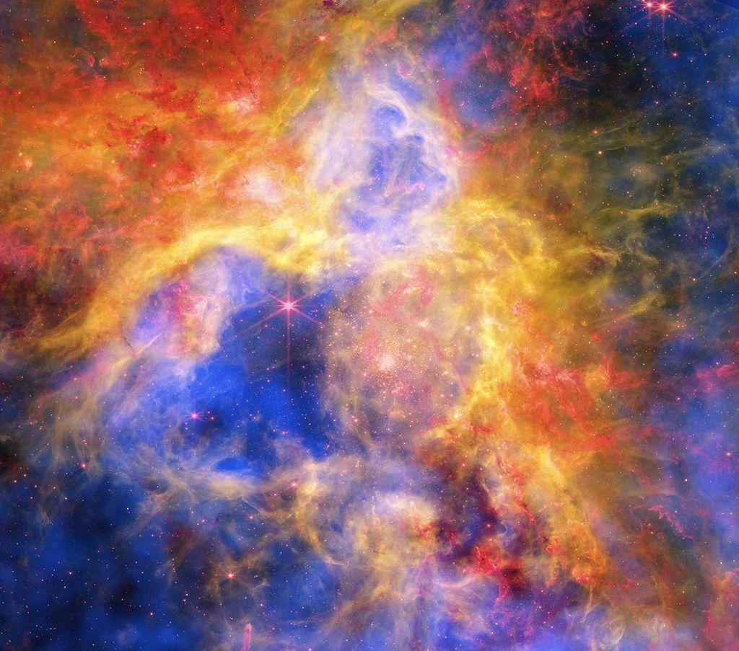
A newly painted NASA 737 aircraft sits on a ramp in Oklahoma on Thursday, Aug. 13, 2026. NASA/Carla Escamilla NASA's 737 aircraft was painted this week in Oklahoma as it progresses with modifications for use as a reduced gravity test aircraft for the agency. NASA's Armstrong Flight Research Center in Edwards, California, took ownership of the aircraft from the United States Air Force in June. The aircraft will perform lunar-gravity parabolic flights to validate astronaut lunar suits and associated crew systems required to support Artemis mission objectives. These flights will happen at NASA's Johnson Space Center in Houston for reduced-gravity operations, with NASA Armstrong oversight. In addition, the aircraft will serve as a key asset for systems‑integration research for flight testing autonomy, sensors, and other digital systems.

44. For West Virginia Engineer, Home Is Where the Heart Is… and NASA, Too
Read more
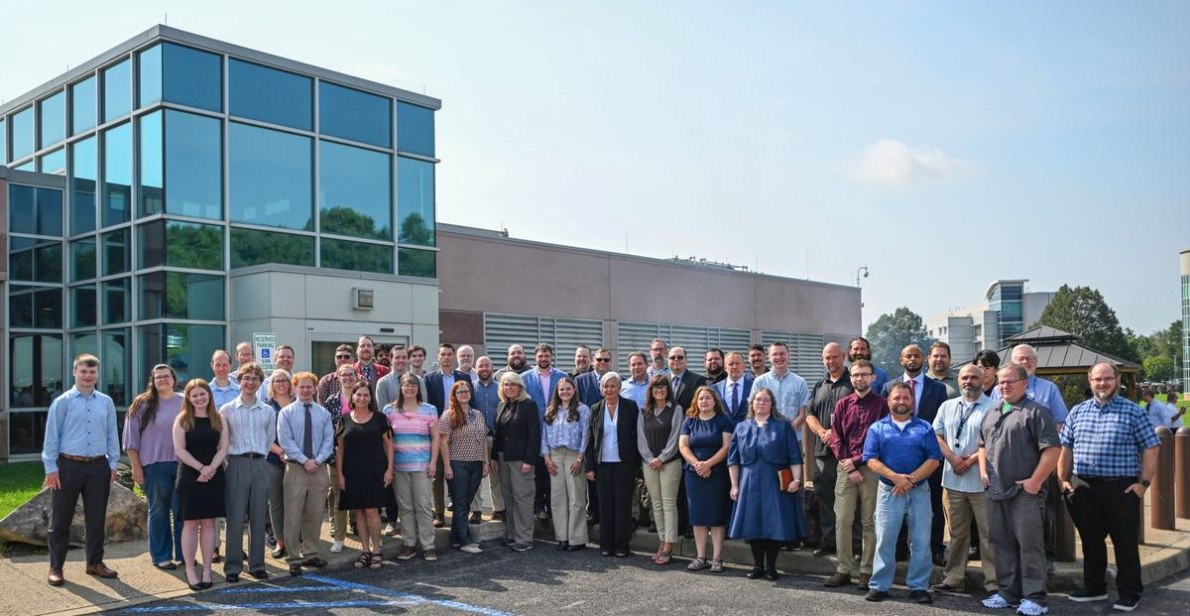
NASA's Katherine Johnson Independent Verification and Validation Facility (IV&V) held a swearing-in ceremony for civil servants on Monday, Aug. 10, 2026, at the facility in Fairmont, West Virginia. In total, 51 new employees were hired at IV&V as part of NASA Administrator Jared Isaacman's directive to strengthen NASA's technical core competencies. Growing up in Grafton, West Virginia, engrossed in Star Wars and all things science fiction, Fletcher Newell had an early interest in space exploration. That interest only grew when, in 2013, his fourth-grade class took a field trip to a nearby NASA facility he had not yet heard of - NASA's Katherine Johnson Independent Verification & Validation Facility, located in nearby. Thirteen years later, Newell and 48 of his colleagues at the facility were sworn in as NASA civil servants during a ceremony on Aug. 10. "I had always admired NASA from afar," said Newell, who started working at IV&V as a systems engineer contractor in early 2025. "To my surprise, the agency was doing impactful work in my backyard." During high school, he began cultivating programming skills that would lay the foundation for his future. A self-professed computer aficionado, Newell taught himself how to code. In algebra class, he discovered that his graphing calculator was programmable, leading him to create basic scripts. He quickly moved to popular software applications, learning how they were built in order to develop his own programs. Artificial intelligence was still on the brink of becoming mainstream, but he was already asking himself, "What are the more interesting things we can teach computers to do?" As a junior in 2019, the precocious programmer merged his talents with his passion for space after being accepted into IV&V's high school internship program. Newell created a database for engineering methods, processing hundreds of documents to facilitate the work of his colleagues from a procedural aspect. "Working as a high school intern really elevated my fascination for NASA," he said. Following graduation in 2020, Newell headed west to Stanford University in Palo Alto, California, majoring in, naturally, computer science, with a focus on AI and machine learning when both were scaling rapidly across industries and in everyday usage. Instead of pursuing internships in the neighboring Silicon Valley - widely considered the global center for technological innovation - he returned to West Virginia for three consecutive summers, cutting his teeth at the Fairmont facility. Fletcher Newell stands in front of the Katherine Johnson Independent Verification & Validation Facility in Fairmont, West Virginia, as a high school intern in 2019. Photo courtesy: Fletcher Newell He began researching AI safety as engineers learned how to give spacecraft more onboard autonomy and have them learn on their own. Later, he was on a team responsible for assessing the safety of Terrain Relative Navigation, a vision-based guidance technology that could enable spacecraft to land on planetary surfaces without GPS. During his final internship, generative AI - which creates content based on user prompts - was becoming widespread, and he worked on teams exploring how to responsibly integrate it into mission assurance. Newell also performed research about autonomous space docking at Stanford's Center for AI Safety, resulting in two publications. Following his undergraduate education, he remained at Stanford to earn a master's in computer science. When it came time to enter the workforce, one organization was atop his list. A contractor opportunity opened up at IV&V, and he leapt at the chance. "I enjoyed the work at IV&V back in high school and college," he said. "There's nothing better than pursuing what aligns with your interests." As a systems engineer, he has worked primarily on mission safety and security, identifying and resolving system defects and vulnerabilities for such spacecraft as Space Reactor-1 (SR-1) Freedom, Orion, Gateway, and the Human Landing System, all while helping guide NASA's responsible adoption and development of AI systems. His colleagues took notice of their junior member's contributions, resulting in Newell being named IV&V Engineer of the Year in 2025 less than a year into the job after identifying more than 70 issues in Gateway - and later SR-1 Freedom - with clear mission impact and, as noted in his award citation, developing a reputation for clearly articulating their implications. "During his internships and now as a full-time engineer, Fletcher has consistently demonstrated exceptional talent, curiosity, and a passion for our mission," said Wes Deadrick, IV&V director. "He could have gone almost anywhere after Stanford. The fact that he chose to come home to build his career supporting NASA through the IV&V Program makes me incredibly proud." The Aug. 10 ceremony for Newell and his colleagues was part of NASA's workforce directive to bring core, mission-critical positions into the civil service, from early-career professionals to seasoned technical experts. "It's an investment in NASA's future, giving us the opportunity to bring exceptionally talented people into the civil service while strengthening long-term technical capabilities that support our nation's most challenging missions," said Deadrick. "At IV&V, initiatives like this help ensure we continue providing independent expertise and mission assurance that our customers depend on." For Newell, as he takes this next step in his professional progression as a civil servant computer engineer, he looks forward to expanding on his responsibilities, especially to help NASA return to the Moon. He is currently helping identify safety and security issues, including ones that could impact crew safety and lead to the loss of spacecraft control, related to the agency's lunar endeavors. "At IV&V, teams are ensuring every major lunar vehicle and system will be ready to safely embark on their missions, not just for flying around the Moon, but also for putting American boots on the surface and eventually establishing and working on a Moon Base," he said. More than a decade after taking that field trip and now working on some of NASA's high-priority missions, Newell readily admits he didn't always envision staying in West Virginia. "It was a little strange coming back, but I was continually getting to do amazing things at an amazing organization in a place I already know," Newell said. "And that's really cool."

45. NASA astronaut Mike Fincke retires after 30 years at the space agency
Read more
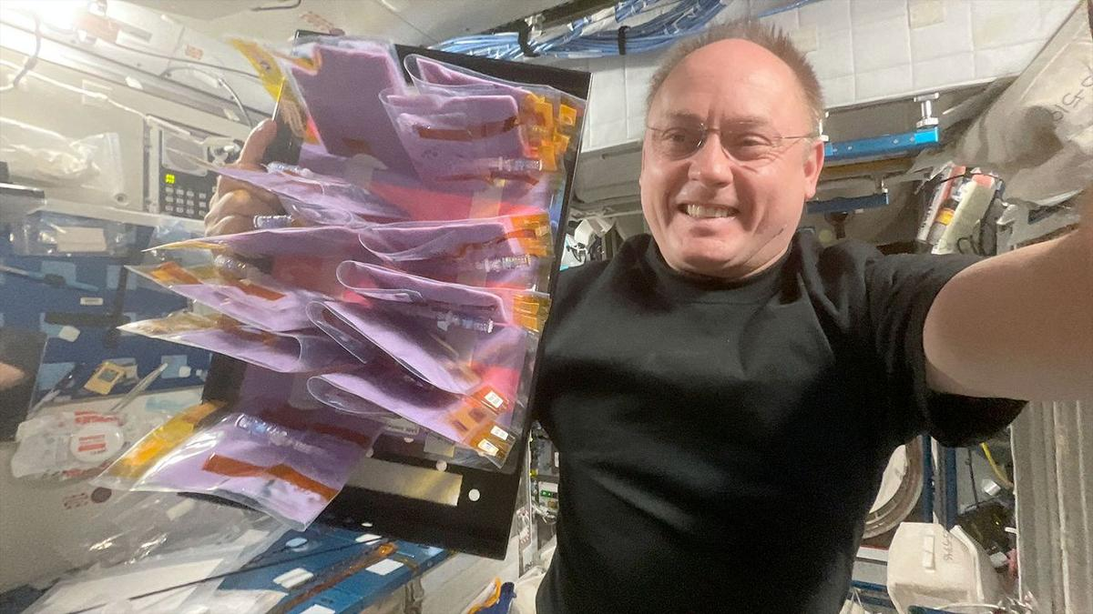
Click for next article Prolific NASA astronaut Mike Fincke has announced his retirement from the U.S. space agency after 30 years of public service. NASA announced Fincke's decision on Wednesday (Aug. 12), celebrating his contributions to spaceflight and long career of accomplishments. "Few people have had the opportunity to shape as many chapters of NASA's history as Mike Fincke," NASA Administrator Jared Isaacman said that day in a statement . Fincke departs as NASA's fourth-most flown astronaut, racking up a cumulative 549 days in space over four separate spaceflights. During those, he performed nine spacewalks and served twice as commander of the International Space Station (ISS). Most recently, he launched as pilot on SpaceX's Crew-11 mission to the ISS, stepping into the role of commander for ISS Expedition 74 from August 2025 to January 2026. Before his acceptance into NASA's 16th astronaut class in 1996, Fincke earned two bachelor's degrees from the Massachusetts Institute of Technology (MIT), in aeronautics and astronautics as well as Earth science, atmospheric and planetary sciences. Following his time at MIT, he did a summer stint at the Moscow Aviation Institute and later earned master's degrees in aeronautics and astronautics, and in planetary geology from Stanford and the University of Houston-Clear Lake, respectively. Fincke also served in the U.S. Air Force prior to his career at NASA. He graduated from the U.S. Air Force Test Pilot School in 1994, then was assigned as a space systems engineer and flight test engineer at Edwards and Eglin Air Force bases in California and Florida, respectively. Those stints were followed by his role as U.S. flight-test liaison for the Japanese-U.S. XF-2 fighter program in Japan. Following his two years of astronaut-candidate training, Fincke was assigned to NASA's Astronaut Office Station Operations Branch's Crew Test Support Team in Russia. There, he served as ISS CAPCOM (Spacecraft Communicator) and ISS crew procedures team lead until he began official spaceflight training in 1999. His first rocket launch was aboard the Soyuz TMA-4 mission to the ISS in 2004, where he served as science officer and flight engineer for Expedition 9 and completed four EVAs (extravehicular activities, or spacewalks). Fincke's second launch brought him back to the ISS in 2008, as a member of Soyuz TMA-13. It was then that Fincke took command of the space station for the first time. As Expedition 18 commander, Fincke added two more EVAs to his career total and oversaw the preparation of ISS facilities to begin supporting an increase from three-person to six-person crews. Fincke was also aboard for the final launch of NASA's space shuttle Endeavour on the STS-134 mission in 2011 , which returned him to the ISS for a third time. As mission specialist and robotic-arm operator, he supported the installation of the space station's dark-matter-hunting Alpha Magnetic Spectrometer (AMS) instrument, and performed three additional EVAs that marked the official completion of ISS orbital assembly and were the last-ever spacewalks by a space shuttle crew . By 2014, Fincke was serving as chief of the Astronaut Office's Commercial Crew Branch, where he played a key role in the development and testing of the SpaceX Crew Dragon and Boeing Starliner spacecraft. In January 2019, he was assigned to Boeing's Crew Flight Test (CFT) mission as joint operations commander, and he remained on the prime crew until June 2022, when he transitioned to the CFT backup crew. Mike Fincke is helped off SpaceX's Crew Dragon after Crew-11 splashdown in the Pacific Ocean on Jan. 15, 2026. (Image credit: NASA/SpaceX) Fincke's most recent mission, Crew-11, launched to the ISS in August 2025. It was the second time he was appointed commander of the space station, this time for Expedition 74, but his stint, and that of the other Crew-11 astronauts, was cut short due to an unexpected medical issue. Leading up to what would have been his 10th career EVA, NASA abruptly canceled spacewalk prep by Fincke and fellow NASA astronaut Zena Cardman after a "medical concern" arose that took priority over the planned station maintenance. Though not considered an emergency, the episode was deemed serious enough for NASA to return the Crew-11 astronauts to Earth earlier than expected, and Fincke and his fellow crewmates safely splashed down in the Pacific Ocean aboard their SpaceX Crew Dragon a week later. During the mission, NASA did not reveal the afflicted astronaut's name and condition, citing privacy concerns. A little more than a month after Crew-11's return, however, NASA and Fincke revealed that he was the crew member who experienced the medical issue, which he later described as a temporary inability to speak, according to an Associated Press report . Fincke fully recovered from the episode and is now in good health. "Mike approached every assignment with experience, humility, and an unwavering focus on the mission," said Scott Tingle, chief of NASA's Astronaut Office, in the agency's announcement. "Whether flying aboard the station, supporting crews from the ground, or helping shape the spacecraft that future crews will rely on, he consistently strengthened our team. His legacy is woven into the way we fly today." NASA did not indicate if Fincke plans to continue his involvement with the space industry through the private sector, but did highlight his dedication to support humanity's drive to explore the cosmos. "I remain deeply committed to the work of exploration," Fincke said in the statement. "NASA gave me the extraordinary privilege of serving alongside remarkable people, flying and helping develop spacecraft, and contributing to the International Space Station from its earliest days through command in orbit … I am excited to carry those lessons forward and help prepare the next generation of engineers, explorers, and leaders."

46. NASA's canceled lunar space station tech will help build the Artemis moon base
Read more
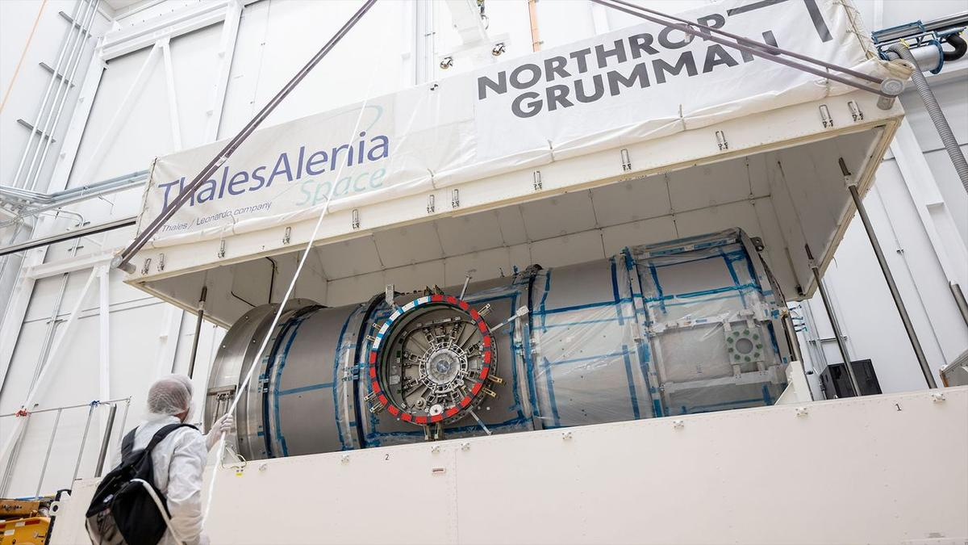
Click for next article Not every canceled NASA program earns a halo after its demise, but one scrapped project is finding new life by contributing its parts to help the space agency achieve its moon base goals faster. Northrop Grumman is repurposing hardware and technology from the Habitation and Logistics Outpost (HALO) space station module for use on a new series of Lunar Infrastructure Demo (LID) missions. HALO was originally designed as the habitation module for NASA's since-cancelled moon-orbiting Gateway space station but found itself on the chopping block when the agency restructured the Artemis program architecture earlier this year. Rather than scrap the unfinished module outright, Northrop Grumman will adapt HALO's electrical and mechanical components to support the development of technologies for a moon base that can survive the cold, weeks-long night at the lunar south pole while sustaining the long-term habitation of astronauts inside. Part of NASA's reasoning for canceling Gateway was the need for expedience. As the agency's vision for Artemis and the return of astronauts to the lunar surface has evolved, China's plans to land the first taikonauts on the moon have steadily taken shape. Those ambitions, and the continued progression of China's lunar program, have kicked off a new space race in which the U.S. and NASA are intent on maintaining their first-place position. In March, NASA Administrator Jared Isaacman announced a shakeup to the Artemis program designed to enable a more step-by-step approach toward developing the technologies needed for a next-generation crewed lunar landing, and to achieve that landing on the shortest timeline possible. That timeline currently puts the first Artemis lunar landing with astronauts on the Artemis IV mission, scheduled for late 2028. Before then, however, NASA is planning nearly two dozen uncrewed missions to the moon to lay the groundwork for the infrastructure needed to precede astronauts' return. And, rather than let HALO rust in a warehouse, Northrop is doubling down on its commitment to the cause. "To help NASA move faster … HALO's power, data and mechanical interfaces will enable NASA to move with speed and begin gathering real lunar surface performance data sooner," the company said in a press release on Aug. 4. Northrop Grumman's Lunar Infrastructure Demos (LID-1, LID-2 and LID-3) will reuse HALO derived technologies to rapidly mature lunar surface power, thermal, autonomy, communications and hosted payload services that can survive the lunar night and scale into persistent infrastructure near the moon's south pole. (Image credit: Northrop Grumman) Northrop announced 3 LID missions to "reuse HALO-derived technologies to rapidly mature lunar surface power, thermal, autonomy, communications and hosted payload services," which will help NASA gather data to better protect robotics and crews during long-duration stints near the moon's south pole, where the agency plans to establish its Artemis moon base. Neither the company nor NASA gave a target timeline for these missions. NASA is targeting the south pole specifically because of the abundance of water ice that scientists have detected in that region on the moon. When harnessed appropriately, such ice concentrations can be used for a variety of applications to enable sustainable habitation on the lunar surface - the ultimate goal of the Artemis program - including potable water, radiation shielding and rocket fuel. NASA believes that overcoming the technological hurdle of "in-situ resource utilization" (ISRU), or the ability to rely on materials locally available to you in order to sustain your survival, is the gold standard of spaceflight that will open the door to humanity's long-term exploration of the cosmos. Manufacturing propellants off Earth , for example, would mean a substantial increase in the distance any particular mission to space can fly, because nearly 95% of a rocket's mass at launch is fuel. So, the ability to refuel in space, circumventing the burden of launching to orbit fully fueled, would give satellites and crewed spacecraft the ability to fly much farther into the solar system than current launch systems allow. As much as Artemis is, in itself, a program to establish a permanent human presence on the moon, NASA also sees it as the proving ground for technologies that could one day sustain astronaut missions to Mars . There is worry, however, over the national security and economic consequences that could accompany China beating the U.S. to the moon, so speed is top of mind for those tasked with the country's lunar return. "As America embarks on the next chapter in human space exploration, our Lunar Infrastructure Demos will help turn the moon into a place where astronauts can stay, work and make discoveries that benefit humanity," said David Schiller, Northrop Grumman's vice president of civil space and sciences, in a statement. "Our ready‑to‑fly, reliable HALO technologies allow NASA to move faster, putting in place robust infrastructure that can endure the lunar night and establish a strong blueprint for a future moon base."

47. On this day in space! Aug. 13, 2014: Game-changing WorldView-3 Earth-observing satellite launches to orbit
Read more
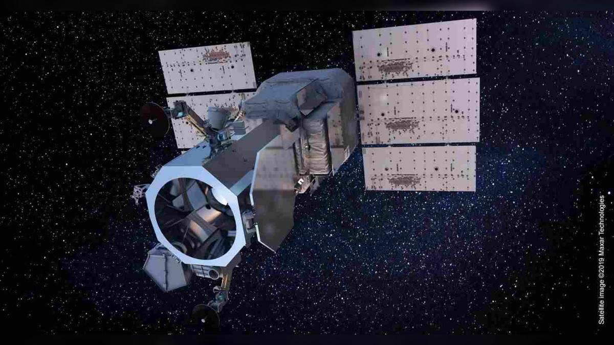
Click for next article On Aug. 13, 2014, a company called DigitalGlobe launched what was then the sharpest-eyed satellite of all time. WorldView-3 is a high-resolution imaging satellite that can resolve features as small as 1 foot (31 centimeters) across. Its instruments allow it to peer through fog and smoke to see Earth's surface at a level of detail that was unprecedented for a non-governmental spacecraft. WorldView-3 lifted off on a United Launch Alliance Atlas V rocket from Vandenberg Air Force Base in California and has been orbiting Earth ever since. The WorldView-3 Earth-observing satellite. (Image credit: Maxar Technologies) Why it mattered WorldView-3 pushed forward the technology of Earth-observing satellites. With its high resolution and ability to create mosaic images and deliver data in record time, the spacecraft changed the game in terms of studying Earth from space. While technology continued to advance beyond WorldView-3, it was a critical step in the process. For example, its data has helped researchers better track methane emissions coming from offshore oil and gas rigs, which is important as methane is a powerful greenhouse gas which contributes substantially to climate change . WorldView-3's data is sorted by an algorithm that helps filter, process and color-correct images that might have been affected by atmospheric effects. With all of the imagery and data from satellites like WorldView-3, researchers can better track and understand contributors to climate change like methane plumes, as well as monitor deforestation and agriculture and study the spread and effects of natural disasters like wildfire. Lastly, in an unexpected but amazing find, in 2015 , archaeologists used data from WorldView-3 to discover what is thought to be a lost Viking village in Newfoundland. The near-infrared imagery captured by the satellite helped an international team to spot this village, which was only the second Viking settlement found in North America.

48. New private 'Perceptor' probes will keep an eye on satellites high above Earth
Read more
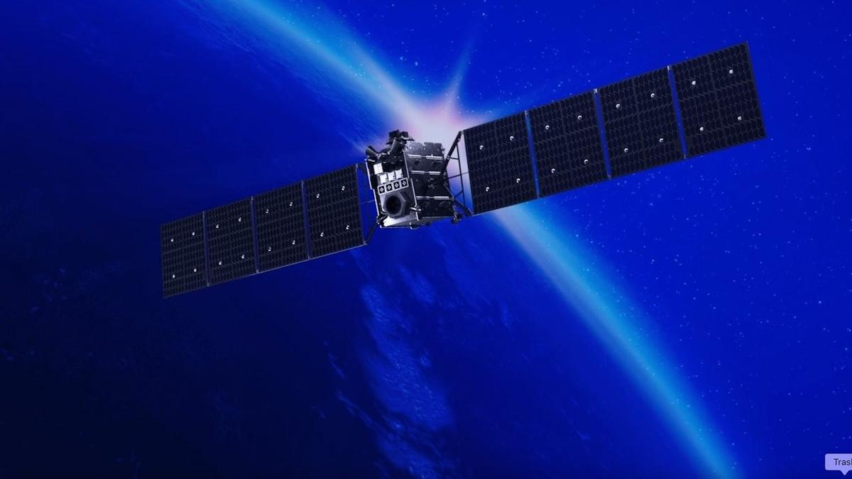
Click for next article Satellites high above Earth may soon have fewer places to hide. San Francisco-based company Astranis announced today (Aug. 13) that it's developing a line of spacecraft called Perceptor, which will keep an eye on satellite activity in geostationary orbit (GEO). GEO lies 22,236 miles (35,786 kilometers) above Earth, an altitude at which orbital speed matches our planet's rotational velocity. It's therefore a popular destination for communications, weather and reconnaissance spacecraft - and, increasingly, an arena for off-Earth spying, as space powers seek to keep tabs on their competitors' activities . Astranis currently operates five satellites in this distant orbital realm, which "support the U.S. military, bring connectivity to remote areas and provide critical capabilities like GPS ," according to the company's website . It plans to leverage and extend this expertise with Perceptor, helping the U.S. government and other potential customers learn more about what's happening high above our heads. The new line will be based on Astranis' "MicroGEO" satellite platform, so named because it's smaller than typical GEO craft. "Astranis provides mission-critical infrastructure for strategic higher orbits. What we found is our means to detect and respond to emerging threats to this infrastructure are sorely lacking," John Gedmark, Astranis' CEO and co-founder, said in a statement today. "There are blind spots that will be used against us if not eliminated," he added. "With Perceptor, we're meeting the increasing demand for security in GEO with our proven on-orbit platform and ability to produce at scale." Four Astranis MicroGEO satellites, which launched atop a Falcon 9 rocket in December 2024. (Image credit: Astranis) Perceptor spacecraft will sport a variety of sensors, which will allow them to take the measure of other satellites and their broader GEO surroundings. "Multi-angle flybys can assess spacecraft capabilities, help troubleshoot anomalies on friendly spacecraft, and provide additional eyes in a domain where awareness has historically been limited," Astranis' statement reads. Each Perceptor will also be highly maneuverable, using electric propulsion "to traverse the full GEO arc, repositioning dozens of times over its mission lifetime," company representatives added. The statement does not provide a target timeline for the first Perceptor missions. But the need for such a capability already exists, as the activities of certain Russian and Chinese satellites show. In 2020, for example, officials with the U.S. Space Force announced that two Russian spacecraft got within 100 miles (160 kilometers) of an American spy satellite, behavior the branch's then-chief described as "unusual and disturbing."

49. Chinese missiles autonomously spot F-22, F-35 heat signatures with 90 percent accuracy
Read more
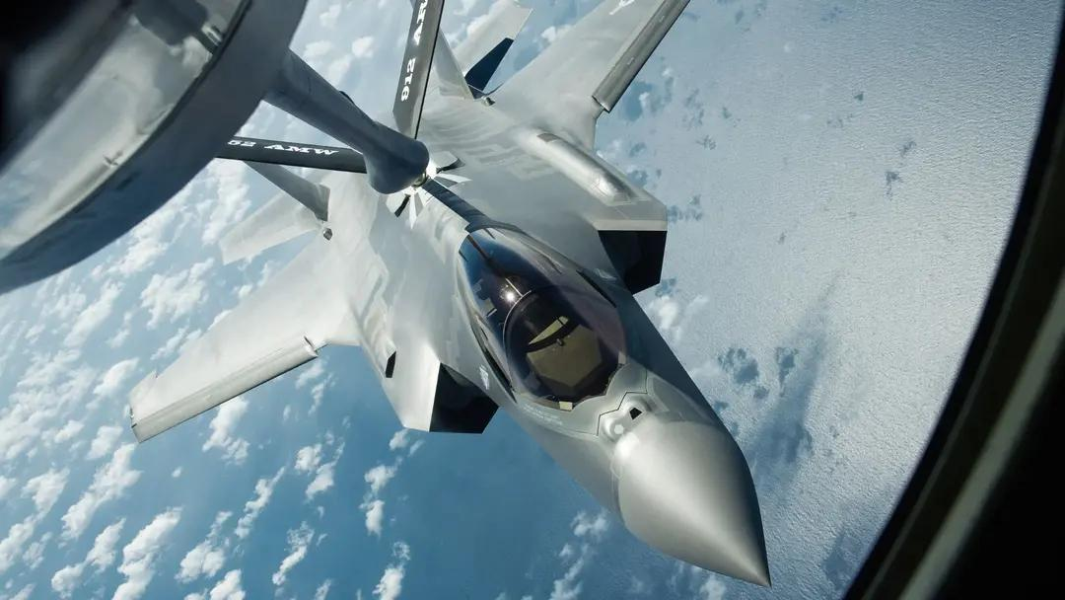
The F-22 and F-35 are notorious for frustrating radar detectors, but their heat signatures are difficult to hide. China has developed a lightweight AI system that could allow air-to-air missiles to recognize their infrared signatures in flight. The new system achieved up to 97.1 percent accuracy identifying F-22 and F-35 targets during simulated laboratory tests. Researchers from the Beijing Institute of Technology and China Airborne Missile Academy designed it for missile-mounted infrared imaging systems. The work tackles a practical problem facing future missile seekers. They need to process infrared imagery almost instantly, yet missiles have strict limits on computing power, weight and available space. Reading fighter heat Aircraft produce infrared signatures through engine exhaust, aerodynamic heating and other sources across the airframe. Heat-seeking missiles can detect those emissions, while fighters can deploy flares to create competing infrared targets. That creates a recognition problem for the missile. An infrared seeker needs to determine whether the heat it sees belongs to the aircraft or a decoy, often with only milliseconds available to make that assessment. The researchers trained their system using 3,245 infrared images collected by a missile-borne scanning system. The dataset included three airborne target categories, with simulated F-22 and F-35 aircraft among them. The model reached 97.1 percent recognition accuracy during testing, according to the researchers. A separate test produced recognition rates of about 90% for the simulated fighter targets. Those results do not show how the system would perform against actual F-22 or F-35 aircraft. Lead researcher An Jiangshan said the relevant test data remains confidential and cannot be disclosed. Making AI smaller The researchers also had to solve a hardware problem before putting the model aboard a missile. Conventional deep-learning systems can require too many computing resources for compact weapons with tight size and power constraints. The team reduced its model to 16.1 percent of the parameters used by previous methods. It also brought computational requirements down to 19.2 percent, according to the study. A dedicated AI accelerator helped push the system further. The hardware uses optimized convolution operations, parallel processing, and data buffering to process infrared imagery more efficiently. During hardware testing, the system achieved 96.4 percent accuracy and processed each image in roughly 1.5 milliseconds. Its overall power consumption reached about 2.2 watts, giving the researchers a relatively low-power system for missile-mounted applications. That speed could matter during an engagement because a missile cannot spend long deciding what its sensor sees. Processing the imagery onboard could let the seeker classify targets without depending on external computing systems. New stealth challenge The research does not establish that Chinese missiles can identify operational F-22 or F-35 fighters. The experiments used simulated targets, and the researchers say further work will be needed to improve both recognition accuracy and processing speed. The team also limited its study to close-range air-to-air missile fuzes. It has not yet established whether the approach could work against surface-to-air missile systems.
50. CM reaches Chamoli to check on disaster victims
Read more
PIONEER EDGE NEWS SERVICE/Jyotirmath With at least seven persons reported dead officially, chief minister Pushar Singh Dhami reached Pipalkoti in Chamoli district amid rough weather, where workers were trapped due to flooding in a tunnel of a hydro power project. Dhami also met the rescued workers in the hospital and directed the officials to ensure their proper treatment. The CM said that every person's life is precious, adding that all the available resources of the government are being used for this rescue and relief operation. The prime priority of the State government is to rescue the workers stranded in the tunnel. Dhami said that the chief minister of the States from where some of the labourers came have already been contacted to communicate that the family members should be informed. A magisterial inquiry has also been ordered to ascertain the reasons for the disaster. In Dehradun, the Disaster Management minister Madan Kaushi visited the State Emergency Operations Centre to review the rescue and relief works being undertaken in Pipalkoti. He sought detailed information about the search and rescue operation.

51. Up to ₹2.08 Lakh/Month Salary! Multiple Life Sciences Jobs at ISRO - BioTecNika
Read more
Multiple Vacancies at ISRO-HSFC | Life Sciences Role Are you looking for high-paying Life Sciences Jobs in India's space research sector? The Human Space Flight Centre has announced Multiple Vacancies under ISRO Careers 2026 for Scientist/Engineer-SD positions. Candidates with a PhD in Biotechnology, Molecular Biology, Bioinformatics, Biomedical Sciences and related disciplines can apply online by 30 August 2026. About the Institute The Human Space Flight Centre (HSFC), Bengaluru, was formed as a new centre in ISRO to realise the vision of the Human Space Flight Programme. As the lead centre for human space activities, HSFC undertakes multidisciplinary research and development in human science and technology while maintaining high standards of reliability and human safety. - Get Jobs Faster - Job Overview Multiple Vacancies Post Code Discipline Vacancies 01 Bioinstrumentation OR Biophysics OR Medical Physics 01 UR 02 Developmental Biology OR Biotechnology 01 UR 03 Cellular & Molecular Biology OR Cell Biology 01 UR 04 Computational Biology OR Systems Biology OR Bioinformatics 01 UR 05 Biomedical Engineering OR Biomedical Sciences 01 UR 06 Biomedical Engineering OR Biomedical Sciences 01 UR Key Responsibilities Post Code 01 Design and validate wearable health monitoring sensors and systems and instrumentation of biomedical sensors. Bio-signal data acquisition and processing. Medical Imaging and informatics. Development of portable diagnostic devices and wearable sensors. Post Code 02 Radiation biology and exposure models. Develop regenerative approaches to preserve musculoskeletal integrity during training and in space. Mammalian and stem cell culture; primary cell lines; 3D/organoid culture systems. In vivo and ex vivo animal physiological studies. Working on disease biology models relevant to astronaut health. Host-pathogen interaction studies under stress/microgravity. Post Code 03 Study immune and cellular adaptation across the astronaut health cycle. Bioinformatics analysis of proteomic data for biomarker identification for spaceflight application. Molecular cloning, confocal microscopy, live-cell imaging and gene editing for spaceflight application. Large-scale proteomic dataset analysis, gene expression and statistical workflows. Post Code 04 In silico models to anticipate astronaut adaptation, assess countermeasures and guide rehabilitation. Development of therapeutics and space-grade diagnostics. Multi-omics integration for spaceflight stressors studies. Modelling cellular pathways, host-microbe interactions and metabolic networks under spaceflight conditions. Computational simulation of closed-loop life support systems. Generative models for predictive simulation of astronaut physiology and disease states through Digital Twin Biology, including neural networks and deep learning. Post Code 05 Gait analysis, exercise countermeasures, motion capture and force-plate studies and rehabilitation programme development. Biomechanical analysis of the musculoskeletal system. Analyse human performance data from wearables. Collaborate on rodent/human analogue design for spaceflight experiments. Post Code 06 Develop and validate bio-imaging systems for microgravity tissue changes. Implement DSP algorithms for ECG/EEG/EMG from wearables, noise reduction and feature extraction. Analyse bioinformatics datasets for space radiation effects on cells and tissues. Development of portable diagnostic devices, biosensors, point-of-care testing and real-time astronaut health monitoring tools. Integration of biomedical devices, wearable sensors and lab-on-chip technologies. Integrate AI/ML for real-time signal and imaging analysis in human/rodent spaceflight experiments. Qualifications Post Discipline Qualification 01 Bioinstrumentation/Biophysics/Medical Physics Relevant PhD + relevant ME/MTech/MS (60%/6.5 CGPA) + BE/BTech (65%/6.84 CGPA). 02 Developmental Biology/Biotechnology Relevant PhD + relevant ME/MTech/MS and BE/BTech, or BS-MS in Biological Sciences/Biology. 03 Cellular & Molecular Biology/Cell Biology Relevant PhD + relevant MSc and BSc, or BS-MS in Biological Sciences/Biology. 04 Computational Biology/Systems Biology/Bioinformatics Relevant PhD + relevant ME/MTech/MS and BE/BTech, or BS-MS in Biological Sciences/Biology. 05 Biomedical Engineering/Sciences Relevant PhD with thesis in biomechanics/human movement/musculoskeletal modelling + relevant ME/MTech/MS and BE/BTech. 06 Biomedical Engineering/Sciences Relevant PhD with thesis in bio-imaging/signal processing/bioinformatics + relevant ME/MTech/MS and BE/BTech. Selection Process Initial screening will be conducted based on applications submitted through the ISRO Live Register portal. The prescribed qualifications are minimum requirements and do not automatically make candidates eligible for an interview. Final selection will be based only on performance in the Personal Interview. How to Apply Applications will be accepted only through the ISRO Live Register portal. These Multiple Vacancies under ISRO Careers 2026 offer an exceptional opportunity for PhD candidates seeking high-paying Life Sciences Jobs in bioastronautics, biomedical research and human spaceflight science. Eligible candidates should complete their online application before 30 August 2026.

52. India-US space ties deepen as NASA invites ISRO to join moon base program - Space
Read more
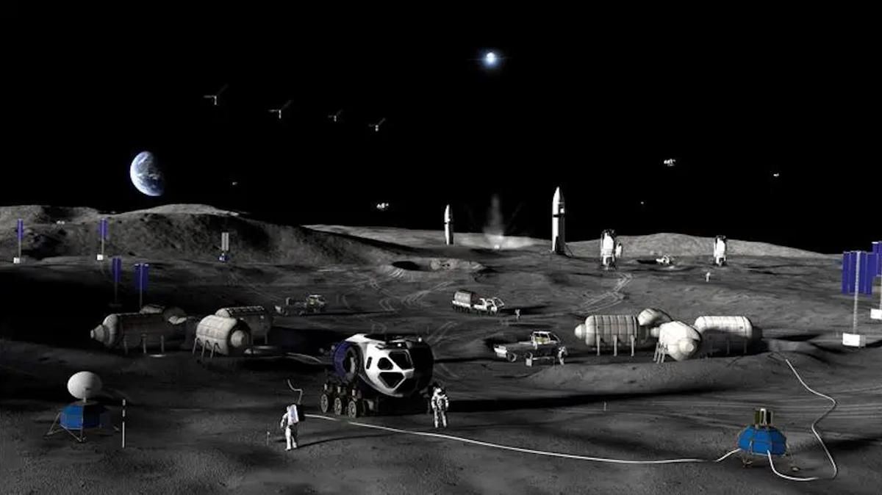
Click for next article NASA plans a to build a permanent base on the moon with a step-by-step approach through 2032. NASA has formally invited India to participate in its effort to build a permanent base near the moon's south pole, adding a new dimension to the deep-space cooperation between the two countries. The invitation was extended last week at the Indian space agency ISRO 's headquarters in Bengaluru during the ninth meeting of the U.S.-India Civil Space Joint Working Group. The CSJWG was established in 2005 as a mechanism for bilateral space cooperation and for addressing challenges and pursuing mutual spaceflight goals. "Building on our successful collaboration in science, NASA reaffirmed its interest in @ISRO joining Moon Base. We're going back to the moon to stay - and we're bringing our partners with us," NASA officials said via X on Tuesday (Aug. 11). Building on our successful collaboration in science, NASA reaffirmed its interest in @ISRO joining Moon Base. We're going back to the Moon to stay - and we're bringing our partners with us. https://t.co/hU9ssn24FPAugust 11, 2026 Beyond the lunar base invitation, "the two sides also agreed to advance discussions for cooperation on open scientific data sharing under the Accords," reads a Tuesday statement by the U.S. Embassy in India. "The Accords" are the Artemis Accords , the U.S.-led diplomatic framework outlining principles for safe and responsible exploration of the moon and beyond. India signed on as the 27th signatory in 2023, joining a coalition that has now grown to 70 nations. Official statements have provided few details on what India's participation in the Moon Base program would entail in practice. The meeting, however, brought together senior space officials from both countries, including V. Narayanan, the chairman of ISRO and secretary of India's Department of Space, and Sergio Gor, the U.S. Ambassador to India, who addressed the opening session, according to the statement. The meeting was co-chaired by M. Sankaran, director of ISRO's U.R. Rao Satellite Centre, on the Indian side, and two people on the U.S. side - Wesley Brooks, assistant secretary of state for the U.S. Department of State's Oceans and International Environmental and Scientific Affairs, and Kathleen Karika, NASA associate administrator for International and Interagency Relations, the statement reads. Over the coming decade, via its Artemis program , NASA plans to build out a sprawling, city-like base near the moon 's south pole, a region of particular interest thanks to permanently shadowed craters there that are thought to contain substantial deposits of water ice. Details of the planned architecture shared by NASA in May envision hilltop habitats to take advantage of sunlight and nuclear power systems located farther away to mitigate radiation risks. The space agency also plans to use small, hopping robots starting in 2028 to scout the south polar region ahead of moon base construction. This effort to gather information and secure access to the surface is the first of three planned phases. Phase 2, from 2029-2032, is intended to establish the base's initial operating capability. Phase 3, from 2032 onward, aims to achieve a semi-permanent crew presence on the lunar surface, NASA said during the May update. Senior space officials from India and the U.S. at the ninth meeting of the India-U.S. Civil Space Joint Working Group at ISRO headquarters in Bengaluru on Aug. 5-6, 2026, where NASA invited ISRO to join its Moon Base program. (Image credit: ISRO) To prioritize infrastructure that supports sustained operations on the moon's surface, increase launch cadence and keep pace with China's lunar ambitions , NASA earlier this year paused development of its long-planned Gateway space station.

53. ISRO's LVM3 upper stage re-enters atmosphere in 9 months. Here's why it matters - theprint.in
Read more
The satellite was injected with a perigee-the point in an elliptical orbit where a celestial body, such as the Moon or an artificial satellite, is closest to the Earth-at 170km and apogee-the highest point of something, or the point in an orbit around the Earth where an object is farthest away-at 29,970 km. After spacecraft injection, the upper stage was passivated to limit any risks of accidental breakup and left in a highly elliptical, 21-degree-inclined GTO. The upper stage of ISRO's LVM3, which was launched on 2 November last year from Sriharikota and successfully injected the CMS-03 communications satellite into a Geostationary Transfer orbit (GTO), re-entered the Earth's atmosphere on 30 July this year. Bengaluru: The upper stage of ISRO's LVM3-M5 re-entered the Earth's atmosphere in the last week of July-about nine months after its flight in November 2025. This was part of a demonstration of planned efforts to limit the orbital lifetime of rocket stages, the space agency said. "ISRO's System for Safe and Sustainable Space Operations Management (IS4OM) kept a close watch on the orbital decay of LVM3-M5 rocket body and regularly predicted its atmospheric re-entry during its final orbital phase. The Multi Object Tracking Radar (MOTR) at Sriharikota was also engaged to track the object wherever feasible, till a few orbits before its re-entry," ISRO said in a statement on Friday. It added that the most probable impact time was estimated around 12.08 UTC (5.38 PM IST) in the Atlantic Ocean. "Only a few elements like gas bottles, nozzles, and tanks, which are made of materials with very high melting points, were expected to survive the intense aerothermal heating during the re-entry," ISRO said. Also read: India rolls out 3 AI-based models for faster, more accurate weather forecasts An important goal Reducing the lifetime of space objects is an important goal that space agencies and companies across the world are aiming to achieve. The longer a space object stays in space, the higher the chances of collisions in orbit. The Inter-Agency Space Debris Coordination Committee (IADC) recommendations say that space objects in Low Earth Orbit (LEO), which have crossed their active life, should not stay in space for more than 25 years. In this mission, the LVM3 stage three was brought back within nine months. "It also meets India's Debris Free Space Mission (DFSM) requirement, which recommends a shorter orbital lifetime of 5 years for rocket stages which pass through the heavily crowded LEO region," ISRO said. (Edited by Saptak Datta)

54. Indian astronauts no longer need to rely on overseas training: ISRO building 'Gaganyatri Nivas' to support ... - Bhaskar English
Read more

English News Tech science ISRO Builds Gaganyatri Nivas: Indias New Hub For Astronaut Training Indian astronauts no longer need to rely on overseas training: ISRO building 'Gaganyatri Nivas' to support astronauts; how this fits into Gaganyaan's plans 7 hours ago Author: Samira Siddiqui Copy link Sending humans to space is not simply about building a rocket and a spacecraft. Astronauts have to undergo years of technical, physical and medical preparation, learn how to respond to emergencies, practise mission procedures repeatedly and remain isolated from potential infections before launch. As India prepares for its first crewed Gaganyaan mission, the Indian Space Research Organisation (ISRO) is also building the infrastructure it will need if human spaceflight is to become a regular capability rather than a one-off demonstration. Gaganyaan is ISRO's first human spaceflight mission, aiming to send three astronauts 400 km above Earth for three days and safely bring them back. Image credit: ISRO One such facility is the proposed Gaganyatri Nivas and Crew Isolation Facility at Satish Dhawan Space Centre (SDSC-SHAR), Sriharikota. ISRO has floated a tender for the planning, design, construction and commissioning of the facility. The project is being taken up as part of the agency's wider effort to establish the infrastructure required for sustained human-spaceflight activities. What is Gaganyatri Nivas? Gaganyatri Nivas can broadly be understood as dedicated accommodation and support infrastructure for astronauts, or Gaganyatris, associated with human-spaceflight missions. The facility is being planned alongside a crew isolation facility at Sriharikota. Astronaut Training Facility established in Bengaluru caters to Classroom training. Image credit: ISRO Gaganyatri Nivas should not be seen as a replacement for ISRO's existing astronaut-training infrastructure. ISRO already has an Astronaut Training Facility in Bengaluru, where Gaganyaan crew training includes classroom instruction, physical fitness, simulator training, and flight-suit training. Instead, the Sriharikota facility would become another important piece of the overall crew-management system, particularly because Sriharikota is India's primary spaceport and the location from which the Gaganyaan mission will eventually launch. Why does an astronaut need to be isolated before launch? Crew isolation is an important part of human-spaceflight preparation. Once astronauts are inside a spacecraft, they cannot simply leave if they develop an infection. A relatively minor illness on Earth can become a serious problem in a confined spacecraft, where medical resources are limited, and the crew has to continue operating critical systems. This is why astronauts are generally placed under controlled medical and environmental conditions before launch. For India, a dedicated facility near the launch complex can make this process more organised. Does this mean Indian astronauts will no longer need training abroad? India's first group of Gaganyaan astronaut-designates underwent training in India as well as overseas training, including a programme in Russia. Earlier ISRO and government documents confirm international cooperation in astronaut selection and training for the first Gaganyaan crew. However, ISRO has steadily expanded its own astronaut-training capabilities. The agency says its Astronaut Training Facility in Bengaluru already supports classroom training, physical fitness, simulator training and flight-suit training. Its training programme includes academic courses, Gaganyaan flight systems, microgravity familiarisation through parabolic flights, aero-medical training, recovery and survival training, flight procedures and crew-training simulators. Therefore, Gaganyatri Nivas should be viewed as part of the expansion of India's domestic human-spaceflight infrastructure, rather than as proof that all astronaut training will now happen at Sriharikota or that overseas training will completely end. Also read: Can animals detect cancer?: Bengaluru startup combining dogs' powerful sense of smell with AI to spot cancer So, where does the actual astronaut training happen? Astronaut training is spread across multiple facilities because it covers technical, medical, physical, and emergency skills. ISRO's Bengaluru facility handles areas such as spacecraft systems, space medicine, microgravity, recovery, and survival training. Astronauts also use virtual-reality and mock-up simulators to practise mission procedures, communication, emergency exits, and unexpected scenarios, preparing them for situations they could face in space. What Gaganyaan Nivas means for India's astronaut programme The new facility does not mean Sriharikota will become India's only astronaut-training centre. Instead, it will add another layer to the country's growing human-spaceflight infrastructure. Bengaluru already houses the main astronaut-training facility, while Sriharikota provides the launch complex and is now being planned to include dedicated crew-isolation and Gaganyatri accommodation facilities. Also read: Do you blindly scan every QR code?: New 'Rogue Auto QR Code' scam could put UPI users at risk; follow these 5 tips to protect yourself Building a wider human-spaceflight ecosystem The Indian Navy and other agencies are involved in crew recovery and survival training, while ISRO, DRDO, the Indian Air Force, academia and other institutions contribute to different aspects of the programme. Together, these efforts are helping India move beyond preparing astronauts for a single mission and build the infrastructure, training systems and expertise needed for a sustained and repeatable human presence in space.

55. 'Strap yourself in and feel the Gs': NASA announces 'Max Power' aerospace expo
Read more
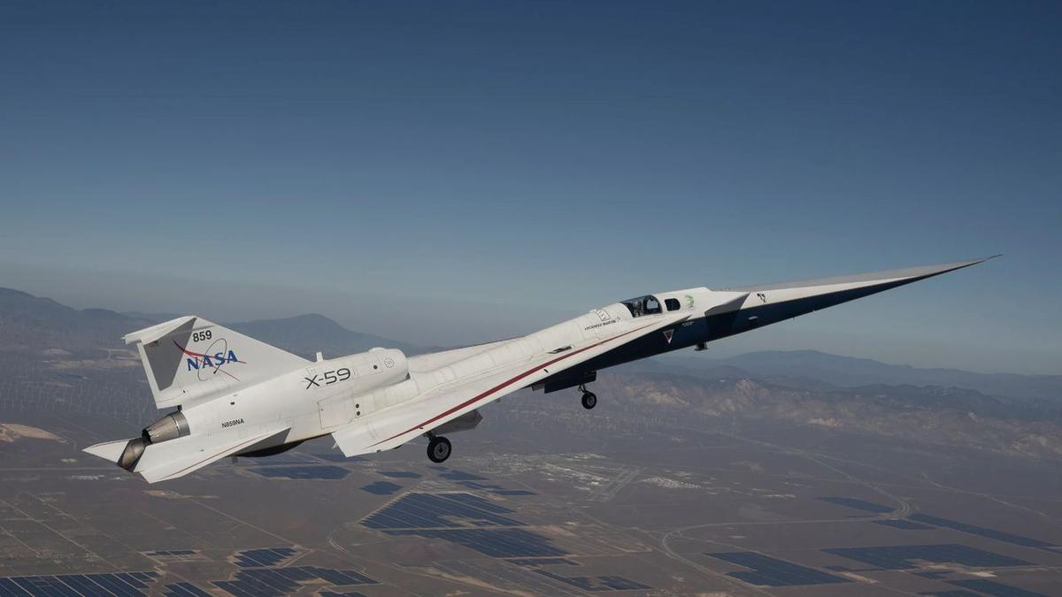
Click for next article NASA's quiet supersonic X-59 aircraft is seen here during a flight on March 20, 2026. The agency will showcase its aerospace tech at its "Max Power" expo at Kennedy Space Center this November. NASA will hold a two-day aerospace exposition this November, and it may draw a surprising number of "Simpsons" fans. The event, which NASA announced today (Aug. 14), will be held Nov. 7 and Nov. 8 at Kennedy Space Center (KSC) on Florida's Space Coast. It's called "Max Power," which is also a famous Homer Simpson pseudonym. In the 13th episode of the show's 10th season, which first aired in February 1999, Homer legally changed his name to Max Power. He wanted to disassociate himself from a bumbling character on the (fictional) TV show "Police Cops" who shared his given moniker. The Simpsons: Max Power part 1 - YouTube Watch On Homer made the switch to Max Power - which he said he got off a hair dryer - without consulting his family, a move that did not go over well. "Wait a minute!" his dad protested. "The family name is my legacy to you. I got it from my father, and he got it from his father, and he traded a mule for it. And that mule went on to save spring break." Homer's wife Marge was also displeased. "But I fell in love with Homer Simpson," she said. "I don't want to snuggle with Max Power." "Nobody snuggles with Max Power," Homer - or rather Max - responded. "You strap yourself in and feel the Gs!" NASA's Max Power expo is about feeling the Gs as well, at least in part. "The two-day event will feature immersive experiences for all ages to enjoy, including air shows, skydiving stunts, technology demonstrations, spaceflight hardware, military aircraft and behind‑the‑scenes access to America's spaceport," agency officials wrote in a description of the expo . "Attend talks led by NASA experts and meet astronauts from some of agency's most famous missions!" NASA Administrator Jared Isaacman , an accomplished pilot as well as a private astronaut , said that he plans to participate in the expo's air show. And, if you're unable to attend this November, you'll likely have other chances down the road. "Certainly, the idea is that this event, Max Power, becomes the first of many," Isaacman said during a press conference today.

56. Water can survive surprisingly close to the Milky Way's supermassive black hole, James Webb Space Telescope finds
Read more
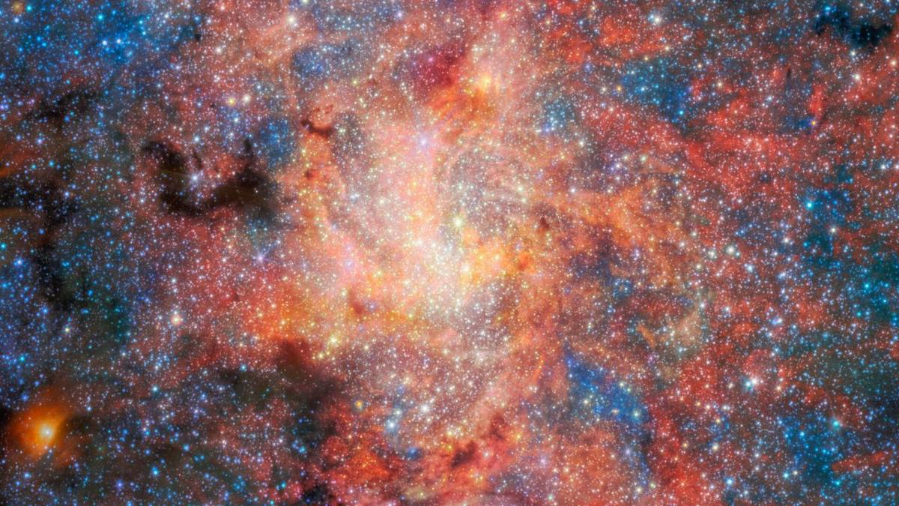
Click for next article The heart of the Milky Way may be more hospitable to water than astronomers thought. Using the James Webb Space Telescope (JWST), researchers detected water and cosmic dust around an aging star only 0.55 light-years from Sagittarius A* (Sgr A*), the supermassive black hole at the center of our galaxy. The new study suggests that water and dust can form and survive surprisingly close to a supermassive black hole , where intense radiation and other harsh conditions might otherwise be expected to destroy them. The team used Webb's Mid-Infrared Instrument (MIRI) to study IRS 3, an aging star located in the crowded environment surrounding Sgr A*, which has a mass of about 4 million suns, according to a statement from the European Space Agency (ESA). (Image credit: ESA/Webb, NASA & CSA, F. Peißker, J. Lu, F. Yusef-Zadeh, N. B. Sabha, C. Chan) "Galactic centres are among the most extreme environments, so understanding whether stars can continue enriching their surroundings there is an important question," Florian Peißker, lead author of the study from the University of Cologne in Germany, said in the statement . "With Webb, we can directly observe how stars behave under these conditions and see that dust production remains remarkably resilient." IRS 3 - one of the brightest mid-infrared sources in the galactic center - is an asymptotic giant branch star , meaning it has reached a late stage of stellar evolution in which it sheds large amounts of gas and dust through powerful stellar winds. Such dying stars act as cosmic recycling centers, returning material to space that can eventually become incorporated into future generations of stars and planets. But IRS 3 lives in a particularly unforgiving neighborhood. The center of the Milky Way is densely packed with stars and exposed to intense radiation, raising questions about whether molecules and newly produced dust can persist there. However, Webb's observations suggest they can. By combining observations of IRS 3's spectrum with simulations of how its light travels through different models of the surrounding material, researchers reconstructed the structure of the star's envelope. They found a layered, shell-like distribution of silicate dust extending roughly 10,000 astronomical units from the star (one astronomical unit, or AU, is the average distance between Earth and the sun ). Temperatures within the envelope fall from about 1,700 degrees Fahrenheit (927 degrees Celsius) near the star to around minus 280 F (minus 173 C) in its outer regions. Webb's observations also revealed clear evidence of water within the envelope - the first such detection for IRS 3. "The detection of water is especially exciting because it shows that molecular material can survive in an environment dominated by intense radiation," Macarena Garcia Marin, co-author of the study and an ESA astronomer, said in the statement. While the observations don't reveal how much water is present, the detection shows that water can survive in the harsh environment near the galactic center . Water and dust are important ingredients in the chemistry that accompanies star and planet formation, meaning material shed by aging stars such as IRS 3 could eventually contribute to future generations of stars and planets. Finding water and dust near Sgr A* therefore suggests that aging stars can continue enriching their surroundings even in the harsh conditions near a supermassive black hole. The findings could help astronomers better understand how material is recycled in the centers of galaxies and the role evolved stars play in supplying those regions with fresh dust and molecules.

57. ISS photobombs the sun during solar eclipse | Space photo of the day for Aug. 14, 2026
Read more
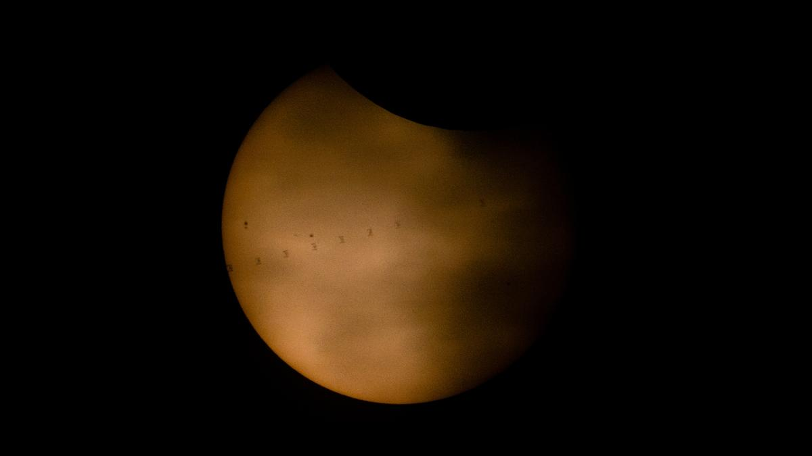
Click for next article The silhouette of the ISS transiting across the sun's face during the Aug. 12, 2026 total solar eclipse. (Image credit: NASA/Joel Kowsky) This week's total solar eclipse captured the world's attention, and millions of skywatchers looked up (with the correct protective eyewear, hopefully) to experience the moon blocking out our star's light. And, as you can see in this image, even the International Space Station (ISS) itself got in on the fun. What is it? On Aug. 12, 2026, the moon completely blocked out the sun's light for millions of lucky skywatchers witnessing a total solar eclipse. But the moon isn't the only thing orbiting Earth. Tons of satellites and probes do too, and that includes the ISS. This created a truly remarkable moment for some skywatchers. With the right equipment, it was possible to see the silhouette of the ISS in front of the sun. This composite image shows eight different frames of the ISS silhouetted on the sun's face as the moon takes a "bite" out of our star to create a partial eclipse. This gif shows the ISS' silhouette moving across the sun's face during a partial solar eclipse on Aug. 12, 2026. (Image credit: NASA/Joel Kowsky) Why is it incredible? Solar eclipses like this week's total solar eclipse really bring people together. It creates opportunities for humans to come together and gather for a common goal. And while the ISS is featured in this image, we may also want to consider the astronauts aboard. In other words, people on Earth weren't the only ones who got to participate in the marvel. The Expedition 75 astronauts on the ISS (NASA astronauts Jessica Meir, Anil Menon, and Jack Hathaway; ESA (European Space Agency) astronaut Sophie Adenot; and Roscosmos cosmonauts Pyotr Dubrov, Andrey Fedyaev and Anna Kikina) caught the show too as they orbited our planet. There they were, in between Earth and the moon, as our planet's neighbor blocked out our star.

58. India-US space ties deepen as NASA invites ISRO to join moon base program
Read more
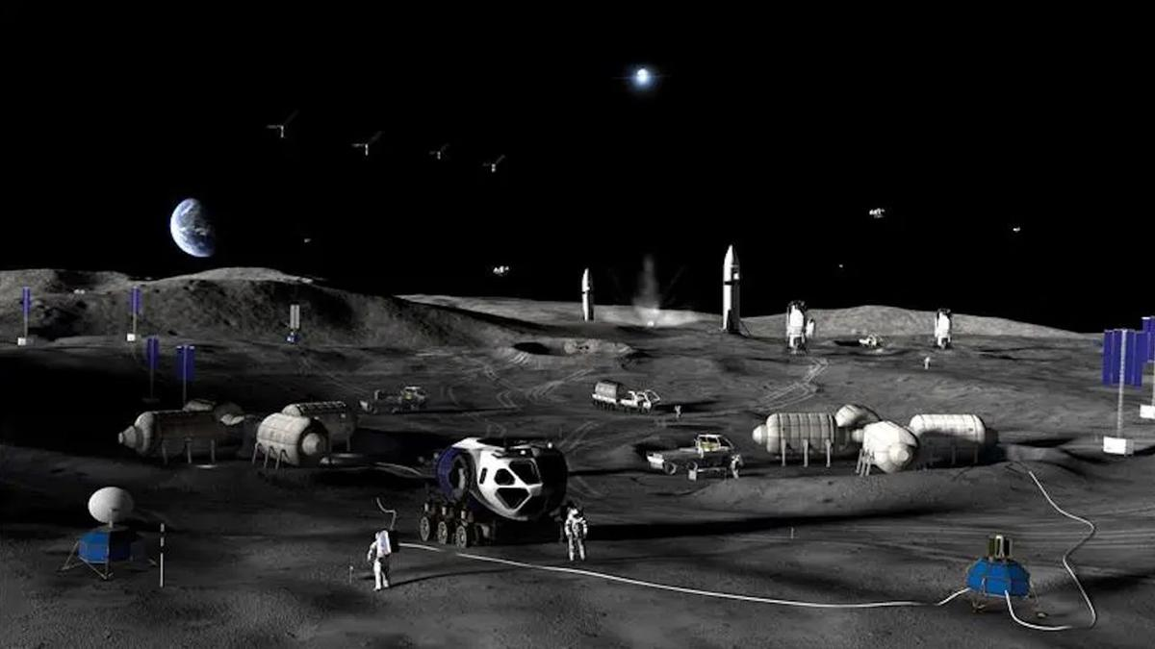
Click for next article NASA plans a to build a permanent base on the moon with a step-by-step approach through 2032. NASA has formally invited India to participate in its effort to build a permanent base near the moon's south pole, adding a new dimension to the deep-space cooperation between the two countries. The invitation was extended last week at the Indian space agency ISRO 's headquarters in Bengaluru during the ninth meeting of the U.S.-India Civil Space Joint Working Group. The CSJWG was established in 2005 as a mechanism for bilateral space cooperation and for addressing challenges and pursuing mutual spaceflight goals. "Building on our successful collaboration in science, NASA reaffirmed its interest in @ISRO joining Moon Base. We're going back to the moon to stay - and we're bringing our partners with us," NASA officials said via X on Tuesday (Aug. 11). Building on our successful collaboration in science, NASA reaffirmed its interest in @ISRO joining Moon Base. We're going back to the Moon to stay - and we're bringing our partners with us. https://t.co/hU9ssn24FPAugust 11, 2026 Beyond the lunar base invitation, "the two sides also agreed to advance discussions for cooperation on open scientific data sharing under the Accords," reads a Tuesday statement by the U.S. Embassy in India. "The Accords" are the Artemis Accords , the U.S.-led diplomatic framework outlining principles for safe and responsible exploration of the moon and beyond. India signed on as the 27th signatory in 2023, joining a coalition that has now grown to 70 nations. Official statements have provided few details on what India's participation in the Moon Base program would entail in practice. The meeting, however, brought together senior space officials from both countries, including V. Narayanan, the chairman of ISRO and secretary of India's Department of Space, and Sergio Gor, the U.S. Ambassador to India, who addressed the opening session, according to the statement. The meeting was co-chaired by M. Sankaran, director of ISRO's U.R. Rao Satellite Centre, on the Indian side, and two people on the U.S. side - Wesley Brooks, assistant secretary of state for the U.S. Department of State's Oceans and International Environmental and Scientific Affairs, and Kathleen Karika, NASA associate administrator for International and Interagency Relations, the statement reads. Over the coming decade, via its Artemis program , NASA plans to build out a sprawling, city-like base near the moon 's south pole, a region of particular interest thanks to permanently shadowed craters there that are thought to contain substantial deposits of water ice. Details of the planned architecture shared by NASA in May envision hilltop habitats to take advantage of sunlight and nuclear power systems located farther away to mitigate radiation risks. The space agency also plans to use small, hopping robots starting in 2028 to scout the south polar region ahead of moon base construction. This effort to gather information and secure access to the surface is the first of three planned phases. Phase 2, from 2029-2032, is intended to establish the base's initial operating capability. Phase 3, from 2032 onward, aims to achieve a semi-permanent crew presence on the lunar surface, NASA said during the May update. Senior space officials from India and the U.S. at the ninth meeting of the India-U.S. Civil Space Joint Working Group at ISRO headquarters in Bengaluru on Aug. 5-6, 2026, where NASA invited ISRO to join its Moon Base program. (Image credit: ISRO) To prioritize infrastructure that supports sustained operations on the moon's surface, increase launch cadence and keep pace with China's lunar ambitions , NASA earlier this year paused development of its long-planned Gateway space station.

59. SpaceX rocket's moon crash highlights 'a tangible operational risk' of lunar settlement
Read more
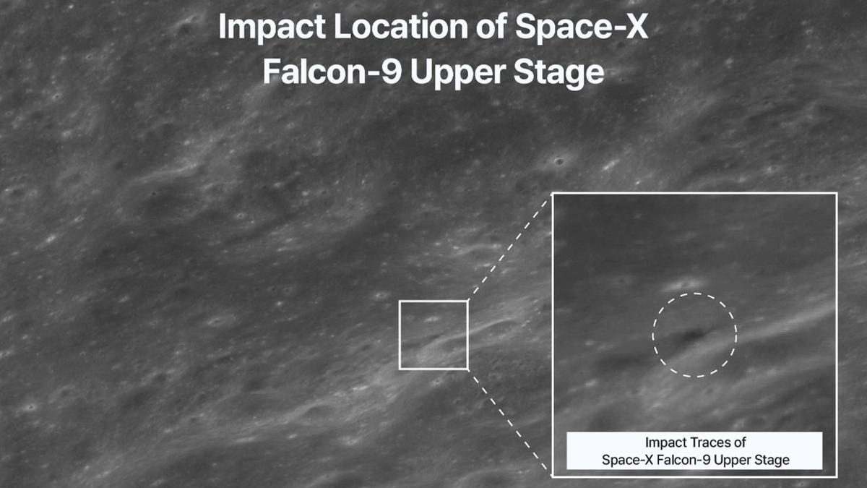
Click for next article South Korea's Danuri lunar orbiter captured this image of the crater blasted out by a SpaceX Falcon 9 upper stage when it hit the moon on Aug. 5, 2026. The moon dust has settled after a 4.5-ton SpaceX rocket body slammed into terrain near Einstein Crater on Aug. 5. That impact site was imaged by South Korea's moon-orbiting Danuri spacecraft, as well as by NASA's Lunar Reconnaissance Orbiter (LRO). Reportedly, a Chinese commercial space debris monitoring satellite tracked and recorded the 5,400-mph (8,690-kph) moon punch, too. Wandering through space for over a year, the leftover Falcon 9 upper stage had sent Firefly Aerospace's Blue Ghost-1 lander on its way to the moon back on Jan. 15, 2025. Also sent moonward on that flight was the Hakuto-R Mission 2's Resilience, a robotic lunar lander developed by the Japanese company ispace. While the moon has reclaimed its serenity, the implications of the uncontrolled collision continue to reverberate. Close encounter Interestingly, there was also the prospect of a too-close-for-comfort conjunction of the Falcon 9 upper stage and Danuri. "We noticed roughly late June that there is an incoming Falcon 9 upper stage toward the moon, and also knew that it would be close to Danuri," Eunhyeuk Kim, a senior researcher at the Korea Aerospace Research Institute (KARI), told Space.com. There was a huge uncertainty in the predicted trajectory of the upper stage, Kim said, while the orbit information of South Korea's Danuri lunar orbiter was quite accurate. "Therefore, we could not neglect the probability of an incoming and close encounter." Before-and-after imagery of the impact site. (Image credit: KARI) Spacecraft maneuver However, around mid July, the KARI/Danuri team performed a maneuver of the spacecraft in preparation of a near-total lunar eclipse on Aug. 28, said Kim. That eclipse will see 96% of the moon's visible surface passing through Earth's dark umbral shadow. Kim said that the orbiter's maneuver brought a slight change in the phase of the spacecraft's orbit, which canceled the probable conjunction between the upper stage and Danuri. At the time of the Aug. 5 impact, Danuri was flying over the moon's south pole area , far away from the hit zone, said Kim. Illustration of the moon, with an arrow pointing to the Falcon 9's upper stage impact site on Aug. 5, 2026. (Image credit: Bill Gray/Project Pluto) High-speed ejecta Dean Sladen is a quality manager and aerospace engineer in the United Kingdom for Accu Components, a high-precision manufacturing firm. "As space agencies and private companies build out permanent lunar infrastructure , uncontrolled rocket stages evolve from a minor nuisance into a tangible operational risk," Sladen told Space.com. "A direct hit is the obvious worst-case scenario, but distant impacts also generate ground shocks and high-speed ejecta that can degrade sensitive equipment over time." Sladen noted that lunar impacts have been a constant throughout history, with meteorites and comets bombarding the surface unhindered by an atmosphere. "Over the past 65 years, artificial objects have added a new dynamic to these events," he added. An artist's concept of astronauts working on the lunar surface. (Image credit: NASA) Genuine hazard Even modest hardware impacts permanently alter the lunar landscape, said Sladen. Given the moon's lack of a substantial atmosphere , there is no air resistance to slow debris down. An impact therefore hurls high-speed ejecta (fine regolith and rock fragments) across vast distances at bullet-like speeds. "While this isn't a major threat to isolated missions today, as we establish permanent lunar infrastructure, high-velocity ejecta poses a genuine hazard to surface habitats, solar arrays and working astronauts ," Sladen said. To mitigate this issue, Sladen suggested that the industry will likely need designated impact zones or strictly controlled, targeted de-orbit protocols to ensure that spent hardware lands far from active installations. "That said, human-made debris is only half the equation," Sladen continued. "Natural meteorites remain an ongoing background threat, and, while massive natural strikes are rare, they hit at significantly higher speeds and carry far more energy," Sladen said. "Controlling our own hardware is simply the part of the risk profile we actually have the power to manage." Plume detections In the meantime, while the Falcon 9 impact was tough to see from Earth , several observations from our planet reported the detection of sodium and lithium gas above the crash site. The European Southern Observatory's (ESO) Very Large Telescope (VLT) in Chile, for example, saw the aftermath of the impact. The ESO reported that a chemical fingerprint of the impact was visible for five to 10 minutes, with an enormous plume of lunar material stirred up due to the hard-hitting hardware. "I'm happy that ESO recorded some evidence of it through VLT, and Danuri has found the exact impact location," said William Jo, a graduate research assistant at the University of Texas, Austin who performed some pre-strike computer simulations. "What we've learned so far is that the plume was too faint to see against the bright lunar surface, and only a large observatory telescope could pick some parts of it out against the dark sky, which is exactly what happened," Jo told Space.com. "The plume must have shot out high," he said, "and I'd like to know how high, or even whether we can replicate the signals." Targets of opportunity " Telescopes make the best spaceships," pointed out Elaina Hyde, director of the Allan I Carswell Observatory at York University in Canada. "We are always on the lookout for 'targets of opportunity' like this event." Hyde organized a livestream event , training the observatory on the collision locale. They were unable to spot the impact, however. "The lunar collision was not on our regular research program, but when it happened, we put it as a high-priority item to observe if the weather was clear," Hyde said. "Anything that happens quickly like this is often a target of opportunity, because you do not get a long time to plan the observation." "However, since it was not visible from our location in Toronto, our 'null' or non detection can actually help to limit the estimates on how big the dust plume was and perhaps some of its properties," said Hyde. (Image credit: Lowell Observatory) Impact response Also on the moon impact watch were observers using Lowell Observatory equipment in Arizona. These researchers managed to measure a response from the rocket stage impact, spotting a sizable sodium and lithium gas plume that lasted between five and 10 minutes after impact, reported Carl Schmidt, an assistant research professor at Boston University's Center for Space Physics. Observers at the 4.3-meter Lowell Discovery Telescope (LDT) in Happy Jack, Arizona used a long slit spectrograph to detect the plume. Graduate students from Boston University continue to analyze data gleaned from the moon wallop. Bright lithium plume "At LDT, we saw a bright lithium plume from the rocket body and fainter sodium [signature], likely from the surface itself," Patrick Lierle of Boston University told Space.com. "The bright lithium plume extends more than halfway up our field of view." The LDT results are also credited to Emma Lovett, a Boston University graduate student. William Jo said he's looking forward to the release of observational data about the impact before he and colleagues can refine their lunar ejecta simulation model. "That data, combined with our simulations, could tell us things like the composition of the lunar material, what orientation the impact hit at, and so on," Jo said.

60. NASA Administrator 'extremely confident' in Artemis 3 mission in 2027
Read more
NASA is potentially less than a year away from the trio of rocket launches that will encompass the Artemis 3 mission and the agency's leader said he is "extremely confident" that the mission will happen in 2027. Isaacman made the statement while joined by Brian Hughes, the Kennedy Space Center director, as well as members of the Florida congressional delegation on Friday. He was there to announce a new NASA-supported, privately run air and space show, called "Max Power" taking place in early November. "I'm extremely confident that we are we are going to be able to launch Artemis 3 next year. That's why we stepped into stacking operations," Isaacman said, referring to the assembly of the Space Launch System (SLS) rocket happening in the Vehicle Assembly Building at KSC. Earlier this summer, the Orion spacecraft's crew and service module were mated together ahed of additional testing. Four out of the ten segments of the solid rocket boosters have been stacked inside High Bay 3 while engine integration onto the core stage happens inside High Bay 2. The Artemis 3 mission will begin with the launch of Blue Origin's New Glenn rocket, which will send a test version of its Blue Moon Mark 2 lander into low Earth orbit. That will be followed days later by the launch of the SLS rocket and Orion spacecraft, which will rendezvous and dock with Blue Origin's vehicle. "I had a chance to visit with the Blue Origin team earlier, walked the assembly line floor today, looking at components that will make their way into the Blue Origin test lander that we will be rendezvousing and docking with," Isaacman said. "And I'll tell you, if you spoke to Blue Origin, they would say the same thing. What we are going to learn from that mission, the amount of risk we're going to be able to bring down in advance of Artemis 4 will be significant. "I think in fact, if you coupled that with the uncrewed landing demonstration, you'd be very confident in what they're going to be able to achieve potentially in 2028." Blue Origin's demonstration lander represents a number of the capabilities that will be featured in their Blue Moon Mark 2 lander, which will be used for crewed landings on the Moon's south pole. The test lander doesn't include the BE-7 engine of the Blue Moon Mark 2, but it does include a life support system and crew habitation area, which will allow the crew to live and work onboard while it's docked with the Orion spacecraft. After the two separate, SpaceX will launch its Starship Version 3 rocket, with a docking adapter on the nose of the upper stage. That Starship will be the target for Orion to dock, but because it won't have a crew habitation area, the astronauts will remain onboard Orion while the two are mated. "Now with respect to SpaceX, I think you're what you're witnessing, you're seeing an increase in launch cadence, and that's critical. If they're able to launch again in early September after their last launch and continue to track inside the month, potentially every couple of weeks before the end of the year, that's going to - we're going to feel very good about their time to contribute to Artemis 3 next year," Isaacman said. "They've already started cutting hardware for that test vehicle. We track that every single day, so that's the test lander. So we're feeling very good about that, and I'd say more so with each step along the way that you get better about Artemis 3, you're feeling that much better about Artemis 4 and its timeline in '28." The Artemis 4 mission is planned to be the first crewed landing on the Moon as part of the Artemis Program. At this stage, NASA hasn't named the crew flight that mission or which lander it will select to perform the landing operation for that mission. Max Power coming to Kennedy The event Friday wasn't billed around an Artemis 3 update, but rather to announce and promote the Max Power air and space technology expo. Isaacman said that the event "is not something that NASA is going to be footing the bill for," but rather managed by sponsors. "These type of events do happen around the world, they're sponsor-driven. We're making available this great real estate, no different than you would see at other major events. Nellis (Air Force Base) has a show, Andrews (Air Force Base) and others," Isaacman said. "We'll be contributing a lot of our talent and we'll be contributing some of our aircraft from the NASA portfolio, which we fly around at various events at normal, well, they're certainly becoming normal course and especially America's 250th birthday." <span data-mce-type="bookmark" style="display: inline-block; width: 0px; overflow: hidden; line-height: 0;" class="mce_SELRES_start"></span> Those sponsors Isaacman referenced weren't mentioned by name during the Friday announcement event, but NASA's webpage for Max Power lists them as: Air Dot Show Delaware North Purpose Entertainment Space Florida UP.Summit Even though they share the name "Max Power," the event is split across three venues with separate tickets being sold by Air Dot Show, Delaware North, and UP.Summit. The number of tickets to each have not been announced and each event under the Max Power umbrella requires the purchase of a separate ticket. "Because the event relies on the funding and structure provided by these external organizations rather than exclusively using NASA's federally appropriated budget, ticketing is handled through their external sites so they can cover their costs of producing the event," NASA wrote on its website under the "Frequently Asked Questions" section. Delaware North, which manages the Kennedy Space Center Visitor Complex, is charging $69.38 per adult per day with taxes and fees ($58.68 per child ages 3-11). It will take place at the KSCVC and feature panels from NASA and other space companies; a space-themed parade; and hands-on activities. UP.Summit is selling tickets for $53.50 per adult per day (including tax), but doesn't mention the cost of children's tickets on its website. It's exhibits and vendors will be set up at Space Florida's Launch and Landing Facility (LLF) and will reportedly feature hardware from Astranis, Astroforge, Blue Origin, Stoke Space, Vast and more. Air Dot Show, which manages the air show portion and will also have aircraft on the ground at the LLF, is charging $49.75 per adult per day for general admission. However, it stipulates that two, one-day tickets at that price need to be purchased together, which brings the total cost after taxes to $112.69. It also notes that this is an "intro sale" price, so the cost may increase as the event draws closer. At those prices, for an individual adult to attend all three events on just one day would cost $179.23. Asked what NASA would be contributing beyond the planes from its air show, Isaacman said some number of personnel would be on hand at the three venues, which will include both Apollo and Artemis astronauts. "You'll see rovers, you'll see landers from the [Commercial Lunar Payload Services] program here, you'll see a lot of hardware that either has adaptability to the early Artemis missions," Isaacman said. "You might get a great view of Artemis 3 on its way out to pad 39B. You'll also see a lot of critical components of the Moon Base that we're building as well." The timing of the Max Power air show may very well coincide with the rollout for fueling demonstration of the SLS rocket. "I certainly hope we have to work some deconfliction issues between the event and Artemis 3 rollout. That would be fantastic," Isaacman said. "But I actually think, if our timing works out, it'll be a fantastic way to compliment what should already be a rather extraordinary event." Isaacman said in response to a media question that while he hope Max Power can serve as an inspiration for future generations to pursue interests that will help NASA or potentially lead to a job at the agency, he said the goal isn't to compete with industry. "We're not hosting the event necessarily to take talent away from others in industry. In fact, I think NASA, as I've said many times, is at our best because we are doing what no company or agency or other nation is capable of doing," Isaacman said.

61. Constipation is common in astronauts-blood tests provide new answers
Read more

For astronauts in space, constipation is a well-known problem. But why this happens has long been unclear. Now, a new study from the University of Copenhagen in collaboration with NASA provides an idea of what happens in the stomach without the influence of gravity.
62. ISRO Scientist Recruitment 2026: Apply for 92 Posts - Education Today
Read more
ISRO Scientist Recruitment 2026: Applications Open for 92 Posts, Check Eligibility and Selection Process Leave a Comment / Daily News Table of Contents - 92 Scientist and Engineer Vacancies Announced - Academic Eligibility for Applicants - Age Limit and Application Fee - Selection Based on GATE Score and Interview - How Candidates Can Apply - Why the Recruitment Matters for Engineering Graduates - Engineering Skills Meet Space Technology - A Career Opportunity Within India's Space Programme The Indian Space Research Organisation (ISRO) has opened applications for 92 Scientist/Engineer 'SC' positions across multiple engineering disciplines, offering qualified candidates an opportunity to build a career with India's premier space research organisation. The recruitment is being conducted through the ISRO Centralised Recruitment Board (ICRB), with candidates required to hold a valid GATE score in the relevant discipline. The recruitment comes at a time when opportunities in space science, engineering and advanced technology are expanding alongside India's growing space programme. For engineering graduates with the required academic qualifications and GATE scores, the vacancies provide an opportunity to enter a highly specialised technical environment. Candidates interested in the posts must complete the online application process by 17th August 2026. Applicants are advised to verify their eligibility and submit their forms well before the deadline rather than waiting until the final day. 92 Scientist and Engineer Vacancies Announced The vacancies have been distributed across several engineering disciplines. Electronics has the highest number of positions, followed by Mechanical and Computer Science. The discipline-wise distribution is: - Electronics: 34 vacancies - Mechanical: 26 vacancies - Computer Science: 13 vacancies - Civil: 10 vacancies - Electrical: 4 vacancies - Refrigeration and Air Conditioning: 2 vacancies - Architecture: 2 vacancies - Civil at PRL: 1 vacancy - Total: 92 vacancies The distribution highlights the range of technical expertise required across ISRO's operations. Engineers from conventional disciplines as well as specialised areas can therefore find opportunities within the recruitment process. Academic Eligibility for Applicants Candidates applying for the Scientist/Engineer 'SC' positions must possess a BE, BTech or equivalent degree in the relevant engineering discipline. Applicants are required to have secured at least 65% aggregate marks or a CGPA of 6.84 on a 10-point scale. Another important requirement is the GATE score. Candidates must have a valid score from either GATE 2025 or GATE 2026 in the corresponding paper. This requirement makes the recruitment particularly relevant for engineering graduates who have recently appeared for the national-level examination. The eligibility criteria are designed to ensure that applicants possess both the required academic foundation and a recognised national-level assessment score before moving to the next stage of recruitment. Age Limit and Application Fee Age is another important criterion that applicants must consider before submitting their forms. Candidates must be 28 years of age or below as on 17th August 2026, subject to the applicable provisions and relaxations specified by ISRO. Candidates belonging to the unreserved category are required to pay an application fee of ₹250. Applicants should carefully review the official notification for applicable provisions before completing the payment and final submission. Since recruitment applications involve document verification at later stages, candidates should ensure that the information entered in the application form matches their educational records and other supporting documents. Selection Based on GATE Score and Interview The selection process combines the candidate's performance in GATE with an interview. According to the recruitment notification, the final merit list will be based on the interview and GATE score. This makes the recruitment particularly important for candidates who have already invested significant preparation in the GATE examination. A strong GATE performance can provide the academic foundation for progressing through the recruitment process, while the interview offers ISRO an opportunity to assess candidates beyond their examination performance. The combination of a national-level examination score and a specialised interview also reflects the technical nature of the positions. Successful candidates are expected to contribute to highly specialised engineering and scientific work within the organisation. How Candidates Can Apply Eligible candidates can complete their applications through the official ISRO recruitment portal. The application process involves several stages, and applicants should carefully follow the instructions provided in the notification. The broad application process includes: - Visiting the official ISRO website and accessing the Careers section - Opening the relevant Scientist/Engineer recruitment notification - Registering with an email ID and mobile number - Entering personal and educational details - Uploading the required documents - Paying the applicable application fee - Submitting the completed application form - Downloading and retaining a copy of the submitted form for future reference Candidates should check every detail before final submission, particularly their educational qualifications, GATE information and personal particulars. Why the Recruitment Matters for Engineering Graduates A Scientist/Engineer position at ISRO represents more than a conventional engineering career. The organisation works across areas involving spacecraft, launch vehicles, satellite systems, electronics, communication, propulsion, remote sensing and other advanced technologies. The recruitment therefore provides qualified engineers with an opportunity to work in an environment where engineering knowledge is applied to complex national space missions. The diversity of disciplines in the latest vacancies also demonstrates that India's space programme requires expertise extending well beyond aerospace engineering alone. For engineering students and recent graduates, the recruitment can also underline the importance of building strong fundamentals alongside preparation for examinations such as GATE. Click below to watch the video. Engineering Skills Meet Space Technology Engineering careers are increasingly extending into specialised sectors such as space technology, satellite systems and advanced research. EducationToday views the ISRO recruitment drive as a notable example of how strong engineering fundamentals, combined with national-level examinations such as GATE, can open pathways into highly specialised careers. The opportunity is particularly relevant for graduates who want to apply their technical knowledge to projects with national significance. It also highlights the growing importance of interdisciplinary engineering capabilities as India's space programme expands into increasingly sophisticated areas of research and technology. For aspiring engineers, such recruitment drives can serve as a reminder that career opportunities are not limited to conventional corporate roles. Public-sector research and technology institutions can also offer pathways into specialised technical work. A Career Opportunity Within India's Space Programme The 92 vacancies offer engineering graduates an opportunity to enter a demanding technical environment and contribute to India's space programme. With recruitment spanning Electronics, Mechanical, Computer Science, Civil, Electrical and other disciplines, the drive reflects the broad engineering expertise required to support complex space missions. For eligible candidates, the immediate priority is to focus on the application deadline. With 17th August 2026 approaching, applicants should verify the eligibility requirements, keep the necessary documents ready, and complete the online registration carefully. The selection process also requires candidates to prepare beyond the application stage. Since the final merit list takes into account both GATE performance and the interview, applicants should be prepared to demonstrate not only academic knowledge but also their understanding of engineering concepts and their suitability for specialised work. The latest recruitment drive provides a significant opportunity for qualified engineering graduates seeking a technically challenging career within India's space sector. Candidates who meet the prescribed requirements should make use of the application window and approach the selection process with careful preparation. 1. How many vacancies are available in ISRO Scientist Recruitment 2026? ISRO has announced 92 vacancies for Scientist/Engineer posts under the 2026 recruitment drive. 2. Who is eligible for ISRO Scientist Recruitment 2026? Eligibility depends on the post and discipline. Candidates generally need the prescribed engineering or relevant technical qualification with the required academic performance specified in the official recruitment notification. 3. What is the age limit for ISRO Scientist/Engineer Recruitment 2026? The age limit varies according to the recruitment notification and applicable category-based relaxations. Candidates should check the official notification before applying. 4. How can candidates apply for ISRO Scientist Recruitment 2026? Eligible candidates can submit their applications online through the official ISRO recruitment portal by completing the form, uploading required documents, and paying the applicable fee, if required. 5. What is the selection process for ISRO Scientist Recruitment 2026? The selection process generally involves shortlisting based on the prescribed criteria, followed by the relevant written test and/or interview, depending on the post and recruitment notification. Post Views: 553 UP Board's Derecognition of 465 Non-Functional Schools Signals a Strong Push for Educational Accountability Daily News

63. Skyroot Aerospace: How Two ISRO Engineers Built India's Space-Tech Unicorn | Independence Day 2026 - news18.com
Read more
Skyroot Aerospace: How Two ISRO Engineers Built India's Space-Tech Unicorn | Independence Day 2026 news18.com

64. 80 years of Independence: From Mangalyaan to Chandrayaan-3, India's rise as a space power - WION
Read more
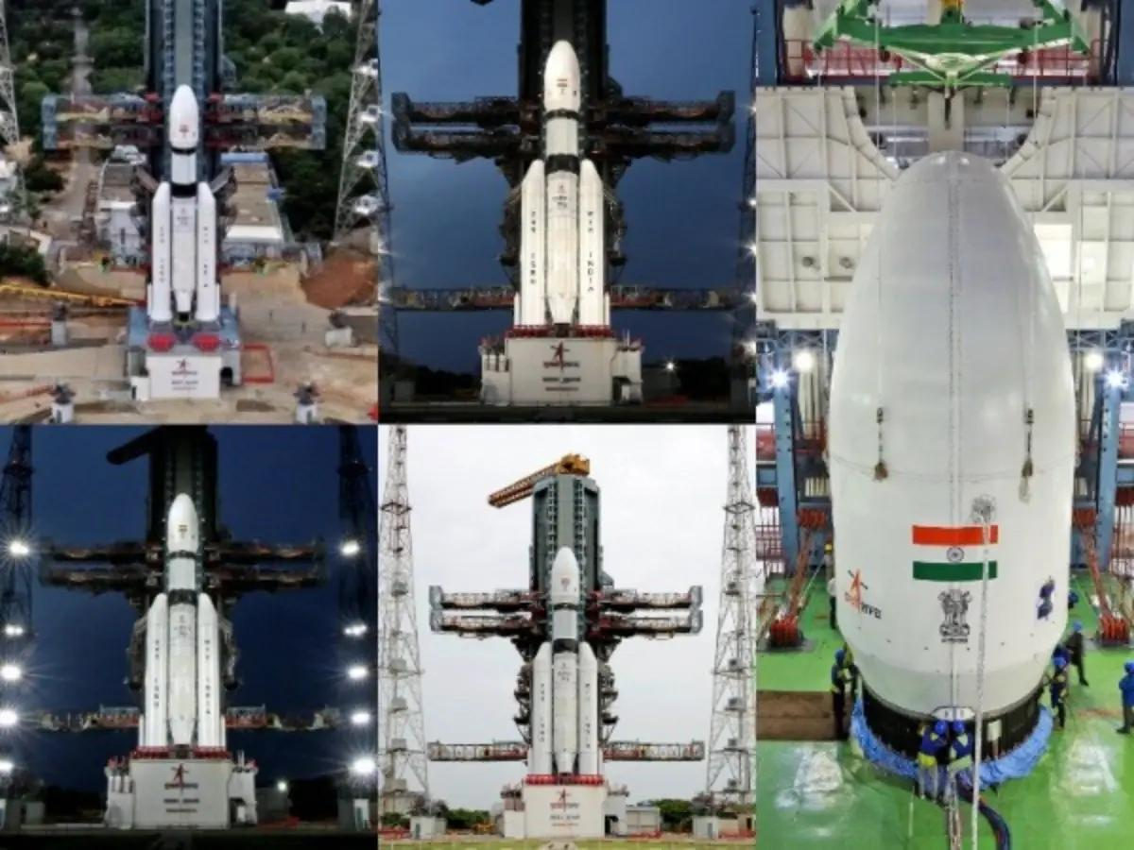
India is amongst the fastest growing economies in the world. In fact it is the sixth-largest economy by nominal GDP, with an estimated size of around $4.15 trillion. When measured by Purchasing Power Parity (PPP), India stands much higher at the third place globally, trailing only the United States and China. Similarly, India has grown by leaps and bounds in the field of science and technology since gaining Independence on August 15, 1947 from the British rule. According to the global ranking, India stands 3rd in scientific publications and ranks 38th in the Global Innovation Index. The country has rapidly scaled its research output, patent filings, and high-impact contributions across global science, technology, and innovation frameworks. Add WION as a Preferred Source One of India's most visible scientific achievements has been its space programme, led by Indian Space Research Organisation (ISRO). Here we take a look at some of the developments and achievements made in Space Science in last two decades made by India. From 2006 to 2026, India has shown exceptional growth like undertaking lunar, Martian, solar, astronomical and deep-space missions and demonstrating advanced technologies such as autonomous satellite docking. Chandrayaan-1: India Reaches the Moon - 2008 A major turning point for India to prove its capabilities in Space Science came on 22 October 2008, when it launched Chandrayaan-1, India's first mission to the Moon, carried 11 scientific instruments from India and international partners. Other than mapping Moon's chemical, mineralogical and geological characteristics, Chandrayaan-1 detected evidence of hydration/water-related signatures on the lunar surface and near-surface environment. The mission demonstrated that India could conduct sophisticated planetary science too and that its capabilities are not limited to merely launching communication and Earth-observation satellites. Mars Orbiter Mission - 2013 On 5 November 2013, ISRO launched the Mars Orbiter Mission or Mangalyaan and became the fourth space agency to successfully place a spacecraft in Mars orbit. The mission was designed for six months but completed seven years in Mars orbit. During its mission the spacecraft studied aspects of the Martian surface, atmosphere, morphology, mineralogy and the Martian exosphere. Also its Mars Colour Camera produced more than 1,100 images for study. Multi-Wavelength Astronomy - 2015 On 28 September 2015 India launched Astrostat, an astronomical observatory designed to study celestial objects in multiple wavelengths. It has helped Indian scientists to investigate phenomena involving stars; galaxies; X-ray sources; black holes; neutron stars and high-energy astronomical events. Chandrayaan-2 in 2019 India launched Chandrayaan-2 on 22 July 2019. The mission consisted of an orbiter, lander and rover. Although the lander did not achieve a successful soft landing, the orbiter continued operating and producing valuable scientific data. Chandrayaan-3: Historic Lunar Landing - 2023 On 23 August 2023, Chandrayaan-3 successfully soft-landed on the Moon. With this India became the first country to land in the Moon's southern high-latitude region and only the fourth country to achieve a soft landing on the Moon.

65. Live coverage: SpaceX to launch satellite replenishment mission for Globalstar from Cape Canaveral
Read more
Globalstar is getting ready to replenish its low Earth orbit satellite constellation with a Saturday night launch onboard a SpaceX Falcon 9 rocket. The mission, dubbed Globalstar 2R Launch 1, will send a batch of eight satellites into orbit with a deployment sequence beginning more than 56 minutes after liftoff and lasting less than 10 minutes. SpaceX's Falcon 9 rocket will take off from Space Launch Complex 40 at Cape Canaveral Space Force Station. Liftoff is scheduled for 9:12 p.m. EDT (0112 UTC), less than 40 minutes prior to another planned Falcon 9 launch from Vandenberg Space Force Base. Spaceflight Now will have live coverage beginning about an hour prior to liftoff. <span data-mce-type="bookmark" style="display: inline-block; width: 0px; overflow: hidden; line-height: 0;" class="mce_SELRES_start"></span> The 45th Weather Squadron forecast a 90 percent chance for favorable weather at liftoff. Meteorologists said there's a chance for interference from cumulus and anvil clouds. "Weak flow at the surface and high pressure over the Gulf will allow afternoon sea breeze formation to push isolated showers and thunderstorms inland through the evening hours," launch weather officers wrote. "Lingering anvil and cumulus clouds will remain low risks throughout both launch opportunities." SpaceX will launch the mission using the Falcon 9 first stage booster with the tail number B1090. This will be its 14th flight. Less than eight minutes after liftoff, B1090 will target a landing back at Landing Zone 40, adjacent to the launch pad. If successful, this will be the fifth landing at this site and the 649th Falcon booster landing for SpaceX. The mission Saturday night was publicly announced by Globalstar in the springtime. It said the launch was scheduled to happen on Sunday, May 17, but the flight was pulled to "allow more time for Globalstar teams to prepare the satellites for launch." The flight announcement came about a month after Amazon announced its intention to acquire Globalstar, which would allow the Amazon Leo to add direct-to-device capabilities to its constellation and compete with companies, like SpaceX and AST SpaceMobile in that domain. "This launch represents another important step in sustaining and strengthening the infrastructure our customers rely on every day," said Dr. Paul E. Jacobs, Chief Executive Officer, Globalstar, in a May 12 press release. "As we continue executing our long-term strategy, replenishing our existing constellation remains a critical part of delivering resilient satellite services around the world." In its latest earnings statement published Aug. 6, Globalstar said it would not be holding any further earnings calls or updates to its forward-looking guidance while the Amazon acquisition is pending. That deal is expected to close sometime in 2027.

द्वारा अभिकल्पित एवं संकलित
DESIGNED & COMPILED BY:
पुस्तकालय एवं सूचना संसाधन प्रभाग
Library & Information Resources Division, IIRS (ISRO), Dehradun
अस्वीकरण | Disclaimer:
सभी लेख / सूचनाएँ सार्वजनिक डोमेन में उपलब्ध हैं तथा केवल सूचना एवं सामान्य जागरूकता के उद्देश्य से
इंटरनेट से संकलित की गई हैं。
All the articles / information are available in public domain and are taken from
Internet for information & general awareness only.

