IIRS Daily Space Digest Friday, 08/05/2026

1. ISRO Gaganyatris outline India's New Space Vision - MSN
"ISRO OR NRSC OR IIRS after:2026-05-07" - Google News
Read more

ISRO Gaganyatris outline India's New Space Vision MSN

2. NASA-ISRO radar system tracks Mexico City sinking up to 2cm a month - madhyamamonline.com
"ISRO OR NRSC OR IIRS after:2026-05-07" - Google News
Read more


Mexico City is sinking at one of the fastest rates in the world, with some areas descending by more than 2cm a month, according to new observations from NASA's NISAR satellite system. The joint mission between NASA and the Indian Space Research Organisation is using advanced radar imaging to monitor subtle changes in Earth's surface in real time. Scientists say the technology is providing the clearest picture yet of the Mexican capital's long-running subsidence crisis. Historic structures across the city show visible signs of the problem. Buildings around the central Zócalo plaza, including the Metropolitan Cathedral and the National Palace, appear tilted due to decades of uneven sinking. Scientists say Mexico City's descent is caused mainly by excessive groundwater extraction. Built on an ancient lake bed, the city sits on soft, clay-like soil that compresses as water is pumped out from underground aquifers. NASA scientist Marin Govorčin told The Guardian the aquifer is being depleted at a rate far greater than natural replenishment from rainfall, causing the ground beneath the city to compact under the weight of urban development. The underground aquifer still supplies about half of the capital's water needs. Experts say the falling water table, which is shrinking by around 40cm each year, is worsening the crisis. The effects are visible across the metropolitan area of about 22 million people, including warped roads, cracked water pipelines, and damage to the metro system. Engineers say leaking infrastructure now causes the city to lose an estimated 40% of its water supply. Among the most striking examples is the Angel of Independence monument on Paseo de la Reforma. Since its completion in 1910, 14 steps have been added to its base as the surrounding land gradually sank. Researchers say the Nisar system could also help monitor earthquakes, volcanoes, landslides, and climate-related changes worldwide. However, experts warn that stopping Mexico City's sinking would require reducing groundwater extraction, a difficult step for a city already struggling with water shortages.

3. How ISRO became the silent force behind Operation Sindoor against Pakistan - WION
"ISRO OR NRSC OR IIRS after:2026-05-07" - Google News
Read more

Conducted without crossing the Line of Control or the international boundary, the operation depended heavily on real-time intelligence, navigation, communication and reconnaissance, capabilities enabled by the Indian Space Research Organisation. When the Indian Air Force released exclusive footage marking the first anniversary of Operation Sindoor, the 88-second video revealed more than precision strikes and coordinated military action. It also highlighted the increasingly central role of space-based surveillance and satellite intelligence in India's modern warfare doctrine. While fighter aircraft, drones and air defence systems dominated the battlefield narrative, the silent architecture supporting the operation came from space. Operation Sindoor was launched in response to the April 2025 Pahalgam terror attack and involved calibrated strikes on terrorist infrastructure linked to Pakistan. Conducted without crossing the Line of Control or the international boundary, the operation depended heavily on real-time intelligence, navigation, communication and reconnaissance, capabilities enabled by the Indian Space Research Organisation. ISRO's Expanding Strategic Role Speaking at an event on May 2025, Indian Space Research Organisation (ISRO) Chairman V Narayanan said at least 10 satellites were working 'round-the-clock for strategic purposes to ensure the safety and security of the citizens of the country'. He stressed that satellite and drone technology had become indispensable for national security operations. "Our satellites must continuously monitor the country's 7,000-km coastline and the entire northern region," Narayanan said, adding that without such technology "the country can't achieve that". India's satellite network played a key role in surveillance, terrain mapping, secure military communication and tracking potential aerial threats during the operation. High-resolution imaging satellites helped monitor enemy movement and identify targets, while communication satellites ensured uninterrupted coordination between different branches of the armed forces. Multi-Layered Defence and Real-Time Monitoring One of the defining features of Operation Sindoor was India's ability to neutralise retaliatory threats. During the night of May 9-10, Pakistan Air Force attempted targeting Indian airfields and logistical infrastructure were thwarted by a multi-tiered defence network integrated with surveillance and tracking systems. Space-enabled monitoring significantly improved India's response time. Satellite inputs, combined with radar and drone intelligence, strengthened air defence coordination and protected both civilian and military installations from major damage. A Shift Towards Technology-Led Warfare Operation Sindoor demonstrated how India's military preparedness is increasingly linked to indigenous technological capability. Over the last decade, sustained investment in satellite systems, missile defence and drone warfare has transformed India's operational capacity. The operation was a tri-services response that embodied precision, professionalism, and purpose. While it was executed on the ground and in the air, ISRO's contribution highlighted a larger strategic reality: in modern warfare, dominance is no longer determined only by troops or firepower, but also by who controls the skies above the battlefield.

4. ISRO advances talks with Russia for semi-cryogenic engines for next-gen rockets - MSN
"ISRO OR NRSC OR IIRS after:2026-05-07" - Google News
Read more

ISRO advances talks with Russia for semi-cryogenic engines for next-gen rockets MSN

5. ISRO reveals electrified moon environment - MSN
"ISRO OR NRSC OR IIRS after:2026-05-07" - Google News
Read more

ISRO reveals electrified moon environment MSN

6. ISRO in talks with Russia's Roscosmos for semi-cryogenic engines - MSN
"ISRO OR NRSC OR IIRS after:2026-05-07" - Google News
Read more

ISRO in talks with Russia's Roscosmos for semi-cryogenic engines MSN

7. Meet the Fleet: NASA Armstrong Continues Legacy of Flight Research
NASA
Read more

NASA's X-59 quiet supersonic research aircraft flies above Palmdale and Edwards, California, during its first flight Tuesday, Oct. 28, 2025, accompanied by a NASA F/A-18 research aircraft serving as chase. NASA/Jim Ross NASA's home for experimental flight is welcoming more flyers to its already high-performing fleet as it continues to support science and aeronautics test missions - continuing the legacy of pioneers like Neil Armstrong. NASA's Armstrong Flight Research Center in Edwards, California, added multiple aircraft this year: two F-15s supersonic jets, a Pilatus PC-12 utility plane, and a T-34 turboprop trainer, which the center will use to support the agency's advancement of aerospace research. Throughout the center's history, pilots have flown everything from large aircraft like the 747 Shuttle Carrier Aircraft and rocket-powered airplanes like the X-15 to high-speed repurposed fighter jets like the F-18. And after almost 80 years, flight research is still going strong in the desert today. "Armstrong has a rich history of flight research, but it's the multidimensional skills of the people we have here, and the knowledge they've built to handle very unique aircraft maintenance and modifications, that stands out," said Darren Cole, capabilities manager for the Flight Demonstrations and Capabilities project at NASA Armstrong. Armstrong has a rich history of flight research, but it's the multidimensional skills of the people we have here … that stands out. Darren Cole Capabilities Manager at NASA Armstrong The center plays a pivotal role in worldwide airborne science missions, flying scientists and equipment from NASA, other government agencies, industry, and academia to collect measurements such as air pollution levels, glacier melt trends, and wildland fire mapping. Scientists can manage experiments in real time aboard flying laboratories like the NASA ER-2, to collect important data with the help of Armstrong's pilots and airborne science team. "We all come together to make the science happen," said Matt Berry, airborne research platforms branch chief at NASA Armstrong. "It is the agility of the Armstrong team that allows us to collaborate with scientists, get their equipment onboard, and to fly them to areas where they need to collect data." The center sits on Rogers Dry Lake, a 44-square-mile slat flat area used for aviation research and test operations. Rogers and the adjacent Rosamond Dry Lake have seen everything from space shuttle landings to emergency test flight recoveries. The Rogers lakebed continues to serve as an important piece of Armstrong's test missions. For NASA Armstrong, it all started with the first attempt by a human to fly faster than the speed of sound in the Bell X-1. In 1946, 13 employees from NASA's predecessor agency, the National Advisory Committee for Aeronautics (NACA), arrived at what was then known as Muroc Army Airfield to prepare for the X-1 tests. A year later, NACA's Muroc Flight Test Unit was established as a permanent facility at the airfield. The center has gone by several names over the years, most recently changing from NASA's Dryden Flight Research Center to NASA Armstrong in 2014. But its legacy has never shifted: The Bell X-1E, the last of the X-1 series of aircraft, now sits in front of NASA Armstrong, welcoming the newest test pilots, engineers, scientists, explorers, and dreamers. And they're using the aircraft of today to break new barriers. "I don't think there is another place in the world with a more diverse fleet of aircraft. We have everything from a low-altitude powered glider to ER-2s, which are flying at high altitudes, and a multitude of aircraft in between," Cole said. From sourcing rare components to machining custom parts in-house, NASA Armstrong's teams transform these aircraft into research workhorses. The center continues its crucial role in leading aeronautics testing, Earth science research, and supporting government and industry partners.

8. NASA Welcomes Paraguay as 67th Artemis Accords Signatory
NASA
Read more

Credit: NASA The Republic of Paraguay signed the Artemis Accords on Thursday during a ceremony in Asunción, becoming the latest nation to commit to the shared principles guiding civil space exploration. "Today, I am proud to welcome Paraguay as the 67th signatory to the Artemis Accords," said NASA Administrator Jared Isaacman. "They join an ever-growing coalition of like-minded nations committed to the peaceful, transparent, and responsible exploration of space. Established by President Trump in his first term, the Artemis Accords provided the principles for how we explore the Moon, Mars, and beyond. Now, with his national space policy, we are putting the Artemis Accords into practice with our Moon Base. We are creating opportunities for all Artemis Accords signatories, including Paraguay, to join us on the lunar surface and advance our shared objectives in this next era of exploration." U.S. Embassy Asunción Chargé d'Affaires ad interim Aaron Pratt shared Isaacman's remarks during the ceremony. Minister President of the Paraguayan Space Agency Osvaldo Almirón Riveros signed on behalf of Paraguay. "The signing of the Artemis Accords represents a historic milestone for Paraguay and reflects our commitment to international cooperation, the peaceful use of outer space, scientific development, and the advancement of national space capabilities," said Almirón Riveros. "This step strengthens Paraguay's position within the global space community and opens new opportunities for research, innovation, and sustainable development." The Paraguayan Space Agency was established in 2014 and has worked to develop capabilities in satellite technology and Earth observation, including with international partners. Its first satellite, GuaraníSat‑1, launched from the International Space Station in 2021. The agency now is preparing to launch its second satellite, GuaraníSat‑2, in October aboard a Falcon 9 from Vandenberg Space Force Base in California. The mission was developed with collaborators from NASA's Jet Propulsion Laboratory and other partners. In 2020, the United States, led by NASA and the U.S. State Department, joined with seven other founding nations to establish the Artemis Accords, responding to the growing interest in lunar activities by both governments and private companies. The Artemis Accords introduced the first set of practical principles aimed at enhancing the safety and coordination between like-minded nations as they explore the Moon, Mars, and beyond. Signing the Artemis Accords means committing to explore peaceably and transparently, to render aid to those in need, to enable access to scientific data that all of humanity can learn from, to ensure activities do not interfere with those of others, and to preserve historically significant sites and artifacts by developing best practices for space exploration for the benefit of all. More countries are expected to sign the Artemis Accords in the months and years ahead, as NASA continues its work to establish a safe, peaceful, and prosperous future in space. For more information about the Artemis Accords, visit: https://www.nasa.gov/artemis-accords

9. NASA Sends Mars Helicopter Blades Beyond Mach 1
NASA
Read more
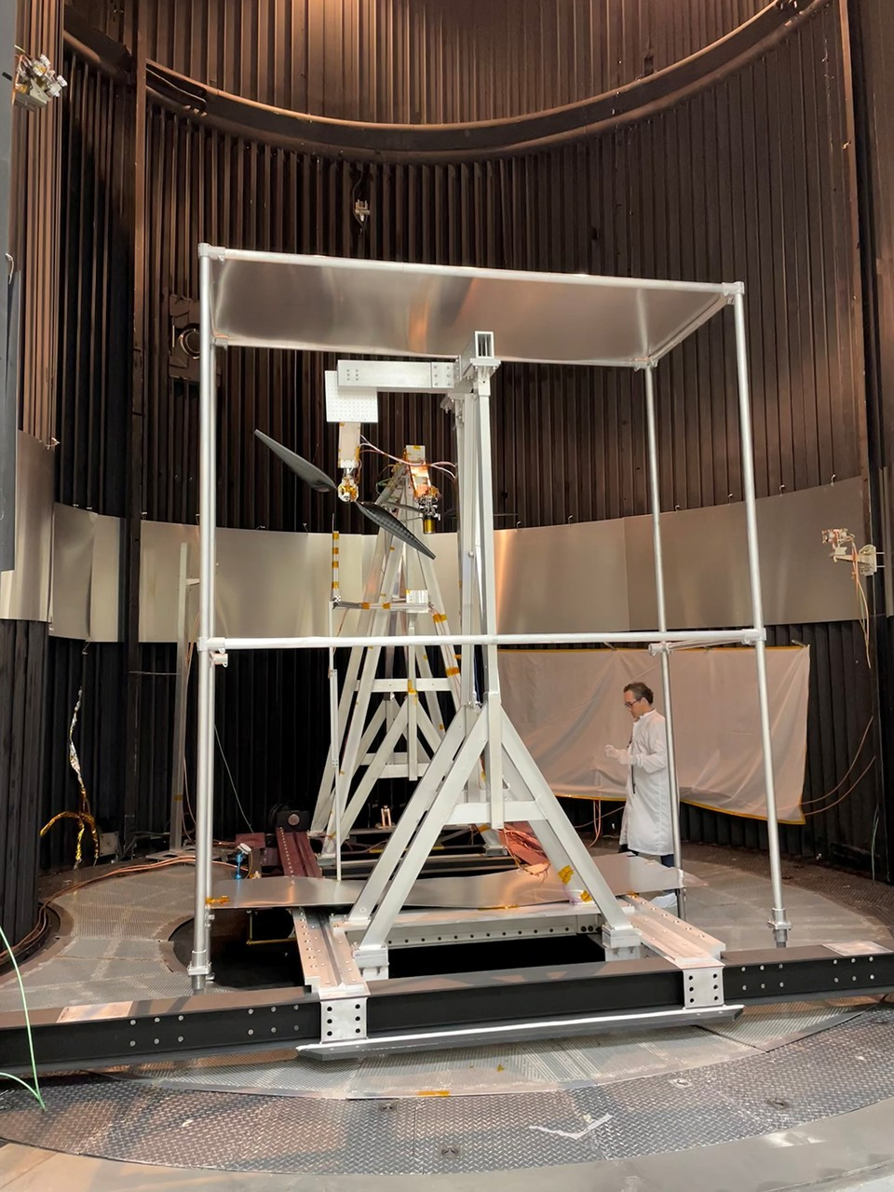

Description Engineer Fernando Mier-Hicks inspects a test stand used to investigate the performance of next-generation Mars helicopter rotor blades at high speeds inside the 25-Foot Space Simulator at NASA's Jet Propulsion Laboratory in Southern California in November 2025. Data from the tests indicate that the rotors could surpass the sound barrier without breaking apart. The test campaign was funded by the agency's Mars Exploration Program in pursuit of maximizing the capability of future aircraft flying at the Red Planet. A division of Caltech in Pasadena, JPL manages the Mars Exploration Program for NASA's Science Mission Directorate in Washington.

10. NASA's Next-Gen Mars Helicopter Rotors Are Moving Fast
NASA
Read more
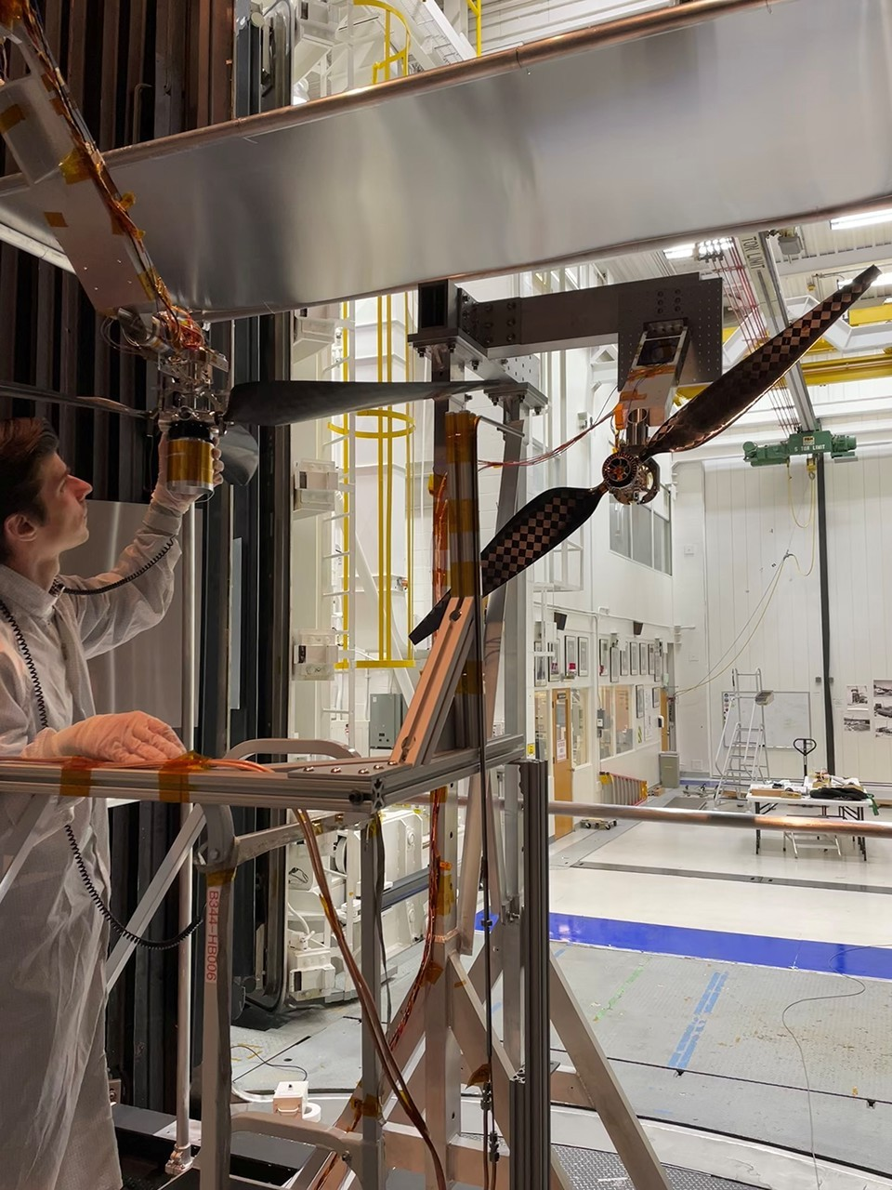

Description Engineer Jaakko Karras inspects a next-generation Mars helicopter rotor blade prior to supersonic speed testing in the 25-Foot Space Simulator at NASA's Jet Propulsion Laboratory in Southern California in November 2025. The three-bladed rotor hanging horizontally in the foreground is the next-gen rotor being tested. The vertically aligned two-bladed rotor provided a "headwind," enabling the tips of the three-bladed rotor to go beyond Mach 1. Data from the tests indicate that the next-gen rotor could surpass the sound barrier without breaking apart. The agency's Mars Exploration Program funded the test campaign in pursuit of maximizing the capability of future aircraft flying at the Red Planet. A division of Caltech in Pasadena, JPL manages the Mars Exploration Program for NASA's Science Mission Directorate in Washington.

11. NASA Pushes Next-Gen Mars Helicopter Rotor Blades Past Mach 1
NASA
Read more

Engineer Jaakko Karras inspects a next-generation Mars helicopter rotor blade prior to testing it at supersonic speeds in the 25-Foot Space Simulator at NASA's Jet Propulsion Laboratory in November 2025. NASA/JPL-Caltech Inside the dark chamber of JPL's 25-Foot Space Simulator, an engineer examines a test stand used to investigate the performance of next-generation Mars helicopter rotor blades at high speeds. The image was taken in November 2025. NASA/JPL-Caltech The rotor blades that will carry NASA's next-generation helicopters to new Martian heights broke the sound barrier during March tests at NASA's Jet Propulsion Laboratory in Southern California. Data from the tests, which took place in a special chamber that can simulate environmental conditions on the Red Planet, indicate that the fastest traveling part of the rotor blade, the tips, can be accelerated beyond Mach 1 without breaking apart. Data gathered from 137 test runs will enable engineers to design aircraft capable of carrying heavier payloads, including science instruments. "NASA had a great run with the Ingenuity Mars Helicopter, but we are asking these next-generation aircraft to do even more at the Red Planet," said Al Chen, Mars Exploration Program manager at JPL. "That's not an easy ask. While everything about Mars is hard, flying there is just about the hardest thing you can do. That's because its atmosphere is so incredibly thin that it is hard to generate lift, and yet Mars has significant gravity." By pushing rotors beyond the speed of sound during recent testing at NASA's Jet Propulsion Laboratory, engineers are unlocking new possibilities for low-altitude aerial exploration of Mars. Credit: NASA/JPL-Caltech Ingenuity, which performed the first powered, controlled flight on another world just over five years ago on April 19, 2021, was a trailblazing technology demonstration that did not carry science instruments. The agency's recently announced SkyFall project and other potential future Mars aircraft will be capable of carrying payloads - including science instruments and sensors - to collect data in support of future human and robotic missions, leveraging the advantages that come with low-altitude aerial exploration. Need for speed In the fast-moving world of rotors, more thrust comes from a quicker spin or a larger diameter. Although this axiom holds true on Earth, engineers designing aircraft for the Red Planet must be much more aggressive. Because the Mars atmosphere is only 1% as dense as Earth's, maximizing thrust requires pushing blade tips toward the speed of sound to achieve significant lift. While small-diameter rotors on Earth can also rotate at thousands of revolutions per minute, they have more air molecules to push and don't need to approach the sonic edge. To view this video please enable JavaScript, and consider upgrading to a web browser that supports HTML5 video NASA's Ingenuity Mars Helicopter does a slow spin test of its blades on April 8, 2021, the 48th Martian day, or sol, of the mission. The rotorcraft, captured here by the Mastcam-Z instrument aboard NASA's Perseverance rover, completed its historic first flight less than two Earth weeks later. NASA/JPL-Caltech/ASU/MSSS The Ingenuity flight team never allowed the rotational speed of their composite-skinned foam rotors to exceed 2,700 rpm during the helicopter's 72 flights at Mars for two reasons: to avoid the unpredictable physics of the sound barrier and to make sure that an unexpected gust of wind (from a dust devil, for instance) wouldn't send the rotor tips over the sonic edge. "If Chuck Yeager were here, he'd tell you things can get squirrely around Mach 1," said JPL's Jaakko Karras, the rotor test lead. "With that in mind, we planned Ingenuity's flights to keep the rotor blade tips at Mach 0.7 with no wind so that if we encountered a Martian headwind while in flight, the rotor tips wouldn't go supersonic. But we want more performance from our next-gen Mars aircraft. We needed to know that our rotors could go faster safely." While Mach 1 on Earth at sea level is approximately 760 mph (1,223 kph), the speed of sound on Mars is significantly slower - roughly 540 mph (869 kph) - due to the planet's thin, cold, carbon-dioxide-rich atmosphere. Blade-proof chamber To begin evaluating the rotors, which were developed and manufactured by AeroVironment in Simi Valley, California, Karras and his team mounted a three-bladed rotor that could be used in future Mars helicopter designs inside the historic 25-Foot Space Simulator at JPL. They evacuated the air and replaced it with just enough carbon dioxide to match the Martian atmosphere, then blasted the rotor with wind as it spun at increasing speeds. The test engineers had taken the precaution of lining part of the chamber with sheet metal in case the blades broke apart during the supersonic experiment. From a control room a few yards away from the chamber, the team watched displays showing data and a view inside the chamber as the rpm climbed as high as 3,750. At that rate, the tips were traveling at Mach 0.98. Then the engineers activated a fan inside the chamber that pelted the rotors with headwinds. After each run, they increased in wind velocity for the next run. The team pushed rotor tip speeds to Mach 1.08, boosting the Mars vehicle's lift capability by 30%. This breakthrough allows future missions to support heavier scientific payloads, including advanced sensors and larger batteries for extended flight. Next the team tried their luck with the two-bladed SkyFall rotor. Because it is slightly longer than the three-bladed version, only 3,570 rpm was needed to achieve the same near-supersonic speed at the rotor tips prior to introducing the headwinds. "The successful testing of these rotors was a major step toward proving the feasibility of flight in more demanding environments, which is key for next-gen vehicles," said Shannah Withrow-Maser, an aerodynamicist from NASA's Ames Research Center in Silicon Valley and member of the test team. "We thought we'd be lucky to hit Mach 1.05, and we reached Mach 1.08 on our last runs. We're still digging into the data, and there may be even more thrust on the table. These next-gen helicopters are going to be amazing." The SkyFall mission design team has incorporated the test team's findings into the performance specifications. Inspired by Ingenuity, the only rotorcraft to fly on another planet to date, SkyFall is designed to carry three next-gen Mars helicopters to the Red Planet in December 2028. More about NASA's Mars Exploration Program The faster-than-sound spin test campaign was funded by the agency's Mars Exploration Program in pursuit of maximizing the capability of future aircraft flying at the Red Planet. A division of Caltech in Pasadena, JPL manages the Mars Exploration Program for NASA's Science Mission Directorate in Washington. For more information about NASA's Mars Exploration Program, visit: https://mars.nasa.gov Media Contacts DC Agle Jet Propulsion Laboratory, Pasadena, Calif. 818-393-9011 agle@jpl.nasa.gov Karen Fox / Alana Johnson NASA Headquarters, Washington 240-285-5155 / 202-672-4780 karen.c.fox@nasa.gov / alana.r.johnson@nasa.gov 2026-029

12. Industry Moon Lander Training Cabin Lands at NASA for Artemis
NASA
Read more

Located in Space Vehicle Mockup Facility at NASA's Johnson Space Center, the full-scale prototype of the crew cabin of Blue Origin's Blue Moon Mark 2 crew lander is over 15 feet (5 m) tall. NASA A full-scale mock-up of a crew cabin for a future industry lunar lander for NASA's Artemis program now is operational for training and testing. The agency and its industry partners will use Blue Origin's Blue Moon Mark 2 crew cabin for mission simulations as the agency prepares to dock with landers in Earth orbit in 2027 and send astronauts to the Moon by 2028. NASA is working with two American companies to develop the human landing systems that will safely transport astronauts from lunar orbit to the Moon's surface and back for Artemis. Blue Origin's lander, launching uncrewed on top of the company's New Glenn rocket, will meet astronauts aboard NASA's Orion spacecraft in lunar orbit. Two astronauts will board the Blue Moon crew lander, which will ferry them to the surface and back to other crew members aboard Orion in lunar orbit following the conclusion of their surface stay. The Blue Moon crew lander that will fly to the Moon will stand about 52 feet tall. Its crew cabin, located at the base of the lander, will be the living and working space where two astronauts will eat, sleep, conduct science, and observe the lunar environment during their stay. The prototype at NASA's Johnson Space Center in Houston is a full-size model, featuring the exterior ladder astronauts will use during their time on the Moon. As NASA and industry teams prepare for future crewed missions to the lunar surface, this model will evolve to support more advanced mission and training needs. Over time, it will become an integrated simulator with interactive systems that help astronauts practice for their flight with ground flight control teams. NASA and Blue Origin can access the exterior and interior of the crew cabin trainer to conduct a series of human-in-the-loop tests, or tests with human interaction, including mission scenarios, mission control communications, spacesuit checkouts, and preparations for simulated moonwalks. The training cabin will also be used to provide design feedback to the Blue Origin team as the lander continues to be developed and mission planning evolves. Following the successful Artemis II test flight that took four astronauts around the Moon, NASA will launch the Artemis III mission next year to test critical systems in Earth orbit, including rendezvous and docking with one or both commercial landers from Blue Origin and SpaceX. The agency and its partners will conduct integrated checkouts of life support, communications, propulsion, and potentially new spacesuits. These operations will pave the way for Artemis IV and V in 2028, which will return NASA astronauts to the Moon using these commercial provide landers. Under Artemis, NASA will send astronauts on increasingly difficult missions to explore more of the Moon for scientific discovery and economic benefits, building the foundation for the first crewed missions to Mars. Learn more about the Artemis program: https://www.nasa.gov/artemis

13. NASA-Supported Small Spacecraft Launches to Study Solar Particles
NASA
Read more

Through NASA, a university-designed small spacecraft is paving the way to studying particles, known as neutrinos, that move through the universe at near-light speeds. The Solar Neutrino Astro-Particle PhYsics CubeSat, known as SNAPPY, launched at 12 a.m. PDT on Sunday aboard a SpaceX Falcon 9 rocket from Space Launch Complex 4 East at Vandenberg Space Force Base in California and was deployed via launch integraor Exolaunch. The SNAPPY project will test a prototype solar neutrino detector in low Earth polar orbit. Weighing approximately half a pound, the prototype detector consists of four crystals and is encased in a shielding block made of epoxy loaded with tungsten dust to match the density of steel. The detector and a dedicated electronics stack for power and readout purposes are housed inside a CubeSat platform from Kongsberg NanoAvionics. The Solar Neutrino Astro-Particle PhYsics (SNAPPY) CubeSat being prepared for integration into the EXOpod Nova deployer. SpaceX The idea behind SNAPPY was sparked by interest in NASA's Parker Solar Probe mission. As the probe prepared to become the first spacecraft to fly through the Sun's corona, Nick Solomey, a professor of mathematics, statistics, and physics at Wichita State University, was inspired knowing the spacecraft would pass an area where the solar neutrino flux, the rate of particles passing through a specific area, is nearly 1,000 times stronger than what reaches Earth. "All life on Earth - past, present, and future - relies on the Sun," remarked Solomey, whose career is centered on elementary particle physics. "We must work to understand this ball of energy to the best of our abilities because it's what makes life on Earth possible." Neutrinos are believed to be the second most abundant fundamental particles in the universe and could help us better understand the structure of the universe, the origin of mass, and the core of the Sun itself. On Earth, neutrino detectors must be buried deep underground to isolate their extremely faint signals. Using what we learn from SNAPPY, a future mission may one day place a detector closer to the Sun, allowing scientists to observe and study solar neutrinos in a completely new way. Before such a mission is possible, researchers must understand how a neutrino detector performs in space, and SNAPPY is designed to take the critical first step. This includes proving it can operate reliably in orbit and eliminating signatures from other activities, such as energy interactions, that could mimic a true neutrino interaction in space. These measurements will help scientists determine whether a future large detector positioned closer to the Sun is feasible. Through NASA's Innovative Advanced Concepts program, within the Space Technology Mission Directorate, SNAPPY was selected for a Phase I award in 2018, followed by a Phase II award in 2019, and a Phase III award in 2021, helping mature the project from its early studies through flight demonstration. NASA's Marshall Space Flight Center in Huntsville, Alabama, designed and built the dedicated electronic readout cards for the SNAPPY detector, and Wichita State University graduate students programmed the payload computer to interact with the electronics. To date, 36 graduate and undergraduate students have had the opportunity to work on the SNAPPY project. This achievement reflects the dedication of experts across agency and academia, including NASA Marshall, NASA's Jet Propulsion Laboratory in Southern California, the University of Minnesota, the University of Michigan, and South Dakota State University. To learn more, visit: https://www.nasa.gov/about-niac/

14. A bizarre 'decapitated' asteroid likely made the moon's largest impact crater. NASA's Artemis astronauts may land near the proof
Latest from Space.com
Read more

Click for next article The moon's largest impact feature, the South Pole-Aitken basin, is so named because it stretches between Aitken crater and the south pole. A violent impact that carved out the moon's largest impact basin may have scattered deep lunar material near the lunar south pole - right where NASA plans to send Artemis astronauts. A new study suggests the South Pole-Aitken (SPA) basin, an impact crater more than 1,200 miles (2,000 kilometers) wide on the moon 's far side, was likely created by a differentiated asteroid . The findings might answer some of science's biggest questions about the SPA's creation - and they could have major implications for future lunar exploration. The SPA basin is one of the moon's most scientifically valuable impact structures because it may expose material excavated from deep within the moon's mantle. Scientists have long debated exactly how the basin formed, including the size, speed and direction of the impactor. Using high-resolution 3D simulations, a team of researchers led by Shigeru Wakita of Purdue University found that SPA's distinctive tapered-ellipse shape is best explained by a 160-mile-wide (260-kilometer-wide) differentiated impactor - a large asteroid that had already separated into a dense iron core and a rocky outer layer, much like a tiny planet. It struck the moon traveling north to south at around eight miles per second (13 kilometers per second) at a shallow 30-degree angle, the researchers say. That shallow angle is key. At that trajectory, the impactor essentially gets "decapitated." Its upper layers shear off while the dense iron core continues plowing forward. "The impactor's core is responsible for the tapered shape of SPA," the authors wrote in the study. By contrast, a simpler, undifferentiated asteroid would have produced a rounder basin. Crucially, the team found the impact would have flung ejecta from the mantle toward the lunar south pole. According to the paper, Artemis astronauts landing near the pole could encounter deposits containing material excavated from depths greater than 56 miles (90 km). "Our work suggests that NASA's Artemis III mission , which will send astronauts to the moon, is likely to sample SPA ejecta, if it lands as planned in the south polar region of the moon," the researchers wrote in the study. (NASA has since revised the Artemis program and announced its first crewed moon landing will be on the Artemis 4 mission no earlier than 2028.) If the simulation is correct, returned samples could help scientists determine the age of the SPA basin and reveal the composition of the moon's deep interior, offering clues to how the moon evolved shortly after its formation more than 4 billion years ago.

