 |  | 

🌌 अंतरिक्ष समाचार | Space News
शनिवार, १५/०८/२०२६ | Saturday, 15/08/2026

1. CM reaches Chamoli to check on disaster victims
Read more
PIONEER EDGE NEWS SERVICE/Jyotirmath With at least seven persons reported dead officially, chief minister Pushar Singh Dhami reached Pipalkoti in Chamoli district amid rough weather, where workers were trapped due to flooding in a tunnel of a hydro power project. Dhami also met the rescued workers in the hospital and directed the officials to ensure their proper treatment. The CM said that every person's life is precious, adding that all the available resources of the government are being used for this rescue and relief operation. The prime priority of the State government is to rescue the workers stranded in the tunnel. Dhami said that the chief minister of the States from where some of the labourers came have already been contacted to communicate that the family members should be informed. A magisterial inquiry has also been ordered to ascertain the reasons for the disaster. In Dehradun, the Disaster Management minister Madan Kaushi visited the State Emergency Operations Centre to review the rescue and relief works being undertaken in Pipalkoti. He sought detailed information about the search and rescue operation.

2. Up to ₹2.08 Lakh/Month Salary! Multiple Life Sciences Jobs at ISRO - BioTecNika
Read more
Multiple Vacancies at ISRO-HSFC | Life Sciences Role Are you looking for high-paying Life Sciences Jobs in India's space research sector? The Human Space Flight Centre has announced Multiple Vacancies under ISRO Careers 2026 for Scientist/Engineer-SD positions. Candidates with a PhD in Biotechnology, Molecular Biology, Bioinformatics, Biomedical Sciences and related disciplines can apply online by 30 August 2026. About the Institute The Human Space Flight Centre (HSFC), Bengaluru, was formed as a new centre in ISRO to realise the vision of the Human Space Flight Programme. As the lead centre for human space activities, HSFC undertakes multidisciplinary research and development in human science and technology while maintaining high standards of reliability and human safety. - Get Jobs Faster - Job Overview Multiple Vacancies Post Code Discipline Vacancies 01 Bioinstrumentation OR Biophysics OR Medical Physics 01 UR 02 Developmental Biology OR Biotechnology 01 UR 03 Cellular & Molecular Biology OR Cell Biology 01 UR 04 Computational Biology OR Systems Biology OR Bioinformatics 01 UR 05 Biomedical Engineering OR Biomedical Sciences 01 UR 06 Biomedical Engineering OR Biomedical Sciences 01 UR Key Responsibilities Post Code 01 Design and validate wearable health monitoring sensors and systems and instrumentation of biomedical sensors. Bio-signal data acquisition and processing. Medical Imaging and informatics. Development of portable diagnostic devices and wearable sensors. Post Code 02 Radiation biology and exposure models. Develop regenerative approaches to preserve musculoskeletal integrity during training and in space. Mammalian and stem cell culture; primary cell lines; 3D/organoid culture systems. In vivo and ex vivo animal physiological studies. Working on disease biology models relevant to astronaut health. Host-pathogen interaction studies under stress/microgravity. Post Code 03 Study immune and cellular adaptation across the astronaut health cycle. Bioinformatics analysis of proteomic data for biomarker identification for spaceflight application. Molecular cloning, confocal microscopy, live-cell imaging and gene editing for spaceflight application. Large-scale proteomic dataset analysis, gene expression and statistical workflows. Post Code 04 In silico models to anticipate astronaut adaptation, assess countermeasures and guide rehabilitation. Development of therapeutics and space-grade diagnostics. Multi-omics integration for spaceflight stressors studies. Modelling cellular pathways, host-microbe interactions and metabolic networks under spaceflight conditions. Computational simulation of closed-loop life support systems. Generative models for predictive simulation of astronaut physiology and disease states through Digital Twin Biology, including neural networks and deep learning. Post Code 05 Gait analysis, exercise countermeasures, motion capture and force-plate studies and rehabilitation programme development. Biomechanical analysis of the musculoskeletal system. Analyse human performance data from wearables. Collaborate on rodent/human analogue design for spaceflight experiments. Post Code 06 Develop and validate bio-imaging systems for microgravity tissue changes. Implement DSP algorithms for ECG/EEG/EMG from wearables, noise reduction and feature extraction. Analyse bioinformatics datasets for space radiation effects on cells and tissues. Development of portable diagnostic devices, biosensors, point-of-care testing and real-time astronaut health monitoring tools. Integration of biomedical devices, wearable sensors and lab-on-chip technologies. Integrate AI/ML for real-time signal and imaging analysis in human/rodent spaceflight experiments. Qualifications Post Discipline Qualification 01 Bioinstrumentation/Biophysics/Medical Physics Relevant PhD + relevant ME/MTech/MS (60%/6.5 CGPA) + BE/BTech (65%/6.84 CGPA). 02 Developmental Biology/Biotechnology Relevant PhD + relevant ME/MTech/MS and BE/BTech, or BS-MS in Biological Sciences/Biology. 03 Cellular & Molecular Biology/Cell Biology Relevant PhD + relevant MSc and BSc, or BS-MS in Biological Sciences/Biology. 04 Computational Biology/Systems Biology/Bioinformatics Relevant PhD + relevant ME/MTech/MS and BE/BTech, or BS-MS in Biological Sciences/Biology. 05 Biomedical Engineering/Sciences Relevant PhD with thesis in biomechanics/human movement/musculoskeletal modelling + relevant ME/MTech/MS and BE/BTech. 06 Biomedical Engineering/Sciences Relevant PhD with thesis in bio-imaging/signal processing/bioinformatics + relevant ME/MTech/MS and BE/BTech. Selection Process Initial screening will be conducted based on applications submitted through the ISRO Live Register portal. The prescribed qualifications are minimum requirements and do not automatically make candidates eligible for an interview. Final selection will be based only on performance in the Personal Interview. How to Apply Applications will be accepted only through the ISRO Live Register portal. These Multiple Vacancies under ISRO Careers 2026 offer an exceptional opportunity for PhD candidates seeking high-paying Life Sciences Jobs in bioastronautics, biomedical research and human spaceflight science. Eligible candidates should complete their online application before 30 August 2026.

3. India-US space ties deepen as NASA invites ISRO to join moon base program - Space
Read more
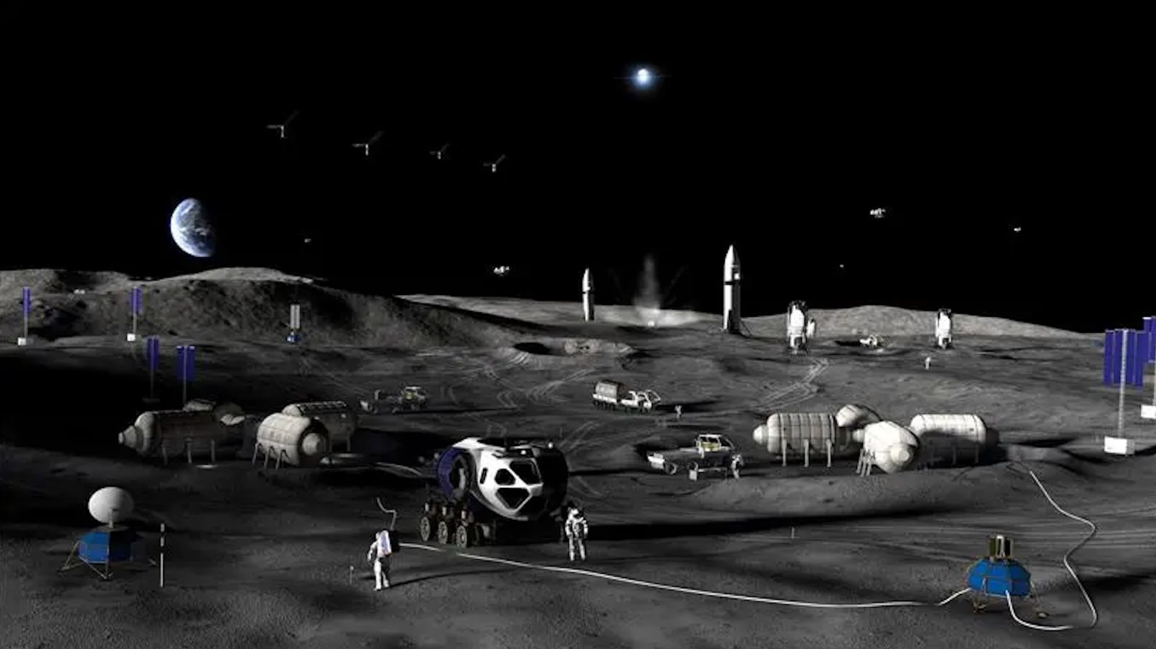
Click for next article NASA plans a to build a permanent base on the moon with a step-by-step approach through 2032. NASA has formally invited India to participate in its effort to build a permanent base near the moon's south pole, adding a new dimension to the deep-space cooperation between the two countries. The invitation was extended last week at the Indian space agency ISRO 's headquarters in Bengaluru during the ninth meeting of the U.S.-India Civil Space Joint Working Group. The CSJWG was established in 2005 as a mechanism for bilateral space cooperation and for addressing challenges and pursuing mutual spaceflight goals. "Building on our successful collaboration in science, NASA reaffirmed its interest in @ISRO joining Moon Base. We're going back to the moon to stay - and we're bringing our partners with us," NASA officials said via X on Tuesday (Aug. 11). Building on our successful collaboration in science, NASA reaffirmed its interest in @ISRO joining Moon Base. We're going back to the Moon to stay - and we're bringing our partners with us. https://t.co/hU9ssn24FPAugust 11, 2026 Beyond the lunar base invitation, "the two sides also agreed to advance discussions for cooperation on open scientific data sharing under the Accords," reads a Tuesday statement by the U.S. Embassy in India. "The Accords" are the Artemis Accords , the U.S.-led diplomatic framework outlining principles for safe and responsible exploration of the moon and beyond. India signed on as the 27th signatory in 2023, joining a coalition that has now grown to 70 nations. Official statements have provided few details on what India's participation in the Moon Base program would entail in practice. The meeting, however, brought together senior space officials from both countries, including V. Narayanan, the chairman of ISRO and secretary of India's Department of Space, and Sergio Gor, the U.S. Ambassador to India, who addressed the opening session, according to the statement. The meeting was co-chaired by M. Sankaran, director of ISRO's U.R. Rao Satellite Centre, on the Indian side, and two people on the U.S. side - Wesley Brooks, assistant secretary of state for the U.S. Department of State's Oceans and International Environmental and Scientific Affairs, and Kathleen Karika, NASA associate administrator for International and Interagency Relations, the statement reads. Over the coming decade, via its Artemis program , NASA plans to build out a sprawling, city-like base near the moon 's south pole, a region of particular interest thanks to permanently shadowed craters there that are thought to contain substantial deposits of water ice. Details of the planned architecture shared by NASA in May envision hilltop habitats to take advantage of sunlight and nuclear power systems located farther away to mitigate radiation risks. The space agency also plans to use small, hopping robots starting in 2028 to scout the south polar region ahead of moon base construction. This effort to gather information and secure access to the surface is the first of three planned phases. Phase 2, from 2029-2032, is intended to establish the base's initial operating capability. Phase 3, from 2032 onward, aims to achieve a semi-permanent crew presence on the lunar surface, NASA said during the May update. Senior space officials from India and the U.S. at the ninth meeting of the India-U.S. Civil Space Joint Working Group at ISRO headquarters in Bengaluru on Aug. 5-6, 2026, where NASA invited ISRO to join its Moon Base program. (Image credit: ISRO) To prioritize infrastructure that supports sustained operations on the moon's surface, increase launch cadence and keep pace with China's lunar ambitions , NASA earlier this year paused development of its long-planned Gateway space station.

4. ISRO's LVM3 upper stage re-enters atmosphere in 9 months. Here's why it matters - theprint.in
Read more
The satellite was injected with a perigee-the point in an elliptical orbit where a celestial body, such as the Moon or an artificial satellite, is closest to the Earth-at 170km and apogee-the highest point of something, or the point in an orbit around the Earth where an object is farthest away-at 29,970 km. After spacecraft injection, the upper stage was passivated to limit any risks of accidental breakup and left in a highly elliptical, 21-degree-inclined GTO. The upper stage of ISRO's LVM3, which was launched on 2 November last year from Sriharikota and successfully injected the CMS-03 communications satellite into a Geostationary Transfer orbit (GTO), re-entered the Earth's atmosphere on 30 July this year. Bengaluru: The upper stage of ISRO's LVM3-M5 re-entered the Earth's atmosphere in the last week of July-about nine months after its flight in November 2025. This was part of a demonstration of planned efforts to limit the orbital lifetime of rocket stages, the space agency said. "ISRO's System for Safe and Sustainable Space Operations Management (IS4OM) kept a close watch on the orbital decay of LVM3-M5 rocket body and regularly predicted its atmospheric re-entry during its final orbital phase. The Multi Object Tracking Radar (MOTR) at Sriharikota was also engaged to track the object wherever feasible, till a few orbits before its re-entry," ISRO said in a statement on Friday. It added that the most probable impact time was estimated around 12.08 UTC (5.38 PM IST) in the Atlantic Ocean. "Only a few elements like gas bottles, nozzles, and tanks, which are made of materials with very high melting points, were expected to survive the intense aerothermal heating during the re-entry," ISRO said. Also read: India rolls out 3 AI-based models for faster, more accurate weather forecasts An important goal Reducing the lifetime of space objects is an important goal that space agencies and companies across the world are aiming to achieve. The longer a space object stays in space, the higher the chances of collisions in orbit. The Inter-Agency Space Debris Coordination Committee (IADC) recommendations say that space objects in Low Earth Orbit (LEO), which have crossed their active life, should not stay in space for more than 25 years. In this mission, the LVM3 stage three was brought back within nine months. "It also meets India's Debris Free Space Mission (DFSM) requirement, which recommends a shorter orbital lifetime of 5 years for rocket stages which pass through the heavily crowded LEO region," ISRO said. (Edited by Saptak Datta)

5. Indian astronauts no longer need to rely on overseas training: ISRO building 'Gaganyatri Nivas' to support ... - Bhaskar English
Read more

English News Tech science ISRO Builds Gaganyatri Nivas: Indias New Hub For Astronaut Training Indian astronauts no longer need to rely on overseas training: ISRO building 'Gaganyatri Nivas' to support astronauts; how this fits into Gaganyaan's plans 2 hours ago Author: Samira Siddiqui Copy link Sending humans to space is not simply about building a rocket and a spacecraft. Astronauts have to undergo years of technical, physical and medical preparation, learn how to respond to emergencies, practise mission procedures repeatedly and remain isolated from potential infections before launch. As India prepares for its first crewed Gaganyaan mission, the Indian Space Research Organisation (ISRO) is also building the infrastructure it will need if human spaceflight is to become a regular capability rather than a one-off demonstration. Gaganyaan is ISRO's first human spaceflight mission, aiming to send three astronauts 400 km above Earth for three days and safely bring them back. Image credit: ISRO One such facility is the proposed Gaganyatri Nivas and Crew Isolation Facility at Satish Dhawan Space Centre (SDSC-SHAR), Sriharikota. ISRO has floated a tender for the planning, design, construction and commissioning of the facility. The project is being taken up as part of the agency's wider effort to establish the infrastructure required for sustained human-spaceflight activities. What is Gaganyatri Nivas? Gaganyatri Nivas can broadly be understood as dedicated accommodation and support infrastructure for astronauts, or Gaganyatris, associated with human-spaceflight missions. The facility is being planned alongside a crew isolation facility at Sriharikota. Astronaut Training Facility established in Bengaluru caters to Classroom training. Image credit: ISRO Gaganyatri Nivas should not be seen as a replacement for ISRO's existing astronaut-training infrastructure. ISRO already has an Astronaut Training Facility in Bengaluru, where Gaganyaan crew training includes classroom instruction, physical fitness, simulator training, and flight-suit training. Instead, the Sriharikota facility would become another important piece of the overall crew-management system, particularly because Sriharikota is India's primary spaceport and the location from which the Gaganyaan mission will eventually launch. Why does an astronaut need to be isolated before launch? Crew isolation is an important part of human-spaceflight preparation. Once astronauts are inside a spacecraft, they cannot simply leave if they develop an infection. A relatively minor illness on Earth can become a serious problem in a confined spacecraft, where medical resources are limited, and the crew has to continue operating critical systems. This is why astronauts are generally placed under controlled medical and environmental conditions before launch. For India, a dedicated facility near the launch complex can make this process more organised. Does this mean Indian astronauts will no longer need training abroad? India's first group of Gaganyaan astronaut-designates underwent training in India as well as overseas training, including a programme in Russia. Earlier ISRO and government documents confirm international cooperation in astronaut selection and training for the first Gaganyaan crew. However, ISRO has steadily expanded its own astronaut-training capabilities. The agency says its Astronaut Training Facility in Bengaluru already supports classroom training, physical fitness, simulator training and flight-suit training. Its training programme includes academic courses, Gaganyaan flight systems, microgravity familiarisation through parabolic flights, aero-medical training, recovery and survival training, flight procedures and crew-training simulators. Therefore, Gaganyatri Nivas should be viewed as part of the expansion of India's domestic human-spaceflight infrastructure, rather than as proof that all astronaut training will now happen at Sriharikota or that overseas training will completely end. Also read: Can animals detect cancer?: Bengaluru startup combining dogs' powerful sense of smell with AI to spot cancer So, where does the actual astronaut training happen? Astronaut training is spread across multiple facilities because it covers technical, medical, physical, and emergency skills. ISRO's Bengaluru facility handles areas such as spacecraft systems, space medicine, microgravity, recovery, and survival training. Astronauts also use virtual-reality and mock-up simulators to practise mission procedures, communication, emergency exits, and unexpected scenarios, preparing them for situations they could face in space. What Gaganyaan Nivas means for India's astronaut programme The new facility does not mean Sriharikota will become India's only astronaut-training centre. Instead, it will add another layer to the country's growing human-spaceflight infrastructure. Bengaluru already houses the main astronaut-training facility, while Sriharikota provides the launch complex and is now being planned to include dedicated crew-isolation and Gaganyatri accommodation facilities. Also read: Do you blindly scan every QR code?: New 'Rogue Auto QR Code' scam could put UPI users at risk; follow these 5 tips to protect yourself Building a wider human-spaceflight ecosystem The Indian Navy and other agencies are involved in crew recovery and survival training, while ISRO, DRDO, the Indian Air Force, academia and other institutions contribute to different aspects of the programme. Together, these efforts are helping India move beyond preparing astronauts for a single mission and build the infrastructure, training systems and expertise needed for a sustained and repeatable human presence in space.

6. 'Strap yourself in and feel the Gs': NASA announces 'Max Power' aerospace expo
Read more
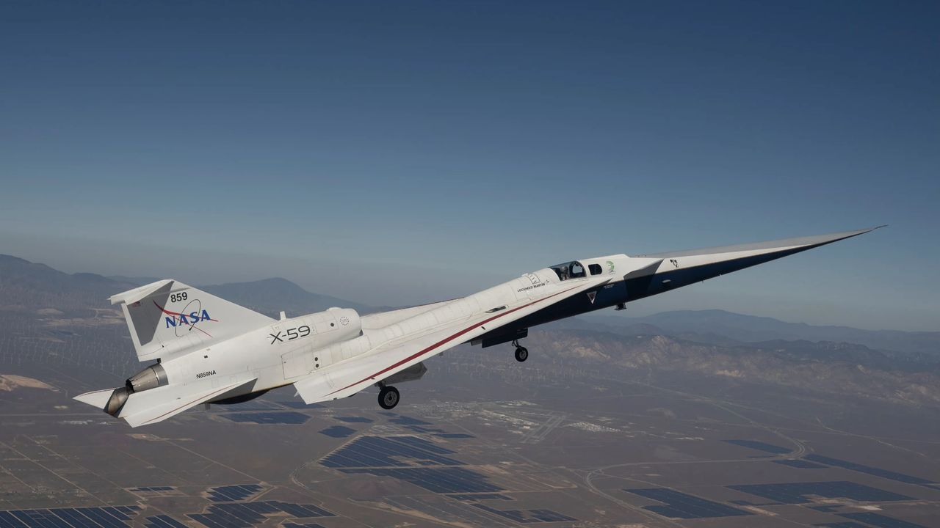
Click for next article NASA's quiet supersonic X-59 aircraft is seen here during a flight on March 20, 2026. The agency will showcase its aerospace tech at its "Max Power" expo at Kennedy Space Center this November. NASA will hold a two-day aerospace exposition this November, and it may draw a surprising number of "Simpsons" fans. The event, which NASA announced today (Aug. 14), will be held Nov. 7 and Nov. 8 at Kennedy Space Center (KSC) on Florida's Space Coast. It's called "Max Power," which is also a famous Homer Simpson pseudonym. In the 13th episode of the show's 10th season, which first aired in February 1999, Homer legally changed his name to Max Power. He wanted to disassociate himself from a bumbling character on the (fictional) TV show "Police Cops" who shared his given moniker. The Simpsons: Max Power part 1 - YouTube Watch On Homer made the switch to Max Power - which he said he got off a hair dryer - without consulting his family, a move that did not go over well. "Wait a minute!" his dad protested. "The family name is my legacy to you. I got it from my father, and he got it from his father, and he traded a mule for it. And that mule went on to save spring break." Homer's wife Marge was also displeased. "But I fell in love with Homer Simpson," she said. "I don't want to snuggle with Max Power." "Nobody snuggles with Max Power," Homer - or rather Max - responded. "You strap yourself in and feel the Gs!" NASA's Max Power expo is about feeling the Gs as well, at least in part. "The two-day event will feature immersive experiences for all ages to enjoy, including air shows, skydiving stunts, technology demonstrations, spaceflight hardware, military aircraft and behind‑the‑scenes access to America's spaceport," agency officials wrote in a description of the expo . "Attend talks led by NASA experts and meet astronauts from some of agency's most famous missions!" NASA Administrator Jared Isaacman , an accomplished pilot as well as a private astronaut , said that he plans to participate in the expo's air show. And, if you're unable to attend this November, you'll likely have other chances down the road. "Certainly, the idea is that this event, Max Power, becomes the first of many," Isaacman said during a press conference today.

7. Water can survive surprisingly close to the Milky Way's supermassive black hole, James Webb Space Telescope finds
Read more
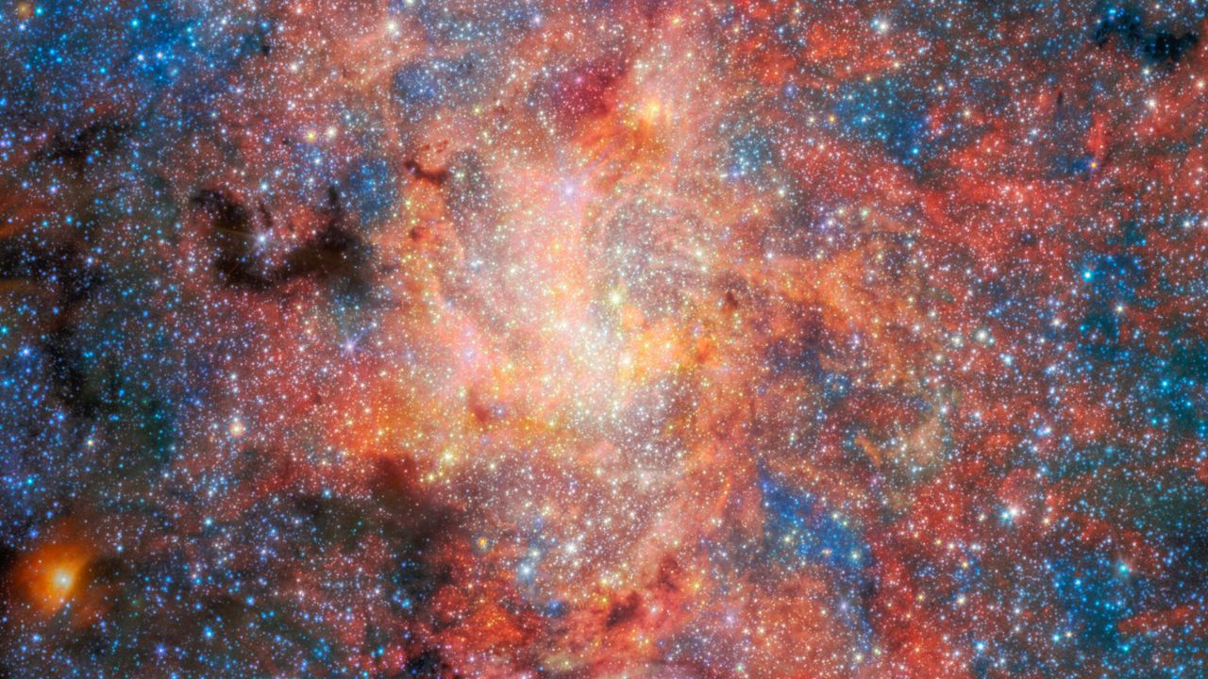
Click for next article The heart of the Milky Way may be more hospitable to water than astronomers thought. Using the James Webb Space Telescope (JWST), researchers detected water and cosmic dust around an aging star only 0.55 light-years from Sagittarius A* (Sgr A*), the supermassive black hole at the center of our galaxy. The new study suggests that water and dust can form and survive surprisingly close to a supermassive black hole , where intense radiation and other harsh conditions might otherwise be expected to destroy them. The team used Webb's Mid-Infrared Instrument (MIRI) to study IRS 3, an aging star located in the crowded environment surrounding Sgr A*, which has a mass of about 4 million suns, according to a statement from the European Space Agency (ESA). (Image credit: ESA/Webb, NASA & CSA, F. Peißker, J. Lu, F. Yusef-Zadeh, N. B. Sabha, C. Chan) "Galactic centres are among the most extreme environments, so understanding whether stars can continue enriching their surroundings there is an important question," Florian Peißker, lead author of the study from the University of Cologne in Germany, said in the statement . "With Webb, we can directly observe how stars behave under these conditions and see that dust production remains remarkably resilient." IRS 3 - one of the brightest mid-infrared sources in the galactic center - is an asymptotic giant branch star , meaning it has reached a late stage of stellar evolution in which it sheds large amounts of gas and dust through powerful stellar winds. Such dying stars act as cosmic recycling centers, returning material to space that can eventually become incorporated into future generations of stars and planets. But IRS 3 lives in a particularly unforgiving neighborhood. The center of the Milky Way is densely packed with stars and exposed to intense radiation, raising questions about whether molecules and newly produced dust can persist there. However, Webb's observations suggest they can. By combining observations of IRS 3's spectrum with simulations of how its light travels through different models of the surrounding material, researchers reconstructed the structure of the star's envelope. They found a layered, shell-like distribution of silicate dust extending roughly 10,000 astronomical units from the star (one astronomical unit, or AU, is the average distance between Earth and the sun ). Temperatures within the envelope fall from about 1,700 degrees Fahrenheit (927 degrees Celsius) near the star to around minus 280 F (minus 173 C) in its outer regions. Webb's observations also revealed clear evidence of water within the envelope - the first such detection for IRS 3. "The detection of water is especially exciting because it shows that molecular material can survive in an environment dominated by intense radiation," Macarena Garcia Marin, co-author of the study and an ESA astronomer, said in the statement. While the observations don't reveal how much water is present, the detection shows that water can survive in the harsh environment near the galactic center . Water and dust are important ingredients in the chemistry that accompanies star and planet formation, meaning material shed by aging stars such as IRS 3 could eventually contribute to future generations of stars and planets. Finding water and dust near Sgr A* therefore suggests that aging stars can continue enriching their surroundings even in the harsh conditions near a supermassive black hole. The findings could help astronomers better understand how material is recycled in the centers of galaxies and the role evolved stars play in supplying those regions with fresh dust and molecules.

8. ISS photobombs the sun during solar eclipse | Space photo of the day for Aug. 14, 2026
Read more
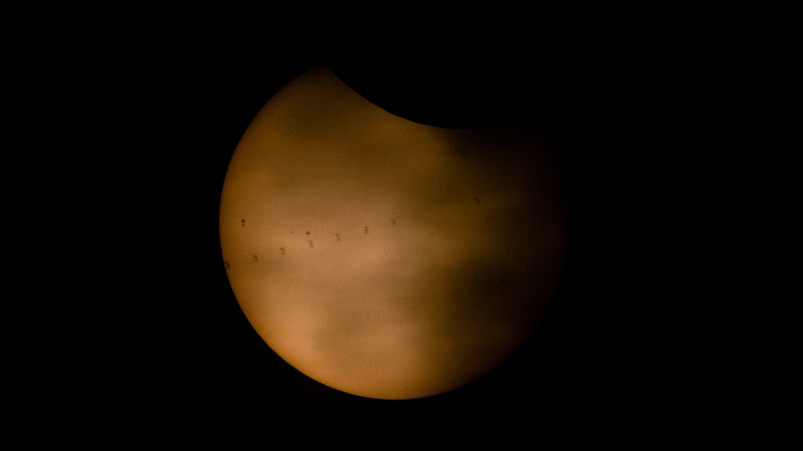
Click for next article The silhouette of the ISS transiting across the sun's face during the Aug. 12, 2026 total solar eclipse. (Image credit: NASA/Joel Kowsky) This week's total solar eclipse captured the world's attention, and millions of skywatchers looked up (with the correct protective eyewear, hopefully) to experience the moon blocking out our star's light. And, as you can see in this image, even the International Space Station (ISS) itself got in on the fun. What is it? On Aug. 12, 2026, the moon completely blocked out the sun's light for millions of lucky skywatchers witnessing a total solar eclipse. But the moon isn't the only thing orbiting Earth. Tons of satellites and probes do too, and that includes the ISS. This created a truly remarkable moment for some skywatchers. With the right equipment, it was possible to see the silhouette of the ISS in front of the sun. This composite image shows eight different frames of the ISS silhouetted on the sun's face as the moon takes a "bite" out of our star to create a partial eclipse. This gif shows the ISS' silhouette moving across the sun's face during a partial solar eclipse on Aug. 12, 2026. (Image credit: NASA/Joel Kowsky) Why is it incredible? Solar eclipses like this week's total solar eclipse really bring people together. It creates opportunities for humans to come together and gather for a common goal. And while the ISS is featured in this image, we may also want to consider the astronauts aboard. In other words, people on Earth weren't the only ones who got to participate in the marvel. The Expedition 75 astronauts on the ISS (NASA astronauts Jessica Meir, Anil Menon, and Jack Hathaway; ESA (European Space Agency) astronaut Sophie Adenot; and Roscosmos cosmonauts Pyotr Dubrov, Andrey Fedyaev and Anna Kikina) caught the show too as they orbited our planet. There they were, in between Earth and the moon, as our planet's neighbor blocked out our star.

9. India-US space ties deepen as NASA invites ISRO to join moon base program
Read more
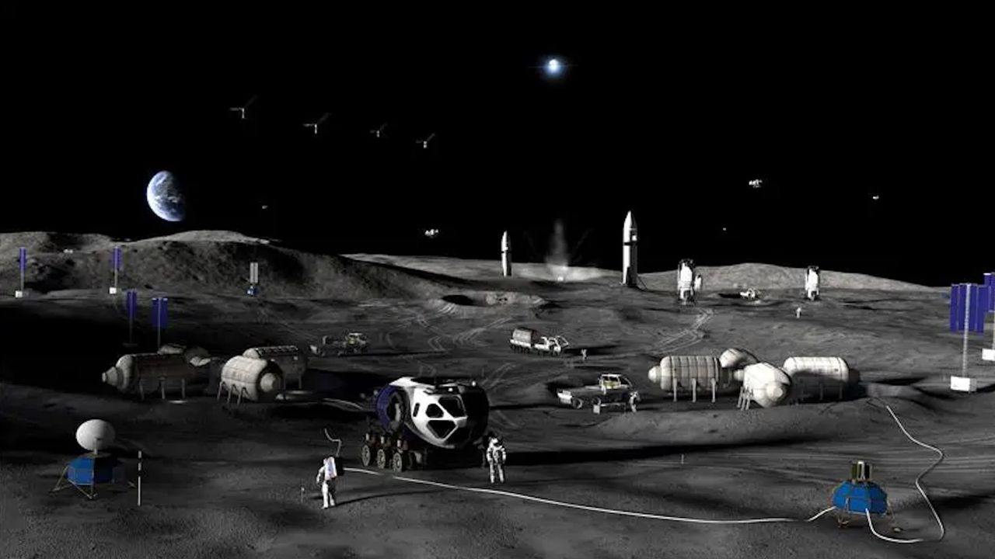
Click for next article NASA plans a to build a permanent base on the moon with a step-by-step approach through 2032. NASA has formally invited India to participate in its effort to build a permanent base near the moon's south pole, adding a new dimension to the deep-space cooperation between the two countries. The invitation was extended last week at the Indian space agency ISRO 's headquarters in Bengaluru during the ninth meeting of the U.S.-India Civil Space Joint Working Group. The CSJWG was established in 2005 as a mechanism for bilateral space cooperation and for addressing challenges and pursuing mutual spaceflight goals. "Building on our successful collaboration in science, NASA reaffirmed its interest in @ISRO joining Moon Base. We're going back to the moon to stay - and we're bringing our partners with us," NASA officials said via X on Tuesday (Aug. 11). Building on our successful collaboration in science, NASA reaffirmed its interest in @ISRO joining Moon Base. We're going back to the Moon to stay - and we're bringing our partners with us. https://t.co/hU9ssn24FPAugust 11, 2026 Beyond the lunar base invitation, "the two sides also agreed to advance discussions for cooperation on open scientific data sharing under the Accords," reads a Tuesday statement by the U.S. Embassy in India. "The Accords" are the Artemis Accords , the U.S.-led diplomatic framework outlining principles for safe and responsible exploration of the moon and beyond. India signed on as the 27th signatory in 2023, joining a coalition that has now grown to 70 nations. Official statements have provided few details on what India's participation in the Moon Base program would entail in practice. The meeting, however, brought together senior space officials from both countries, including V. Narayanan, the chairman of ISRO and secretary of India's Department of Space, and Sergio Gor, the U.S. Ambassador to India, who addressed the opening session, according to the statement. The meeting was co-chaired by M. Sankaran, director of ISRO's U.R. Rao Satellite Centre, on the Indian side, and two people on the U.S. side - Wesley Brooks, assistant secretary of state for the U.S. Department of State's Oceans and International Environmental and Scientific Affairs, and Kathleen Karika, NASA associate administrator for International and Interagency Relations, the statement reads. Over the coming decade, via its Artemis program , NASA plans to build out a sprawling, city-like base near the moon 's south pole, a region of particular interest thanks to permanently shadowed craters there that are thought to contain substantial deposits of water ice. Details of the planned architecture shared by NASA in May envision hilltop habitats to take advantage of sunlight and nuclear power systems located farther away to mitigate radiation risks. The space agency also plans to use small, hopping robots starting in 2028 to scout the south polar region ahead of moon base construction. This effort to gather information and secure access to the surface is the first of three planned phases. Phase 2, from 2029-2032, is intended to establish the base's initial operating capability. Phase 3, from 2032 onward, aims to achieve a semi-permanent crew presence on the lunar surface, NASA said during the May update. Senior space officials from India and the U.S. at the ninth meeting of the India-U.S. Civil Space Joint Working Group at ISRO headquarters in Bengaluru on Aug. 5-6, 2026, where NASA invited ISRO to join its Moon Base program. (Image credit: ISRO) To prioritize infrastructure that supports sustained operations on the moon's surface, increase launch cadence and keep pace with China's lunar ambitions , NASA earlier this year paused development of its long-planned Gateway space station.

10. SpaceX rocket's moon crash highlights 'a tangible operational risk' of lunar settlement
Read more
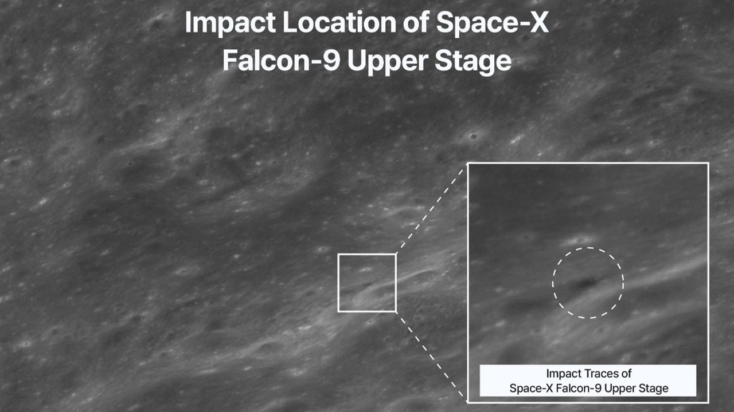
Click for next article South Korea's Danuri lunar orbiter captured this image of the crater blasted out by a SpaceX Falcon 9 upper stage when it hit the moon on Aug. 5, 2026. The moon dust has settled after a 4.5-ton SpaceX rocket body slammed into terrain near Einstein Crater on Aug. 5. That impact site was imaged by South Korea's moon-orbiting Danuri spacecraft, as well as by NASA's Lunar Reconnaissance Orbiter (LRO). Reportedly, a Chinese commercial space debris monitoring satellite tracked and recorded the 5,400-mph (8,690-kph) moon punch, too. Wandering through space for over a year, the leftover Falcon 9 upper stage had sent Firefly Aerospace's Blue Ghost-1 lander on its way to the moon back on Jan. 15, 2025. Also sent moonward on that flight was the Hakuto-R Mission 2's Resilience, a robotic lunar lander developed by the Japanese company ispace. While the moon has reclaimed its serenity, the implications of the uncontrolled collision continue to reverberate. Close encounter Interestingly, there was also the prospect of a too-close-for-comfort conjunction of the Falcon 9 upper stage and Danuri. "We noticed roughly late June that there is an incoming Falcon 9 upper stage toward the moon, and also knew that it would be close to Danuri," Eunhyeuk Kim, a senior researcher at the Korea Aerospace Research Institute (KARI), told Space.com. There was a huge uncertainty in the predicted trajectory of the upper stage, Kim said, while the orbit information of South Korea's Danuri lunar orbiter was quite accurate. "Therefore, we could not neglect the probability of an incoming and close encounter." Before-and-after imagery of the impact site. (Image credit: KARI) Spacecraft maneuver However, around mid July, the KARI/Danuri team performed a maneuver of the spacecraft in preparation of a near-total lunar eclipse on Aug. 28, said Kim. That eclipse will see 96% of the moon's visible surface passing through Earth's dark umbral shadow. Kim said that the orbiter's maneuver brought a slight change in the phase of the spacecraft's orbit, which canceled the probable conjunction between the upper stage and Danuri. At the time of the Aug. 5 impact, Danuri was flying over the moon's south pole area , far away from the hit zone, said Kim. Illustration of the moon, with an arrow pointing to the Falcon 9's upper stage impact site on Aug. 5, 2026. (Image credit: Bill Gray/Project Pluto) High-speed ejecta Dean Sladen is a quality manager and aerospace engineer in the United Kingdom for Accu Components, a high-precision manufacturing firm. "As space agencies and private companies build out permanent lunar infrastructure , uncontrolled rocket stages evolve from a minor nuisance into a tangible operational risk," Sladen told Space.com. "A direct hit is the obvious worst-case scenario, but distant impacts also generate ground shocks and high-speed ejecta that can degrade sensitive equipment over time." Sladen noted that lunar impacts have been a constant throughout history, with meteorites and comets bombarding the surface unhindered by an atmosphere. "Over the past 65 years, artificial objects have added a new dynamic to these events," he added. An artist's concept of astronauts working on the lunar surface. (Image credit: NASA) Genuine hazard Even modest hardware impacts permanently alter the lunar landscape, said Sladen. Given the moon's lack of a substantial atmosphere , there is no air resistance to slow debris down. An impact therefore hurls high-speed ejecta (fine regolith and rock fragments) across vast distances at bullet-like speeds. "While this isn't a major threat to isolated missions today, as we establish permanent lunar infrastructure, high-velocity ejecta poses a genuine hazard to surface habitats, solar arrays and working astronauts ," Sladen said. To mitigate this issue, Sladen suggested that the industry will likely need designated impact zones or strictly controlled, targeted de-orbit protocols to ensure that spent hardware lands far from active installations. "That said, human-made debris is only half the equation," Sladen continued. "Natural meteorites remain an ongoing background threat, and, while massive natural strikes are rare, they hit at significantly higher speeds and carry far more energy," Sladen said. "Controlling our own hardware is simply the part of the risk profile we actually have the power to manage." Plume detections In the meantime, while the Falcon 9 impact was tough to see from Earth , several observations from our planet reported the detection of sodium and lithium gas above the crash site. The European Southern Observatory's (ESO) Very Large Telescope (VLT) in Chile, for example, saw the aftermath of the impact. The ESO reported that a chemical fingerprint of the impact was visible for five to 10 minutes, with an enormous plume of lunar material stirred up due to the hard-hitting hardware. "I'm happy that ESO recorded some evidence of it through VLT, and Danuri has found the exact impact location," said William Jo, a graduate research assistant at the University of Texas, Austin who performed some pre-strike computer simulations. "What we've learned so far is that the plume was too faint to see against the bright lunar surface, and only a large observatory telescope could pick some parts of it out against the dark sky, which is exactly what happened," Jo told Space.com. "The plume must have shot out high," he said, "and I'd like to know how high, or even whether we can replicate the signals." Targets of opportunity " Telescopes make the best spaceships," pointed out Elaina Hyde, director of the Allan I Carswell Observatory at York University in Canada. "We are always on the lookout for 'targets of opportunity' like this event." Hyde organized a livestream event , training the observatory on the collision locale. They were unable to spot the impact, however. "The lunar collision was not on our regular research program, but when it happened, we put it as a high-priority item to observe if the weather was clear," Hyde said. "Anything that happens quickly like this is often a target of opportunity, because you do not get a long time to plan the observation." "However, since it was not visible from our location in Toronto, our 'null' or non detection can actually help to limit the estimates on how big the dust plume was and perhaps some of its properties," said Hyde. (Image credit: Lowell Observatory) Impact response Also on the moon impact watch were observers using Lowell Observatory equipment in Arizona. These researchers managed to measure a response from the rocket stage impact, spotting a sizable sodium and lithium gas plume that lasted between five and 10 minutes after impact, reported Carl Schmidt, an assistant research professor at Boston University's Center for Space Physics. Observers at the 4.3-meter Lowell Discovery Telescope (LDT) in Happy Jack, Arizona used a long slit spectrograph to detect the plume. Graduate students from Boston University continue to analyze data gleaned from the moon wallop. Bright lithium plume "At LDT, we saw a bright lithium plume from the rocket body and fainter sodium [signature], likely from the surface itself," Patrick Lierle of Boston University told Space.com. "The bright lithium plume extends more than halfway up our field of view." The LDT results are also credited to Emma Lovett, a Boston University graduate student. William Jo said he's looking forward to the release of observational data about the impact before he and colleagues can refine their lunar ejecta simulation model. "That data, combined with our simulations, could tell us things like the composition of the lunar material, what orientation the impact hit at, and so on," Jo said.

11. NASA Administrator 'extremely confident' in Artemis 3 mission in 2027
Read more
NASA is potentially less than a year away from the trio of rocket launches that will encompass the Artemis 3 mission and the agency's leader said he is "extremely confident" that the mission will happen in 2027. Isaacman made the statement while joined by Brian Hughes, the Kennedy Space Center director, as well as members of the Florida congressional delegation on Friday. He was there to announce a new NASA-supported, privately run air and space show, called "Max Power" taking place in early November. "I'm extremely confident that we are we are going to be able to launch Artemis 3 next year. That's why we stepped into stacking operations," Isaacman said, referring to the assembly of the Space Launch System (SLS) rocket happening in the Vehicle Assembly Building at KSC. Earlier this summer, the Orion spacecraft's crew and service module were mated together ahed of additional testing. Four out of the ten segments of the solid rocket boosters have been stacked inside High Bay 3 while engine integration onto the core stage happens inside High Bay 2. The Artemis 3 mission will begin with the launch of Blue Origin's New Glenn rocket, which will send a test version of its Blue Moon Mark 2 lander into low Earth orbit. That will be followed days later by the launch of the SLS rocket and Orion spacecraft, which will rendezvous and dock with Blue Origin's vehicle. "I had a chance to visit with the Blue Origin team earlier, walked the assembly line floor today, looking at components that will make their way into the Blue Origin test lander that we will be rendezvousing and docking with," Isaacman said. "And I'll tell you, if you spoke to Blue Origin, they would say the same thing. What we are going to learn from that mission, the amount of risk we're going to be able to bring down in advance of Artemis 4 will be significant. "I think in fact, if you coupled that with the uncrewed landing demonstration, you'd be very confident in what they're going to be able to achieve potentially in 2028." Blue Origin's demonstration lander represents a number of the capabilities that will be featured in their Blue Moon Mark 2 lander, which will be used for crewed landings on the Moon's south pole. The test lander doesn't include the BE-7 engine of the Blue Moon Mark 2, but it does include a life support system and crew habitation area, which will allow the crew to live and work onboard while it's docked with the Orion spacecraft. After the two separate, SpaceX will launch its Starship Version 3 rocket, with a docking adapter on the nose of the upper stage. That Starship will be the target for Orion to dock, but because it won't have a crew habitation area, the astronauts will remain onboard Orion while the two are mated. "Now with respect to SpaceX, I think you're what you're witnessing, you're seeing an increase in launch cadence, and that's critical. If they're able to launch again in early September after their last launch and continue to track inside the month, potentially every couple of weeks before the end of the year, that's going to - we're going to feel very good about their time to contribute to Artemis 3 next year," Isaacman said. "They've already started cutting hardware for that test vehicle. We track that every single day, so that's the test lander. So we're feeling very good about that, and I'd say more so with each step along the way that you get better about Artemis 3, you're feeling that much better about Artemis 4 and its timeline in '28." The Artemis 4 mission is planned to be the first crewed landing on the Moon as part of the Artemis Program. At this stage, NASA hasn't named the crew flight that mission or which lander it will select to perform the landing operation for that mission. Max Power coming to Kennedy The event Friday wasn't billed around an Artemis 3 update, but rather to announce and promote the Max Power air and space technology expo. Isaacman said that the event "is not something that NASA is going to be footing the bill for," but rather managed by sponsors. "These type of events do happen around the world, they're sponsor-driven. We're making available this great real estate, no different than you would see at other major events. Nellis (Air Force Base) has a show, Andrews (Air Force Base) and others," Isaacman said. "We'll be contributing a lot of our talent and we'll be contributing some of our aircraft from the NASA portfolio, which we fly around at various events at normal, well, they're certainly becoming normal course and especially America's 250th birthday." <span data-mce-type="bookmark" style="display: inline-block; width: 0px; overflow: hidden; line-height: 0;" class="mce_SELRES_start"></span> Those sponsors Isaacman referenced weren't mentioned by name during the Friday announcement event, but NASA's webpage for Max Power lists them as: Air Dot Show Delaware North Purpose Entertainment Space Florida UP.Summit Even though they share the name "Max Power," the event is split across three venues with separate tickets being sold by Air Dot Show, Delaware North, and UP.Summit. The number of tickets to each have not been announced and each event under the Max Power umbrella requires the purchase of a separate ticket. "Because the event relies on the funding and structure provided by these external organizations rather than exclusively using NASA's federally appropriated budget, ticketing is handled through their external sites so they can cover their costs of producing the event," NASA wrote on its website under the "Frequently Asked Questions" section. Delaware North, which manages the Kennedy Space Center Visitor Complex, is charging $69.38 per adult per day with taxes and fees ($58.68 per child ages 3-11). It will take place at the KSCVC and feature panels from NASA and other space companies; a space-themed parade; and hands-on activities. UP.Summit is selling tickets for $53.50 per adult per day (including tax), but doesn't mention the cost of children's tickets on its website. It's exhibits and vendors will be set up at Space Florida's Launch and Landing Facility (LLF) and will reportedly feature hardware from Astranis, Astroforge, Blue Origin, Stoke Space, Vast and more. Air Dot Show, which manages the air show portion and will also have aircraft on the ground at the LLF, is charging $49.75 per adult per day for general admission. However, it stipulates that two, one-day tickets at that price need to be purchased together, which brings the total cost after taxes to $112.69. It also notes that this is an "intro sale" price, so the cost may increase as the event draws closer. At those prices, for an individual adult to attend all three events on just one day would cost $179.23. Asked what NASA would be contributing beyond the planes from its air show, Isaacman said some number of personnel would be on hand at the three venues, which will include both Apollo and Artemis astronauts. "You'll see rovers, you'll see landers from the [Commercial Lunar Payload Services] program here, you'll see a lot of hardware that either has adaptability to the early Artemis missions," Isaacman said. "You might get a great view of Artemis 3 on its way out to pad 39B. You'll also see a lot of critical components of the Moon Base that we're building as well." The timing of the Max Power air show may very well coincide with the rollout for fueling demonstration of the SLS rocket. "I certainly hope we have to work some deconfliction issues between the event and Artemis 3 rollout. That would be fantastic," Isaacman said. "But I actually think, if our timing works out, it'll be a fantastic way to compliment what should already be a rather extraordinary event." Isaacman said in response to a media question that while he hope Max Power can serve as an inspiration for future generations to pursue interests that will help NASA or potentially lead to a job at the agency, he said the goal isn't to compete with industry. "We're not hosting the event necessarily to take talent away from others in industry. In fact, I think NASA, as I've said many times, is at our best because we are doing what no company or agency or other nation is capable of doing," Isaacman said.

12. Constipation is common in astronauts-blood tests provide new answers
Read more
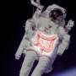
For astronauts in space, constipation is a well-known problem. But why this happens has long been unclear. Now, a new study from the University of Copenhagen in collaboration with NASA provides an idea of what happens in the stomach without the influence of gravity.

13. China may have quietly supercharged its new naval frigate with 50% more missiles
Read more
China may be preparing a more heavily armed version of its Type 054B frigate, potentially giving the warship 50 percent more missile launch capacity than the first ships in the class. The change would raise the vessel's vertical launch system capacity from 32 cells to as many as 48. That could give the frigate greater staying power during missile attacks and more flexibility when carrying different weapons. Satellite imagery from US intelligence company Vantor provides the clearest indication of the possible upgrade. A June 28 image shows a Type 054B being fitted out at Shanghai's Hudong Zhonghua shipyard with a different VLS arrangement near its bow. Larger missile battery The first two Type 054B frigates have four eight-cell VLS units. The unfinished ship appears to have six units, suggesting a possible total of 48 cells if the same configuration applies. Song Zhongping, a Chinese military commentator and former PLA instructor, said the increase would address a potential limitation in the existing design. He argued that 32 cells could restrict the weapons available during sustained combat. A larger battery would give the frigate more opportunities to engage incoming threats before exhausting its ready ammunition. It could also allow commanders to balance air-defense weapons against anti-submarine systems more effectively. The Type 054B's VLS supports the HHQ-16 surface-to-air missile and the rocket-assisted Yu-8 anti-submarine weapon. More cells would therefore increase the number of weapons the ship can carry for different missions. The imagery does not establish the final weapon load, however. China has not publicly confirmed that the unfinished frigate will receive a 48-cell system. Designed for wider deployments The Type 054B is a larger successor to China's Type 054A frigate, with an estimated displacement of about 5,000 tonnes. Its armament includes eight anti-ship missiles and a 100mm main gun, while its expanded flight deck supports the Z-20 naval helicopter. The ship also incorporates changes intended to improve survivability and detection. Chinese state media has highlighted automated air-defense functions, including artificial intelligence algorithms designed to reduce potential gaps in coverage. A redesigned hull reduces the ship's radar signature compared with older frigates. Those changes support a role that increasingly extends beyond China's immediate coastal waters. The first two Type 054Bs, Luohe and Qinzhou, entered service last year. Luohe joined the Liaoning aircraft carrier during live-fire exercises in the western Pacific in May. Qinzhou later took part in naval and air patrols around the disputed Scarborough Shoal. The deployments demonstrate the class's growing role in China's operations across contested and distant waters. More firepower The additional launch cells could matter most when Type 054Bs operate with smaller task groups or without major destroyer support. Frigates often provide escort and screening duties while larger warships handle heavier offensive missions. Song said the Type 054B needs enough ammunition to remain effective during both group operations and independent deployments. More launch capacity would extend that combat endurance without requiring a much larger hull.

