 |  | 

🌌 अंतरिक्ष समाचार | Space News
मंगलवार, १८/०८/२०२६ | Tuesday, 18/08/2026

1. Govt launches two modules to digitise PMGSY process
Read more

- Policy - 1 min read The modules are electronic measurement book (e-MB) and electronic billing (e-billing), replacing the paper-based measurement and billing system that had been in use for two decades. Kumar Anshuman - ET Bureau - Published On Aug 17, 2026 at 09:36 AM IST Select ETGovernment as Preferred Choice on Google Copy Link Share on WhatsApp Share on Linkedin Share on X Share on Telegram Share on Facebook The modules, developed by the National Rural Infrastructure Development Agency (NRIDA), went live on Friday. The rural development ministry has launched modules to digitise the road construction process under the Pradhan Mantri Gram Sadak Yojana ( PMGSY ). The modules are electronic measurement book ( e-MB ) and electronic billing ( e-billing ), replacing the paper-based measurement and billing system that had been in use for two decades. The modules, developed by the National Rural Infrastructure Development Agency (NRIDA), went live on Friday. "By digitally connecting field measurement, verification, billing and payment, the system creates a clear and traceable process - from execution of a work to settlement of the contractor's bill. The focus is to use technology to simplify processes, strengthen transparency and accountability, and ensure more efficient management of rural road projects under PMGSY," rural development secretary Rohit Kansal told ET. He added that digital recording will reduce duplication, minimise manual errors and provide a reliable audit trail. Advt This will also help manage the progress of rural road construction in a centralised data system, Kansal said. Until now, road construction has been measured and recorded manually, leading to some inaccuracies in data. Government sources informed ET that the digital modules will enable rapid access to the scheme's development. Pradhan Mantri Gram Sadak Yojana was launched in 2000, and since then, nearly one lakh kilometres of roads have been built, connecting 1.63 lakh hamlets under the scheme. Kumar Anshuman , --> - By - See more on: - PMGSY , - digital modules , - rural development , - road construction , - e-MB , - e-billing Telegram Facebook Comments What are your thoughts? Comment Now --> Comment Now Read Comment (1) All Comments By commenting, you agree to the Prohibited Content Policy Post Find this Comment Offensive? Choose your reason below and click on the submit button. This will alert our moderators to take actions REASONS FOR REPORTING Foul Language Defamatory Inciting hatred against a certain community Out of Context / Spam Others Report Join the community of 2M+ industry professionals. Subscribe to Newsletter to get latest insights & analysis in your inbox. All about ETGovernment industry right on your smartphone! - Download the ETGovernment App and get the Realtime updates and Save your favourite articles. Scan to download App --> - Home - News - Govt launches two modules to digitise PMGSY process

2. Hubble & Gaia solve our galaxy's merger mystery
Read more
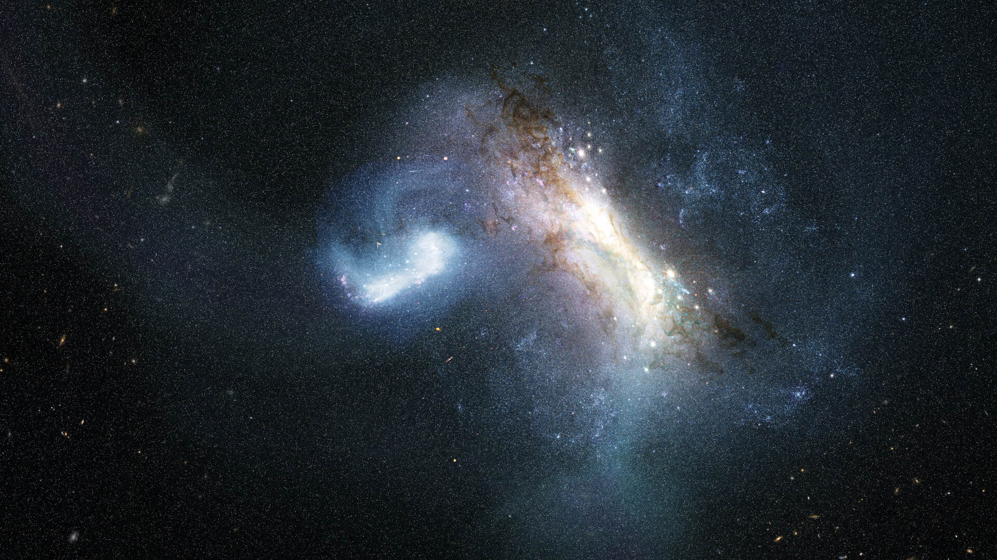
Science & Exploration Hubble & Gaia solve our galaxy's merger mystery 17/08/2026 503 views 12 likes Our home galaxy, the Milky Way, grew to its current size in part by consuming smaller galaxies. Now, new data from the NASA/ESA Hubble Space Telescope show definitive evidence of a dwarf galaxy merging with the young Milky Way galaxy in the earliest phases of its evolution. This finding extends our knowledge of our galaxy's history 1.8 billion years farther back in time than before. LKH Milky Way merger (artist's impression) The Milky Way galaxy today is a massive spiral galaxy home to hundreds of billions of stars. However, our galaxy wasn't always so large; it has grown by forming new stars from its gas clouds as well as collecting stars, gas, and dark matter from other galaxies through mergers. The most recent massive merger in our galaxy's history took place with the Sagittarius dwarf galaxy, beginning over 6 billion years ago and still ongoing today. Looking back into the even more distant past, researchers learned that the Milky Way galaxy consumed another dwarf galaxy called Gaia-Sausage-Enceladus 10 billion years ago. This ancient merger greatly affected the structure of our galaxy's disc of stars. Other, smaller mergers occurred between these two. But our galaxy's history doesn't stop there. Both observations and simulations have suggested that another large merger preceded these two, though the specifics of the event have been heavily debated. Now, Hubble has uncovered definitive evidence of an earlier merger that occurred about 11.8 billion years ago, or just 2 billion years after the Big Bang. "Our home is the Milky Way galaxy, but we do not know how our house was built," said Davide Massari, lead author, Astrophysics and Space Science Observatory of Bologna in Italy. "In this paper we discover where the first significant batch of bricks came from: a dwarf galaxy that we call LKH." Cosmic archaeological sites Gaia mapping the stars of the Milky Way Immense astronomical surveys and precision data from spacecraft like ESA's Gaia mission have been instrumental in piecing together the history of our galaxy. The farther back into our galaxy's history that scientists attempt to look, the more difficult it becomes to tell what happened. When our galaxy was young, it was smaller and much closer in size to the galaxies it clashed with. It was also more chaotic, and it's possible that the signs of mergers have been erased over billions of years. It's into this murky past that Hubble peered. Researchers used Hubble to study some of the Milky Way galaxy's globular clusters: immense, roughly spherical collections of tens of thousands to a few million stars. Globular clusters contain some of the oldest stars in our galaxy, and they can act as cosmic archaeological sites that preserve stars from other galaxies the Milky Way galaxy has collected. "Thanks to the high resolution and depth of Hubble imaging, we could measure the age and the metal content of these clusters with unprecedented precision," said Chiara Zerbinati, study co-author, University of Bologna in Italy. "Coupled with measurements from Gaia, this made it possible to distinguish a population of globular clusters that are different from the others. These are the clusters that were born in LKH, and they tell us when that galaxy was devoured by ours, and how massive it was." Hubble in free orbit The team analysed Hubble observations of 39 globular clusters in the inner 20 000 light-years of our galaxy, where evidence of the most ancient mergers should be preserved. They expected this sample to contain globular clusters that formed within the young Milky Way galaxy as well as those collected from the Gaia-Sausage-Enceladus dwarf galaxy about 10 billion years ago. Using Hubble's sensitive observations to determine each cluster's precise age and associated metallicity - the abundance of elements heavier than helium - they determined there was a third population of globular clusters in the inner regions of our galaxy. The team found that these clusters are older than the group collected in the Gaia-Sausage-Enceladus merger, but younger than those born in the Milky Way galaxy, regardless of their metal content. These clusters, therefore, came from a separate and even earlier merger - in which the Milky Way galaxy absorbed a dwarf galaxy containing roughly 500 million times the mass of the Sun in stars, a significant fraction of our galaxy's mass at the time. They named this dwarf galaxy Low-energy-Kraken-Heracles, or LKH, in honour of three earlier research papers that championed the idea of a merger early in our galaxy's history. Such a large merger so early in the Milky Way galaxy's formation has profound implications for the evolution of our galaxy. "Some past studies have argued that the earliest phases of our galaxy's evolution were defined by stars born only in our galaxy," says Davide. "Here, we have shown that stars born in external galaxies also need to be considered." The team plans to continue their work to unravel the history of the Milky Way galaxy by studying its globular clusters, aiming to characterise all the massive mergers that our galaxy has experienced across cosmic history. "Hubble is observing globular clusters that have never been studied before, and this will help us characterise the merger events that are far back in time in the Milky Way galaxy's history," said Fernando Aguado-Agelet, co-author, University of Vigo and the University of La Laguna in Spain. More information The Hubble Space Telescope is a project of international cooperation between ESA and NASA. Links Science paper Release on esahubble.org Release on NASA website Contact: ESA Media relations media@esa.int

3. Total solar eclipse 2026 (Official ESA broadcast)
Read more
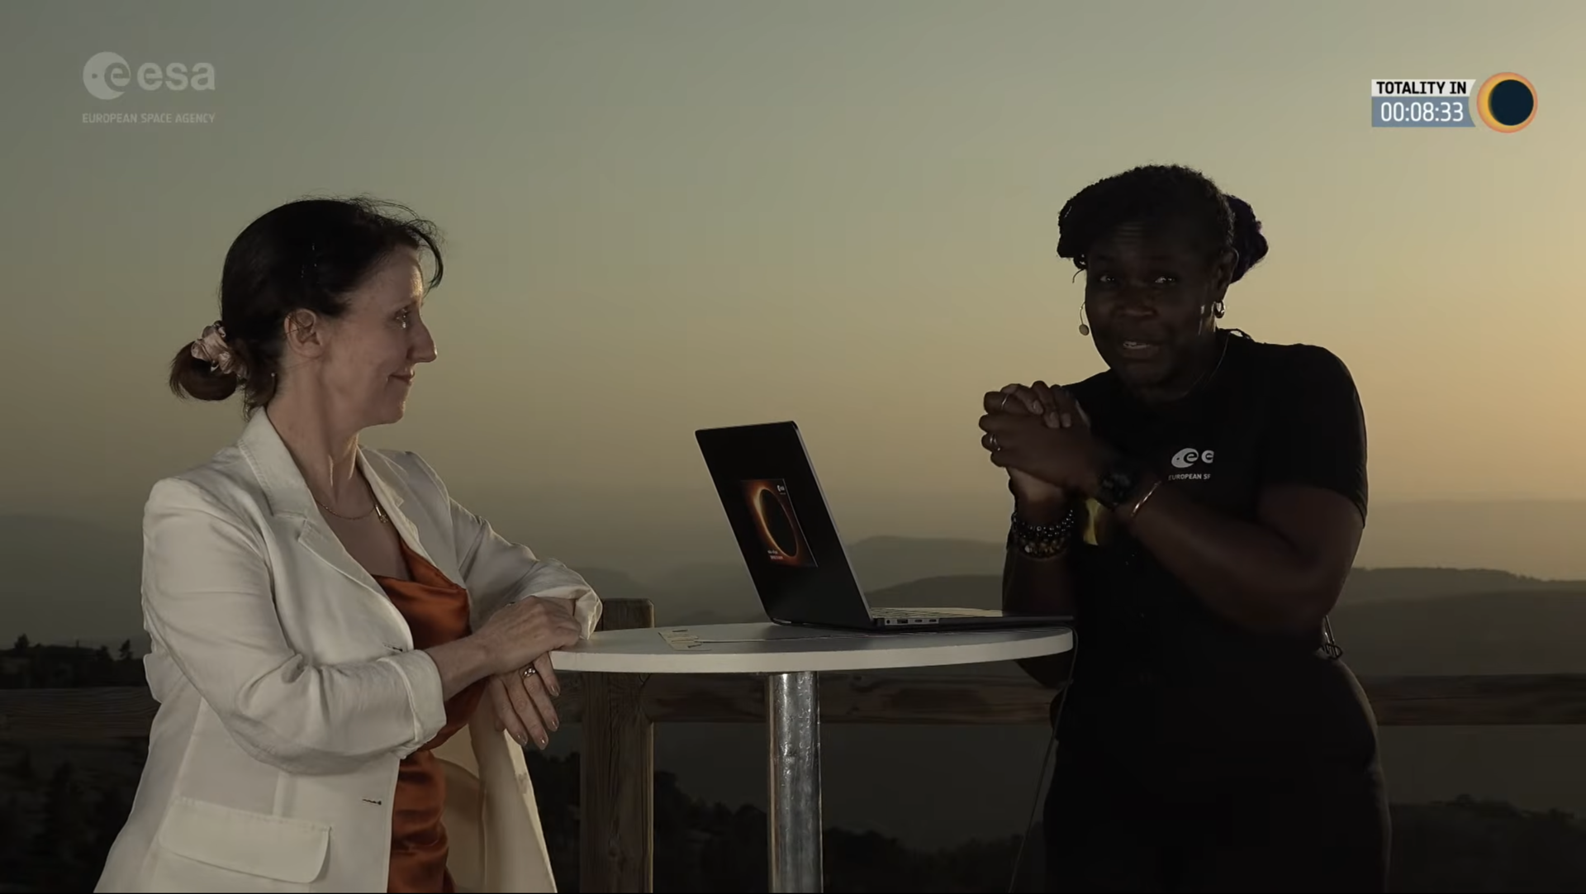
We broadcast live from the Observatorio Astrofísico de Javalambre in Spain as a total solar eclipse crossed Europe on 12 August 2026. The path of totality swept across Greenland, Iceland, Spain and a small area of northeastern Portugal, while much of Europe experienced a partial eclipse. A total solar eclipse occurs when the Moon passes directly between Earth and the Sun, completely blocking the face of the Sun. The Observatorio Astrofísico de Javalambre is a world-class astronomical observatory located within the path of totality. During the broadcast, scientists, astronomers and special guests explored the science behind eclipses, the Sun and their wider relevance for space science and Earth. The broadcast was hosted by Dame Dr Maggie Aderin, award-winning space scientist and science communicator, and featured ESA's Director of Science Carole Mundell alongside other guests. It included live telescope views of the eclipse, expert commentary and interviews, insights into solar science and space weather, behind-the-scenes coverage from the observatory, and discussions on ESA's activities linked to the eclipse. Learn more about ESA's activities surrounding the 2026 eclipse, as well as those coming to Europe in 2027 and 2028.

4. NASA Selects Companies to Provide Payload Processing Services
Read more
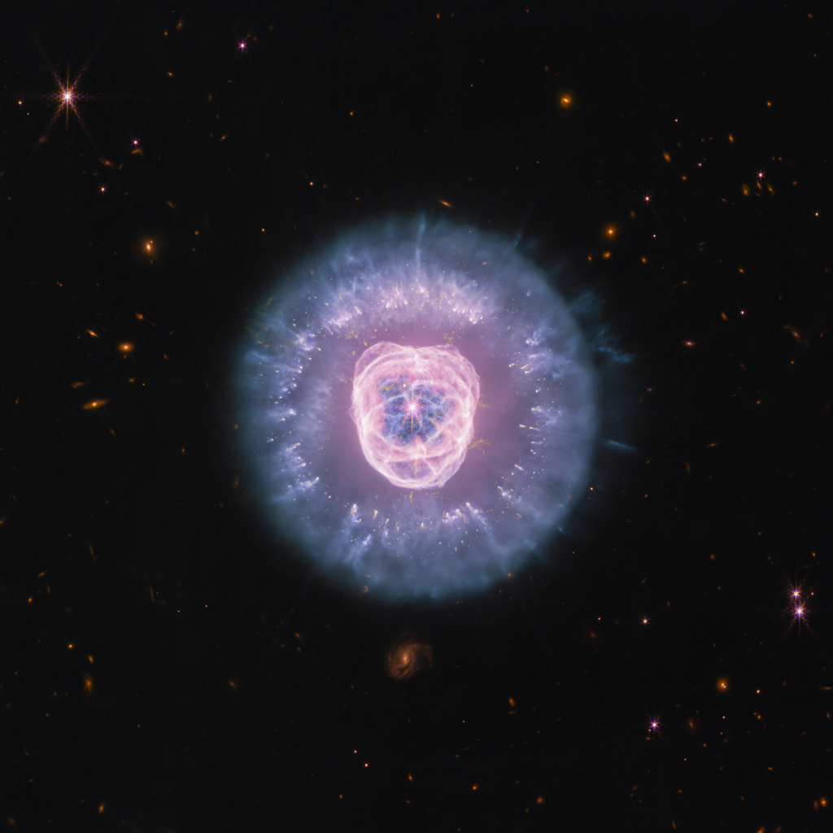
Credit: NASA NASA has selected four companies to provide payload processing facilities under the Spacecraft Processing Operations Contract on‑ramp provision. The provision enables qualified providers to offer commercial payload processing services for agency missions launching from multiple locations where capabilities were not available at the time of the initial contract award. Contract awardees are: All Points Logistics LLC Blue Origin LLC Firefly Aerospace L3Harris Technologies Inc. Through the contract, NASA procures facilities and services required to perform prelaunch processing of spacecraft and associated rocket hardware for delivery to the launch pad. The Spacecraft Processing Operations Contract is a multiple-award, commercial, firm-fixed-price, indefinite-delivery/indefinite-quantity contract vehicle that has an aggregate ceiling price of $100 million with an ordering period through Feb. 1, 2033. NASA's Launch Services Program at the agency's Kennedy Space Center in Florida will manage the contract. The program works with private industry, mission, and international partners to launch science payloads ranging from small satellites with colleges and universities to NASA's highest-priority missions. For more information about NASA's launch services, visit: https://www.nasa.gov/lsp -end- Joshua Finch Headquarters, Washington 202-358-2546 joshua.a.finch@nasa.gov Leejay Lockhart Kennedy Space Center, Fla. 321-747-8310 leejay.lockhart@nasa.gov

5. NASA Challenge Tests Wheel Designs for Moon Base Mobility
Read more
NASA engineers, NASA Robotics Academy students, and teams from the Rock and Roll with NASA Challenge pose with the wheel prototypes at NASA's Johnson Space Center Rock Yard in Houston on July 31, 2026. NASA/Luna Posadas Nava As NASA prepares to establish the Moon Base, advancing surface mobility will be key to helping crews and robotic systems travel farther across the lunar surface. To help advance that capability, the Rock and Roll with NASA Challenge invited public innovators to design and build next-generation lunar rover wheels. Five teams from 128 submissions and 49 countries advanced to the final phase of the competition, where they tested their prototypes on July 31 at NASA's Johnson Space Center in Houston. The Huff Helo lunar wheel prototype is tested at Johnson Space Center's Rock Yard. NASA/Luna Posadas Nava The challenge sought lightweight, durable, and scalable wheels that could support longer-duration lunar surface operations. The designs also needed to be compliant enough to absorb impacts, maintain traction at higher speeds, and withstand the harsh lunar environment. "Every additional kilometer a rover can reliably travel will expand how far we can explore, what science we can achieve, and what infrastructure we can build," said Ed Herrera, robotics engineer at Johnson and co-leader of the challenge project. NASA Johnson uses ground prototypes to test mobility technologies, while lunar terrain vehicles will be delivered to the lunar surface through the Commercial Lunar Payload Services initiative. For the challenge, the wheels were fitted to MicroChariot, a 45-kilogram test rover, and put through a series of courses at Johnson's Rock Yard to evaluate their performance across different types of terrain. NASA Robotics Academy students navigate the lunar wheel prototype Scotch Pad Tyres fitted on the MicroChariot rover at Johnson's Rock Yard. NASA/Luna Posadas Nava "Crowdsourcing gives us an opportunity to look beyond traditional approaches for lunar wheel design," Herrera said. "The more wheel technologies we can develop and understand, the more options we have to meet the needs of different vehicles, terrains, and missions on the Moon and Mars." Those ideas were reflected in five distinctly different designs. The HTR Variable Flex Lunar Wheel created by Hellenic Technology of Robotics SA uses an internal system designed to vary the wheel's stiffness depending on terrain and vehicle needs. The team adapted technology it had been developing for terrestrial wheels for about a decade. The Hiper Wheel created by Hyperbola uses tensioned cables and a corigated structure that provides spring-like behavior, allowing the wheel to flex without relying on traditional radial spokes. The Huff Helo Flexible Titanium Wheel created by Huff Helo Inc. uses formed titanium sheet metal as both structure and spring. During testing, the team found that the strength of the design also made the wheel more rigid, causing it to bounce over some obstacles rather than conform to the terrain. The Payne Aviation Wheel created by Deborah and Craige Payne took inspiration from aviation and history. Its designer, an aircraft mechanic, combined a pneumatic approach with ideas from early automobile tire designs. The winning Scotch Pad Tyres team poses with their prototype and MicroChariot at Johnson's Rock Yard. NASA/Luna Posadas Nava The winning Scotch Pad Tyres concept came from an Australian mechanical engineer Daniel Bloomfield and his son Isaac Bloomfield. Their prototype uses a Nomex-based tire structure supported around an aluminum hub. The soft material allows the tire to deform around terrain, while internal support helps it maintain its shape. A treated outer surface of epoxy and corundum grit was integrated to improve traction. The Rock Yard testing also demonstrated why different terrains may require different approaches. Loose material can affect traction, while rocks and slopes place different demands on wheels such as vehicle stability. The HTR Variable Flex Lunar Wheel prototype sits alongside NASA's Space Exploration Vehicle at Johnson's Rock Yard. NASA/Luna Posadas Nava As lunar exploration expands, different vehicles will require different combinations of speed, load capacity, durability, and terrain performance. Seeking that variety was part of the challenge design. The design options gave engineers different technologies to consider and potentially advance. "This challenge brought in new ideas from outside traditional industries and helped us identify wheel technologies that may be suitable for longer-duration surface operations," said Lucien Junkin, robotics engineer at Johnson and co-leader of the challenge project. The next phase could evaluate how the wheels respond to lunar-like dust, vacuum, and extreme temperatures in Johnson's thermal vacuum chambers. Engineers could also assess the designs over longer distances and at different sizes and loads. "Mobility is key to everything we want to do on the Moon," Junkin said. "The farther we want to explore, the more we need to advance the wheel technologies that can get us there." The Common Robotics Project of the Robotic Systems Technology Branch within Johnson's Engineering Directorate conducted the Rock and Roll with NASA Challenge. NASA's Center of Excellence for Collaborative Innovation, part of the Prizes, Challenges, and Crowdsourcing Program within the Research and Technology Mission Directorate, managed the challenge contract. Students in NASA's Robotics Academy helped prepare hardware and support the competition, while engineers from NASA's Glenn Research Center in Cleveland supported reviews of concepts and proposals. HeroX administered the challenge on behalf of NASA.

6. Hubble Solves Merger Mystery From Milky Way's Early Years
Read more
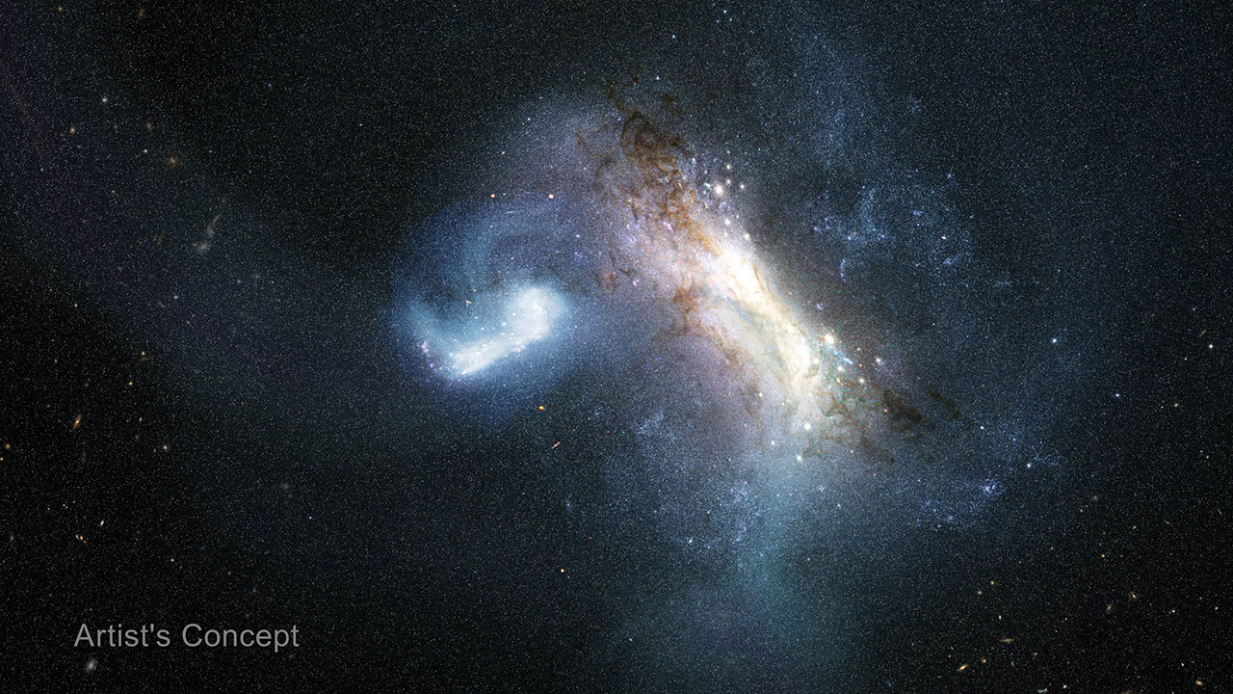
About 12 billion years ago, a dwarf galaxy known as LKH collided with a young Milky Way and merged with it. This artist's concept portrays that collision. NASA's Hubble Space Telescope uncovered definitive evidence of this collision by studying globular star clusters. Illustration: NASA, ESA, Joseph Olmsted (STScI) Our home galaxy, the Milky Way, grew to its current size in part by consuming smaller galaxies. Now, new data from NASA's Hubble Space Telescope shows definitive evidence of a dwarf galaxy merging with the young Milky Way galaxy in the earliest phases of its evolution. This finding extends our knowledge of our galaxy's history 1.8 billion years farther back in time than before. The results published Monday in the journal Nature Astronomy. The Milky Way today is a massive spiral galaxy home to hundreds of billions of stars. However, our galaxy wasn't always so large; it has grown by forming new stars from its gas clouds as well as collecting stars, gas, and dark matter from other galaxies through mergers. The most recent massive merger in our galaxy's history took place with the Sagittarius dwarf galaxy, beginning over 6 billion years ago and still ongoing today. Looking back into the even more distant past, researchers learned that the Milky Way galaxy consumed another dwarf galaxy called Gaia-Sausage-Enceladus 10 billion years ago. This ancient merger greatly affected the structure of our galaxy's disk of stars. Other, smaller mergers occurred between these two. But our galaxy's history doesn't stop there. Both observations and simulations have suggested that another large merger preceded these two, though the specifics of the event have been heavily debated. Now, Hubble has uncovered definitive evidence of an earlier merger that occurred about 11.8 billion years ago, or just 2 billion years after the big bang. "Our home is the Milky Way galaxy, but we do not know how our house was built," said Davide Massari, lead author, Astrophysics and Space Science Observatory of Bologna in Italy. "In this paper we discover where the first significant batch of bricks came from: a dwarf galaxy that we call LKH." Cosmic archaeological sites Immense astronomical surveys and precision data from spacecraft like ESA's (European Space Agency's) Gaia mission have been instrumental in piecing together the history of our galaxy. The farther back into our galaxy's history that scientists attempt to look, the more difficult it becomes to tell what happened. When our galaxy was young, it was smaller and much closer in size to the galaxies it clashed with. It was also more chaotic, and it's possible that the signs of mergers have been erased over billions of years. It's into this murky past that Hubble peered. Researchers used Hubble to study some of the Milky Way galaxy's globular clusters: immense, roughly spherical collections of tens of thousands to a few million stars. Globular clusters contain some of the oldest stars in our galaxy, and they can act as cosmic archaeological sites that preserve stars from other galaxies the Milky Way galaxy has collected. "Thanks to the high resolution and depth of Hubble imaging, we could measure the age and the metal content of these clusters with unprecedented precision," said Chiara Zerbinati, study co-author, University of Bologna in Italy. "Coupled with measurements from Gaia, this made it possible to distinguish a population of globular clusters that are different from the others. These are the clusters that were born in LKH, and they tell us when that galaxy was devoured by ours, and how massive it was." The team analyzed Hubble observations of 39 globular clusters in the inner 20,000 light-years of our galaxy, where evidence of the most ancient mergers should be preserved. They expected this sample to contain globular clusters that formed within the young Milky Way galaxy as well as those collected from the Gaia-Sausage-Enceladus dwarf galaxy about 10 billion years ago. Using Hubble's sensitive observations to determine each cluster's precise age and associated metallicity - the abundance of elements heavier than helium - they determined there was a third population of globular clusters in the inner regions of our galaxy. The team found that these clusters are older than the group collected in the Gaia-Sausage-Enceladus merger, but younger than those born in the Milky Way, regardless of their metal content. These clusters, therefore, came from a separate and even earlier merger - in which the Milky Way galaxy absorbed a dwarf galaxy containing roughly 500 million times the mass of the Sun in stars, a significant fraction of our galaxy's mass at the time. They named this dwarf galaxy Low-energy-Kraken-Heracles, or LKH, in honor of three earlier research papers that championed the idea of a merger early in our galaxy's history. Such a large merger so early in the Milky Way galaxy's formation has profound implications for the evolution of our galaxy. "Some past studies have argued that the earliest phases of our galaxy's evolution were defined by stars born only in our galaxy," says Massari. "Here, we have shown that stars born in external galaxies also need to be considered." The team plans to continue their work to unravel the history of the Milky Way galaxy by studying its globular clusters, aiming to characterize all the massive mergers that our galaxy has experienced across cosmic history. "Hubble is observing globular clusters that have never been studied before, and this will help us characterize the merger events that are far back in time in the Milky Way galaxy's history," said Fernando Aguado-Agelet, co-author, University of Vigo and the University of La Laguna in Spain. The Hubble Space Telescope has been operating for more than three decades and continues to make ground-breaking discoveries that shape our fundamental understanding of the universe. Hubble is a project of international cooperation between NASA and ESA (European Space Agency). NASA's Goddard Space Flight Center in Greenbelt, Maryland, manages the telescope and mission operations. Lockheed Martin Space also supports mission operations at Goddard. The Space Telescope Science Institute in Baltimore, which is operated by the Association of Universities for Research in Astronomy, conducts Hubble science operations for NASA.

7. China bounces back from Long March rocket explosion with back-to-back launches (video)
Read more
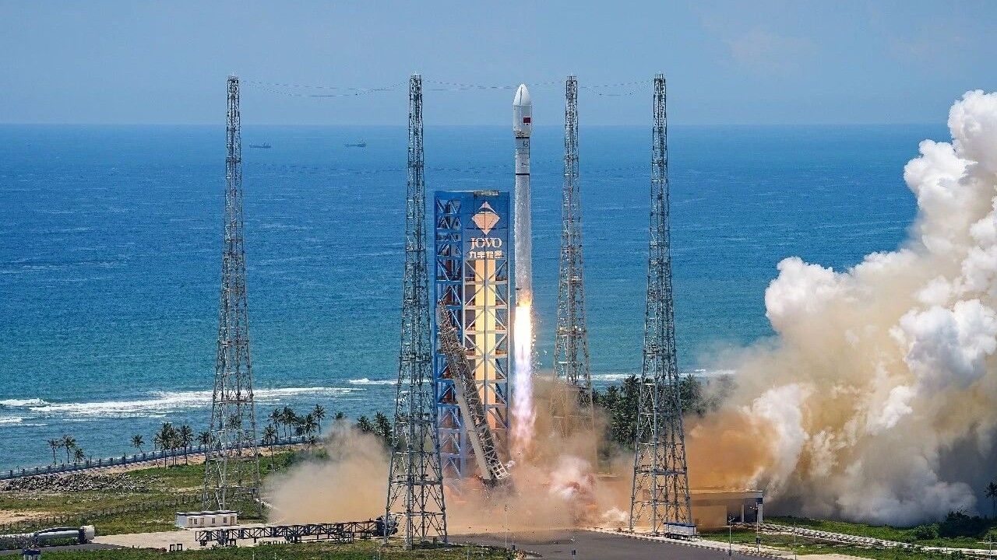
Click for next article China just completed not one but two space missions, less than a week after a Long March 7A rocket explosion briefly grounded its fleet. The state-owned China Aerospace Science and Technology Corporation ( CASC ) returned to flight with the launch of a Long March 12 rocket from the Hainan Commercial Space Launch Site in Wenchang. The rocket lifted off on Aug. 16 at 12:10 a.m. EDT (0410 GMT; 12:10 p.m. local time in China) and delivered a stack of 24 internet-beaming satellites into low Earth orbit (LEO). It was the first launch since China's Long March 7A exploded mid-flight on Aug. 10. Footage of that mission showed the Long March 7A's fairing section and the upper portion of the launch vehicle bending backward about 85 seconds after liftoff, resulting in the total loss of the rocket and its payload, the Zhongxing-4B communications satellite . China's Long March 12 rocket lifted off with a stack of 24 internet satellites on Aug. 16, 2024. (Image credit: CASC/Hu Zhipeng) Less than 24 hours after the successful Long March 12 mission, and about 1,300 miles (2,100 kilometers) north of the Wenchang launch site, a Long March 2C rocket lifted off from the Taiyuan Satellite Launch Center, in Shanxi province. The launch occurred on Aug. 16 at 11:02 p.m. EDT (0302 GMT and 11:02 a.m. local time in China on Aug. 17), and delivered the "SEO" satellite for the United Arab Emirates to its planned orbit, according to the China National Space Administration . Of the pair launched over the weekend, the Long March 12 is much more similar to the Long March 7A; the two stand 203 feet (62 meters) and 197 feet (60 m) tall, respectively. But the two rockets are designed with different purposes. The slightly wider Long March 12 is a two-stage rocket optimized for delivering relatively heavy payloads to LEO and sun-synchronous orbits, while the three-stage Long March 7A is designed for higher-altitude missions to geostationary transfer orbit and beyond. In contrast, the Long March 2C stands only about 141 feet (43 m) tall. The two-stage rocket is used primarily for smaller payloads to LEO, with a lifting capacity of only about 3.9 tons, and has a long list of launches dating back to 1982. The newest of the three, the Long March 12, was introduced in 2024 and has now launched seven missions - all successful. Last week was the Long March 7A's second failure in a total of 18 launches since the rocket's debut in 2020. CASC hasn't provided an update on the Long March 7A incident, other than a statement indicating that the cause is under investigation. As that continues, China has more launches on the horizon.

8. Blue Origin adding second pad to Cape Canaveral launch complex amid rocket explosion repairs
Read more
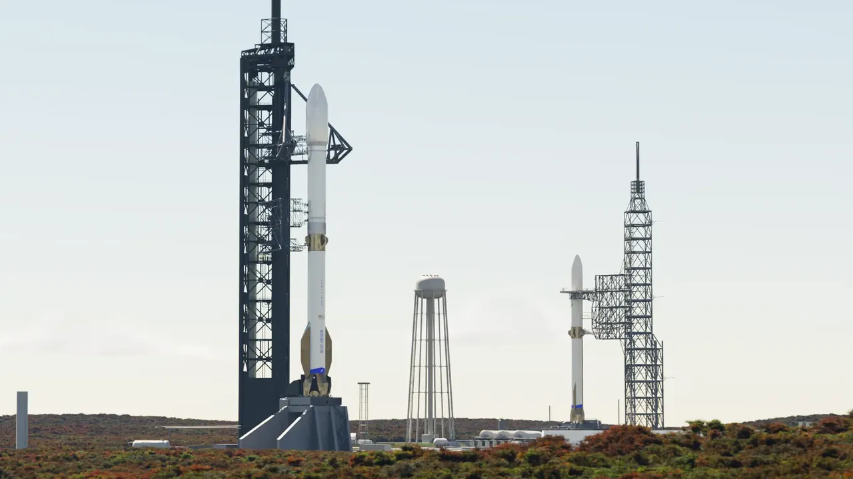
Click for next article Blue Origin plans to return its Florida launch site to a dual-pad facility to support its bigger, more powerful New Glenn "9x4" rocket, which is still under development. As facility repairs continue following the explosion of one of Blue Origin's New Glenn "7x2" rockets during tests at Cape Canaveral Space Force Station's Launch Complex-36 in May, the company has announced its intent to expand the site with an additional pad. The company also plans to build operations infrastructure for the complex on land nearby, which will include a Vertical Integration Facility (VIF) for the New Glenn 9x4 vehicle, and a Payload Processing Facility (PPF). Blue Origin has expressed confidence in its ability to complete repairs at its existing LC-36 pad (LC-36A) in time for New Glenn 7x2 to return to launch by the end of the year, but the company did not state a timeline for the readiness of LC-36B or an expected debut of New Glenn 9x4. The 7x2 and 9x4 designations are a denotation of the rockets' engine configurations. It's similar to SpaceX's name for the Falcon 9 rocket, which is powered by nine Merlin 1D engines on its first stage, arranged in a circle of eight around a single engine in the center. New Glenn's first stage is powered by Blue Origin's BE-4 engines, and the rocket's second stage uses BE-3Us. Both New Glenn first-stage configurations are designed for landing and reusability. The 7x2 flies with seven BE-4 engines on its first stage and two BE-3Us on its second stage. Subsequently, the taller, yet-to-debut New Glenn 9x4 will be powered by nine BE-4 engines on its first stage and four BE-3Us on its second stage. It will therefore be capable of launching larger, heavier payloads into space. For roughly four decades beginning in the 1960s, LC-36 was home to two pads that supported the Atlas-Centaur family and, later, the Atlas I, II and III rockets. In that time, the pads hosted launches of NASA's Surveyor , Mariner and Pioneer probes, as well as commercial and national-security payloads. But that era ended in the mid-aughts as those Atlas rockets reached retirement. LC-36A hosted its final launch in 2004, LC-36B launched its last rocket in 2005, and the complex was decommissioned and demolished. A render of the Vertical Integration Facility with Launch Complexes 36A & 36B in the distance. (Image credit: Blue Origin) Blue Origin took over the lease for LC-36 in 2015, began construction of its own launch facility in 2016, and launched the first New Glenn 7x2 rocket from the facility in 2025. Since that debut, New Glenn has flown two more missions, with the most recent lifting off in April. The company had planned for as many as eight to 12 launches in 2026, but May's static test fire explosion has reduced that number to a hopeful one (1). The fourth New Glenn rocket (NG-4) was slated to deliver a stack of Amazon Leo wireless internet satellites to orbit before its destruction during testing on May 8, which also resulted in extensive damage to LC-36 facilities. Less than a month later, Blue Origin CEO Dave Limp provided a repair update with the assurance that New Glenn would fly again before the end of 2026 . He also outlined some early upgrades that would be integrated into LC-36 as a result of the unexpected repairs , including the replacement of New Glenn's transporter erector with "an alternative vertical conop (operational concept)," for transporting the rocket to the pad. Proud to honor the legacy of Launch Complex 36. Rebuilding LC-36A and flying again this year remains our priority. Alongside that work, a separate team is beginning work on LC-36B, the operational home for New Glenn's 9x4. We're sourcing 2,500 tons of steel columns that will be… https://t.co/7MkYajmGLzAugust 12, 2026 "LC-36 has served as a cornerstone of American spaceflight for decades, supporting a broad range of missions for NASA and commercial partners," Blue Origin said in a statement . "Now, this historic site is entering a new era, furthering New Glenn operations." According to Limp, the additional pad will require as much as 2,500 tons of steel, much of which will go toward building a700-foot-tall (213 meters) launch tower.

9. Hubble solves merger mystery from Milky Way's early years
Read more

Our home galaxy, the Milky Way, grew to its current size in part by consuming smaller galaxies. Now, new data from NASA's Hubble Space Telescope show definitive evidence of a dwarf galaxy merging with the young Milky Way in the earliest phases of its evolution. This finding extends our knowledge of our galaxy's history 1.8 billion years farther back in time than before. The res...

