संकलन
SANKALAN
22nd July 2026 to 28th July 2026
ई-न्यूज़लेटर | e-Newsletter

 |  | 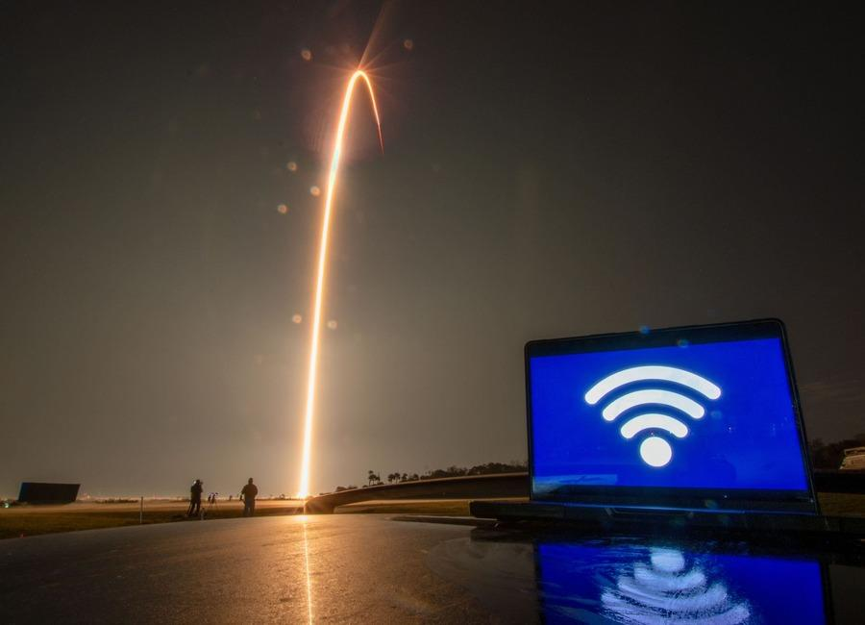
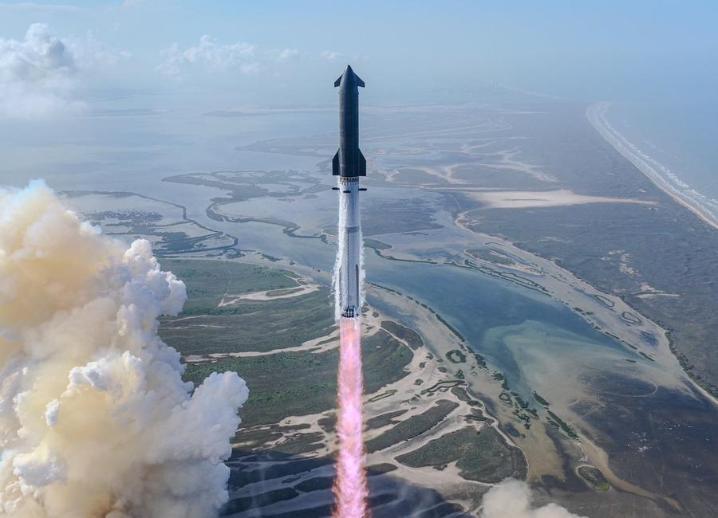 |  | 
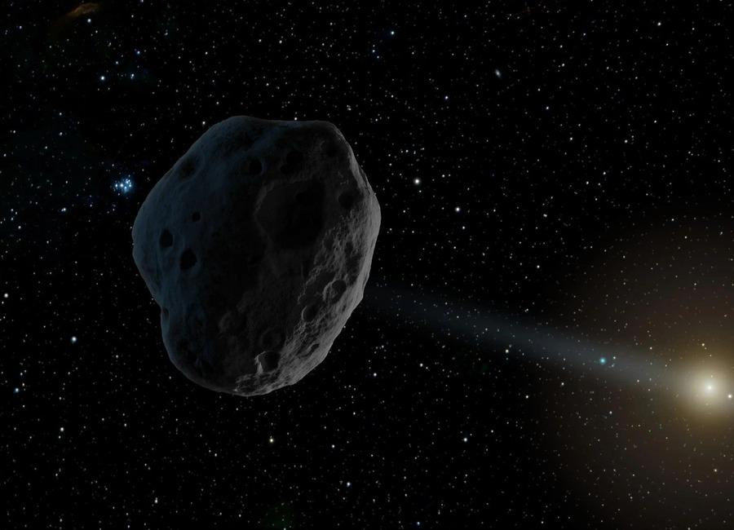 | 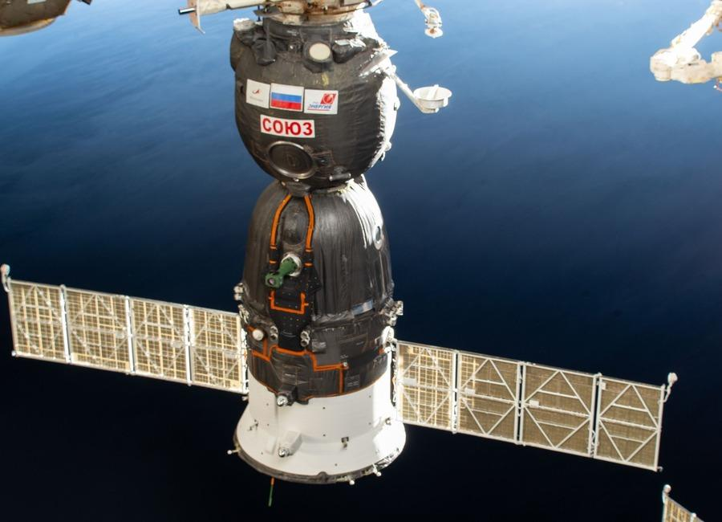 | 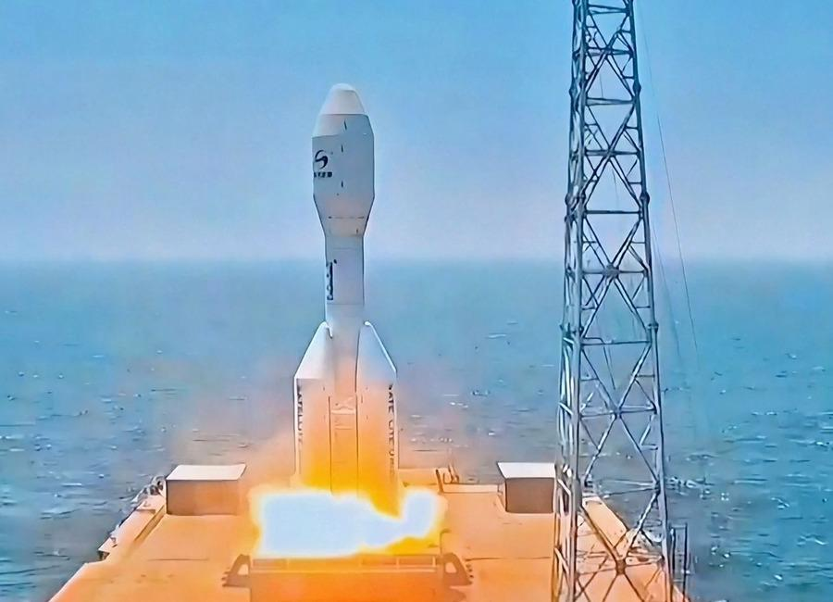

Indian Institute of Remote Sensing (ISRO), Dehradun
Collection of recent developments in the realms of Space Technology

Table of Contents
S. No. | Title
1 | Monsoon clouds swallow 95% of India, Isro satellite images show: What to expect - India Today
2 | Six years of Chandrayaan-2: How ISRO's lunar mission reshaped India's Moon programme - DD India
3 | ISRO Recruitment 2026 | Govt Life Science Job with Salary Up to ₹56,000/Month - BioTecNika
4 | Isro chairman congratulates Skyroot Aerospace on Vikram-1 orbit success - The News Mill
5 | US-India Satellite Delivers Data, Reveals 'Hummingbird' in Antarctica
6 | Precision Astrometry Using Optically Independent Spacecraft for Graviational Wave Detection
7 | James Webb Space Telescope discovers the secrets of cosmic 'factories' that filled the early universe with stardust
8 | Space Force orders 36 more Golden Dome missile-tracking satellites, for $1.75 billion
9 | Artemis III astronauts will beam 4k video from Orion to Earth using SpaceX Starlink lasers
10 | With 3 spacecraft, multiple launches, Artemis III to be Nasa's most complex mission
11 | ISRO satellite captures monsoon clouds blanketing 95% of India; IMD issues rain alert - WION
12 | 5 systems over Bay of Bengal, Arabian Sea revive monsoon rain, Isro images show - India Today
13 | Robotic Servicing Mission Launches with NASA Support
14 | NASA Sets Coverage for Astronaut Chris Williams, Crewmates Return
15 | Mapping Io's Hidden Heat With NASA's Juno
16 | NASA's Juno Peers Beneath Io's Surface
17 | NASA Joins Genesis Mission to Accelerate AI-Driven Discovery
18 | China's record-breaking Gravity-1 rocket launches 9 satellites from a ship at sea (video)
19 | After nearly 30 years, NASA realized this near-Earth asteroid is actually a comet. The discovery may help us defend the planet some day
20 | 'The court has to intervene now': Indigenous groups and conservationists condemn SpaceX's South Texas land swap
21 | More than 300 active landslide zones await permanent treatment
22 | ISRO Recruitment 2026 Notification Out for 242 Assistant, UDC, JPA, and Steno Posts, Application Dates, Eligibility - Adda247
23 | India wanted a space industry. Scientists quitting ISRO is how that happens - ThePrint
24 | ISRO Satellite Detects Massive Rain Clouds | Weather Alert Across India - Kanak News Odisha
25 | ISRO to launch LVM3 | DD News - DD News
26 | Who Is Kandula Jessie? 14-Year-Old Andhra Student Selected For Mission ShakthiSAT, Dreams Of Joining ISRO - Brut
27 | Watch the total solar eclipse with ESA in León
28 | Vulcan Centaur swapped out again: NASA goes with SpaceX Falcon Heavy rocket for launch of space weather mission
29 | Scientists may have finally solved the mystery of the sun's missing silver
30 | NASA's retired astronauts are hitting the road to get young people to vote: 'one small step for you, and one giant leap for our country.'
31 | Satellite spots a 'hummingbird' in Antarctica | Space photo of the day for July 23, 2026
32 | The James Webb Space Telescope's disappearing 'Little Red Dots' may lead to another cosmic puzzle
33 | Live coverage: SpaceX ready for 2nd attempt to launch Starship Flight 13 following post-abort engine work
34 | NASA's new space telescope will tackle some of the universe's biggest mysteries
35 | NISAR S-Band SAR Data Products Release - ISRO
36 | Govt says ISRO has developed & operationalised wide range of space-based applications to benefit society - News On AIR
37 | SpaceX's Starship megarocket makes the 'softest splashdown' ever after launching next-gen Starlink satellites in Flight 13 test (video)
38 | What lurks beneath the volcanoes of Jupiter's moon Io? NASA's Juno probe just took a peek
39 | Lightning strike on Chinese rocket captured in epic launch photo
40 | Super Heavy-Starship rocket chalks up mostly successful test flight
41 | UK in pole position to lead key instrument in NASA's hunt for Earth-like worlds
42 | Could hydrogen fuel aviation by 2050? NASA-backed study evaluates five alternatives
43 | ISRO Recruitment 2026 Notification Out for 242 Assistant, UDC, JPA, and Steno Posts, Application Dates, Eligibility - Adda247
44 | Jitendra Singh congratulates ISRO for successful completion of IADT-02 for Gaganyaan Mission - DD News
45 | Opinion | Vikram-1: Launches India's Private Space Revolution - The Global Kashmir
46 | India becomes third country to joins China, US in commercial space race with Skyroot launch - Qatar Tribune
47 | We talk with astronaut Michael Foale about the 1997 Space Station Mir crisis: 'He took all the blame of the collision on his shoulders'
48 | NASA astronaut, 2 cosmonauts returning to Earth on July 26: Watch it live
49 | SpaceX Falcon 9 launches Starlink satellites from West Coast
50 | SpaceX launches Starship on another test flight, this time with the most advanced Starlinks
51 | Starship launches Starlink satellites, achieves most successful splashdown yet
52 | China possibly making new class of stealthy attack submarine, satellite images suggest
53 | Isro begins public release of Nisar data through Bhoonidhi - The Times of India
54 | ISRO-NASA Satellite Data Reveal 60 CM Ground Shift In Venezuela Earthquake - ETV Bharat
55 | Isro satellite images show 90% of India is under cloud cover. How much rain is likely? - India Today
56 | From Aadhaar to ISRO: What the six-member NTA reform panel brings to the table - Moneycontrol.com
57 | ISRO Bengaluru receives hoax bomb threat, investigation underway - The News Mill
58 | NASA Astronaut Chris Williams, Crewmates Return from Space Station
59 | I'm not an astronaut, but I went to the International Space Station (sort of)
60 | China's new alloy can withstand extreme heat; could be used in reactors, hypersonic missiles
61 | ISRO Recruitment 2026 Notification PDF Out for 244 Assistant, UDC, JPA, and Steno Posts, Application Dates, Eligibility - Adda247
62 | Assam floods: Isro's Nisar satellite captures Brahmaputra's might from space - India Today
63 | Before Team Nilekani, ex-ISRO chief-led panel tried to fix exams - The Indian Express
64 | Venezuela earthquakes shifted ground by nearly 2 feet, NASA-ISRO satellite finds | To read what more the satellite found | Inshorts - Inshorts
65 | Starship in space! See highlights of SpaceX megarocket's epic Flight 13 test launch (video)
66 | Rocket Lab to start launching missile-defense missions from Alaska under $266 million Space Force deal
67 | Curiosity Mars rover inspects cracked wheel | Space photo of the day for July 27, 2026
68 | How NASA plans to build the Habitable Worlds Observatory
69 | Could we send a spacecraft to a black hole?
70 | Are we missing alien lighthouses?

 |  | 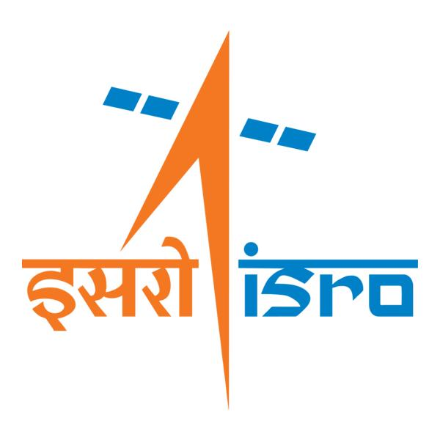

🌌 अंतरिक्ष समाचार | Space News
बुधवार, २२/०७/२०२६ | Wednesday, 22/07/2026

1. Monsoon clouds swallow 95% of India, Isro satellite images show: What to expect - India Today
Read more
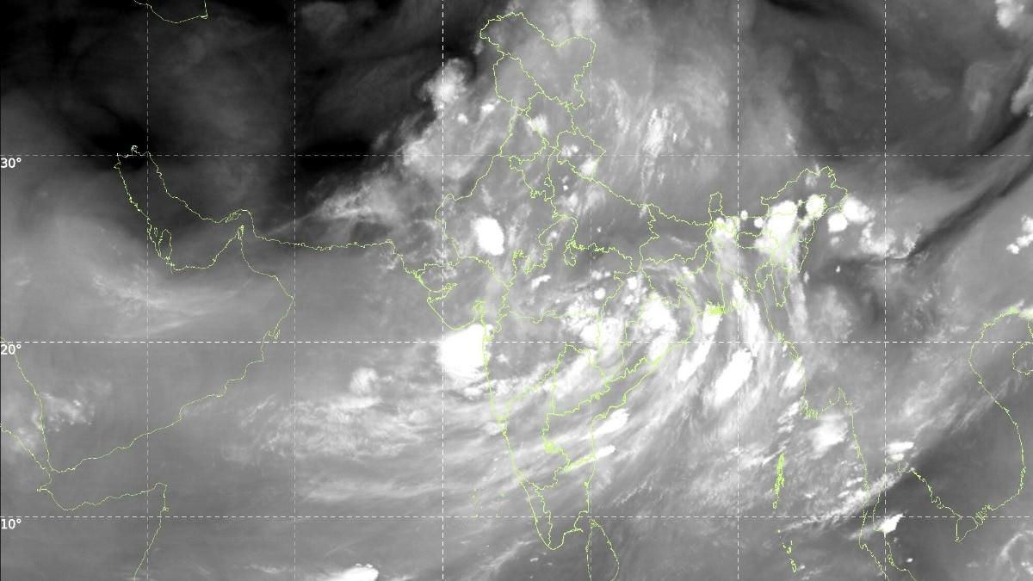
Somewhere around 3 am on July 22, while most of India slept, a satellite parked 36,000 km above the equator quietly took the country's photograph. India was not in it. Only cloud. That is not a figure of speech. Images from India Meteorological Department (IMD), taken by Isro satellites INSAT-3DR and INSAT-3DS between 2.15 am and 3.27 am, show a cloud sheet lying across nearly the entire subcontinent. Read Full Story WHAT DOES ISRO'S INSAT SATELLITE IMAGE OF INDIA SHOW? The thermal infrared frame is the plain one. Thermal infrared simply means the satellite is photographing heat rather than light, which is why the picture works perfectly well in the middle of the night. It shows a curved cloud band sweeping from the north Bay of Bengal across Odisha, Chhattisgarh and Madhya Pradesh, out towards Gujarat and the Arabian Sea. Western Rajasthan and Kutch are the main gaps. The INSAT-3DS thermal infrared frame from 3 am on July 22 traces a curved cloud band running from the north Bay of Bengal to Gujarat, leaving only western Rajasthan and Kutch clear. (Photo: IMD) The water vapour frame is the moisture channel. It shows a loaded atmosphere from the Arabian Sea to the Himalayas, which is what lets clouds keep forming for days rather than hours. WHY DO COLD CLOUD TOPS MEAN HEAVY RAIN The third image is the one forecasters reach for first. It maps cloud top brightness temperature. Air cools as it rises, so the taller a cloud grows, the colder its top. Measure that temperature from space, and you have measured the cloud's height without leaving the ground. It is one of the oldest tricks in monsoon research. Red patches over Bihar, the northeast and the Himalayan foothills mark cloud tops colder than minus 60 degrees Celsius, placing those thunderstorms 12 to 16 km above the ground. (Photo: IMD) The red and pink blobs over Bihar, the northeast and the Himalayan foothills mark tops colder than minus 60 degrees Celsius, some below minus 80. That puts them roughly 12 to 16 km up, brushing the tropopause, the lid where the weather-making layer of the atmosphere ends. Only a fully grown cumulonimbus, the anvil-topped thunderstorm cloud, climbs that high. The rain gauges agree. In the 24 hours to July 20, IMD logged 37 cm at Williamnagar in Meghalaya and 22 cm at Shama in Uttarakhand. WHERE IS THE MONSOON TROUGH RIGHT NOW? The monsoon trough is the low-pressure belt lying across northern India in the rainy season, and it decides who gets rain. Drift it up to the Himalayan foothills and the plains dry out. The IMD's bulletin puts it near its normal position, with cyclonic circulations, which are simply columns of spinning air, over Punjab, southern Uttar Pradesh, the Jharkhand-Bihar belt, southwest Rajasthan and Assam. Crucially, a trough in the middle atmosphere runs from the west-central Bay of Bengal all the way to the northeast Arabian Sea. That is the diagonal streak of cloud slicing across your image. WILL THIS FIX INDIA'S RAINFALL DEFICIT? Not on its own. June 2026 gave India 99.5 mm, about 40 per cent below normal and the fifth-driest June since 1901. IMD's monthly outlook expected July to finish below 94 per cent of its long period average of 280.4 mm. The IMD expects active monsoon conditions over northwest and northeast India for four to five days, while west-central and south peninsular India stay subdued. A cloud sheet this wide is a very good night for the monsoon. It is not yet a good season. - Ends

2. Six years of Chandrayaan-2: How ISRO's lunar mission reshaped India's Moon programme - DD India
Read more
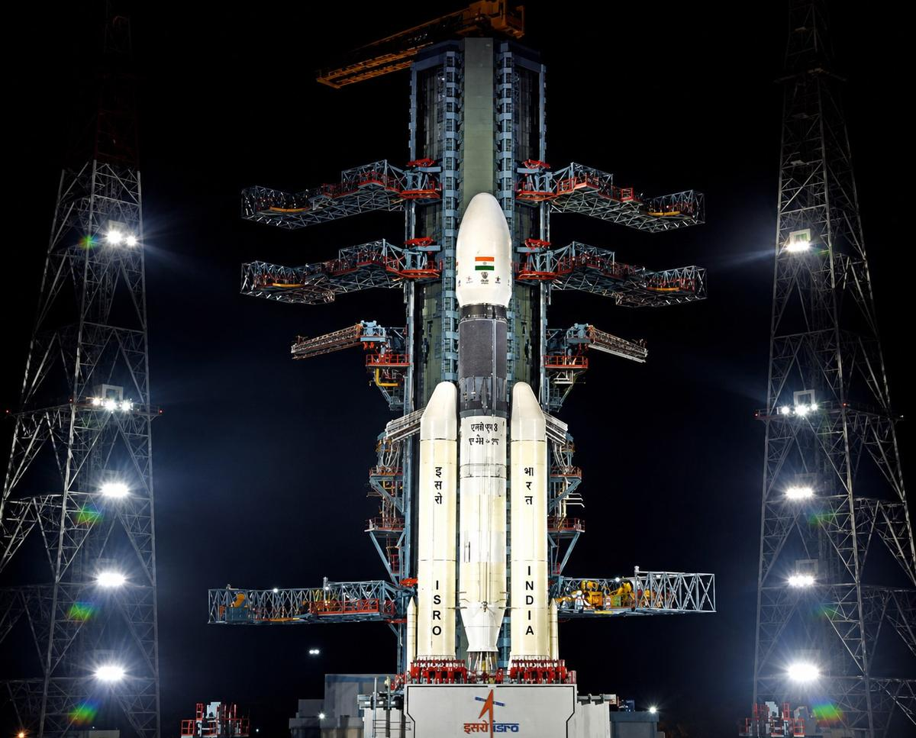
Six years ago, on July 22, 2019, the Indian Space Research Organisation (ISRO) launched Chandrayaan-2, India's second mission to the Moon and its first attempt at a soft lunar landing. Although the Vikram lander did not achieve a successful touchdown, the mission marked a significant technological milestone. Its orbiter continues to study the Moon and generate valuable scientific data years after launch, while the mission also validated several critical technologies and generated engineering insights that were incorporated into Chandrayaan-3, contributing to its historic success in 2023. What was Chandrayaan-2? Approved at a total cost of Rs 970 crore, Chandrayaan-2 was launched aboard the GSLV Mk III-M1 rocket from the Satish Dhawan Space Centre in Sriharikota on July 22, 2019. Of the total project cost, Rs 603 crore was allocated for the mission, while Rs 367 crore was spent on the launch vehicle. The mission had two primary objectives: To conduct scientific studies of the Moon through the orbiter's payloads. To demonstrate indigenous technologies for a soft landing and rover operations on the lunar surface. The Chandrayaan-2 spacecraft comprised three modules: Orbiter: Designed to conduct long-term remote sensing of the Moon and carry out scientific observations from lunar orbit. Vikram Lander: Built to attempt a precision soft landing near the Moon's largely unexplored south polar region. Pragyan Rover: A six-wheeled robotic rover housed inside Vikram, designed to explore the lunar surface and conduct in-situ scientific experiments. Mission timeline July 22, 2019: Chandrayaan-2 was launched aboard the GSLV Mk III-M1 rocket from the Satish Dhawan Space Centre in Sriharikota. July-August 2019: After four Earth-bound manoeuvres, the spacecraft performed the Trans-Lunar Injection (TLI) manoeuvre and began its journey to the Moon. August 20, 2019: Chandrayaan-2 successfully entered lunar orbit. Late August 2019: A series of orbit-lowering manoeuvres placed the spacecraft in a 119 × 127 km lunar orbit. September 2, 2019: The Vikram lander separated from the orbiter in preparation for its landing attempt. September 7, 2019: Following two successful de-orbiting manoeuvres, Vikram began its powered descent towards the lunar surface before making a hard landing during the final phase. What happened during the landing? After a series of precise Earth and lunar manoeuvres, Chandrayaan-2 entered lunar orbit on August 20, 2019. The Vikram lander separated from the orbiter on September 2 to begin preparations for its descent to the lunar surface. The powered descent on September 7 began as planned. Vikram successfully completed the rough braking phase, descending from an altitude of 30 km to 7.4 km while reducing its velocity from 1,683 metres per second to 146 metres per second. However, during the subsequent fine-braking phase, the reduction in velocity exceeded the mission's designed limits. This caused the lander's trajectory to deviate from the planned path, pushing key flight parameters beyond the permissible range. As a result, Vikram made a hard landing within about 500 metres of its designated landing site, leading to the loss of communication with the spacecraft. Why was the mission still a success? Although the Vikram lander and Pragyan rover could not complete their planned surface operations, ISRO described Chandrayaan-2 as a major technological success. The mission successfully demonstrated several critical capabilities, including the launch of a complex lunar mission, precise Earth and lunar orbital manoeuvres, lander separation, de-boost operations and the successful execution of the rough braking phase during descent. These achievements validated key technologies and provided invaluable engineering data for future lunar missions. The orbiter emerged as the mission's biggest achievement. Carrying eight state-of-the-art scientific instruments, the orbiter has continued studying the Moon's surface composition, mineralogy, exosphere and water signatures. The precision of the launch and orbital manoeuvres extended its operational life from the planned one year to about seven years. The scientific data generated by the orbiter continues to be shared with researchers, contributing to studies on the Moon's geology and environment. Foundation for Chandrayaan-3 Data collected from the Chandrayaan-2 descent was used by ISRO to modify landing algorithms, strengthen the lander structure, and expand the landing zone for subsequent missions. These modifications were implemented in the Chandrayaan-3 mission, which achieved a soft landing near the Moon's south pole on August 23, 2023. With this landing, India became the fourth nation to achieve a soft lunar landing and the first to land in the south pole region. The Chandrayaan-2 orbiter remains operational in lunar orbit, providing scientific data to researchers. Remembered as much for its achievements as its challenges, Chandrayaan-2 remains one of ISRO's most ambitious missions. Six years on, it continues to hold a significant place in India's space exploration journey and reflects the country's growing ambitions in exploring the Moon and beyond.

3. ISRO Recruitment 2026 | Govt Life Science Job with Salary Up to ₹56,000/Month - BioTecNika
Read more

ISRO Recruitment 2026 | Govt Life Science Job with Salary Up to ₹56,000/Month BioTecNika

4. Isro chairman congratulates Skyroot Aerospace on Vikram-1 orbit success - The News Mill
Read more
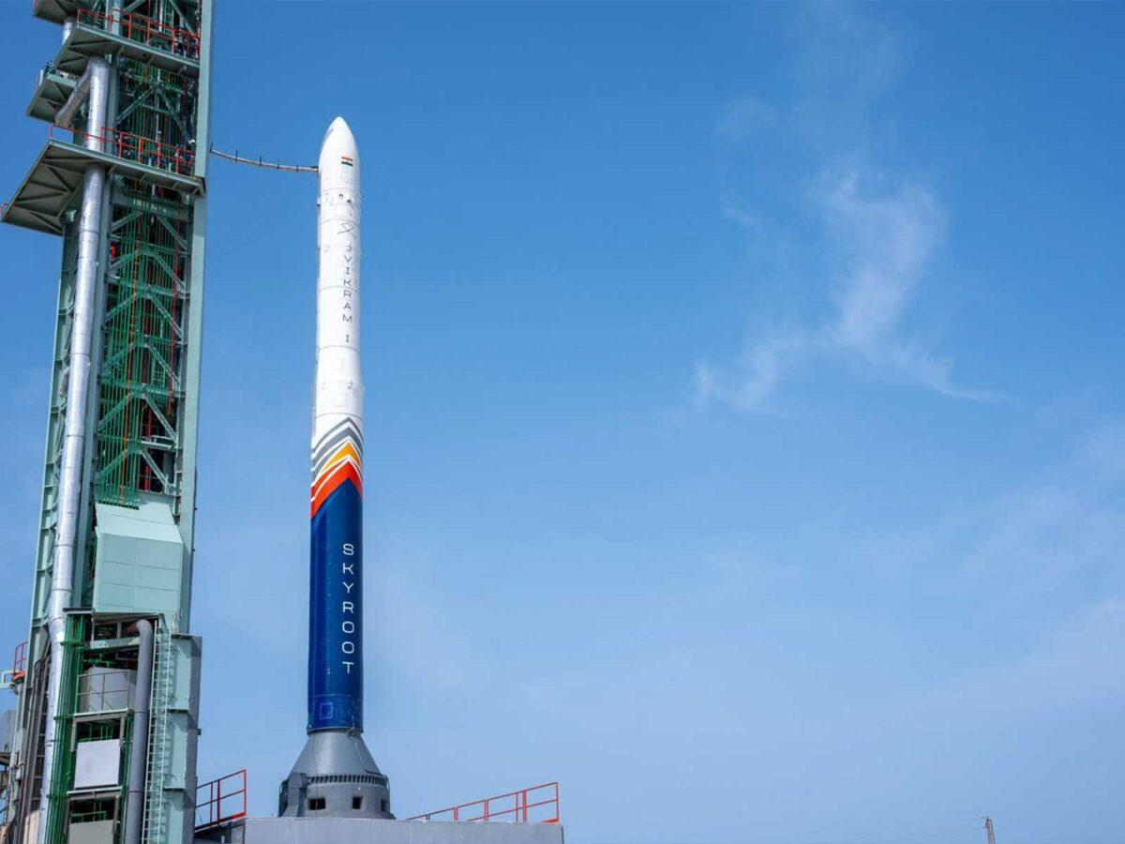
Isro chairman congratulates Skyroot Aerospace on Vikram-1 orbit success The News Mill

5. US-India Satellite Delivers Data, Reveals 'Hummingbird' in Antarctica
Read more

Main Figure A Scientists used data from the L-band radar aboard the U.S.-India Earth-orbiting NISAR satellite to produce this image of Nunatak Zaterjavshijsja, a mountaintop in East Antarctica, poking out amid a stream of ice flowing northeast to the ocean. NASA/JPL-Caltech The image shows Nunatak Zaterjavshijsja at center-left, surrounded by ice fractured with crevasses, which are shown as sharp, green lines. The magenta portions of the image represent more regular surfaces, such as smooth ice. NASA/JPL-Caltech Main Figure A Scientists used data from the L-band radar aboard the U.S.-India Earth-orbiting NISAR satellite to produce this image of Nunatak Zaterjavshijsja, a mountaintop in East Antarctica, poking out amid a stream of ice flowing northeast to the ocean. NASA/JPL-Caltech The image shows Nunatak Zaterjavshijsja at center-left, surrounded by ice fractured with crevasses, which are shown as sharp, green lines. The magenta portions of the image represent more regular surfaces, such as smooth ice. NASA/JPL-Caltech Main Figure A NISAR's L-Band Radar Reveals 'Hummingbird' in Antarctica Curtain Toggle 2-Up Image Details Scientists used data from the L-band radar aboard the U.S.-India Earth-orbiting NISAR satellite to produce this image of Nunatak Zaterjavshijsja, a mountaintop in East Antarctica, poking out amid a stream of ice flowing northeast to the ocean. The annotations point out the sharp green lines that indicate ice fractured with crevasses. Magenta represents more regular surfaces, such as smooth ice. Credit: NASA/JPL-Caltech As of July 20, the public can access data from the two powerful radar instruments aboard the NISAR (NASA-ISRO Synthetic Aperture Radar) satellite. Teams in the United States and India will release files processed from the satellite's L-band and S-band radars on an ongoing basis, helping researchers and other users track the movement of Earth's land and ice masses, monitor changes in ecosystems like forests and wetlands, and respond to natural hazards such as landslides and earthquakes. The release comes as NASA and ISRO (Indian Space Research Organisation) prepare to celebrate the first anniversary of NISAR's July 30, 2025, launch from India's Satish Dhawan Space Centre. Since that time, the mission engineering and science teams have been busy calibrating instrumentation, refining algorithms, and monitoring nearly all the planet's land- and ice-covered surfaces twice every 12 days. Along the way, the team has captured scenes from around the globe - urban street grids, agricultural fields, landslides, earthquakes, and sinking land in Mexico City. An early image released Tuesday revealed the fractured, barren surface of an Antarctic landscape in stark detail. In a merging of science and serendipity, it also resembles something else entirely: a hummingbird. Despite its otherworldly quality, the Antarctic image shows a very real geographical feature called Nunatak Zaterjavshijsja, a mountaintop in East Antarctica, poking out amid a stream of ice flowing northeast to the ocean. As the moving glacier passes the obstruction, the mountain's topography causes stresses in the ice, heavily fracturing the surrounding surfaces with deep cracks, called crevasses, which show as sharp green lines in the image. "First, it's a beautiful image, with rich details of features that provide insights to how the glacier is moving. Then, because radar can often see through snow and deep into the ice, NISAR can observe fundamentally different properties of Antarctic ice than can be seen in optical imagery," said Seongsu Jeong, the signal analysis engineer who produced the image at NASA's Jet Propulsion Laboratory in Southern California. "With NISAR we're seeing what's hidden beneath the surface." Story in magenta, green Generated with measurements that NISAR's L-band instrument gathered in August 2025, as U.S. and Indian mission teams tested the satellite's systems, the "hummingbird" exemplifies one of the young mission's hallmarks: intricately detailed imagery that is both informative and eye-catching. The colors show differences in the way polarized microwave signals, which vibrate in different directions, interact with and reflect from the ice. Over Antarctica, NISAR transmits radar waves toward Earth with a horizontal polarization. The orientation of the signals that return - either horizontal, vertical, or both - provide clues about the object or surface that reflected them. Signals that come back with a horizontal polarization likely bounced off a more regular surface, such as smooth ice. Those signals appear magenta in the image. Signals that return with vertical polarization may have refracted as they partially penetrated the snow and ice or scattered at different angles as they reflected off irregular surfaces, such as the faces of crevasses. Called volume scattering, these observations are displayed in green. The white represents areas in which magenta and green signals scatter back strongly, a possible indication that there is an equal blend of surface and volume scattering. The same scene viewed in optical light is almost entirely white with ice and snow. Slight shadows and rippling indicate the presence of the mountaintop, and textures in the surrounding area suggest the ice is not completely smooth. An image from the Landsat 9 satellite shows Nunatak Zaterjavshijsja on Nov. 2, 2025. Because microwaves can penetrate frozen surfaces, signals from NISAR's L-band radar captured more detail of the structure of the surrounding icescape than is visible in this optical image. USGS Access to data The NISAR satellite is the first free-flying space mission to feature two radar instruments: an L-band system and an S-band system. The systems are complementary due to their differing wavelengths. For example, the longer-wave L-band can pass through tree canopies, imaging the ground beneath. Meanwhile, depending on leaf sizes, S-band can collect observations of those canopies. The Indian science team, based at ISRO's Space Applications Centre in Ahmedabad, recently started releasing S-band data via the Bhoonidhi portal. On July 20, the U.S. side of the mission started releasing calibrated products continuously for all L-band measurements collected since June 17. By the end of the year, the team expects to have released all data acquired earlier during science operations. The NISAR project science team previously had two limited releases of L-band data, the first in January of about 25 sample products and a release in February of thousands of pre-calibrated products. As with the earlier releases, data users will be able to download the latest files at the Alaska Satellite Facility Distributed Active Archive Center in Fairbanks, which hosts and distributes all NASA synthetic aperture radar data. The NISAR mission's science data output is vast, on the order of dozens of terabytes a day, due to the satellite's frequent coverage of nearly all the land and ice surfaces on Earth. It scans from within a few degrees of the South Pole in Antarctica to 77.5 degrees north latitude, above the Arctic Circle. More about NISAR Managed by Caltech, JPL leads the U.S. component of the project and provided the satellite's L-band SAR and antenna reflector. The spacecraft bus and its S-band SAR were provided by ISRO. The NISAR satellite is the first to carry two SAR instruments at different wavelengths, collecting data using the spacecraft's giant drum-shaped reflector, which measures 39 feet (12 meters) wide - the largest radar antenna reflector NASA has sent into space. To learn more about NISAR, visit: https://science.nasa.gov/mission/nisar/ Media Contacts Andrew Wang / Andrew Good Jet Propulsion Laboratory, Pasadena, Calif. 626-379-6874 / 818-393-2433 andrew.wang@jpl.nasa.gov / andrew.c.good@jpl.nasa.gov 2026-049

6. Precision Astrometry Using Optically Independent Spacecraft for Graviational Wave Detection
Read more

Paul StankusBrookhaven Science Associates The scientific goal is to enable a new method for observing gravitational waves at low frequencies, based on the astrometric GW signature - gravitational waves passing by the Earth will cause a (very small) coordinated apparent motion of all sky objects. Our innovation is to deploy a new approach to precision […]

7. James Webb Space Telescope discovers the secrets of cosmic 'factories' that filled the early universe with stardust
Read more

Click for next article Using the James Webb Space Telescope (JWST), astronomers have discovered the secrets of early galaxies that pumped the infant cosmos full of dust, which would become vital for the birth of new stars and the growth of galaxies. However, while the JWST is powerful enough to see many of these early galaxies, it is still limited when it comes to delving into them in great detail. So, the team at the heart of this research worked around this by studying a much closer and more modern galaxy with many characteristics that resemble the universe's first galaxies. In lieu of being able to study the processes that occurred in the early universe that allowed galaxies to be seeded with "metals, (the term astronomers use to describe elements heavier than hydrogen and helium), the researchers turned their attention to a dwarf galaxy just 4.6 million light-years away. "Directly studying the galaxies that populated the early universe is still very difficult, which is why observing a nearby galaxy like Sextans A, which presents similar chemical conditions, offers us a precious opportunity to understand how the first generations of stars evolved and what role they played in transforming the interstellar medium," team leader Claudio Gavetti of the National Institute for Astrophysics (INAF) said in a statement. How does Sextans A impersonate ancient galaxies? The early universe was a pretty dull place in terms of chemistry. That is because it was dominated by the lightest element, hydrogen, with some helium and a tiny smattering of heavy elements, or metals. That means that the first generation of stars, so-called POP III stars , were correspondingly metal-poor. During their lives, however, POP III stars fused hydrogen and helium in their cores to forge heavier elements. When these original stars reached the ends of their lives, they exploded in supernova explosions that dispersed these metals into the interstellar medium, the vast clouds of dust and gas between stars. Eventually, dense and cool patches in these vast clouds collapsed under their own gravity, birthing the next generation of stars, POP II stars, which, thanks to the supernova deaths of their predecessors, were richer in metals. The dwarf galaxy Sextans A observed by the James Webb Space Telescope. (Image credit: NASA, ESA, CSA, STScI, Janice Lee (NOIRLab). Image processing: Alyssa Pagan (STScI).) Our own star, the sun , is classed as a POP I star, meaning it is even richer in metals than these second-generation stars. However, not all modern galaxies are so metal-rich; this is especially true for dwarf galaxies like Sextans A, even though it lies at the outer edge of our cosmic backyard, known as the " local group ." Sextans A is so metal-poor that it is estimated to contain only between 1% and 7% of the heavy elements found in the sun. That makes it a great proxy for the study of metal-poor early galaxies. Using the JWST's NIRCam (Near-InfraRed Camera) and MIRI (Mid-Infrared Instrument) instruments, Gavetti and colleagues obtained high-resolution observations of Sextans A that allowed them to map the dwarf galaxy's entire population of stars during an evolutionary phase known as the "asymptotic red giant branch." This phase occurs when stars larger than the sun exhaust helium in their cores, creating an inert carbon heart, but nuclear fusion continues in outer alternating helium- and hydrogen-burning layers. These stars "puff out" as a result of this and can undergo thousandfold increases in brightness. An image of the galaxy Sextans A where Red indicates the infrared emission of dust, blue the emission of atomic hydrogen gas, and green the far-ultraviolet emission created by newly formed stars. (Image credit: Yong Shi) The team's findings revealed that around 90% of the asymptotic red giant branch stars they studied were not surrounded by envelopes of dust. However, around 20 or so of these stars were embedded in thick dust shells. They also found that these "dust factories" formed between 2 billion and 3 billion years ago from stars with an initial mass about 1.5 times the mass of the sun. This research is a leap forward in understanding which stars in the early universe were most likely to create the metal dust that would have enriched the next generations of stars. That means it helps paint a complete picture of how the universe as we see it today took shape. The scientists behind this study say that this type of research would have been impossible before the launch of Webb.

8. Space Force orders 36 more Golden Dome missile-tracking satellites, for $1.75 billion
Read more

Click for next article The U.S. Space Force is adding three dozen spacecraft to its growing constellation designed to detect and track incoming missiles from orbit. The Space Development Agency (SDA) announced the agreements, worth a combined $1.75 billion, on July 14, naming L3Harris Technologies and Sierra Space as the recipients. Each company will provide 18 Accelerated Missile Defense Tranche 3 (AMDT3) spacecraft, for a total of 36 satellites that will grow the SDA Proliferated Warfighter Space Architecture's Tranche 3 Tracking Layer constellation, part of the Trump Administration's Golden Dome initiative. All 36 are expected to be ready for launch by the end of 2028, according to an SDA statement . SDA's contracts with each company differ slightly. One calls for "18 missile warning and missile tracking variant space vehicles" from Sierra Space, while the other requests "18 missile defense variant space vehicles" from L3Harris, all equipped with infrared sensors to add to the constellation's global network. L3Harris will receive up to $955 million for its 18 satellites, which the Space Force describes as "Hypersonic and Ballistic Tracking Space Sensor-like" (HBTSS) spacecraft. Sierra Space's agreement has the potential to reach $798 million for its 18-satellite contribution. Altogether, the 36 spacecraft will be distributed across four orbital planes as part of a hybrid missile-defense architecture designed to provide "global stereo coverage" of next-generation missile threats. The Tracking Layer uses infrared imaging in low Earth orbit to detect and track missiles, and it transfers that data in real time through a low-latency communications network to military forces on the ground. According to the agency, the new satellites will increase the constellation's coverage and integrate into the spacecraft of SDA's first three Tranches. "AMDT3 expands upon SDA's previous and current Tracking Layer generations - Tranches 1, 2 and 3," said SDA Director G.P. Sandhoo, "marking another milestone in delivering a resilient, global missile warning, missile tracking, and missile defense capability." Sierra Space will base its satellites on the Horizon vehicle, from the company's Eclipse satellite series, which it also used in the design of the spacecraft it provided for the Tranche 2 Tracking Layer program, according to a Sierra Space release . Stack of Satellites from Sierra Space. (Image credit: Sierra Space) L3Harris plans to build on the success of the HBTSS satellites the company developed for the Military Defense Agency, according to an L3Harris release . The company "has more than 70 missile tracking and defense satellites on order, including five on orbit, between MDA's HBTSS program and SDA's Tracking Layer across Tranche 0, 1, 2 and 3," the company said. The 36 satellites from L3Harris and Sierra Space are in addition to the 72 Tranche 3 Tracking Layer spacecraft SDA ordered in December 2025, via contracts worth $3.5 billion. L3Harris was included in those agreements as well, along with Lockheed Martin, Rocket Lab and Northrop Grumman. In total, the two rounds of awards bring the Tranche 3 constellation to a planned 108 satellites, worth about $5.25 billion. If all goes to plan, all of them will be available to launch by the end of 2029. The newly contracted satellites from L3Harris and Sierra Space could begin heading to space sooner than that, however. SDA describes the new contracts as "accelerated," though a launch timeline has not been established to the overall group. Once in orbit, the Space Force will assume responsibility for the satellites' operation and integration "in support of joint force operations and delivering warfighting capabilities," the SDA statement said.

9. Artemis III astronauts will beam 4k video from Orion to Earth using SpaceX Starlink lasers
Read more
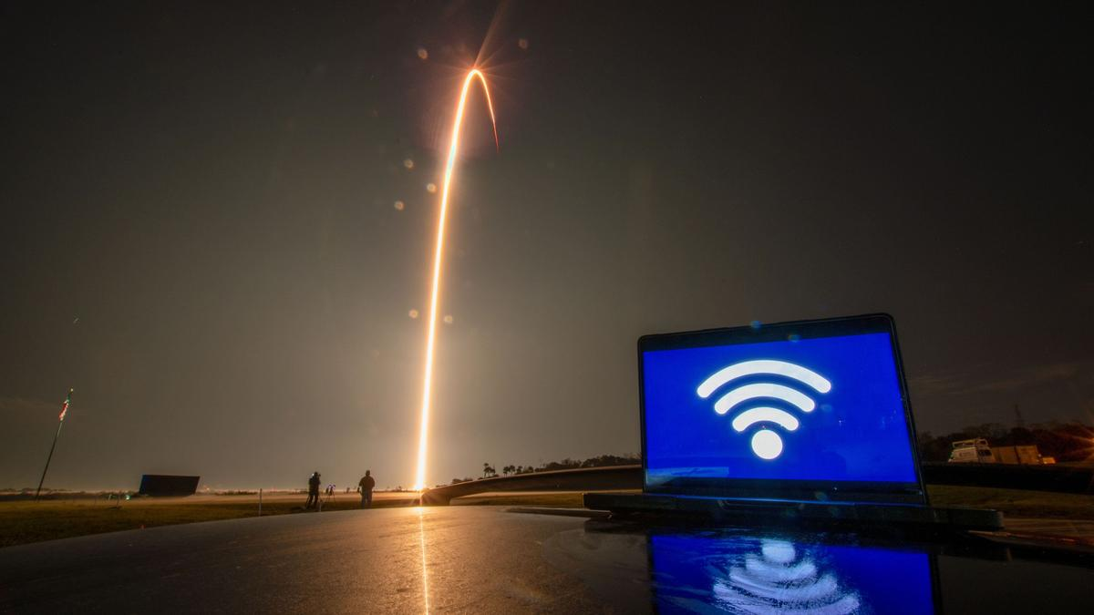
Click for next article Orion is getting an upgrade on Artemis III, and the astronauts aboard are getting WiFi (sort of). NASA is partnering with SpaceX to equip the Orion spacecraft for Artemis III with a pair of Starlink mini laser terminals, designed to operate on SpaceX's existing Starlink network. The two panels will be installed on Orion's exterior, and will augment the spacecraft's existing communications systems. The added capability is expected to provide a greater data capacity from Orion to NASA's mission control in Houston, which may include high-definition live video from orbit. The mission is currently scheduled for the second half of 2027, and will also include another sizable contribution from SpaceX : a Starship rocket. SpaceX currently operates more than 10,000 Starlink spacecraft in LEO, which provide satellite internet coverage across nearly the entire globe to commercially-available wireless terminals about the size of a laptop. Combined, those more than 10,000 and counting satellites are equipped with over 25,000 lasers currently in operation in LEO to maintain the network's interconnectedness, according to a NASA update . The company previously demonstrated the Starlink constellation's use as a communication relay network during the privately funded Fram2 mission that launched the first human into a polar orbit around Earth in 2025. SpaceX frequently utilizes its high-data capabilities to stream high-definition live views of its Falcon 9 and Starship rocket launches from orbit. Artemis III is the third in a program of NASA missions with the goal of returning astronauts to the moon and establishing a permanent base on its surface. Artemis III is designed as a practice run for NASA's Orion capsule to rendezvous and dock with the program's commercial lunar lander vehicles, Starship , and Blue Origin's Blue Moon spacecraft, in low Earth orbit (LEO). That's a lot closer to home compared to the Artemis II mission that NASA launched in April of this year. Artemis II was Orion's first flight with astronauts onboard, and flew a 10-day mission around the far side of the moon. NASA used laser communications during Artemis II as well, using terminals on Orion and ground stations at NASA's Jet Propulsion Lab in California and White Sands Complex in New Mexico to transmit data loads too big for the agency's Near Space and Deep Space radio networks. With flight sticking to LEO during Artemis III, communication limitations become a lot easier to surmount. If all goes according to plan during Artemis III, NASA has scheduled the first Artemis moon landing on the following mission, Artemis IV. NASA is targeting 2028 to launch Artemis IV, and has selected Starship as the lunar lander that will return astronauts to the lunar surface.
10. With 3 spacecraft, multiple launches, Artemis III to be Nasa's most complex mission
Read more
Nasa's upcoming Artemis III mission is shaping up to become the agency's most complicated human spaceflight ever, requiring three separate spacecraft, multiple rocket launches, and nearly two weeks of orbital operations before paving the way for future lunar landings. Unlike previous lunar missions, Artemis III will see Nasa's Orion spacecraft rendezvous and dock with two commercial lunar landers in Earth orbit-SpaceX's Starship and Blue Origin's Blue Moon-making it the first Nasa crewed mission to carry out such operations with multiple crew-capable spacecraft. Artemis III mission will test two commercial lunar landers Artemis III is part of Nasa's broader programme to send astronauts to the Moon again. Four astronauts will launch aboard the Space Launch System (SLS) rocket inside the Orion spacecraft, where they will spend about two weeks performing rendezvous and docking operations with Blue Moon and Starship in low Earth orbit. These demonstrations are intended to validate the spacecraft and mission procedures before astronauts attempt a lunar landing on Artemis IV, currently targeted for 2028.

11. ISRO satellite captures monsoon clouds blanketing 95% of India; IMD issues rain alert - WION
Read more

The Indian monsoon has returned across the nation in full swing after a brief seasonal lull. Following the development, the India Meteorological Department (IMD) has released several images showing heavy clouds blanketing the entire country. The image was captured by ISRO's advanced INSAT-3DS weather satellite, which was recorded on July 22, 2026, between 3:00 PM and 3:27 PM Indian Standard Time (IST). "Active monsoon Conditions likely over northwest, central and adjoining north peninsular India, east and northeast India during next 3-4 days," the IMD said in a press release. The released thermal infrared image shows a curved cloud band stretching from the northern Bay of Bengal, moving across Odisha, Chhattisgarh and Madhya Pradesh, before extending towards Gujarat and the Arabian Sea. IMD explained," Different types of clouds reflect in different amounts based on their physical properties like the amount and size of raindrops/ice crystals and their density. Cumulonimbus clouds appear brightest. Thick (low / medium) clouds like cumulus, stratus, stratocumulus appear comparatively brighter than the thin (Higher) clouds like cirrus. Sea surface appears darker in this imagery." Add WION as a Preferred Source Earlier climate models have predicted a below-normal southwest monsoon for 2026; however, wider parts of the nation are currently showing overcast skies with the expectation of widespread rainfall. IMD's rain forecast According to the IMD, widespread severe weather is expected between July 22 and July 24, with isolated areas likely to see heavy to very heavy rainfall across multiple regions. In particular, extremely heavy rain is forecast for isolated pockets of Jammu and Kashmir, Ladakh, southwest Madhya Pradesh, southeast Rajasthan, Konkan, and Goa. This intense spell of rain will also impact central Maharashtra between July 22-23, before moving on to heavily saturate the Gujarat region between July 22-24. Meanwhile, rainfall activity is expected to remain relatively subdued over south Peninsular India over the coming week.

12. 5 systems over Bay of Bengal, Arabian Sea revive monsoon rain, Isro images show - India Today
Read more

Delhi and the plains of northern India spent last week under a dry, sulky sky. This week, the sky changed its mind. Rain has returned to swathes of the country, from the hills of Uttarakhand to the coast of Odisha, and the reason lies in a piece of weather machinery that meteorologists have been watching build for days: a cluster of spinning air pockets working together with the monsoon's main highway, the monsoon trough. Read Full Story Fresh images from Isro's INSAT-3DR and INSAT-3DS satellites, captured on the morning of July 22, show exactly how this system looks from space. WHAT IS A CYCLONIC CIRCULATION, AND WHY DOES IT MATTER FOR RAIN? A cyclonic circulation is a pocket of swirling wind around a patch of lower air pressure, spinning anticlockwise in the Northern Hemisphere. It is a smaller, gentler cousin of a cyclone, and it does not need a name or a warning bulletin, but it does the same basic job: it pulls in moist air, forces it to rise, and helps it cool into clouds. According to the India Meteorological Department (IMD), five such circulations are currently feeding the monsoon, sitting over Haryana, northeast Madhya Pradesh, southwest Rajasthan, north Chhattisgarh and the west-central Bay of Bengal. A trough also links the Bay of Bengal circulation onward to the northeast Arabian Sea, effectively wiring both seas into a single rain engine over the north and west of the country. WHAT IS THE MONSOON TROUGH, AND HOW DOES IT WORK WITH THESE CIRCULATIONS? The monsoon trough is a long, low-pressure belt that runs across the country through the peak monsoon months, roughly from Rajasthan in the northwest down towards the Bay of Bengal in the southeast. Think of it as the monsoon's main road. Rain-bearing systems tend to travel along it, and wherever it sits is usually where the heaviest, most persistent rain falls. With five circulations sitting along or near this line, air converges from multiple directions at once, forcing warm, moist air upward until it cools, condenses and builds into towering rain clouds. WHAT DO ISRO'S SATELLITE IMAGES SHOW OVER INDIA RIGHT NOW? The clearest picture comes from INSAT-3DR's infrared imagery taken on July 22. On the India sector image, the IMD marks the Bay of Bengal in named zones, the northwest bay, northeast bay, west-central bay and so on, and the coldest, whitest cloud tops sit squarely in the northwest and northeast bay zones, spilling across Odisha, West Bengal, Jharkhand and Bihar. That white and pale-pink colouring marks cloud tops at roughly minus 50 to minus 70 degrees Celsius or colder, the signature of deep, vigorous convection rather than ordinary low cloud. A second band of red and green, slightly warmer but still high cloud, drapes diagonally across central India towards the west coast. Isro's INSAT-3DR captures the coldest, most intense cloud tops over the northwest and northeast Bay of Bengal (left), the engine behind this week's return of rain to India. A separate cold-cloud mass presses into the Gujarat and Maharashtra coast in this INSAT-3DR image of the Arabian Sea (right), showing the western flank of the same monsoon system. The companion image, centred on the Arabian Sea, shows a similar story on the other flank. The strongest cold-cloud mass sits over the east-central Arabian Sea, pressing into the Gujarat and Maharashtra coastline, while the rest of the sea towards Oman and Somalia stays largely clear. This is consistent with the moisture channel that links the Bay of Bengal circulation to the northeast Arabian Sea. IMD's separate cloud-top brightness temperature product, a wider view stretching from the Arabian Sea to Southeast Asia and captured a few hours earlier, plots contour lines directly onto the cloud field. IMD's cloud-top brightness temperature contours mark out several distinct convective cores across central India, each one a separate pocket of intense monsoon activity. (Photo: IMD/ISRO) It shows several distinct cold cores scattered across central India, roughly between Gujarat and Odisha, with contours reaching into the minus 60 to minus 80 degree range at their coldest points, each one a separate pocket of intense convection rather than one uniform blanket of cloud. Nighttime imagery from the newer INSAT-3DS satellite, taken a few hours after midnight on July 22, tells the same story in a different light. Its thermal picture shows a distinct diagonal band of bright, cold clouds running from the Arabian Sea across Gujarat, Madhya Pradesh and Chhattisgarh towards the Bay of Bengal and Bangladesh, a visual trace of the monsoon trough itself. The matching water vapour image, which tracks moisture higher up in the atmosphere rather than at the cloud tops, shows that same diagonal band lit up brightly, confirming that the moisture feeding this system is not just sitting near the surface but is saturating the atmosphere several kilometres up, exactly the conditions needed to keep the rain going. WHY DID DELHI AND NORTH INDIA GET RAIN AGAIN AFTER THE DRY SPELL? For the first ten days of July, the trough had drifted north towards the Himalayan foothills, a classic break phase that left central and northern India dry while the northeast stayed wet. The pattern has since shifted back towards the plains, with heavy to very heavy rain forecast for Haryana, Chandigarh, Delhi, Punjab and western Uttar Pradesh, alongside continuing rain over Bihar, Jharkhand, West Bengal, Chhattisgarh, Konkan, Goa and the northeastern states. DOES THIS ACTIVE SPELL CONTRADICT THIS YEAR'S EL NINO CONCERNS? Not quite. El Nino, a warming of the central and eastern Pacific Ocean, tends to weaken the Indian monsoon over an entire season by nudging global wind patterns the wrong way. But the monsoon does not rain evenly. Season-long patterns like El Nino set the background mood, while shorter, week-to-week systems like these five circulations and the trough decide what happens on a given day. El Nino pushes the Pacific jet stream, which is the fast-moving river of air high above the Earth, southward and further east. This shift brings wetter winters to the southern United States while leaving the north warmer and drier than usual. (Photo: Radifah Kabir) A well-organised trough feeding off five circulations can produce a genuinely active spell even in a season with a subdued broader outlook, which is precisely what the satellite images are now showing. WHAT SHOULD PEOPLE EXPECT IN THE COMING DAYS? IMD's outlook points to widespread rain continuing over Konkan and Goa, the western Himalayan states and the northeast, with fairly widespread activity over central India, including Chhattisgarh and both halves of Madhya Pradesh. Isolated pockets could see heavy to very heavy falls, particularly over Gujarat and Maharashtra, so localised waterlogging and travel disruption remain a real possibility even as the rain brings welcome relief to a monsoon season that had been running behind. - Ends

13. Robotic Servicing Mission Launches with NASA Support
Read more

Following its liftoff from Cape Canaveral on July 21 aboard a SpaceX Falcon 9 rocket, the Mission Robotic Vehicle (MRV) hosting the NASA-supported Robotic Servicing of Geosynchronous Satellites (RSGS) payload is now en route to geosynchronous Earth orbit, where it will use its advanced robotics to service spacecraft. RSGS leverages in-space robotics expertise from NASA, aligned with the agency's broader goals to advance U.S. capabilities for in-space servicing, assembly, and manufacturing that can be applied to space commerce and exploration. Northrop Grumman's Mission Robotic Vehicle hosting the NASA-supported Robotic Servicing of Geosynchronous Satellites (RSGS) payload launched aboard a SpaceX Falcon 9 rocket on July 21. The RSGS program is funded by the Defense Advanced Research Projects Agency (DARPA) and uses twin robotic arms developed by the U.S. Naval Research Laboratory. SpaceX Funded by the Defense Advanced Research Projects Agency (DARPA), the RSGS program uses twin dexterous robotic arms designed and developed by the U.S. Naval Research Laboratory. DARPA provided the robotic arm assembly for integration onto Northrop Grumman's MRV, the nation's first multi-mission robotic in-space servicer. The spacecraft will inspect and upgrade satellites in orbit by installing small propulsion modules - called mission extension pods - extending the operational life of existing spacecraft for years. RSGS brings together government agencies and industry to test advanced robotic systems in space. NASA's Goddard Space Flight Center in Greenbelt, Maryland, began supporting the RSGS mission in 2024 under an interagency agreement with DARPA. NASA's contributions to the mission leverage its legacy of servicing missions including the Hubble Space Telescope servicing missions and the Robotic Refueling Missions on the International Space Station. NASA support to RSGS program includes the development of dynamic simulation and analysis tools, software analysis for performance verification, and a team of flight robot operators who will support highly technical procedures in orbit. Hundreds of satellites are in geosynchronous orbit. Of those, fully functional satellites are often decommissioned early because they run out of fuel or their equipment becomes obsolete. RSGS establishes a critical U.S. capability to extend the lifetime of spacecraft in orbit, allowing for more innovative and cost-effective mission designs. By Colleen Wouters NASA's Goddard Space Flight Center, Greenbelt, Md.

14. NASA Sets Coverage for Astronaut Chris Williams, Crewmates Return
Read more
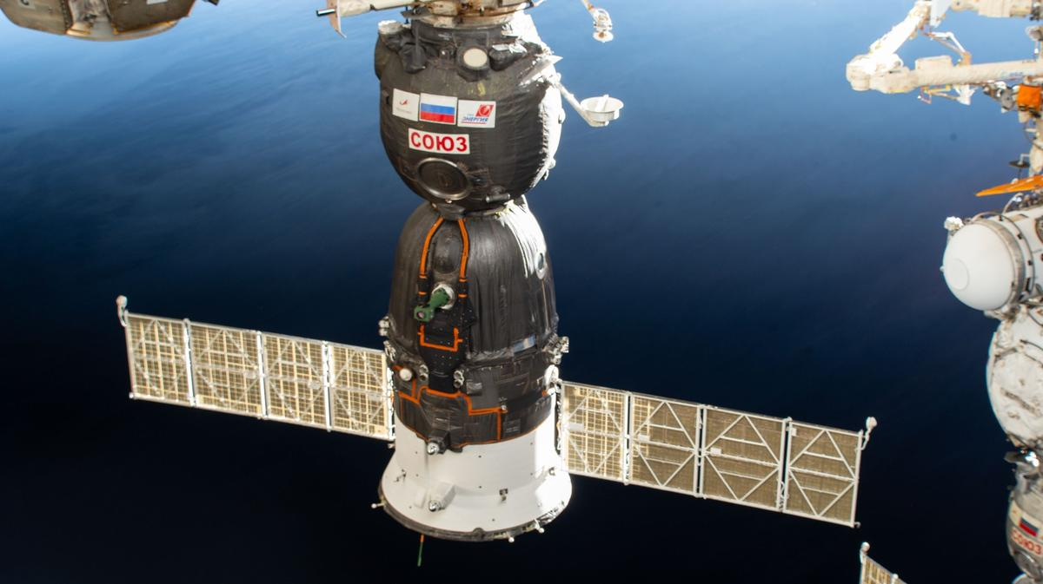
The Roscosmos Soyuz MS 28 spacecraft is pictured in November 2025 shortly after docking to the International Space Station's Rassvet module. Credit: NASA NASA astronaut Chris Williams and Roscosmos cosmonauts Sergey Kud-Sverchkov and Sergei Mikaev are wrapping up their 241‑day mission aboard the International Space Station. The crew and its Soyuz MS-28 spacecraft will undock from the orbiting laboratory's Rassvet module at 3:02 a.m. EDT Sunday, July 26, heading for a parachute-assisted landing at 6:26 a.m. (3:26 p.m. local time) on the steppe of Kazakhstan, southeast of Dzhezkazgan. NASA's live return coverage will stream through a variety of platforms. Learn where to watch online: https://www.nasa.gov/live Williams and his crewmates will complete 3,856 orbits and travel more than 102 million miles before returning to Earth. The flight marks the first mission for Williams and Mikaev and the second for Kud‑Sverchkov. After landing, the crew will fly by helicopter to Karaganda, Kazakhstan, where recovery teams are based. Williams then will return to NASA's Johnson Space Center in Houston, while Kud‑Sverchkov and Mikaev head back to their training base in Star City, Russia. NASA's live return coverage is as follows (all times Eastern and subject to change based on real-time operations): Saturday, July 25 9:40 a.m. - Coverage of the Space Station Expedition 74/75 change of command ceremony begins. Kud‑Sverchkov will transfer command of the orbital complex to NASA astronaut Jessica Meir. Expedition 75 officially begins when Soyuz MS‑28 undocks. 11:10 p.m. - Coverage of crew farewells and hatch closing begins. 11:30 p.m. - Hatch closing Sunday, July 26 2:30 a.m. - Coverage of undocking begins. 3:02 a.m. - Undocking 5:15 a.m. - Coverage of deorbit and landing begins. 5:32 a.m. - Deorbit burn 6:26 a.m. - Landing For more than 25 years, people have lived and worked continuously aboard the International Space Station, advancing scientific knowledge and making research breakthroughs not possible on Earth. The space station helps NASA understand and overcome the challenges of human spaceflight, expand commercial opportunities in low Earth orbit, and build on the foundation for long-duration missions to the Moon, as part of the Artemis program, and to Mars. To learn more about International Space Station research, operations, and its crews, visit: www.nasa.gov/station -end- Joshua Finch / Jimi Russell Headquarters, Washington 202-358-1100 joshua.a.finch@nasa.gov / james.j.russell@nasa.gov Leah Cheshier / Anna Schneider Johnson Space Center, Houston 281-483-5111 leah.d.cheshier@nasa.gov / anna.c.schneider@nasa.gov

15. Mapping Io's Hidden Heat With NASA's Juno
Read more

Description This graphic illustrates the areas of Jupiter's moon Io sampled by the Microwave Radiometer (MWR) instrument aboard NASA's Juno spacecraft during two close flybys. The black overlapping lines show the instrument's footprints during Perijove 57 on Dec. 30, 2023, when the spacecraft primarily mapped the northern hemisphere. The blue lines represent Perijove 58 on Feb. 3, 2024, which focused heavily on the moon's mid-latitudes and equatorial regions. Both passes mapped the side of Io that constantly faces Jupiter. The sweeping, overlapping patterns are a result of the spacecraft spinning at two revolutions per minute as it flew past the moon at a distance of roughly 930 miles (1,500 kilometers). NASA's Jet Propulsion Laboratory, a division of Caltech in Pasadena, California, manages the Juno mission for the principal investigator, Scott Bolton, of the Southwest Research Institute in San Antonio. Juno is part of NASA's New Frontiers Program, which is managed at NASA's Marshall Space Flight Center in Huntsville, Alabama, for the agency's Science Mission Directorate in Washington. The MWR was built by JPL. Lockheed Martin Space in Denver built and operates the spacecraft. More information about Juno is at: http://www.nasa.gov/juno and http://missionjuno.swri.edu

16. NASA's Juno Peers Beneath Io's Surface
Read more
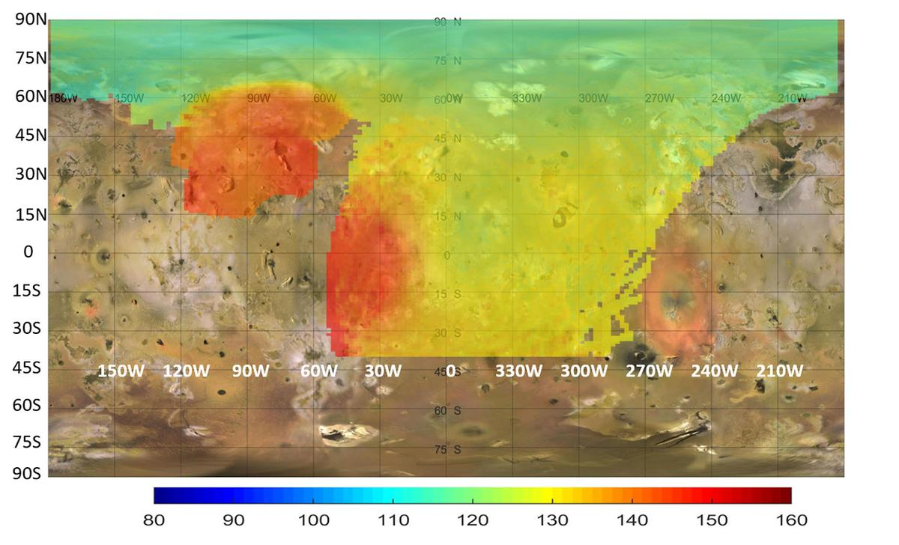
Description This map represents data captured by the Microwave Radiometer (MWR) aboard NASA's Juno spacecraft, indicating heat rising from just beneath the surface of Jupiter's moon Io. While infrared instruments measure the temperature of the moon's surface, the lowest frequency microwave channels (0.6 and 1.25 gigahertz) on the MWR can penetrate between about 6 and 20 feet (2 and 6 meters) into the crust. The colors on this map illustrate a distinct temperature gradient across the moon, with the most extreme, localized heat output in red. The most prominent red anomaly in the upper left (between 60 and 120 degrees west longitude) reveals subsurface temperatures 18 to 36 degrees Fahrenheit (10 to 20 degrees Celsius, or 10 to 20 Kelvin) warmer than the surrounding area. This massive regional heat source coincides with the Zal Montes Patera complex, an area where Juno's Stellar Reference Unit observed an active lava flow. A second major subsurface heat source is also visible near the equator, stretching from 0 to 50 degrees west longitude. Together, these distinct microwave anomalies indicate significant internal heating occurring within the upper tens of meters of Io's crust. Contrasting with these intense hot spots are the yellow and green regions, which reflect temperatures more common across the moon. The yellow areas represent intermediate temperatures that naturally warm up to near -190°F (-123°C, or 150 Kelvin) as they approach the equator. Meanwhile, the green areas, primarily visible toward the higher northern latitudes, indicate the coolest subsurface temperatures, dropping to around -298°F (-183°C, or 90 Kelvin) near the pole. NASA's Jet Propulsion Laboratory, a division of Caltech in Pasadena, California, manages the Juno mission for the principal investigator, Scott Bolton, of the Southwest Research Institute in San Antonio. Juno is part of NASA's New Frontiers Program, which is managed at NASA's Marshall Space Flight Center in Huntsville, Alabama, for the agency's Science Mission Directorate in Washington. The MWR was built by JPL. Lockheed Martin Space in Denver built and operates the spacecraft. More information about Juno is at: http://www.nasa.gov/juno

17. NASA Joins Genesis Mission to Accelerate AI-Driven Discovery
Read more
Credit: NASA NASA is supporting the Genesis Mission, a national effort to drive the use of artificial intelligence in tackling complex scientific and engineering challenges to advance a new era of discovery. President Donald J. Trump issued the Executive Order "Launching the Genesis Mission" on Nov. 24, 2025, creating a national mission to leverage artificial intelligence to accelerate scientific discovery. The mission is led by the White House Office of Science and Technology Policy and has now expanded to more than 15 federal agencies in a whole-of-government initiative. NASA is exploring how its missions, data, and expertise can support National Science and Technology challenges and help develop the powerful AI tools envisioned under the Genesis Mission, opening the door to faster breakthroughs, new knowledge, and discoveries that benefit the American people and help unlock some of the world's greatest mysteries. "America has invested for generations in the data, missions, and technical expertise that make NASA one of the world's greatest engines of discovery," said NASA Administrator Jared Isaacman. "The Genesis Mission is an opportunity to turn that foundation into faster science, stronger engineering, and better mission outcomes. Leveraging our relationships with interagency counterparts, NASA can advance AI tools that accelerate exploration, strengthen American leadership in space, and open new paths to understanding our planet and the universe. Likewise, NASA is committed to applying our research and development to other initiatives within government for the benefit of American taxpayers." NASA introduced new Genesis Mission National Science and Technology Challenges that center on two major priorities: strengthening America's superiority in space and igniting a new era of innovation driven by more than 70 years of science and engineering by the agency. To operate safely in a space environment that is growing more crowded and dynamic each year, and to maintain America's leadership in space, NASA must develop advanced systems faster than traditional engineering methods allow. These systems must work together reliably across spacecraft, communications, logistics, surface operations, and other mission capabilities. By combining NASA's mission expertise with the Department of Energy's computing and AI capabilities, the Genesis Mission can shorten the path from concept to operational readiness and strengthen America's ability to operate and lead in space. NASA also will explore how AI can unlock new discoveries from more than 150 petabytes of data collected across decades of missions and research. NASA's telescopes, satellites, orbiters, landers, and aeronautics programs have produced an extraordinary record of Earth, the solar system, and the universe, but the scale and complexity of these archives make it difficult to examine every observation using traditional methods. Advanced AI tools could help scientists connect data from different missions, instruments, simulations, and fields of study, identify patterns that might otherwise remain hidden, improve predictions, and reveal new discoveries in data that may have already been studied. By turning NASA's mission archives into engines of discovery, the Genesis Mission can expand the return on generations of American investment in space and strengthen research across a wide range of scientific fields. As the Genesis Mission advances, NASA remains dedicated to harnessing its decades of scientific and mission data and engineering capabilities to accelerate new innovations and discovery. For more information about NASA's missions, visit: http://www.nasa.gov -end- George Alderman / Elizabeth Shaw Headquarters, Washington 202-358-1600 george.a.alderman@nasa.gov / elizabeth.a.shaw@nasa.gov

18. China's record-breaking Gravity-1 rocket launches 9 satellites from a ship at sea (video)
Read more
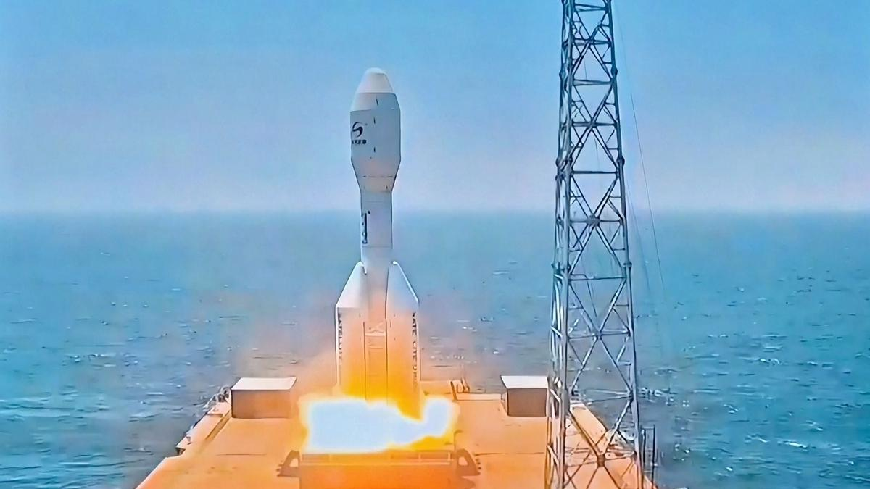
Click for next article The world's most powerful solid-fuel rocket just aced its third-ever mission. Gravity-1, a distinctively squat and stubby rocket , launched Tuesday night (July 21) from the deck of a ship stationed off the coast of Shanghai. Liftoff occurred at 10:54 p.m. EDT (0254 GMT and 10:54 a.m. Beijing time on July 22), according to the state-run Chinese outlet Xinhua, which further reported that all nine satellites reached "their designated orbits." Details about those satellites were not provided. Orienspace's Gravity-1 rocket launches nine satellites to orbit from a ship at sea on July 21, 2026. (Image credit: CCTV) Gravity-1 is operated by Orienspace, a company based in the eastern Chinese province of Shandong. The rocket stands about 100 feet (30 meters) tall - less than half the height of SpaceX 's workhorse Falcon 9 vehicle. Gravity-1 consists of three core stages and four strap-on boosters, all of which feature solid rocket motors. The launcher can haul up to 14,300 pounds (6,500 kilograms) of payload to low Earth orbit (LEO), making it the most powerful solid rocket in the world. (For comparison: The liquid-fueled Falcon 9 can deliver a maximum of 50,265 pounds, or 22,800 kg, to LEO.) The Chinese vehicle now has three flights under its belt, all of which launched from ships at sea and achieved full mission success. Gravity-1's first two flights occurred in January 2024 and October 2025 . There won't be such a long gap before Gravity-1 flies again, if all goes to plan. The rocket is expected to launch a batch of Chinese internet satellites in the next few months, according to the state-run outlet CGTN. And Orienspace's ambitions don't end with Gravity-1. The company is also developing Gravity-2 and Gravity-3, larger, more powerful rockets that will feature liquid-fueled core stages and solid rocket boosters. Gravity-2 could be ready to fly by the end of the year, CGTN reported. And that vehicle will likely lift off from an ocean-based pad as well. "Sea launch of solid-propellant rockets paves the way for future launch of liquid rockets at sea," said Gravity-1 chief designer Xu Guoguang, according to CGTN. "We are also considering other methods, such as launching from drilling platforms."

19. After nearly 30 years, NASA realized this near-Earth asteroid is actually a comet. The discovery may help us defend the planet some day
Read more
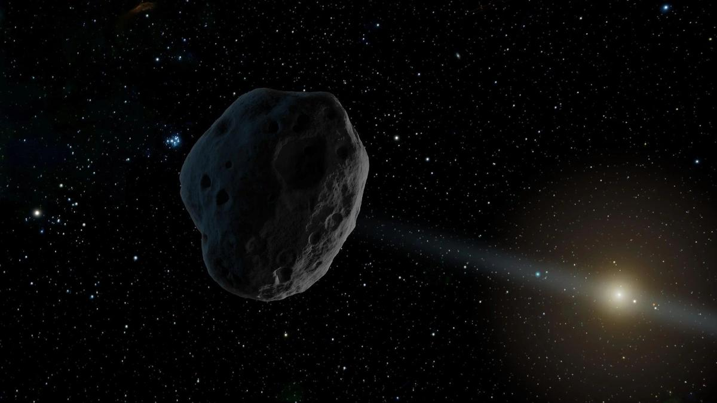
Click for next article An illustration of a near-Earth asteroid like the 1998 SH2, which turned out to be a comet. A near-Earth object that astronomers believed was an asteroid for nearly three decades has been unmasked as a faint, active comet, revealing a case of cosmic mistaken identity that could help improve planetary defense. The object, known since its discovery in 1998 as 1998 SH2, appeared to be an ordinary asteroid . It follows a 4.5-year orbit around the sun and showed no obvious signs of cometary activity, such as the glowing coma or tail produced when sunlight vaporizes surface ice. However, during a close pass about 2 million miles (3 million kilometers) from Earth in August 2025, researchers using NASA's Deep Space Network planetary radar system noticed something unexpected: The object wasn't where orbital predictions said it should be, according to a statement from the space agency. That discrepancy prompted scientists to take a closer look, and what they found surprised them. Using decades of precision optical astrometry - measurements of the object's position against background stars - researchers found that gravity alone couldn't explain its irregular motion. Instead, they detected tiny nongravitational forces consistent with jets of gas escaping from the object's surface as hidden ice warmed in sunlight. "After we measured the nongravitational perturbations affecting the motion of 1998 SH2 and recognized they weren't compatible with the object being an asteroid, we suspected the object could be an active comet ," Davide Farnocchia, lead author of the study and navigation engineer with NASA's Center for Near-Earth Object Studies at the Jet Propulsion Laboratory, said in the statement. To test the idea, the team observed the object with the European Southern Observatory's Very Large Telescope in Chile and the Canada-France-Hawaii Telescope atop Mauna Kea . The observations revealed a faint but unmistakable comet tail, confirming the object's true identity. The discovery earned 1998 SH2 a second designation: P/1998 SH2, officially recognizing it as a comet. Beyond solving the mystery, the finding has important implications for planetary defense . Unlike rocky asteroids, comets can subtly change course as gas escaping from their surfaces acts like tiny thrusters. Identifying those nongravitational forces allows scientists to more accurately predict an object's future orbit and assess any potential impact risk. "This work shows the importance of continuously tracking near-Earth objects ," Farnocchia said in the statement. "Because of outgassing, the motion of comets is more significantly perturbed than that of asteroids. "Detecting these perturbations can be an important diagnostic tool for planetary defense that will help understand which objects may be comets rather than asteroids, how their orbits evolve, and how that influences their Earth impact risks." The study also suggests that 1998 SH2 may not be unique. The researchers noted that analyzing the motions of near-Earth objects with increasingly precise astrometry could reveal more hidden comets that have long been classified as asteroids because they lack obvious tails or glowing comas. As astronomers continue to monitor the growing population of near-Earth objects, subtle orbital changes may prove just as revealing as spectacular comet tails, uncovering more examples of cosmic mistaken identity while helping scientists better understand which objects pose potential threats to Earth .

20. 'The court has to intervene now': Indigenous groups and conservationists condemn SpaceX's South Texas land swap
Read more
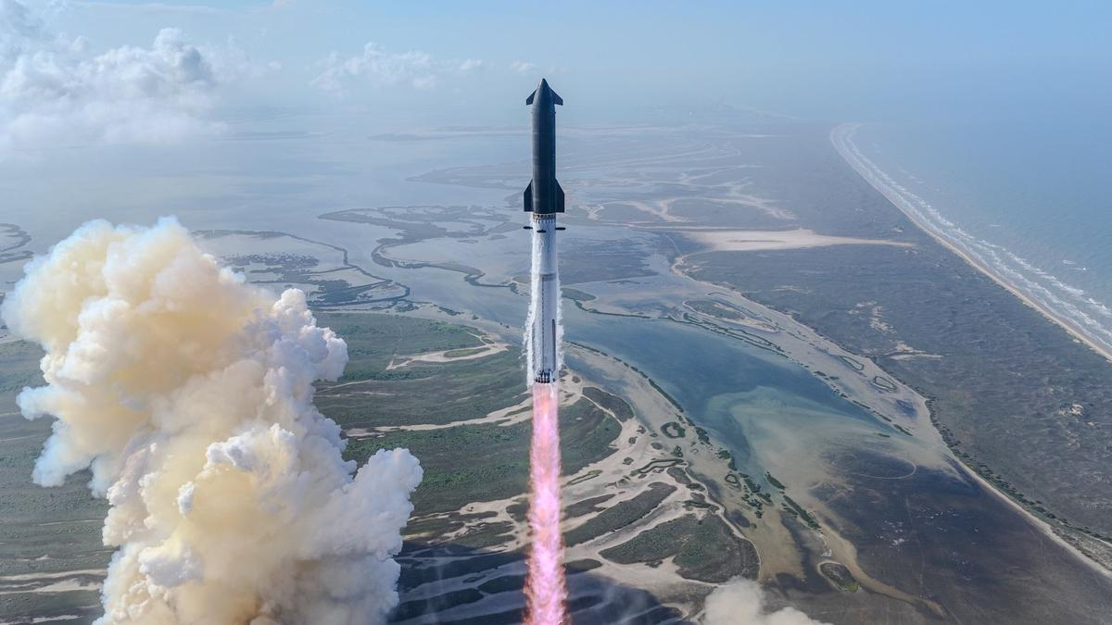
Click for next article SpaceX's Starship megarocket launches on its 12th test flight, on May 22, 2026, from the company's Starbase site in South Texas. Starbase sits very close to the Lower Rio Grande Valley National Wildlife Refuge. The fight continues against SpaceX's controversial South Texas land swap. That deal, which the company made with the U.S. Fish and Wildlife Service (USFWS), gives SpaceX 727 acres (294 hectares) of public land that's currently part of the Lower Rio Grande Valley National Wildlife Refuge. In exchange, the company hands over 683 acres (276 hectares) of its territory in the area, not all of it contiguous, to the USFWS. Last month, a coalition of conservation and tribal groups sued the USFWS over the swap , saying it degrades the refuge and violates multiple laws, including the National Wildlife Refuge System Improvement Act of 1997. And yesterday (July 20), those groups filed an emergency injunction, asking a federal judge to stop the exchange until the courts can rule on the ongoing case. "Federal officials are racing to fork over America's public lands to one of wealthiest corporations on Earth before the courts can even weigh in," Laiken Jordahl, national public lands advocate at the Center for Biological Diversity, said in a statement yesterday (July 20) . "This refuge is one of the last places left for the public to enjoy nature in the Rio Grande Valley," Jordahl added. "Why should Texans be forced to surrender even more of their public lands to a trillion-dollar corporation ? The court has to intervene now, because once these refuge lands are transferred to SpaceX, they're gone forever." The land set to be transferred to SpaceX is near Starbase, the manufacturing and launch hub for the company's Starship megarocket. SpaceX sees Starship as transformational; it's the biggest and most powerful launcher ever built, and it's designed to be fully and rapidly reusable. SpaceX's Starbase site sits amid wetlands with high biodiversity in South Texas. (Image credit: SpaceX) Starship remains in the development-and-testing phase. It has flown 12 suborbital test flights to date, all of them from Starbase, and is gearing up for Flight 13 this Thursday (July 23). These launches pose a threat to the wildlife that the 90,000-acre (36,420 hectares) refuge was established to protect, according to the Center for Biological Diversity, a conservation nonprofit based in Tucson, Arizona. "A 2024 study found that, after one launch, every single monitored shorebird nest near the launch site suffered egg damage or loss," the organization said in yesterday's statement. "Instead of taking any enforcement actions or working with SpaceX to reduce or eliminate its harm to the refuge, the Service [USFWS] is now citing the resulting degradation as justification for handing the public land to SpaceX." Some of the land being transferred to SpaceX is part of the Palmito Ranch Battlefield National Historic Landmark, where the final battle of the Civil War was fought. This means the swap also violates the National Historic Preservation Act, according to the Center or Biological Diversity. The Center or Biological Diversity and its partners also take issue with how the land deal was made. "The proposed land exchange was first made public in March, but records obtained under the Freedom of Information Act show internal agency planning began as early as April 2025," yesterday's statement reads. "In those discussions with the regional director of the Service, the agency developed 'the most expedited schedule possible' for completing a land transfer and recommended hiring additional staff to meet what they described as an 'optimum timeframe.'" The plaintiffs in the lawsuit against the USFWS are the Center for Biological Diversity, Save RGV, the Carrizo/Comecrudo Nation of Texas, Inc., and the South Texas Environmental Justice Network.
21. More than 300 active landslide zones await permanent treatment
Read more

PIONEER EDGE NEWS SERVICE/Dehradun More than 300 active landslide zones across Uttarakhand are yet to undergo permanent scientific treatment, even as the monsoon has set in and the risk of landslides has increased across the State. According to the Public Works Department (PWD), Uttarakhand has over 420 active landslide zones. While about120 locations have been treated with the support of THDC India Limited and other agencies, the remaining vulnerable sites continue to await long-term stabilisation measures. Many of these locations witness recurring landslides every monsoon, disrupting traffic and affecting residents, tourists and Char Dham pilgrims. Major vulnerable stretches include Bhatta Fall and Kimadi Road on the Dehradun-Mussoorie route, Sirohbagad, Narkota and the Gaurikund Road in Rudraprayag, Pagalnala and Helang in Chamoli, Sukki Top, Dabarkot and Dharasu in Uttarkashi, Garbadhar, Ogla, Jauljibi and the Dharchula-Tawaghat road in Pithoragarh, Kapkot, Bharari and Shama in Bageshwar and Kwarab, Kosi, Dhaulchhina and Takula in Almora. PWD executive engineer Arun Kumar Pandey said that the department is carrying out scientific treatment of the remaining landslide-prone locations in a phased manner to provide a long-term solution to recurring landslides and frequent road closures. He said that machinery, workers and officials have been deployed at sensitive locations and remain on alert to respond quickly to landslides and other rain-related emergencies. Pandey added that restoration teams have also been positioned to clear blocked roads and restore connectivity as quickly as possible. However, with over 300 identified landslide zones still awaiting permanent mitigation measures, several key highways and hill roads remain vulnerable to disruptions during the ongoing monsoon season, highlighting the need to expedite long-term stabilisation work.

22. ISRO Recruitment 2026 Notification Out for 242 Assistant, UDC, JPA, and Steno Posts, Application Dates, Eligibility - Adda247
Read more
ISRO Recruitment 2026 Notification Out for 242 Assistant, UDC, JPA, and Steno Posts, Application Dates, Eligibility Adda247

23. India wanted a space industry. Scientists quitting ISRO is how that happens - ThePrint
Read more
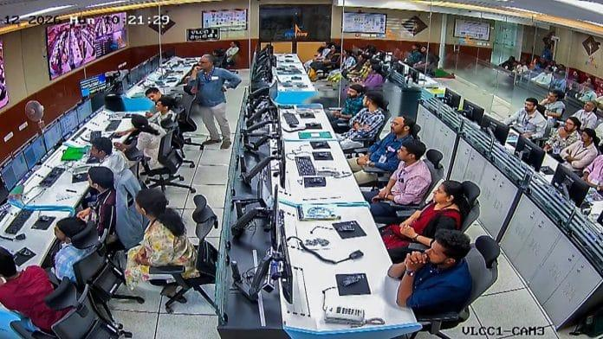
For decades, ISRO was effectively the only organisation in India where an engineer could work on launch vehicles, propulsion systems or spacecraft. That monopoly was both a strength and a limitation. It allowed ISRO to build remarkable capabilities under severe budget constraints, but it also meant that India's entire space ecosystem depended overwhelmingly on a single government institution. While the concern is understandable, it sits on an unstated premise: that every scientist who leaves ISRO is a scientist India has lost. It isn't. The objective of India's space programme is not to maximise the number of scientists employed by ISRO. It is to maximise India's ability to build rockets, satellites and world-class space technology. Those are not the same thing. Reports that around 120 scientists have resigned or sought voluntary retirement from the Indian Space Research Organisation over the past few months have triggered predictable concern. The Department of Space has tightened scrutiny of resignations from scientists working on critical programmes, while commentators have described the departures as a "brain drain" that threatens India's ambitions in space. Recognising this, the government began liberalising the sector in 2020. It established IN-SPACe to authorise and facilitate private participation, opened ISRO's facilities to non-government entities, adopted the Indian Space Policy 2023 to give private firms a much larger role across the space value chain, and later liberalised foreign investment rules to attract greater capital into the sector. A country that only wanted a successful space agency would not have done any of this. India wanted a space industry. If that was the objective, then the recent resignations should not come as a surprise. They are one of the most predictable consequences of the reform. A private space industry cannot exist without experienced space engineers. Startups developing launch vehicles cannot wait fifteen years for an entirely new generation of engineers to accumulate flight experience. In the early years of any industry, expertise has to come from somewhere. In India's case, it comes largely from ISRO. This is how industries develop. Consider Skyroot Aerospace. When two ISRO scientists left the organisation in 2018 to found the company, the decision could easily have been portrayed as ISRO "losing talent". This week, Skyroot's Vikram-1 became the first privately-built Indian rocket to reach orbit, making India only the third country with private orbital launch capability. The company has raised $160 million from investors including Singapore's sovereign wealth fund GIC and funds managed by BlackRock. Its $1.1 billion valuation has made it India's first space unicorn. Global capital is not making Indian aerospace talent flee. It is chasing it. Did India lose capability when those scientists resigned? Or did it gain another organisation capable of building orbital rockets? The same logic applies more broadly. Scientists leaving ISRO to join Indian space companies are not taking their expertise out of the country. They are taking it to other Indian organisations working on Indian technology. That is not a brain drain. It is the emergence of a genuine labour market for aerospace talent. Nor are these engineers overwhelmingly leaving for foreign firms. Export controls and national security restrictions make aerospace one of the least portable professions in the world. An ISRO propulsion engineer's alternatives are, almost by definition, Indian ones. Indeed, it is difficult to celebrate the rise of India's private space sector while simultaneously lamenting that private companies are hiring experienced engineers. These are not contradictory developments. They are the same development viewed from different perspectives. Also read: Skyroot's Vikram-1 success shows it's time for ISRO to redefine its role Managing the transition This does not mean every resignation is inconsequential. Losing experienced engineers from mission-critical programmes can create genuine short-term challenges. Aerospace expertise takes years to develop, and major projects inevitably depend on institutional memory. But that is a question of managing the transition to a more competitive ecosystem, not of preventing the transition itself. ISRO can manage it the way every organisation facing competition for talent does: retention incentives for mission-critical roles, structured knowledge transfer, and succession planning, rather than by trying to make leaving harder. For decades, ISRO has been treated as synonymous with India's space programme. That was understandable when ISRO was almost the only institution capable of undertaking frontier space missions. It is becoming less accurate today. A mature space ecosystem consists of launch companies, satellite manufacturers, propulsion startups, component suppliers, software firms, investors, universities and research institutions, not just a national space agency. The success of India's space reforms should therefore be measured not by whether ISRO retains a monopoly over aerospace talent, but by whether India develops multiple organisations capable of competing at the technological frontier. Ironically, the anxiety surrounding these resignations may itself be evidence that the reforms are beginning to work. For the first time in India's history, talented aerospace engineers have meaningful alternatives to a government career. They can build launch vehicles in startups, attract global investment, pursue commercial opportunities and expand India's space capabilities beyond a single institution. That is precisely what a liberalised space sector was supposed to achieve. The real question is not why scientists are leaving ISRO. It is why we expected them never to. Ajay Mallareddy is co-founder of Hyderabad-based Centre for Liberty. His X handle is @IndLibertarians. (Edited by Theres Sudeep)

24. ISRO Satellite Detects Massive Rain Clouds | Weather Alert Across India - Kanak News Odisha
Read more

ISRO ସାଟେଲାଇଟ୍ ଦେଲା ଚେତାବନୀ | ବାଦଲରେ ଲୁଚି ରହିଛି ଝଡ଼ ବର୍ଷା ! | ମହାକାଶରୁ ମିଳିଲା ପ୍ରଥମ ଝଲକ ISRO Satellite Weather Update: India's advanced weather satellites INSAT-3DR and INSAT-3DS have captured extensive cloud cover across large parts of the country, helping meteorologists monitor active monsoon conditions. The latest satellite imagery indicates dense cloud formations over eastern, central, and northern India, including Odisha and the Bay of Bengal. These observations support weather forecasting by identifying regions with the potential for heavy rainfall, thunderstorms, and lightning. Watch this report to understand how ISRO's space technology helps improve weather monitoring and early warning systems across India. Stay updated with the latest weather news, ISRO updates, and breaking news from India and Odisha. Like, Share & Subscribe for more updates. #ISRO #WeatherUpdate #HeavyRain #Monsoon #INSAT3DS #OdishaWeather #IndiaWeather #BreakingNews Special Report: ISRO Satellite Detects Massive Rain Clouds | Weather Alert Across India ISRO satellite weather update ISRO latest satellite images INSAT 3DS weather satellite INSAT 3DR cloud images India weather today Heavy rain alert India Odisha weather update Bay of Bengal weather Monsoon update India Satellite cloud images India IMD rain forecast ISRO weather satellite Thunderstorm forecast India Odisha rain news India monsoon news Weather forecast today Satellite weather monitoring Heavy rainfall prediction Latest weather news India Kanak News weather update Kanak News is Odisha's leading 24x7 news and current affairs TV channel from Eastern Media Limited. Odisha's largest media house that also publishes the daily 'Sambad'. Get the latest updates on news, politics, sports, business, current affairs, entertainment, technology and health updates from Kanak News. Breaking News, Live news updates, Odia News Live, Live Odia News, odisha news, latest odisha news, odisha news today, odisha politics, odisha latest updates Join us on WhatsApp to get the latest updates: https://whatsapp.com/channel/0029Va9qLIDAYlUKjL5iF90c For the latest Odisha News, follow us: Website: https://kanaknews.com/ Instagram: https://www.instagram.com/kanaknewsofficial/ LinkedIn: https://www.linkedin.com/company/kanak-news Facebook: https://www.facebook.com/KanakNews App Kanak :- https://play.google.com/store/apps/details?id=com.kanak__news.app&hl=en Twitter: https://twitter.com/kanak_news Telegram: https://t.me/kanaknewsofficial WhatsApp: https://whatsapp.com/channel/0029Va9qLIDAYlUKjL5iF90c

25. ISRO to launch LVM3 | DD News - DD News
Read more
ISRO to launch LVM3-M2 space vehicle to carry 36 OneWeb Internet satellites to space on October 23 India's space agency, the Indian Space Research Organisation (ISRO), is gearing up to launch 36 OneWeb internet satellites into space using its powerful Geosynchronous Satellite Launch Vehicle Mark III (GSLV Mk III) rocket. The launch is expected to take place on the 23rd of October 2023, and it will mark a significant milestone for India's space program and its aspirations to become a global leader in the space industry. The OneWeb constellation is a low Earth orbit (LEO) satellite system that is designed to provide high-speed internet connectivity to people around the world, particularly in remote and underserved areas. OneWeb is a joint venture between the UK government and Indian telecom giant Bharti Global, and it aims to provide affordable, high-speed internet access to billions of people who are currently without reliable connectivity. The 36 OneWeb satellites that ISRO will be launching are part of a larger constellation that is being built to provide global coverage. This is not the first time that ISRO has launched OneWeb satellites into space, as the agency has already launched 74 of them in previous missions. However, this upcoming launch is significant because it will be the first time that ISRO will be using its GSLV Mk III rocket to launch OneWeb satellites. The GSLV Mk III rocket is one of the most powerful rockets in ISRO's arsenal, and it is capable of launching heavy payloads into space. It has been in development for many years, and its successful test launch in 2017 was a major milestone for ISRO. Since then, the rocket has been used in several missions, including the successful launch of India's Chandrayaan-2 mission to the Moon in 2019. The launch of the 36 OneWeb satellites will be a complex and challenging mission for ISRO. The satellites will be launched into a polar orbit, which is a type of orbit that passes over the Earth's poles. This requires the GSLV Mk III rocket to follow a specific trajectory, which is different from the typical equatorial orbit that ISRO's rockets usually launch into. Additionally, the satellites will be deployed in a tight cluster, which will require precise timing and coordination to ensure that they are all placed in the correct orbit. Despite the challenges, ISRO is confident in its ability to successfully launch the 36 OneWeb satellites into space. The agency has a long history of successful launches, and it has proven its expertise in launching satellites into various orbits. ISRO has also been actively working on developing new technologies and capabilities, such as reusable rockets and space-based surveillance systems, which will further enhance its capabilities in the space industry. The launch of the 36 OneWeb satellites will be a significant milestone for India's space program and for the OneWeb constellation. It will demonstrate India's growing capabilities in the space industry and its ability to contribute to global initiatives such as OneWeb. The success of this mission will also pave the way for future collaborations and partnerships between India and other countries in the space industry, which will drive innovation and progress in space exploration and technology. By-Rishav Vatsh

26. Who Is Kandula Jessie? 14-Year-Old Andhra Student Selected For Mission ShakthiSAT, Dreams Of Joining ISRO - Brut
Read more

Who is Kandula Jessie? Meet the Andhra Pradesh Class 10 student selected for Mission ShakthiSAT after completing 550 training sessions and being selected from nearly 12,000 applicants across 108 countries. See also on Brut Kandula Jessie, a 14-year-old student from Andhra Pradesh, has earned a place in Mission ShakthiSAT, an international lunar CubeSat programme led by Space Kidz India. The Class 10 student from East Godavari district secured her place after competing with nearly 12,000 girls from 108 countries. Her journey from a government school classroom to an international space programme is a story of hard work, curiosity and perseverance. ALSO READ: Who Are Rudy Arora And Sarthak Dhawan? The Two Childhood Friends Who Built A $13 Million AI Startup Before Turning 21 Who Is Kandula Jessie? Kandula Jessie studies in Class 10 at Zilla Parishad Girls High School (ZPGHS) in Dhavaleswaram, East Godavari district of Andhra Pradesh. She comes from a modest family. Her father works as a carpenter, while her mother is a homemaker. Jessie initially studied at a private school, but financial constraints forced her family to move her to a government school. She continued to excel in her studies and developed a keen interest in science. Her science teacher, Manimala, who heads the school's Atal Tinkering Lab, recognised her enthusiasm for STEM subjects and encouraged her to apply for Mission ShakthiSAT. Jessie's achievement has attracted attention because she earned a place in a highly competitive international programme despite her family's financial challenges. ALSO READ: From Coding At 14 To A $60 Billion AI Deal: How Aman Sanger Could Become A Billionaire How Kandula Jessie Was Selected For Mission ShakthiSAT Jessie's selection involved months of preparation. She completed 550 online sessions across 21 modules, covering subjects such as satellite systems, propulsion, thermodynamics and other areas of space technology. The selection process also included a one-hour interview with international scientists and a one-minute video presentation explaining Mission ShakthiSAT and the importance of STEM education. To prepare for the interview, Jessie worked on improving her English communication skills with the support of her teachers. Her efforts paid off. She was selected among 20 participants from India after competing with nearly 12,000 girls from 108 countries. According to regional media reports, Jessie is the only Telugu student among the 20 participants selected from India. ALSO READ: Harshita Arora's Story From School Dropout To One Of YC's Youngest General Partner What Is Mission ShakthiSAT? Mission ShakthiSAT is an all-girls global lunar CubeSat initiative led by Space Kidz India, a Chennai-based organisation that promotes space education among school students. The mission brings together girls from different countries to learn about satellite technology, engineering and space research through practical training and collaboration. According to the organisers, practical training will begin in New Delhi on 23 August, while The organisers plan to launch the CubeSat from Sriharikota in October after the August training programme. ALSO READ: How Gunjan Kumar Overcame A Collapsed Lung To Reach IIT Delhi With His Mother's Help Kandula Jessie's Dream Of Working At ISRO According to her teachers, Jessie is an enthusiastic learner who enjoys asking questions and exploring new ideas. Her achievement has inspired several classmates to take an interest in science and apply for similar opportunities. Jessie has said that being selected for Mission ShakthiSAT has strengthened her dream of working at the Indian Space Research Organisation (ISRO). She hopes the experience will help her build the skills needed to pursue a career in India's space sector.

27. Watch the total solar eclipse with ESA in León
Read more

Science & Exploration Watch the total solar eclipse with ESA in León 23/07/2026 4942 views 28 likes Discover the science behind one of nature's most extraordinary phenomena and experience a total solar eclipse with the European Space Agency (ESA), the City of León and the University of León. On 12 August, millions of people across Europe will look to the sky to witness one of nature's most spectacular phenomena: a total solar eclipse. For many, it will be their first opportunity to experience one. Northern Spain will be one of the best places in the world to experience totality - when the Moon completely covers the Sun. Totality will only be visible from Greenland, Iceland, northern Spain and a small area of northeastern Portugal. To mark this extraordinary occasion, ESA, together with the City of León and the University of León, is organising a free public event at the Palacio de Exposiciones y Congresos de León. The event will bring together scientists, engineers and astronomy experts, who will guide visitors through the science behind the eclipse with interactive activities, talks and live observations throughout the day. It will be a unique opportunity to experience totality alongside the people who study the Sun and our Universe every day. The full programme is free of charge and open to all, with no registration required. Total solar eclipse 12 August 2026 - Global map A full day of space activities From 10:00-14:00 CEST, visitors can explore a wide range of hands-on workshops, experiments and interactive activities designed for all ages. From the science of the Sun and eclipses to Europe's space missions, aerospace engineering and the history of astronomy, the daytime programme offers something for families, space enthusiasts and anyone curious about how we explore and understand our Universe. In the late afternoon, the programme moves outdoors. Gates open at 17:30 CEST, giving visitors plenty of time to find a place before the main stage programme begins at 18:30 CEST. The evening programme combines science talks and expert commentary to guide visitors through every stage of the eclipse, explaining what is happening in the sky and why the 12 August 2026 eclipse is such a remarkable event. Total solar eclipse 12 August 2026 - Map of totality in Spain Programme From family workshops and interactive demonstrations in the daytime to an evening of science and eclipse observation, here is what visitors can expect throughout the day: A DAY OF SCIENCE FOR THE WHOLE FAMILY Indoor area of the Palacio de Exposiciones y Congresos, León 10:00-14:00 CEST Enjoy workshops, experiments and hands-on activities for all ages. Discover the science of the Sun and eclipses, explore space through play and experimentation, and learn how to observe the eclipse safely. Total solar eclipse 2026: a morning of science for the whole family EXPERIENCE THE ECLIPSE WITH US Outdoor area of the Palacio de Exposiciones y Congresos de León 17:30-21:45 CEST Practical information Date: Wednesday 12 August 2026 Venue: Palacio de Exposiciones y Congresos de León, Spain Daytime activities: 10:00-14:00 CEST Gates open for evening programme: 17:30 CEST Evening stage programme: 18:30-21:45 CEST Free of charge. No registration required. Language: The stage programme will be conducted in Spanish. Some workshops will be available in Spanish and English (see Workshop table above). Free certified eclipse glasses will be available while stocks last. Before you come Arrive early to make the most of the day's activities and secure a good viewing spot before the evening stage programme begins. Use certified eclipse glasses whenever any part of the Sun is visible. Only during totality, when the Moon completely covers the Sun, is it safe to look directly at the eclipse without eye protection. Bring water, suncream and a hat for the observation, as temperatures can be high. Check this page regularly for the latest programme updates and practical information. Can't join us in León? If you are unable to join us in León, you can also follow the eclipse through ESA's live broadcast from the Observatorio Astrofísico de Javalambre in Teruel, Spain. The broadcast will be available in English on ESA Web TV and YouTube from around 19:30 CEST on 12 August. More information will be published soon. If you are a member of the media and would like to cover either event, please visit our media platform for registration details.

28. Vulcan Centaur swapped out again: NASA goes with SpaceX Falcon Heavy rocket for launch of space weather mission
Read more
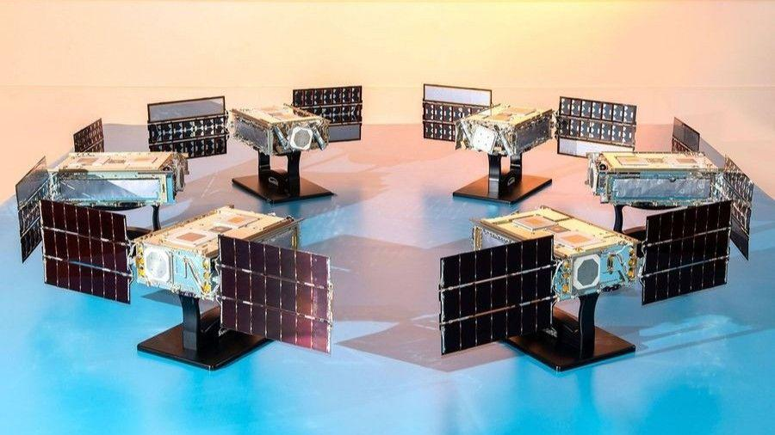
Click for next article NASA's SunRISE mission, which consists of six small satellites, will now fly on a SpaceX Falcon Heavy rocket rather than a ULA Vulcan Centaur. NASA is shaking things up for its next mission to research the sun. The six satellites of NASA's Sun Radio Interferometer Space Experiment (SunRISE) mission are poised to launch to Earth orbit soon, to serve as an early warning system for incoming solar storms. They were originally slated to lift off on a United Launch Alliance (ULA) Vulcan Centaur rocket but have now been assigned a SpaceX Falcon Heavy , according to a NASA mission update . SunRISE will fly to space as part of a rideshare mission sponsored by the U.S. Space Force's (USSF's) Space Systems Command (SSC). Though it's not stated specifically in the NASA release, that may be a hint as to why the mission's rocket was changed. On its most recent launch, USSF-87, Vulcan experienced an anomaly in one of its solid rocket boosters - the second such incident to occur during the rocket's four launches to date. Vulcan succeeded in delivering the USSF-87 payload to its designated orbit on that launch, but the recurrence of the booster issue during ascent prompted the Space Force to pause national security launches on Vulcan until it could be addressed. Which mission SunRISE will be manifested on has not yet been released, but SSC has already shifted other launches between Vulcan and SpaceX's Falcon 9 , so NASA's change in rockets for SunRISE could indicate either that the mission has been remanifested on a different SSC rideshare, or that another SSC mission has been shifted from Vulcan entirely. SunRISE is a heliophysics study under the NASA Science Mission Directorate's "missions of opportunity" umbrella and is part of the Explorers Program run by Goddard Space Flight Center in Greenbelt, Maryland. It consists of six small satellites, each about the size of a mailbox. The mini-constellation's mission is led by scientists at the University of Michigan and will be managed out of NASA's Jet Propulsion Laboratory in Southern California. The half-dozen smallsats will be delivered to an orbit about 22,000 miles (35,000 kilometers) above Earth - just above a geostationary parking altitude - and fly in a giant 10-mile (16-km) "X" formation, each extending its roughly 10-foot (2.5-meter) antenna booms to act as a single large radio telescope to track solar radio bursts. These kinds of bursts travel faster than the energetic particles from a solar storm, and precede their arrival when shot towards Earth. Powerful solar storms, like the one that hit Earth in January , are capable of disrupting or disabling satellites by interfering with onboard electronics, sensitive instruments and communications systems. If a storm is severe enough, it can pose a radiation threat to astronauts in orbit and even airborne passengers flying near Earth's poles , where the planet's magnetic field is weaker. The SunRISE satellites, seen at left, will fly in formation, illustrated on the right, working as one large radio telescope in Earth orbit. (Image credit: NASA/JPL-Caltech) SunRISE will help researchers better understand the behavior of incoming solar radio bursts, but the mission won't serve as an alert system by itself. Instead, scientists will use data collected by the spacecraft to improve prediction models for impending space weather , which in turn could lead to mitigation plans to better thwart the effects of such solar events on orbital infrastructure. Falcon Heavy is SpaceX 's heavy-lift launch vehicle, capable of launching up to 58,860 pounds (26,700 kg) to geostationary transfer orbit. It's a triple-booster rocket that consists of three modified Falcon 9 first stages, and has launched 12 times since it debuted in 2018. Four of those have delivered national security payloads to orbit, with the most recent of those, USSF-52, launching in December 2023. Falcon Heavy's most recent flight overall occurred this past April, when it sent the Viasat-3 F3 telecom satellite to orbit .

29. Scientists may have finally solved the mystery of the sun's missing silver
Read more

Click for next article An X-class solar flare erupted on the left side of the sun on the evening of Feb. 24, 2014. This composite image, captured at 7:59 p.m. EST, shows the sun in X-ray light with wavelengths of both 131 and 171 angstroms. For several years now, astronomers who study the sun have faced a little mystery - our star seemed to hold too little silver. Whenever scientists examined the sun's outer layers, they've seen significantly less silver than they've expected to find. Where, then, did the missing silver go? As it turns out, this mystery may finally be solved. Newly published research suggests that the sun 's missing silver may have been hiding in plain sight all along. At first, the real mystery might seem to be why you'd seek silver in the sun at all. After all, 98.5% of the sun's mass is made from lightweight hydrogen and helium. Silver is just a tiny fraction of the remaining 1.5%, which also includes traces of other heavy elements like iron and copper. These trace elements can illuminate the history of the cosmos. Silver is thought to form when dying stars violently explode in supernovas . When astronomers find silver in the sun and other stars, they can retrace the silver's origins and how stars have evolved over the eons. "By studying the light of stars of different types and ages, we hope to understand where silver is formed in the universe, and how it has been distributed throughout the Milky Way over time," says Sema Caliskan, the lead author of the research and now a postdoc at the University of Liège in Belgium, in a statement . Silver is particularly interesting because it's also found in utterly ancient meteorites called CI chondrites . These meteorites formed from the same primordial matter that created the sun, 4.6 billion years ago. As a result, when scientists break into CI chondrites that have fallen to Earth, they expect to find silver levels that match those they see in the sun. (Image credit: Anish Amarsi/Uppsala University) Astronomers can measure the latter from afar by looking at sunlight's spectral lines . As light streams out from the sun's heart, it crashes into the atoms of our star's outer layers, which absorb the light at certain wavelengths. Look at a spectrum of sunlight, and you'll see dark lines where light has been absorbed. Atoms of different elements absorb different wavelengths, so each element leaves a distinct fingerprint. Scientists can pore over these spectral fingerprints to reconstruct what elements created them and in what quantities. Therein lies the mystery: The sun seemed to contain much less silver than CI chondrites would indicate. This missing silver is a source for confusion in the sun's history. Caliskan and her colleagues wondered if astronomers were missing something. They could not visit the sun in person, but they could still find where the silver might be hidden by simulating the sun's atoms on a computer. If they could create a high-silver model that still spawned the low-silver spectral lines, that model could be a good guess for the silver's whereabouts. Other scientists had tried this before to limited success, but their simulations had been relatively simple. As light strikes an atom, the light has all sorts of intricate effects on the atom's innards. These effects can alter how the atom absorbs the light and, therefore, change how astronomers see that light. Past models hadn't accounted for many of these tricky "non-equilibrium effects", because simulating them is far easier said than done. They're messy and complex and they vary a great deal from atom to atom. In fact, no known scientists had ever tried to simulate a silver atom with non-equilibrium effects before Caliskan and her fellow investigators took on the challenge. They tried with their best guesses and the power of the Tetralith supercomputer in Linköping, Sweden. Indeed, these non-equilibrium effects seem to explain the silver mystery. Based on their model, Caliskan and colleagues calculated that the sun holds 55% more silver than astronomers have measured. This isn't a perfect match for the CI chondrites, but it's close enough that investigators can rule out any extraordinary cause. Instead, the missing silver may have been right there, in the sun all along, simply occluded from astronomers' view by tricks of physics. Next, Caliskan and colleagues plan to use this method to simulate other types of stars.

30. NASA's retired astronauts are hitting the road to get young people to vote: 'one small step for you, and one giant leap for our country.'
Read more
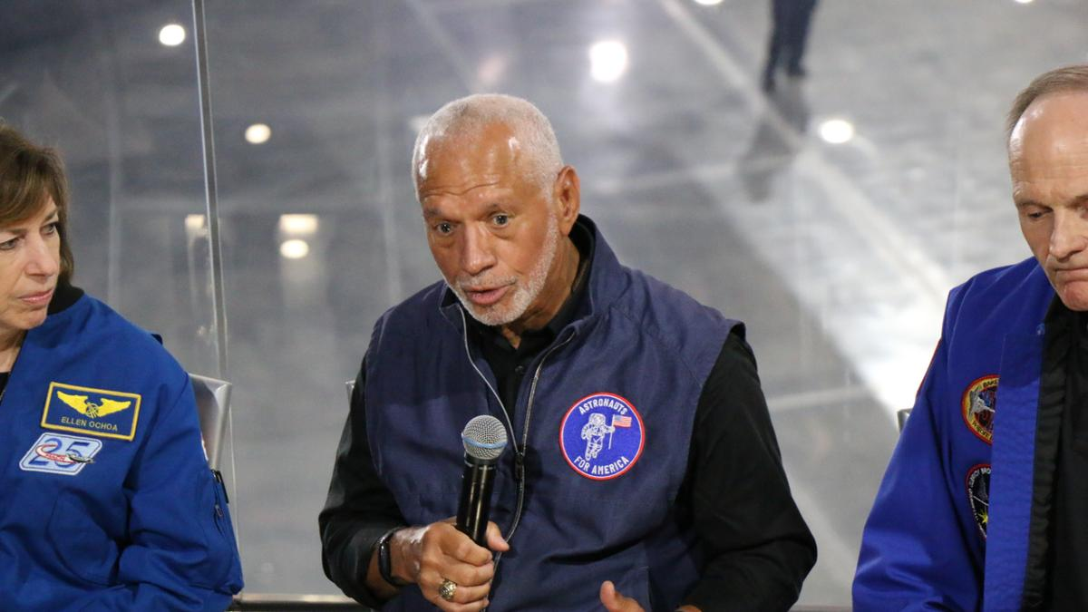
Click for next article LOS ANGELES - Standing in the shadow of the space shuttle Endeavour, a group of retired NASA astronauts announced their plan to travel the country visiting colleges to try to inspire younger generations to get out and vote. This campaign comes as we lead up to the November midterm election. This past year, a group of retired NASA astronauts teamed up for a single cause: to defend the U.S. constitution. They banded together as part of a non-profit, non-partisan activist organization called Astronauts for America. So far, they have been speaking out, using their astronaut expertise, platforms, cultural relevance and role model status to speak out in support of "science, evidence-based decision-making, public service and the rule of law," their website reads . Now, as the group announced at an event at the California Science Center's new air and space center - home to the shuttle Endeavour - they're hitting the road on a campaign tour of colleges called "Vote for Freedom." "We have to do what we can to ensure that the country makes it through the challenges that we're dealing with here, and that is the message that we're going to be taking to colleges and universities," Apollo 9 astronaut Rusty Schweickart told Space.com . "And the agency that we have, the immediate agency, is to vote." This tour will send astronauts from the group on a four-month jaunt across the country. Astronauts from the group's more than 100 members will visit state and community colleges, county fairs and even town halls, aiming to reach first-time voters and young people who might be new to voting. "I'm really excited to look a bunch of younger Americans in the eye and make sure that they know that someone that they can trust said: ;Listen, you matter, because our country matters, and our country needs you,'" former NASA astronaut Cady Coleman told Space.com. "It's with a uniquely American kind of freedom that we were able to go to the moon, and that same freedom launched the spaceship behind us 25 times into space. Now we see those freedoms under heavy threat," former NASA astronaut Steve Smith said during the event. "We're seeing chaos instead of community, violence instead of votes, lies instead of laws, and fear instead of fate. That's how democracy and freedom die." "The mission is all that matters. Now, our country is the mission, and our message is simple: going to the polls is one small step for you, and one giant leap for our country," Smith added. Former NASA astronaut Steve Smith speaks alongside other former astronauts in front of the space shuttle Endeavor at the California Science Center on July 20, 2026. (Image credit: Space.com/Chelsea Gohd) This campaign leads up to the U.S. midterm elections this November. Midterm elections happen halfway through every four-year presidency. This election allows voters to decide what Congress looks like, and which political party controls Congress. This can ultimately have a major impact on what laws and decisions are passed moving forward, and whether Congress will reject or change actions by the president moving forward. And this group of astronauts is serious about the importance of getting people out to exercise their right to vote. "I'm a child of the segregated South; I grew up in Columbia, South Carolina," former astronaut and NASA Administrator Charlie Bolden, who also serves as a steering committee member for Astronauts for America, said at the event. "I graduated in 1964. Anybody know what happened in 1964? The Voting Rights Act. So, as a person growing up in my hometown, it wasn't a guarantee that my mom and dad were going to be able to go out and vote. I look at what's going on today about people trying to restrict the ability of people to cast their ballot. That's not who we are. That's not America." The group of astronauts recently spoke out about voting access after the U.S. Supreme Court ruled in favor of protecting the right to absentee voting, in response to attempts by the Trump administration to place restrictions on the current voting process. Especially leading up to the November midterms, each vote carries significant weight. And while this nonpartisan group isn't telling you who to vote for, they do think that everyone who can should vote. "As astronauts, we signed an oath to our nation, and we are mission-oriented people. And our nation is now the mission," Coleman added. "We need to recognize that everyone's voice is important, and one of the voices that we don't hear very much is the young people. And we want them to understand that, even though sometimes change can seem daunting, their perspective is really important, and, you know, their voice is important."

31. Satellite spots a 'hummingbird' in Antarctica | Space photo of the day for July 23, 2026
Read more

Click for next article A hummingbird shape in satellite data from NISAR is actually a mountaintop spotted in Antarctica. (Image credit: NASA/JPL-Caltech) In satellite data captured over Antarctica, what appears to be a beautiful, colorful hummingbird emerges from the crest of a mountaintop. What is it? While there are no hummingbirds flying around Antarctica , we can see what looks like a small, purple bird in a new satellite image of an Antarctic mountain. The dark belly of this "bird" at the center of this image is actually the top of the mountain Nunatak Zaterjavshijsja in East Antarctica. What looks like a bird's tail is a stream of ice flowing northeast all the way out to the ocean, and what appear to be feathers splaying outward from the mountaintop are actually crevasses down the mountain. These crevasses are formed by a glacier fracturing the mountain's surface as it flows in the icy current toward the ocean. This view was captured by radar instruments onboard the satellite NISAR (NASA-ISRO Synthetic Aperture Radar) that launched as a collaboration between NASA and ISRO (Indian Space Research Organisation). The director of NASA's Earth Science Division called NISAR " the most sophisticated radar we've ever built " in a pre-launch briefing last year. Why is it incredible? At first glance, this image is puzzling. What could it possibly be? Its bold colors and sharp lines evoke almost alien qualities. But the strange beauty of the shapes and colors in this satellite image reveal important information about glacier movements on the mountain. "First, it's a beautiful image, with rich details of features that provide insights to how the glacier is moving. Then, because radar can often see through snow and deep into the ice, NISAR can observe fundamentally different properties of Antarctic ice than can be seen in optical imagery," Seongsu Jeong, the signal analysis engineer who produced the image at NASA's Jet Propulsion Laboratory, said in a statement . "With NISAR we're seeing what's hidden beneath the surface." And now anyone can explore NISAR's data. Earlier this week, on July 20, NISAR started making the data from its radar instruments public . Moving forward, mission teams will be rolling out this data so researchers everywhere can use it to study and protect our ever-changing planet.

32. The James Webb Space Telescope's disappearing 'Little Red Dots' may lead to another cosmic puzzle
Read more
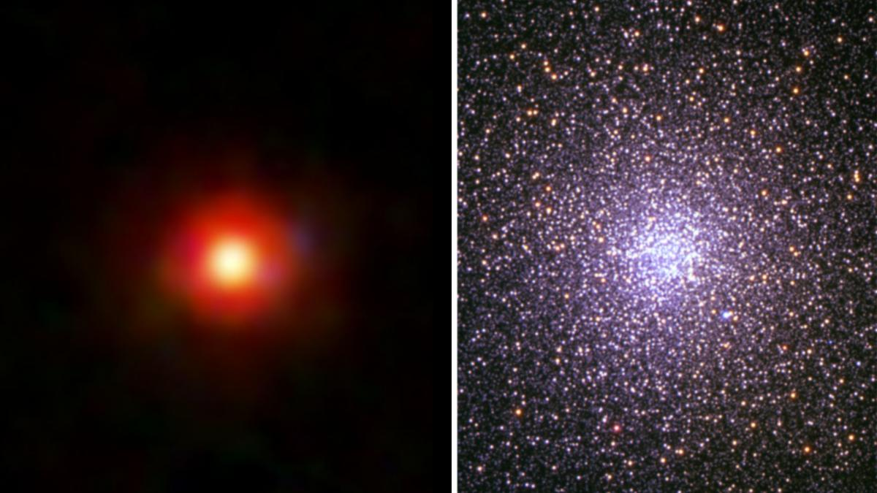
Click for next article Did Little Red Dot like the one on the left evolve into globular clusters like 47 Tucanae (right)? Paleontologists now know that many of the dinosaurs didn't disappear but instead evolved into modern birds, and new research suggests that "cosmic dinosaurs" observed by the James Webb Space Telescope (JWST) didn't go extinct either. Rather, they may have evolved into familiar sights in the modern universe: vast conglomerations of densely packed stars called "globular clusters." Little Red Dots became quite the puzzle for astronomers in 2022, when the JWST began to routinely spot them in abundance around 600 million years after the Big Bang . That is because these objects seemingly disappear before the cosmos gets to around 2 billion years old. Astronomers have proposed many different explanations for Little Red Dots, including the suggestion that they could be " black hole stars ," or black holes wrapped in vast shrouds of dense gas and dust. This team theorizes that a forming globular cluster with a supermassive star , a hypothetical short-lived stellar body with between 1,000 and 10,000 times the mass of the sun, would also look a lot like a Little Red Dot at its heart. "These may not be just a strange new JWST population with no connection to the universe around us today," team leader John Chisholm of the University of Texas Austin said in a statement . "Instead, Little Red Dots may persist past the early universe, evolving into something relatively familiar. "Little Red Dots could be galaxies, they could involve black holes, or they could be something even more unexpected. Our work shows that forming globular clusters with supermassive stars should be part of that conversation." An unfamiliar side to a familar sight Globular clusters are generally seen in large galaxies and are densely packed with up to many millions of ancient stars. Our galaxy, the Milky Way , is host to at least 150 globular clusters, and though familiar, astronomers still aren't quite sure how they form. "We usually see them [globular clusters] after billions of years of evolution, at a time when their massive stars are gone, their gas has been cleared out, and dynamical processes have changed their masses and structures," team member Danielle Berg of UT Austin said in the statement. "That makes it very hard to reconstruct the original conditions they formed in." It is thought that the stars in globular clusters all formed at the same time in the early universe. However, at this time the cosmos should only have had hydrogen, helium and a smattering of heavier elements (which astronomers call "metals") available for star construction. Yet, many stars in globular clusters are strangely abundant in helium and metals like nitrogen, sodium and aluminum, while lacking the expected levels of carbon, oxygen and magnesium. "This specific pattern indicates nuclear fusion at very high temperatures, much higher than in the cores of even massive normal stars," team member Mike Boylan-Kolchin of UT Austin said in the statement. "A supermassive star is precisely the kind of environment that could produce this combination." Globular cluster NGC 6638, as seen by the Hubble Space Telescope. (Image credit: ESA/Hubble & NASA, R. Cohen) Supermassive stars capable of generating this kind of heat would form in the dense environments of early globular clusters in which stellar collisions and mergers would be expected to occur over and over again. The resultant supermassive stars would be short-lived, lasting just around 1 million years (remember the sun is middle-aged at 4.6 billion years old) - but this would be sufficient time to forge the elements needed to explain the peculiar chemistry of globular clusters. When these supermassive stars die in supernova explosions , the elements they forged would be blasted out to become the building blocks of the next generation of stars. This would provide the stars of modern globular clusters with their unusual chemical fingerprints. "In our model, the supermassive star that helps make the object look like a Little Red Dot would live for only a short time," Chisholm continued. "Once that star dies, the object may no longer look like a Little Red Dot, even if the cluster itself survives billions of years." Just some of the "little red dot" galaxies discovered by the JWST. (Image credit: NASA, ESA, CSA, STScI, Dale Kocevski (Colby College)) Strange chemistry isn't the only thing linking early globular clusters with Little Red Dots, however. Not only does the team propose that the distribution of Little Red Dots in the early universe matches the distribution of modern globular clusters, but they also say models of Little Red Dot evolution show that their estimated masses could easily lead to the masses of globular clusters seen in the recent universe. There is also the issue of timing. Little Red Dots appear around 600 million years after the Big Bang, and that is also the time that scientists estimate that globular clusters would have begun to form. "There's no single smoking gun at this point that says Little Red Dots are globular clusters, but it would explain a lot of diverse and surprising observations," said Boylan-Kolchin.

33. Live coverage: SpaceX ready for 2nd attempt to launch Starship Flight 13 following post-abort engine work
Read more
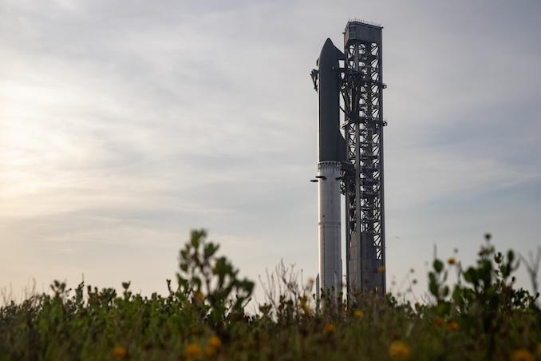
Update July 23, 4:10 p.m. EDT (2010 UTC): SpaceX waived off a launch attempt due to weather; targeting July 24. SpaceX will take another run at launching its Starship-Super Heavy rocket from southern Texas, but not until after Tropical Storm Bertha finished pushing through Texas. Like the attempt one week ago, a 90-minute launch window will open at 5:45 p.m. CDT (6:45 p.m. EDT / 2245 UTC) on Friday, July 24. The flight comes after days of work replacing and testing multiple Raptor engines on the Super Heavy booster. Spaceflight Now will have live coverage beginning about two hours prior to liftoff. <span data-mce-type="bookmark" style="display: inline-block; width: 0px; overflow: hidden; line-height: 0;" class="mce_SELRES_start"></span> Moments before the post-ignition abort on Thursday, July 16, on-screen telemetry data showed four engines that apparently did not ignite. During the pre-dawn hours of Friday, July 17, Ship 40 (S40) was de-stacked from Booster 20 (B20) and returned to the production site at Starbase. Later that day, SpaceX also removed B20 and rolled it along the nearly three trek back to the production site as well. Founder Elon Musk said that at least two Raptor engines needed to be removed following the hard engine stop during the launch attempt. Following a week of work, B20 returned to Pad 2 on Tuesday, July 21. The following day, SpaceX loaded it with both liquid oxygen and liquid methane before draining the vehicle again. "Additional preflight testing on Super Heavy complete. Now starting preparations to launch Starship as soon as tomorrow, Thursday, July 23," SpaceX posted on social media following the test's conclusion. "Weather is currently a significant watch item for launch." Ship 40 returned the pad on Wednesday, July 22, and was stacked atop Booster 20 that evening. One of the main objectives of this 13th test flight is to deploy 20 Starlink V3 satellites from S40. SpaceX has previously deployed Starlink simulators from previous Starships, but this would be the first deployment of production satellites. "As part of this initial test, Starship is planned to deploy 20 satellites which will extend solar arrays and antennas and will attempt to connect with the larger Starlink constellation via high-capacity lasers," SpaceX said on its website. "The Starlink satellites will be on the same suborbital trajectory as Starship and are expected to demise upon reentry approximately 20 minutes after deployment." SpaceX also plans to perform a Raptor engine relight following the roughly 11-minute satellite deploy sequence. Teams also hope that work done on the sea-level Raptor engines combined with a new startup sequence on the Ship upper stage will allow for a successful boostback burn on Booster 20 and a splashdown in the Gulf of Mexico. During Starship Flight 12 back in May, SpaceX said the startup sequence of the engines on Ship 39 "caused the directional flip of the booster to be off by approximately 90 degrees." That coupled with issues with five out of 33 sea-level engines on the booster prevented a nominal boostback burn and Booster 19 was lost prematurely. "The Super Heavy on this upcoming flight has hardware modifications to improve re-light reliability along with updates to engine alarms and aborts to match the conditions seen in the multi-engine flight environment," the company said. Other engine improvements are designed to prevent an early shutdown seen during Flight 12 that prevented an engine relight demonstration on that mission. Work on the upper stage's heat shield to help push it towards future, full reusability will also be on display. "Multiple tiles will be attached to the metallic side of Starship's aft flaps along with modified tiles and attachment mechanisms in the heat shield covering the aft skirt to gather flight data on different attachment options," SpaceX said. "Finally, Starship's heat shield will have load sensing tiles to take measurements as the vehicle experiences higher dynamic pressure on ascent than previous flights, putting added stress on the tile attachments in exchange for increased payload to orbit capability." A nearly identical version of the Starship Version 3 rocket flying today will be used on the Artemis 3 mission, which will include a docking between Starship and NASA's Orion spacecraft. A new report published by the Government Accountability Office (GAO) on Thursday looks at a series of NASA's long-term projects, including those involved with the Artemis Program. It points to "a series of testing challenges" encountered by SpaceX when it comes to the Human Landing System version of Starship that will be used to return humans to the Moon. NASA wants to perform a lunar landing with astronauts as soon as 2028 with either Starship or Blue Origin's Blue Moon Mark 2 lander. The GAO report noted not only is SpaceX "more than a year behind its original schedule for key events," like the critical design review and an uncrewed landing demonstration, but development of its Raptor engines is described as a "top risk." "According to HLS officials, the latest version of the Raptor engine incorporates improvements such as welded fuel joints designed to prevent the fuel leaks that resulted in the loss of the Starship vehicle during flight testing in March 2025," the report stated. "Flight test 12, conducted in May 2026, was the first flight test of the new version of the engine." The GAO report noted that NASA officials pushed back on some assessments and stated that the report's assessment "does not reflect all ongoing programmatic changes stemming from adjustments made to the Artemis campaign in February and March 2026." "Officials did not have any technical corrections on the assessment," the report said.

34. NASA's new space telescope will tackle some of the universe's biggest mysteries
Read more

NASA is about to launch a space observatory that could help settle some of the biggest mysteries in modern astronomy. The Nancy Grace Roman Space Telescope will study how the universe began, what it is made of and how it has evolved over time.
35. NISAR S-Band SAR Data Products Release - ISRO
Read more

July 24, 2026 The NASA-ISRO Synthetic Aperture Radar (NISAR) mission is a groundbreaking Earth observation initiative providing unprecedented insights into our planet's dynamic surfaces. As the world's first spaceborne radar mission to employ dual-frequency (L-band and S-band) instrumentation, NISAR utilizes an advanced 12-meter reflector and innovative SweepSAR acquisition technology. This architecture allows the observatory to achieve an exceptional combination of wide-swath (~240 km) and high-resolution imaging without traditional coverage trade-offs. Operating in a 747 km Sun-synchronous orbit, NISAR provides persistent, all-weather global coverage with a rapid 12-day repeat cycle, generating a dense time-series of data essential for monitoring rapid environmental changes, geohazards, and resource management. The mission is currently in science operations phase, acquiring data across global observation tracks as per the Reference Observation Plan, with S-band SAR data being acquired through ISRO ground stations and subsequent data processing, archival, and dissemination being carried out at the Integrated Multi-Mission Ground Segment for Earth Observation Satellites (IMGEOS), Shadnagar, NRSC. Calibration and Validation (Cal/Val) activities are systematically performed using the PAN India Corner Reflector (CR) network, homogeneous distributed targets, and selected science targets to establish and maintain baseline radiometric, geometric, and polarimetric consistency across all acquisition geometries. S-Band SAR data Products Release ISRO has released the NISAR S-Band SAR daily processed data products through Bhoonidhi, ISRO'S EO data dissemination hub (https://bhoonidhi.nrsc.gov.in). This data comprises of S band SAR collections over Indian land mass along with global locations spanning across diverse NISAR science themes. Onward Processing Release (Cycle 25 Onwards): Starting with Cycle 25 (commenced July 8, 2026) , all acquired S-Band SAR products are systematically generated from the operational production environment and made directly available for user download. Starting with , all acquired S-Band SAR products are systematically generated from the operational production environment and made directly available for user download. Historical Dataset Reprocessing: Datasets acquired prior to Cycle 25 will undergo systematic reprocessing in phased manner and will be added to archives. Datasets acquired prior to Cycle 25 will undergo systematic reprocessing in phased manner and will be added to archives. Product Version Baseline: Current released datasets are with Product Baseline version (Baseline v1.4.0 CRID P00500) Following S-band SAR data products are being released Standard Products L1-RSLC: Range-Doppler Single Look Complex L2-GSLC: Geocoded SLC L2-GCOV: Geocoded Polarimetric Covariance Matrix Interferometric Products L1-RIFG: Nearest-Time Interferogram L1-RUNW: Nearest-Time Unwrapped Interferogram L2-GUNW: Geocoded Nearest-Time Unwrapped Interferogram Offset Products L1-ROFF: Range-Doppler Pixel Offsets L2-GOFF: Geocoded Pixel Offset Produc Accessing NISAR data through Bhoonidhi NISAR data products are disseminated through Bhoonidhi, ISRO's Earth Observation data dissemination hub (https://bhoonidhi.nrsc.gov.in). Registered users can access the Browse&Order interface to search, visualize, and download available NISAR products by specifying the area of interest, acquisition period, product type and NISAR data specify advanced filters. Level-1 and Level-2 products are available for access for data covering diverse NISAR science themes in accordance with the ISRO observation plan. Programmatic access is also supported through the Bhoonidhi API for authorized users. The portal serves as the primary distribution platform for NISAR S-band data products and a dedicated NISAR information page is made available containing associated documentation, product specifications, calibration status, and release updates for users (https://bhoonidhi.nrsc.gov.in/NISAR). Calibration Status The current data product release incorporates the latest radiometric, geometric, and polarimetric calibrations derived from in-flight Cal/Val activities. Calibration parameters and algorithm enhancements will continue to evolve over the operational lifetime of the mission, with updates notified to the user community as processing baselines advance. Users may observe residual radiometric banding in low signal-to-noise ratio (SNR) regions such as oceans, deserts, and other homogeneous surfaces in this version of products. Although, RFI mitigation has been applied to all scenes, residual RFI artifacts may still be present in certain areas, for which improvements are planned in future releases. Tools at Bhoonidhi for NISAR data To facilitate seamless data handling and scientific analysis without extensive local processing overheads, Bhoonidhi provides an integrated suite of user utilities: HDF to GTiff Tool: Utility providing format conversion of NISAR HDF5 datasets into GeoTIFF and Cloud-Optimized GeoTIFF (COG) formats, with option for spatial sub-setting by point coordinates or user-defined shapefiles. Utility providing format conversion of NISAR HDF5 datasets into GeoTIFF and Cloud-Optimized GeoTIFF (COG) formats, with option for spatial sub-setting by point coordinates or user-defined shapefiles. SARPOL TOOL: A QGIS-integrated processing suite supporting NISAR format conversions along with Hybrid and Full Polarimetric decomposition techniques for SAR data analysis. Explore & Access Datasets: Search, visualize, convert, and download NISAR S-Band products directly on ISRO's Bhoonidhi Portal → https://bhoonidhi.nrsc.gov.in NISAR_S2_PR_GCOV_024_084_A_007_3700_DHNA_A_20260702T001555_20260702T001631_P00500_P_F_I_001 AOI: Nagapattinam district, Tamil Nadu FCC Legend Red- HH Green - HV Blue - HH / HV This false-color composite (FCC) derived from NISAR S-SAR data in HH+HV polarization highlights vegetation (green), land (purple), and water bodies (dark) across the East coastal region. The composite enhances the discrimination of mangroves, agricultural fields, wetlands, and coastal lagoons based on their radar backscatter characteristics. The image was acquired on 2 July 2026, providing valuable information for coastal resource management and environmental monitoring. NISAR_S2_PR_GCOV_025_026_D_125_3700_SHNA_A_20260710T004942_20260710T005015_P00500_M_P_I_001 AOI: East, Antarctica This NISAR S-SAR GCOV image, acquired on 10 July 2026, captures a coastal region of East Antarctica, showing glacier terrain, an extensive ice sheet, drifting sea-ice floes, and the surrounding Southern Ocean. The strong radar backscatter from the ice features contrasts with the darker open water, enabling clear discrimination of different cryospheric components. This scene demonstrates the capability of S-band SAR for monitoring Antarctic ice dynamics, sea-ice distribution, and glacier-ocean interactions. NISAR_S2_PR_GCOV_025_019_D_075_2500_CRNA_A_20260709T124208_20260709T124245_P00500_M_F_I_001 AOI: Brahmaputra River, Assam Polarimetric Decomposition Legend Red - Even Bounce Green - Volume Blue - Odd Bounce This Hybrid Polarimetric M-δ (M-Delta) decomposition image derived from NISAR S-SAR data captured on 09th July 2026 represents the Brahmaputra River basin through dominant scattering mechanisms. Surface scattering (blue) is prominent over the river channels and smooth water surfaces, double-bounce scattering (red) is associated with built-up features and vegetation-water interactions, while volume scattering (green) highlights vegetated floodplains and surrounding forested areas. The decomposition enhances the characterization of hydrological and land-cover features, supporting floodplain mapping and environmental monitoring. NISAR_S2_PR_GCOV_025_013_D_067_3700_DHNA_A_20260709T023820_20260709T023857_P00500_M_F_I_001 AOI: Idaho, USA FCC Legend Red - HH Green - HV Blue - HH / HV This false-color composite (FCC) derived from NISAR S-SAR data which is acquired on 09 July 2026 in HH+HV polarization highlights vegetation (green), cultivated land (purple), and water bodies (dark) across the Burley agricultural region in Idaho, USA. Variations in radar backscatter enable clear identification of center-pivot irrigation systems, agricultural fields, and surrounding terrain. The image supports precision agriculture, irrigation monitoring, and sustainable land resource management. NISAR_S2_PR_GCOV_025_143_A_043_2500_CRNA_A_20260718T024931_20260718T025004_P00500_M_F_I_001 AOI: Greenland Polarimetric Decomposition Legend Red - Even Bounce Green - Volume Blue - Odd Bounce This Hybrid Polarimetric M-Chi decomposition image derived from NISAR S-SAR hybrid Polarimetric data highlights the dominant scattering mechanisms across Northeast Greenland National Park acquired on 18 July 2026. Surface scattering (blue) is prominent over smooth water surfaces and ice streams, double-bounce scattering (red) is associated with rough exposed terrain and ice-rock interfaces, while volume scattering (green) represents tundra vegetation and heterogeneous land surfaces. The decomposition enhances the characterization of cryospheric and hydrological features, supporting glacier monitoring, ice dynamics, and environmental change assessment. NISAR_S2_PR_GCOV_025_024_A_173_3700_DHNA_A_20260709T215709_20260709T215746_P00500_M_F_I_001 AOI: Indonesia

36. Govt says ISRO has developed & operationalised wide range of space-based applications to benefit society - News On AIR
Read more
The Government has said that the Indian Space Research Organisation (ISRO) has developed and operationalised a wide range of space-based applications to benefit all sections of society, including the welfare of the Scheduled Caste community. Science and Technology Minister Dr. Jitendra Singh informed this in a written reply in the Lok Sabha today. The Minister said that key space application areas include satellite-based Potential Fishing Zone (PFZ) advisories, crop acreage and production forecasting, agrometeorological advisories for farmers, crop insurance support, geospatial support for flagship government programmes, tele-education, telemedicine, the Vessel Communication and Support System, and disaster management support. Mr. Singh noted that ISRO has established robust awareness and capacity-building programmes to promote the use of space technology for societal, governance, and disaster management purposes, enabling decision-makers to operate effectively at the grassroots level. He added that these initiatives are designed to be inclusive and accessible to targeted beneficiaries across the country. The Minister further said that the benefits of Earth observation, satellite communication, and navigation applications, particularly in terms of improved connectivity and navigation services, are reaching SC farmers, students, and disaster-prone regions within satellite coverage areas. He also highlighted that the Department has undertaken several measures to ensure the inclusive use of space technology, including the implementation of flagship initiatives such as Digital India, the BharatNet Programme, the Vessel Communication and Support System (VCSS) under the Pradhan Mantri Matsya Sampada Yojana (PMMSY), and the PM e-VIDYA scheme for tele-education.

37. SpaceX's Starship megarocket makes the 'softest splashdown' ever after launching next-gen Starlink satellites in Flight 13 test (video)
Read more
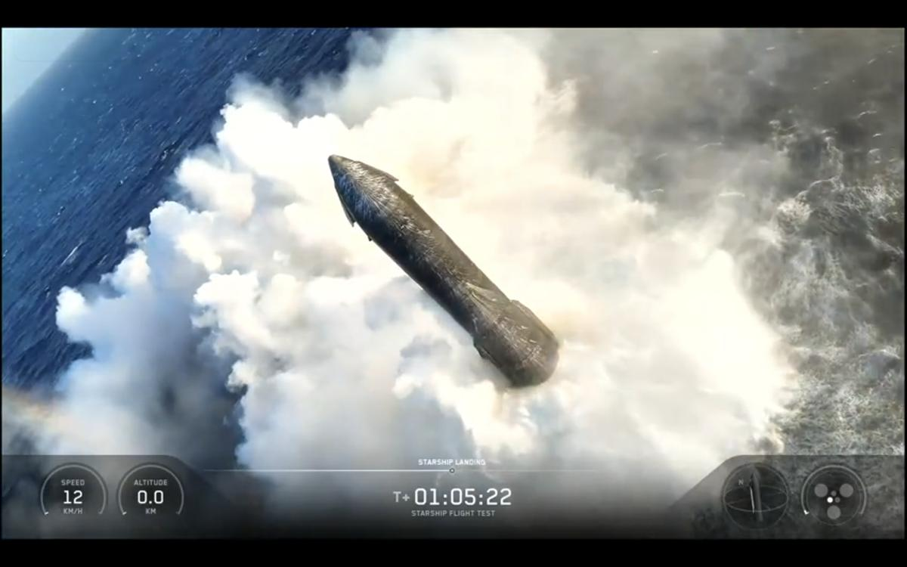
Click for next article SpaceX launched the world's most powerful rocket on a critical 13th test flight late Friday, but there was no triskaidekaphobia on this mission. The July 24 test launch, Space's Starship Flight 13 mission , sent a towering rocket the size of a 40-story skyscraper into space from South Texas, returned its massive Booster to Earth, and then - in a feat perhaps none saw coming - gently landed its Starship upper stage in the Indian Ocean, where it tipped over to float belly up on the sea. "Starship is intact, floating in the ocean and transmitting telemetry!" SpaceX CEO Elon Musk wrote on X . Image 1 of 3 SpaceX's Starship Flight 13 test flight lifts off from Starbase, Texas on July 24, 2026. (Image credit: SpaceX) SpaceX's Starship Flight 13 test flight lifts off from Starbase, Texas on July 24, 2026. (Image credit: SpaceX) SpaceX's Starship Flight 13 test flight lifts off from Starbase, Texas on July 24, 2026. (Image credit: SpaceX) Image 1 of 3 View Original Image 2 of 3 View Original Image 3 of 3 View Original $39.99 at Amazon Starship Die Cast Rocket Model Was $47.99 Now $39.99 on Amazon. Even if you can't see SpaceX's Starship in person, you can score a model of your own. Standing at 13.77 inches (35 cm), this is a 1:375 ratio of SpaceX's Starship as a desktop model. The materials here are alloy steel and it weighs just 225g. "That is a first," SpaceX spokesperson Dan Huot added in live commentary as a drone beamed stunning views of Starship bobbing in the waves. "That is the softest splashdown we have ever had with Starship in the Indian Ocean." The splashdown capped what appeared to be a mostly successful test flight of SpaceX's biggest Starship ever. With a mighty roar, Starship Flight 13 lifted off from SpaceX's Starbase, Texas launch site at 6:51 p.m. EDT (2251 GMT) on a test flight that lasted just over one hour. It was only the second flight of the company's new Starship Version 3 design , or V3, and SpaceX was hoping for a better outing than its first attempt in May. During that previous test, the Starship Flight 12 mission , the massive Super Heavy first-stage Booster suffered engine problems after stage separation and failed to make a water landing in the Gulf of Mexico. It crashed instead. Lucky Flight 13 Friday's Starship Flight 13 mission fared a bit better. SpaceX initially tried to launch Flight 13 on July 16, but the rocket aborted the try at the last second due to engine issues. SpaceX replaced some first-stage Raptor engines in time for a July 23 launch attempt, but waved off due to weather, setting the stage for Friday's successful liftoff. Minutes into the flight, the Super Heavy Booster successfully separated from its Ship upper stage, aced a flip maneuver and returned to Earth. There was a problem during the landing burn. Only five engines appeared to fire when 13 were required to slow the Booster to landing speed. It hit the Gulf waters harder than planned, its camera views cutting out. "It didn't look like we lit all 13 engines that we were planning for that initial landing burn," Huot said. "We were targeting a softer splashdown and, as you saw, it came in with quite a bit of velocity." SpaceX's Starship Flight 13 Booster hits the Gulf of Mexico waters hard, with only 5 of 13 planned engines firing during a landing burn, on July 24, 2026. (Image credit: SpaceX) Starlink V3 makes a debut Starship is intact, floating in the ocean...' - Elon Musk, SpaceX CEO Despite the Booster's rough landing, there were clear successes on Starship Flight 13. While sailing on its suborbital trajectory, Flight 13's Ship upper stage deployed 20 next-generation Starlink Version 3 internet satellites - large, flat satellites equipped with laser communications links and expansive solar arrays that will replace SpaceX's current Starlink internet megaconstellation. Starship is designed to launch 60 Starlink V3 satellites at a time, spitting them out through a slit-like payload bay door like a giant PEZ candy dispenser . All 20 Starlink V3 satellites deployed smoothly, with the last two switching on flashlights and looking back at their Ship carrier before floating off into orbital darkness. The satellites did not stay in space. They fell to Earth and burned up (by design) due to their suborbital flight path. The Ship upper stage (which SpaceX also refers to as Starship) then reignited one of its six Raptor engines to test a critical engine relight capability that will allow future Starships to enter and leave orbit. The burn went off without a hitch - a milestone since SpaceX had not always performed the burn if a test didn't go smoothly. Then it was time for reentry, with cameras beaming back stunning views of Starship wrapped in super-hot plasma as it fell back to Earth. The spacecraft executed a three-engine burn to flip over into a vertical landing position, but did shift down to two engines, then one before it toppled over to rest on the waves. The sight of a floating Starship triggered a cacophony of cheers from SpaceX teams at Starbase and its Hawthorne, California rocket factory in the company's livestream. After all, Starships usually explode after they tip over. "This is just the first time we've put a Starship into the water," SpaceX's Dan Huot said during live commentary. He called it SpaceX's "softest splashdown" ever. "This is a dream scenario for this team that's trying to get this heat shield data." A view of SpaceX's Starship Flight 13 Ship vehicle wrapped in plasma during reentry on July 24, 2026. (Image credit: SpaceX) The heat shield isn't the only thing SpaceX's recovery team will be looking at. Live views from Starship showed its six engines intact along with its flaps and other systems. Teams will be poring over what they can retrieve from the sea to help improve future Starship upgrades . SpaceX is developing Starship to be a fully reusable launch system, a 407-foot-tall (124 meters) megarocket capable of taking Starlink fleets to orbit as easily as it lands NASA astronauts on the moon . That part is key. NASA has tapped SpaceX's Starship to land its Artemis IV astronauts on the moon in 2028, but SpaceX has yet to ever complete an entire Earth orbit with Starship after 13 test flights and three years of launches. It's been a decade since Elon Musk first unveiled what SpaceX now calls Starship during a 2016 speech. Image 1 of 4 SpaceX's Starship Flight 13 Ship vehicle floats in the Indian Ocean just after splashdown on July 24, 2026. (Image credit: SpaceX) SpaceX's Starship Flight 13 Ship vehicle floats in the Indian Ocean just after splashdown on July 24, 2026. Some flames are visible at the nose. (Image credit: SpaceX) SpaceX's Starship Flight 13 Ship vehicle floats in the Indian Ocean just after splashdown on July 24, 2026. The flames near the nose are now gone. (Image credit: SpaceX) A view of SpaceX's Starship Flight 13 Ship during its final landing and splashdown in the Indian Ocean on July 24, 2026. (Image credit: SpaceX) Image 1 of 4 View Original Image 2 of 4 View Original Image 3 of 4 View Original Image 4 of 4 View Original Over the next two years, SpaceX must not only send a Starship into orbit. The company also aims to return a Ship to Earth to catch it in the "chopsticks" of its Mechazilla launch pad at Starbase . (The company has already done so with its Super Heavy Booster stages.) SpaceX also must successfully demonstrate in-space Starship refueling , complete an orbital tanker version of Starship, and finish a crewed lander version complete with a life support system that can keep astronauts alive on the moon. That's a lot on the Starship to-do list and NASA is watching. "Congrats on getting Flight 13 underway," NASA Administrator Jared Isaacman wrote on X after the launch . "Excited for what will be learned from this mission. When Starship comes online, its capabilities will be game-changing, not least of which will be ensuring we never give up the Moon again!" In a lunar coincidence, Friday's launch coincided with the 57th anniversary of the Apollo 11 astronauts' return to Earth after their historic moon landing flight. But for now, SpaceX is clearly celebrating. "I'm a little over the moon right now," Huot said. "Wow. Lucky number 13. Hell of a great day for Starship."

38. What lurks beneath the volcanoes of Jupiter's moon Io? NASA's Juno probe just took a peek
Read more
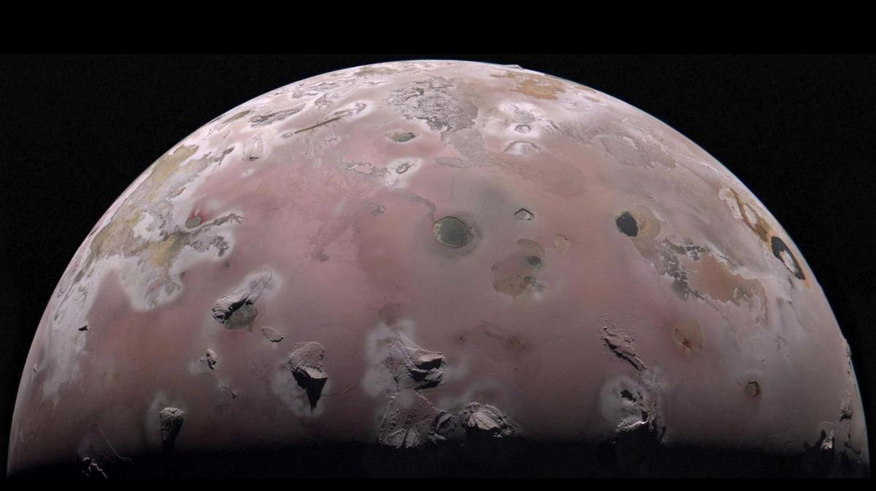
Click for next article The north polar region of Jupiter's volcanic moon Io was captured by NASA's Juno during the spacecraft's 57th close pass of the gas giant on Dec. 30, 2023. Data from that flyby and one on Feb. 3, 2024, is helping scientists understand Io's interior. Scientists have measured temperatures beneath the surface of Jupiter's volcanic moon Io, offering the first-ever glimpse of the hidden heat driving the most volcanically active world in the solar system. During close flybys of Io in late 2023 and early 2024, NASA's Juno spacecraft turned its Microwave Radiometer (MWR) instrument toward the moon, probing roughly six to 20 feet (two to six meters) beneath its surface. Originally designed to peer through Jupiter's thick clouds, the instrument instead revealed a powerful new way to study how heat moves through planetary crusts, according to a statement from the space agency. "The surprising discovery that we could see below a rocky moon's surface has important implications for studying Earth's volcanoes," Scott Bolton, coauthor of the study and Juno's principal investigator, said in the statement. "Juno has taught us that if we look with an MWR-type instrument near a volcano on Earth , we might see a similar signature in the subsurface temperature gradient, providing new information on how terrestrial volcanoes work." Until now, researchers had relied almost entirely on infrared observations, which detect only the temperature of Io's surface . By probing several feet underground, Juno has revealed how heat moves through the moon's crust for the first time. The measurements showed temperatures rising by more than 40 degrees Fahrenheit (22 degrees Celsius) just a few feet below the surface - far more than sunlight alone could explain. Juno's subsurface heat map also revealed localized regions of elevated heat, with temperatures measuring between 18 and 36 degrees F (10 to 20 degrees C) warmer than the surrounding terrain, according to the statement. Juno's observations uncovered another surprise, too. Despite being known for its towering mountains and active volcanoes , much of Io's surface appears remarkably smooth and composed of unusually low-density material. Researchers think the moon is blanketed by porous layers of volcanic ash, sulfur frost and other eruptive debris that continually resurface Io, burying older terrain beneath fresh deposits. Scientists think the heat detected beneath Io's surface could be rising steadily from the moon's molten interior through a conductive crust or coming from pockets of cooling lava flows trapped just below the surface. Either way, the data provide the clearest picture yet of how Io transports heat from its interior. Unlike Earth, where volcanism is driven largely by heat from radioactive decay, Io is continuously stretched and squeezed by Jupiter's immense gravity as it orbits the giant planet. This constant tidal flexing generates enormous amounts of internal heat, fueling hundreds of active volcanoes and making Io the most volcanically active object in the solar system . By improving scientists' understanding of how heat and magma move beneath a planet's surface before eruptions, the same microwave techniques used by Juno could one day help researchers better monitor Earth's volcanoes and improve eruption forecasting. "Io provides a unique window into learning how tidal heating works throughout the cosmos, a fundamental process that provides energy and heat to worlds that are far from their parent star," Bolton said in the statement. "This process can not only create the most volcanic body in the solar system, in the case of Io, but also fuels the subsurface oceans on the moons of giant planets, such as Europa and Ganymede. Up until this point we could only observe the heat escaping at the surface or through eruptions. Now we can characterize how the heat is moving from the interior toward the surface." Because Io is an extreme example of volcanic activity, it serves as a natural laboratory for studying how heat moves through planetary crusts. Those insights could help scientists better understand ancient volcanism on Mars , Venus, and Earth's moon, whose landscapes were shaped by massive eruptions billions of years ago. The technique could also aid the search for life elsewhere. While Io itself is far too hostile to support life, microwave instruments can also probe beneath icy surfaces. Juno has already used the same instrument to study Jupiter's moons Europa and Ganymede , where scientists believe vast oceans lie hidden beneath thick shells of ice. Understanding how heat moves through those crusts is key to determining whether they could harbor environments suitable for life as we know it.

39. Lightning strike on Chinese rocket captured in epic launch photo
Read more
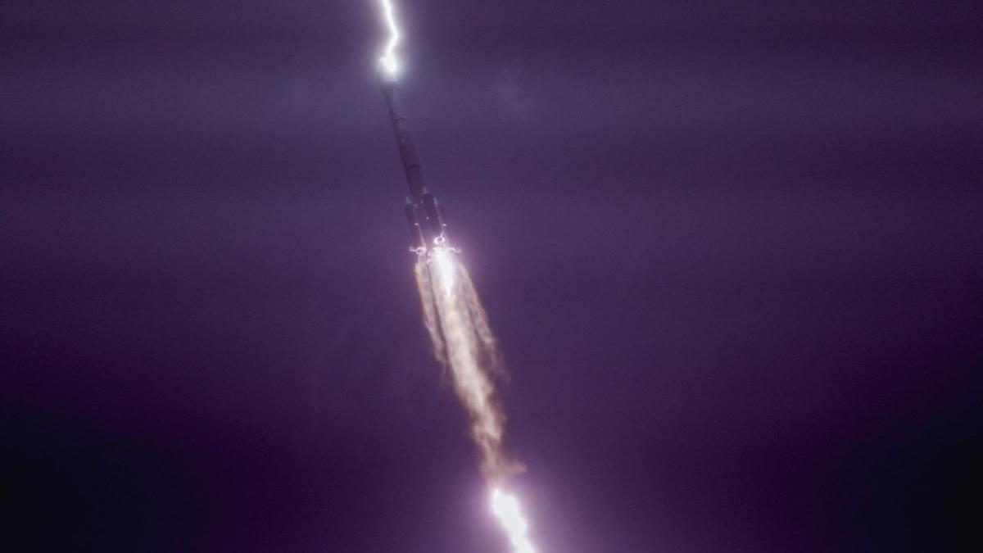
Click for next article A Long March-3B carrier rocket carrying the Tianlian II-06 satellite blasts off from the Xichang Satellite Launch Center on July 23, 2026 in Xichang, Sichuan Province of China. (Image credit: Zhou Quan/VCG via Getty Images) Lightning struck a Chinese rocket shortly after liftoff this week, as seen in incredible video and photographs. A Long March-3B rocket lifted off from China's Xichang Satellite Launch Center on Thursday (July 23) carrying a communications relay satellite destined for geostationary orbit. Some 30 seconds into flight, lightning struck the rocket, leading to awestruck cries from crowds gathered nearby to watch the launch. Despite the strike, the rocket delivered the satellite to its intended orbit as planned, according to the China Aerospace Science and Technology Corporation (CASC). The satellite will help relay communications to the nation's Tiangong Space Station and other crewed missions. This isn't the first time lightning has struck a rocket shortly after liftoff. A lightning bolt famously struck the Saturn V rocket carrying NASA's Apollo 12 mission, the second to ever land astronauts on the moon. In fact, the rocket was struck twice. According to a report NASA issued after the mission, some non-essential instruments and sensors experienced "permanent effects" from the strikes. Nevertheless, the mission put astronauts Charles "Pete" Conrad, Alan Bean and Richard "Dick" Gordon on the moon as planned. More recently, lightning struck a Russian Soyuz rocket in 2019 shortly after it launched. Like in this most recent example, the vehicle was able to place its Glasnost communications satellite in orbit despite the strike. Une fusée Longue Marche 3B vient de se prendre la foudre peu après son décollage de Xichang.Ce n'est pas la première fusée à subir ça, la Saturn V et la Soyouz-2 ont été aussi foudroyées par exemple. Aucun échec n'est lié à la foudre... pour l'instant.pic.twitter.com/vrAqaGAnnCJuly 23, 2026 But not all rockets struck by lightning fare so well. In 1987, a bolt struck the United Launch Alliance Atlas/Centaur-67 rocket, leading to a malfunction in one of the computers that guided the vehicle and "ultimately causing the breakup of the vehicle," NASA wrote in a report of the incident .

40. Super Heavy-Starship rocket chalks up mostly successful test flight
Read more
SpaceX launched it's 13th Super Heavy-Starship rocket Friday, with the giant booster chalking up an on-target but "hard" splashdown off the Texas Gulf Coast while the Starship upper stage carried out a successful sub-orbital hop to the Indian Ocean. Powered by 33 methane-fueled Raptor engines, the 397-foot-tall two-stage rocket blasted off from SpaceX's "Starbase," Texas, launch site at 5:51 p.m. EDT, putting on a spectacular show for area residents and tourists as it climbed away atop some 16 million pounds of thrust. A launch attempt July 16 ended with a last-second computer-commanded abort when four Raptors failed to start properly. Those issues were addressed and the launch was reset for Thursday, only to have low clouds prompt a 24-hour delay. But the weather cooperated Friday, all 33 first stage engines fired up normally and the rocket thundered away through a mostly clear sky. It was the second test flight of a third-generation Super Heavy-Starship, building on lessons learned during the initial flight of a "V3" rocket in May when the booster missed its landing target and the Starship suffered an early engine shutdown on the way to space. This time around, the booster appeared to perform as planned throughout its ascent and again during its flip around for a tail-first descent to splashdown after separating from the Starship upper stage. But as the booster dropped toward the Gulf, only 10 of 13 engines restarted and at the moment of splashdown, only five appeared to be running. The stage hit the water at a higher velocity than expected, making a "hard" splashdown. The booster is designed to fly itself back to its launch gantry where huge mechanical arms, known as "chopsticks," can pluck it out of mid air. But for the initial flights of the third-generation rocket, But that requires a relatively slow final descent, For good reason, it now appears, SpaceX opted for initial version 3 splashdowns in the Gulf as a safety precaution. The Starship upper stage, meanwhile, completed its climb to space with all six of its Raptor engines operating smoothly. Once coasting along its sub-orbital trajectory, the Starship deployed 20 third-generation Starlink internet satellites in a real-world test of the rocket's Pez-like payload dispenser, releasing the satellites one at a time from a slot near the nose of the vehicle. Six of those satellites were equipped with cameras to inspect the Starship's heat shield tiles and general condition to help engineers assess the usefulness of such video for determining the health of future Starships before re-entry. In a final test, the Starship briefly re-ignited one of the Raptor engines to demonstrate its ability to re-start in space, which will be required for future flights to the moon. The spacecraft then faced the blazing heat of a belly-first re-entry before flipping upright and settling to a dramatic rocket-powered splashdown northwest of Australia one hour and five minutes after launch. The Starlinks, on the same sub-orbital trajectory as the Starship, were expected to fall back into the atmosphere and burn up, or as SpaceX puts it, "demise," before reaching the sea. Engine issues aside, the Starship's performance was welcome news to NASA, which is counting on a variant of the upper stage to serve as a lunar lander for astronauts in the agency's Artemis program. For moon missions, SpaceX will need to launch up to 15 or so Super Heavy-Starship tankers to refuel the lander before it can head for the moon to await the arrival of astronauts in a Lockheed Martin-built Orion capsule. From there, the 165-foot-tall lander will carry two crew members down to the surface, landing vertically near the moon's south pole. The astronauts then will ride an external elevator down to the surface and back up again when their exploration is complete. With the first such landing targeted for 2028, SpaceX must ramp up its Super Heavy-Starship test schedule to get the vehicle certified for human spaceflight and to demonstrate the reliability required to safely launch more than a dozen tankers within days of the lander's launch. As of now, the moon lander variant has not yet flown and no Starship of any kind has yet been put into Earth orbit. Many NASA veterans have criticized the complexity of the mission architecture and the number of flights that will be needed to get a single lander to the moon. The Government Accountability Office said in a report released Thursday that SpaceX faces major challenges getting the Super Heavy-Starship ready for operational use. "SpaceX's progress in developing its cryogenic fuel management technologies is a top risk for the program," the GAO said. "At present, SpaceX's plan for (moon missions) requires on-orbit propellant transfer between multiple Starship vehicles in low-Earth orbit before the HLS (Human Landing System) Starship can be sent to and dock with the Orion spacecraft in lunar orbit." Another concern is completing development of the upgraded Raptor engines, "addressing issues identified through testing." "Furthermore, SpaceX is more than a year behind its original schedule for key events," the GAO said. "These include the critical design review, the long duration and propellant transfer demonstrations and the uncrewed lunar landing flight test." The agency said moon lander officials "also stated that they anticipate encountering technical challenges in the development of the third version of the Starship vehicle, which SpaceX plans to use for the first Starship orbital test flights." NASA managers are hedging their bets. Blue Origin, owned by Amazon-founder Jeff Bezos, also is working on moon landers for NASA to carry both cargo and Artemis astronauts to the lunar surface. The spacecraft will be launched by the company's New Glenn rocket. That lander, too, will require refueling in space. If the Starship lander isn't ready in time to meet NASA's landing target, agency may be able to use Blue Origin's lander instead. But during preparations to test fire the main engines of the third New Glenn rocket, the launcher exploded in a spectacular fireball, virtually vaporizing the rocket and seriously damaging its pad. The company hopes to resume test flights by year's end, but few details have been provided. In the meantime, NASA is pressing ahead with preparations for an interim Artemis flight next year in low-Earth orbit. Four astronauts will be launched in an Orion capsule to test the rendezvous and docking procedures that will be needed in lunar orbit for a moon landing mission. The crew will dock with a Blue Origin lander, open hatches and float inside as part of the test flight. They then will rendezvous and dock with a Starship. But in that case, a modified production model will be used instead of an actual moon lander. It will have no crew accommodations and the astronauts will not go inside.

41. UK in pole position to lead key instrument in NASA's hunt for Earth-like worlds
Read more

UK astronomers are a step closer to playing a leading role in NASA's search for alien life in the coming decades as they continue developing one of the core instruments of the Habitable Worlds Observatory (HWO). The exciting mission-the U.S. space agency's next flagship space telescope after the Nancy Grace Roman Space Telescope-is expected to launch in the 2040s.

42. Could hydrogen fuel aviation by 2050? NASA-backed study evaluates five alternatives
Read more
NASA-backed researchers have identified five alternative aviation fuels that could help meet rising jet fuel demand over the next 25 years. Their latest analysis argues that expanding beyond conventional Jet A and Jet A-1 could strengthen domestic fuel supplies and reduce reliance on imported oil. The study comes as airlines prepare for a sharp increase in fuel consumption worldwide. Researchers also point to growing concerns over supply constraints and price volatility in traditional jet fuel markets. SAF closest to scale The National Laboratory of the Rockies (NLR) evaluated sustainable aviation fuel (SAF), liquid hydrogen, liquefied natural gas (LNG), liquefied ethane, and an experimental fuel called Jet X. NASA funded the report, which examines each fuel's production potential, technical readiness, and infrastructure needs. Researchers project global jet fuel demand will increase from just over 100 billion gallons in 2025 to 165 billion gallons by 2050. That forecast has renewed interest in fuels that can be produced using domestic feedstocks and electricity instead of imported crude oil. SAF remains the most mature option in the report. Airlines can already blend it with conventional Jet A fuel at concentrations of up to 50% without modifying existing aircraft or airport infrastructure. Most commercially available SAF comes from used cooking oil, animal fats, greases, and alcohol-based feedstocks. Scientists are also developing production methods that use algae, biomass, and municipal waste. Despite reaching the commercial market in 2016, SAF still accounts for only about 1% of global aviation fuel use. High production costs and limited biorefining capacity continue to slow wider adoption. NLR estimates available feedstocks could eventually support production of roughly 132 billion gallons of SAF annually. That volume would meet about 80% of projected global jet fuel demand in 2050 if production capacity expands. "The transportation fuel market is a global one," said Kristi Moriarty, senior vehicle and infrastructure analysis researcher at NLR. Government decisions influence whether companies invest in new SAF plants and production pathways, she added, noting faster deployment would be needed to satisfy future demand. Cryogenic fuels emerge The report also examines liquid hydrogen, LNG, and liquefied ethane, which belong to a group known as cryogenic fuels. These fuels must remain in insulated tanks at very low temperatures to stay in liquid form. None of them can replace Jet A in today's aircraft. Airports would need new fueling systems, aircraft manufacturers would have to certify new designs, and regulators would need global standards for handling and distribution. Researchers still see significant long-term potential. Liquid hydrogen offers high energy relative to its weight and produces no carbon emissions during flight, making it attractive for future regional aircraft. Several aerospace companies are already developing hydrogen-powered aircraft and propulsion systems. The Federal Aviation Administration is also working with NLR to prepare airports for future hydrogen operations. LNG could provide another lower-cost option because the United States has abundant natural gas resources. Liquefied ethane remains largely experimental, although researchers say it offers greater energy density than LNG and production continues to increase. Jet X remains experimental Jet X sits much earlier in development than the other fuels. Researchers are studying new liquid hydrocarbon chemistries that could improve fuel economy, reduce harmful aromatics, improve local air quality near airports, and limit contrail formation. The report says years of additional testing will be needed before Jet X can demonstrate compatibility with aircraft engines, airport equipment, and fueling infrastructure. Researchers believe continued work across multiple fuel pathways will give the aviation industry greater flexibility as demand continues to rise.
43. ISRO Recruitment 2026 Notification Out for 242 Assistant, UDC, JPA, and Steno Posts, Application Dates, Eligibility - Adda247
Read more
ISRO Recruitment 2026 Notification Out for 242 Assistant, UDC, JPA, and Steno Posts, Application Dates, Eligibility Adda247

44. Jitendra Singh congratulates ISRO for successful completion of IADT-02 for Gaganyaan Mission - DD News
Read more
Union Minister Dr Jitendra Singh on Friday congratulated Indian Space Research Organisation (ISRO) for the successful completion of the Second Integrated Air Drop Test (IADT-02) for Gaganyaan, India's first human spaceflight mission scheduled for launch in 2027. He described the achievement as a significant milestone in preparing for the ambitious mission. Taking to social media platform X, Singh wrote, "Congratulations ISRO for the successful accomplishment of Second Integrated Air Drop Test (IADT-02) for Gaganyaan, India's first Human Space flight scheduled next year." He further noted, "The second Integrated Air Drop Test (IADT-02) was successfully conducted at Satish Dhawan Space Station, Sriharikota. This marks an important milestone towards the readiness for the Gaganyaan mission." India's first human spaceflight will be launched from Sriharikota in 2027. Although the mission has faced multiple delays due to its technological complexity, India has been developing the capabilities indigenously. Notably, such critical spaceflight technologies are closely guarded, and no country shares them. The government has allocated approximately Rs 10,000 crore for the Gaganyaan programme. The mission is now in its final phase, with the first crewed flight expected in the first quarter of 2027. Earlier, on April 8, ISRO Chairman V. Narayanan stated that all preparations for the uncrewed Gaganyaan missions are progressing smoothly. Speaking at the inaugural session of the 2nd International Conference on Smart Spacecraft Mission Operations, he said, "We are meeting just before the first uncrewed Gaganyaan mission. This is no ordinary mission but a crucial one for India. There will be three uncrewed missions before the final crewed launch. All activities for the first mission are progressing well, though challenges remain." The conference was also attended by former ISRO chiefs A.S. Kiran Kumar and S. Somanath, along with ISRO centre directors, students, and representatives from space startups. Meanwhile, India's human spaceflight preparations advanced further on April 4, as four selected astronauts began a high-altitude experiment in Ladakh under the "Mission Mitra" (Mapping of Interoperable Traits and Reliability Assessment). The programme aims to evaluate human performance in extreme environments. The astronauts, including Group Captain Shubhnashu Shukla and P. Balakrishnan Nair, arrived in Leh earlier this week for acclimatisation. The mission is supported by a multidisciplinary team of scientists, engineers, medical experts, and psychologists, marking another crucial step in India's journey towards human space exploration. -IANS

45. Opinion | Vikram-1: Launches India's Private Space Revolution - The Global Kashmir
Read more

The historic mission reflects the rise of startups, bold reform, and India's ambition to become a global space powerhouse India's space program has earned much admiration through its ability to accomplish a great deal with few resources. Through the launching of satellites to other countries and successful Chandrayaan and Aditya programs, the country has made a name as a dependable and innovative space entity. At the moment, the Indian Space Future program is taking a new direction in which private organizations will be involved in shaping the future space endeavours. With the forthcoming launch of the first privately designed and developed orbital rocket called Vikram-1 in the country by Skyroot Aerospace, there is much to celebrate in India's space program. The launch of the rocket is a product of good policy decisions that have made it possible for India's space industry to accommodate entrepreneurs and startups. From Government Monopoly to Private Participation Over the past few decades, ISRO had been involved in almost all the space-related operations in India. Although this approach resulted in international success stories, increasing demands for satellite launches and other space technologies pointed out the need for higher involvement of private companies. The Indian government understood this necessity, and the process of changes began. The Indian Space Policy 2023 was adopted as the key document of this revolution. The document regulated the tasks of ISRO, private companies, and governing bodies but provided an opportunity for the involvement of non-government entities in all stages of the value chain of the space industry. These reforms have shifted India's space sector from being government-driven to innovation-driven, encouraging healthy competition and attracting new investment. The Rise of India's Space Startups Among many other signs of such changes is the tremendous expansion of India's startup environment. For instance, as recently as 2014, India had just one start-up space firm. Now, however, the number has reached 400+, placing India among the leading nations in terms of space start-up growth. Some of the start-ups work on innovations such as reusable rocket launchers, satellite construction and launch facilities, new propulsion systems, earth observation, communication systems, and space technologies based on artificial intelligence. Moreover, jobs have been created in engineering, research, software development, and entrepreneurship. The expansion of the startup ecosystem demonstrates that India's space programme is no longer limited to government laboratories but has become a vibrant innovation economy. Vikram-1: A Historic Private Launch Of the new private sector ventures that have been launched, Skyroot Aerospace has emerged as a forerunner. Its Vikram-1 launch vehicle has been aptly named after Dr Vikram Sarabhai, the father of India's space program. This new launch vehicle can be used to launch payloads weighing up to 350 kg into LEO orbit. Vikram-1 uses cutting-edge technology in combination with indigenous innovation in its design, which includes use of lightweight carbon composites, efficient solid fuel propulsion, and 3D-printed liquid engines. The first launch mission of the Vikram-1 launch vehicle has been named Mission Aagaman. This mission will use Vikram-1 to launch multiple payloads for different customers. Policies That Made the Impossible Possible The success of Vikram-1 has much to do with the changes in policy that have taken place in recent years. The creation of the Indian National Space Promotion and Authorization Centre (IN-SPACe) has resulted in a one-stop regulatory environment for private firms. IN-SPACe allows startups to make use of ISRO's launch pad, test sites, expertise, and scientific knowledge. Private companies no longer need to start from scratch and can work in collaboration with Indian space organizations, saving time and money. Innovation has been boosted in this way, and at the same time, the scientific knowledge of the nation has been utilized by all players. Fueling Innovation Through Financial Support Apart from innovation, funds are also necessary for innovation to take place. Acknowledging the same, the government has taken up various programs for helping budding firms in the space industry. The IN-SPACe Seed Fund Scheme offers early-stage funding opportunities to innovative startups working on technological innovation. Technology Adoption Fund (TAF) is used for turning research work into commercially feasible technology. Further, ₹1,000 crore Venture Capital Fund is being offered as an encouragement for private sector participation in the space technology sector. Opening India's Space Sector to Global Investment Another major reform that has taken place is in FDI regulations. With foreign firms having more involvement in satellite manufacturing and launch mechanisms and other associated technology sectors, India will prove to be a very inviting destination for foreign investors. Such reforms will ensure that capital inflows will increase, there will be better technology flow and partnership building, and most importantly, India will be more competitive in the international space business scenario. With demand for cheaper satellite launch services growing internationally, India is poised to tap into this sector. Building a Thriving Commercial Space Economy India's ambitions regarding space have gone well beyond just exploring outer space. Now, commercialisation of space has become one of the pillars of India's space policy. NewSpace India Limited (NSIL), which is the commercial arm of ISRO, has taken the responsibility of technology transfer, satellite launch and partnering with private industry. With the cooperation of ISRO and Indian firms, India's scientific successes can be converted into business success as well as enhancing the industrial capability of the nation. The value of India's space economy presently is around USD 8.4 billion, but in 2030, India's space economy will touch the mark of USD 40 - 45 billion, while in 2040, the economy will be worth USD 100 billion. More Than a Rocket: A Symbol of New India Vikram-1 represents far more than a technological accomplishment. It reflects the confidence of Indian entrepreneurs, engineers, scientists, and policymakers who have worked together to create a supportive environment for innovation. The mission demonstrates that India's future in space will not rely solely on government agencies but on strong partnerships between public institutions, private enterprises, startups, and investors. It showcases the country's ability to transform policy reforms into tangible technological achievements. The Road Ahead With Vikram-1 set for takeoff, there are high hopes that this rocket symbolizes a nation committed to emerging as a leader in space technology. Policy backing, research funding, international partnerships, and fostering private-sector innovations will be important in keeping this momentum going. From just one space start-up in 2014 to the current count of over 400, the success of such visionary policy reforms is demonstrated. Vikram-1 therefore not only marks the launch of the first privately designed orbital rocket in India; it marks a new era altogether. This is an era in which innovation meets opportunities and entrepreneurship goes hand-in-hand with science. The Author is a writer, social educator and researcher from District Baramulla, Jammu and Kashmir, India, and holds a master's in Gender Studies and a BED. Writes on social issues, education, and gender perspectives, promoting awareness, inclusive development and positive change. shoaibhat2018@gmail.com

46. India becomes third country to joins China, US in commercial space race with Skyroot launch - Qatar Tribune
Read more

Agencies London India's first privately developed orbital rocket has given the country's fledgling commercial space industry a long-sought proof point, but analysts say Skyroot Aerospace must now show it can launch regularly, cheaply and reliably enough to win customers in a crowded global market. Skyroot's Vikram-1 rocket lifted off on Saturday from the Satish Dhawan Space Centre in Sriharikota in the southern Indian state of Andhra Pradesh, carrying several customer payloads and in-orbit experiments on its maiden orbital mission, called "Mission Aagaman". The rocket injected its payload into a 450km (280-mile) orbit on its first attempt, making India the third country to achieve orbital launch capability through private enterprise, after the US and China. The milestone drew comparisons on social media with SpaceX's Falcon 1, which reached orbit only on its fourth attempt. It was also seen as a step forward in India's ambition to grow its space economy from about $8.4 billion to $44 billion by 2033, targeting about 8 percent of the global market. For decades, the state-run Indian Space Research Organisation (ISRO) was virtually the only major player in the country's space sector. Experts said the launch was significant, but Skyroot still had a long way to go before it could turn a successful test into a commercial business. "They will have to undertake one or two more launches before they declare the system operational. After the system becomes operational, the Vikram-1's rocket launcher system, then only then can they attract the market globally," Ajay Lele, a space expert, told India's state-run broadcaster Doordarshan. Indian Prime Minister Narendra Modi and opposition leader Rahul Gandhi both hailed Skyroot's achievement, which was delivered by a team whose average age was 28, according to local media reports. "Knowing just how hard this is, I couldn't contain the excitement at Mission Control as the rocket we built with so many dreams successfully inserted satellites into orbit - on its very first attempt," Pawan K Chandana, chief executive of Skyroot, wrote on social media. Chandana co-founded the company with Naga Bharath Daka in 2018, and both are former ISRO scientists. UK-based astrophysicist Peter Hague congratulated the young Skyroot team on social media, noting that the rocket "leapt off the pad quickly" and delivered the payload to orbit despite having a "bit messy" moment at one stage of the flight. The Indian mission comes amid intensifying competition in the global small-satellite launch market, where start-ups are trying to challenge incumbents led by Elon Musk's SpaceX. Small satellites are used for communications, Earth observation, research, internet-of-things networks and technology demonstrations. Customers often seek either low-cost ride-share slots or dedicated launches to precise orbits. Over the last seven to eight years, SpaceX has launched thousands of small satellites into orbit, both for its own Starlink constellation and for customers through its dedicated SmallSat Rideshareprogramme. Despite the challenging path ahead, Lele said Skyroot's success was particularly important, noting that Japanese companies had failed in attempts to put a payload into orbit over the past few years. India opened its space ‌sector to private investment in 2020, allowing start-ups to build rockets, satellites and launch services - activities that were for decades provided by the ISRO. The country now has more than 400 space start-ups, according to local media reports. India was the first Asian nation to place a spacecraft into Mars orbit in 2014. Three years ago, it achieved a soft landing on the moon, becoming only the fourth country to do so. "Skyroot is positioning itself as a 'space taxi' for dedicated small-sat launches into precise orbits, exactly where global demand outstrips supply," said Srinivasan Balakrishnan, director of strategic engagements and partnerships at the Delhi-based think tank Indic Researchers Forum. "With 70-80 per cent of future payloads expected from overseas such as the US, Europe and Southeast Asia, a successful cadence could generate millions per launch." Balakrishnan said launching satellites set in motion a "virtuous cycle" for more investment in India's space industry, such as for satellite manufacturing, ground systems and data analysis. Early revenues, such as those for propulsion components, had already started flowing in, he added. Another Indian company, Agnikul Cosmos, is actively planning and developing launch vehicles specifically designed to put small satellites into space. Its flagship launch vehicle, Agnibaan, is a highly customisable, orbital-class rocket engineered to carry payloads of up to 500kg to low Earth orbit. A proven private launch capability also strengthened India's strategic autonomy, feeding into a government drive to become self-reliant even for defence technology, Balakrishnan said. "It won't replace dedicated military systems overnight, but it adds resilience and innovation speed, much like how private players bolster supply chains elsewhere," he said.

47. We talk with astronaut Michael Foale about the 1997 Space Station Mir crisis: 'He took all the blame of the collision on his shoulders'
Read more
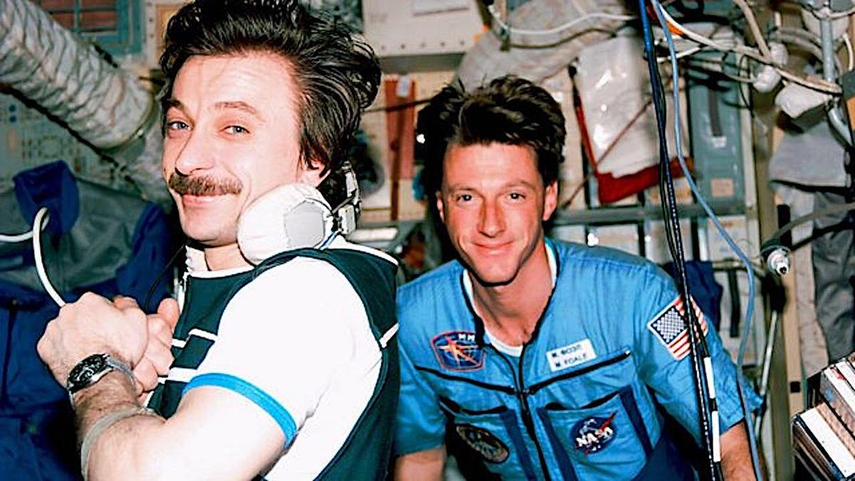
Click for next article ONCE UPON A TIME IN SPACE | Clip | Fix the Ship - YouTube Watch On All systems are go! PBS just launched the second episode of its " Once Upon a Time in Space " miniseries on Tuesday, titled "The Russian Thing," and we've got an exclusive clip from the harrowing chapter that focuses on near disasters aboard the Space Station Mir in 1997. In addition to the video, we're also proud to share an exclusive interview with NASA's celebrated British-American astronaut Michael Foale , who is featured prominently in the new segment regarding the infamous cargo pod collision on Mir, which caused a decompression incident that became a life-threatening crisis. Hailing from British filmmaker James Bluemel and his crew that delivered the award-winning "Once Upon a Time in Northern Ireland," " Once Upon a Time in Space " is a 4-part exploration of human spaceflight. Its weekly episodes trace pivotal events in spacefaring history via the personal experiences of astronauts, cosmonauts, and loved ones left on Earth from the birth of the Space Shuttle program to the blossoming of today's commercial spaceflight industry. Preview - Once Upon a Time in Space - YouTube Watch On "James Bluemel is a very perceptive director, and he was different from others that have interviewed me," Foale tells Space. "What I loved about his method was he would dig up clips from our training or at different points when I was a brand new astronaut, looking really young and had a surfer boy haircut. I love windsurfing. He would dig up clips I don't know where from. And then he'd show it to you, and then he'd say, 'What do you think?'" Foale - a distinguished veteran of six space missions who retired in 2013 - takes us back to that day of May 25, 1997, when a manual docking maneuver caused an unmanned Progress cargo ship to collide with Mir, ripping a large hole in the Russian space station's Spektr module. The crew's valiant attempt to halt the pressure leak and save the station is like something straight out of a Hollywood thriller. With only 23 minutes of oxygen left, Foale and cosmonauts Vasily Tsibliev and Alexander 'Sasha' Lazutkin were able to repair the damage and stop the tumbling spacecraft from spinning wildly out of control. "The root cause of the accident was trying to save money," he explains. "And the root cause was an attempt to do a manual docking from a large distance longer than any cosmonaut or astronaut does a manual docking from and doing it without the radar. The radar was built in Ukraine and cost $2 million in that timeframe. And the Russian managers did not want to pay Ukraine $2 million. "So someone in the Energia corporation - they're the guilty company - decided they would try and get this crew at the last minute to try and do a manual rendezvous and docking without the radar from about a six-kilometer starting point. And that test was with a Progress we'd already filled up with trash and was meant to be de-orbited into the Pacific Ocean. Before it was going to be de-orbited finally, it was going to do this test." (Image credit: PBS) Unfortunately, that test went horribly wrong due to Vasily Tsibliev not being able, based on measurements he could make in real time, to determine the exact closing velocity of the Progress. "He couldn't ascertain distance very well, but you need the distance first, and then you need to divide by time to get the velocity," notes Foale. "That was not possible in that situation and never attempted again. It caused a much higher velocity than Vasily could extinguish using the one thruster set that were turned on the Progress. "So it bounced off, literally bounced off after crumpling part of the Spektr module and bending one of the solar arrays. The joint cracked at the base of the solar array into the module, and that's where the unseen hole is or was. And that's where the air was leaving from. It was a multiple hit that caused it to float away. And we were told as a crew about three days later, because we asked what had happened to it. They said, 'Well, engine was capable of being fired. It was capable of reorienting itself, and it de-orbited into the Pacific.'" The Soviet space station Mir before being de-orbited in 2001 (Image credit: NASA) In the aftermath of the collision, an adapter was sent up to try and connect power back from the Spektr module into the Mir system. "Vasily and Sasha were planned to do an internal spacewalk into the Spektr module to get to those cables that Sasha and I had had to disconnect to save the station," Foale adds. "They were going to go back in during an internal EVA. Vasily, because of the stress of the event, didn't pass the medical test done before the spacewalk, and they wire you up for a heart monitor. "So then a day later, a call came up from the head of the program, Valery Ryumin, saying, 'Oh, Michael, you're on the radio. I'm going to ask you, would you be willing to go in and do the spacewalk inside the Spektr module instead of Vasily?'", remembers Foale. "I just knew that that was going to create a huge issue with me and Vasily because it was so humiliating for him. And he took all the blame of the collision on his shoulders, which was unfair." Foale retired from NASA and space travel after a brilliant 30-year career with the agency and six space shuttle missions, but the lifestyle adjustment was a bit troubling at first. Alexander 'Sasha' Lazutkin (L) and Michael Foale (R) aboard Mir (Image credit: NASA/BBC/PBS) "That was a depressing moment when I was being told, 'Oh, you're done,'" he shares. "I knew I couldn't survive the envy of my astronaut colleagues who are younger than me and haven't flown but once or twice. So I knew I was kind of done in space, at least with NASA. I was dreaming of being an astronaut guide like Peggy Whitson or Michael Lopez-Alegria on an Axiom mission. Those were my daydreams initially. I miss space, but I've found other things to replace that fun. "I've always been turned on emotionally and romantically by soaring and flying. So living in Texas amongst the mountains with fantastic stars every night and soaring here, it's not space. It's not in a spacesuit outside the Mir looking at it, but it's pretty cool. I do go back to a much more comfortable situation in the evening, and I do ride my bike. "As a 69-year-old now, I have a pretty good late-life pastime. But you have to make do. And hey, you have to keep telling yourself you're one of the luckiest guys around. I would say I was naively optimistic about the international collaboration in space. The show that James Bluemel has put together, "Once Upon a Time in Space," in some ways it looks like a fairytale to me when I look back on it."

48. NASA astronaut, 2 cosmonauts returning to Earth on July 26: Watch it live
Read more

Click for next article NASA Astronaut Chris Williams Soyuz MS-28 Re-entry and Landing - YouTube Watch On A U.S.-Russian crew returned to Earth from the International Space Station early Sunday morning (July 26), after 241 days in orbit. A Soyuz spacecraft carrying NASA astronaut Chris Williams and Sergey Kud-Sverchkov and Sergei Mikaev of the Russian space agency Roscosmos undocked from the orbiting lab on Sunday at 3:03 a.m. EDT (0703 GMT). The Soyuz, known as MS-28, landed on the steppe of Kazakhstan 3 hours and 24 minutes later, at 6:27 a.m. EDT (1027 GMT). Roscosmos' Soyuz MS-28 spacecraft is seen as it lands in a remote area near the town of Dzhezkazgan, Kazakhstan with Expedition 74 NASA astronaut Chris Williams and Roscosmos cosmonauts Sergey Kud-Sverchkov, and Sergei Mikaev aboard, on Sunday, July 26, 2026. (Image credit: NASA/Bill Ingalls) The crew's departure activities began on Saturday morning with a change-of-command ceremony aboard the International Space Station (ISS). Kud‑Sverchkov handed over the reins of the orbiting lab to NASA astronaut Jessica Meir , part of the transition from ISS Expedition 74 to Expedition 75 (which officially began when Soyuz MS‑28 undocked). The crew then gave their farewells and closed the hatches between the ISS and Soyuz MS-28 on Saturday night. NASA astronaut Chris Williams, left, Roscosmos cosmonaut Sergey Kud-Sverchkov, center, and Roscosmos cosmonaut Sergei Mikaev are seen inside the Soyuz MS-28 spacecraft after they landed in Kazakhstan on Sunday, July 26, 2026. (Image credit: NASA/Bill Ingalls) Soyuz MS-28 launched to the ISS on Nov. 27 , which was Thanksgiving Day. That liftoff kicked off the first space mission for Williams and Mikaev and the second for Kud‑Sverchkov, who now has logged 426 days and 9 minutes in space. The MS-28 trio orbited Earth 3,856 times and traveled a total of more than 102 million miles (164 million kilometers).

49. SpaceX Falcon 9 launches Starlink satellites from West Coast
Read more
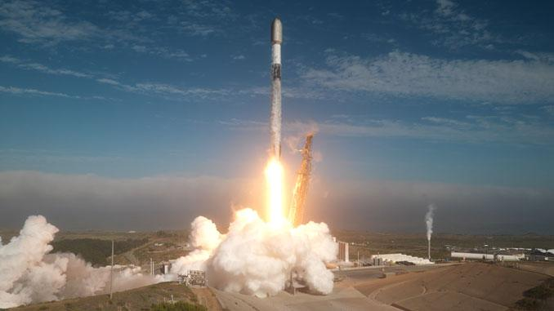
A SpaceX Falcon 9 launched from the West Coast Saturday, carrying another batch of satellites for the company's Starlink internet service. Liftoff from Vandenberg Space Force Base in California occurred at 8:51 a.m. PDT (11:51 a.m. EDT / 1551 UTC). The Falcon 9 look a southerly trajectory on departure from Space Launch Complex 4E, as it targeted an 97-degree inclination orbit. The Falcon 9 first stage booster, launching for an eighth time, touched down on the droneship, 'Of Course I Still Love You', stationed about 380 miles downrange in the Pacific Ocean. The booster, B1100, previously launched the NROL-105 mission for the US government spy satellite agency and six previous Starlink missions. SpaceX confirmed a successful deployment of the 24 Starlink V2 Mini satellites from the Falcon 9 second stage into a 168 x 160-mile orbit just over an hour into the mission. The Starlink 17-51 mission was the seventh of eight planned Falcon 9 launches this month from Vandenberg. SpaceX's West Coast pad has become the company's workhorse launch facility in recent months as it focuses on Starship preparations in Florida. By comparison, four Falcon 9 missions have flown from Space Launch Complex 40 at Cape Canaveral in July so far and one more is planned.

50. SpaceX launches Starship on another test flight, this time with the most advanced Starlinks
Read more
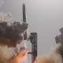
SpaceX's mammoth Starship rocket blasted off Friday on another test flight stretching halfway around the world, this time releasing 20 of the most advanced Starlinks.

51. Starship launches Starlink satellites, achieves most successful splashdown yet
Read more

SpaceX has completed another major milestone in the development of its fully reusable Starship launch system, successfully deploying the first batch of next-generation Starlink V3 satellites during the rocket's 13th integrated flight test while returning the upper stage in what appears to be its most controlled splashdown to date. Launched from Starbase, Texas, the roughly 122-meter (400-foot) rocket completed several key objectives, including deploying 20 Starlink V3 satellites, relighting a Raptor engine in space, and gathering extensive data during atmospheric re-entry. Although the Super Heavy booster failed to complete a soft water landing after multiple engines did not reignite, the mission nevertheless marked another significant step toward SpaceX's long-term goal of a fully reusable launch system. First operational Starlink deployment from Starship According to SpaceX, Flight 13 was the first Starship mission to deploy operational Starlink V3 satellites rather than mass simulators used during earlier test flights. The mission released 20 satellites while following a suborbital trajectory, allowing engineers to validate the vehicle's payload deployment system under realistic flight conditions. The satellites briefly established contact with the existing Starlink network before re-entering Earth's atmosphere and burning up as planned, since the mission was designed to test deployment procedures rather than place the spacecraft into operational orbit. Reuters noted that the upgraded Starlink V3 satellites are expected to provide greater bandwidth and support future capabilities such as direct-to-cell connectivity. A smoother return through Earth's atmosphere One of the mission's biggest successes came after payload deployment. SpaceX carried out another demanding atmospheric re-entry campaign, including an in-space Raptor engine relight and a controlled descent into the Indian Ocean. The company intentionally flew the vehicle through challenging re-entry conditions to collect data on its thermal protection system, flight controls, and structural performance. SpaceX reported that Flight 13 resulted in Starship's "softest splashdown ever," with the vehicle remaining largely intact after touchdown. The publication also noted that improvements to the heat shield were evident, despite engineers deliberately testing the system under increasingly demanding conditions. Booster recovery remains a work in progress Not every objective was achieved. During its return toward the Gulf of America, the Super Heavy booster experienced engine restart problems that prevented a fully controlled splashdown. According to SpaceX, some of the booster's engines failed to reignite during the landing burn, causing the first stage to impact the water harder than planned. While the booster was lost, SpaceX has repeatedly emphasized that Starship's flight-test campaign follows an iterative development strategy in which every mission is intended to gather engineering data rather than achieve operational perfection. The company described Flight 13 as another opportunity to evaluate vehicle performance across ascent, stage separation, payload deployment, and re-entry. Building toward fully reusable spaceflight Beyond testing the rocket itself, Flight 13 also demonstrated Starship's growing role in SpaceX's future launch architecture. Successfully deploying operational Starlink satellites, validating in-space engine relight, and returning the upper stage largely intact represent important steps toward routine Starship missions. The vehicle is expected to become the primary launcher for future generations of Starlink satellites while also supporting NASA's Artemis lunar program and, eventually, SpaceX's long-term ambitions for Mars exploration. Although challenges remain, particularly recovering the Super Heavy booster, Flight 13 demonstrated measurable progress across several of the program's most important technologies. With each successive test, Starship continues moving from experimental prototype toward the fully reusable heavy-lift launch system SpaceX believes will support its next generation of commercial, lunar, and interplanetary missions.

52. China possibly making new class of stealthy attack submarine, satellite images suggest
Read more

New satellite imagery has been released that appears to show what analysts believe is a new kind of Chinese submarine. Captured by BlackSky back in May of this year, the new attack submarine appears to be under construction at the Jiangnan Shipyard in Shanghai. Concrete details on it are thin on the ground, but analysts believe it could be an improved version of China's existing Type 093 "Shang" class. If true, this would represent another step in China's modernization of its undersea capabilities. From what can be gathered, the new submarine appears to have a smaller conning tower than the Type 093, and appears to be shorter. The smaller tower could be significant as it could reduce drag and turbulence when submerged. This would, in turn, reduce its acoustic signature, making it more stealthy. Hull design is also just one part of a vessel's design. If the idea is to make it more acoustically stealthy, then the submarine would likely also feature other refinements like vibration isolation, anechoic coatings, sonar arrays, etc. New Chinese submarine spotted If true, this would make the submarine considerably harder to detect and track using things like passive sonar. For potential rivals in theatres like the Indo-Pacific, it could, in theory, thwart detection efforts from P-8 "Poseidon" aircraft, seabed sensor networks, etc. This would feed into China's anti-access/area-denial strategy within its sphere of influence. "Its role may be to silently approach U.S. aircraft carriers underwater and launch attacks," former Vice Admiral Masao Kobayashi, who served as commander of the Japan Self-Defense Forces' submarine fleet, told Asahi. In reality, this translates to making it riskier for Western navies to operate near Taiwan or the South China Sea in general. If this new submarine is as quiet as believed, it could, in theory, stalk and potentially attack U.S. carrier strike groups. Reduced drag would also translate into higher speeds when submerged, and much improved energy efficiency. That would enable it to travel further and operate for longer between resupply. According to reports, the submarine appears to be around 393 feet (120 meters) long and 33 feet (10 meters) wide. It would also be just the latest in new submarines developed and launched by China in recent years. Between 2021 and 2025, Asahi explains, China has deployed an estimated ten submarines, with a total displacement of around 79,000 tons between them. Beyond that, analysts are somewhat split on how to classify the new submarine. New class or improvement? Some believe it to be an entirely new class, while others prefer to see it as an improved variant of the Type 093. It is also not clear how the submarine is powered and propelled, with some believing it is likely nuclear-powered. However, it is impossible to tell from satellite imagery alone. "The submarine appears to be a new class," Timothy Heath, owner of research firm Perceptum, told the South China Morning Post (SCMP). Whatever the case, it is important to note that we only have satellite imagery to go by right now. Chinese authorities have neither confirmed nor denied the new submarine's existence.
53. Isro begins public release of Nisar data through Bhoonidhi - The Times of India
Read more
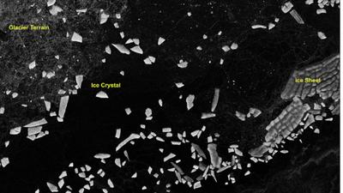
Antractica_dop_10Jul2026_HH_polarization BENGALURU: Isro has made public the first batch of S-Band radar data from the Nasa-Isro Synthetic Aperture Radar (SAR) or Nisar mission, releasing it through Bhoonidhi, the agency's earth observation data portal.The agency also shared sample images from Tamil Nadu (Nagapattinam), Antarctica, Assam (Brahmaputra basin), Idaho, Greenland and Indonesia showing the radar's range of applications, from tracking coastal wetlands to mapping irrigation patterns and ice movement, underlining the mission's relevance to both scientific research and everyday resource management, from coastal planning to precision farming and disaster monitoring.Nisar is a joint mission between Nasa and Isro, and is the first spaceborne radar to carry two frequency bands, L-band and S-band, on a single satellite. It uses a 12-metre reflector antenna and a scanning technique called SweepSAR, which lets it capture a wide strip of the Earth's surface, about 240 km across, in high resolution without sacrificing coverage.Orbiting the Earth at 747km, the satellite revisits the same spot every 12 days, building up a steady stream of images useful for tracking floods, glaciers, farmland and other fast-changing features, regardless of weather or daylight.Isro said the mission is now in its science phase, gathering data from locations around the world as per its observation plan. The S-band data is received at Isro's ground stations and processed at the Integrated Multi-Mission Ground Segment for Earth Observation Satellites in Shadnagar, run by the National Remote Sensing Centre.A nationwide network of ground-based reflectors is being used to check the accuracy of the data, alongside other reference targets chosen for specific scientific purposes."...All data gathered from Cycle 25 onwards, which began on July 8, 2026, is now available for download as soon as it is processed. Older data, collected before Cycle 25, will be reprocessed in stages and added to the archive over time," Isro said.The release includes several categories of processed imagery, ranging from raw radar scans to geocoded and interferometric products that can detect subtle shifts in the Earth's surface, useful for monitoring subsidence, landslides and glacier movement.Users can search, view and download the data on Bhoonidhi after registering, using filters such as location, date and product type. Isro has also added two tools on the portal: one that converts the radar files into more widely used formats such as GeoTIFF, and another, built for QGIS software, that helps researchers analyse the data further.Isro noted that some scenes may show faint striping over featureless areas such as deserts and oceans, and occasional interference from radio signals, adding that both issues would be addressed in future updates as calibration improves.Launched on July 30, 2025, Nisar, had beamed back its first images of Earth in Sept last year, Nasa had announced, adding that the spacecraft was to begin its full operations later that year.

54. ISRO-NASA Satellite Data Reveal 60 CM Ground Shift In Venezuela Earthquake - ETV Bharat
Read more

ETV Bharat / international ISRO-NASA Satellite Data Reveal 60 CM Ground Shift In Venezuela Earthquake A rescue dog from the Argentine search and rescue team searches for bodies in the rubble of a collapsed building in Caraballeda, La Guaira state, Venezuela, on June 28, 2026, following twin earthquakes. ( AFP ) Washington: The twin earthquakes that struck north Venezuela last month shifted the earth almost two feet at some places, leading to massive devastation in Caracas and La Guaira, an analysis of data from the NISAR satellite has revealed. Researchers studied the images of the Earth taken by the NASA-ISRO Synthetic Aperture Radar (NISAR) satellite on June 13 and 18 (before the quake) and on June 25 and 30 to detect the changes in the terrain after the June 24 earthquake. On June 24, a magnitude 7.2 earthquake struck northern Venezuela, followed by a magnitude 7.5 mainshock 39 seconds later. It killed more than 5000 and injured 16,700 while causing large-scale damage in Caracas and La Guaira. The states of Trujillo, Yaracuy, Carabobo, Aragua and Miranda had also been affected. Scientists used a technique called InSAR, which compares data from repeat passes to detect subtle changes in the distance between the satellite and the ground, NASA said in a statement earlier this month. This was the first time the NISAR urgent response system was used to map surface displacement from a large earthquake. The fault is part of a network of fractures that lies along the boundary between the Caribbean plate to the north and the South American plate to the south. Scientists say faults along this plate boundary, including the San Sebastian fault system, where these quakes likely occurred, and possibly part of the Bocono system, have long been accumulating strain. The fault rupture propagated offshore, toward the east, and then back onshore near the international airport north of Caracas. Just south of this fault section, along this part of the fault, the displacement was far greater than elsewhere, reaching as much as 60 centimetres (24 inches).

55. Isro satellite images show 90% of India is under cloud cover. How much rain is likely? - India Today
Read more
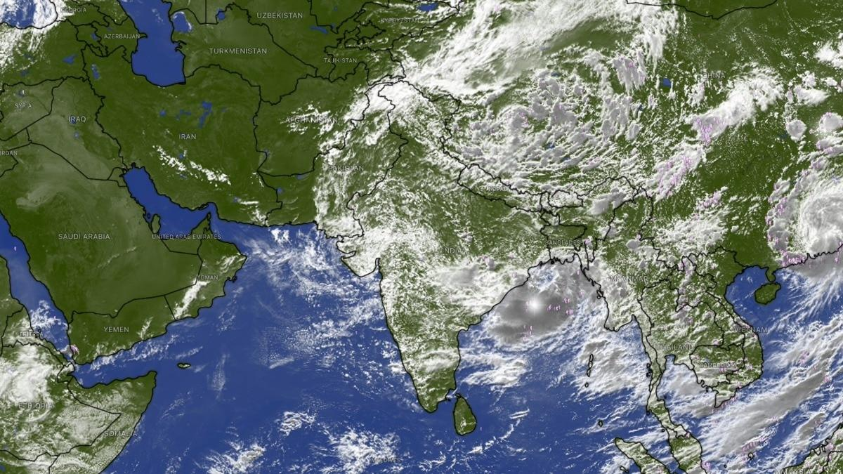
Four days ago, India's landmass nearly vanished from view from the skies. The Indian Space Research Organisation (Isro)'s weather satellites, parked far above the equator, found almost nowhere left to look through, as a cloud sheet stretched from the Arabian Sea to the Bay of Bengal and covered close to 95 per cent of the country. That peak has passed, but the sheet has not broken up. Based on the latest thermal infrared, cloud top brightness temperature and water vapour imagery captured by Isro's Insat 3DR and Insat 3DS satellites, and released through the India Meteorological Department (IMD), somewhere between 88 and 92 per cent of India's landmass, call it roughly 90 per cent, is under cloud cover at this moment. Read Full Story Both figures come from reading separate satellite channels closely against IMD's own written bulletins, rather than a single official pixel-count released for public use, so they are close, defensible estimates rather than laboratory-grade readings. So to be clear: 95 per cent was the peak, recorded around 21 to 22 July. Roughly 90 per cent is where things stand today, a slight easing, not a clearing. And a cloud sheet still this large is never just scenery. It is fuel, hanging over the country right now, waiting to fall. IMD's latest bulletin spells out exactly where that fall is headed over the coming week. WHAT DOES TODAY'S CLOUD COVER LOOK LIKE FROM SPACE? The latest thermal infrared images show clouds still dominating central and eastern India, Bay of Bengal and the northeast, with a dense, cold cluster visible over the Odisha-Andhra coast. Western Rajasthan and parts of the desert belt remain the clearest patches on the map, much as they were during the earlier peak. That pattern traces the monsoon trough, a belt of low pressure across northern India that governs where rain falls in the days ahead, not just where cloud sits today. Cloud top brightness temperature imagery showing the coldest cloud tops sitting directly over the Odisha-Andhra coast. (Photo: IMD) The IMD's latest bulletin places the trough south of its normal position, with a low-pressure area that formed over the northwest Bay of Bengal and adjoining West Bengal coast now lying over that same stretch of coast. This system, the IMD says, is likely to meander over the same region and become more marked over the next two to three days, which means the cloud sitting over eastern India right now is set to intensify rather than clear. HOW MUCH RAIN WILL THIS LEVEL OF CLOUD COVER BRING OVER THE COMING WEEK? The IMD's seven-day rainfall forecast, issued alongside this imagery, gives a direct, region-by-region answer for what happens next. Himachal Pradesh, Jammu and Kashmir, and Uttarakhand are forecast to get fairly widespread to widespread rain through the end of the month, with isolated heavy rainfall continuing for most of that period. Water vapour imagery showing dry air still sitting over Pakistan and western Rajasthan while the rest of India stays moist. (Photo: IMD) Chhattisgarh and East Madhya Pradesh face a similar run of widespread rain across nearly the entire seven-day outlook, while Odisha, sitting directly beneath the strengthening low-pressure system, is forecast to get very heavy rainfall. By contrast, the IMD's forecast keeps south peninsular India, including Tamil Nadu, Rayalaseema and interior Karnataka, largely in the "isolated to scattered" category through the coming week, the driest classification on its scale, confirming the coming rain will follow the same uneven pattern the satellite images already show. WHERE WILL THE HEAVIEST RAIN LAND OVER THE NEXT FEW DAYS? The clue sits in cloud top brightness temperature, or CTBT, which tells forecasters how tall a cloud has grown, using a simple rule of physics: air cools as it rises, right up to a layer called the tropopause, roughly the ceiling of the atmosphere that makes our weather. The colder a cloud's top reads from space, the taller and more capable of heavy rain it is. The latest CTBT imagery shows the coldest, tallest cloud tops sitting over the Odisha-Andhra coast and the Bay of Bengal, exactly where the IMD's low-pressure system now sits. With that system expected to become more marked over the next two to three days rather than weaken, Odisha and the surrounding coast should expect the current spell of extremely heavy rainfall to continue before any easing. WILL THE WESTERN DRY POCKET STAY DRY OVER THE COMING WEEK? Largely, yes, though not entirely. The latest water vapour imagery still shows a long, dark band of dry air sitting over Pakistan, Afghanistan and India's own north-western desert. The IMD's forecast reflects this, keeping West Rajasthan mostly in the "isolated to scattered" rainfall category through much of the coming week. There is one live exception. A low-pressure system over southwest Rajasthan is driving fresh extremely heavy rainfall. (Photo: PTI) The IMD's latest bulletin confirms a separate low-pressure area, which had earlier lain over southeast Rajasthan, has moved westward and now sits over southwest Rajasthan and neighbourhood. This system is what drove the exceptionally heavy rainfall recorded over Gujarat in the recent 24-hour period, with isolated extremely heavy rainfall likely to continue over Gujarat, even as the desert belt further west and north stays largely untouched. SO HOW LONG WILL THIS LEVEL OF CLOUD COVER AND RAIN LAST? The IMD's latest outlook does not describe conditions easing back to normal any time soon. Both the Bay of Bengal low and the Rajasthan low are forecast to remain active and intensify over the next two to three days, keeping central, eastern and northwestern India under significant cloud and rain through the end of the month. South peninsular India is expected to remain comparatively drier over the same period. Expect the next satellite pass to show cloud cover still sitting somewhere in the high 80s to low 90s, well below the peak of 95 per cent but far from clearing, with the heaviest rain continuing to track wherever these two low-pressure systems happen to sit. - Ends Published By: Radifah Kabir Published On: Jul 26, 2026 13:29 IST

56. From Aadhaar to ISRO: What the six-member NTA reform panel brings to the table - Moneycontrol.com
Read more

From Aadhaar to ISRO: What the six-member NTA reform panel brings to the table The six-member panel brings together experts from technology, space research, intelligence, cybersecurity, education administration and logistics to recommend structural and technological reforms for a more secure, transparent and accountable NTA. Moneycontrol News

57. ISRO Bengaluru receives hoax bomb threat, investigation underway - The News Mill
Read more

ISRO Bengaluru receives hoax bomb threat, investigation underway The News Mill

58. NASA Astronaut Chris Williams, Crewmates Return from Space Station
Read more
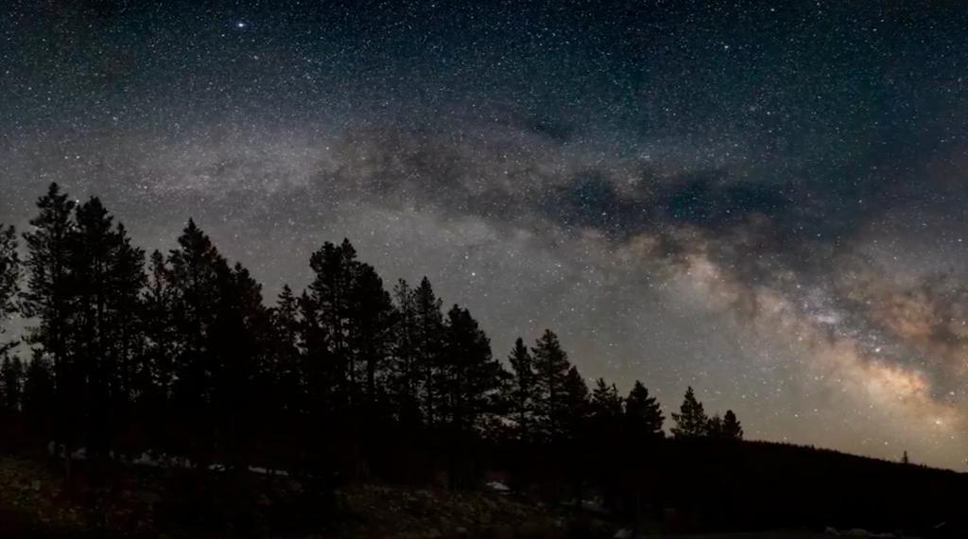
The Soyuz MS-28 spacecraft is seen as it lands in a remote area near the town of Zhezkazgan, Kazakhstan with Expedition 74 NASA astronaut Chris Williams, and Roscosmos cosmonauts Sergey Kud-Sverchkov, and Sergei Mikaev aboard, Sunday, July 26, 2026. NASA/Bill Ingalls Concluding an eight-month science mission aboard the International Space Station, NASA astronaut Chris Williams returned to Earth on Sunday alongside Roscosmos cosmonauts Sergey Kud-Sverchkov and Sergei Mikaev. The crew made its safe, parachute-assisted landing at 5:27 a.m. CDT (3:27 p.m., Kazakhstan time), southeast of Dzhezkazgan, after departing the space station at 2:03 a.m., aboard the Soyuz MS-28 spacecraft. The crew was in space for 241 days, orbiting the Earth 3,856 times and traveling more than 102 million miles. They launched to the International Space Station on Nov. 27, 2025. The mission was the first for Williams and Mikaev and the second for Kud-Sverchkov. While aboard the orbiting laboratory, Williams supported a wide range of scientific investigations and technology demonstrations. He helped advance research for new cancer treatments and improved in-space manufacturing of materials used in high-performance computers and electronics. Williams also completed two spacewalks to prep for space station power system upgrades and to replace a faulty joint on the Canadarm2 robotic arm. The crew's work aboard the space station helps improve life on Earth and prepare for future human missions to the Moon and Mars. Following post-landing medical checks, the crew members will fly by helicopter to Karaganda, Kazakhstan, where recovery teams are based. Williams then will board a NASA aircraft bound for the agency's Johnson Space Center in Houston. For more than 25 years, people have lived and worked continuously aboard the International Space Station, advancing scientific knowledge and making research breakthroughs not possible on Earth. The space station helps NASA understand and overcome the challenges of human spaceflight, expand commercial opportunities in low Earth orbit, and build on the foundation for long-duration missions to the Moon, as part of the Artemis program, and to Mars. To learn more about International Space Station research, operations, and its crews, visit: www.nasa.gov/station -end- Joshua Finch / Jimi Russell Headquarters, Washington 202-358-1100 joshua.a.finch@nasa.gov / james.j.russell@nasa.gov Leah Cheshier / Anna Schneider Johnson Space Center, Houston 281-483-5111 leah.d.cheshier@nasa.gov / anna.c.schneider@nasa.gov

59. I'm not an astronaut, but I went to the International Space Station (sort of)
Read more
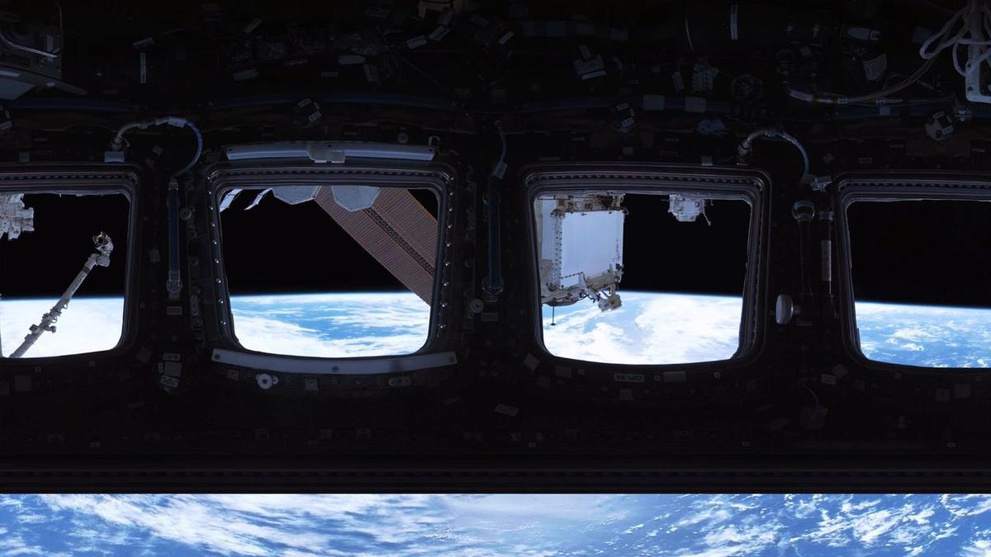
Click for next article NEW YORK - I'm the kind of person who, every so often, falls into accidental daydreams about the concept of space. Usually because I'm listening to some sort of sad girl Spotify playlist, I start feeling infuriated that we may never learn the true meaning of the cosmos and become embarrassingly poetic about our isolation on Earth. I tend to ponder how strange microgravity is and begin Googling things like "what lies beyond the edge of the universe best evidence we have" and "when commercial rocket launch become same price JetBlue flight." I'm pretty sure I've lived in these clouds ever since I got past the Freddi Fish and Microsoft Paint phase of my internet literacy - but then, a month before my 30th birthday, something huge happened. On a random Tuesday, I woke up, brushed my teeth, made myself an espresso, sauntered over to the Franklin Avenue C, and went to the International Space Station . Once I got there, it was bizarre to float through the corridors and living quarters I've written about for so long as a science journalist and thought about for even longer. The walls felt lived in. The station's speed in orbit seemed a little too fast for comfort. The highly esteemed cupola - a protruding corner of the station with seven windows arranged in the shape of a daisy - was far larger than I imagined. In fact, the entire ISS was way more enormous than I can explain. Solar panels tower over you like rust-colored billboards and the station's floors threaten to collapse any second, fooling you as you gaze down at Earth . It's a little scary to be so exposed to the void of space, and that's true even when you're there in virtual reality. Yes, unfortunately (or fortunately, depending on your caution levels) I launched to the ISS through a virtual reality experience called " Space Explorers: The ISS Experience " shown at Eclipsio in Manhattan. It's probably the closest I'll ever get to the real thing, until of course my dream of a cheap RocketBlue economy seat becomes possible. And most importantly, I'm here to tell you that if you're ever able to do the same, you should do it, too. Here's what you'd see The way it works is you put on some VR glasses and follow instructions in your headset to walk a certain direction or move your hands a certain way - your "hands" in the digital world look like floating yellow outlines of hands that correspond to the movements of your actual hands. To be transparent, my glasses were a bit glitchy. My digital hands were quite a bit unstable, for example, which did distract me a little bit but it was easy to get over. Okay, once you're in the world of space, which is simply darkness, a few things happen (which I won't spoil). Eventually, a life-size structure of the International Space Station (ISS) appears. Suddenly, you're within the station. The interior of this structure isn't totally accurate to reality, to be clear. It's a gray, translucent rendering of the ISS's insides that you can explore. Still, the size is meant to be true to life. People walking around the Eclipsio space during the show. (Image credit: Space Explorers: The ISS Experience) Along the way, you can touch giant floating orbs that bring you a short snippet of video to watch. It is because of these snippets that I think this show is 100% worth it. Each one corresponds to the location in which the orb sits - a cupola orb might show you a couple of astronauts floating around and looking out the window, while one near the gym equipment might bring you straight into a training session with Artemis II mission specialist Christina Koch. Perhaps you'd like to venture "outside" and float eye-level with the station's robotic arm. In your periphery to the left, a spacewalker traverses the exterior of the station. To the right, the Earth is majestic. In front of you, sunlight hitting the laboratory's worn white walls causes a realistic glare. You can't help but squint. And the reason these snippets are outstanding is that they are made with real footage from the ISS. A still from Space Explorers: The ISS Experience. (Image credit: Space Explorers: The ISS Experience) A show made by astronauts I sat down with Félix Lajeunesse, co-founder of Felix & Paul studios - the organization behind the exhibit - to learn how this was possible. What does it take to recreate the ISS with this level of detail, and this level of soul? "It took about a year and a half to two years to just prepare for this project, and eventually cameras were sent up there in space," he said. "That was the beginning of a three year production." More specifically, the footage you see in this VR show was filmed across six NASA expeditions and involved shipping three cameras to space - two cameras operating inside the ISS and one camera designed to function in the vacuum of space. That latter camera was attached to the Canadian robotic arm on the exterior of the station and operators on the ground could remotely control it to achieve the cinematic quality they wished. The astronauts first put it on the sliding table of the ISS's Japanese module. Then, the camera was egressed from the station and the robotic arm could pick it up. When it came to the interior cameras, however, that's where the astronauts themselves stepped in. "It's not a traditional camera - it's a virtual reality camera," Lajeunesse said. "So, if you're going to be around a table, for example, having coffee together in the morning, well, this camera is not going to be in the middle of the table because no one would ever be there. It will be at the same height as the rest of you around the table because in the end it's going to be replaced by a person being there with you." "This kind of anthropomorphic idea that the camera is a person really resonated with them," he added. In order to ensure the camera didn't interfere with the many experiments and procedures on the station Lajeunesse and his team made sure to send the astronauts what he calls a "shooting script" for each day of work. This script explained which different camera positions were desired; if anything wasn't possible, the astronauts would offer suggestions of better locations. "We had this ongoing conversation with them during the production, as if it was on a real set, essentially," Lajeunesse said. And speaking with Lajeunesse, it became remarkably clear that this show wouldn't have been as heartfelt as it is without the astronauts' own desire to create it. It seems like the astronauts wanted to be able to share their indescribable experience of living beyond our planet with those stuck on it. This is a way for them to show their families the place they used to call home. The team even made sure to premiere the U.S. version of the show at Houston, Texas, often called "Space City" because that's where NASA astronaut training happens at the agency's Johnson Space Center . "Our first audience in the United States were the astronauts," Lajeunesse said. "It was quite an extraordinary and emotional turnout - almost all of them referred to experiencing this as going back home." A time capsule for future generations As upsetting as it is, the International Space Station isn't forever. Unless a potential boosting mission reaches fruition, it'll be de-orbited and mostly lost in the flames of reentry in the year 2030. Its charred remnants will probably be placed in museums. One day, those museums will be visited by people who never lived during a time when you just knew the iconic lab was up there somewhere in the sky. When that day comes, this ISS show will grow in sentimental value. It may end up offering the only way for ISS astronauts to go "home." "VR points to the capacity to create simulations that are just as rich and vibrant and open and possibilities than reality itself." Lejeuneusse said, comparing it to console video games or movies. "I think it's probably the most human medium there's ever been." He hopes that, someday, VR will improve to the point where it becomes possible to generate open worlds that we can all be a part of together. Perhaps, he says, artificial intelligence will be a big part of that. "This feeling of witnessing the Earth, this sense of the overview experience is something pretty special, pretty emotional for people, and something that could not be communicated through any other media," he said. As for what's next? The team is working on a show in Las Vegas called Interstellar Arc , a science fiction futuristic VR experience that Lajeuneusse says is even more interactive than this International Space Station one. But still, he emphasizes that while future VR shows may continue to increase in capabilities, there will always be something profound about the ISS project. "You know, the International Space Station is one of the most extraordinary examples of human collaboration; human cooperation. It's many different countries, some of them which are opponents at the political stage, that kind of all came together to build this enormous structure in space habitat where humans can go and live," he said. "It was all built through cooperation, and it's all maintained through cooperation." "When they're up there, they're kind of like a microcosm of humanity," he added. "Just the fact that it exists, just the fact that it continues to exist. We should marvel at that."

60. China's new alloy can withstand extreme heat; could be used in reactors, hypersonic missiles
Read more

In a breakthrough that could reshape the future of aerospace and advanced engineering, researchers in China have developed a new metal alloy capable of maintaining its strength at temperatures as high as 2,400 degrees Celsius. The innovation addresses one of the biggest challenges in materials science-creating metals that remain structurally stable under extreme heat while continuing to bear heavy mechanical loads. Already known for its exceptionally high melting point The research, led by a team from Xi'an Jiaotong University, centres on a specially engineered tantalum-based alloy. Tantalum is already known for its exceptionally high melting point of nearly 3,000°C, making it one of the most heat-resistant metals available. However, even tantalum alloys have traditionally suffered from a loss of strength at very high temperatures. The Chinese researchers claim to have overcome this limitation by designing an alloy with an optimized internal microstructure that resists deformation even in extreme thermal environments. Modern technologies such as hypersonic aircraft, reusable spacecraft, advanced rocket engines and next-generation nuclear reactors require materials that can survive enormous temperatures without weakening. Conventional high-performance alloys, including nickel-based superalloys widely used in jet engines, begin to lose their mechanical strength as temperatures approach 2,000°C. Newly developed alloy remains capable of supporting heavy loads The newly developed alloy reportedly remains capable of supporting heavy loads at temperatures up to 2,400°C, representing a significant improvement over existing high-temperature structural materials. Metals generally become softer as temperatures rise because their internal crystal structures become more mobile. Once temperatures exceed roughly 60% of a metal's melting point, atoms can move more freely, causing the material to deform under stress. According to the researchers, the new tantalum alloy has been engineered with a carefully controlled microscopic structure that slows this process. By stabilising the material's internal arrangement, the alloy retains its strength even under conditions that would normally weaken conventional metals. The findings were published in the peer-reviewed journal Nature, highlighting the scientific significance of the work. If the material performs similarly outside laboratory conditions, it could have wide-ranging industrial applications, including hypersonic missile and aircraft components, rocket nozzles and combustion chambers, spacecraft thermal protection systems, advanced gas turbines, and nuclear reactor components. The ability to operate safely at such extreme temperatures could improve engine efficiency, extend component lifespan and reduce cooling requirements in demanding engineering environments. While the laboratory results are promising, commercial adoption will require further testing. Scientists must demonstrate that the alloy can be manufactured economically, withstand repeated heating and cooling cycles, resist oxidation and corrosion, and perform reliably over long service periods. Tantalum is also an expensive metal, meaning large-scale industrial use will depend on whether production costs can be reduced without compromising performance. The development reflects the growing pace of innovation in advanced materials research. As countries compete to build faster aircraft, more efficient space vehicles and safer nuclear technologies, breakthroughs in high-temperature alloys are becoming increasingly important. If successfully commercialized, the new tantalum-based alloy could expand the limits of engineering design, enabling machines and vehicles to operate in environments previously considered too extreme for conventional metals.
61. ISRO Recruitment 2026 Notification PDF Out for 244 Assistant, UDC, JPA, and Steno Posts, Application Dates, Eligibility - Adda247
Read more
ISRO Recruitment 2026 Notification PDF Out for 244 Assistant, UDC, JPA, and Steno Posts, Application Dates, Eligibility Adda247

62. Assam floods: Isro's Nisar satellite captures Brahmaputra's might from space - India Today
Read more

As Assam grapples with another devastating flood season, India's latest Earth observation satellite, Nisar, has captured a stunning close-up view of the mighty Brahmaputra River, revealing its vast network of braided channels, islands and floodplains from space. The image, acquired on July 9, 2026, covers a section of the Brahmaputra near Debitala in Assam, extending towards the West Garo Hills of Meghalaya. It showcases the river's enormous width and constantly shifting network of channels that make the Brahmaputra one of the most dynamic rivers in the world. The dark ribbons cutting across the image represent the river's multiple water channels, while the lighter surrounding areas show floodplains, vegetation and inhabited landscapes. The river collects water from glaciers, snowmelt and intense rainfall. (Photo: Isro) The image highlights how the Brahmaputra does not flow through a single channel but spreads across a wide valley, splitting and rejoining around dozens of sandbars and river islands known as chars. The satellite observations come as Assam continues to battle severe flooding. This year's floods have claimed 68 lives and affected more than 5.24 lakh people, with several districts remaining inundated. Developed jointly by the Indian Space Research Organisation (Isro) and NASA, Nisar is designed to monitor changes on Earth's surface with unprecedented precision. Unlike conventional optical satellites, its radar can image the ground through clouds and during both day and night, making it especially valuable during the monsoon when thick cloud cover limits traditional satellite observations. The detailed imagery helps scientists map river channels, monitor erosion, identify flooded regions and track how the Brahmaputra changes course over time. These observations are crucial because the river is constantly reshaping its banks, eroding land in one place while depositing sediment in another, making Assam one of India's most flood-prone states. Currently in its science operations phase, Nisar is collecting observations across the globe while its data is processed by Isro's ground stations and the National Remote Sensing Centre. For a river as powerful and unpredictable as the Brahmaputra, the satellite's regular observations offer an unprecedented view of its changing landscape, helping scientists and disaster managers better understand floods and improve future preparedness. - Ends

63. Before Team Nilekani, ex-ISRO chief-led panel tried to fix exams - The Indian Express
Read more
As the Supreme Court on Monday (July 27) heard petitions seeking changes to the conduct of the NEET examination after the 2026 paper leak controversy, the Centre informed the court that it has constituted a high-powered committee under entrepreneur and Infosys cofounder Nandan Nilekani to recommend the next phase of examination reforms. This came on the same day the Central government introduced the Public Examinations (Prevention of Unfair Means) Amendment Bill in Lok Sabha to strengthen the anti-paper leak law and increase the punishment for those involved in paper leaks. The Centre's decision regarding the Nilekani-led committee has brought attention to an earlier reform blueprint: the K Radhakrishnan Committee report. The Committee, which was constituted in 2024 after the NEET-UG 2024 paper leak controversy, submitted a report containing 101 recommendations "with short term, medium term and long-term perspective". The report was prepared under former ISRO Chairman Dr K Radhakrishnan and submitted to the Ministry of Education in October 2024. The panel said that the report was developed after "twenty-three formal full-day physical sittings" and more than 37,000 responses received from students and parents through the MyGov portal. Its stated vision was to transform the National Testing Agency (NTA) into "a nimble, zero-error, adaptive and integrative process". Why was it constituted? Constituted amidst "the rousing public concern on the integrity of entrance tests after reports of breaches and leakage of question paper", initially, the Ministry of Education asked the panel to recommend reforms in three areas: improving examination processes, strengthening data security, and reviewing the NTA's structure and functioning. Its mandate later expanded after directions from the Supreme Court in Vanshika Yadav v. Union of India. The additional terms of reference included examination security and administration, technological safeguards, policy and stakeholder engagement, international collaboration, staff training, and mental-health support for students. What did it find? Instead of treating paper leaks as isolated incidents, the report argued that vulnerabilities existed across the entire examination ecosystem. It mapped weaknesses throughout what it called the "Testing Life Cycle" - from printing and transporting question papers to candidate verification, examination centre management, and grievance redressal. The report found that the NTA had been "operating as a single window agency" despite having "conducted more than 240 examinations since its inception involving over 5.4 crore candidates". It concluded that the agency's "present capacity and internal domain expertise need to be augmented". Replacing physical transport with digital delivery The report's central technological recommendation was Computer-assisted Secure Pen-and-Paper Testing (CPPT), designed "to eliminate potential breaches during the printing, storage and transportation chains" of question papers. Instead of printing papers at central presses and transporting them across the country, encrypted question papers would be transmitted electronically to secure servers at examination centres and printed there shortly before the examination. At the same time, candidates would continue writing conventional pen-and-paper tests. Also read | NEET and beyond, a systematic assault on education By eliminating the need to transport printed question papers over long distances, the committee believed the model would significantly reduce opportunities for leaks during transit. DIGI-EXAM The committee also proposed a digital authentication framework called DIGI-EXAM, modelled "on the lines of 'Digi Yatra'", to ensure "that ONLY the candidate writing the exam joins the intended programme". Instead of verifying candidates only on examination day, the system envisaged a continuous "multi-stage authentication of candidate's" across application, examination, and admission stages using Aadhar, biometrics, and AI-based analytics. A complete overhaul of the NTA The report argued that technology alone would not solve the NTA's problems. It said the agency needed stronger institutional capacity and should reduce dependence on outsourced agencies for critical examination functions. Former ISRO Chairman Dr K Radhakrishnan. The report was submitted to the Ministry of Education in October 2024. Photo: Wikimedia Commons Former ISRO Chairman Dr K Radhakrishnan. The report was submitted to the Ministry of Education in October 2024. Photo: Wikimedia Commons It recommended that the NTA's Governing Body "be recast as an empowered and accountable Apex Body" headed by a Director General "not below the rank of Additional Secretary to GoI". It also proposed creating 10 dedicated verticals within the agency, including Nation-wide Testing Centre Infrastructure, Information Security, Vigilance and Forensics, and Research and Development. Testing centres To reduce dependence on private vendors, the committee recommended developing "at least 1,000 SecureTesting Centres… in a phased manner, in reputed Government institutions," in accessible locations requiring power supply, seating requirements, technical support and candidate support facilities such as lockers for phones, ventilation in exam halls, help desks, and waiting areas for families of the candidates. For remote and underserved regions, it proposed mobile testing centre buses equipped with laptops and servers that would function as fully operational examination centres for around 150 candidates. For examinations involving very large numbers of candidates, the report recommended moving towards Multi-Session Testing spread over several days or weeks. It also described Multi-Stage Testing for NEET-UG as "a viable possibility". Where multiple sessions are held, it stressed that score normalisation should be transparent and properly established and documented. Over the longer term, it also recommended gradually shifting towards Computer Adaptive Testing, in which question difficulty adjusts according to a candidate's performance. Mental health The report also placed considerable focus on student welfare to make their approach "holistic". Its recommendations included creating a dedicated mental-health cell within the NTA, tele-helplines, counselling services, and teacher sensitisation programmes. It also suggested that "a suitable oversight mechanism may be considered for Coaching Institutes", citing concerns over student stress and the financial burden placed on families. Newsletter Follow our daily newsletter so you never miss anything important. On Wednesday, we answer readers' questions. Subscribe The committee recommended equipping the NTA's Grievance Reporting and Redressal Cell with AI and machine learning-based interactive chatbots so that candidates could "receive clarifications in the language of their choice" for queries that arise during the examination process. On implementation Recognising that expert reports often remain on paper, the committee proposed establishing "a high-powered steering committee" under the Ministry of Education to oversee implementation of its recommendations "in mission mode and within a time frame". The proposed body, it said, would mentor the NTA, help overcome implementation bottlenecks and submit regular progress reports to the ministry.

64. Venezuela earthquakes shifted ground by nearly 2 feet, NASA-ISRO satellite finds | To read what more the satellite found | Inshorts - Inshorts
Read more

- - - Venezuela earthquakes shifted ground by nearly 2 feet, NASA-ISRO satellite finds - - - - - - - - inshorts Venezuela earthquakes shifted ground by nearly 2 feet, NASA-ISRO satellite finds Data from the NASA-ISRO NISAR satellite revealed that twin earthquakes in northern Venezuela on June 24 shifted parts of the ground by nearly two feet. The magnitude 7.2 and 7.5 tremors struck 39 seconds apart, killing more than 5,000 people. The analysis marked the first use of NISAR's Urgent Response system for a natural disaster. tap for more at Firstpost / yesterday To read what more the satellite found Tap here Share Load More

65. Starship in space! See highlights of SpaceX megarocket's epic Flight 13 test launch (video)
Read more
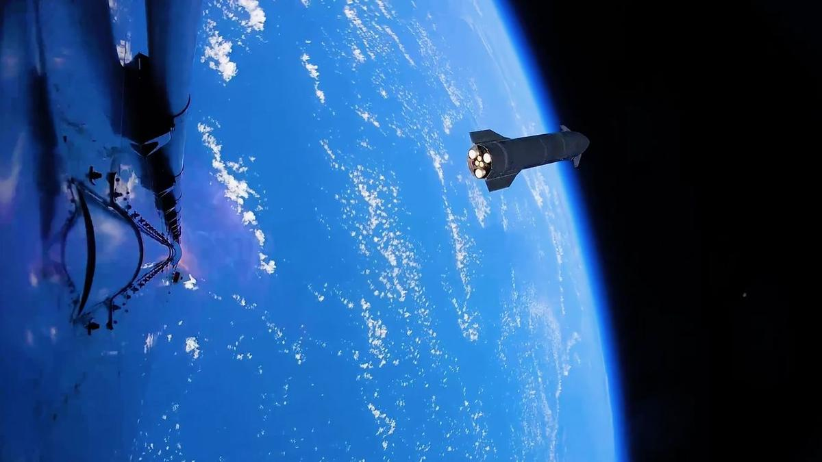
Click for next article The 13th test flight of SpaceX's Starship megarocket went pretty well - and provided some amazing visuals, too. Flight 13 launched on Friday (July 24), sending the 408-foot-tall (124 meters) Starship Version 3 (V3) vehicle aloft from SpaceX's Starbase site in South Texas. Starship's Super Heavy booster had some engine issues on its way back to Earth. But the Ship upper stage hit all of its marks, successfully deploying 20 next-gen Starlink satellites, re-igniting one of its Raptor engines in space as planned and splashing down softly off the coast of Western Australia. So softly, in fact, that Ship didn't explode after hitting the water - a first for a Starship flight. The two stages of SpaceX's Starship megarocket separate during the vehicle's 13th test flight, on July 24, 2026. (Image credit: SpaceX) SpaceX shared these milestones with us in real time, via the company's Flight 13 launch webcast. And the company highlighted a few of them after the fact as well, with some stunning imagery published on its X account. One Friday post , for example, shows footage from Super Heavy of Ship cruising away shortly after stage separation, its six Raptors glowing with exertion against the backdrop of a gorgeously blue Earth . Another Friday X post provides a Ship's-eye view of the vehicle's descent toward the Indian Ocean, steering its way from sky to sea. The video switches over to drone footage just before Ship hits the water, capturing from above the dramatic splashdown - and Ship's survival, despite the outbreak of a sizeable fire around its nose. $39.99 at Amazon Starship Die Cast Rocket Model Was $47.99 Now $39.99 on Amazon. Even if you can't see SpaceX's Starship in person, you can score a model of your own. Standing at 13.77 inches (35 cm), this is a 1:375 ratio of SpaceX's Starship as a desktop model. The materials here are alloy steel and it weighs just 225g. Both Ship and Super Heavy are designed to be fully and rapidly reusable. Eventually, both vehicles will return to the launch site shortly after liftoff, for capture with their launch tower's "chopstick" arms, refurbishment and reflight. SpaceX has already caught Super Heavy on three Starship test flights and will try to do the same with Ship for the first time on Flight 14, provided no red flags emerge during Flight 13 data review, according to SpaceX founder and CEO Elon Musk . Starship conducted its first test flight in April 2023. Flight 13 was the second launch Version 3 of the vehicle, the first iteration of the vehicle that's designed to be operational.

66. Rocket Lab to start launching missile-defense missions from Alaska under $266 million Space Force deal
Read more
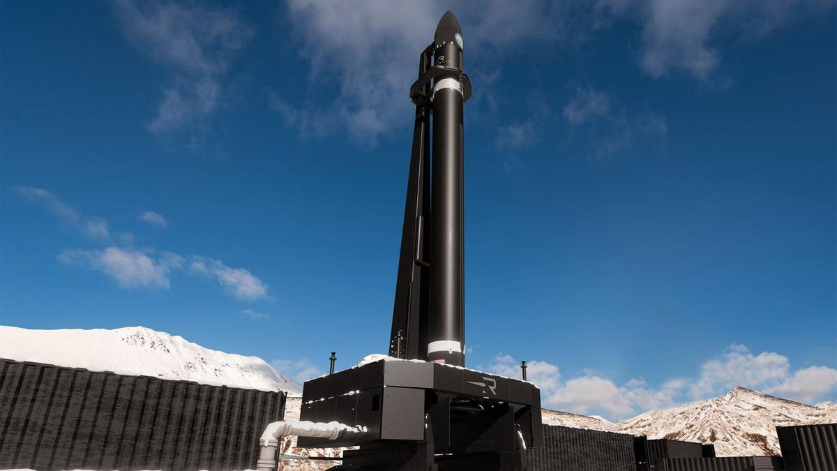
Click for next article Rocket Lab has signed a contract with the U.S. Space Force to launch up to 18 missile-defense missions, most of them from the Pacific Spaceport Complex in Alaska. Rocket Lab is expanding its launch operations to the snowy north. The California-based company, which already flies from New Zealand and Virginia, just inked a $266 million deal with the U.S. Space Force to fly up to 18 missile-defense missions , most of them from Alaska. "The size and scale of this contract reflects the Space Force's confidence in our ability to meet their urgent national security demands with speed, responsiveness and scale, and we're proud to provide the high-frequency launch capacity required to keep the U.S. ahead of global threats," Rocket Lab founder and CEO Peter Beck said in a statement today (July 27). The contract covers 12 suborbital launches, with the possibility of up to six more. These missions "will primarily take place" from the Pacific Spaceport Complex , a picturesque site on Alaska's Kodiak Island, which is most famous for its thriving population of brown bears. The spaceport has hosted nearly three dozen missions since opening in 1998, most of them suborbital flights for the U.S. military. Recently, however, it has supported launches of private orbital rockets - specifically, those built by Astra and ABL Space Systems (now known as Long Wall). The newly announced Rocket Lab missions will almost certainly be performed by HASTE , a suborbital variant of the company's workhorse Electron small-satellite launcher that customers use to test hypersonic technologies in the flight environment. They may also be part of the United States' sprawling Golden Dome missile-defense initiative, though we don't know that for sure; today's release provides few details about the launches. A Rocket Lab HASTE suborbital rocket launches on the "Prometheus Run" mission for the U.S. military on Nov. 18, 2025. (Image credit: Rocket Lab) Rocket Lab's primary launch site is on Māhia Peninsula, on the North Island of Peter Beck's native New Zealand. The company also flies from two pads on Wallops Island, Virginia, one of which has been the jumping-off point for all HASTE suborbital launches to date. HASTE debuted in June 2023 and now has nine missions under its belt. Electron lifted off for the first time in May 2017 and has flown 82 times to date.

67. Curiosity Mars rover inspects cracked wheel | Space photo of the day for July 27, 2026
Read more
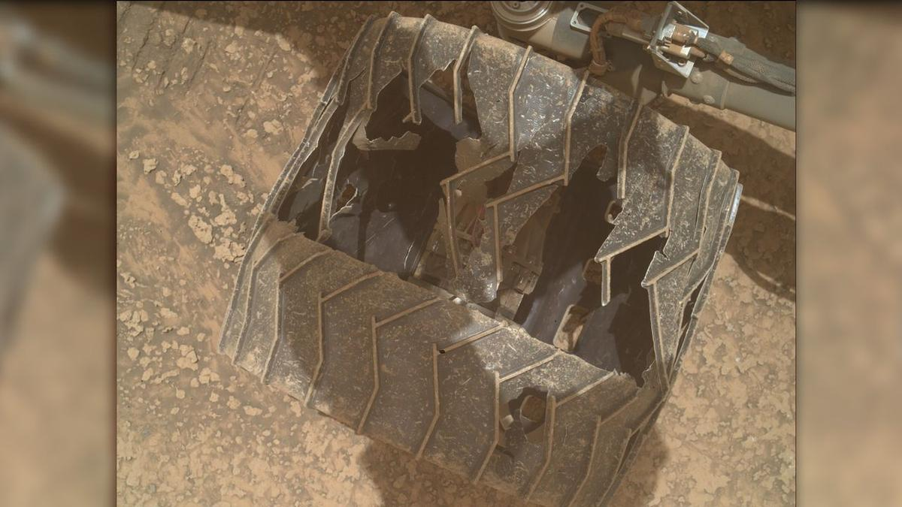
Click for next article A photo of one of NASA's Curiosity Mars rover's wheels, taken by the rover using its Mars Hand Lens Imager (MAHLI) on July 23, 2026, or Sol 4963 of its mission. (Image credit: NASA/JPL-Caltech/MSSS) NASA's Curiosity Mars rover has experienced some serious wear and tear during its nearly 14 years on the Red Planet. A new photo posted to Curiosity's raw image server offers a close-up of the damage one of the rover's wheels has experienced as it explores the Martian surface . What is it? Curiosity landed in Mars' Gale Crater on Aug. 5, 2012, touching down while hanging under a 'sky crane' that lowered it to the planet's surface. Since then, the rover has traveled over 20 miles (32 kilometers) across the rocky Martian soil, searching for potential signs of ancient life on the Red Planet. All of that mileage has taken a toll on the rover, as these new images show. Curiosity weighs over one ton, and the terrain on Mars can be quite rocky and rugged. NASA and the Jet Propulsion Laboratory (JPL) periodically use the rover's cameras to check on the wheels, and despite the holes and cracks, the agency said in a 2024 statement that they're "holding up well despite taking some of the worst abuse from Mars." Images of NASA's Curiosity Mars rover's wheels, taken by the rover on July 23, 2026, or Sol 4963 of its mission. (Image credit: NASA/JPL-Caltech/MSSS) Why is it amazing? We've been exploring Mars for decades now, so it can be easy to take for granted how incredible it is that we get new images beamed from the surface of another planet to Earth daily from NASA's two robotic explorers. These images of Curiosity's wheels help illustrate the incredible feats of engineering and science it took to place wheeled robots safely on the surface of another planet where they spend years and travel dozens of miles to bring us answers about what other worlds are like. While they might not be human, Curiosity and Perseverance nonetheless represent humanity's first foray into becoming an interplanetary species. The groundwork laid by the rovers and other Mars orbiters, landers and probes could someday help humanity take its first steps on another planet.

68. How NASA plans to build the Habitable Worlds Observatory
Read more

We've been covering the journey of the Habitable Worlds Observatory for some time now. Over the past few years, it's gone from a proposal to a relatively fleshed-out plan for how and what the next Great Observatory should do-in this case, look at and characterize potentially habitable exoplanets.

69. Could we send a spacecraft to a black hole?
Read more

Black holes represent some of the most extreme environments in the universe. They are the sources of the strongest gravitational fields, allowing us to test Einstein's theory of general relativity to an extent impossible with small objects. But we are also reaching the limit of what we can learn about one remotely. So, various authors have put forward ideas for how we might eve...

70. Are we missing alien lighthouses?
Read more

Searching for extraterrestrial intelligence has so far primarily meant focusing on one particular type of signal-and that signal has normally been based on our own current cutting-edge technology. But what if that's the wrong way to look for signs of alien intelligence? What if a resource-conscious civilization decided it was too complicated to send femtosecond lasers in high-e...

द्वारा अभिकल्पित एवं संकलित
DESIGNED & COMPILED BY:
पुस्तकालय एवं सूचना संसाधन प्रभाग
Library & Information Resources Division, IIRS (ISRO), Dehradun
अस्वीकरण | Disclaimer:
सभी लेख / सूचनाएँ सार्वजनिक डोमेन में उपलब्ध हैं तथा केवल सूचना एवं सामान्य जागरूकता के उद्देश्य से
इंटरनेट से संकलित की गई हैं。
All the articles / information are available in public domain and are taken from
Internet for information & general awareness only.

