 |  | 

🌌 अंतरिक्ष समाचार | Space News
गुरुवार, १८/०६/२०२६ | Thursday, 18/06/2026

1. Europe's Ariane 6 prepares for heaviest-ever Ariane launch with 36 Amazon Leo satellites
Read more
An Ariane 6 rocket stands on the launch pad in French Guiana ahead of a mission carrying 36 Amazon Leo internet satellites into low-Earth orbit. (Image: X/ESA) Europe's powerful Ariane 6 rocket is set to make history today, June 17, by launching the heaviest payload ever carried by an Ariane launcher. The mission will send 36 Amazon Leo internet satellites into low-Earth orbit, marking another major step in Amazon's effort to build a global satellite broadband network. The launch is scheduled from Europe's Spaceport in Kourou, French Guiana, during a 29-minute launch window that opens at 7:53 am EDT (5:23 pm IST). The mission is being conducted by Arianespace, the French launch services provider that operates the Ariane 6 rocket. The flight will be a milestone for both Amazon and Europe's next-generation heavy-lift rocket. According to Arianespace, the mission will carry the largest satellite stack and the heaviest payload ever launched by an Ariane vehicle.

2. ISRO successfully conducts 2nd integrated air drop test for Gaganyaan mission | Akashvani News - Newsonair
Read more
The Indian Space Research Organisation (ISRO) has successfully conducted the second integrated air drop test (IADT-02) for the upcoming Gaganyaan mission at Sriharikota in Andhra Pradesh. The system is essential to ensure safe recovery of the crew module - the capsule in which astronauts sit during a human flight. After the module's release, a parachute system, comprising 10 parachutes, was deployed, helping the capsule decelerate to a safe splashdown speed. The IADT-02 follows the successful completion of the first IADT, which took place on August 24, 2025, at the Satish Dhawan Space Centre in Sriharikota. In the first IADT, a 4.8-tonne dummy crew module was dropped from a height of three km by a Chinook helicopter. Air drop tests recreate the last leg of a spacecraft's return to the Earth. An aircraft or helicopter drops the spacecraft from a height to test various systems under different scenarios. These are the deployment of the parachute system in case the mission is aborted mid-flight, system performance when one parachute fails to open, and the spacecraft's orientation and safety during splashdown. Union Minister Jitendra Singh congratulated the ISRO for successfully conducting the test. India's first human spaceflight will be launched from Sriharikota in 2027.

3. Jitendra Singh congratulates ISRO for successful completion of IADT-02 for Gaganyaan Mission - DD News
Read more
Union Minister Dr Jitendra Singh on Friday congratulated Indian Space Research Organisation (ISRO) for the successful completion of the Second Integrated Air Drop Test (IADT-02) for Gaganyaan, India's first human spaceflight mission scheduled for launch in 2027. He described the achievement as a significant milestone in preparing for the ambitious mission. Taking to social media platform X, Singh wrote, "Congratulations ISRO for the successful accomplishment of Second Integrated Air Drop Test (IADT-02) for Gaganyaan, India's first Human Space flight scheduled next year." He further noted, "The second Integrated Air Drop Test (IADT-02) was successfully conducted at Satish Dhawan Space Station, Sriharikota. This marks an important milestone towards the readiness for the Gaganyaan mission." India's first human spaceflight will be launched from Sriharikota in 2027. Although the mission has faced multiple delays due to its technological complexity, India has been developing the capabilities indigenously. Notably, such critical spaceflight technologies are closely guarded, and no country shares them. The government has allocated approximately Rs 10,000 crore for the Gaganyaan programme. The mission is now in its final phase, with the first crewed flight expected in the first quarter of 2027. Earlier, on April 8, ISRO Chairman V. Narayanan stated that all preparations for the uncrewed Gaganyaan missions are progressing smoothly. Speaking at the inaugural session of the 2nd International Conference on Smart Spacecraft Mission Operations, he said, "We are meeting just before the first uncrewed Gaganyaan mission. This is no ordinary mission but a crucial one for India. There will be three uncrewed missions before the final crewed launch. All activities for the first mission are progressing well, though challenges remain." The conference was also attended by former ISRO chiefs A.S. Kiran Kumar and S. Somanath, along with ISRO centre directors, students, and representatives from space startups. Meanwhile, India's human spaceflight preparations advanced further on April 4, as four selected astronauts began a high-altitude experiment in Ladakh under the "Mission Mitra" (Mapping of Interoperable Traits and Reliability Assessment). The programme aims to evaluate human performance in extreme environments. The astronauts, including Group Captain Shubhnashu Shukla and P. Balakrishnan Nair, arrived in Leh earlier this week for acclimatisation. The mission is supported by a multidisciplinary team of scientists, engineers, medical experts, and psychologists, marking another crucial step in India's journey towards human space exploration. -IANS

4. From 14 to 200 days: ISRO's heaters to conquer Moon's harsh nights - theweek.in
Read more
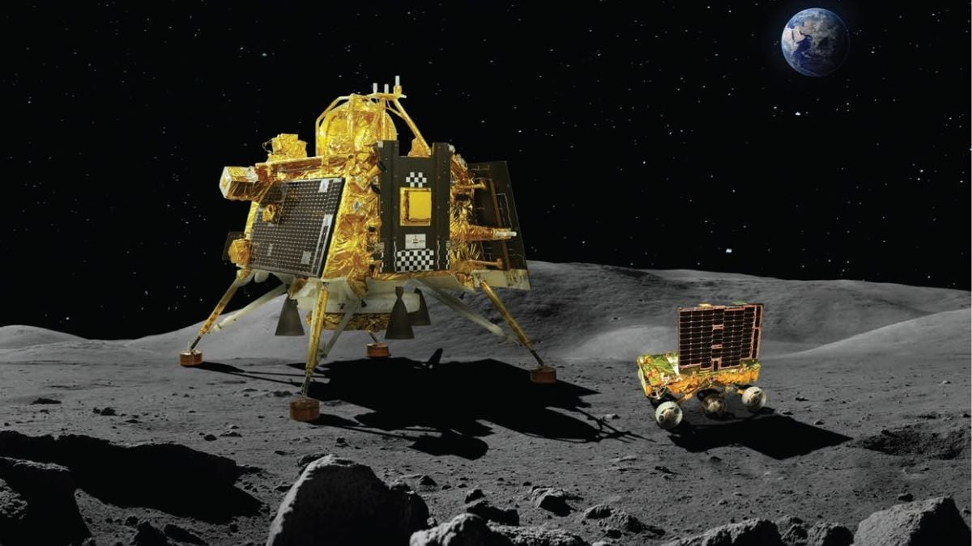
India is taking a big and exciting step in its Moon journey. ISRO, together with the Department of Atomic Energy (DAE), is working on a special artificial heating systems for future Moon landers. This move is significant because currently, a lander can work on the Moon for only about 14 days. But with this new heating technology, a lander could survive and work for 100 to 200 days. ISRO Chairman V. Narayanan recently shared this news. Experts say that it could change the way India explores the Moon. Why heaters matter On the Moon, one day lasts about 14 Earth days, and one night also lasts about 14 Earth days. "During the day, sunlight falls on solar panels, and the lander easily gets power to work. But when night comes, there is no sunlight at all. The temperature drops to a harsh -180°C or even lower, especially near the poles. In such terrible cold, the batteries, electronics, and scientific instruments can get damaged and stop working forever," explained space analyst Girish Linganna. During the mission Chandrayaan-3, its Vikram lander made history on August 23, 2023, when India became the first country to land softly near the Moon's South Pole. During the lunar day, Vikram worked wonderfully and did its job beautifully. But when the cold night came, it went silent, because it did not have enough heating to survive that freezing darkness. This is the exact problem the new heaters want to solve. Narayanan had said that the new artificial heaters would keep the important parts of the lander warm during the dark, freezing night. He said that if this technology works, future landers could stay active on the Moon for 100 to 200 days instead of just 14. This is a joint effort: DAE brings its deep knowledge of nuclear and thermal technology, while ISRO brings its space engineering skills. If they succeed, India can do long scientific studies and collect data for months instead of only a few weeks. India is not the only country trying to win this battle against the Moon's cold night. Many nations have faced this same problem. Most of them used devices called radioisotope heater units (RHUs) or radioisotope thermoelectric generators (RTGs). These clever machines make heat from the natural decay of radioactive materials like plutonium-238. They give steady warmth, and sometimes electricity too, even when there is no sunlight. "The Soviet Union's Lunokhod rovers in the 1970s used polonium-210 heaters and survived for several months. China has done very well too. Its Chang'e-3 mission with the Yutu rover and the far-side Chang'e-4 with Yutu-2 used RHUs along with solar power, special insulation, and phase-change materials. Because of this, they survived many lunar nights, and Yutu-2 kept working for years. During the cold nights, the systems went into a low-power sleep mode while the heaters kept them warm. But Chang'e-5 had no RHU, so it could not survive the second night," added Linganna. The United States has a long history, too. NASA used RTGs to power its Apollo experiment packages, which worked for years across many lunar cycles. For its modern Artemis missions and rovers like VIPER, NASA is now building clever "warm box" designs. These are insulated boxes for electronics connected through heat pipes and thermal switches, which manage heat without depending too much on nuclear sources. NASA is also testing ideas like storing heat in lunar soil and using advanced batteries. Japan's SLIM lander gave a pleasant surprise in 2024 by surviving multiple lunar nights even though it was not designed for it, thanks to smart power management and a bit of good luck. As experts point out, all these efforts show one truth: there are many ways to fight the cold, from active heaters to passive insulation. This heater technology comes at the right time, because India is preparing Chandrayaan-4, our first mission to bring Moon samples back to Earth. It has been approved with a budget of over Rs 2,100 crore and is expected around 2028. It is a complex mission with many parts launched on two LVM3 rockets. A lander will collect 2-3 kg of samples using a robotic arm and drill, an ascender will lift off, the parts will join together in orbit, and finally return to Earth. For such long work near the South Pole, surviving the night is a must. Challenges still remain, like making the heaters safe and reliable and managing power carefully. As Narayanan said, surviving many lunar nights would be a real game-changer. With heaters conquering the Moon's long, dark night, India's future missions can unlock deeper secrets of the Moon.

5. ISRO & Chandigarh University Launch Month-Long Space Research Program - Quantum Zeitgeist
Read more

From June 15 to July 11, 2026, scientists from the Indian Space Research Organisation, the Indian Institute of Space Science and Technology, and the Semiconductor Laboratory are directly mentoring students and research scholars at Chandigarh University's Kalpana Chawla Centre. The month-long KCC Space Technology & Research Program aims to bolster space technology education and research through intensive, hands-on training. Dr. S Sudhakar, Deputy Director, U R Rao Satellite Centre, ISRO, served as Chief Guest at the launch, emphasizing the critical role of science and technology in India's development and the importance of developing technology within India for success in the rapidly evolving space sector. ISRO-Chandigarh University Program Launches Space Technology & Research Initiatives This initiative offers hands-on exposure to the technologies shaping India's space capabilities. The launch event featured prominent ISRO leadership, including Dr. S Sudhakar, who highlighted the importance of indigenous technology development. He underscored that achieving strong results requires building internal capabilities and relying on domestic talent, and that acquiring technology from elsewhere often comes at a significant cost. This focus on self-reliance has contributed to India's past successes despite resource limitations. Dr. Sudhakar detailed ISRO's roadmap extending to 2047, encompassing advanced exploration missions and long-term human spaceflight programs. He predicted growing demand for space-based services, including surveillance, communication, and navigation, with expanding applications in the defense sector. Prof. ISRO has always been at the forefront of achieving maximum impact with limited resources. Prof. Priyadarshnam, Head & Project Director, SSPACE, Indian Institute of Space Science and Technology (IIST)

6. NASA Announces Public-Private Partnership to Advance Mars Science
Read more

NASA Administrator Jared Isaacman announces a public-private partnership to advance Mars science during an event at Relativity Space on June 17, 2026. Credit: Relativity Space NASA Wednesday announced a new public‑private partnership to advance Mars science by combining the agency's scientific leadership with commercial innovation. Under this model, NASA will provide the Aeolus atmospheric‑science instrument payload suite, while Relativity Space supplies the spacecraft, rocket, and cruise operations necessary to deliver the instruments to Mars. This partnership reflects NASA's growing commitment to approaches that accelerate discovery, expand mission cadence, and strengthen the foundation for future human exploration. By leveraging commercial investment and development capacity, NASA can focus resources on high‑value science while enabling more frequent opportunities to gather critical data about Mars, data essential to safely navigating the Martian atmosphere and ultimately landing humans on the surface. "Public-private partnerships like this are a force multiplier for science," said NASA Administrator Jared Isaacman. "By pairing NASA's world‑class instruments with commercial innovation and investment, we can deliver more science, more often, and reduce the time it takes to get essential data into the hands of researchers preparing for future human missions to Mars." Aeolus, scheduled to launch in 2028, is a NASA‑developed suite of four complementary instruments designed to provide the first integrated, daily, global view of Martian winds, temperatures, dust, and clouds. By improving models for dust, winds, temperature, and seasonal atmospheric behavior, Aeolus will generate the detailed environmental knowledge required to reduce risk for future crewed and uncrewed landings. These measurements will directly inform entry, descent, and landing systems and support safer, more predictable mission planning for astronauts. Aeolus builds on more than two decades of NASA missions that have studied the Martian atmosphere, including orbiters such as MAVEN (Mars Atmosphere and Volatile Evolution), the Mars Reconnaissance Orbiter, and Mars Odyssey, while taking the foundation laid by earlier missions even further, continuing NASA's tradition of expanding the frontiers of Mars science. Researchers at NASA's Ames Research Center in California's Silicon Valley will design, build, and integrate the payload, while Relativity Space will manage spacecraft development and mission operations. "As NASA's Innovation Center of Excellence, Ames is committed to delivering the technologies, capabilities, and creative partnerships that enable the agency's boldest missions," said Dr. Eugene Tu, center director, NASA Ames. "Aeolus reflects how innovative collaboration accelerates science and strengthens the foundation needed for one day landing humans on Mars." The Aeolus payload suite includes four NASA‑built instruments: Doppler Wind and Temperature Sounder (DWTS‑Ozone): Measures wind and temperature profiles from the surface up to approximately 37 miles (60 km). A collaboration with GATS. Thermal Limb Sounder (TLS): Provides vertical temperature profiles and observations of dust and water‑ice clouds. A collaboration with Xiomas Technologies. Surface Radiometric Sensor Package (SuRSeP): Measures surface energy balance, dust, and cloud properties. Wide‑Field Context Camera (WFCC): Captures daily global images of atmospheric activity. NASA will support operations of science instruments for at least one Martian year, while Relativity Space maintains the spacecraft. As part of the agreement, NASA will develop the data‑processing pipeline needed to transform raw measurements into high‑quality, ready‑to‑use data products for broad scientific use. This effort is supported under NASA's first six‑year reimbursable Space Act Agreement, providing a stable framework for sustained collaboration, predictable development, and mission continuity. Learn more about Mars science at: https://science.nasa.gov/mars -end- Camille Gallo / Cheryl Warner Headquarters, Washington 202-358-1600 camille.m.gallo@nasa.gov / cheryl.m.warner@nasa.gov Jeanne Neal Ames Research Center, Silicon Valley 650-604-4789 jeanne.c.neal@nasa.gov

7. Hubble Sees Swarm of Galaxies
Read more

This NASA Hubble Space Telescope image features the galaxy cluster MACS0329-0211. NASA, ESA, M. Postman (STScI); Image Processing: G. Kober (NASA/Catholic University of America) Looking somewhat like a swarm of bees returning to their hive, this NASA Hubble Space Telescope image released on June 12, 2026, features the galaxy cluster MACS0329-0211. Galaxy clusters like MACS0329-0211 are important signposts in the story of how the structure of the universe evolved, and are the ultimate telescopic lenses, placing gravitationally lensed galaxies from the earliest stages of the universe into our view. Zoom into this galaxy swarm and you will find large, oval-shaped elliptical galaxies, and thin spiral and lenticular galaxies viewed from the edge. We can also see the full, face-on view of spiral galaxies and their curving spiral arms. The image's upper-right quadrant holds faint arcs of distant galaxies gravitationally lensed by the cluster's massive gravity. The largest of these arcs appears above the bright oval shape of a giant elliptical galaxy. Closer inspection of the image's center reveals several bright-white intersecting curves that appear as a distorted figure eight. This may be another distant galaxy whose light was magnified and distorted by this massive cluster's gravity. Hubble looked at MACS0329-0211 as part of an observing program of X-ray bright galaxy clusters. Researchers used Hubble's two main cameras, the Advanced Camera for Surveys and its Wide Field Camera 3, to gather data visible and infrared light from the cluster. Hubble's ability to see such a broad spectrum of light makes it a valuable tool in understanding the very nature of these galaxy clusters. Image credit: NASA, ESA, M. Postman (STScI); Image Processing: G. Kober (NASA/Catholic University of America)

8. James Webb Space Telescope discovers extreme exoplanet being roasted by its home star
Read more

Click for next article Illustration shows the exoplanet HD 80606 b as it is roasted by its host star. If you thought summer here on Earth could get pretty brutal, spare a thought for the extrasolar planet, or exoplanet, designated HD 80606 b. Using the James Webb Space Telescope, astronomers have discovered that this gas giant exoplanet, located 217 light-years away, is being roasted by its host star. The planet, it seems, really puts the "hot" in " Hot Jupiter ," a category of gas giant planets that come so close to their stars that they can complete an orbit in a matter of days, sometimes even hours. The 111-day orbit of HD 80606 b brings the exoplanet so close to its host star that the James Webb Space Telescope (JWST) saw its temperature soar to an incredible 1,100 degrees Fahrenheit (600 degrees Celsius). This causes an extreme change in the chemistry of this world, which makes it an ideal case study for the JWST. "Hot Jupiters are already considered some of the most extreme exoplanets we know of, but even among that population, HD 80606 b is one of the most extreme," team leader Tiffany Kataria of NASA's Jet Propulsion Laboratory in Southern California said in a statement . "We typically think of hot Jupiters as hot gas giants sitting right next to their stars, but this planet's highly eccentric orbit creates a completely different beast." Who ordered the roasted exoplanet? Kataria and colleagues investigated HD 80606 b, its temperature and its chemistry using a technique in astronomy called spectroscopy , which breaks light down into individual wavelengths. This can reveal a world's chemistry because elements absorb and emit light at characteristic wavelengths. Thus, when light from a star passes through the atmosphere of a planet, the chemicals in that atmosphere leave their fingerprints on this spectrum. Using the JWST's MIRI (Mid-Infrared Instrument), the team observed this Hot Jupiter before, during, and after its close approach to its parent star, HD 80606. This required a great deal of planning given the extremely elliptical orbit of HD 80606 b. A lurid NASA poster depiucting the predicament of exoplanet HD 80606 b. (Image credit: NASA/JPL-Caltech) This isn't the first time astronomers have studied HD 80606 b, the roasted exoplanet was previously investigated using NASA's now-defunct Spitzer Space Telescope. "Spitzer did amazing work on this exoplanet, and now the JWST is building on that legacy by enabling us to drill down to distinguish specific chemical signatures like methane and carbon dioxide, which is just amazing progress," team member Ryan Challener of the Cornell Center for Astrophysics and Planetary Science said in the statement. "There's so much to learn from this one dataset here - we really are just getting started deciphering what the JWST has to tell us." The JWST has followed that work to present a far more detailed picture of this exoplanet than before. In fact, the $10 billion space telescope has revealed that HD 80606 b is even more violent than anticipated. "The JWST has shown that the planet's increase in temperature was even more extreme than we anticipated based on Spitzer data," Kataria said. The team's findings were presented Tuesday (June 16) at the 248th meeting of the American Astronomical Society in Pasadena, California.

9. 'Best. Mars. Mission. Ever.' Scientists hail MAVEN's legacy as NASA retires Red Planet orbiter
Read more
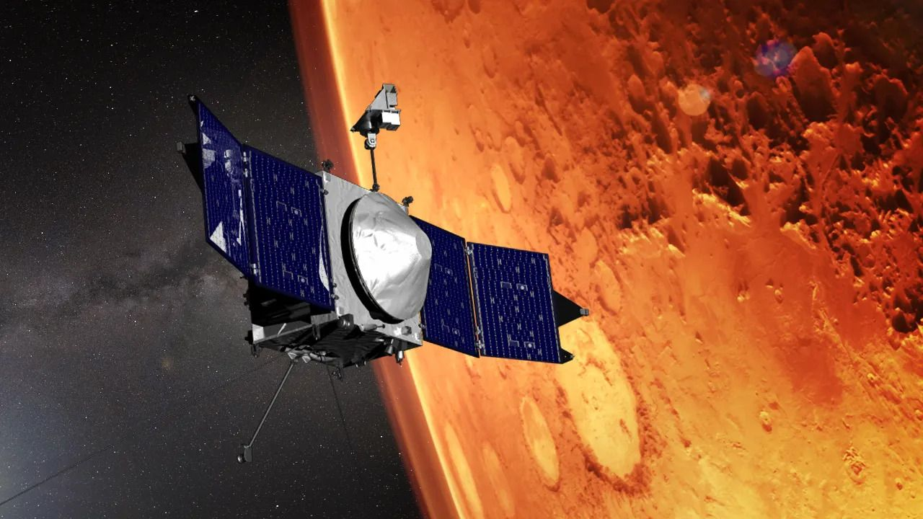
Click for next article Following months of unsuccessful recovery efforts, NASA has officially begun decommissioning the MAVEN orbiter, bringing to a close an 11-year mission that transformed scientists' understanding of Mars and became one of the agency's most valuable assets at the Red Planet. The decision follows the loss of contact with the spacecraft in December 2025. That loss happened after a routine communications blackout while the probe passed behind Mars . Mission controllers spent months attempting to restore contact, including sending commands designed to reboot the spacecraft's computers, but MAVEN remained silent. A review board convened by NASA in February found the spacecraft had been operating normally in the weeks leading up to the anomaly. Fragments of telemetry later recovered from recorded radio signals indicated that MAVEN emerged from behind Mars in a safe mode while spinning at roughly 2.7 revolutions per minute - an unexpected state for a spacecraft that was not designed to rotate during normal operations. Investigators found that the rotation likely drained the spacecraft's batteries over several hours, eventually causing its communications system to lose power. The underlying cause of the anomaly remains unknown, however, and a final report is expected later this year. "The conclusion is that the spacecraft is not recoverable," Mike Moreau, MAVEN's project manager at NASA's Goddard Space Flight Center, said during a press conference earlier this month. "The team really has experienced the loss of a loved one with the end of the mission." Yet as scientists mourn the spacecraft, they are also celebrating a mission that far exceeded its original goals. "The team is certainly broken up about this," said Shannon Curry, MAVEN's principal investigator and a scientist at the University of Colorado Boulder. "But at the same time, we are incredibly proud of the science we've accomplished over the last decade." Launched from Cape Canaveral in November 2013, MAVEN - short for Mars Atmosphere and Volatile Evolution - arrived at Mars less than a year later as NASA's first mission devoted to understanding the planet's atmosphere. Originally planned to last just two years, the spacecraft was tasked with determining how Mars lost the thick atmosphere that once allowed liquid water to persist on its surface. Long before MAVEN arrived, scientists knew Mars had not always been the cold, dry world seen today. Ancient river valleys, lake beds, deltas and other geological features pointed to a wetter past, when liquid water flowed across the landscape. For those conditions to exist, Mars would have required a much denser atmosphere than the thin envelope of gas surrounding the planet today. For more than a decade, MAVEN circled Mars in a highly elliptical orbit, measuring particles escaping into space and observing how the atmosphere responded to solar activity. Among its most significant findings was evidence that solar storms can dramatically accelerate the loss of atmospheric gases, helping explain how Mars evolved from a potentially habitable world into the cold, barren planet seen today. NASA officials and members of the MAVEN mission team celebrate the probe's successful arrival in Mars orbit on Sept. 21, 2014. (Image credit: NASA TV) The mission also discovered new types of planetwide auroras , revealed how global dust storms can accelerate the loss of water from Mars, and provided the first direct observations of atmospheric sputtering , a process in which energetic particles strike the upper atmosphere and eject atoms into space. "We now have a better understanding of atmospheric escape at Mars than at any other planet, including Earth," Curry said. Over its lifetime, the mission contributed to more than 800 scientific publications, according to NASA , helping establish the clearest picture yet of the forces that transformed Mars over billions of years. As NASA's fleet of Mars missions grew, MAVEN's importance came to extend well beyond atmospheric science. Although it supported just over 8% of relay sessions during its lifetime, the spacecraft returned nearly 18% of all science data transmitted from the Martian surface, underscoring its value as a high-capacity communications asset. The four remaining active orbiters - Mars Odyssey, Mars Reconnaissance Orbiter, Mars Express and the European Space Agency's Trace Gas Orbiter - have adjusted operations to compensate, and NASA is exploring a future commercial telecommunications network to help fill the void. Its loss leaves a noticeable gap in the network, but not an unmanageable one, scientists say. "There is a slight delay on occasion, because we don't have as many assets in view, to getting our science data back, and MAVEN was critical in returning science data versus operational data," said Tiffany Morgan, the director of NASA's Mars Exploration Program. "The Mars Relay Network is resilient enough at this point in time to accommodate, for the most part, the loss of MAVEN with the added delay." MAVEN's Imaging UltraViolet Spectrograph obtained images of rapid cloud formation on Mars between July 9-10, 2016. The ultraviolet colors of the planet have been rendered in false color, to show what we would see with ultraviolet-sensitive eyes. Mars' tallest volcano, Olympus Mons, appears as a prominent dark region near the top of the image, with a small white cloud at the summit that grows during the day. Three more volcanoes appear in a diagonal row, with their cloud cover (white areas near center) merging to span up to a thousand miles by the end of the day. (Image credit: NASA/MAVEN/University of Colorado) The timing of its loss does bring some missed opportunities. MAVEN will no longer be able to complement observations from NASA's ESCAPADE mission , a pair of spacecraft launched last year to further investigate the Martian magnetosphere and atmospheric escape. Even in retirement, however, MAVEN's story may not be entirely over. Curry said mission scientists may attempt additional imaging campaigns later this year using cameras aboard Mars rovers, although previous efforts to spot the silent spacecraft from the surface have proven unsuccessful. Beyond offering a final glimpse of the orbiter, any successful observation could provide investigators with additional clues about the spacecraft's final movements. The spacecraft is expected to remain in orbit around Mars for another 50 to 100 years before atmospheric drag eventually pulls it into the planet's atmosphere, where it will burn up like a shooting star. Asked what she would write on MAVEN's tombstone, Curry did not hesitate: "Best. Mars. Mission. Ever."

10. Arianespace launches its heaviest payload to date with Amazon Leo flight
Read more
Update June 17, 11:20 a.m. EDT (1520 UTC): Arianespace confirms deployment of all Amazon Leo satellites. Arianespace launched its largest and heaviest payload to date on a version of its Ariane 6 rocket that incorporated new solid rocket boosters Wednesday morning. The mission was designated VA269 by Arianespace and Leo Europe 03 (LE-03) by Amazon. It sent 36 Amazon Leo broadband internet satellites into low Earth orbit. This was the third of 18 Ariane 6 flights booked by Amazon Leo to deploy its constellation and followed successful flights in February and April. "We have both institutional and commercial clients and our main and biggest client today is Amazon. And I must say, we are very proud to work together," said David Cavaillolès, CEO of Arianespace, during a pre-launch press briefing. "For me, it's much more than a contract. It's really a partnership." Liftoff from Europe's Spaceport in French Guiana happened at 9:21 a.m. Kourou time (8:21 a.m. EDT / 1221 UTC). <span data-mce-type="bookmark" style="display: inline-block; width: 0px; overflow: hidden; line-height: 0;" class="mce_SELRES_start"></span> While all three of the Amazon Leo missions for Arianespace have used the Ariane 64 configuration of the rocket with four solid rocket boosters, the LE-03 mission will debut the upgraded version, called P160C. Compared to the predecessor P120C design, the P160C is a meter longer and holds about 156 tons of solid propellant. That's about 14 more tons than the P120C boosters, allowing for a 10-15 percent increase in performance for the launcher. The P160C boosters can produce 3,800 kN of thrust each at liftoff compared to 3,700 kN of thrust from the P120C boosters. This iteration of the Ariane 64 can deliver 36 Amazon Leo satellites to orbit, four more than previously. Cavaillolès said described this upcoming launch as a big milestone for the company. "It's important and we want to secure this milestone. This is our focus as of today, but of course, the story doesn't stop there," Cavaillolès said. "The more we launch, the better we know the launcher. We are already looking at further improvements. So we'll do our best to keep increasing the performance of the launcher and thus the number of satellites we can carry for each launch." For the first time, Ariane 64 will fly with four P160C boosters. 📏 +1 meter longer than P120C 🔥 156 tonnes of propellant pic.twitter.com/q5gdSWT274 - Arianespace (@Arianespace) June 4, 2026 Less than 2.5 minutes after liftoff, the four P160C boosters separated from the Ariane 6 main stage, followed by fairing jettison less than a minute later. The first and second stages separated nearly eight minutes into flight and the Vinci engine began the first of two, pre-deployment burns. The deployment sequence for the Amazon Leo satellites began nearly an hour-and-a-half into flight and conclude at about one hour and 51 minutes post-liftoff. The Vinci engine then performed a de-orbit burn about two hours and 40 minutes after takeoff. "When this mission is complete, Arianespace will have launched 100 of our satellites to date. That's three missions in less than five months, which is just fantastic," said Steven Metayer, vice president of Production Operations at Amazon. "It's just something we really count on to build that constellation out at rate across all providers." Building a constellation Prior to Wednesday's launch, Amazon has deployed 331 satellites on 12 missions by three different launch providers: Arianespace, SpaceX, and United Launch Alliance. Metayer said production of the satellites is ramping up and is exceeding the rate at which they are currently able to get them into orbit. He said Amazon is currently manufacturing "several satellites per day" at their facilities in the State of Washington. In Florida, he said they are able to receive satellites at their payload processing facility at NASA's Kennedy Space Center and get them integrated into a dispenser in about a week. "We're comfortable right now running ahead of launch. We know that when these heavy lift vehicles, such as the Ariane 64 and then you add the Vulcan and New Glenn to that, we know that we'll have quite a consumption rate demand from launches," Metayer said. "So we're comfortable right now building ahead of where we need to be and to make sure we never ever run out of satellites." Those two launchers, New Glenn and Vulcan, are both grounded for an undetermined amount of time. For ULA, it's Vulcan rocket has been grounded due to a problem with one of its solid rocket boosters during the USSF-87 mission in February. The timeline for concluding its anomaly investigation isn't publicly known, but Metayer said Amazon is anticipating being able to launch its first Leo Vulcan mission "sometime in Q3, the end of Q3." ULA stacked its first Vulcan rocket that will carry Amazon Leo satellites inside the newly completed Vertical Integration Facility - Amazon (VIF-A) at Space Launch Complex 41 at Cape Canaveral Space Force Station. The rocket will roll out to the pad for a wet dress rehearsal this summer to validate ULA's new Centaur upper stage, which the company said is optimized for low Earth orbit missions. Behind the scenes as prep continues for Leo Vulcan 1 (LV-01), the first of 38 Vulcan missions on contract with @ULAlaunch. Teams have completed integration of the first LEO-optimized Centaur upper stage with Vulcan inside Amazon's dedicated Vertical Integration Facility (VIF-A),… pic.twitter.com/2BZgecrbbl - Amazon Leo (@Amazonleo) June 2, 2026 On the Blue Origin side of the equation, a month after recovering from an upper-stage, in-flight anomaly on its NG-3 mission, the company lost its sole launch pad in an explosion of its New Glenn rocket during a static fire test on May 28. During an appearance at the annual VivaTech conference in Paris on Wednesday, Blue Origin CEO Dave Limp reaffirmed the company's goal of resuming launches from Cape Canaveral Space Force Station by the end of the year. "We brought in 400 pieces of heavy equipment, brought in construction workers that were working 24/7. And so now the pad has been cleared of all debris. It's amazing how quickly that's happened," Limp said to panel moderator and former NASA astronaut Mike Massimino. "Just yesterday, we started the reconstruction. We're going to fly this year." Metayer noted that the 24 launches procured using New Glenn rockets represent "less than 25 percent of our total." "We definitely want to see New Glenn come to service and we definitely look forward to flying on them, but they're not the only provider," Metayer said. "We have a diversified launch portfolio intentionally to do that and we have quite a few launches coming up on others." Metayer said Amazon is planning on launching about six more times this year across multiple launch vehicles. The next one after the Ariane 64 mission on Wednesday is expected to be the Leo Atlas 08 mission on July 3, which will be the final non-government launch of an Atlas 5 rocket. He said they also have one more Ariane 64 launch scheduled this year, but didn't specify exactly when. Here's the current lineup of launchers procured by Amazon: ULA's Vulcan - 0/38 ULA's Atlas V - 7/9 (one used for Protoflight mission) Blue Origin's New Glenn - 0/24 Arianespace's Ariane 6 - 2/18 SpaceX's Falcon 9 - 3/13 Metayer said the reliability of Arianespace since its debut has been important for the company as it rolls out its constellation. "They definitely have stepped up, you know. I will say, they're very reliable on their manifest dates, they're very reliable and safe on their insertions in orbit," he said. "So we definitely would continue to look forward to the next 16 launches with them on our existing contract and we see them being a player long term beyond that." Amazon was up against a challenging deadline with the Federal Communications Commission since it was originally required to have deployed and be operating half of its 3,232 satellite constellation by July 30, 2026. However, earlier this month, the FCC granted a waiver requested by the tech giant, but not without some conditions attached. "Specifically, we impose upon Amazon Leo meaningful conditions that incent the company to continue deploying satellites at a rapid clip by temporarily demoting the spectral priority of satellites launched after the relevant July 2026 milestone deadline, until and unless Amazon Leo builds those satellites at a faster pace," wrote Jay Schwarz, the chief of the FCC's Space Bureau. "We act today mindful of the specific record developed on Amazon Leo and in a way that will encourage rapid builds and launches." He added that "any authorized satellites in the Gen1 Authorization that are not deployed and operational, will temporarily lose the associated priority status granted in both the 2020 Ka/Ku-band Processing Round and the 2021 V-band Processing Round and will be reassigned to a later priority status. This loss of status will last for twenty (20) months-until March 30, 2028-or until 50% of the constellation is launched and operational, whichever occurs first."

11. Mars mission simulations reveal key to teamwork under pressure
Read more
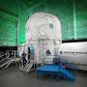
Whether it's to the moon or Mars, a NASA mission requires some essential preparations: designing and developing the spacecraft, astronaut training and safety checks, clear goals, and strategies and procedures for maintaining communication between crews on Earth and in space.

12. Payload electronics and flight software being developed for NASA's Landsat 10 spacecraft
Read more

Southwest Research Institute (SwRI) is developing electronics and flight software for the NASA/U.S. Geological Survey (USGS) Landsat 10 satellite, which is set to launch in 2031 to collect new and improved Earth observation data. The mission continues NASA's and USGS's partnership on the ongoing Landsat program, which has launched nine satellites since 1972 and provided more th...

13. NASA's Webb catches exoplanet getting roasted
Read more

One well-done gas giant, coming right up! That's the latest from researchers analyzing NASA's James Webb Space Telescope observations of HD 80606 b, an exoplanet four times the mass of Jupiter with an extremely elliptical orbit that sweeps close by its sun-like star. The research team is presenting its study and preliminary findings Tuesday at the 248th meeting of the American ...

